Gender and Disability Workforce Development Program

Increasing women’s wellbeing and preventing violence against women with disabilities are strategic priorities for Women with Disabilities Victoria (WDV). A key initiative to support this is the WDV Gender and Disability Workforce Development Program, funded through Victoria’s Action Plan to Address Violence Against Women and Children.

The need for violence prevention programs tailored for people with disabilities and the disability sector is well supported. The higher risks of violence against women with disabilities is documented in research such as Voices Against Violence and Stop the Silence. Further, the National Community Attitudes Towards Violence Against Women Survey and the Scope 1 in 4 Poll have findings indicating a need for tailored prevention programs on violence against women with disabilities.

The Gender and Disability Workforce Development Program is designed to change culture across whole organisations, working with clients, staff, managers and executives. This aim is to increase awareness of how to deliver gender equitable and sensitive services as a strategy for improving women’s well-being and status and reducing gender based violence.

WDV piloted all Program packages throughout 2014/2015 alongside an evaluation process to be completed in August 2015.

Program packages
The piloting of the Gender and Disability Workforce Development Program consists of:

- Train the Trainer Program
- Delivery of training to:
- Disability Support Workers Workshops
- Service Management Leadership Workshop
- Senior Executive Leadership Workshop
- Peer Education Programs for women with disabilities
- Follow up Communities of Practice

Train the Trainer
Fundamental to the program is training women with disabilities to co-facilitate the training with professional trainers from women’s health and violence prevention and response services. This model demonstrates equitable professional relationships with women with disabilities.
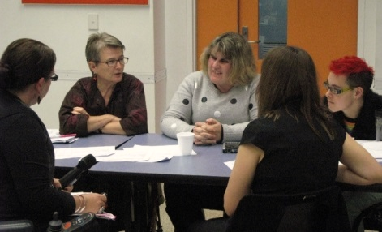
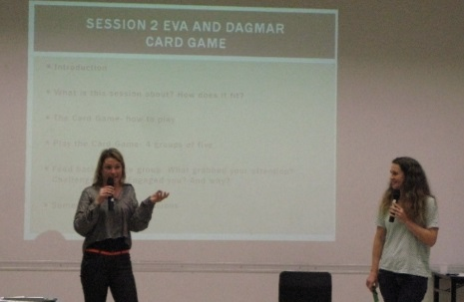

Gender and Disability Workforce Development Train the Trainer Program Participants

Human Rights and Quality Services: What does gender have to do with it?”
Staff training was piloted with two Victorian disability agencies (Yooralla and Gateways Support Services). As frontline service providers, disability workers are in a key position to support women with disabilities to uphold their right to achieve their goals.

The objective of the program is to improve the quality of gender sensitive practice amongst disability workers by improving their knowledge and skills in regard to:
- Concepts of gender, gender equality, gender relations and sex
- The socio-economic disadvantage of women with disabilities and its impact on social inclusion
- Human rights obligations pertaining to gender and disability
- The relationship between marginalisation, disability, gender stereotypes and violence
- Gender sensitive practice in delivering disability services
- Good practice in health promotion and primary prevention of violence against women

Women with Disabilities: Our Right to Respect
This peer education program allows women with disabilities to build understanding of rights, healthy relationships, what violence is and how to seek support to feel safe. At the same time, participants can build confidence and relationships to improve well being.

Evaluation and business modelling
Following completion of the program and program evaluation in August 2015, an appropriate business model for an expanded roll out of the program is planned.

For more information contact:
Fofi Christou
Gender Equity Training Co-ordinator
Women with Disabilities Victoria
Email: fofi.christou@wdv.org.au
Ph: 03 92867805

