D I A S Inc

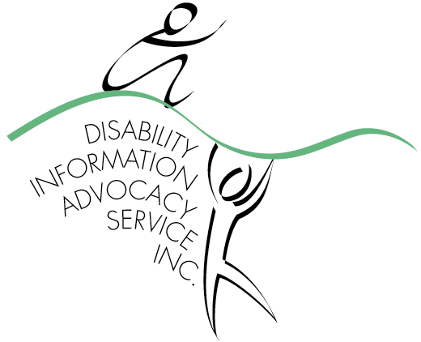
Disability Information Advocacy Service Inc
96 Russell Street (PO Box 1469) Bathurst NSW 2795
Tel: 02 6332 2100 Fax: 02 6332 6611 Email: admin@dias.net.au
Website: www.dias.net.au

for people with disability

NDIS Quality and Safeguards Framework Consultation Team
30 April 2015

Dear Sir /Madam

Re: Consultation paper Proposal for a National Disability Insurance Scheme Quality and Safeguarding Framework

Disability Information and Advocacy Service Inc. (DIAS) appreciates the opportunity to provide feedback for the National Disability Insurance Scheme (NDIS) Proposal for a Quality and Safeguarding System. Due to time constraints within my organisation, my intention is to direct my feedback to the following areas:
1. Systems for Handling Complaints
2. Reducing and Eliminating Restrictive Practices

I would also like to take this opportunity and make reference to our organisation’s membership with Disability Advocacy Network Australia (DANA) and acknowledge my full support of DANA’s submission covering in depth the proposed National Disability Insurance Scheme (NDIS) Quality and Safeguarding System.

About DIAS
DIAS provides free, independent information, advocacy, and referral to people with disability, their families and carers without any conflict of interest to approximately nine local government areas (LGAs) over 31,000 km² in the Central West/Orana region. DIAS is the only Disability Advocacy Support Organisation of its kind within the following regions; Bathurst, Blayney, Orange, Cowra, Mudgee, Parkes, Wellington, Dubbo and surrounding towns.

- Systems for Handling Complaints
Last year our organisation assisted 144 persons in some of the following areas; abuse/neglect, discrimination, education, employment, service access, service provider policy/practice, vulnerable/isolated, independent living and health and has documented statistics to demonstrate this. We have observed numerous persons accessing DIAS have limited or no family members to assist them or their ageing parents are unable to manage speaking up on their behalf. There should definitely be an external complaints system through which complaints can be escalated. An external system would also assist with identifying patterns and systemic issues.

An effective complaints system is even more important in regional areas, where the capacity of people with disability to “take their business elsewhere” is severely limited. Independent advocacy in regional areas is important for the same reason, but also because people with disability are more isolated and have less access to peer support and lobbying.

It is essential independent advocacy is funded appropriately to ensure people with disability have access to independent support. This has to be separate from National Disability Insurance Agency (NDIA) funding to participants as it is a basic human right to be heard and should not be linked to an economy of the individual to “afford” assistance to be heard.

Currently we have twenty six clients and affirm people with disability have a right to access independent advocacy support to promote, protect and ensure their full and equal enjoyment of all human rights enabling full community participation” consistent with the National Disability Advocacy Framework, which establishes a person’s entitlement to independent advocacy support.

Independent disability advocacy deals with complaints in almost all of its interactions with clients. By involving independent advocates, it is possible to de-escalate a situation so that no formal complaint is required. Disability advocates saves complaint handling services an enormous time of work and resources by assisting people and services to work through the issues without a formal complaint having to be made.

Although the National Disability Insurance Agency (NDIA) model supports self advocacy for clients with access to decision making assistance, by the time the client contacts our organisation they have often exhausted all their options for self advocacy. They either do not have the skills or despite having the skills have made no progress. In our experience, issues often go unresolved at a service provider level, despite having a system in place. For persons who choose to escalate their complaint, they often require the support of an advocate to do so.

A role exists for Community Visitors and independent advocates to help with identifying areas of service provision which are lacking in quality and assist people with disability to have these addressed, particularly where these people have limited communication or decision making capacity. The complaints mechanisms need to support this. The Community Visitor or an independent advocate can raise concerns on behalf of people who would otherwise be unable to make a complaint. In addition, with the powers available to the Community Visitor, they can access supported accommodation services and in turn uncover issues which may have been unnoticed or left unaddressed. The proposed monitoring of services would mean that issues for some of the most vulnerable people may be missed, if the Community Visitor’s role is disbanded.

There are little or no complaints systems for people who have a disability whom are cared for at home and do not access services. Where we have complaints of abuse by the client, for example financial abuse, it is very difficult to take action as the person is concerned about their relationships with their family and loss of their carer.

- Reducing and Eliminating Restrictive Practices
Disability advocacy endorses the reduction and elimination of restrictive practices and only condone the use of restrictive practices to ensure someone is kept safe from harm of themselves and/or when there is harm to others. I would like to make the following comments on Reducing and Eliminating Restrictive Practices:

- Government has traditionally provided behavior management support to families directly. The proposal mentions reducing and eliminating restrictive practices in NDIS funded supports but does not address how families will be supported to implement the behavior support plans and in turn reduce the restrictive practices in these types of settings. Ensuring families have access to behaviour management supports is important in preventing people with disability ending up in supported accommodation or on the street.

- Independent advocacy is significant in identifying when a restrictive practice/s is not recognised by service providers through complacency, ignorance or for any other reason. As disability advocates, we often encounter situations where families and service providers have used restricted practices and is considered has being part of the persons behavior support and have been unaware that this is unlawful. This is often brought to our notice when we are in conversation with our clients or their carers when seeing them about other matters. It is a concern that restrictive practices still occur in supported accommodation environments without proper authorisation when services are provided directly to support. Staff training is critical.

- Should mandatory reporting not extend to every incident, there should still be a process for identifying practices in use that are not accompanied by a formal behavior management plan, Community Visitor, independent advocacy, and/or sampling. However mandatory reporting, of the use of restrictive practice is critical.

- It is essential that approval involves an independent body/person to represent the individual particularly when the person has limited decision making capacity or communication. I believe it is crucial that the decision should not come down to one individual such as a senior practitioner or guardian but have a panel with appropriate expertise in the first instance, particularly in regard to using restraint or seclusion. Scheduled review is essential to prevent indefinite use once the restrictive practice has been placed.

- As disability advocates, our work has engaged us in educating persons whom work with people with disability on human rights, discrimination and restrictive practices.

Thank you for the opportunity to outline our organisation’s views on the NDIS Quality and Safeguarding System Consultation draft

Yours sincerely

Susan Smidt
Manager

