Ability Incorporated Advocacy Service
PO Box 417
Alstonville NSW 2477

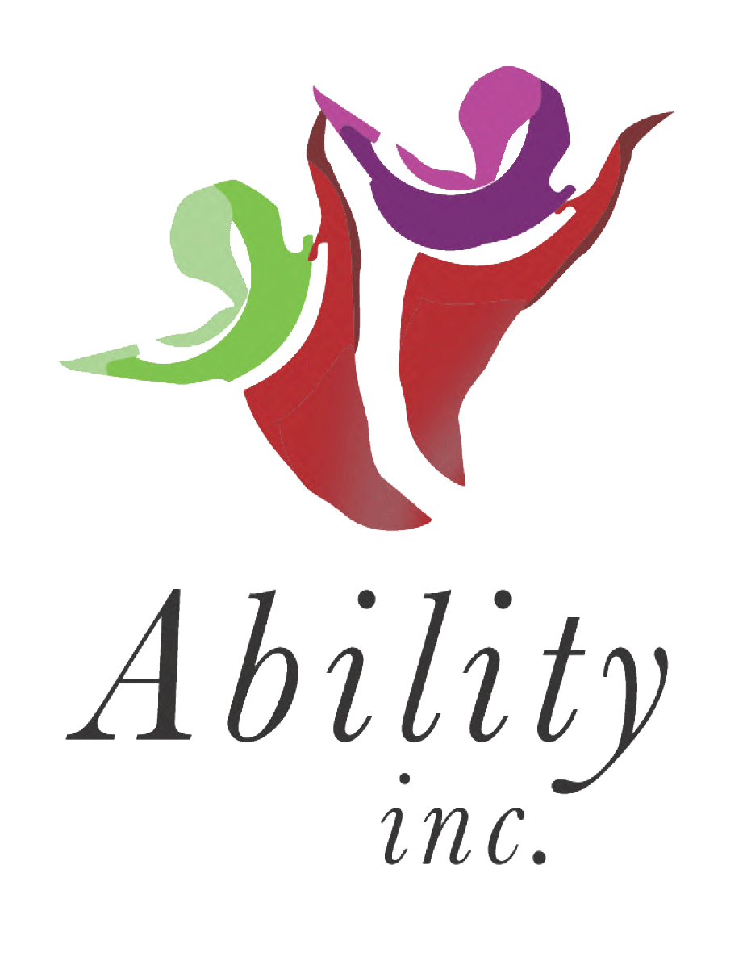
23rd July 2015

Ability Incorporated’s Submission to the National Disability Framework

Ability Incorporated Advocacy Service is a Disability Advocacy Service which has been in operation since 1990.

Over the 25 years since inception the organization has seen many changes taking place in the area of disability advocacy.

Throughout this period we have remained separate and transparent from all service provision.

After reviewing the National Disability Advocacy Framework, we realize that there is one fundamental omission. That is, that disability advocacy is independent.

We support the framework’s principles, objectives, outcomes, and outputs.
However we would like to note that in the objectives of the Framework it is quoted:

People with disability have access to effective disability advocacy that promotes protects and ensures their full and equal enjoyment of all human rights enabling full community participation.

If advocacy is going to be funded through the NDIS, we feel that people will not be able to have access to effective disability advocacy as their funding packages will limit their ability to have advocacy support over their other day to day needs.

We would strongly recommend that independent advocacy is funded outside of the NDIS.

Advocacy needs to independent from service provision, outside and separate from services that provide direct support for people with disability.

Many people in society are disempowered by systems which have a significant effect on nearly every aspect of their lives. These are people who are disempowered to such an extent that they are unlikely to be able to fulfill their basic human rights.
A person’s initial hopes and dreams can be severely limited by this.
Independent advocacy can help to widen a person’s horizons and enable them to become an active member of the community.

Many people do not have family supports in their lives. Service providers can have a conflict of interest. Whereas independent advocacy is free as possible from conflicts of interest like these, is completely separate from service providers and funding bodies, and focus solely on advocacy.

Independent advocacy is important to ensure justice, equality and fairness.

We would like to include in our submission case examples of where independent advocacy has provided meaningful outcomes for people with disability:

Ability Incorporated supported an elderly parent whose son lived independently and was in receipt of an attendant care funding package.
This man was morbidly obese, had an amputated leg, and suffered from schizophrenia. The service ceased support due to the fact that the man was a smoker, and the service felt this was a WHS issue. The advocate, with both the parent and the consumer's permission, sought an explanation from the service provider as to why they were not supporting the man, and asked how they were using the funding. The service could not give a credible explanation. The advocate took the matter to the funding body to find out how the service could be resumed as quickly as possible. The advocate suggested using some of the funding to install a extractor fan to remove the tobacco smoke. Further the advocate engaged the community Occupational Therapist who conducted an assessment and a new reclining wheel chair and shower commode was obtained. The advocate also communicated with the Department of Housing to gain approval for the extractor fan to be installed. Eventually this was done and the service was resumed.

Story for the National Disability Advocacy Framework

Mary works in an Australian Disability enterprise. She contacted me after attending a self advocacy training session I delivered.
Mary said that she wanted to live her own life, and have her own money. Mary lived in a caravan beside the rented house where her family lived. Mary said that she has two bank accounts; one for her wages, one for the DSP. Her mother goes to the bank to make withdrawals on the accounts, and gives her an allowance. Mary contributed towards rent, food, utilities and transport into town. I asked Mary if she had spoken to her mother about her plans. Mary said yes and that her mother becomes angry and doesn’t want to talk about it. Mary said that her mother is applying to be her financial manager. Mary doesn’t want this to happen.
Discussing the advocacy plan with Mary, I realise that she lacks numeracy and literacy skills, but very good at retaining information by memory. Mary disclosed that she often has temper tantrums where she throws away her epilepsy medication. Mary said that she has never been allowed to operate any kitchen equipment and the washing machine.
We identified that to be successful in objecting to the FM application, Mary will need:
- Numeracy and literacy skills
- Independent living skills
- Support at Guardianship hearing
Fortunately for Mary, we were successful in applying for the funding into the Life Moves program, enabling Mary to gain independent living skills. Mary was referred to the local community college where she enjoys learning to read and write.
Most importantly, at the Guardianship hearing Mary was able to demonstrate that she has the capacity to manage her finances. Mary is now happy living in her own unit with her pet cat.

DISCRIMINATION CASES:
Outcome One:
A family contacted Ability Incorporated for advocacy support regarding discrimination towards their daughter at school. She suffers with cerebral palsy and had a Special Teachers Aide to support her at school.
An incident occurred at school which made the family extremely distressed, and upon investigating the matter it was decided that the child had been discriminated against on many occasions due to her disability. An advocate lodged a complaint to the Principal of the school and this was unresolved, so then the advocate lodged an official complaint with the Anti-discrimination Commission.
With support with a Legal Aid Solicitor who specialises in Discrimination Law and their family advocate, a favourable outcome negotiated for the family at the Hearing. Their daughter was awarded compensation, and a new Teachers Aide was employed. The school also changed their policies to reflect the decision of the Anti Discrimination Commission to prevent this type of behaviour for future students who attend the school with disability. The families independent advocate was able to ensure justice, equality and fairness.
Outcome two:
A family were referred to Ability Incorporated by a Family Support Service in 2012 for advocacy support. This family has requested that their home be modified in 2007 by the Dept of Housing NSW & Aboriginal Housing, as her son was diagnosed with muscular dystrophy.
In 2012 the modification still weren’t carried out, hence the referral to Ability Incorporated for independent advocacy support. This family was very distressed and anxious when we met. The advocate lodged an official complaint to the Dept of Housing (DOH), and this was investigated. An Occupational Therapist was employed to meet with the family and make recommendations for suitable modification to be carried out within the next 6 months. This was never carried out, so after the six month period, the advocate then contacted Legal Aid and the mother & the advocate met up with a Solicitor to discuss the situation. An official complaint was then lodged to the Human Rights Commission of Australia due to a serious breach of Human Rights and Discrimination by DOH.
The Human Rights Commission held a conciliation conference in the local area and this took all day. The advocate spoke on the clients behalf at the hearing and her Solicitor represented the legal arguments. At the end of the hearing, it was agreed that The Department of Housing and Aboriginal Housing would purchase a home and carry out modification work as recommended by an Occupational Therapist. This had a timeline of 7 months.
Again this wasn’t adhered to. So the next step was to go to the Federal Court of NSW. Legal Aid was granted as this was a clear breach of Human Rights and Discrimination. The matter was very successful, and The Federal Court ordered that the Dept of Housing & Aboriginal Housing work together and purchase a home for the family, in a region of their choice, and have the home fully modified for wheelchair access. This matter is currently in the development stage. A home has been purchased, and the client is currently reviewing the draft plans for the modifications. We are anticipating that the family will be moved in to their new home by the end of the year.

TAFE MATTER:
Another client who suffered from An Acquired Brain Injury had applied to the local TAFE College to enroll in a course. Her application was rejected, and she was extremely upset. She was very vulnerable, and felt that she was discriminated against due to her disability as she would require a scribe and support to participate in class. She wanted some advocacy support with her application. Her initial application was rejected and she was extremely upset. She thought she didn’t get into her chosen course due to her disability and felt that she was being discriminated against.
The advocate lodged an official complaint the TAFE course coordinator and the disability officer on numerous occasions on her behalf, and she was soon offered a placement in a course of her choice. This client was very pleased with the outcome.

A client of Ability Incorporated was experiencing difficulty with his home phone service with Telstra for a period of 6 years. The client’s independent advocate lodged an official complaint with Telstra, and organised for the line to be serviced and checked by a Telstra technician. They found that there was a fault in the phone line outside his home.
After a long discussion with Telstra they agreed to refund this client an amount of $500 as compensation for the faulty line. He was very happy.

We firmly believe that the established advocacy organizations (both state and federally funded), have achieved a commendable “track record” for supporting and assisting people with disability.

We feel that these services should be given the first option of any funding made available through the new National Disability Advocacy Framework, whether this is within our out of the NDIS.

Thank you,

Yours Truly,

Doug Hollingworth
Manager.

