Accessible Arts response to the National Disability Advocacy Framework review
Accessible Arts welcomes the opportunity to offer a submission as part of the National Disability Advocacy Framework. We acknowledge the Department of Social Security Services’ renewed commitment to ensure that the National Disability Advocacy Framework continues to provide access to robust advocacy supports parallel to the NDIS.

This response specifically addresses the need for the Framework to consider the place of the arts and arts and disability peak organisations.

As an overarching comment, we recommend that the National Disability Advocacy Framework considers the intent of the National Arts and Disability Strategy as part of what the Framework it will facilitate. http://cmc.gov.au/sites/www.cmc.gov.au/files/arts-disability-0110.pdf

The National Arts and Disability Strategy establishes four strategic focus areas around access and participation, arts and cultural practice, audience development and strategic development. Without the contribution of people with disabilities engaged in arts and cultural pursuits, the nations cultural life is depleted. If people with disability are unable to include creative and cultural activities in their lives and wish to do so, the Advocacy Framework must support as mechanism for individual, organisational and government action leading to “choice, wellbeing and support to pursue their life goals”. We also recognise the National Disability Advocacy Framework’s contribution to increasing the participation of people with disability as one element in the realisation of Goal 27 of the NSW 2021 Plan, ‘Enhanced participation in arts, sporting and recreation activities contributes to economic, social and cultural development across the State and delivers benefits to the community and the economy’.

In going forward Accessible Arts would reinforce the value of and the role that the national network of arts and disability organisations has played in supporting people with disability to be involved in the arts and to consider a cultural life. Improving access to the arts is vital in shaping Australian identities and in building strong, prosperous, resilient and inclusive societies. All Australians should have the opportunity to participate in the cultural life of the nation, regardless of our abilities, age, gender, cultural and linguistic diversity, or geographic location.

To date this aspect of life has not always been recognized in the documents, processes and guidelines relating to the NDIS. We and other arts and disability organisations have found that we have had to advocate for ‘second editions’ to acknowledge the arts along with other aspects of society. If the NDIS does not promote the arts equally along with other fields of endeavour then the National Disability Advocacy Framework must consider how it will serve the community of people with disability who want to engage in the arts and cultural activities.

Promising practices in engaging people with disabilities in the arts have emerged over the last few years as a result of strategic investment by government by innovative and inclusive practices by remarkable artists with disability and by access champions from within arts and disability organisations, but artists and audiences with disability remind us that there is still more to be done.

Accessible Arts is not funded as an advocacy body due to the definition of a Peak Body. Accessible Arts does not have members, however we have been very effective over the past ten years advocating for the arts for people with disability. We have done this despite not having a membership base, using a raft of successful consultative methods. The new framework will hopefully recognise the place of our network and other agencies that practice systemic advocacy, as part of their work.

Accessible Arts is the peak arts + disability organisation in NSW. It provides leadership in arts + disability through information, advocacy and the facilitation of excellence in arts practice. Accessible Arts knows that the elevated awareness of inclusive practices across both the arts and disability sectors is still embryonic.

Yours sincerely,
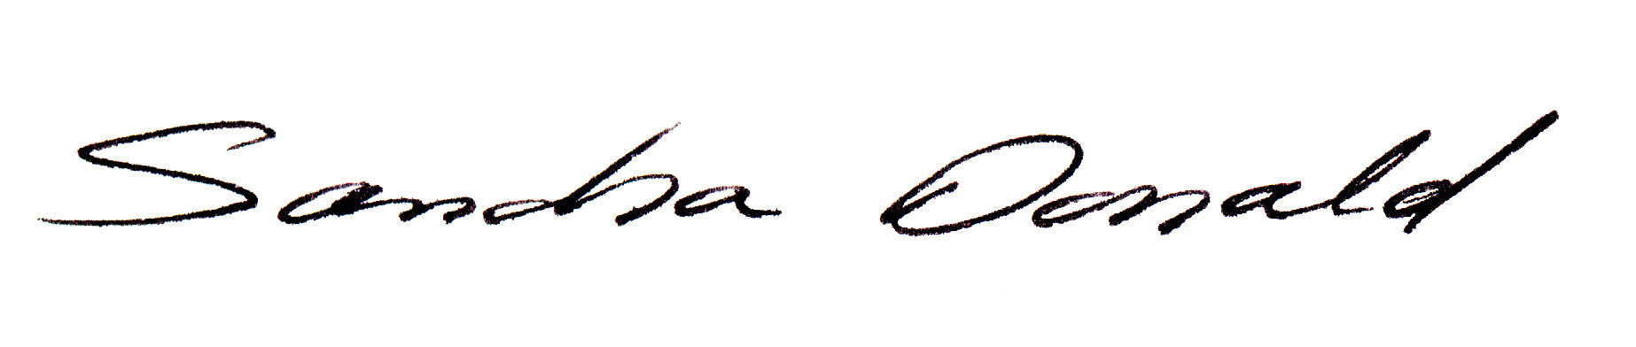

Sancha Donald
Chief Executive Officer

July 2015

