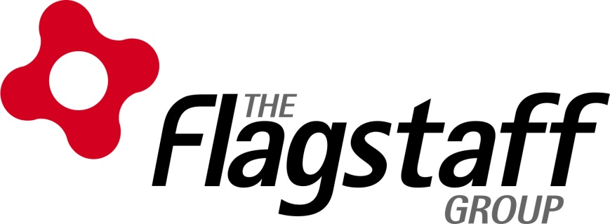
Submission
National Disability Employment Framework
10 July 2015

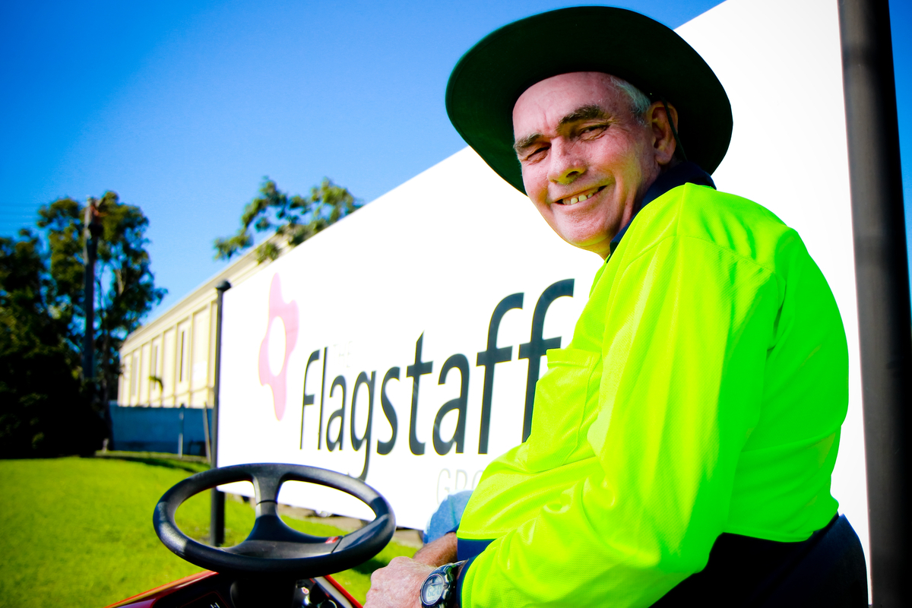

Contents

Executive Summary 3
Introduction 4
National Disability Employment Framework Principles 5
Barriers & Benefits to Open Employment Workforce Participation 5
Continuum of Employment 9
NDIS 10
Contact Details 11

Executive Summary

The following submission is prepared on behalf of the Flagstaff Group for the purpose of providing feedback in regards to the new National Disability Employment Framework issues paper that was circulated for consultation.
The submission addresses specific areas of the issues paper including:
- Framework Principles
- Benefits and barriers to employing a person with a disability
- Continuum of work structure and services
- ADE’s
- NDIS

Flagstaff provides its feedback from the view of an Australian Disability Enterprise operating 7 business divisions with 275 people with a disability. In addition, Flagstaff also engaged the feedback of parents and carers of our employees which was collated by way of a focus group whereby specific questions as part of the issues paper were raised along with a series of other queries that relate to challenges for people with a disability in transitioning to open employment.

It is important to note that the parent/carer participants of the group represent dependents working within Flagstaff’s supported employment environment across a diversity of ages, types of disability, and period of employment within an ADE. Representatives have also experienced firsthand a diversity of employment services and support including other ADE’s, educational institutions including Universities, TTW courses, DES and JSA providers and had experiences securing work and trialling employment in the Open employment market.

Introduction

The Flagstaff Group is located in the Illawarra and Shoalhaven NSW and was formed in 1966 to provide meaningful employment for people with a disability. Over the last 48 years Flagstaff has grown and now employs 340 staff, of whom 278 are people with a disability.

Flagstaff is a Not for Profit Social Enterprise that is 85% self-sustainable through its commercial operations and just 15% dependent on government funding. All earnings within the group are re-invested within the organisation to enable further employment opportunities for our people.

Flagstaff provides supported employment in a commercial environment across a range of business divisions including:
- Commercial Laundry
- Fine Foods/Dry Beverage Coffee Packaging & Distribution
- Shoalhaven site – Grounds Maintenance, Cleaning
- Print and Mail
- Light Engineering
- Paper and Cardboard Recycling
- Café Vizione

Flagstaff Group is a leader in achieving open employment outcomes for our employees and providing training opportunities to attain qualifications on the job.

Flagstaff runs a Vocational program aimed at years 9-11 school students and is designed to provide students with a disability, access to work experience and vocational training in a supportive business environment.

Flagstaff runs a Workskills program for all new employees covering modules from communication, personal presentation, conflict resolution and meeting workplace expectations.

In addition Flagstaff offers a work based Transition to Work program providing employees with the opportunity for career development by attaining a Certificate II Qualifications in Process Manufacturing, Food Processing and Waste Management with TAFE and State Training, to help employees acquire a Nationally Recognised qualification.

National Disability Employment Framework Principles

In reviewing the principles as stated in the issues paper which are foundational to the framework, in general Flagstaff supports these principles.

Flagstaff recommends adding an additional principle that is targeted to addressing the inadequate support employees experience in open market once on the job and the issue of misconceptions about employing people with a disability. The principle would be centred on:
“Employer education of people with disabilities needs in the workplace”

Barriers & Benefits to Open Employment Workforce Participation

Flagstaff identifies a number of significant gaps and barriers in the open employment market impacting people with a disability in securing and maintaining employment. In saying this, Flagstaff is cognisant of the many benefits for people with disability in participating in the workforce and has a number of comments and suggestions below.

Work Readiness
One of the core barriers to workforce participation that Flagstaff witnesses on a daily basis is a lack of work readiness that a person with a disability may have when commencing work. Many people with a disability have a lack of transferable and/or recent work skills and adequate understanding of workplace behaviours.

Whilst an ADE, Flagstaff’s business environment has a high level of commercial performance that replicates a traditional commercial working environment in the Open Market. Many of Flagstaff’s new employees may have participated in a TTW program or have utilised the skills of a DES or job service, however one of the biggest barriers encountered is the genuine lack of understanding on the foundational elements of what coming to work entails.

Concepts such as keeping to work start and finish times, personal presentation and hygiene, ability to engage with others or take directions, completing a work day in a structured manner and sustaining a task for a period of time are all factors needing to be covered to achieve work readiness.

Flagstaff recommends the utilisation of ADE’s and supported employment as a transitional pipeline for training, work readiness and building work muscle in alignment with other employment and training services.

ADE’s offer excellent opportunities for people with a disability to become confident in what is required in a workplace and explore tasks and activities that can help build confidence and resilience. Flagstaff recommends that the framework explores ways in which ADE’s can be leveraged in this manner.

Support, Tolerance and One on One Supervision
In gaining input from parents and carers on the barriers to open employment, there was unanimous feedback from all parents that whilst many people with a disability working in the supported employment environment had significant capabilities to offer, they did not feel that their children would be able to sustain employment in open market unless it could replicate a support model and commitment to supervision and tolerance that Australian Disability Enterprises or supported employment environments currently offered.

Whilst Flagstaff’s supported environment provides HR guidance, intensive training support and counselling to help employees carry out their tasks, there is a significant amount of one on one supervision and support that is required to enable to the person with a disability to formulate these traits.

The challenge for many people with a disability that experience a start in an open employment environment is in the lack of understanding the employer may have on the individuals support requirements.

Flagstaff parents and carers have a genuine concern that people with a disability entering the open employment arena under the current structure may not be adequately treated, supported or understood.

Parents of employees felt there is a potential risk to safety and negative emotional and psychological impact on the person with a disability due to a lack of understanding from the employer and their staff on the needs of a person with a disability. Underestimation surrounding the levels of adequate structure, resource and support from open employment environments to provide an environment that is conducive for a person with a disability to work within had been witnessed.
There is a need to increase employer support in open employment to assist employers in understanding and providing the level of one-on-one supervision required. Clearly understanding the realistic needs of a person with a disability helps Open employers upfront.

Flagstaff parents and carers understand the challenges for businesses to accept a person with a disability in a high paced working environment, however believe that without tolerance from the employer and their own organisations commitment to support the person from within the organisation, a barrier will remain.

The gap in understanding must be overcome with education to businesses and greater social inclusion for people with a disability across all facets of the community is required.

Employer Education
The benefits of employing a person with a disability are extensive however there is great importance on providing employer education about employing a person with a disability as part of the framework.

Flagstaff recommends the creation of a dedicated media and communications campaign to private business and development of support resources, tools and consultation opportunities for potential employers to be aware of the supervision and requirements to support a person with a disability in the workplace.

Clearly articulating the benefits of employing a person with a disability and what is required to harness these benefits is also crucial.

Government Targets
In an effort to show leadership to the broader open employment market and the wider community on the benefits of employing people with a disability, Flagstaff believes that it is most important for the government to demonstrate its commitment of providing employment within its own departments and services similar to many government departments in European countries.

Skillset Demands and Creation of Relevant Roles
Flagstaff identifies that there is currently a lack of clear work pathways and job opportunities that come with adequate supervision and support.

Across small and large businesses in the open employment market, there is a constant push for staff to be self-motivated and work autonomously without supervision. This philosophy poses significant issues for a person with disability that may require ongoing oversight and assistance within their role forever.

Flagstaff believes that there are significant opportunities for the utilisation of training and work experience combined with a commercial supported employment environment for people with a disability in gaining adequate skills, competence and confidence to attempt a role in open employment.

Flagstaff identifies a gap in labour forces within the Aged care and Disability services sector which with the appropriate training, support and supervision could be ideal roles for people with disabilities moving forward.

The government needs to think outside of the square regarding ways in which they can support ADE’s and private business to work together concurrently in building this work based capability to enable to person with a disability to gain a job with adequate and ongoing supervision and support for the employee once they are in the role.

Work Experience
Enabling private business to engage in the permission of work experience for people with a disability to experience firsthand the open employment environment is key.

Barriers such as access to insurances and training are currently present. One Flagstaff parent described the many hours of personal leave they took to work with a local cinema to provide their son with the opportunity to train in general cinema customer service duties. The parent themselves acted as a support person for the employee and currently pays for public liability insurance for the person with a disability to engage in work experience as the cinema was not able to cover the person with a disability under their general work insurance. Support to enable employers the ability to take on insurances related to providing work experience opportunities is essential.

Supported Employment Safety Net
In accepting an opportunity and progressing into open employment attracts a perceived lack of a safety net for people with a disability if the open employment placement does not work out.

Flagstaff has a number of employees who have attempted the transition to the open employment market on a number of occasions, and due to the aforementioned challenges of lack of support and understanding experienced by their employers have had to return to the supported employment environment.

Flagstaff parents and carers referenced a number of negative experiences in securing and trialling work in the open employment sector which resulted in the employees losing their open employment position.

With this in mind, the new framework must provide an adequate safety net that promotes and supports people with a disability to keep trying the open employment space with the fall back of an alternative supported employment option for them to move back to in the event that they are unable to sustain this is imperative.

Continuum of Employment

Flagstaff is concerned with the identification and categorisation of the two levels of people with a disability in finding employment:
- Disability Management Service is for job seekers with disability, injury or health condition who need assistance to find a job and occasional support to keep a job.
- Employment Support Service provides assistance to people with permanent disability and who need regular, ongoing support to keep a job.

In relation to the above “categories “of disabilities that a person may be allocated to in future to identify needs, it is imperative that the framework moving forward to be designed and have flexibility to accommodate not just for “categories” of people with disability, but rather be based on individual needs depending on the person’s requirements, in alignment with the NDIS goals.

Flagstaff believes that vital changes to the ways in which the facets of the workforce continuum work together is crucial to achieving better outcomes and support. Traditionally, ADE’s have only experienced ad-hoc interaction with DES providers and any instances of ‘shared clients’ happened by chance or by the involvement of another agency (e.g. an advocacy service). This lack of a cohesive and coordinated response adversely impacted on the vocational skills development for a person with a disability and was not conducive to achieving open employment outcomes.

Under pressure to produce outcomes, particularly in areas of high unemployment, DES providers operating with resources dictated by fiscal restrictions were able to place their work ready clients into open employment and provide some assistance for other clients to enter into some form of study.

Clients with no (or limited) work skills or who were not behaviourally work ready often did not progress into meaningful open employment opportunities and instead their interaction with the DES did not go beyond regular ‘catch up’ visits.

Ensuring that ADE’s and employment services are provided incentives and funding to collaborate are provided as part of the new structure going forward is crucial to enabling better workforce participation for people with a disability.

Flagstaff welcomes the recent Governments recent changes to the rules surrounding a person with a disabilities involvement with both a Disability employment service whilst working in a supported employment environment.

The two functions of the supported workplace combined with the employment assistance in acquitting open employment are complimentary and help the person with a disability to gain relevant on the job experience whilst actively looking for open employment.

In addition to this a key issue raised by a number of parents and carers of employees from their experiences with DES providers and open employment placements was that whilst employees received some initial support for a few weeks at commencement of a job placement, the period of support was not adequate or extensive enough to adequately “on-board” a person with a disability. Changes to the rules of service provision to enable employment service providers the ability to provide support and guidance on the job for longer periods of time is critical.

NDIS

Flagstaff believes that the NDIS offers a great opportunity for providing both supported work opportunities to people with a disability but also offering an opportunity for the various levels of the employment continuum to work together to achieving open employment goals.

Reducing barriers and incentives that assist ADE’s, DES and JSA organisations to work together to help achieve end goals is paramount for achieving employment outcomes and must be considered in the redesign.

In the way that NDIS is person centred, so too is the employment pathway and capabilities of every person with a disability and the NDIS framework must recognise this complexity for the individual.

Employment outcomes can be best supported with acknowledgment and funding for the training and additional support that is often required for ADE’s to help build skills development and work readiness. Ability for clients to access support and funding for such training and career development should be considered in the design of the employment framework for NDIS.

Flagstaff sincerely appreciates the opportunity to participate in providing this feedback and looks forward to the next stage of the consultation process in August /September 2015.

Contact Details

For any further details on the submission please do not hesitate to contact us on:
Karen Burdett
Group Sales and Marketing Communications Manager
02 4272 0203
Mobile 0427 813 016
Karen.burdett@flagstaffgroup.com.au

Roy Rogers
Chief Executive Officer
02 4272 0218
Mobile 0427 789 802
Roy.Rogers@flagstaffgroup.com.au

