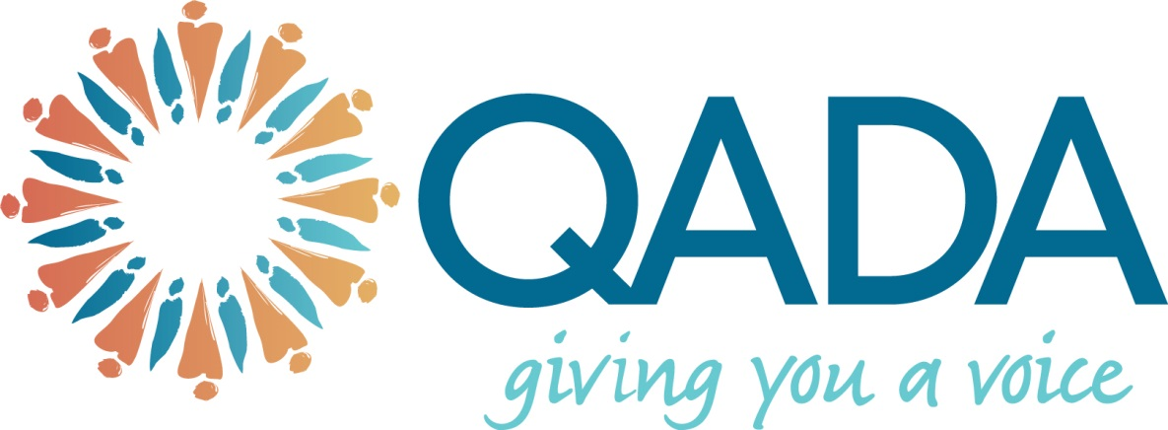

National Disability Advocacy Framework Review

July 2015

Overview- QADA
QADA is jointly funded by the Queensland and Australian Governments to offer free, confidential and client directed advocacy support to recipients of aged and community care services, and carers of recipients of these services.
QADA also provides support and representation to assist adults whose decision making capacity is being questioned, with guardianship and administration matters through assistance at QCAT hearings.
QADA is an independent advocacy service that operates throughout Queensland with a head office in Brisbane and regional offices in Cairns, Townsville, Rockhampton, Mackay, Wide Bay, Toowoomba and the Gold Coast. QADA is part of a broader network of aged care advocacy providers across Australia, federally funded through the National Aged Care Advocacy Program (NACAP).
QADA’s mission is to provide information and support to our clients enabling them to exercise their rights and their responsibilities through informed decision-making. QADA assists vulnerable people and communities, wherever they are throughout Queensland to resolve issues that affect their lives through the provision of high quality advocacy support and representation.
QADA actively participates in consumer engagement activities to identify local issues affecting individuals and communities, to gather information to influence service planning, and to suggest recommendations to make changes at a systemic level for service providers and government.

Submission
Overall the National Disability Advocacy Framework provides a comprehensive basis for establishing advocacy practice which is responsive to the needs of people with disability.
The current framework works within the principles of empowerment and inclusion. This is extremely important for the introduction of the NDIS as the changing service model will operate from a client driven perspective. However, consideration needs to be given to how people with limited capacity whether that be ongoing or episodic are able to administer these principles. Where supports are required to assist the person to achieve these principles, this should be acknowledged in the framework.
There needs to be acknowledgment that advocates may have a much more hands on role with the upcoming NDIS as many people may require additional support to ensure they are able to access the system and that their goals and wishes are articulated and maintained. This may mean additional episodic support from advocates as they work with people with disability through each phase of the process. However, it needs to be clear that the advocate’s role is on a required basis only and that long term dependent relationships should be avoided.
In addition, many NDIS participants will self manage which will require different skills to what they may have utilised previously, this may require supported decision making with everyday requirements that should fall outside the scope of advocacy.
Those that may be experiencing additional disadvantage due to gender, sexual orientation, ethnicity and cultural background may require further, specific support to ensure there needs are taken into account. This may include using alternative supports and services such as interpreters, cultural workers, elders and family members where appropriate. Building relationships and networks within local community is particularly important for Aboriginal and Torres Strait Islanders as well as those from CALD backgrounds to build trust and engage with the advocacy process. Flexibility around how and what advocacy support is provided to people experiencing additional disadvantage is important to maintain trust and accessibility for these client groups.
Recommendations
Whilst the framework provides an overarching guide for advocacy within the disability sector it does not specify how advocacy may be implemented on a practical level.
The following model may be used as a guide to developing a consistent, client responsive approach to advocacy within the disability sector.
Disability Advocacy Model
- Advocacy services need to be independent from government departments, service providers and other organisations to remove any possible conflict of interest and act solely on the client’s behalf.
- It is recommended that government fund a national/statewide advocacy service through block funding in order to meet the individual advocacy needs of people with disability. This allows for the appropriate and adequate support to be provided and ensure equity and consistency of service throughout Australia. The concept that advocacy can be bought from an individual’s funding package will not work given the variability of individuals need for advocacy support.
- By implementing a national/statewide call centre for information and advice with a local presence in each region for representation would enable consistency of the advocacy approach as well as accessibility and local knowledge to obtain successful outcomes for clients.
- Conducting face to face support and representation where possible is particularly important for people with disability, this ensures communication is appropriate and action agreed. In addition, the client is able to fully participate throughout the advocacy process and develop skills to self advocate into the future.
- Gaining the client’s permission, working with the client and involving them as much as possible in the decision making process is vital to successful advocacy practice.
- Educating clients one on one and on a broader level to understand and exercise their rights and responsibilities is important to achieving self-reliance and maximum participation in exercising their rights and responsibilities.
- Working from a collaborate, positive approach rather then adversarial whist vigorously advocating for the client and remaining independent, ensures outcomes are achieved whilst relationships are maintained once the advocacy process is finalised.
- Where appropriate and with the client’s permission working from a holistic approach may be important, for example involving those that are involved in the client’s life and have relevance to achieving positive outcomes, such as an alternative decision makers, family, friends, health professionals and other supports.
- Appropriate training, knowledge and skill development for advocates is required to ensure consistency of process and professionalism, including appropriate negotiation techniques, communication skills, problem solving, sector knowledge, professional boundaries, cultural awareness training and suicide awareness.
- Providing appropriate supervision and support is needed for ongoing professional development and to ensure accountability of the advocacy process.

The National Aged Care Advocacy Program (NACAP) is currently under review and learnings from this review in relation to how advocacy support is delivered to vulnerable Australians may be appropriate to inform the National Disability Advocacy Framework Review.
Contact
Geoff Rowe
Chief Executive Officer
Queensland Aged & Disability Advocacy Inc (QADA)
Tel: 07 3637 600
Email: geoff.rowe@qada.org.au

