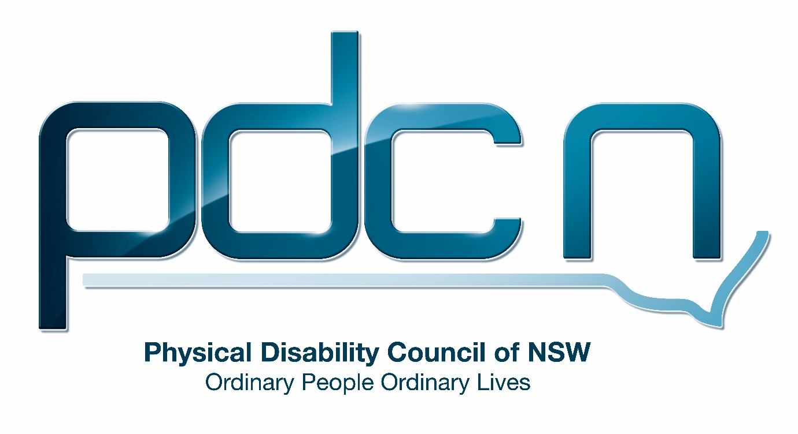

Submission for the Australian Government
Department of Social Services

National Disability Employment Framework - Issues Paper

8 July 2015

Physical Disability Council of NSW
3/184 Glebe Point Road
Glebe 2037

Jordana Goodman or Serena Ovens
02 9552 1606
www.pdcnsw.org.au
admin@pdcnsw.org.au

Who is the Physical Disability Council of NSW?

The Physical Disability Council of NSW (PDCN) is the peak body representing people with physical disabilities across New South Wales. This includes people with a range of physical disability issues, from young children and their representatives to aged people, who are from a wide range of socio-economic circumstances and live in metropolitan, rural and regional areas of NSW
The objectives of PDCN are:
• To educate, inform and assist people with physical disabilities in NSW about the range of services, structure and programs available that enable their full participation, equality of opportunity and equality of citizenship
• To develop the capacity of people with physical disability in NSW to identify their own goals, and the confidence to develop a pathway to achieving their goals (ie: self-advocate).
• To educate and inform stakeholders (ie: about the needs of people with a physical disability) so they are able to achieve and maintain full participation, equality of opportunity and equality of citizenship.

Overview
The Physical Disability Council of NSW appreciates the opportunity to consider, and make comment to the Department of Social Services National Disability Employment Framework’s Issues Paper (May 2015).
PDCN will not be making comments on all the questions raised, but will respond to the various sections where we can add contribution to the discussion.
Discussion
The Department of Social Services Issues Paper aims at investigating strategies to address barriers to employment and identifies physical disability as comprising 3.4 million people (81% of 4,213,900 people with disability). Included in this group were conditions affecting the musculo-skeletal system and connective tissue which were reported by one third (33 per cent) of people with disability. These conditions included back problems (15 per cent) and arthritis and related disorders (14 per cent).
Background Information

Australians with Disability
The Australia Bureau of Statistics (ABS) data identifies people with physical disability as consisting of 10.5% of all people in the labour force. Subsequently this group makes up a large portion of the Australian workforce. The following data addresses employment of people with physical disability in relation to gender, severity of disability, the number of hours worked per week, unemployment rates and labour participation:
- People with disability with moderate, severe and profound limitations had approximately twice the rate of unemployment than people without disability. The rate of unemployment was even more significant for females.
- In 2003 for males with a disability, unemployment rates ranged from 7.2 - 10.0% and for those without a disability, 5.3%. For females with a disability this ranged from 8.1- 24.6% and for females with no disability; 5.6% unemployment.
- When comparing unemployment rates for those with a severe or profound disability against those with no disability the biggest difference could be seen for people aged between 25- 29 years, and 55- 59 years.
- Among people with disability, labour participation rates were most stable between 30 and 44 years of age.
- More people with disability were employed part - time than people without a disability.

Workforce Participation of People with Disability
What can improve employment outcomes for people with disability?
What can help reduce barriers for people with disability seeking employment?
What can help reduce barriers for employers hiring people with disability?
How can we promote the benefits of employing people with disability?

Similarly to the wider Australian population, employment provides economic security to assist with the purchase of household expenses and assists with personal wellbeing for people with disability. Subsequently it is considered as a high priority by government departments and the following documents and programs:

- United Nations Convention on the Rights of Persons with Disabilities (UNCRPD)
- Disability Discrimination Act 1992
- Disability Standards for Education 2005
- Shut Out: The Experience of People with Disabilities and their Families in Australia (2009).
- National Disability Strategy 2010- 2020
- National Disability Insurance Scheme (NDIS)
- National Disability Insurance Scheme Act 2013

As an example of recent employment trends PDCN has used data available from the Australian Public Service Commission identifying a significant decline in the employment of people with disability between 1997 and 2011 from 5.7% down to 3.0%. With the different State Public Service Commissions’ identifying that employment of people with disability spanned from 1.4% in the Northern Territory to 7.0% in Tasmania. These estimates are well below international levels of similar Public Service Commission’s in New Zealand and the United Kingdom with approximately 8.0% employment of people with disability. PDCN believes that an increased employability not only benefits people with disability, but benefits a range of stakeholders including customers using the service, co-workers and Human Resource departments.

Despite a low unemployment rate, a relatively high average wage and strategies adopted by the Australian Government to increase the employment of people with disability, employment outcomes have been poor. Internationally Australia ranks seventeenth compared to twenty- nine other nations when determining the severity of poverty, and ranks twelfth for the average income of the working-age population.

Due to limited earning capacity people with disability are often in poverty as a result of being on the Disability Support Pension and/ or being on part- time wages. The vast majority of low income renters with a disability (96%) receive a government benefit are subsequently in the two lowest income quintiles. This limited earning capacity is coupled with additional household expenses often associated with having a disability. These additional expenses often include:

- Aids and equipment
- Medical appointments and prescriptions
- Daily personal care needed within the home and place of employment
- Taxi transport due to an inability of accessing public transport, and
- Home modifications.

Research on the costs and benefits of employing people with disabilities found that the cost of recruiting an employee with disabilities was generally lower, productivity was equal or greater than other workers in the vast majority of cases, and most workers with a disability exhibited better attendance and lower occupational health and safety incidents than those without a disability.

Barriers to accessing employment include the following:

- Negative employer attitudes regarding potential risks associated with employing a person with disability
- Employer concerns about costs associated with the initial recruitment and the ongoing needs of retaining a person with disability
- A lack of resources and ability to access advice and information on the immediate and future cost of recruitment.
- Although modifications to workplaces can be funded through the Commonwealth Government, access to work sites is a concern commonly identified by employers considering recruiting a person with disability. With the progressive implementation of the Disability (Access to Premises - Buildings) Standards access to workplaces should become less of a concern
- Inaccessible public transport also reduces the ability of people with disability to access the worksite
- PDCN considers the lack of uniform education as fundamental to increasing accessibility to employment. All institutions which provide educational services including child care centres, schools and universities, colleges of technical and further education, apprenticeship and trade schools and private educational institutions, need to be considered as significant to acquiring employment. Without primary, secondary and tertiary education people with disability will continue to face barriers when trying to attain employment, financial and health outcomes. Employment status is even more fundamental if people with disability are being recruited to replace an ageing workforce. Data from the ABS found that students with disability are less likely to complete Year 12 than students without disability (33.3 per cent compared with 54.9 per cent). This is significant given that early school leavers are more likely to be unemployed for longer periods, earn lower incomes, and accumulate less wealth over their lifetime compared to those whom complete schooling. To achieve an increase in the proportion of secondary students with year 12 qualifications a greater number of educational facilities need to provide access, and for this reason PDCN believes that state government educational departments need to adopt a plan lasting at the most ten years that identifies access improvements, similar to that with State Government Departments’ of Transport.

The following strategies are recommended for employers to reduce barriers experienced by people with disability seeking employment:

- Workplaces that encourage accessibility and diversity by providing effective leadership
- Management and Human Resource Departments that provide leadership for the implementation of inclusive workplaces
- Clarify and support the role for Managers and supervisors to enhance the recruitment, training opportunities and promotion of people with disability
- Proactively address employee concerns regarding bullying, workplace alienation and disengagement
- Participate in departmental networks to enhance joint collaboration.

The following options are recommended for promoting the benefits of employing people with disabilities:

By employing a diverse workforce with employees from different cultures, nationalities, different backgrounds, living circumstances, and people with disability, businesses can prepare for a greater variety of consumer needs by meeting a larger range needs. The Better Business Awards program encourages businesses to be more sustainable, have a more competitive advantage, ability to project future commercial demand, contribute generously to community need, and/or a business that reinforces employee loyalty.

The success of employers that recruit a more varied workforce including people with disability could be further promoted by implementing any of the following;
- Testimonials on the business website
- Social media
- Better Business Awards
- Industry Awards

National Disability Insurance Scheme (NDIS)
In what way do you think the NDIS can support employment outcomes for people with disability?
What do you think we can learn from the NDIS to improve job services for people with disability?

PDCN believe that the NDIS can support employment outcomes for people with disability through the inclusion of employment goals within an individual’s plan, increase a person’s choice and control over their lives, and in particular in this case, their employment options.

The development of these goals then allows for the individualised funding of services and supports to assist in the implementation of same, including provision of aids/eqt, training necessary to move towards employment (such as travel training and skills development) and support through the employment process (in areas such as writing job applications, interviews, workplace assessment, modifications and initial placements)

As the NDIS is still in its initial pilot and implementation phase many outcomes may not yet be fully discernible, however in the long term the NDIS may be able to provide learnings for both employers and individuals on best practice implementation plans, ensuring job services are aware of typical or common employment issues, are able to address these identified areas of concern prior to the individual taking up employment, and maintain awareness and assistance for the individual throughout employment, therefore ensure better outcomes and employment retention for people with disability in the workplace.

Australian Disability Enterprises (ADE’s)
CAN WE IMPROVE SUPPORT FOR PEOPLE MOVING OUT OF ADE’s INTO OPEN EMPLOYMENT?
HOW CAN ADE’s OPERATE AS VIABLE BUSINESSES?
PDCN would not be in favour of the continued existence of ADE’s as these are institutional environments, where people with disability have experienced poor outcomes - in terms of rates of pay, skills and qualifications development and a lack of opportunity.
Additionally these businesses work on a segregated model, and do not reflect any of the principles of inclusion, choice or control to which Australia has made a commitment to through ratification of the UNCRPD.
In terms of improving support for people moving out of ADE’s into open employment PDCN would recommend ensuring that those employed to assist in this process have a balanced workload and area able to respond to each individual’s circumstance. Many of those employed to do so presently find the number of individuals they are working with at any given time exceeds their ability to do so effectively.
PDCN also believes there needs to be a recognition from the prospective employer in this instance that there may need to be a process of skills development and transition in order to enable the individual transferring into the open workplace.
Whilst transition to work programs (TTW) can be made available, it should be recognised that these individuals have worked in closed and segregated settings with minimal interaction with non-disabled peers, and may need additional support particularly in the area of behaviours and interaction with other staff.

Principles for Changes to Disability Employment Services
DO YOU AGREE WITH THESE AS THE UNDERLYING SET OF PRINCIPLES FOR CHANGE?
ARE THERE OTHER PRINCIPLES YOU WOULD INCLUDE?

Principles | Benefits
Individual funding based on needs and aspirations | Choice and control to the individual
Market-based service provision | Flexibility, innovation and responsiveness to individually based consumer choices
Long-term career planning and capacity building | Sustainable employment outcomes that meet current and future labour market needs
Understanding of employer needs | Better match between job seeker and jobs, leading to better, longer term employment
Increased open employment options | Social and economic gains for the individual and broader community
Whole-of-government coordination and use of technology | Improved service pathways and reduced ‘red tape’ for clients and service providers
The person is supported through the life-course | An integrated approach that maximises lifetime wellbeing

PDCN would ask for clarification in relation to the ‘market based service provision’ principal, and would wish to understand who are the’ benefitting consumers’ making the choices? Care should be given that others instead of the person with disability are making choices as this would not reflect a person centred approach. Additionally PDCN also has concern with the use of the term ‘service provision’. Any principles underlying change should not use terms that have negative connotations, such as ‘service provision.’
PDCN also believe that as well as addressing the ‘Understanding of employer needs’ principle there should also be a principle that recognises the skills and attributes of the employee, and how these can benefit an employer.
Principle: Recognition of skills and attributes of an employee
Benefits: Improved alignment of job role for employee, and better outcomes of employment

In Principle 3 : Long-Term Career Planning and Capacity building, PDCN recommend a change of wording from ‘capacity building’ to ‘professional development’ as we believe that this is a more appropriate term in the open employment sector as other employees (non-disabled) would not have their career development labelled as ‘capacity building’.
Overall in principles suggested there in an inconsistency of language use, reference has been made to the individual as a ‘job seeker’ at times, and a ‘client‘ at others or simply referred as ‘person’.

Conclusion:
PDCN values a framework that recognises the contribution of people with disability to the workforce, and believe that with ongoing commitment from all stake holders involved and continued evaluation of effectiveness, this will lead to increased participation and better employment outcomes for people with disability.

Australian Bureaux of Statistics – (2003) 4430.0 Disability, Ageing and Carers: Summary of Findings
Australian Public Service Commission (2013) Australian Public Service Disability Employment Strategy- As One
Deloitte Access Economics (2011) The Economic Benefits of Increasing Employment for People with Disability
Commonwealth Department of Social Security (2015) Disability Employment Framework
Commissioned by the Australian Network on Disability (2011) The Economic Benefits of Employing a Person with Disability

