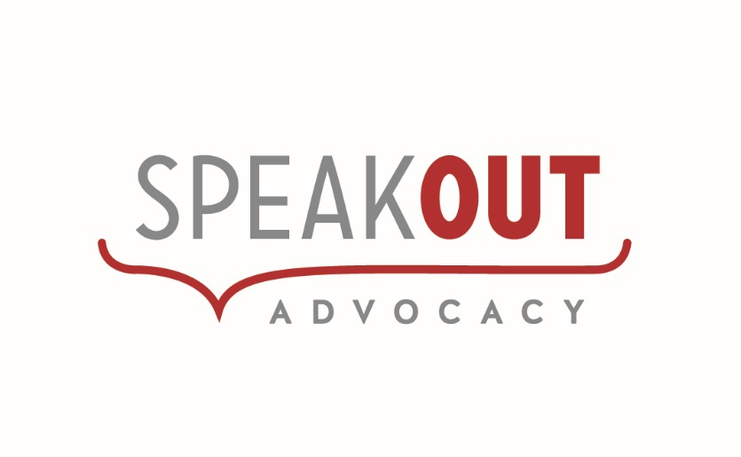
Review of the
National Disability Advocacy Framework
Submission to the Department of Social Services
July 2015

Speak Out is a statewide, independent, non-government organisation that provides individual advocacy, family advocacy, self advocacy and systemic advocacy.
Initially established in 1982 to promote self advocacy through the annual conference, Speak Out commenced delivery of advocacy services in 1989.
Speak Out aims to develop a respectful and inclusive community by promoting and defending the rights of people with disability.
We achieve this through our advocacy work; good governance that includes people with intellectual disability; and building the capacity of communities.
Speak Out is also a membership organisation for people with intellectual/cognitive disability. Self-Advocacy groups and Peer Support groups meet each month.
We welcome the opportunity to give feedback to the review of the National Disability Advocacy Framework.

- Do you believe the current Framework encompasses your vision of advocacy in the NDIS environment? If not, what changes are required?
Overall the current framework is ‘fit for purpose’ and provides a sound structure. To encompass our vision of advocacy in the NDIS environment, we believe it requires changes to:
- Increase and strengthen focus on Rights and the CRPD
- Recognise and promote the crucial role of self advocacy and capacity building
- Include and value group self advocacy for the role it plays in empowering people, building skills and expertise; and informing systemic work.
- Are the principles of the Framework appropriate for guiding the delivery of advocacy for people with disability in a changing disability environment, including in the context of the NDIS? If not, what changes are required?
While Speak Out supports the principles contained in the framework, we believe the principles should be strengthened to reflect and acknowledge:
- The Rights of people with disability and protecting rights – drawing on international conventions such as the CRPD; and the principles underpinning the NDIS
- Equity and including people with disability in all aspects of life
- Working collaboratively and in partnership with people with disability
- The importance of advocacy being independent, on the side of the person with disability, vigorous; and free from conflict of interest
- Respect for individual autonomy, choice and control; and self-determination
- That access to advocacy should be free; and accessible
- The importance of information and equitable access to information - in Easy English and other formats.
- Are the outcomes of the Framework still relevant or should different ones be included? If so, what should be included?
The outcomes are particularly relevant for the future of disability advocacy in the NDIS environment.
We strongly support that people with disability should have maximum choice and control over their lives and decisions that impact upon them – this includes goals, planning and design/delivery of their supports. We disagree with the use of ‘enjoy’ to describe people with disability experiencing choice, well being and the pursuit of goals as it is patronizing and inappropriate.
While advocacy organisations consistently push for people with disability to be involved in all aspects of the development, delivery and evaluation of disability and broader government policies, programs and services that impact them; government needs to make opportunities available for people with disability to be actively involved – actively seeking input and utilizing this feedback for continuous improvement and shaping of services.
- Are the outputs of the Framework still relevant or should different outputs be included?
The outputs of the Framework are still relevant but should include more emphasis on:
- Working in partnership with people with disability
- Self advocacy as a vital and essential ingredient of successful change and sustainable systems
- People with disability directing the advocacy plan
- Evidence-based systemic advocacy.
Outputs should also include an appropriate level of funding for a peak body (such as DANA) to assist the ongoing development of a robust advocacy sector and enable effective communication with government, the NDIS and advocacy organisations.
- Does the Framework identify what is needed in the current and future disability environment? If not, what changes are required?
The National Disability Advocacy Framework is applicable to the NDIS environment and broadly contains what is needed.
We support the future policy direction that advocacy be independent from the broader service delivery system that provides support to people with disability.
Disability Advocacy assists many people, in many different situations, with many different issues. It is crucial that there is ongoing recognition, support and funding of individual advocacy, family advocacy, self advocacy and systemic advocacy for issues that are not related to the NDIS.

Contact: Jenny Dixon
General Manager
Speak Out Advocacy
manager@speakoutadvocacy.org
03 62312344

