November 2015

Review of the Interactive Gambling Act 2001

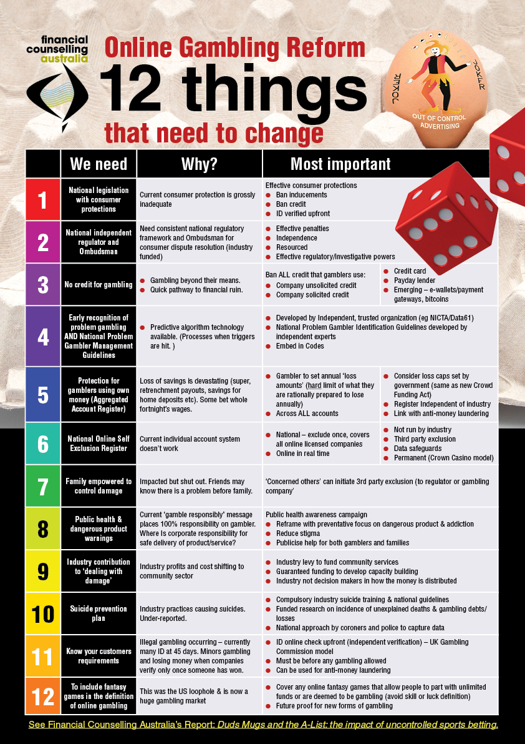
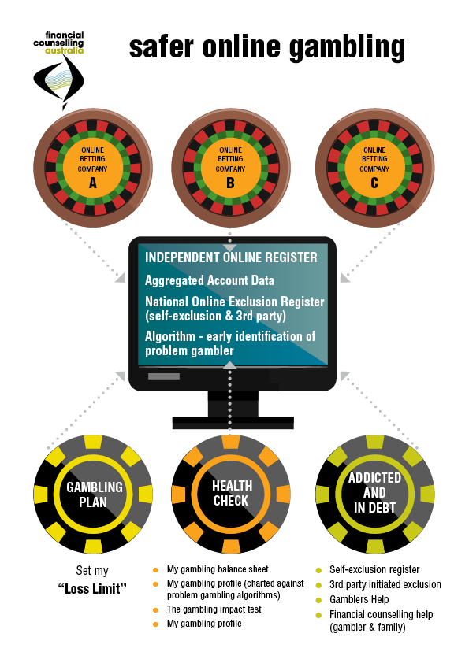

Financial Counselling Australia (FCA) is the peak body for financial counsellors in Australia.

Table of Contents
submission contact
Lauren Levin
p: 0411 050 035

p: 03 8554 6978
tw:@FCAupdate

PO Box 3482
South Brisbane BC
Q 4101

6/179 Queens St
Melbourne 3000

info@financialcounsellingaustralia.org.au | www.financialcounsellingaustralia.org.au

1.0 Message to the IGA Review from two problem gamblers 1
2.0 The Priorities 3
2.1 Duds, Mugs and the A-List – Articulates the problem 3
2.2 The first priority: an adequate consumer protection framework 3
2.3 The second priority: prevent new forms of gambling harm from taking hold in Australia 4
2.4 This is what the future will look like 5
3.0 What Needs to Change: An Overview 7
3.1 ‘Responsible Gambling’ is an Outmoded Concept: We Need an Equal Onus on Corporate Responsibility 7
3.1 ‘Problem Gambler’ is a misleading concept. Why wait for serious harm before acting? 7
3.2 12 Things That Need to Change and a Model 8
4.0 What Needs to Change: Detail 11
4.1 National Legislation with Consumer Protections – including an Ombudsman 11
4.2 National Regulatory Structure 12
4.3 No credit for gambling – credit cards & payday loans 14
4.4 Early recognition of problem gambling via algorithm 17
4.5 Protection for gamblers using their own money – LOSS limit safety nets 19
4.6 National Online Exclusion Register 22
4.7 Family Empowered to Control Damage – Third Party Exclusion 23
4.8 Public Health and Dangerous Product Warnings 26
4.9 Industry Contribution to ‘Dealing with the Damage’ 27
4.10 Suicide Prevention Plan 28
4.11 Responsible Gambling Know Your Customer (RG-NYC) requirements 28
4.12 Broad Definition of Gambling to Include Fantasy Games and Emerging Forms 31
5.0 The Advertising ‘Joker Wildcard’ – ban advertising like tobacco 34
7.0 Conclusion – our gambling vision for Australia 37

About Financial Counselling

Financial counsellors assist people in financial difficulty, providing information, support and advocacy to help their clients deal with their immediate financial situation and minimise the risk of future financial problems. The majority of financial counsellors work in community organisations, although some are employed by government. Their services are free, confidential and independent.

About gambling financial counselling

There are 50 specialist gambling financial counselling positions in Australia, although generalist financial counsellors also see clients with gambling issues. Some clients with issues with gambling seek help to stop gambling; others initially seek help to deal with their debts and may later seek support to stop gambling.

Some people see a financial counsellor when they are unable to meet ordinary living expenses or are struggling with gambling-related debt. Family members impacted by a problem gambler’s losses may also seek assistance from financial counsellors to attempt to safeguard family assets, get help in dealing with debt collectors, and to formulate a harm minimisation plan. For some clients, bankruptcy is an option. Financial counsellors work closely with therapeutic gambling counsellors. Sadly, financial counsellors regularly see suicidal clients.

Contact person for this submission

Lauren Levin, 0411 050 035
Manager, Policy and Projects
lauren.levin@financialcounsellingaustralia.org.au

1.0 Message to the IGA Review from two problem gamblers

‘To all those people who say it is a matter of will power’

Get people thinking about the statement ‘gamble responsibly’ and why gambling needs to come with a warning. The reason is that unlike smoking that will guarantee everyone is addicted, gambling will become addictive to some people, we just don't know who. It might be you, it might be your children... no one knows who it will be. A bit like the grim reaper commercials about aids in the 80s. You don't know who will get addicted.
If you don't know who will get addicted, but it is guaranteed some people will, then how can it be a "social" thing to do? How can it benefit society? Anything we have to do in moderation because some people will get addicted to it cannot be very social. This is what needs to change … the view that gambling is a social thing to do …
What they are doing is rolling the dice on whether or not it is them that will become addicted.
To all those people who say it is a matter of will power, and I could have just stopped I would say this.
Not once did I ever wake up and think to myself the plan for today and the future is to spend all my money gambling, wreck my business, hurt those I loved and cause chaos, spend years in rehabilitation and battle daily the disease of addiction. That's just what happened. No one plans stuff like that in their lives ….

Anthony, Nov 2015

Anthony, Nov 2015
v

Credit card gambling – Ron’s story

I pretty much had it fairly under control until it became online. My father introduced me to Betfair and it escalated from there. Why? It is all just numbers. It is like a game and there is no tangible effect because you’re not parting with your cash. One day, I placed 1,900 bets (yes) in a day because of the ease of doing it. With online betting you are not separating with your hard earned cash, because you’re not seeing it go out of your pocket. It is like playing space invaders.
Obviously being able to link credit cards, all you do is top up, top up, top up. I’d just attach my credit card to the account. I think that there should be a monitor - a means test. You put in your income - find what’s a reasonable amount of money to lose. Might say it is a nanny state, but it is a health problem.
Using a credit card is just money that you don’t have. I’ve never failed to pay my bill - paid at least the minimum amounts. I juggled between 5 different cards, I just maxed them all out. I had $150,000 on them. I stopped three years ago, but the debts are still there. I’m meeting the obligations each month and a bit more.
When I started, the advertising wasn’t as great as it is now. Now the marketing is 10 times as great as when I was doing it. Subconsciously it was all rubbing away at you.
I wouldn’t have a clue how much I spent each year. I’d say $20-$30k a year. Betfair would offer you a spreadsheet/activity statement but it only worked for a 3-month period.
If you register for a self-exclusion, it should stop the user ... They can’t just bleed this person dry. Not fair that the astute punter gets his account cut off, but the dumb ass like myself is allowed to continue without limits. I think that is only fair. That is a responsible measure.
What sort of impact did it have on your family? I nearly lost my wife. It nearly cost me my family. Luckily I have a good wife. [When she found out] she asked why I was lying to her. She then asked to check all the records of the Betfair account. That’s how I know that I placed 1,900 debts in one day - she found out what I was doing on the kid’s birthdays (when I wasn’t home). She kicked me out for a few days ... I rang gamblers help.
Ron, Nov 2015
(note name has been changed)

2.0 The Priorities

2.1 Duds, Mugs and the A-List – Articulates the problem

FCA’s recent report ‘Duds, Mugs and the A-List – the impact of uncontrolled sports betting’, documents concerning practices in the Australian online sports betting industry. Although specific companies were deliberately not named in the report, all of the case studies related to onshore legal sports betting corporations. The Duds, Mugs and the A-List report forms part of this submission.

2.2 The first priority: an adequate consumer protection framework

The Australian online sports betting industry is made up predominantly of large international gambling corporations, and two major Australian-owned corporations. In this submission they are referred to as ‘the industry’.

Through their grassroots casework, financial counsellors are direct witnesses to the consumer detriment resulting from online sports betting. Financial counsellors can also assess how well these companies operate with respect to consumer protection. Financial counsellors, because they work with a range of industries – banks, telecommunication companies, utilities and debt collectors - are also uniquely placed to compare different industries and the extent of consumer protection, both in theory and practice.

At every level, the Australian online gambling industry performs poorly when it comes to basic consumer protections. The industry claims that it is performing well, unlike the ‘unscrupulous operators … illegal SP bookmakers, and loan sharks’. However, everything that the financial counselling sector is seeing demonstrates that the Australian industry operates without concern for consumers, and that responsible gambling compliance occurs neither in spirit, nor practice.

The massive advertising expenditure magnifies the detriment of this unregulated and out of control industry operating legally in Australia. The harm occurring right now in suburban homes, is the harm that can be most easily mitigated, and this is where we should start.

2.3 The second priority: prevent new forms of gambling harm from taking hold in Australia

We are at a crossroads when it comes to online gambling. As a community we can choose between two options: either the gambling marketplace is allowed to expand exponentially, for example, by legalising in-play betting or allowing ‘illegal offshore operators’ to operate legally, or alternatively, banning harmful practices and limiting the extent to which gambling becomes entrenched.

From a harm minimisation perspective, the most appropriate option is to ban in-play betting, online casinos, fantasy games, and other emerging forms of online gambling. If there are opportunities to gamble, more families will be damaged. There is no upside, other than industry profits.

For many Australians, a consumer protection/harm minimisation framework will be ‘too little, too late’ as the damage has already be done. A consumer protection framework may look good on paper, but for many people this will be ineffective because they lack the skills, knowledge, and internal fortitude to battle large corporations and regulators. Simultaneously, consumer advocates are inadequately funded and cannot meet current demand – they are unable to take up the cases of people who are harmed. Regulatory responses are also notoriously slow, and individuals seldom get the redress they seek.

With this in mind, the first priority is to prevent the new forms of gambling harm from taking hold in Australia. Although some people are already gambling via the ‘illegal offshore operators’, consider what would happen if our TV, train stations and social media were flooded with the advertising spend of these new operators … we’d literally open the proverbial gambling floodgates.

If ‘illegal offshore gambling’ is legalized and the online casinos are no longer illegal, we will see a rise in advertising with these newly legalized products looking for market share … it is foreseeable that the gambling spend will double.

Then what will happen? More people will gamble … lots more.

2.4 This is what the future will look like

The impact of In-play betting

Should in-play betting be legalised, there are estimates that profits may increase by 30%-40% and possibly more. Gambling profits are of course funded by consumer losses … so obviously the consumer detriment is huge. More Australians will lose money that they cannot afford to lose. This is money not spent on paying living expenses, saving, investing, or spending in the broader economy. The losses to the Australian community are huge.

These numbers are not exaggerations – this is an excerpt about Irish global conglomerate Paddy Power’s newly released ‘stellar performance report’ on betting commentary site CalvinAyre.com (Nov 18 2015).

Excluding Australian operations, online sports betting stakes rose 16% but revenue fell 12% … This was partially offset by a 13% gain in gaming/B2B revenue, but overall online revenue still fell 3% year-on-year …

It was a different story at the Australian Sportsbet operation, which saw betting turnover rise one-third and revenue up nearly one-quarter. The ranks of new customers swelled by 22% and in-play telephone betting stakes rose 38%, which is enough for Sportsbet to justify continued investment in its telephone operations.

Sportsbet recently launched its new Punters Club offering, which has already witnessed the birth of 5k betting clubs, leaving the company optimistic that the product will add a further boost to future revenue.

Online casinos

The overseas experience is that where multiple forms of online gambling are permitted, that the big companies diversify their product offerings through acquisition. Ladbrokes UK for example, has online casinos and online slot games in addition to its sports betting operations.

We will see multiple product offerings in Australia too. This can happen overnight as the industry already has the knowledge, the products and the strategy in place. Our concern is that when these companies start advertising, the market will grow significantly.

Fantasy games

When the US effectively banned sports betting in 2006, there was a regulatory exemption made for fantasy games. Now the fantasy market is a significant generator of gambling revenue (and consumer losses). It is clear to all observers that the categorisation of fantasy games as a game of ‘skill’ (versus luck) is impossible to regulate.

We need to learn from the US experience, and not allow this industry to develop in Australia. The focus needs to be on the consumer’s ability to lose money, irrespective of any claims to playing with skill or luck. Gambling is simply where an individual can lose money without anything in return, other than a mere chance of winning.

New forms of gambling

The online gambling market is constantly evolving. Games are morphing into gambling games. Gambling products are being changed to be more interactive and engaging and look like games. Pokies will be online. Casinos will be virtual reality, with users able to walk around the virtual reality online casinos choosing their poison.

All forms of gambling will require consumer protections and therefore any definition should be wide enough to cover emerging forms. Alternatively a regulator or Minister could be given the power to deem an activity as gambling.

We suggest that the definition of gambling focuses simply on the ability of a consumer to lose money.

3.0 What Needs to Change: An Overview

3.1 ‘Responsible Gambling’ is an Outmoded Concept: We Need an Equal Onus on Corporate Responsibility

The concept of ‘responsible gambling’ with the advertising message ‘remember to gamble responsibly’ shifts the onus to individuals for any problems, rather than recognising that there is an equal responsibility for gambling corporations to operate ethically and fairly. The ‘responsible gambling’ concept therefore suggests that people who become ‘problem gamblers’ are somehow at fault and bear the full responsibility for their own downfall.

However, what FCA documented in the Duds, Mugs and the A-List report was a systematic targeting of new and existing gamblers by gambling corporations. The practices outlined in that report were exploitative, ruthless and unethical.

We propose a suite of ’12 things that need to change’ – this framework places equal onus on corporate responsibility in the way in which we think about gambling.

As a problem gambler said:

“Just because a gambler may be prepared to press that button, and fall off the cliff, doesn’t mean that companies should be allowed to drive them to the cliff edge in a limousine.”

3.1 ‘Problem Gambler’ is a misleading concept. Why wait for serious harm before acting?

There is no single moment when a problem gambler crosses the line and has a problem. The loss threshold is not absolute either – each gambler has his or her own cross over point for a devastating loss. For one family, it could be missing your child’s birthday party because the father is gambling (see case study Ron’s story, page 5) and the spouse’s devastation when she discovers the web of lies – loss of trust is a catalyst for marital breakdowns. For another, spending the family’s once a week/month restaurant treat or the electricity bill money is problematic. It doesn’t have to be something as dramatic as gambling losses leading to the loss of a family home, although we see that happening too.

We don’t wait for a methamphetamine user to become an addict before recognising a problem – we random drug test drivers because even some ice is problematic. Similarly waiting for a gambler to be at the end of the line in the extreme harm category is a poor approach.

The AWC writes: The incidence of problem gambling is significantly lower in online wagering in comparison to land-based gaming (poker machines, casinos) with the Productivity Commission Report on Gambling (2010) estimating that 75-80 per cent of problem gambling is directly related to the use of poker machines.

We question the relevance of arguing whether the incidence of problem gambling is higher/lower in one form of gambling as a precursor to acting. We don’t say, ‘it is OK to ignore terrorism deaths in Australia because last year there were only say, 15 terrorist related deaths’.

And we query the AWC’s use of comparisons. We know that currently the absolute number of people gambling with harm at pokies is greater than the emerging online gambling, however that is not of itself relevant to anything. The Duds, Mugs, and the A-List Report showed that with online sports betting:

- The quantum of harm is huge
- The speed of addiction is fast
- There is no limit to the amount someone can lose

We also know that the trend for online gambling is upward, so quoting the 2012 absolute numbers is a distortion of the incidence of harm.

3.2 12 Things That Need to Change and a Model

The diagrams on the next two pages set out our blueprints for reform:

- “12 things that need to change” – this submission has further information about each area. Note that the 12 points are in no particular order of priority. They are a package and all important.

- A model describing ‘safer online gambling’
Best printed A3

4.0 What Needs to Change: Detail

4.1 National Legislation with Consumer Protections – including an Ombudsman

We recommend:

- That consumer protection is enshrined in national legislation - in the same way that the financial industry is regulated. The finance industry has important consumer obligations set out in the National Consumer Credit Protection Act 2009 (NCCPA). There is also a Banking Code of Practice, which is monitored by the Code Compliance Monitoring Committee (CCMC), under a MOU with the Financial Ombudsman Service (FOS).
- There is a suite of consumer protections in the financial marketplace, with consumer redress available via industry, regulators, and ombudsmen. A similar structure is needed in online gambling.
- A national gambling ombudsman (funded by industry like other industry ombudsmen schemes). External Dispute Resolution schemes are an important feature of the Australian consumer marketplace.

There are strong precedents for industry External Dispute Resolution (EDR) models that are effective for both consumers and industry. Examples are the Financial Ombudsman Scheme (FOS), the Telecommunications Industry Ombudsman (TIO) and Energy/Water ombudsmen in each state.

The benefit of the ombudsman model is that:

- It is industry funded
- Consumers have an effective pathway for resolving disputes
- The model builds in an incentive for industry to improve, as individual companies bear the costs of their own disputes. Complaints to the TIO have dropped substantially for example - that is exactly the sort of incentive driven program that could lead to better consumer outcome in the gambling arena.
- Ombudsman schemes report to regulators about systemic issues, and are an important part of the performance feedback loop.
- Proven concept

4.2 National Regulatory Structure

Online regulators need to be nimble to deal with the changing face of online gambling. Consider when games become gambling (as is already happening with the convergence of the gaming and the gambling industries). This discussion by a gaming developer has fascinating insights.
The games are apps on our mobile devices. They are easy to download and often free. But with convergence, these apps offer opportunities to gamble. There will be as many mobile app gambling-gaming companies as there are app developers, and the owners will be located … anywhere in the world.
Telco service providers may be the most effective point of regulation in this brave new world of gambling – the ISPs or mobile service providers may be the only ones who can see a user’s age, where the betting location, payment mechanisms and more. The IGA’s review would do well to consider a regulatory model where the regulator has the skills and mindset to regulate in a dynamic, IT driven gambling world. It is not a good fit with the existing state based pokies/casino designed state regulators. Our guess is they would never effectively keep abreast of the IT led changes.

We recommend:

Plan A (preferred option) - National independent regulator (funded via an industry levy)

This is the easiest way to establish a consistent regime. The burden of funding a national regulator is an industry cost – the gambling industry is the main beneficiary of a consistent operating environment and the ensuing profits. There are a number of precedents for industry-funded regulators, e.g. Australian Prudential Regulation Authority (APRA). Treasury is currently consulting about ASIC moving to user based funding, a form of industry funding.

While there is an existing regulatory structure in each State and Territory, there appears to be significant discrepancy in regulatory effectiveness from a consumer protection perspective. This State-based system is not working for consumers. Further, it imposes a regulatory compliance burden for online gambling companies having to meet compliance obligations in multiple jurisdictions. This complicated compliance model is difficult for both industry and consumers and in the spirit of cutting the regulatory burden, a national model should be reconsidered.
This regulator will need sophisticated IT capacity to regulate as discussed above.

Plan B - Use an existing national regulator to regulate online gambling

ASIC already regulates financial matters including consumer credit. Gambling has crossovers with financial transactions. Alternatively ACMA already regulates the Interactive Gambling Act, although we note that investigative referrals to the Australian Federal Police are largely unsuccessful and rejected on ‘priority’ grounds.

Plan C (least preferred) – use state gambling regulators with nationally consistent legislation

Using existing state regulators to regulate the Commonwealth’s online domain is arguably a flawed model for regulation of online gambling. We have already seen the reluctance and inability of some of the existing regulators to actively regulate the online corporations. There will be political difficulties in achieving nationally consistent legislation.

If this were the model selected, it is imperative to have

- A strong industry code of conduct AND

- A national ombudsman scheme, which could deal with complaints, and monitor compliance against the Code of Conduct

This Code of Conduct/Ombudsman model mirrors the development of consumer protection mechanisms in banking. Prior to 2010, the Financial Ombudsman Service (FOS) was a national ombudsman but the credit legislation was state based. The consumer credit legislation has evolved from State to Federal legislation. The FOS measures industry conduct against the law, ‘good industry practice’ (such as the Banking Code of Practice), and fairness. This approach encourages industry to improve practices.

This model could work for gambling. The industry would need a strong national Code of Conduct with the corporations signing up to all the consumer protection measures. Each state regulator would ideally need to impose a requirement that any company licensed in their state or territory has to be a signatory to the National Code.

State legislation should also follow the South Australian model - any gambling account holder who lives in a 5000-5999 postcode is subject to South Australian regulation - regardless of where the gambling corporation is licensed (see Figure 1 below). This means that South Australian regulation applies to the NT and Norfolk Island bookmakers. If all States had similar provisions, there could be more effective regulation of externally licensed gambling corporations.

Figure 1: SA Code makes its law applicable regardless of where the gambling company is licensed
South Australia: Gambling Codes of Practice Notice 2013 (Version No. 005, as at 30 July 2015)
(6) A gambling provider which—
(a) provides gambling services by telephone, internet or other electronic means; and
(b) has taken reasonable steps to ensure that it records valid addresses for its account holders
will only be regarded, for the purposes of this notice, as providing those gambling services to a person in South Australia (being an account holder) if the person’s address as recorded in good faith by the gambling provider has a postcode in the range 5000–5999.

4.3 No credit for gambling – credit cards & payday loans

The Duds, Mugs and the A-List report documented the consumer detriment associated with gambling on credit. At the end of the day, ALL the different forms of credit used for gambling are harmful to consumers, and those clients presenting for financial counselling typically have multiple forms of debt – all of which are legally enforceable.

Figure 2: Gambling with any forms of credit is dangerous (note that split is only an estimate)

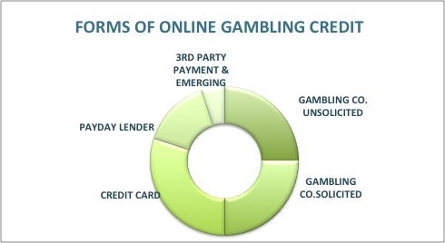

We agree with the Liberal Party position on problem gambling that was taken to the 2013 election: ‘‘Responsible gambling is all about people gambling within their means. Extending lines of credit to gamblers runs contrary to this principle and the Coalition will legislate to prohibit the practice’.

It is essential that credit cards not be used for gambling. The argument that the lender has assessed suitability, including repayment capacity and that therefore an individual can afford the credit can be easily rebutted. Credit card lenders only assess that the loan is ‘not unsuitable’ – that is based on the consumer’s ability to repay the minimum monthly payment, which is 2-3%. Just paying the minimum payment means those debts will take years to pay off.

In some states, (e.g. Victoria) casinos already ban ATM credit options from being selected as payment methods – recognizing that credit is a particularly harmful form of funding gambling.

See Section 4.2 of Dud, Mugs for analysis of how credit is legislated in gambling vs the provision of credit

We recommend:

- A ban on all forms of credit for gambling including:

  - Company provided credit: Australian law should prohibit the provision of credit by gambling operators. It should require that gamblers use their own money.

  - Financial institution credit: a ban on the use of credit cards for gambling payments – Citibank already do this. There are unique codes by which gambling purchases are identified. Most banks already code these ‘credit’ transactions as ‘advance payments’, which attract a higher interest rate without an interest free period.

  - Credit provided through payday lenders: this is the most dangerous form of gambling credit, due to the high cost structure of these short-term loans. ASIC has documented its concern about the lack of information used to assess credit applications. Clients presenting at financial counsellors with gambling issues, often have multiple payday loans.

  - Emerging forms of credit should be considered – e-wallets, payment gateway, Bitcoins, etc. We recently saw a client with a large Paypal debt, which funded gambling. We foresee that there will be cross selling of online gambling and online loans. Legislation needs to be future-proofed to capture emerging forms of credit for gambling.

Figure 3: Citibank credit cards coded so can't be used for gambling
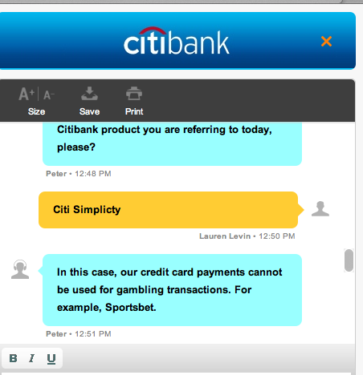

- Credit should be defined to include a ‘deferred settlement’ arrangement, which is how industry credit is currently branded. (Terms are usually seven days and no fees or charges are applied. We note that most gambling corporations use the term ‘credit’ on their websites to promote their ‘deferred settlement’ facilities.)

- At the very least, the provision of credit by gambling operators should be subject to the provisions of Australian consumer credit legislation.

This is the least preferred option as it still allows gambling on credit – inevitably harmful for most people. These companies will face significant challenges in implementing the rigorous credit assessments required under consumer law – regulators will require significant resourcing to educate and take action.

- The government consider a model based on the US experience in effectively banning credit in the online gambling space.

The US has effectively banned financial institutions from being the intermediaries for gambling credit (and all transactions going to illegal gambling institutions). The primary legislative tool is the Unlawful Internet Gambling Enforcement Act, 2006, which is a Federal Act combined with state legislation defining unlawful gambling (mostly includes sports betting and online casinos).

This high level targeting of banks is effective, as no bank would risk its banking license to finance gambling. It works. It is much simpler than policing whether gambling corporations are providing credit responsibly.

4.4 Early recognition of problem gambling via algorithm

Online gambling generates a lot of data. The data linked to gamblers who have self-excluded due to problem gambling is a rich source of information. This information can be used to develop a predictive algorithm to identify a person with an emerging problem gambling pattern. Once this ‘at risk gambler’ is identified, there is the opportunity for intervention to prevent that person from becoming a problem gambler.

Who should receive the ‘at risk flag’ information?

- The gambler with appropriately tested harm minimisation messages. These messages should be informed by problem gambling academics/professionals and tested before use. Gamblers have told us that they were the last to know that they had a problem. This technology could change this.

- The company, effectively putting the company on notice that its customer is at risk of becoming a problem gambler.

South Australia already has a requirement for predictive monitoring in its Code as part of its ‘inducements and loyalty’ provisions.

Risks:

- That an algorithm will set the ‘line’ in the wrong place, only capturing the most extreme problem gambling not the ‘severely impacted’
- That an algorithm will be used by industry to market to these out of control gamblers.
- That industry will not train their staff to follow best practice procedures so not much will change.

What should or shouldn’t be done when someone is flagged as being at risk?

This is an important step. There is a two-step process:

- The industry together with gambling mental health professionals and gambling financial counselling professionals can develop industry Mental Health Problem Gambler Prevention Guidelines. The aim is to have an expert informed process for gambling corporations to follow to prevent an identified ‘at risk’ person from becoming a problem gambler.

- Implementation: to be effective, the end result (the Guideline) needs to be enforceable by the regulator-ombudsman. The standard of conduct will be referenced in the National Code of Conduct for at risk problem gamblers.

One option is the ‘Mental Health Guidelines’ model developed by Professor Anthony Jorm from the Melbourne School of Population and Global Health.

We recommend:

- The development of a predictive algorithm to identify emerging problem gamblers, using a trusted Australian partner – such as NICTA (now called Data61 following a very recent merge with CSIRO).

Companies such as Bet Buddy (UK), that already have a similar product, are not suitable partners, as the core business of this company are products that gambling companies utilise to identify profitable customers and market effectively to them – a clear conflict of interest.

Key elements:

  - Developed by a trusted partner – no conflicts
  - Based on problem gamblers identified in self-exclusion registers – this means that access to data is required
  - Able to be embedded in the National Account Win-Loss Aggregator – so the aggregated gambling accounts data is washed through the algorithm. This will give gamblers an ‘all online gambling accounts’ perspective on their gambling pattern.
  - Manage privacy issues early. If data is defined as financial or profit/loss data the pathway is easier than health data, vis-à-vis privacy.

- The development of national Problem Gambler Identification Guidelines, which is the ‘so what next?’ test of what needs to be done by industry and others when an account is flagged as at risk of becoming a problem gambling account.

Key elements:

  - Expert informed
  - Capable of being embedded in the Code and being applied in a regulatory framework.
  - Industry training strategy

4.5 Protection for gamblers using their own money – LOSS limit safety nets

Prima facie, losing one’s own money can be just as harmful as gambling on credit. Financial counsellors see clients who have devastated their financial security by losing a superannuation lump sum, accident compensation payouts meant to last a lifetime, retrenchment or redundancy payouts, savings for renovations to the family home, losing homes by not keeping up with mortgage repayments, or simply gambling and losing most of a fortnightly salary. Often that money is family money. Financial counsellors often see spouses whose partners have gambled the rent, bill or food money.

Problem gamblers have informed us that they wished that there had been a safety net to put a bottom on the amount they could lose. No one rationally would want to lose their house or their super – nor the partners and children who walk out when the devastation is revealed.

We recommend:

Aggregated loss limits – set by gambler (hard limits)

We recommend that an externally run register be established which holds aggregated account data, with the ‘aggregated loss limit’ – set by the gambler across all accounts. A consumer’s bottom line is the aggregated losses across all accounts, not with individual companies. The language is deliberately around ‘how much are you prepared to lose?’ Gambling is risky so language must focus on the bottom line of losses.

Precedent for aggregated data

There is a legislative precedent for aggregated data held by the credit-reporting bureaus (VEDA, Dunn & Bradstreet and Experian). The latest comprehensive credit reporting Privacy Act amendments came into force in March 2014 – they facilitated industry creditors having access to a person’s comprehensive credit information across all financial institutions and a range of industry creditors.

This is conceptually similar to a register aggregating data from multiple accounts held by the gambler. The similarities:

- Consumers receive a ‘credit score’ in comprehensive credit reporting – there could be a ‘gambling risk score’ to indicate the likelihood of problem gambling risk.
- Credit report industry users can purchase alerts from the Credit Reporting Bureaux. These alerts flag a trigger for an increased risk – e.g. when a regular customer defaults or bankrupts. In gambling, a company could receive an alert when their regular gambling customer has a problem gambling risk trigger with another gambling company. This is an aspect of ‘know your customer requirements’.
- Consumer have legislated rights to access their credit reports and dispute contents or ask for a correction. Gamblers could have similar rights to information. With gambling, we may want the data available to third party apps that the person choses to download to manage their gambling.

Important considerations around the loss limit

- The limits needs to be hard limits – problem gamblers advise that when the urge to gamble hits, they will just re-set their limits or place multiple smaller bets below the bet limit, or open an account with a new company.
- That the limit be set when an account is set up, with an annual review. When someone reaches their limit, they can no longer exceed that spend. It is not a preference, but a limit. Weekend sports comes back each weekend with yet more marketing emails, so having short cooling off periods is not as strong as sticking to one’s self determined annual loss limit, set in a rational moment of reflection.
- The default position should be a low ‘social’ amount set by Government.

An independent online Account Aggregator Register

Important considerations:

- Companies should be prohibited from offering unsolicited loss limit increases (same as the 2012 legislation prohibiting unsolicited credit card limit increases)
- Run independently – not by industry
- Designed to empower and protect gamblers from financial loss
- Real time data
- Gambler privacy protections
- Linked to National Online Exclusion Register
- Data cannot be used by industry to target gamblers to gamble
Privacy considerations

The Privacy Act allows for information to be shared with other bodies with appropriate disclosures - companies would have to amend privacy notices to customers to reflect giving data to the Account Aggregator Register – this is not problematic as they already share with related bodies and credit bureaux.

Warning

It is also important that gambling companies do not have access to information that allows them to target gamblers who are not their customers, nor know information that is confidential. Appropriate encryptions and other protective devices would need to be built in.

Legislated government nominated loss cap for non-professional gamblers – Crowd Funding Bill precedent

The Minister for Small Business, Ms Kelly O’Dwyer has just announced that details of the Government’s new crowd-sourced equity funding legislation, will be released in December 2015 – the government is considering the implementation of a cap on the amount individuals can either invest in a particular company on one campaign, a cap on the amount they can invest across a 12 month period, or both. The Corporations and Markets Advisory Committee (CAMAC) proposed that retail investors be limited to $2,500 per issuer a year, with a $10,000 aggregate investment over a year, allowing small investments into four ventures annually. Sophisticated investors have a higher amount.

There is now a precedent for government recognizing the risky nature of investments for unsophisticated investors, the ordinary Australians who want to have an investment punt – and pre-emptively providing protection from self-harm. This has clear parallels with gambling. Many gamblers and their families would be very grateful if their gambling was capped in the ‘it’s just entertainment’ realm of losses.

4.6 National Online Exclusion Register

FCA proposes a National Online Exclusion register, so that those who are concerned about their gambling only need to supply their details once rather than to each individual online bookmaker.

Currently, gamblers have to self-exclude from each gambling company individually. It is time consuming, the links and forms are not consistently easy to find, the process may be cumbersome and the forms unnecessarily arduous to fill out (in contrast to the ease of setting up an account). Some companies’ self-exclusions periods expire after a limited period, from as little as three months. Gamblers find that there are new companies that emerge that induce them back to gambling (they may be swapping lists with non-excluded companies). This register needs to be best practice, following the rigorous lifetime ban model of Crown Casino Melbourne, with a re-set only through expert evaluation.

Important

- National, exclude once – either with company or register – and it covers all online licensed companies
- Online in real-time (everything else is real time in the online gambling world and a self-exclusion register should be also)
- Independent, run by a trusted body (not industry) – responsible to the regulator or commission
- Data safeguards from misuse
- Brand strongly
- Find a name that resonates – not all gamblers look for the term ‘self-exclusion’
- Unique logo to be used on each gambling company’s web pages (same position, same logo, size specified, all pages … so easily found)
- Marketing budget so it becomes known
- Allow for third party exclusions (see below)

4.7 Family Empowered to Control Damage – Third Party Exclusion

We recommend:

Concerned others are able to access the exclusion register, with a third party process

Family members suffer harm from a problem gambler, yet they are currently powerless to do very much. They sometimes call the gambling company to say ‘is my partner gambling? I need to know. I know the money has gone’ only to be laughed at and sent away with a reference to ‘privacy regulations – we can’t tell you anything.’ The partner may not have money to pay the household bills, but cannot stop the household money going out of a joint account - which the gambler has attached to their online sports betting account.

Two recent Australian studies have found strong correlations between households with gambling and presentations of family violence. The Royal Commission into family violence has also been asked to act on problem gambling. The Women’s Legal Service Victoria, in Stepping Stones, found that for women experiencing family violence and particularly economic abuse - where there was also gambling present – these women experienced particularly bad family violence.
Except from a report by the Women’s Legal Service Victoria (Sept 2015)
STEPPING STONES: LEGAL BARRIERS TO ECONOMIC EQUALITY AFTER FAMILY VIOLENCE
There was a high incidence of co-morbidity of family violence and problem gambling revealed in this research.
“He would gamble all the money in the credit cards ....” (Nadia)
Some women also experienced an increase in violence when their partner had gambled and lost, or wanted to gamble and couldn’t.
Report on family violence (continued)
Women discussed trying to contact gamblers help with little effect. There was no screening for family violence, nor assistance to women in protecting themselves and the children from the impact of the gambling.
Women had particular difficulty in entering payment plans and meeting payment deadlines when their abuser was also a problem gambler.
“So I rang up Gamblers Anonymous and they were just basically useless, they said ‘well you can’t help a gambler unless he helps himself’ and I said ‘well, where does that leave me?!’”
“I was actually dealing with a gambler ... you couldn’t actually make a forward plan, because it wasn’t likely to happen because a compulsive gambler isn’t able to moderate when there is money there, it’s like an obsessive eater, they can’t, they won’t moderate.”
Margaret
“I did a lot of negotiating then and I just got into the habit of phoning the electricity companies up which weren’t all together very helpful at all, um … to say listen, don’t have the money, can we negotiate this, how can I go into a payment plan? But then he’d delve into the account and lo and behold when it came around to the payment it was empty.”
Jacqui
We found very little research on the co-occurrence of gambling and family violence and what help is available to women. Further research on the links between gambling and family violence would be valuable in determining how best to assist women experiencing family violence and financial hardship as a result of gambling.

Only South Australia and Tasmania currently have 3rd party exclusion - most important aspect of this scheme is that it triggers a point of intervention

In South Australia and Tasmania there is a Regulator or Tribunal process for third parties to be heard. Both processes involve the gambler being notified and brought into the discussion. We understand that typically the gambler ends up receiving professional help, and subsequently self-excludes (as opposed to an involuntary exclusion).

This means that the most important aspect of this scheme is that it triggers a point of intervention. In South Australia, the regulator recommended to the SA government that anyone be able to raise a concern about another person’s gambling, without a requirement for that person to be harmed. With young men and online sports betting, it may be that a friend knows that his mate’s gambling habits are out of control, but it is hidden from the family. The process has built in assessments to verify the nature of the gambling, which mitigates risks.

Family members need a similar process to officially flag problem gambling with a company. There is no reason why, when put on notice by a family member, that the company cannot assess the gambler’s full account, and have a discussion with the gambler about implementing a plan to address problematic gambling.

What can a company do when a concerned person (or the gambler) contacts it and puts them on notice that there is a problem?

Companies already routinely close accounts or restrict ‘winning gamblers’ to nominal bet amounts – when they are put on notice, by a third party, or the customer, they should implement a remedial plan. The company has its own duty to provide its product in a responsible and safe manner.

We recommend:

- That third parties have a legislated right to initiate the involuntary third party exclusion process
- That companies must act on external advice that a customer may be a problem gambler. Actions may include:
  - Closing accounts
  - Reduce $ bet amount and introduce bet frequency limits
  - Advising the concerned caller how to initiate third party exclusion processes and how to receive free financial counselling advice (protecting joint assets and managing debt)

4.8 Public Health and Dangerous Product Warnings

The current ‘gamble responsibly’ message places all of the responsibility on the individual gambler. All corporations, including gambling corporations, have a responsibility to provide safe products and services.

We recommend:

- Development of a strategy that is delivered independent of industry – industry advertisements that say ‘gamble responsibly’ are not as effective in contrast to a well-thought out, evidence based preventative campaign. We would not have alcohol companies putting out anti-drinking campaigns. Good examples of powerful public health campaigns include the ‘Drink Drive – bloody idiot’ and the Victorian Transport Accident Commission’s current road accident prevention campaign ‘Towards Zero – there is no one that someone won’t miss ‘.

- Governments fund a public health awareness campaign with multiple aims:

  - Reframe with dangerous product emphasis (not ‘gamble responsibly’ which blames the individual and may be counterproductive).
  - Reduce stigma
  - For family members and friends to intervene – the gamblers tell us that they were the last to know they had a problem.
  - For gamblers to admit they have a problem – in the same way that Beyond Blue has de-stigmatized depression.
  - Publicise avenues of help – e.g. gambling financial counselling and gamblers help (recognize multiple doorways approach)

- Co-locate public health messages with the gambling companies’ advertising – billboards, TV, radio, social media etc.

- Consulting with Australian gambling academics researching this area to inform the approach. We are advised that a poorly targeted approach can be detrimental.

4.9 Industry Contribution to ‘Dealing with the Damage’

There are many winners from ‘big gambling’ but there are many losers – the problem gamblers and their families, and the community sector organisations who pick up the pieces when lives implode.

There are also the taxpayers who pay for the opportunity cost of the lost income – when a 40-something transport worker John gambled his entire redundancy payment, was suicidal and on the verge of homelessness and the financial counsellor advocated for his ‘special circumstances’ to obtain government welfare payments. The government also paid for his gambling counselling and financial counselling. There is the softly spoken teacher who has reached the age where he can access his super, but lost $40,000 in just two months. Will taxpayers chip in with pension money? Most probably if he continues his pattern. The FIFO worker’s wife and young kids left, he lost his new house, and is struggling to get a job with the mining boom receding. Will he ever recover? He will be paying off the gambling debts for many years, so hard to see him buying another house – and his credit rating is impacted so who will loan him money at an affordable rate?

Financial counselling services are in demand with many agencies having waiting lists. Some gambling support services cannot keep people on their books for longer than a few months, to manage demand – due to funding constraints. So people impacted may receive only limited help or delayed help, when we know that overcoming a gambling addiction may take ongoing work. These services are ultimately mostly taxpayer funded. It will only get worse as gambling increases – the AWC expects in-play betting to account for a 50% increase in business by 2020. The industry’s revenue is a function of a gambler’s losses. We expect demand for professional support services to rise, but there is no funding strategy in place to meet this.

We recommend:

- Industry funding for community support services, including financial counselling. A percentage levy is most practical as it can move proportionately with turnover (turnover, is a proxy for consumer losses, which reflects demand for community support services).
- That the funding be ongoing - we need to focus on capacity building.
- That a transparent plan be formulated to assist those impacted by gambling – including funding preventative programs.
- That industry is not permitted to be the decision-makers for how these funds are distributed. This has not worked with pokies community benefit funds. Dr Charles Livingstone has documented how the pokies ‘community benefit’ money is used in practice. He points out that the money is often spent on projects which are in the interests of the gambling venue and where the community receives little benefit.

4.10 Suicide Prevention Plan

We know that financial counsellors and other gambling support services see clients who are suicidal. We also know that only 15 per cent of those in trouble seek help. We do not know how many of the ‘unexplained deaths’ in coronial findings were for people who were experiencing financial difficulties as a result of gambling. This information is currently not captured. We need research to identify the extent of the problem, and guide the next steps.

We recommend:

- Industry establish national guidelines on suicide prevention with compulsory training for all employees – someone designing customer marketing needs to be aware of their impact just as much as those talking to customers.
- Funded research on the incidence of unexplained deaths and gambling debts (data available from credit reporting bureaus, coroners, the Australian Financial Security Authority bankruptcy database, banks/credit card data, and the gambling industry)
- National approach by both coroners and police to have their respective processes and forms capture the existence of gambling debts and significant losses.

4.11 Responsible Gambling Know Your Customer (RG-NYC) requirements

Know your Customer (KYC) requirements are an established part of the banking and gambling sectors compliance obligations vis-à-vis anti-money laundering and terrorism financing. These are set out in the Anti-Money Laundering and Counter-Terrorism Financing Act 2006. The industry in Australia and overseas are already required to have strict compliance procedures. There are high penalties for breaches including late notification.

We propose similar RG-KYC obligations in the context of provision of corporate responsible gambling services. It should not be too onerous for industry to comply given that extensive compliance infrastructure is already in place.

Consider these scenarios (all from clients reported in the Duds, Mugs and the A-List Report):

- If a customer is an ordinary employee and regularly bets small amounts but one day, suddenly bets $250,000 then the company should ‘know its customer’, not accept the bet and inquire as to the source of the funds.
- A young man who secretly bet thousands of dollars on his father’s credit card in a just a few weeks – he suicided citing his shame. If someone bets with a credit card that has a different name to the account holder – following responsible gambling KYC requirements, the payment via an unfamiliar credit card should not go through.
- A man on a disability pension is offered $80,000 of credit, which he used. He had always bet small amounts. The company initiated legal proceedings to claim the house that he shared with his mother. With RG-KYC requirements, it would be obvious that he couldn’t pay that back from his income.
- If a 30-something man with gambling debt phones his bookmaker requesting help, saying he cannot cope with his gambling debt situation and is desperate and in a bad mental state – he is told ‘try to see if you could borrow some money, or we could give you tips on who to bet with ...’. Knowing your customer in a gambling context, means understanding their mental state – this should be straightforward when the person rings and is agitated and providing the clues.

A suite of tailored Responsible Gambling Know Your Customer (RG-KYC) requirements are required. A breach should have similar penalties as existing anti-money laundering KYC compliance breaches.

We recommend:

That industry and regulators develop RG-KYC requirements including but not limited to the following:

- No-one should be allowed to gamble without upfront ID verification. The current 45-90 day window is inappropriate. Under-age gamblers are playing before their ID is verified.
- An individual’s aggregated gambling spend should be in proportion to income. If someone is betting $100,000 p.a. (or even $20,000) and their declared income is $40,000, there is something wrong.
- RG-KNC requirements be linked with anti-money laundering and terrorism financing requirements. The Aggregated Account Register that FCA has proposed would provide useful information to government.

Figure 4: All licensed gambling companies already have stringent 'know your customer' compliance mechanisms in place
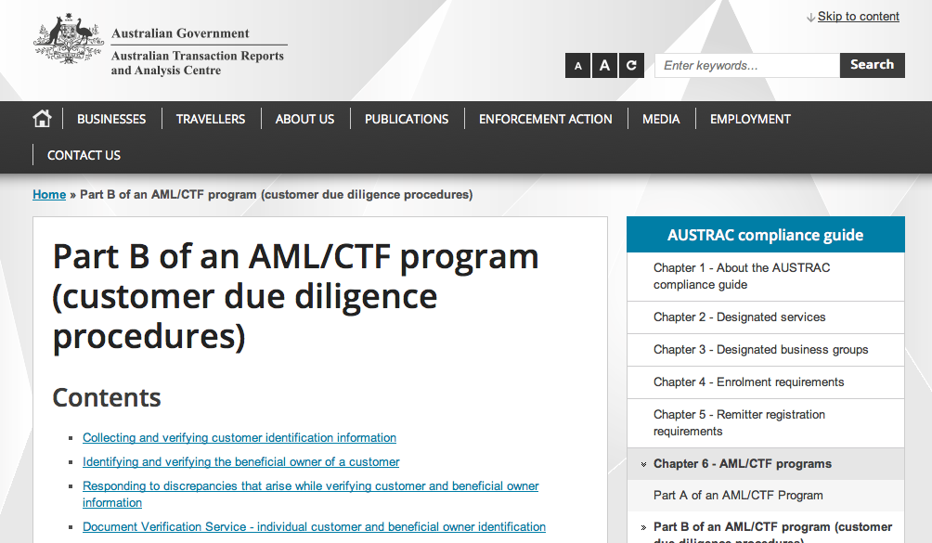

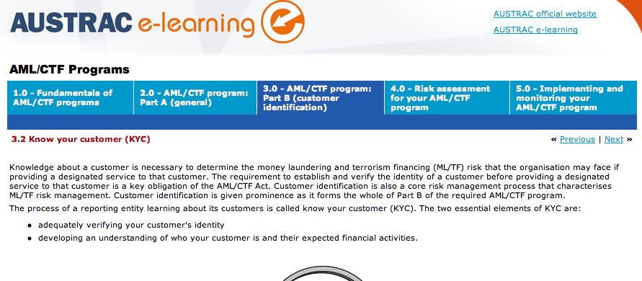

Broad Definition of Gambling to Include Fantasy Games and Emerging Forms

The Interactive Gambling Act does not cover online fantasy games. However we need to learn from the US experience and ensure the definition of gambling covers all known forms of online gambling. Further, our legislation should be future proofed to cover new forms of gambling – possibly by a deeming provision, so a regulator or Minister could deem something to be online gambling for the purposes of the legislation.

The fantasy game market is huge in the US and emerged as the ‘loophole’ in the Unlawful Internet Gambling Enforcement Act 2006. This Act covers both sport fantasy games and more general games. At the time of the UIGEA Act, fantasy games were a low-key pastime, defined as a game of skill (so not gambling). Today this industry offers daily contests, and multi-dollar prizes with bets on individual sports. The largest player, DraftKings became television's number one advertiser, showing an advertisement every minute and a half in the week leading up to the National Football League season. This is big business.

Last week, New York’s Attorney General declared fantasy games to be illegal gambling in New York, thereby prohibiting their operation. In October 2015, the Nevada Gaming Control Board and the state's attorney general ruled that daily fantasy meets the definition of sports gambling and requires a license to operate within the state. There is a big debate as there is now evidence of the huge social cost of this form of gambling (and tax implications).

Peer to peer e-sports games, where a player competes against another player somewhere in cyberspace is an emerging form of gambling. Virtual reality online casinos are yet another form.

The gaming industry is predicting big money in adding gambling to games. They are talking about mobile app distribution (as opposed to online web based gambling):

What we want to do is look at formats like casual games, strategy games, word games, endless runners, shooters and add gambling mechanics or allow people to wage within those games.

We think we're going to hit a sweet spot where they don't monetize as much as those as hardcore casino games but they monetize much more than current mobile games, with the added benefit of reaching so many more people that it's going to be financially successful.

Betable is bringing gambling to games and I think the way to think about us [Gambleit] is that we're bringing games to gambling.

Betable is adding gambling real-money monetization method to social games, which is a great business. What we're trying to do is change the gambling business itself, in the sense that we think that there's an opportunity to create new and interesting content for people who don't find the traditional gambling games interesting.

If you look at surveys by the American Gaming Association, very few people under 40 are interested in slot machines. So we're trying to be a bridge for the gaming community into the gambling community …

The mobile app gambling may provide a different regulatory touch-point, because the mobile phone carriers have a lot of information about their customers, as the gaming insider, David Change describes below.

The people that can make a difference are the carriers because they have so much data. They know who you are. They know where you're connecting from. They know what cell tower you're hitting. So they can do so much in terms of age verification, payment, geolocation.

They could create their own gambling app store where they could verify that gaming companies have the right licenses and are permitted to do this stuff. They could get involved in a really big way if they chose to because they have so many important data points that are key to the gambling industry.

We cannot predict the online gambling future, so regulatory discretions are important, in order to future-proof the IGA.

We recommend

- Fantasy games be captured in the definition of online gambling
- Games that have an add-on gambling element be captured (so irrelevant whether it looks like a game or a gambling product)
- Legislation is future proofed – ministerial or regulator discretion to deem new manifestations to be ‘illegal online gambling’ or ‘legal online gambling’, so regulated either way.
- Definitions focus on consumer’s capacity to lose money, not ‘skill or luck’. A loss includes an entry fee, repeated game in-play purchases, direct or indirect betting with money or fantasy money, purchase of vouchers … any form of spending for a chance to win a larger amount.

That’s the end of our ’12 things that need to be done’
BUT the proverbial elephant in the room is ….
ADVERTISING (and the advertising of inducements)

5.0 The Advertising ‘Joker Wildcard’ – ban advertising like tobacco

Gambling advertising – even gamblers hate it. The gamblers we interviewed expressed their upset at their children being exposed to advertising about gambling and the ‘normalization’ of gambling.

Even a large gambling company member admitted that the companies know that advertising is out of control – they’re spending too much due to competitive pressures … and they would not resist advertising being wound back.

Advertising works, and new gamblers are lured. Addicted gamblers describe how difficult it is for them to get through periods like the spring racing carnival, with its saturated advertising coverage.

It will get much worse if other forms of gambling start to advertise.

Regulation of gambling advertising – shut the sport loophole

From Dec 1 2015, there is a new Code applicable to gambling advertising. However, as with the previous code, it does not apply to sport. This loophole for sport (and current affairs) means that there will still be a lot of sports betting advertising. The new Code has actually expanded the existing loophole and gambling advertising will be available in replays as well as live sporting events. This means that the situation is set to worsen.

Internet advertising – not difficult to control

Google and Facebook require their advertisers to comply with national laws – so it is relatively easy to control Internet advertising. If you’re in a country where online gambling is not allowed, Facebook and Google will not accept the advertisements, for example, see the Google per country, gambling advertising spec for the United States (below).
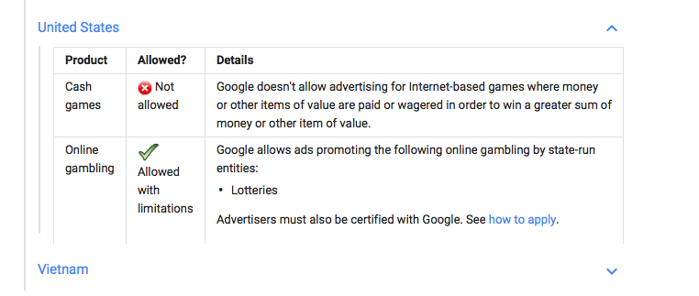
Figure 5: Google advertising policies on online gambling comply with domestic laws. In Singapore online gambling advertising is not permitted. In the US, only state run lotteries can advertise online.
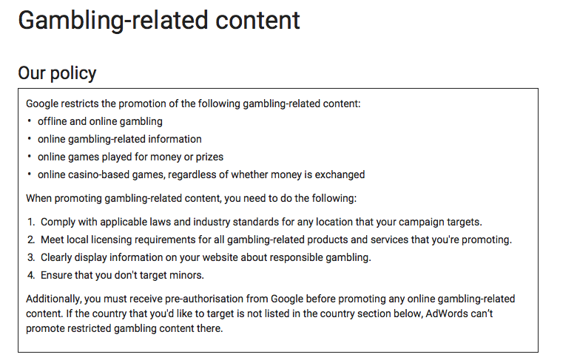

Facebook also restricts its advertising and has both restricted and prohibited content:

The Interactive Gambling Act 2001, section 7A carries directions about advertising.
We believe that we should follow the precedent set by the tobacco advertising ban - a staged process. The ban is set out in the Tobacco Advertising Prohibition Act 1992. The first stage was the 1992 legislation, and in 2012, the restrictions on tobacco advertising were extended to the Internet and other electronic media in Australia.

We recommend:

- Follow the tobacco-advertising journey, and ban advertising totally, but with a staged approach. There could be a grandfathering clause for existing large sponsorship contracts (if they can demonstrate that there is no legal way out). This way, the AFL and other vested interests will be on notice that the codes have to find alternative sponsors.
- Find alternative sponsors by following the tobacco model, where revenue raised by an industry levy was used to fund organisations such as VicHealth. VicHealth then replaced existing gambling sponsorship dollars with ‘healthy sponsorship’.
- Advertising regulation – we need regulation now which covers the broad spectrum of C21 manifestations of marketing including direct advertising, inducements, sponsorship and promotions:
  - TV/radio
  - Physical advertising – billboards, sporting stadiums, buses and logos on player uniforms
  - Internet
  - Social media
  - Direct marketing via mailing lists, email and texts - including inducements, loyalty cards
  - Other – sports commentary,
  - And any new forms that the Minister deems to be advertising (to future proof it)

Important
In the interim, close the advertising code loophole, which provides an expanded exemption for advertising during sporting and current affairs programs.

7.0 Conclusion – our gambling vision for Australia

The first question the Government and the IGA Review must grapple with is our vision for Australia. What sort of country do we want to live in? What do we want for the next generation? How much gambling is the right level of gambling for Australia? Are there limits?

Where does gambling fit into the Treasurer’s vision of being in nation where we have a life plan to ‘work, save, invest’? Is it ‘work, save, ^{(gamble)}, invest’?

We can only work out what needs to be done, when we have a vision.

The United States formulated a vision where sport was for its own enjoyment, and online gambling was not part of that vision. It has not been 100 per cent successful, but policy hardly ever is.

Australia has never articulated a vision, and we are now in the insidious position where it seems that there is no such thing as too much gambling. We have no limits, and Australians have the largest gambling losses per capita in the entire world. Gambling advertising is ubiquitous.

There is no such thing as an absolute right. Free speech is limited by a prohibition against defamation or the incitement of violence. Freedom of movement and association is curtailed to some extent by concerns about national security, which we see in our responses to the threats posed by terrorism.

Industry is asserting that it has a competitive right to a level playing field with overseas players, who are offering in-play betting. They are asserting their competitive ‘right’ because it is in their interest to do so. They know that in-play betting will double their business revenue. We know that their increase in revenue is a family’s loss of much more than money.

We know that the true cost of online gambling is far in excess of the money lost. Financial counsellors, in addition to seeing broken gamblers, also see the women whose partners have gambled their savings, surreptitiously redrawn on the almost paid off mortgage to gamble, used the family wage so there is no money for the utility bills, and so it goes on. However, the second biggest cost is the breach of trust. As one woman said ‘I saw his gambling record. He was gambling when he missed our child’s birthday. He lied, and lied and lied.’ These lies destroy families. Many women try to save the marriages by bailing out their spouses. To do this, the woman (with her intact credit record) may take out a personal loan to repay the gambler’s debts, to save the family house, and start again. Later, when the partner relapses, she leaves … but with the burden of the debts in her name. Or the family court divides the family property – which includes assets and debts, including gambling debts. The most devastating cost, but not on the gambling company’s ledger, are the suicides.

This means that the rights of companies to make profits, must be balanced against the rights of individuals, families and our community. The argument that individuals have an unfettered right to gamble is nonsensical. Problem gamblers, who have informed our work, are pleading for protections – for government to fetter their so called ‘right’ to wreck their lives. In retrospect their right to gamble was more about the gambling companies’ right to drive them to the cliff’s edge.

As a problem gambler, wrote to FCA “even though it is the gambler who keeps pushing the bet button ... and jumping off the cliff ... that there is no need for the gambler to be chauffeur driven in a limo to the edge of that cliff by the betting companies.”

A suite of consumer protections if properly resourced and implemented, may mitigate a small amount of damage. However, this is just harm reduction. The government should be recognising that the ‘gambling product’ is harmful, just as ice or tobacco are harmful, and choosing to just chip away at only at one corner with some harm minimisation measures is not really going to do the job. We would never accept the logic that since ice addiction only impacts a very small percentage of Australians, that we just accept its existence, and have some harm minimisation crumbs tossed at the users.

A much better response would be to:

- Start with a ban on advertising, as we did with tobacco,
- Ban all forms of credit,
- Introduce consumer self-management tools as set out above
- Introduce an online account aggregator (with compulsory loss limits) and
- Exclusion register, including 3rd party exclusion – and
- Flag when people are on a problem gambling trajectory though the ‘algorithm’
- Fully fund the services that have to pick up the pieces, like financial counselling, domestic violence services (there is a relationship between family violence and gambling), gamblers help and others.
- And the other remaining ‘things that need to be done’ on our list.

And then formulate a comprehensive vision for the Australia in which we want to live. Without the vision we don’t know where we want to go. But we can see where we’re currently heading.

See press release, August 17, 2016, Australian Wagering Council, ‘AWC responds to calls for increased regulation of wagering in Australia’.
Illegal gambling requires a broad definition or regulator or ministerial discretion to deem new forms of gambling as ‘illegal gambling. E.g TopBetta has tournaments that people buy into with real money, then bet with fantasy money. See The Australian, ‘Nick Chan calm on Seven exit as he bets on TopBetta, Nov 16 2015, http://m.theaustralian.com.au/business/media/nick-chan-calm-on-seven-exit-as-he-bets-on-topbetta/story-e6frg996-1227610066030. Or gambling in a virtual reality environment, see 13 November 2015, ‘Gambling on virtual reality: the online casinos of the future’, http://venturebeat.com/2015/11/13/gambling-on-virtual-reality-the-online-casinos-of-the-future/
http://calvinayre.com/2015/11/18/business/paddy-power-aussie-sportsbet-site-offsets-poor-sports-results/
Unlawful Internet Gambling Enforcement Act 2006 – see https://www.fdic.gov/news/news/financial/2010/fil10035a.pdf
See the AWC website http://australianwageringcouncil.com/policy-representation/key-policy-positions
http://www.ccmc.org.au/what-we-do/
See the TIO’s annual report, http://annualreport.tio.com.au/performance/complaint-numbers
The Australian Prudential Regulation Authority (APRA) oversees banks, credit unions, building societies, general insurance and reinsurance companies, life insurance, private health insurance, friendly societies and most members of the superannuation industry. APRA is funded largely by the industries that it supervises.
http://www.treasury.gov.au/ConsultationsandReviews/Consultations/2015/Proposed-industry-funding-model-for-ASIC
http://www.liberal.org.au/helping-problem-gamblers
The terms and conditions state:“Cardholders must not, or won’t be able to transact: For the purpose of gambling or in connection with unlawful activities…” (October 2015)
See ASIC’s submission to the Review of the small amount credit contract laws , October 2015. http://download.asic.gov.au/media/3436335/asic-submission-review-of-small-amount-credit-contract-laws-30-october-2015.pdf
E-Merchants provides the debit card used by Ladbrokes, Sportset, Bet365 and others – it has recently signed a MOU with Cash Converters International. Cash Converters is a leading supplier of short-term payday loans. See http://www.proactiveinvestors.com.au/companies/news/64615/emerchants-deal-hints-at-strong-international-upside-64615.html
Summary: The Act prohibits gambling businesses from knowingly accepting payments in connection with the participation of another person in a bet or wager that involves the use of the Internet and that is unlawful under any federal or state law (termed “restricted transactions” in the Act). Most states define online sports betting as unlawful. The Act also requires Treasury to promulgate regulations requiring certain participants in payment systems that could be used for unlawful Internet gambling to have policies and procedures reasonably designed to identify and block or otherwise prevent or prohibit the processing of restricted transactions. These regulations are independent of any other regulatory framework, such as the Bank Secrecy Act or consumer protection regulations. A joint rule has been issued by Treasury and the Federal Reserve Board that designates five payment systems as covered by the Act. For more info see: https://www.fdic.gov/news/news/financial/2010/fil10035a.pdf
Part 3 - Inducements & Loyalty, 55 (2), ‘In addition to the matters required by sub-clause (1)(a), an acceptable loyalty program must include a facility for predictive monitoring of the patterns of gamblers’ gambling activity, with the purpose of intervening in cases where there is a risk of problem gambling.’ . See the Gambling Codes of Practice Notice 2013 - http://www.iga.sa.gov.au/files/GCoP13-V05.pdf
There is a precedent for banning unsolicited credit increases. From 1 July 2012 changes to the National Consumer Credit Protection Act 2009 mean that credit providers cannot send invitations to customers unless the customer has previously provided their consent. When a customer applies for additional credit (irrespective of whether they are responding to a credit limit increase invitation) the financial institution must ensure that it satisfies its responsible lending obligations under the National Credit Code. See also NATIONAL CONSUMER CREDIT PROTECTION AMENDMENT (HOME LOANS AND CREDIT CARDS) ACT 2011 (NO. 84, 2011) - SCHEDULE 1 See 133BE Credit provider not to offer etc. to increase credit limit of credit card contract
17 November 2015, ‘Small Business Minister Kelly O’Dwyer announces easing of regulations on equity crowdfunding’ http://www.startupdaily.net/2015/11/small-business-minister-kelly-odwyer-announces-easing-of-regulations-on-equity-crowdfunding/
It makes sense for government to consider constructing the register that will be able to be used for both online gambling and physical venues – use the opportunity without significant additional cost.
See ‘Problem gambling and family violence : prevalence and patterns in treatment-seekers’, Dowling, Nicki, Jackson, A C, Suomi, A, Lavis, T, Thomas, S A, Patford, J, Harvey, P, Battersby, M, Koziol-McLain, J, Abbott, M and Bellringer, M E 2014, Problem gambling and family violence : prevalence and patterns in treatment-seekers, Addictive behaviors, vol. 39, no. 12, pp. 1713-1717, http://dro.deakin.edu.au/view/DU:30066196. Also http://www.heraldsun.com.au/leader/north/problem-gamblings-links-to-family-violence-job-loss-and-depression-explored-at-health-forum/news-story/5a0e2996729e784fef2fa9dbab0fac04
‘Royal Commission asked to act on gambling to reduce family violence’, 18 Jul 2015, http://www.abc.net.au/news/2015-07-18/royal-commission-asked-to-act-on-gambling-to/6630244
See the Report pg 67 ‘LEGAL BARRIERS TO ECONOMIC EQUALITY AFTER FAMILY VIOLENCE , Women’s Legal Service, Sept. 2015 http://www.womenslegal.org.au/files/file/Stepping%20Stones%20Report(1).pdf
http://www.tac.vic.gov.au/road-safety/tac-campaigns/tac-latest-campaigns/towards-zero
E.g. Victorian Responsible Gambling Commission has commissioned research on advertising and social media. See http://www.responsiblegambling.vic.gov.au/information-and-resources/research/recent-research. We believe that there is further research that will be released in coming months.
‘Who wins from ‘Big Gambling’ in Australia?’, The Conversation, March 16 2015, http://theconversation.com/who-wins-from-big-gambling-in-australia-22930
As quoted in The Australian, 18 November 2015, ‘Regulate sport bets ‘or risk losing billions’ to online operators’’ – The AWC told the IGA review - ‘In-play betting, the fastest growing segment of online gambling, last year accounted for 19 per cent of all sports betting, a figure tipped to increase to 50 per cent by 2020.’
See gambling academic Charles Livingstone’s analysis, ‘How real are claims of poker machine community benefits?’, The Conversation, Oct 20, 2015, http://theconversation.com/how-real-are-claims-of-poker-machine-community-benefits-49136
See http://www.problemgambling.gov.au/facts/, http://www.psych.usyd.edu.au/gambling_treatment_clinic/resources/Facts_and_Figures%20Gambling_pdf.pdf
For example, Qld police death reporting forms, have a box for financial difficulty but not gambling. The existing data is not analyzed by anyone. At the time of death, the police are not asking the right questions to identify gambling. Coroners are also not requesting gambling debt or the incidence of gambling data. The approach by the various coroners is ad hoc re gambling related deaths.
E.g. Penalties for failing to submit an SMR (suspicious matter report) to AUSTRAC. If an SMR is submitted after the relevant reporting period or not submitted at all, AUSTRAC can apply to the Federal Court of Australia for a civil penalty order of up to 100,000 penalty units for a body corporate.
This may have prevented ‘Max’ in the Duds, Mugs Report from making two $250,000 bets. He is now in jail as it was money embezzled from his employer. See page 7.
This case study was subsequent to the report.
https://www.fdic.gov/news/news/financial/2010/fil10035a.pdf
http://www.cnbc.com/2015/10/15/cash-drops-and-keystrokes-the-dark-reality-of-sports-betting-and-daily-fantasy-games.html
‘N.Y. AG declares DraftKings, FanDuel are illegal gambling, not fantasy’, 12 November 2015, http://espn.go.com/chalk/story/_/id/14100780/newyork-attorney-general-declares-daily-fantasy-sports-gambling
See ‘Peer-to-peer eSports wagering site Gaimerz.com set for launch’, 2 November 2015, http://www.igamingbusiness.com/press/peer-peer-esports-wagering-site-gaimerzcom-set-launch
See for example, ‘Gambling on virtual reality: the online casinos of the future’, 13 November 2015, http://venturebeat.com/2015/11/13/gambling-on-virtual-reality-the-online-casinos-of-the-future/
See the interesting commentary by Gamblit Gaming's CMO David Chang who talks about how to monetize mobile games with real-money gambling., ‘Gamblit Gaming on the potential of mashing up casual games with casino and gambling mechanics’ Oct 14 2014, http://www.pocketgamer.biz/comment-and-opinion/60064/gamblit-gaming-on-the-potential-of-mashing-up-casual-games-with-casino-and-gambling-mechanics/
As above.
Some games have an initial large monetary deposit, and then play with fantasy money until that runs out. Users then have to deposit more funds.
Nov 10, 2015, http://www.afl.com.au/news/2015-11-10/sport-exempted-from-new-hardline-booze-ads-ban
See Google’s gambling advertising policy at https://support.google.com/adwordspolicy/answer/6018017?hl=en-AU
See https://www.facebook.com/policies/ads/#restricted_content
See this state by state overview of gambling and advertising http://www.communicationscouncil.org.au/public/content/ViewCategory.aspx?id=509
Dr Charles Livingstone. Monash University public health academic has knowledge of this process.
See Scott Morrison: Work, save, invest the new mantra for the new Treasurer’, Sept 14 2015, Sydney Morning Herald, Read more: http://www.smh.com.au/federal-politics/political-news/scott-morrison-work-save-invest-the-new-mantra-for-the-new-treasurer-20150923-gjti9x.html#ixzz3s0m4xRHj
2.1% of Australians aged 14 years and over have used meth/amphetamines in the previous 12 months. Of these people, 50.4% report crystal or ice as main form of the drug used.1 - See more at: http://www.druginfo.adf.org.au/topics/quick-statistics#amphetamines

