Illegal offshore wagering and consumer protection
November 2015

- Introduction

1.1 This is the British Gambling Commission’s response to the request from the Department of Social Services, Australian Government, for views on a number of questions relating to illegal offshore wagering including the efficacy of approaches to protect the consumer.

1.2 We are not in a position to assess the impact of illegal offshore wagering and associated financial transactions on the Australian economy (question 2) or directly to suggest what measures could be implemented to improve the enforcement of the Interactive Gambling Act 2001 or other relevant legislation (question 3) but, by describing our experience in tackling analogous issues in Britain, we may be able to assist the review in considering possible options and in answering the remaining questions (1, 4 - 7).

1.3 While we permit and regulate all forms of remote gambling, this contribution focuses in particular on the regulation of betting but within an overall context that favours inclusive regulation and targeted controls, rather than prohibition, as a way to minimise gambling related harm and keep crime, such as sports betting corruption and organised crime, out of gambling.

1.4 This note describes in
- section 2, the history and development of the current regulatory regime for gambling in Britain
- section 3, the current market size and gambling prevalence and
- section 4, the prevalence and characteristics of problem and at risk gambling.
It then goes on to discuss in
- section 5, the British approach to maintaining a socially responsible legal gambling market and minimising illegal competition and
- section 6, protecting the consumer .
Finally the note focuses in
- section 7, on betting integrity issues and
- section 8, on our approach to compliance and enforcement for licensees.

- Background
2.1 The Commission was set up under the Gambling Act 2005 (the Act) as the national gambling regulator covering England, Scotland and Wales. It was formally established in October 2005 and took over the role previously played by the Gaming Board for Great Britain in regulating casinos, bingo, gaming machines with its remit extended to cover almost all commercial gambling including non remote betting and remote gambling.

  - From 2007, when the Act came fully into force, the Commission regulated all British land based and online commercial gambling ,where the operator’s key equipment was based in Great Britain apart from spread betting (the responsibility of the Consumer and Markets Authority), larger society lotteries and, since 2013, the National Lottery. The Commission is also responsible for advising central, devolved and local government on issues related to gambling. The Commission is a Non-Departmental Public Body, sponsored by the Department for Culture, Media and Sport (DCMS). It operates at arm’s length from government and its advice is independent. Its work is funded by licence fees, set by DCMS and approved by Parliament, from the gambling industry.

The Gambling Act 2005
  - The Act extended national regulation to betting and arcades and permitted far wider advertising of gambling facilities. It introduced a statutory objective in relation to protecting the under age and other vulnerable people from gambling related harm and it put in place for the first time a framework for regulating internet gaming (ie casino and poker).
Previously only bookmakers, overseen by local authorities, were permitted to accept bets by remote communication as an extension of their premises based activity but remote gaming operators had not been permitted to be based in Britain.
  - Remote gambling was defined in the Act (section 4) as gambling in which persons participate by the use of remote communication (ie internet, telephone, television, radio or other technology for facilitating communication).There was no restriction on the number of remote operating licences that the Commission could issue (with the exception of non-remote pool betting on horse racing which was restricted to one licensee) but applicants needed to demonstrate that they are fit and proper to hold an operating licence.

  - In exercising its functions under the Act the Commission is under a duty to pursue, and wherever appropriate to have regard to, the licensing objectives, and permit gambling, in so far as the Commission thinks it reasonably consistent with pursuit of the licensing objectives. The licensing objectives are:
- preventing gambling from being a source of crime or disorder, being associated with crime or disorder or being used to support crime
- ensuring that gambling is conducted in a fair and open way
- protecting children and other vulnerable persons from being harmed or exploited by gambling.

  - The Commission’s functions in relation to licensing and regulation can broadly be categorised as those of licensing, compliance and enforcement (see part 5 of the Act). The ability to award or deny licences and to impose conditions on the way in which operators conduct their business is key in terms of ensuring that only suitable operators are involved in the provision of gambling. The Commission then has wide powers of investigation and regulatory and criminal prosecution powers with the ability to fine, impose additional conditions or revoke licences.

  - The Commission issues remote and non-remote operating licences for the following gambling activities, as applicable:
    - betting (including fixed odds betting, pool betting and betting exchanges)
    - casino (including casino games and poker)
    - bingo
    - lotteries and external lottery managers
    - software developers and suppliers.

2.8 There is no distinction between licences for B2C and B2B operators; those B2B operators providing facilities for gambling to other gambling operators such as platforms providing bingo, slots and poker facilities to B2C operators, require operating licences. Those developers and suppliers of gambling software to our licensees also require licences. The Commission also requires personal management licences for holders of key functional posts such as finance director, CEO/COO and marketing director.
2.9 The original 2005 Act permitted operators regulated in EEA States and in whitelisted jurisdictions to advertise and offer services to UK consumers. In the years following the 2005 Act coming into effect, British based operators started to move their remote betting operations from the UK to whitelisted or EU jurisdictions such as Gibraltar where they could operate with little or no gambling duty or other obligations such as the horse race betting levy and with lower corporate tax. In addition other EU states, which had hitherto banned remote betting and gaming or limited it to pool betting and state monopolies focussed on their home markets, started to license remote gambling operators, adding to the potential range of legal gambling available to customers in Britain.

2.10 While by and large the licensing requirements of other EU and white listed jurisdictions were comparable to those in Britain, this had left the Commission with no information or oversight on the performance of operators supplying the vast bulk on the British market or on how the market was developing; very limited scope for identifying emerging risks or evaluating the effectiveness of regulatory measures and with consumers facing slightly different regulatory regimes and entirely different avenues for complaint and redress depending on which operator they transacted with.

  - The Commission was not therefore in a position to advise the government effectively on the impact of remote gambling or its regulation and, in so far as we were able to identify emerging risks or issues, would have to persuade an increasing number of other regulators, to act in concert with us if we were to be able to protect British consumers. Many of those regulators did not have our ability to change licensing requirements or take enforcement action without departmental or legislative approval. We were not able for example to insist on operators cooperating on a national self exclusion database for remote gambling or using only software suppliers also licensed by the Commission and we were constrained in terms of the player protection measures we could impose, given the scope for overseas-based competitors not facing the same requirements to attract customers away from GC licensees.

  - In relation to sports betting integrity, the Commission was unable to require suspicious betting reports from overseas betting operators and could not access information on particular betting transactions without first satisfying other regulators of the need for such information. Depending on the powers of the other regulators, requests might have to be made via overseas police forces. While some suspicious and unusual betting information was provided voluntarily, particularly by Betfair, its provision was patchy and the lack of timely information and the ability to investigate swiftly were major concerns for the Commission’s Sports Betting Intelligence Unit.

  - In 2010 the government accepted the advice of the Commission that the Act should be amended to require all those advertising and providing facilities for gambling to those in Britain to hold a Commission licence, in other words to change the main focus of regulation from the point of supply to the point of consumption. The amending legislation, the Gambling (Licensing and Advertising) Act came into effect on 1 November 2014. By the time the necessary consultation processes had been completed and a slot found in the legislative timetable, over 85% of the British remote gambling market was being supplied by operators licensed elsewhere in the EU or in white listed jurisdictions.

  - Following implementation of the 2014 Act the Commission now licences operators responsible for virtually all the remote gaming and betting market in Britain, probably well over 95%. Nearly 150 operators are or have remained overseas-based but are now subject to Commission licensing and regulation for their UK facing activity. They provide regulatory returns with information on their performance both in terms of revenue by type of gambling and in relation both to player characteristics and to compliance activities, such as numbers self-excluding, breach of self-exclusion, software or security problems and changes in key personnel.

  - More specifically in relation to remote betting activity, all operators legally providing betting facilities to those in Britain are now subject to licence conditions requiring them to report suspicious transactions or suspected breaches of sports governing bodies rules to both the sporting body and the Commission.

  - All are now also subject to the requirement to make a contribution towards research, education and treatment in relation to gambling-related harm. Many overseas operators in fact already did so but the licence requirement greatly reduces the scope for freeloading and, as a backstop, brings such operators within the ambit of the 2005 Act’s reserve powers to raise a levy payable to the Gambling Commission for ‘purposes related to, or by way of providing financial assistance for projects related to:

a) addiction to gambling
b) other forms of harm or exploitation associated with gambling or
c) any of the licensing objectives.’

To date the government has not used this power, relying instead on the voluntary contributions made by the industry to the Responsible Gambling Trust.
  - We now have a relatively complete picture of the British remote and non remote gambling market activity and are able to oversee and monitor operators, track trends and identify changes and the ability to move swiftly to address non-compliance or emerging risks. With many people gambling both remotely and non-remotely ie in premises and operators developing multi-channel strategies, this overview of the complete market is important in terms of understanding and mitigating risks to players and to the licensing objectives.

- Current market size and gambling prevalence

3.1 In addition to the data provided by regulatory returns from its licensees (see our industry statistics) the Commission collects quarterly survey data on participation in gambling and on attitudes to gambling. When it comes to participation, our latest published quarterly participation survey for online activity shows the following for those respondents which have engaged in any online activities over the past four weeks.

 | National Lottery | Sports betting | Other lotteries | Horse betting | Bingo | Online fruit/slot machine games | Roulette, poker cards or dice
Four week participation (online) | 68% | 14% | 14% | 10% | 5% | 4% | 4%

3.2 Overall the gambling market (including the National Lottery) has increased for both the non-remote and remote sectors, although the table below highlights the difference in growth rates and shows remote Gross Gambling Yield (GGY) ie gambling revenue less winnings paid out, is estimated to have grown faster than the GGY for non-remote. Recent third party estimates for mobile GGY as a proportion of total interactive GGY (combined remote betting and gaming) show growth from 4% in 2008 to 42% in 2015(e).

3.3 Third party estimates of the size of the British remote betting market put it at around £1.4 bn by this year, having almost doubled in size since 2011 and set against a backdrop of an overall growth in remote gambling of almost 55% to around £3.4 bn during this period.

3.4 In terms of non-remote, betting (excluding machines in bookmakers) has decreased slightly to around £1.5bn, set against an increase of 14% for non-remote gambling in general. Growth in the non-remote sector is being driven by casinos and the machine GGY contributing to certain sectors. In general this is indicative of the wider customer move from non-remote to remote within the overall growth in gambling revenue. Some examples are given below for the biggest non-remote sports betting sectors by GGY, showing a decrease for horses and dogs and an increase for football, although revenues for the latter are affected by whether the year contains a significant football championship such as the World Cup.

3.5 We do not have a historical, detailed breakdown by individual sports for remote betting as this pre-dates the Gambling (Licensing and Advertising Act) 2014 and our newly acquired ability to collect data on all operators legally supplying our domestic market. Similarly we do not have Commission figures for the trends in in-play betting or betting by mobile but initial indications from the first 6 months figures since the 2014 Act came into effect suggest that both now account for around 50% of total remote betting revenue.

% Growth in GGY | Apr 2011-  Mar 2012 | Apr 2012-  Mar 2013 | Apr 2013-  Mar 2014 | Oct 2013-  Sep 2014 | Change since 2011
Total market  (including National Lottery) | 6.6% | 4.8% | 3.2% | 5.9% | 22.2%
Non-remote | 4.0% | 5.4% | 2.4% | 1.6% | 14.1%
Remote  (UK consumer estimates) | 5.2% | 1.2% | 18.4% | 22.6% | 54.5%
Non-remote betting | -5.2% | 6.9% | -3.4% | 0.9% | -1.2%
Remote betting | 11.8% | 27.8% | 18.5% | 16.8% | 97.6%
Non-remote horses | -3.2% | 2.1% | -0.1% | -3.6% | -4.8%
Non-remote dogs | -6.6% | -2.4% | -1.4% | -2.7% | -12.6%
Non-remote football | -13.5% | 21.1% | -16.8% | 23.3% | 7.5%
Source – Industry statistics (non-remote), Gambling Compliance & H2GC (remote)

- Problem gambling

4.1 We also work with the Departments of Health in England and Scotland to run problem gambling question modules in their regular health surveys. We deliberately moved away from the earlier British Gambling Prevalence Studies run in 1999/2007/2010 as the health surveys provide us with far more detailed demographic data and, as a larger survey, more gamblers at risk or with gambling problems.

  - Annex 1 provides more detailed analysis of the results of the health and prevalence studies. Broadly speaking participation, in terms of people gambling, remains fairly stable, if participation in the national lottery main draws is excluded, despite the big increase in advertising and the accessibility of gambling. The revenue from gambling has however increased overall. Similarly the rates of problem and at risk gambling appear to be largely stable possibly even falling. Interestingly the best correlation with problem gambling is with the number of activities an individual undertakes not with particular products. This suggests that banning or restricting particular products, as opposed to monitoring players’ use of such products and intervening appropriately, risks displacing problematic gambling either to other gambling products or to illegal providers of the particular product.

  - From February 2016 the Commission will start publishing the results quarterly of an on line tracker survey started earlier this year. The survey explores online gambling behaviour in-depth and includes questions for example on gambling activities, devices used, number of accounts, social gaming. It will include a mini problem gambling screen that we have developed and validated against the health survey figures to give us an early indication of trends in problem and at risk gambling.

5 Maintaining a socially responsible legal gambling market and minimising illegal competition

  - The British experience suggests that having a legal gambling market which is attractive to players in terms of choice and (price) competitiveness of the products available to them and attractive to operators in terms of there being scope to make a reasonable commercial return from providing gambling in a highly responsible way, will greatly reduce the scale of any illegal activity. Conversely if players cannot get access to a reasonably priced attractive range of gambling products, they are likely to be receptive to approaches from illegal/unlicensed operators. And if competing operators find the black market commercially attractive by being able to offer consumers products which are not permitted legally, such as in-play betting, that undermines the commercial viability and attractiveness of the licensed market with the overheads of responsible gambling provision.

  - The British approach therefore tries to combine an attractive legal market, open to innovation with as wide a range of products as possible, with a regulatory framework and tools that, while minimising the regulatory overhead, supports the pursuit of the licensing objectives ie keeping gambling crime free, fair and open and protecting the vulnerable, and deters the less responsible or plain illegal from undercutting and undermining the responsible licensees. We see a potential virtuous circle in:
- regulating rather than prohibiting
- enabling consumers to have access to the products they want at reasonable prices but in a regulated and monitored environment
- requiring high social responsibility standards from licensees in the way they market and provide gambling
- limiting access to legal marketing and payment providers to those with licences with firm action against those attempting illegal access to the market
- building up the evidence base by requiring data from licensees and looking to them to develop and improve their own monitoring and player protection tools and contribute to communal research education and treatment.

In this way operators have the incentive (underpinned by regulation and sanction) both to operate in the licensed market and to work together with other stakeholders and the regulator to develop and maintain improved ways of protecting consumers and promoting betting integrity.

  - The key features that contribute to the effectiveness of the Commission’s approach in relation to minimising illegal competition are:

- It is risk and principled based focused on outcomes not detailed prescription. It places the onus on the operator to act responsibly and to lead developments in responsible gambling and combating crime and sports betting corruption. Operators are better placed than the regulator to work out how most cost effectively to secure licensing objectives. The role of the regulator in our view is to oversee and hold operators to account for their performance in relation to the licensing objectives. This helps holds the regulatory overhead on business to the minimum consistent with maintaining high consumer protection standards. That in turn makes it harder for unlicensed operators to undercut our licensees.

- There is strong deterrence and disruption for those attempting to supply illegally:

  - The requirement for licences for B2Bs as well as B2Cs, for licensed operators to use only Commission licensed software suppliers and then holding licensees jointly and separately responsible for any shortcomings, expecting licensees to terminate contracts with those who are not up to standard and or who deal with unlicensed or illegal operators competing with our licensees.

  - The requirement for personal licences for key executives including the marketing director (given the critical importance of marketing to the success of remote gambling businesses) and holding those licensees personally to account for the conduct of their businesses and who they associate with.

      - Working with third-party advertising and marketing organisations such as Google and Facebook to ensure they understand that any operator or affiliate trying to market products from an unlicensed operator would be acting illegally and that they would be potentially liable themselves to prosecution and indeed involvement in money laundering if they knowingly carried or benefited from illegal product. The requirement on licensees to display the Commission kitemark which can be checked against the Commission licence register provides an easy way to check legal status.

      - Working with payment providers where we have arrangements with Visa, MasterCard and others whereby if we demonstrate an operator does not have a licence, the merchant acquirer will refuse to continue to deal with them, a powerful deterrent and disruption tool as that potentially affects the operator’s business dealings worldwide. We are encouraging, and seeing evidence of, merchant acquirers checking that operators are properly licensed before providing processing facilities to them.

    - Co-operation and sharing of intelligence with other regulators and law enforcement bodies. When licensing operators we ask for their rationale for operating in any “grey” market which they are deliberately targeting or from which they get 3% or more of their total revenue from players or in the case of operators with total revenue of less than £5m per annum – any markets they are targeting where the revenue is more than 10% of their total revenue. We ask why they are satisfied that such operations are legally and financially responsible.

- Approaches to protect the consumer

6.1 There are three main strands to the Commission’s approach to protecting the consumer:
- building our understanding of the risks to the consumer and how best to mitigate them
- ensuring our licensees are focused on maintaining and improving the way in which they provide gambling responsibly
- promoting better public understanding of gambling related harm and how to minimise it.
with the Commission’s Licence conditions and codes of practice (LCCP) critical to achieving each.

  - The LCCP set out the rules which operators must observe to meet the Commission’s three licensing objectives. Provisions within the conditions and codes cover issues including the promotion of responsible gambling, tools to help players control their gambling, marketing and self-exclusion, and secure the provision of data to help build the evidence base. For example, the following provisions in place since 2007 are relevant to all licensees, but this is not an exhaustive list:

- report suspicious betting activity to the Commission and sports bodies
- adhere to regulations for the prevention, detection and reporting of money laundering
- employ stringent age verification checks and other key social responsibility measures
- provide players with the ability to limit deposits and time playing
- only provide credit for betting under strict conditions relating to the customer’s circumstances
- periodically report activity such as revenue, amount of customer funds held and other key gambling related information
- report significant events and provide information about their business to enable the Commission to monitor the ongoing suitability of licensees
- comply with technical and information security requirements and commission independent testing of gambling systems before they are released
- make contributions to research, education and treatment.

  - With nearly a decade’s experience of regulating remote gambling and working with other regulators facing similar issues and the move to point of consumption regulation, we reviewed and strengthened the LCCP provisions relating to social responsibility. The longstanding provisions for providing players with the ability to set deposit limits and to self exclude have been tightened up. Provision for ‘time out’ (short periods of exclusion of 1 day, I week and I month) must now be offered. In addition to the ability to self exclude from an individual operator, customers will be able to self-exclude from all remote operators once the national self-exclusion scheme has been developed. Operators are now required to keep customers’ funds segregated from working capital and to disclose to customers what if any protection there is in the event of bankruptcy. The Gambling Commission ‘kite mark’, which links to the Commission licensing register, must be displayed by licensees. This enables players and third parties to check an operator’s licensed status.

  - The Advertising Standards Authority’s code is supported by LCCP and a requirement has been introduced to display key terms and conditions prominently alongside any marketing offers or within one click if space is restricted. Misleading and potentially unfair marketing of ‘free bets and bonuses’ is an area where we still have concerns and we are focussing our efforts on raising standards.

  - Further revisions to LCCP may be needed but this illustrates the potential value in licensing operators who then have an incentive to comply with raised marketing standards to retain their ability to market legally as they are subject to sanctions if they do not.
  - Operators are also required to monitor players’ behaviour and to consider intervention if their play indicates potential issues such as problem gambling or money laundering (not mutually exclusive). Remote gambling has the advantage over much non-remote gambling in that it is account based and leaves a highly detailed audit trail. It lends itself therefore to the development of indicators of potential harm and provides the material for developing and evaluating various tools for players to control their own gambling and for operators to spot the potential need to offer assistance. The Commission, advised by its Responsible Gambling Strategy Board, has been encouraging the industry funded Responsible Gambling Fund to commission research into identifying indicators of potential harm in remote play patterns and then to trial and evaluate ways of using such indicators to mitigate the risks, for example by improved tools offered to players or by more effective intervention by the operator.

  - Other areas being researched include improving the way in which information on the return to players is provided, considering the impact of voluntary and enforced pauses in play, and considering what might usefully be done by way of educating players and those who might influence them on how to gamble safely but there is still remarkably little robust evidence about what works either in the UK or elsewhere. In many cases the Commission has used informed judgement, based on advice for example from the RGSB, to put in place prudential player protection requirements pending improved understanding from research and evaluation of those measures.

  - While our data on underage gambling suggests that despite the degree of normalisation and advertising of gambling over the past decade, problem and at risk gambling rates among children and young people have not increased and if anything may have declined slightly, we remain particularly focussed on the need to protect the underage and improving ways to do so. An area of current concern to the Commission and government is the use of social media to market betting and other forms of gambling targeted on those with specific sports or gaming interests when the recipients may in fact be underage as there is no age verification in relation to the marketing. Again we are working with other regulators (the ASA, Ofcom etc) to see how best to use our various powers to protect the underage from gambling related harm when using social media.

  - As part of the process of ensuring that operators put the pursuit of the licensing objectives (keeping gambling fair and safe for all) at the heart of what they do, we have introduced a requirement on the ‘high impact’ gaming and betting operators (which between them account for over 80% of the British market) to produce annual assurance statements. These, like statements of internal control in financial accounts, are intended to be succinct statements of how the operator is pursuing the licensing objectives and how effective they think they are. They will include a narrative statement about the extent to which they are reliant on money from those gambling to excess and what they are doing to reduce that dependence. This should require relatively little extra effort from operators who are already putting social responsibility at the heart of what they do but will help force others, in particular their boards and senior executives, to give social responsibility the attention it needs. It will also help foster and enable the Commission to disseminate emerging good practise.
- Betting integrity

7.1 A key component of the Commission’s work on betting integrity is the licence condition 15.1 which requires betting operators to share information on suspicious activity with the Commission and sports governing bodies. This information is reported to the Commission’s Sports Betting Intelligence Unit which works with operators, sports and law enforcement to ensure an early and effective response to emergent issues.

7.2 The changes to legislation in 2014 now require all operators offering markets in Britain to be licensed by the Commission and are therefore bound by this licence condition. This has greatly enhanced our oversight of the domestic gambling market. It enables us to combine information from the remote and non remote sectors and the leverage to require operators to look at players across channels (ie remote and non-remote, different gambling activities) giving us greater access to information. Such information is not of course available from unregulated or illegal markets making sports betting corruption in those markets far harder to detect or deter.

  - Although the Commission could impose restrictions on types of bets offered or insist on approving sports governing bodies’ rules before allowing operators to offer betting on those sports we do not consider that such action is necessary or would be proportionate in the British context. In particular we considered whether to restrict in play betting in 2009 but concluded there was no real evidence that this would help the fight against sports betting corruption and a risk that, given its growing popularity, consumers would simply try to access illegal sites. We have continued to monitor developments in this area and need to update our earlier position paper which is now some dated technologically. We have however no indications that our views should change. In-play betting is popular and some sports see it as helping to maintain support for matches and teams that might otherwise struggle to attract much attention.
  - While in-play betting may theoretically provide some increased opportunities for corruption, there is little evidence to support the view that in play betting fosters betting corruption in well regulated markets. See for example the extensive discussion of this in the RGA report Sports betting: commercial and integrity issues which reviews various studies in section 4.38 onwards. Our view remains that having and sharing the information on suspicious betting patterns combined with strict and enforced sport rules for players and sports officials is a more effective approach to deterring and detecting any problems than blanket prohibition and driving those keen to bet in play on to illegal sites. It is in the interests of the licensed industry to work with regulators, law enforcement and the sport’s governing bodies and pool information to deter and detect betting corruption.

  - In September 2015 the UK published the Sports and Sports Betting Integrity Action Plan, (the Action Plan) which sets out the framework of collaboration and cooperation agreed by the betting industry, sport, law enforcement, the Gambling Commission and Government to protect Britain’s national and international reputation for being a safe place to enjoy sport and sports betting. Education and other preventative measures play a key part in tackling threats to sports integrity and form an essential element of Britain’s overall strategy to prevent and deter those seeking to corrupt or manipulate betting markets and sporting events.

  - Sport has responsibility and accountability for specific deliverables within the Action Plan; they will review the provision and effectiveness of education programmes to raise awareness of the risks of betting integrity across athletes, coaches, officials and those in governance roles. They are also committed to establishing clear frameworks across sport to ensure codes of conduct, betting rules and contractual provisions establish clear frameworks to enable appropriate sanctions to be applied.

  - Sanctions can only be applied if supporting evidence of breaches of sports codes or criminal activity is available and accessible. Gathering this evidence relies heavily on licensed operators reporting potentially suspicious betting activity; and in any given period reports from operators equate to between 70–80% of the total reports received by SBIU. Legislation and information sharing protocols support the further gathering of intelligence, including that related to betting accounts, which can be used in both sports and criminal investigations. Such action would not be possible if betting was illegal or unregulated and there is the risk of pushing bettors to these sites if competitive markets were not available via the legal and regulated routes.

- Approach to compliance and enforcement for licensees
8.1 In terms of ensuring licensees comply with their licence conditions and codes of practice and to deter non-compliance and illegal provision, as noted above the Commission has the full range of regulatory sanctions, including fines, the ability to impose licence conditions and to suspend or revoke licences and, more relevant to illegal providers to prosecute. Those third parties knowingly involved with an illegal operator also risk action under the anti-money laundering legislation as they would be handling the proceeds of crime.

8.2 We have however made it clear to licensed operators that if they are open about any shortcomings, have convincing plans to put things right, are willing to share any learning with the rest of the industry, and to divest themselves of any commercial benefit they may have received from the shortcomings, there may be no need for formal and time-consuming formal regulatory sanctions process. They can pre-empt the need for formal regulatory action by proposing a voluntary settlement covering those aspects, including in particular an agreed public statement so that other operators can make sure they address similar shortcomings immediately and the public can be assured that effective regulatory action is being taken. This helps avoid formal and time-consuming formal regulatory sanctions process in favour of earlier moves to put things right and ensure the lessons are widely learnt.

  - We see transparency about what is expected and performance against those expectations as part of the key to maintaining high standards and encouraging self-policing on the part of the industry and minimising the regulatory overhead which ultimately the consumer pays for. We consider this approach promotes greater public understanding about what responsible gambling provision looks like and what to expect from the industry and also harnesses the pressure of public opinion in support of more responsible operators. The early indications are that such voluntary settlements and the associated publicity and shared learning is having a beneficial impact on standards and beginning to work as a deterrent.

  - As noted above, having oversight and regulatory control of virtually all those providing gambling to our consumers enables the Commission to work with the betting and sports industries to understand better the risks to the licensing objectives from gambling and gives the Commission the ability with its licensing leverage to encourage and if necessary impose the development of better tools for players and operators to minimise harm from gambling or its use for crime.

Gambling Commission November 2015

Keeping gambling fair and safe for all

For further information or to register your interest in the Commission please visit our website at: www.gamblingcommission.gov.uk

Victoria Square House • Victoria Square • Birmingham B2 4BP
T 0121 230 6666 • F 0121 230 6720 • E info@gamblingcommission.gov.uk
Annex 1: Trends in online betting

From September 2013 to September 2015 overall rates of participation in betting have remained relatively stable, as shown in the table below:

Betting activity | Year to September 2013 (%) | Year to September 2014 (%) | Year to September 2015 (%)
Horses | 4 | 7 | 4
Dogs | 0.7 | 0.5 | 1
Sports | 4 | 4 | 4
Other events | 1 | 1 | 1

The earlier surveys were conducted with very different methodologies but, allowing for that, there appears to have been little shift in terms of the rates of online betting and gambling between 2007 and 2012 – 3% flat for gambling and 4% moving to 5% for betting.

There is a mixed picture in terms of trends in mode of participation across betting activities across this period. For the more traditional betting activities (betting on horses or dogs) splits of mode of participation have remained relatively consistent with no apparent shift towards online play. There has however been a move towards online play for betting on sports and betting on events. Online past four week participation in sports betting has increased from 55% of those that bet on sports in the year to September 2013 to 63% in year to September 2015. A greater shift has been seen amongst those that bet on ‘other’ events; with the percentage of online players rising from 45% to 59% across the same period. This increase in online play appears to be substitution for non-remote play as play rates for the latter have fallen for both activities (50% to 40% for sports betting, 67% to 48% for betting on ‘other’ events).

In addition to the survey data we collect we also now receive information via regulatory returns on the proportions of GGY which are attributable to mobile and in-play betting. Data from operators shows that in-play betting constitutes 49% of all betting GGY generated whilst mobile play constitutes 48% of all gambling GGY.

While we do not have comparable figures for earlier years as our regulatory returns only covered those operators licensed by the Commission, it was clear from analysts’ reports and industry commentators that in play betting was well established by 2007 and growing since then. The use of mobiles and tablets for gambling developed along with smart phones and fast broad band coverage and some major operators have indicated by the time the 2014 Act came into effect a substantial proportion of their worldwide betting revenue came from in play betting and from mobiles.

Profiling those who bet online

Overall those who bet online tend to be under the age of 45 with just 28% aged 45 or over. The table below shows age distribution of those who had bet online in the past year compared to the overall gambling population:
 | 16-24 | 25-34 | 35-44 | 45-54 | 55-64 | 65-74 | 75+
Betting online in past 12 months | 15% | 31% | 26% | 15% | 7% | 4% | 2%
Any gambling activity in past 12 months | 8% | 13% | 19% | 20% | 18% | 15% | 7%

In addition the vast majority of those that have bet online in the past 12 months are male; just 20% of this group are female.

In terms of educational background those that bet online were more likely to have qualifications than both the general population and the population of gamblers as a whole, as the chart below shows:

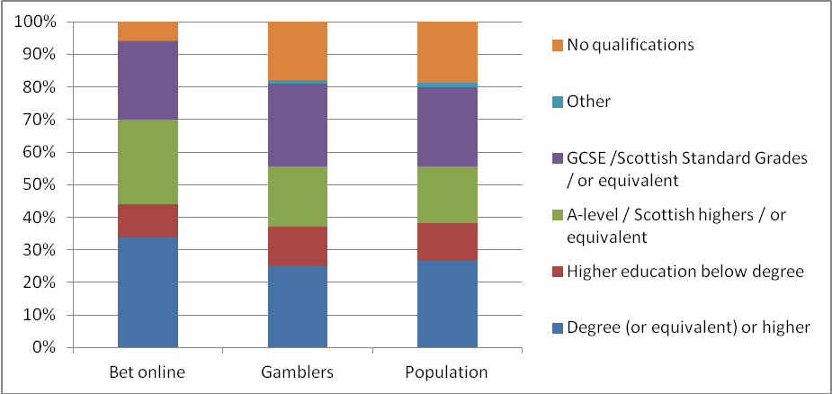

In terms of household income those that bet online were also more likely to be from the top three income quintiles than the general population or the gambling population as a whole:

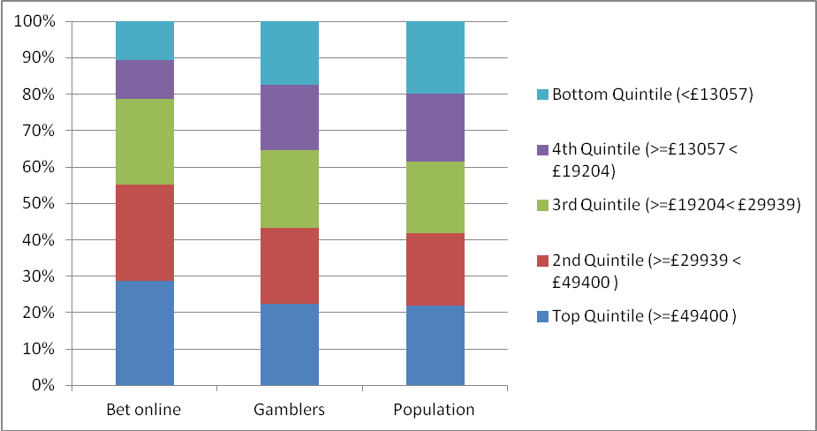

Those that have bet online in the past 12 months also tend to be more engaged in gambling than the gambling population as a whole. Amongst those that had bet online the average number of activities participated in the past 12 months was 5.6, compared to 2.3 for the overall gambling population.

Problem and at-risk gambling

The latest assessment of rates of problem and at-risk gambling in England and Scotland is provided by the Health Survey England and Scottish Health Survey 2012. These surveys formed replacement vehicles for the BGPS assessments of problem and at-risk gambling; employing the same problem gambling screens (PGSI and DSM-IV).

The Health Surveys found that the population prevalence of problem gambling remains low with 0.6% of the population (16+) being classified as problem gamblers according to either screen. Despite these low rates of problem gambling amongst the population there are certain groups which are more likely to be problem gamblers; for example amongst men aged 16-24 2.4% were classified as problem gamblers.

The PGSI screen further categorises respondents into two at-risk categories; low and moderate risk. Overall 3.2% of the population were classified as low-risk (score of 1 or 2) and a further 1% were classified as moderate risk gamblers (score of 3-7). Again young men were more likely to be classified as at-risk gamblers with 24% of this group classified as either low or moderate risk.

Problem gambling rates also varied by activity; ranging from 1.8% of those that had bet on horse races in person to 16% of those that had spread bet. Rates of problem gambling amongst those that bet online were 2.6%; similar to rates amongst those that had played football pools and bingo in-person (both 2.8%). Amongst those that had gambled online rates were 4.8%; similar to rates amongst those that had played casino table games in person (4.7%) and bet on sports events in person (4.5%).

The table below shows rates for all activities for the BGPS 2007 and Health Survey England / Scottish Health Survey 2012. The results appear to show a fall in problem gambling rates amongst those that have gambled or bet online, however care should be taken when interpreting the results due to the change in methodology.

Activity | BGPS 2007 (%) | Combined HSE / SHeS 2012 (%)
National Lottery | 1 | 0.8
Scratchcards | 1.9 | 1.3
Other lottery | 2.1 | 1.4
Football Pools | 3.5 | 2.8
Bingo (not online) | 3.1 | 2.8
Slot Machines | 2.6 | 1.8
Machines in Bookmakers | 11.2 | 5.7
Casino table games (not online) | 5.2 | 4.7
Online gambling on slots, casino or bingo games | 7.4 | 4.8
Online betting with a bookmaker | 6 | 2.6
Betting exchange | 9.8 | 8.8
Horse races (not online) | 1.7 | 1.8
Dog races (not online) | 5.2 | 3.7
Sports events (not online) | 6 | 4.5
Other events (not online) |  | 9.1
Spread betting | 14.7 | 16
Private betting | 2.3 | 1.6
Any other gambling | 6.1 | 8.3
Despite these correlations between problem gambling and individual activities secondary analysis of the data shows that the primary association with problem gambling is number of activities participated in, as shown in the chart below:

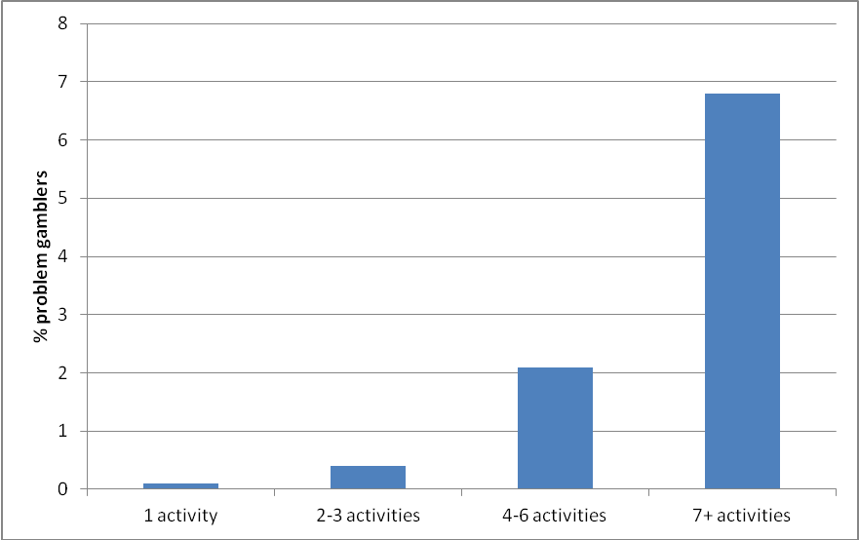

This suggests that restriction of individual gambling activities / activities in certain environments is unlikely to have an overall impact on rates of problem gambling.

Relevant research underway – online tracker survey

In March 2015 the Commission began collecting survey data via an online methodology to explore online gambling behaviour in-depth. The survey consists of 2,000 responses per quarter from an even split of online panel respondents and freshly sourced sample. The questionnaire broadly covers:
- Past four week participation in gambling activities
- How respondents have participated (online / in-person / both)
- Devices used to gamble (PC / laptop / mobile etc)
- Location of gambling (home / work etc)
- Number of accounts held with gambling operators and trajectory of spend
- In-play participation
- PGSI mini-screen
- Social gaming participation.

The survey is conducted on a quarterly basis and the results will be published in February 2016 once a full year of data is available. Subsequent waves will be published on a quarterly basis.

See www.gamblingcommission.gov.uk for further information on the Gambling Commission.
Larger society lotteries are those with annual proceeds of over £20k; smaller society lotteries are licensed by local licensing authorities.
The National Lottery Commission which regulated the National Lottery was merged into the Gambling Commission in October 2013.
The pool monopoly, The Tote, was sold in July 2011 with its monopoly on track-based pool betting in place until July 2018
Gambling software is software that can impact on the fairness of the gambling – see June 2014 note ‘What is gambling software on www.gamblingcommission .gov.uk
The Gambling Act 2005 allowed the Secretary of State to make regulations specifying places which are to be treated as if they were EEA states, known as the “White List”. In respect of remote gambling there were four states on the “White List”: the Isle of Man, Tasmania, the States of Alderney, and Antigua & Barbuda. The new legislation means that the white list was phased out, as operators anywhere in the world were allowed to apply for a Gambling Commission licence.
Section123
Responsible Gambling Trust
The next publication of industry statistics on 26 November will include for the first time data from licensees covering the whole British gambling market, not just those based in Britain and subsequent editions will show the emerging trends.
Estimate by H2GC
The health surveys have a combined sample of 13,106 compared to 7,756 in BGPS 2010.
Gambling participation and prevalence of problem gambling
http://www.gamblingcommission.gov.uk/pdf/Latest-LCCP-and-Extracts/LCCP-sector-summary-for-remote-betting.pdf
http://www.gamblingcommission.gov.uk/Technical-standards.aspx
http://www.gamblingcommission.gov.uk/pdf/Strengthening-social-responsibility-LCCP-responses.pdf
http://www.rgsb.org.uk/ RGSB’s role is to provide independent advice to the Gambling Commission and, via the Gambling Commission, DCMS on the strategy and priorities for research education and treatment.
In-Running Betting Position Paper
2014 Remote Gambling Association report ‘sports betting :commercial and integrity issues’
http://www.gamblingcommission.gov.uk/pdf/SBI-Action-Plan.pdf
One survey in year to September 2014 took place in a period covering the Grand National which explains the spike in horserace betting.
Betting on other events includes betting on politics, television show outcomes etc.
In BGPS 2007 sports events and other events were covered in one ‘other betting in a bookmakers’ category.
The PGSI mini-screen is a short form 3 item version of the full 9 item PGSI screen. The screen was developed to allow a quick assessment of whether someone is likely to be experiencing issues with their gambling and asks three broad questions about financial difficulties related to gambling, worrying / guilt about gambling and others having said the individual may have a problem with their gambling.

