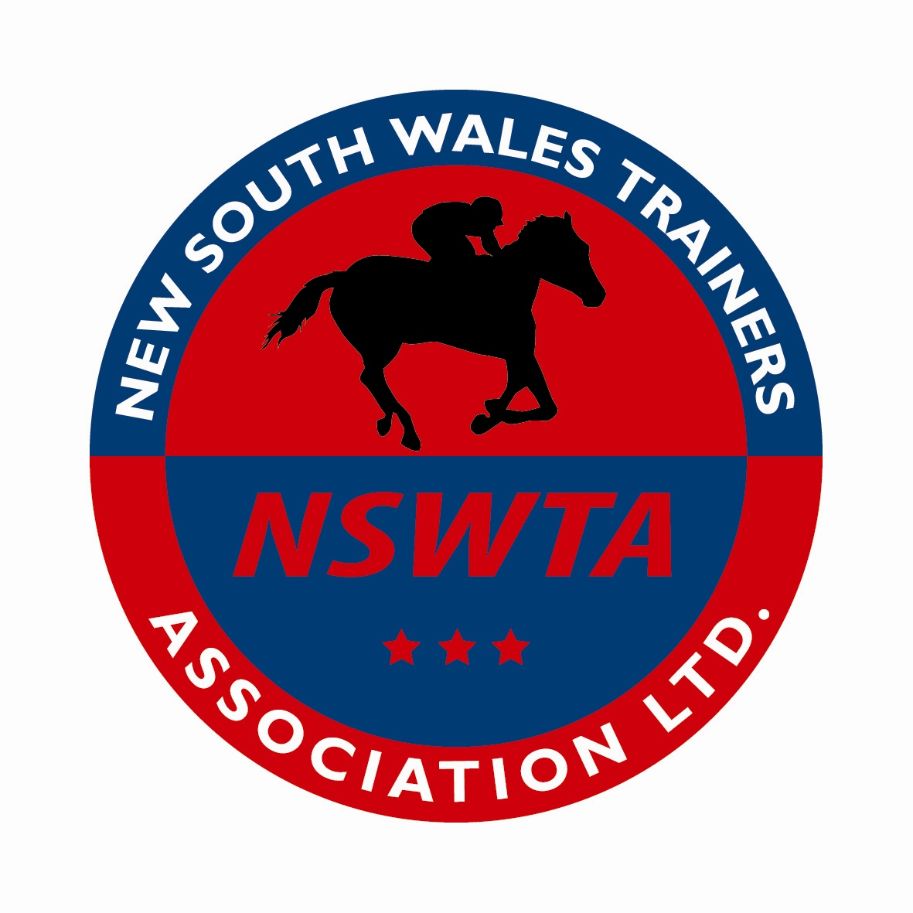
NSWTA – ATC Admin Building – Alison Rd Randwick - www.homeofracing.com.au

13 November 2015

Dear Minister

Thank you for the opportunity to comment on the Federal Government Review of the Interactive Gambling Act (IGA). There are around 1000 Thoroughbred Horse Trainers in NSW who employ thousands of staff across the NSW. We make this submission as it vitally important that the income streams that fund racing are sustainable. Many trainers are already struggling financially, particularly in regional areas, putting thousands of their employee’s jobs at risk. In our view any gambling activity that risks those jobs must be regulated and enforced..

The two main issues the NSWTA would like to see addressed are Industry funding sustainability and integrity.

Research suggests that a growing percentage (we understand around 14%) of bets in Australia are placed with overseas operators not licensed in Australia. This poses not only a threat to the industry revenues that fund jobs in racing as well as the sport’s integrity. Any new threats to integrity are likely to place added pressure on the income to the racing industry presenting an undesirable cycle of decline. These unregulated entities are able to operate with an unfair advantage, posing risks to Australian jobs, unprotected punters and the racing industry as whole.

Live betting' or ' in the run betting' for thoroughbred horse racing poses another threat to the integrity of racing. Jockeys and Trainers are under enough pressure as it is without having to deal with accusations brought about by from 'live in the run betting'. It creates a difficult environment for racing and opens the door for integrity issues which are obviously amplified with live sports that last for much longer than 90 seconds. Furthermore industry research suggests that the racing industry and venues that support it, could lose millions in revenue due to migration. Evidence suggests that betting agencies are likely to emphasise 'live in the run betting' products on sports such as Rugby League, AFL, Soccer etc that run for over an hour, to generate intensified betting. This could result in further losses to the racing industry where each individual race is usually over in less than 2/3 minutes. Therefore 'live in the run betting' provides a further risk for the integrity a racing and a reduction in funds. A double whammy for jobs in racing.

Corporate bookmakers that are flagrantly flouting the law by offering in the run betting products should be charged and prosecuted for defiantly breaking Australian laws. In the USA enforcement would be brutal for such disregard for a country’s laws. Sportingbet (now William Hill) found this when a decade ago its then Chairman was arrested and gaoled when entering the USA for taking bets from US citizens in foreign jurisdictions in contravention of USA Federal gaming laws.

Any new laws in this area need to be enforceable and adequate resources applied toward that enforcement. The NSWTA wants to see any new laws protect the sustainability of Australia’s 5th largest industry as well as enforcing integrity.

Yours sincerely

Steve McMahon
Chief Executive
NSW Trainers Association
Mob: 0452078779
stevemcmahon77@gmail.com
www.homeofracing.com.au

