Prepared by
Megan Butt and Nicole Hitchens
Disability Advocates
Our Mission:
We partner with individuals and organisations to promote independence, strength and wellbeing in our community through support, advocacy and education.
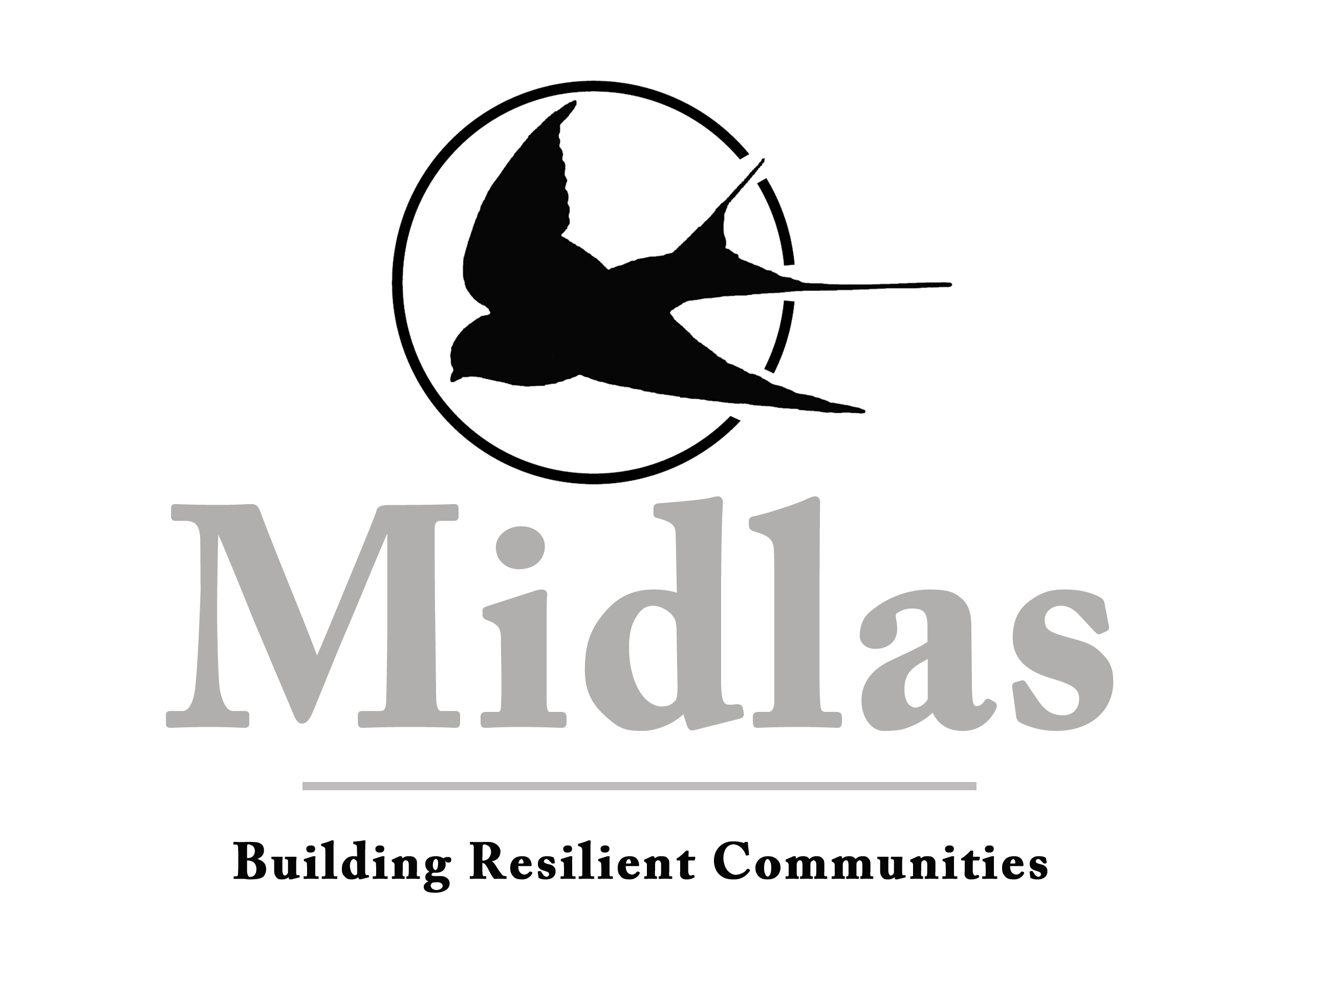
National Disability Advocacy Program Review Submission
2nd June 2016
Response to Discussion Paper
Review of the National Disability Advocacy Program
Midlas Submission
Prepared by
Megan Butt and Nicole Hitchens
Disability Advocates

Introduction
Midland Information Debt and Legal Advocacy Service Inc. (Midlas) is a not-for-profit community organisation based in Midland, Western Australia. Midlas provides individual disability advocacy for people with disabilities living in the City of Swan, Town of Bassendean, Shire of Mundaring and Shire of Kalamunda. We assist clients with disabilities, carers and guardians to ensure they understand their rights and responsibilities and can participate fully in their community.
Midlas assists people with disabilities in relation to accessing disability and mainstream services, providing linkages and referrals, support through the National Disability Insurance Scheme (NDIS) and assistance going through the appeal processes, assisting clients to access income support payments and communicate with Centrelink.
Below is the response to the questions raised in the Discussion Paper.
Models of Advocacy
There are several benefits in providing only one or two models of advocacy within an NDAP organisation. For organisations that are funded for only 1-2 advocacy models there are greater opportunities for clients to receive a more well-rounded and effective service. In addition, staff are able to develop their skills and experience in delivering those models of advocacy. It can allow for the establishment of effective referral networks when the need for another form of advocacy is identified that the service does not provide. This would increase the awareness and understanding of the different advocacy agencies within the region that can support clients most appropriately.
People with disabilities may benefit from engaging with smaller style, community based organisations who provide only 1-2 models of advocacy. For many people with disabilities, accessing larger organisations can feel overwhelming (be a barrier) and may lead to them not accessing any advocacy support at all. Given that referrals would be made if/when other models of advocacy are required, casefiles can be shorter and more targeted in their support. Casefiles can have a clear direction with actions to be taken by the particular agency under their corresponding model of advocacy. This may allow for a higher number of clients to receive quality advocacy and support.
Organisations that provide services in addition to disability advocacy, such as financial counselling and tenancy advocacy, may be able to receive support from Disability Advocates when required. Often it is more appropriate for a person with a disability to be linked with another service within the organisation due to the area of expertise or assistance required. NDAP organisations delivering more than 2 advocacy models as part of their service may not have the time or resources to allow for holistic service delivery. For example, a person with a disability may need to link with a financial counsellor due to the need to build financial literacy in the area of budgeting. However, the financial counsellor or client may benefit from the involvement with a Disability Advocate to provide a more comprehensive, well rounded service to ensure that the information and options provided have been understood.
The purpose of providing advocacy is to improve the lives of people with disabilities. Providing multiple models of advocacy support under one organisation may create issues for the client with a disability in achieving their goals. The purpose of the different advocacy models may in fact directly or indirectly support other parties. For example if a person with a disability has an unpaid carer – both of whom access the service for support through individual and family advocacy – there may be a conflict in what each party is requesting as a resolution to the same issue. For example, a person with a disability who has difficulty managing their finances may want support in setting up payment plans, whereas the family may want to investigate Public Trustee/income management options. Although it is important to recognise and support the informal networks that people with disabilities have, that individual may not want their family, carer or other parties to be involved. The provision of multiple advocacy models within one service may impact on an individual with a disabilities’ ability to express themselves appropriately without fear of judgment and to ensure that their rights are supported – including the right to dignity of risk.
The drawbacks of not providing all types of advocacy may mean, particularly in rural and remote areas, access to all models of advocacy is limited if there is only one organisation available. A person with a disability may need to access more than one provider to ensure that they receive the appropriate advocacy support to address their issues. Having to link with multiple providers in order to get individual needs met, may lead to people with disabilities not engaging with advocacy services at all. If a person is engaging with more than one advocacy provider, it does run the risk of ‘doubling-up’ in service and having an impact on the success of that advocacy support. Larger organisations may have the ability to see a higher number of clients with disabilities and if delivering multiple advocacy models, could assist with more complex and intensive issues. Organisations providing more than 1 model of advocacy may require staff who are more experienced or may require upskilling to ensure quality services continue to be delivered.
If it is determined that the best way forward for advocacy organisations to continue to support people with disabilities is to deliver multiple advocacy models, additional support and training will be required to ensure the successful transition to this delivery model.
Improving access to advocacy supports
Consideration needs to occur to as to how to promote the benefits of independent advocacy and address the barriers to accessing advocacy for people with disabilities who may experience further disadvantage due to geographical distance, social isolation, communication difficulties and lack of culturally appropriate information. Engaging with Aboriginal and Torres Strait Islander, CaLD community and outreach organisations could be a way of working collaboratively with existing services. Informal advocacy often occurs naturally through these organisations so it may be more effective to establish partnerships with those organisations to deliver advocacy support. The idea of an outreach ‘hub’ service may be a way of improving access to advocacy supports as people linked with an Aboriginal or CaLD service, may feel more comfortable opening up in an environment in which they feel supported and safe.
For people with disabilities who live in rural, regional and remote locations, the ability to access advocacy can be restrictive due to geographical location. When appropriate, further use of technology like Skype, email and telephone can be a way of overcoming this barrier. As any type of travel does incur a cost either to the individual or to an organisation, this needs to be factored in to funding provision. Despite the benefits of using technology as a means of engaging people with disability, this may not always be appropriate and is dependent on the ability of the person, the availability of the technology and the operational costs that a person may incur. The use of technology should not substitute the importance of face-to-face interactions with an Advocate.
People with disabilities would benefit from the development of targeted resources and information highlighting the potential benefits of advocacy and where to access services. Information should be available in a wide range of formats including Easy English and written in languages other than English. There should be consideration to include some support to fund translating services. These services can be costly to organisations – particularly if the advocacy support is more long term in nature – but are integral in enhancing access for both people for whom English is not their first language and people who are blind or vision impaired. It would also be important to provide support for NDAP organisations in writing Easy English documents to assist in alleviating this barrier for people with communication/reading difficulties.
The development of the NDAP Provider Finder available through the Department of Social Services website is an online tool which people can use to locate advocacy services within a specific area/advocacy model. This could be a good starting point for someone who is not aware of advocacy services within their area or assisting someone in referral to a provider. Unfortunately at present the information on this website does not always seem to be accurate or updated regularly and searches often result in inappropriate agencies being recommended. An example of this is Midlas contact information which has not been updated despite numerous attempts by the agency to rectify this with DSS.
Often NDAP organisations who are funded for 1 model of advocacy will naturally be providing other models of advocacy – even though they have no funding attached to this. For example, an Advocate that is funded for individual advocacy may be asked to assist a child with a disability. Due to that child’s age and/or level of capability/capacity, most of the support is facilitated through communication and meetings between the Advocate and the parent/guardian. The parent may express issues relating to their ability to continue in their caring role. An Advocate may work with that parent to link them with a support group or a peak agency like Carers WA which crosses over into family advocacy. This example highlights the varied and often underutilised role of a Disability Advocate when only funded under 1 advocacy model. Individual advocacy can transition into self-advocacy support once that person with a disability has developed the skills needed to be able to express themselves. The capacity for a person with a disability to self-advocate may be on a continuum - where at times, the client needs individual advocacy support even when they are strong in their own ability to self-advocate.
This ‘flexible approach’ utilising different advocacy models has been beneficial when assisting participants and families through the NDIS appeals process. Midlas are funded to provide NDAP services and independent advocacy support through External Merits Review (EMR) funding. Advocates have been able to support clients through the Internal Review which is the first stage of reviewing a decision made by the National Disability Insurance Agency (NDIA). As many of the clients we support are children with disabilities, most of the communication occurs with the main parent/carer. Moral support is often a large component of the assistance needed when appealing an NDIS decision as parents and carers can already be quite stressed. It has been invaluable to be able to continue to support those participants and carers through the 2 types of NDIS appeals – Internal Review and EMRs. As the Advocate who provided the support during the Internal Review process carried on through the EMR, this ensured that the process was not affected by having to conduct a hand over to another organisation and place additional stress on the family who have to build trust with yet another person and organisation.
Improving the advocacy evidence base and coordination on systemic issues
The reporting of systemic issues is crucial to addressing the current challenges for people with disabilities and investigating ways of reducing the need for advocacy support. Although NDAP organisations who are not funded for systemic advocacy regularly feedback information in relation to current patterns, trends and challenges, clearer information on the larger stakeholders involved and how to report needs to be explored.
The potential for twice yearly NDAP meetings needs to be explored to give the opportunity for NDAP organisations to report on issues to relevant systemic bodies as well as opportunity to “share notes” on issues brought to the attention by each agency to see if there are any patterns emerging that may be need to be addressed systemically. This would provide an easier way of capturing information in addition to the standard reporting requirements as per funding agreements. It would be useful for NDAP agencies who are not funded for systemic advocacy, to be kept updated with current projects and submissions so there is greater opportunities to collaborate with larger disability bodies and provide meaningful data and case studies. It is crucial for the appropriate strategies and mechanisms to be developed to enable information to be de-identified and shared easily without breaching client confidentiality. It needs to be noted that if systemic advocacy is not supported and funded appropriately, that any recommendations made regarding expanding and coordinating the evidence base will be redundant.
The interface with the NDIS and addressing conflict of interest
It should be transparent to a person with a disability the difference between NDIS support and advocacy support. An NDAP organisation who has decided to register as a provider as well as delivering advocacy support needs to establish clear strategies to address potential conflicts of interest. It is expected that organisations who choose to register with NDIA have policies and procedures on handling/avoiding this conflict and are required to complete regular reporting to the NDIA to ensure that these safeguards remain in place. In addition, the need for a Service Agreement between the participant and the NDAP/registered organisation should clearly highlight the safeguards that are to be implemented and available to that client and options regarding alternate advocacy support if/when it is needed.
There should be consideration as to how an organisation will deliver NDIS registered services and advocacy to a client. It may not be appropriate for the same Advocate to also be assisting a client with support coordination. It has been identified that advocacy should remain independent to NDIS - meaning that any person with a disability, regardless of NDIS funding, can access services. A staff member delivering NDAP advocacy and NDIS services to a single client may blur these two distinctive roles and impact on the eventual outcomes for the person with a disability. Office space and proximity to other staff members should be taken into account when addressing this conflict of interest. This may also have an impact when going through the appeals process with a participant. If an Advocate delivers a registered NDIS support and the client then requests a review in relation to their NDIS plan, assisting that client through an appeal may be considered to be a conflict by the NDIA.
Organisations who provide other services in addition to advocacy may pose risks as well. For example an organisation who has Tenancy Advocacy may register for support under the Improved Living Arrangement (0008) budget. This would allow for assistance with understanding accommodation and tenancy obligations. That client could also wish to engage with an Advocate to support them in understanding the information provided or assist them with expressing themselves. If a Disability Advocate was sourced from within the same organisation, there may be issues with trying to remain independent. It is recommended that the client is always provided with options to engage with other Disability Advocacy organisations situated within the same area if they wish and that this is documented.
Understanding and improving access to Justice
People with disabilities continue to experience barriers to accessing the justice system. These barriers can include cost, resources and time, the availability of legal aid funding and pro bono assistance, wait lists, understanding and navigating the system, rights and communication. Many of the clients who seek support from disability advocates are wishing to review their guardianship and administration orders. Advocates can provide this support but are limited in their capacity/knowledge and understanding of the laws encompassing these orders as they are not lawyers. Often more time is required to ensure that the Advocate has a solid grasp on the relevant Acts and the processes for reviewing these orders. For Western Australia there is only one organisation (Sussex Street) who are funded to provide free information and advice to people who feel that they have been discriminated against because of their disability. For people with disabilities who do not fall within this scope, there are less opportunities to obtain legal advice, both in the short and long term. If an NDAP organisation is operating within a Community Legal Centre there is potential to access legal assistance but again there is eligibility criteria that must be met (e.g. services only for domestic violence and violence restraining orders).
As the National Disability Insurance Scheme (NDIS) is set to expand in January 2017 to additional areas within Western Australia, further consideration regarding the availability of Central Assessment Provider (CAP) funding needs to occur. For participants who are going through an External Merits Review there is the option to be linked with a CAP provider if the case is deemed complex and/or novel. This allows the inherent power balance to be reduced as both parties – NDIA and participant - will then have legal representation. Once this funding is restricted due to wider roll out of NDIS in Australia, it is expected that there will be fewer opportunities to link with legal assistance. An understanding of the underpinning NDIS legislation (Act, Operational Guidelines and Rules) is crucial when going through an EMR. As Advocates are not lawyers and do not necessarily have legal aptitude, it can be difficult at times to interpret this legislation without additional time to prepare and a power imbalance is then apparent.

