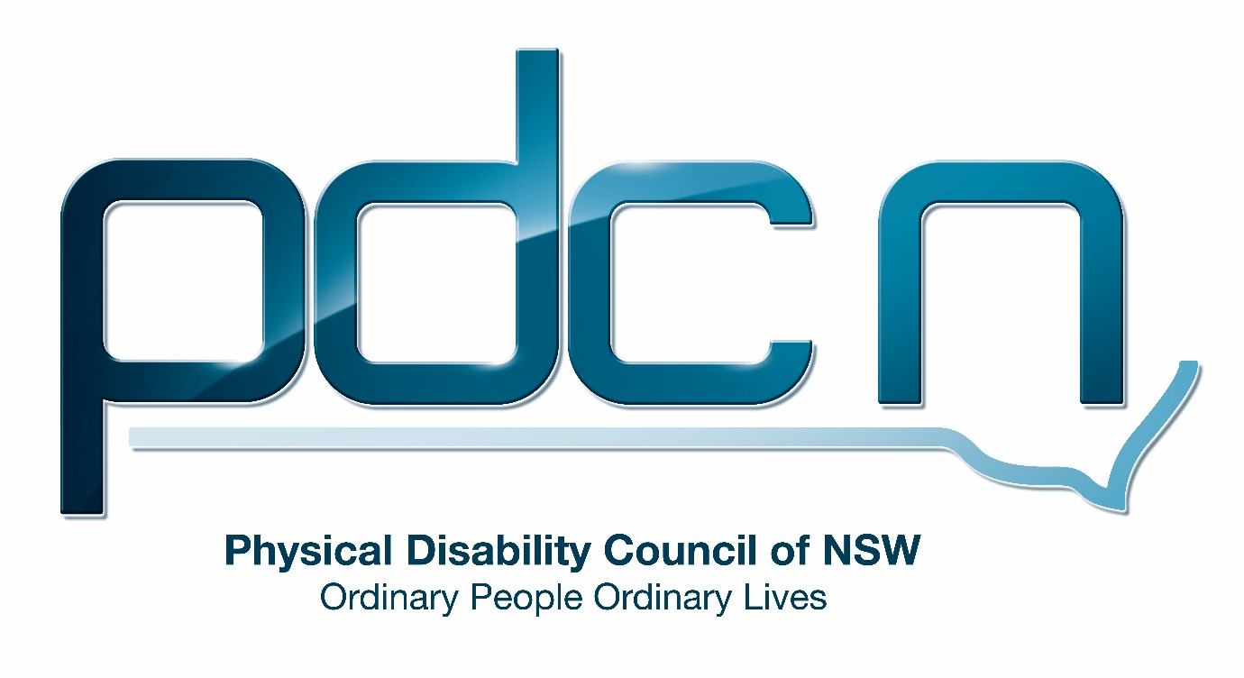

Submission to the Department of Social Services

Review of the National Disability Advocacy Program

21 June 2016

Serena Ovens, Executive Officer

Physical Disability Council of NSW
3/184 Glebe Point Road, Glebe NSW 2037

02 9552 1606
www.pdcnsw.org.au
serena.ovens@pdcnsw.org.au

Who is the Physical Disability Council of NSW?
The Physical Disability Council of NSW (PDCN) is the peak body representing people with physical disabilities across New South Wales. This includes people with a range of physical disability issues, from young children and their representatives to aged people, who are from a wide range of socio-economic circumstances and live in metropolitan, rural and regional areas of NSW.

Our core function to is influence and advocate for the achievement of systemic change to ensure the rights of all people with a physical disability are improved and upheld.

The objectives of PDCN are:

• To educate, inform and assist people with physical disabilities in NSW about the range of services, structure and programs available that enable their full participation, equality of opportunity and equality of citizenship
• To develop the capacity of people with physical disability in NSW to identify their own goals, and the confidence to develop a pathway to achieving their goals (ie: self-advocate).
• To educate and inform stakeholders (ie: about the needs of people with a physical disability) so they are able to achieve and maintain full participation, equality of opportunity and equality of citizenship.

Introduction:
The Physical Disability Council of NSW (PDCN) appreciates the opportunity to comment on the review of the National Disability Advocacy Program (NDAP).

PDCN is heartened to see that the Commonwealth Government has affirmed its commitment to continuing to have an effective NDAP program. However, with the current and expected further changes to advocacy program funding across most States and Territories, it is increasingly likely that the NDAP program will become the only program funding some types advocacy throughout Australia. To this end PDCN would wish to ensure that the NDAP program is responsive to this increased need, and NDAP funding is increased in accordance to the additional need, whilst also providing a consistent and equitable funding model across all Australia.

PDCN would also recommend that the NDAP program places emphasis on remaining a program that provides a strong and independent advocacy sector, free from conflict of interest, and increases its ability to provide people with access to effective disability advocacy that focusses on promoting and protecting their full and equal access to all human rights, citizenship and community participation.

It should be noted that in responding to the NDAP review, it would have been helpful to have had access to the finalised review of the updated National Disability Advocacy Framework.

Models of Advocacy and improving the evidence base and coordination on systemic issues
PDCN agrees with some of the comments in the NDAP review that advocacy supports should be available to all people in all locations, and focus on the human rights of the individual, however we do not believe that the only way to do this is to have advocacy bodies that provide all forms of advocacy, and that in reality this is very unlikely to be achieved.

Far better would be to acknowledge the expertise required in the varying areas of advocacy specialisation, and to fund a program where NDAP contracts are flexibly drafted to allow organisations to be responsive to need, and build in the ability to work in partnerships and refer to other organisations as appropriate to meet this need.

In addition, ensuring that all NDAP funded advocacy bodies are involved in collaboration, information sharing and reporting issues, would allow for systemic issues and trends to be highlighted and provide opportunities for these to be systemically addressed. It should be noted that most systemic issues would need to be managed by State based systemic advocacy organisations, whom have local understanding - as laws and government policy are on the whole specific to each State and Territory, and some may in fact be specific to a particular type of disability, requiring a systemic body that is familiar with the individual cohort.

One way to improve coordination of information and the funded NDAP organisations as a whole would be to fund a National Advocacy Peak Body (such as Disability Advocacy Network Australia - DANA) whose roll it could be to oversee the collection of advocacy data, research trends and identify gaps, provide the professional development of the NDAP (and broader) advocacy sector organisations, build strategy and protocols such as a National Advocacy Code of Practice, to continually strengthen the work and worth of the sector.

The discussion paper recommends in its vision that a reformed NDAP is one that ‘includes a data collection system that contributes to the evidence base and provides information on systemic issues to policy makers.’ The inclusion of a key performance indicator for NDAP funded organisations requiring the use of this tool and to report trends, issues and gaps identified within their advocacy work is key to ensuring this evidence base is attained and able to be actioned.

Recommendation 1:
The NDAP continues to fund the varying different types of advocacy (especially those not funded under the NDIS) and not assume a ‘one type fits all’ approach

Recommendation 2:
That NDAP contracts allow for flexible delivery, ensuring advocacy bodies be responsive to need, and not fully constrained by specific deliverables

Recommendation 3:
That NDAP contracts include key performance indicators ensuring the use of data collection tools, and information sharing btw advocacy organisations themselves, and an oversight body

Recommendation 4:
The NDAP fund an oversight body (such as DANA) to provide national support, professional development opportunities, and oversee the collation of data, trends and gaps in the NDAP program, ensuring systemic issues are identified, and can be forwarded to the appropriate systemic organisation for address.

Improving access to advocacy supports
Advocacy is important for all disability cohorts, be they indigenous, culturally and linguistically diverse (CALD), those in rural, regional and remote areas, have high communication needs, or be socially isolated.

It is important that the NDAP program recognises the additional time and cost that advocacy for these cohorts may require, such as where time is needed to develop trust in indigenous and CALD communities, or where interpreters are required to support language needs, and in rural locations, where the additional travel and time to reach individuals is significant.

The NDAP program must fund the organisations that support these groups accordingly, ensuring that the quality of work they do is not decreased due to the increased operational costs involved in providing their advocacy services.

For the socially isolated and those institutionalised again there may be significant additional work required to begin the development of an understanding of their rights, and the concepts of ‘having a voice, choice and control over their lives’.

Some advocacy organisations may need to be funded specifically to go out and find these people and begin the process of engaging with them to begin the journey to be fully inclusive members of community.

Strategies that ensure the advocacy needs of these groups are met include the training of advocates on cultural competency, partnering with local organisations whom have relationships into these communities, and the acknowledgement of face to face work as the most likely to achieve success with these cohorts.

The preparation of materials in various languages, easy English, Auslan, and audio, and the need for interpreters, including language based, AUSLAN, and hand over sign for deaf/blind will also ensure better outcomes for these groups.

Recommendation 5:
The NDAP program ensures appropriate additional levels of funding to cover the specific needs of indigenous, CALD, socially isolated, institutionalised and other high needs cohorts ensuring advocacy support is available and not restricted due to the additional time/cost in meeting the needs of these cohorts.

The National Disability Insurance Scheme (NDIS) and addressing conflict of interest
The implementation of the NDIS throughout Australia is an initiative of which PDCN wholly welcomes and supports. However, the move to providing individuals with the ability to have full choice and control over their lives is very likely to bring about an increased need for advocacy, as individuals endeavour to link with mainstream community and a competitive service provision market, and in doing so experience barriers to achieving their full participation in community.
In addition is must be noted that the NDAP provides advocacy to a much broader range of people than those that will fall under the NDIS scheme as funded individuals, and must still support those over the age of 65, those whom do not qualify for the NDIS, and as mentioned above, those whom do qualify but in working towards achieving their goals, experience issues for which they will need an advocate to assist them to resolve.
To this end it is important that the NDAP program funding occurs via select tender, open to only those organisations that are experienced, independent disability advocacy organisations.
Where an NDAP funded advocacy organisation chooses to also work as a service provider under the NDIS (for plan management and decision making supports) it would be important to ensure that the organisation has clear policies on managing conflict of interest, though it should be noted that advocacy services have a deep knowledge of conflict of interest, as this is in fact what we manage in undertaking most of our advocacy work.
As individuals are provided with funding to gain access to ‘advocacy like activities’ within their funded packages, it would be inappropriate to disallow NDAP advocacy organisations, especially those providing individual advocacy, to be registered as service providers – however there would need to be clear financial processes showing the division of funds spent on NDAP activities, as opposed to those provided through NDIS funding. In addition, it would be appropriate for these organisations to clearly show a policy/process for redress to another independent organisation or body (such as the Disability Ombudsman) should an NDIS client for whom they are advocating be unhappy with their advocacy provision.
PDCN would argue that traditional service providers (providing care/rs, activity programs, oversight of homes, etc) should not be eligible for NDAP funding, and should in fact be providing informal advocacy as part of their service delivery aims, to continually monitor and improve their services. It is unlikely these providers could offer advocacy to a client when it is their own service provision that is in question, without their being a significant conflict of interest.
The NDIS’s Quality and Safeguards framework, and ILC framework will also address some of the necessities that organisations would need to put in place to ensure no conflict of interest, however at this point in time both frameworks are in finalisation and cannot be commented on in this submission.
In NSW, the Government has committed to giving the Commonwealth all of the funds it currently directs to disability, including the funds for all types of advocacy, information and representation, (approximately $10 million per annum) to support the implementation of the NDIS. The NDIS has also clearly stated that ‘systemic advocacy, legal review and representation will be funded outside of the NDIS’
This loss of funding, and subsequent non-inclusion of advocacy within the NDIS will inevitably lead to gaps in supports for people with disability, especially those who fall outside of the scheme.
It is imperative that the NDAP recognises these gaps, and ensures that in NSW, and any other State/Territory where this may also have occurred, it increases its funding to meet this unmet need.
Recommendation 6:
That a select tender process is used for the allocation of NDAP funding, ensuring only experienced independent advocacy organisations are eligible for NDAP funding

Recommendation 7:
That clear policies, complaints mechanisms and financial accountability systems are in place where an NDAP funded organisation chooses to also be an NDIS service provider

Recommendation 8:
An increase in NDAP funding is ensured to recognise both the increased demand for advocacy under the NDIS and cover the reduced levels of funding for advocacy in NSW to ensure no greater gaps in supports occur for people with disability

Understanding and improving access to justice
As the NDAP discussion paper notes, people with disabilities are over represented in the criminal justice system and often experience barriers to justice. At present the NDAP acknowledges that only 5 organisations are funded for legal advocacy, and all of those reside in Victoria.
PDCN would suggest that numerous organisations in each State and Territory should be funded to support legal advocacy provision, and that this not just court based legal advocacy (which would by necessity need to be carried out by legal practitioners,) but also advocacy organisations that support people through the whole legal process, such as police interviews and court ordered interventions.
Additionally, independent advocacy should be available for appealing decisions of the NDIS, where plans are inappropriately funded, and through external merits reviews.
Most effective would be a range of advocacy services whom could work with people with disability at all levels of the judicial system, some of which would need to be professionally qualified legal practitioners, others advocates (such as the IDRS in NSW) whom could work with an individual throughout the initial stages of proceedings where different levels of support and expertise are required.
Recommendation 9:
NDAP funding ensures there are various advocacy organisations with differing expertise are funded across all States and Territories

Summary of recommendations

- The NDAP funds a range of different types of advocacy in all states and territories

- NDAP contracts allow for flexible delivery, and have performance requirements for data collection and information sharing

- The NDAP fund an oversight body for the systemic collection & collation of data, ensuring systemic issues are identified & addressed; and assists in professional development and the maintenance of a National Advocacy Code of Practice

- The NDAP program ensures appropriate additional levels of funding to cover the specific needs of indigenous, CALD, socially isolated, institutionalised and other high needs cohorts

- A select tender process is used for the allocation of NDAP funding, targeted at experienced independent advocacy organisations only

- Clear policies, complaints mechanisms and financial accountability systems are in place where an NDAP funded organisation chooses to also be an NDIS service provider

- NDAP funding is increased to respond to increased demand for advocacy under the NDIS and cover gaps in advocacy provision where State funds for advocacy programs have been hand back to the Commonwealth.

- Representation of State advocacy organisations not currently funded by NDAP, but likely to be able to tender in the new NDAP be part of the targeted stakeholder workshops to be undertaken as part of this review.

Review of the National Disability Advocacy Program Discussion paper, 2016, p3
NDIA information, Linkages and Capacity Building Framework Commissioning Draft 2015, p16

