Delivering an integrated carer support service

A draft model for the delivery of carer support services

© Commonwealth of Australia 2016
Department of Social Services
Tuggeranong, Canberra ACT
With the exception of the Commonwealth Coat of Arms, all material presented under a Creative Commons Attribution 3.0 Australia licence (www.creativecommons.org/licenses/by/3.0/au).
The details of the relevant licence conditions are available on the Creative Commons website (accessible using the links provided).
This document must be attributed as:
Department of Social Services. 2016. Delivering an integrated carer support service: A draft model for the delivery of carer support services, Australian Government, Canberra.
Contents

1 Introduction 4
2 Overview of the draft service delivery model 7
Objectives 7
Structure of the Service 8
An overview of future services 11
3 Program Overview 12
An overview of the future programs 14
4 Detailed Service Descriptions 15
Defining the services 15
1. Awareness and Community Linkages 16
2. Information and advice 17
3. Peer support 18
4. Education and Training 19
5. Counselling 20
6. Needs Assessment and Planning 21
7. Coaching and mentoring 22
8. Respite – short-term and emergency 23
9. Targeted financial support 24
5 About how carers might experience the model 25
An overview of how carers could experience the service 26
6 Implementing a new model 27
7 Next Steps 29
8 Frequently Asked Questions 29
ANNEX A: Draft service delivery model (accessible version) 34
ANNEX B: Program overview (accessible version) 36
ANNEX C: Carer experience (accessible version) 38
GLOSSARY 39
WORKS CITED 40

1 Introduction

Background
In recognition of the need to support and sustain the vital work of unpaid carers, the Australian Government committed $33.7 million over four years to design an Integrated Plan for Carer Support Services (the Plan). The Plan is being developed to reflect the Australian Government’s priorities for carers, and outlines actions to improve access to information and services specifically for carers.
The Plan has two key stages. The first stage was the design and implementation of Carer Gateway.
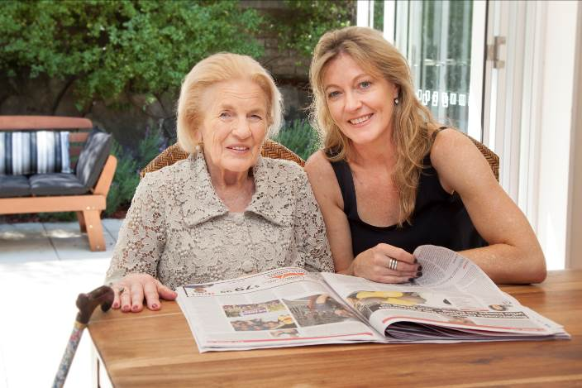
Carer Gateway launched in December 2015, and established a website (www.carergateway.gov.au) and national contact centre, dedicated to the delivery of carer-specific information. Its purpose is to provide a recognisable source of clear, consistent and reliable information to help carers navigate the system of support and services.
The second stage of the Plan is to work with the sector to design an integrated system of carer-specific supports and services that could better support carers in the future.
The Plan is intended to complement the significant investment made in the reforms in other sectors, including aged care and disability, aimed at providing better support for many Australians.
This document, through definition of a service delivery model, presents a vision for a future carer support system.
The draft service delivery model (the model) defined in this document is not final. This draft version of the model is intended to generate discussion and capture feedback on the most effective and efficient way of delivering supports in a future system.
This document should be read in conjunction with the Draft Service Concept that was released for public consultation in May 2016.
The Draft Service Concept is available on the Department of Social Services’ public consultation platform, DSS Engage, at www.engage.dss.gov.au.
A response to the feedback received through that process is available at https://www.dss.gov.au/disability-and-carers/programmes-services/for-carers/integrated-plan-for-carer-support-services.

About this document
Through the public consultation process on the Draft Service Concept, there was feedback regarding the suitability of the document for different audiences. There was support for the level of detail provided in the document, however feedback also identified opportunities to improve the readability of future documents.
In response to that feedback, this document has been structured differently. It contains sections targeted at the interests of the different audiences likely to read the document:
- service providers, peak body organisations and other associations will likely be interested in reading about:
  - the services delivered at different levels (Sections 2 and 4); and
  - the proposed program structure (Section 3);
- carers may wish to focus on:
  - the supports and services available (Section 5) in the future and how they would go about accessing these supports and services.
All readers will be interested in:
- potential implementation of the model (Section 6);
- what the next steps (Section 7) will be for this model; or
- more detail provided about the model in a set of Frequently Asked Questions (Section 8).
Each section is also accompanied by a diagram, with an explanation of what is proposed as part of the model.

How has this document been developed?
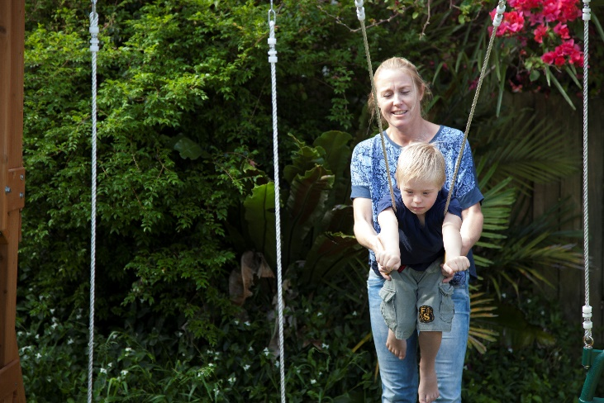
To inform the design of the future system, the Department of Social Services (DSS) is working with carers, service providers, peak bodies and individuals with carer-specific expertise in a process of co-design.
This has been undertaken in two phases; the definition of the current arrangements by which carers access support; and the design of the future carer support service system.
In order to design an effective and sustainable system, it is necessary to understand how carers access and receive support and services today.
DSS has undertaken a number of research activities to support this understanding.
- An environmental analysis (Current State Report) to identify the organisations currently supporting carers and understand their processes, types of staff and technology.
- Market research (Carer Service Development Research) to understand the needs of carers in relation to a carer information and support service.
- An analysis of meta-reviews of the international evidence on the effectiveness of supports in achieving good outcomes for carers.
- An analysis of international evidence on the effectiveness of these supports when delivered through different means, such as telephone, face-to-face and online channels.
- Engagement with organisations currently delivering supports and services similar to those identified in the Draft Service Concept.
- Targeted interviews with carers in different circumstances to understand their caring journey and how they felt at different stages of their journey.
The first three activities were used to develop the Draft Service Concept, which identified the high level services aimed at providing improved outcomes for carers.
The last three research activities have been undertaken, throughout June to August 2016, to inform thinking about how the services outlined in the Draft Service Concept could best be delivered.

2 Overview of the draft service delivery model

Objectives
The role of the integrated carer support service would be to:
- proactively support carers earlier, and build their capacity to sustain their caring role;
- provide support where carers are in, or at risk of a crisis, which might adversely affect their caring role;
- provide support for carers to improve their long term social and financial outcomes; and
- support carers to participate in everyday activities such as education and the workforce.
The Draft Service Concept identified a range of services which have been shown to be effective in supporting carers. While some of these services are delivered today, they are not consistently available and carers are often not accessing those services until either part way into their caring journey or when a crisis or emergency has occurred.
The model seeks to help carers to access and receive support earlier in their caring journey and on a more proactive basis. Consequently, the model has been designed with four primary objectives in mind:
- to encourage and normalise uptake of services proven to help carers, earlier in their caring journey;
- to help and support more carers, than under current arrangements;
- to deliver a service carers will value; and
- to provide a service carers find easy to access and use.
The table below describes these objectives and how they will be achieved.
Objective | Mechanism
Encourage and normalise earlier uptake of services proven to help carers, in their caring journey | - Raising awareness in the broader community including, the primary health sector, schools, community and cultural groups and organisations.  - Linking carers to support when they come into contact with other parts of the aged care, community care, disability, social services and health systems (e.g. My Aged Care, Centrelink).
Help more carers | - Introduce online channels for service delivery to make services more accessible at a time and place of carers choosing.  - Maximise the amount of funding which goes towards services for carers by ensuring efficiency in operational and administrative costs.  - Making sure that access channels preferred by particular carers are available and the benefits promoted.
Deliver a service carers  will value | - Delivering an information and support service which carers trust and includes knowledge of national, regional and local supports.  - Provide opportunities to include carers and those with a lived experience in the delivery.
Provide a service carers find easy to access and use | - Encourage carers to access supports by ensuring:  - Supports can be accessed in as few steps as possible; and  - Providing multiple ways for carers to engage with the service (no wrong door) based on their preferences.

Structure of the Service
This model proposes three levels of service delivery: national, regional and local.
- At a national level, it is envisioned that some services, such as phone and online counselling, will be delivered centrally, and the system as a whole will be supported by national infrastructure.
- At a regional level, it is envisioned that regional hubs will deliver services for carers, including preventative and emergency supports.
- At a local level, local service providers would be contracted to deliver services, as coordinated by regional hubs.

The Role of Regional Hubs
The model proposes a key role for regional hubs in promoting services and assisting carers to access, and engage with, support services. In order to achieve this, regional hubs would need to:
- have a deep understanding of the services available for carers in their areas of responsibility through service mapping;
- forecast demand for the services to be delivered, using data about the carer population in their region;
- analyse and understand gaps in service delivery, within their region; and
- identify and target high risk cohorts of carers in their region.
In particular, regional hubs would play a pivotal role in encouraging carers to seek support and services earlier in their caring journey. Many carers do not identify themselves as carers, they think of themselves as family or friends. As a result, they may not receive the support they could benefit from until they have reached a crisis or emergency. It is often those around them who identify individuals as being a carer, such as doctors, nurses, social workers, teachers and others in the general community.
Raising awareness and building partnerships in the community is key to reaching carers earlier in their journey and providing support before a crisis occurs. Regional hubs would play an important role in this by establishing and maintaining relationships with other providers and community groups within their region. This would ensure that carers are being appropriately linked in from other services and organisations in the community, as well as ensuring that regional hubs are able to refer carers appropriately to supports that will benefit them and their circumstances. Regional hubs would therefore need to:
- build relationships with local cultural and community groups to raise awareness for carers in different cohorts;
- build relationships with social, health, education and law enforcement organisations to promote awareness and value of carers in our communities;
- build relationships with respite providers in their area, which may result in easier negotiation of respite places (particularly in residential aged care settings);
- provide oversight to carer coaches, working at a local level; and
- establish and support peer support groups at a local level.
The regional hubs would also be responsible for undertaking needs and eligibility assessments to coordinate access to respite and targeted financial support.

The Role of National Services
Consultations carried out to date have identified that there are opportunities to:
- improve uptake of some services through exposure and awareness raising at a national level; and
- better support service delivery through nationally provided infrastructure and resources.
Many of the services available at a national level would be accessed on a self-service, on demand basis. Carers would be able to seek information through a national website or engage with other carers in online discussions. Delivering services through national platforms enables improved access to supports for large numbers of people. It also provides a way for carers to seek preliminary support, before deciding whether to seek more intensive supports.

Local Service Delivery
Access to support in carers’ local areas will be facilitated through the regional hubs. The use of regionally coordinated services, which can be delivered locally, brings economies of scale and enables more funding to be spent on actual services for carers.
Supports such as emergency and short term respite would leverage existing community care relationships and infrastructure. Many of these services are funded through the larger service systems (e.g. aged care and disability systems) and will be important to utilise, rather than duplicate such infrastructure. Funding, coordinated by regional hubs, would support carers to access these services.
Carers would also be able to access coaching and mentoring in their local area, through a locally based workforce. Similarly, peer support activities and groups would be accessed in their local area.
Targeted education programs, delivered by carer support staff at regional hubs, would also be delivered locally. This would be in addition to the many programs run by organisations funded through other Government programs.

Linking to Other Funded and Non-Funded Carer Support Services
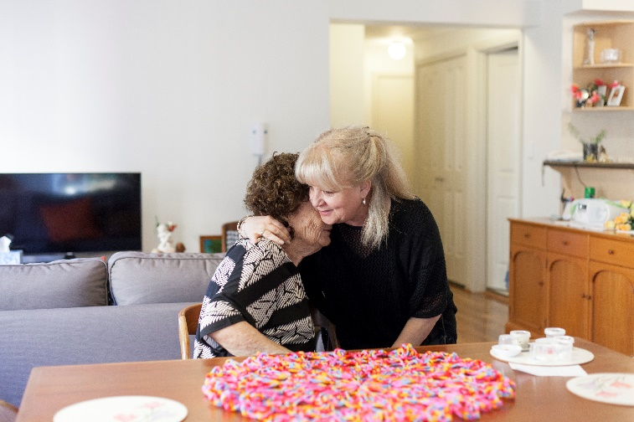
Many organisations funded through programs outside of DSS, deliver carer support services.
It is important to recognise that these services play a valuable role in supporting carers. The model seeks to complement these services:
- by ensuring carers are, where appropriate, linked to these existing supports; and
- that regional hubs have a detailed understanding of what the service landscape is, to ensure that funding dedicated to developing and delivering services, is spent on the programs that are required.

The proposed new carer support service would also work with other service systems, which carers may be interacting with. Regional hubs, in particular, would play an important role in engaging with these organisations. Examples of scenarios where regional hubs may interact with other services systems include:
- a regional hub becomes aware of a carer experiencing a high level of strain, where care recipient support services are not yet in place;
- a regional hub becomes aware that a person being cared for has had a significant change in circumstances and may require additional support to alleviate burden on the carer; or
- a participant in another service system becomes aware of a carer who is experiencing strain or who could benefit from carer support services.
In each of these cases, there would be an interaction between the services and commonly some form of information exchange. It is expected that other parts of the integrated carer support service, such as the national counselling provider, would also engage with other service systems, in support of a carer’s needs.

An overview of future services
An overview of the services that would be available in the model, and their delivery at national, regional and local levels. An accessible version of this service delivery model overview is provided at Annex A.
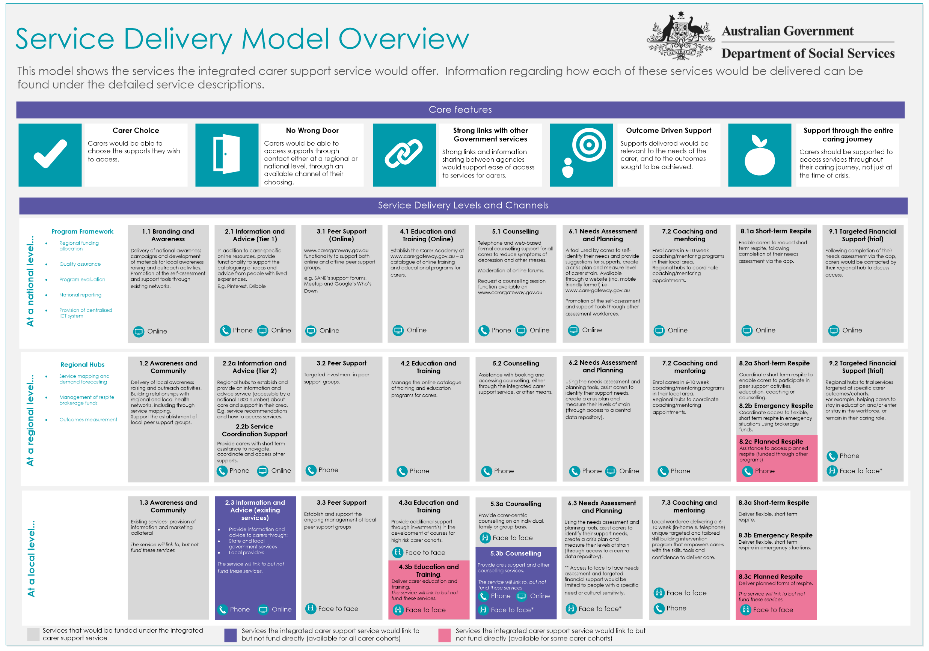

3 Program Overview
The model would be supported by funding of the following four programs:
- National Education and Training Initiative;
- National Counselling Program;
- Regional Hub Program; and
- a supporting National Infrastructure Program.
The National Education and Training Initiative would deliver education and training programs for carers to:
- support them to build capacity and resilience to continue in their caring role;
- equip them with practical caregiving skills and confidence to deliver care;
- deliver high quality education programs for carers, particularly high risk carer cohorts; and
- support for the attainment of formal care qualifications (certificate level), including recognition of prior skills and learning.
The National Counselling Program would deliver high quality, therapeutic counselling, specifically for carers, to assist with:
- emotional support, including coping skills and strategies;
- grief and loss;
- change; and
- practical advice and problem solving support.
The Regional Hub Program would provide funding to support the establishment and ongoing service delivery of the regional hubs. The objectives of this program would be to:
- support the identification of carers early in their caring journey, through awareness raising activities across the health sector and general community, particularly those in high risk carer cohorts (i.e. young carers);
- provide high quality information and advice for carers based on their circumstances and needs;
- provide carers short-term support to navigate, coordinate and access other services;
- support the establishment and ongoing access to peer support groups and events;
- support carers to access relevant education and training programs in their area through maintenance of the online catalogue of programs available;
- identify carers needs and support them to connect with supports relevant to those needs;
- through needs and eligibility assessment, coordinate access to respite and targeted financial support;
- provide proactive support through monitoring and follow-up for carers experiencing strain;
- provide high quality coaching and mentoring for carers, relevant to their circumstances and needs;
- provide short term respite to enable carers to participate in counselling, coaching, education or peer support activities;
- provide emergency respite where carers are unable to continue their caring role due to crisis, or an unforeseen event;
- support carers to access planned respite and support services through collaboration with organisations such as My Aged Care and the National Disability Insurance Agency (NDIA);
- deliver targeted financial support to assist carers to stay in education and/or enter the workforce;
- effectively connect carers to complementary supports though the development of effective relationships with providers within the region;
- provide carer-centric individual, family and group therapeutic counselling; and
- contribute to improved service development and individual carer outcomes through the recording and monitoring of the impact of supports provided.

Supporting Programs
The delivery of these programs would be supported by the National Service Infrastructure Program. The National Service Infrastructure Program would involve the procurement and/or development of:
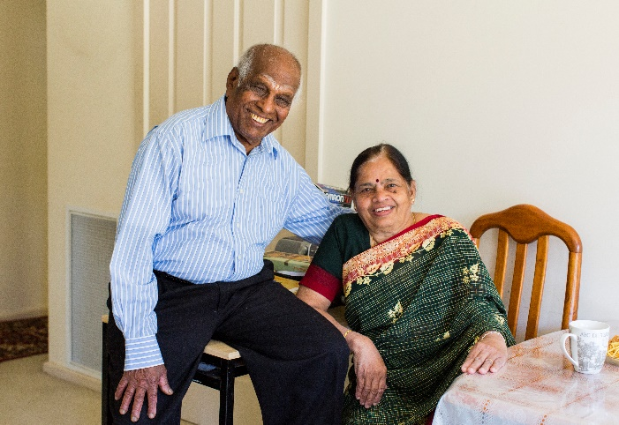
- a national website;
- self-assessment and support tools
(e.g. available through an app or mobile website); and
- a shared carer record, to retain information including:
  - basic demographic and contact information;
  - emergency care plan;
  - their use of support services, and outcomes measured; and/or
  - controls for any online account the carer may have.
The National Service Infrastructure Program would create linkages between the three primary programs through access to the shared carer record, a consistent approach to assessment and planning, and better access to relevant and accurate carer-specific support and information.

Governance
This service model would require governance at both a national and a regional level. At a national level, the governance would involve:
- a quality assurance framework to ensure the quality of those services delivered through the national programs were of an appropriate standard;
- an evaluation framework to ensure the services were delivering the outcomes the programs are intended to deliver; and
- a national reporting framework to monitor key performance indicators for the respective services.
Regional hubs would be responsible for:
- ensuring appropriate quality management practices and agreements are in place with providers they sub-contract to;
- providing governance of the carer coaching workforce; and
- collecting outcome data for the services they deliver.

An overview of the future programs
An overview of the proposed programs, and their objectives, outcomes and delivery principles. An accessible version of this diagram is provided at Annex B.
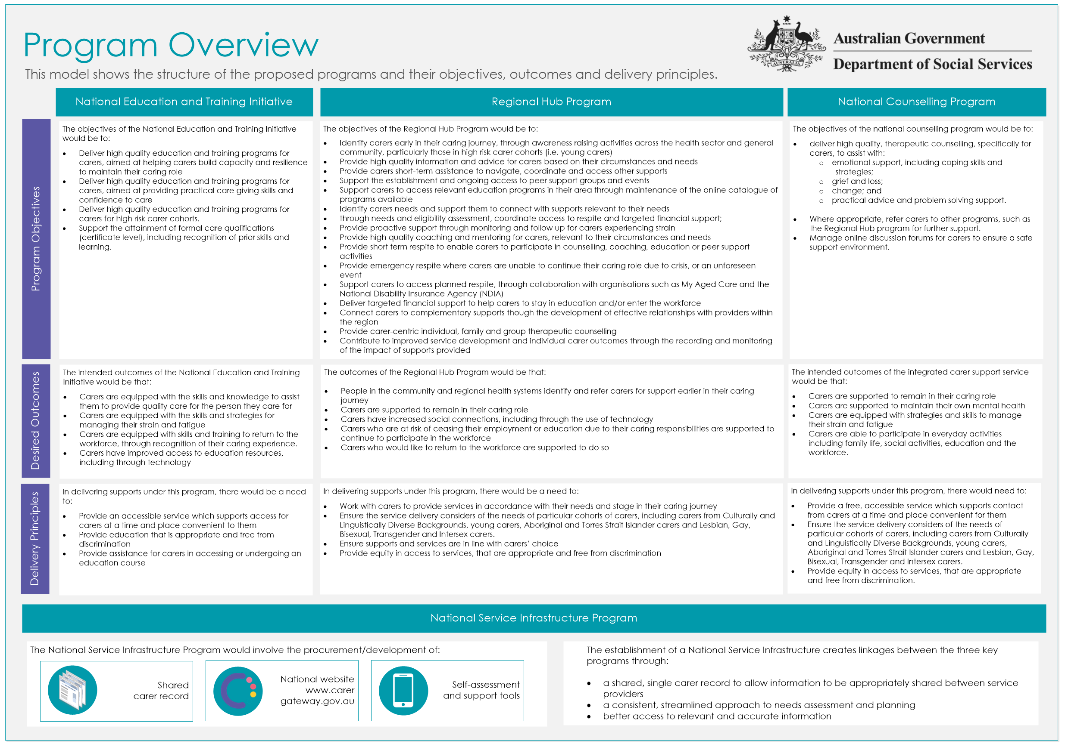
Discussion Questions
- In relation to the program overview, do you believe that the objectives, outcomes and delivery principles are appropriate for the services required to be delivered under each program? Do you believe that the services proposed to be delivered at the national, regional and local level are targeted appropriately?
- A key factor in the effectiveness of regional hubs will rely upon their ability to understand the local service landscape and identify service gaps. If you were operating a regional hub, how would you undertake service mapping for your region? How would you ensure that you had captured a complete view of the available supports for carers in your region?

4 Detailed Service Descriptions

Defining the services
A service is defined as an interaction between a carer or other user, and the integrated carer support service. This ranges from a simple interaction such as making an enquiry, to more complex interactions such as the coordination and receipt of respite.
The services proposed to be delivered through the model have been grouped into the following categories:
- Awareness and community linkages;
- Information and advice;
- Peer support;
- Education and training;
- Counselling;
- Needs assessment and planning;
- Carer coaching and mentoring;
- Respite (emergency, short term and planned); and
- Targeted financial support.
Each service is described in the tables below in terms of:
- the purpose of the service;
- who the service will benefit;
- how carers will be able to access the service;
- the channels the service will be delivered through;
- the supporting technology capabilities;
- the workforce involved in the delivery of the service; and
- the program which will fund the service.

Services delivered together
It is important to note that there may be some overlap between the services. For example,
face-to-face education programs involve a degree of peer support. Similarly, in some cases, educators may attend some peer support groups or forums to deliver one-off education and training.
The delivery and program models allow for flexibility in the way in which these programs are ultimately delivered.

Awareness and Community Linkages
 | 1.1 At a national level… | 1.2 At a regional level… | 1.3 At a local level..
The purpose of this service is to… | raise awareness in the general community about carers, their value to society and their needs.
This service will benefit… | all carers, including carers who do not seek support for themselves, or who do not identify as carers.
Carers will be able to access this service… | N/A | N/A | N/A
The primary channels for this service will be… | - To be defined | - Awareness raising events and outreach activities  - Relationships with local organisations  - Relationships with regional organisations, including Public Health Networks, GPs, cultural groups and communities, Aged Care Assessment Teams, etc.  - Service mapping of local providers and support organisations. | - Existing providers and service organisations
The people who support the delivery of this service will be… | - A national campaign provider | - Carer support staff at regional hubs | - Other Government funded services
The supporting technology capabilities will include… | - A national website  - Social media
The service will be funded under the… | - National Service Infrastructure program | - Regional Hub program | - N/A

Information and advice
 | 2.1 At a national level… | 2.2a/b At a regional level… | 2.3 At a local level…
The purpose of this service is to… | provide carers with access to relevant information, via a digital platform. | 2.2a provide carers with information and advice, tailored to their needs and circumstances.  2.2b provide carers with short term support to navigate, coordinate and access other services. | provide carers with information and advice, in conjunction with other existing funded service delivery.
This service will benefit… | all carers.  There will be no access restrictions or requirements.
Carers will be able to access this service… | - By visiting the website | - By contacting their regional hub (via the national 1800 number)  - As part of outreach activities and events | - As part of service delivery activities
The channels for this service will be … | - Online  - Hardcopy materials | - 2.2a Phone (through a national 1800 number), hardcopy materials (national collateral)  - 2.2b Phone (through a national 1800 number) | - Hardcopy materials (national collateral)
The people who support the delivery of this service will be… | - An online web support team (to assist users experiencing technical difficulties) | - Carer support staff at regional hubs | - Other Government funded services
The supporting technology capabilities will include… | - National website  - An ideas and inspiration wall for carers to read and post carer related content (similar to Pinterest)  - National marketing and mailing system
The service will be funded under the… | - National Service Infrastructure program | - Regional Hub program | - Other Government funded programs

Peer support
 | 3.1 At a national level… | 3.2 At a regional level… | 3.3 At a local level…
The purpose of this service is to… | help carers to connect and share their caring experiences.
This service will benefit… | all carers. There will be no access restrictions or requirements.
Carers will be able to access this service… | - Through the website using the online peer support group finder  - By creating an account with a few basic details | - By contacting their regional hub (via the national 1800 number)  Carers who are not already known to the service may need to answer some questions about their circumstances to enable them to connect them with an appropriate group | - At a location and time agreed with the peer support facilitator
The channels this service will be delivered through are… | - Online | - Phone (access) | - Face to face (peer support groups)
The people who support the delivery of this service will be… | - An online web support team (to assist users with technical difficulties) | - Carer support staff at regional hubs | - Peer group facilitators
The supporting technology capabilities will include… | - An online peer support group finder  - An online discussion forum supported by an electronic monitoring system to scan and moderate posts for inappropriate content  - A carer record  - Online learning catalogue (including Peer group facilitator training)
The service will be funded under the… | - National Service Infrastructure program | - Regional Hub program | - Regional Hub program

Education and Training
 | 4.1 At a national level… | 4.2 At a regional level.. | 4.3a/b At a local level…
The purpose of this service is to… | Help carers to obtain skills to:  - care for the person they are looking after;  - build resilience to enable them to maintain their caring role;  - increase their capacity to communicate with health professionals, and navigate and access service systems (eg: NDIS); and  - attain care related qualifications (certificate level) should carers wish to enter or return to the workforce in a care related field.  Help carers to find education resources relevant to them, either in an online format or in their local area.
This service will benefit… | all carers.  There will be no access restrictions or requirements for education. Formal qualifications may involve co-contribution towards the program.
Carers will be able to access this service… | - By navigating to the website and viewing openly available materials  - By creating an account with a few basic details on the online learning platform (where the carer is engaging in a course with multiple modules) | - By contacting their regional hub (via the national 1800 number)  - Through contact with the education organisation delivering the training | - 4.3a At a time and location coordinated by the regional hub.  - 4.3b As arranged by the relevant funded provider
The channels for this service will be … | - Online | - Phone (access and support) | - Face to face (with the educator)
The people who support the delivery of this service will be… | - An online web support team (to assist users with technical difficulties) | - Carer support staff at regional hubs | - Education delivery staff
The supporting technology capabilities will include… | - National website  - Online learning catalogue  - A carer record
The service will be funded under the… | - National Service Infrastructure program | - Regional Hub program  - National Education Initiative | - 4.3a Regional Hub program  - 4.3b Other Government funded programs

Counselling
 | 5.1 At a national level… | 5.2 At a regional level… | 5.3a/b At a local level…
The purpose of this service is to… | support carers in their caring role, through the provision of therapeutic counselling (e.g. motivational interviewing).
This service will benefit… | all carers.  Noting that service will be delivered on a prioritised basis (determined by the level of carer strain), following registration and needs identification
Carers will be able to access this service… | - By creating an account with a few basic details  - By logging into an existing carer account  - By completing the needs assessment and planning process and requesting a session | - By contacting their regional hub (via the national 1800 number) | - 5.3a By contacting their regional hub (via the national 1800 number)  - 5.3b Through the relevant program
The channels for this service will be … | - Online  - Phone | - Phone (access) | - 5.3a Face to face  - 5.3b Through the relevant program
The people who support the delivery of this service will be… | - Trained counsellors  - An online web support team (to assist users with technical difficulties) | - Carer support staff at regional hubs | - 5.3a Trained counsellors, either brokered or employed by the Regional Hub  - 5.3b Through the relevant program
The supporting technology capabilities will include… | - National website  - Online booking and scheduling system  - A carer record  - Self-assessment and support tools |  | - 5.3a A carer record  - 5.3b Through the relevant program.
The service will be funded under the… | - National Service Infrastructure program  - National Carer Counselling program | - Regional Hub program | - 5.3a Regional Hub program  - 5.3b Other Government funded programs

Needs Assessment and Planning
 | 6.1 At a national level… | 6.2 At a regional level… | 6.3 At a local level…
The purpose of this service is to… | help carers to identify their needs and suggest appropriate supports (both informal and formal) to address these areas, and determine their eligibility for respite and targeted financial support.
This service will benefit… | all carers.  There will be no access restrictions or requirements.
Carers will be able to access this service… | - By creating an account with a few basic details  - By logging into an existing carer account  - By creating an account with a few basic details | - By contacting their regional hub (via the national 1800 number)  - As part of outreach activities and incidental contact | - At a location and time agreed with the peer support facilitator
The channels for this service will be … | - Online | - Phone | - Face to face **
The people who support the delivery of this service will be… | - An online web support team (to assist users with technical difficulties) | - Carer support staff at regional hubs | - Carer support staff from regional hubs
The supporting technology capabilities will include… | - A carer record  - Self-assessment and support tools
The service will be funded under the… | - National Service Infrastructure program | - Regional Hub program | - Regional Hub program
** Face-to- face carer assessment would be limited to carers who may need assistance to communicate or where there is a sensitivity e.g. young carer or carer from a Cultural and Linguistically Diverse background.

Coaching and mentoring
 | 7.1 At a national level… | 7.2 At a regional level… | 7.3 At a local level…
The purpose of this service is to… | help carers to acquire skills and resilience to assist them in managing their caring role, through delivery of a goal oriented support program
This service will benefit… | all carers.  Noting that service will be delivered on a prioritised basis, following registration and  needs identification
Carers will be able to access this service… | - By logging into their digital carer account  - By creating an account with a few basic details  - By completing the needs assessment and planning process and requesting a coaching program | - By contacting their regional hub (via the national 1800 number) | - At a location and time coordinated with the regional hub
The channels for this service will be … | - Online | - Phone (access) | - Face to face (with the carer coach)
The people who support the delivery of this service will be… | - An online web support team (to assist users with technical difficulties) | - Carer support staff at regional hubs | - Carer coaches (local workforce consisting of a mix of paid and volunteer staff – lived experience will be an essential carer coach attribute)
The supporting technology capabilities will include… | - National website  - Online booking and scheduling system  - A carer record  - Self-assessment and support tools
The service will be funded under the… | - National Service Infrastructure program | - Regional Hub program | - Regional Hub program

Respite – short-term and emergency
 | 8.1a At a national level… | 8.2a/b At a regional level… | 8.3a/bAt a local level…
The purpose of this service is to… | Provide information and support and assist carers in arranging respite services to meet emergency or short term carer needs (e.g. participate in activities such as education, peer support or coaching, or in response to an unforeseen circumstance).
This service will benefit… | carers who are experiencing a crisis or emergency, and require respite within a 24-hour period all carers.  Noting that service will be delivered on a prioritised basis (determined by the level of need). Needs identification would form part of this process.
Carers will be able to access this service… | - By creating an account with a few basic details  - By logging into their digital carer account  - By completing the needs assessment and planning process and requesting a call back from a regional hub | - By contacting their regional hub (via the national 1800 number) | - Coordinated by regional hubs
The channels for this service will be … | - Online | - Phone | - Face to face
The people who support the delivery of this service will be… | - An online web support team (to assist users with technical difficulties) | - Carer support staff at regional hubs | - Local provider staff
The supporting technology capabilities will include… | - National website  - Online booking and scheduling system  - A carer record  - Self-assessment and support tools
The service will be funded under the… | - National Service Infrastructure program | - Regional Hub program | - Regional Hub program

Targeted financial support
 | 9.1 At a national level… | 9.2 At a regional level…
The purpose of this service is to… | Provide targeted financial support for carers, to support them to:  - remain in the workforce, where they are at risk of being unable to continue their caring role  - return to the workforce, whilst continuing their caring role; and  - undertake, or remain in, formal education.
This service will benefit… | the carer cohorts most likely to benefit from the service.  Noting that service will be delivered on a targeted basis and will be subject to assessment and eligibility criteria.
Carers will be able to access this service… | - By creating an account with a few basic details  - By logging into their digital carer account  - By completing the needs assessment and planning process and requesting a call back from a regional hub | - By contacting their regional hub (via the national 1800 number)  - By completing the needs assessment and planning process and requesting a call back from a regional hub
The channels for this service will be … | - Online | - Phone
The people who support the delivery of this service will be… | - An online web support team (to assist users with technical difficulties) | - Carer support staff at regional hubs
The supporting technology capabilities will include… | - National website  - A carer record  - Self-assessment and support tools
The service will be funded under the… | - National Service Infrastructure program | - Regional Hub program

5 About how carers might experience the model
The success of this model will rely on providing carers with a valuable and positive service experience. This will be essential to encourage carers to access supports, from the early stages in their caring journey, and on an ongoing basis.
Carers can be found in almost every age group across Australia. This means that the future service will need to provide ways of accessing and receiving supports in a number of different ways, to account for the different preferences and needs of different groups of carers.
To account for this, this model has been designed so carers can access support in more than one way and in as few steps as possible. For those carers who seek support themselves, they may choose to:
- use digital service offerings through the national website and their carer account; or
- contact their regional hub for access to supports and services.
For those carers who do not identify themselves as being a carer or where a third party refers them, with consent, to the service (e.g. Centrelink), the carer would receive initial proactive contact from their regional hub. They would then be able to choose the way they interact with the service in future.
Almost all supports available through digital means would be able to be accessed through a carers regional hub, to ensure that there is equity in access for carers who may not have access to technology or who prefer not to use digital services.
Carers will also be able to change the way they interact based on the service throughout their journey. For example, a carer may choose to make initial contact with their regional hub, before going online to access support. Some carers may choose to start with accessing online supports before making contact with their regional hub and engaging in face-to-face supports.
How carers experience the model, will therefore be related to how they choose to access support.
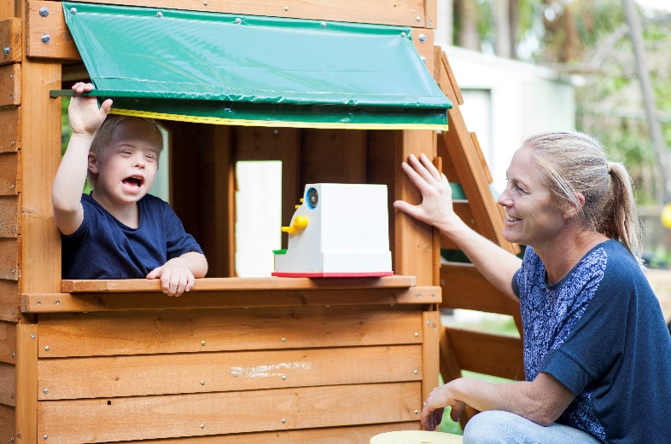

An overview of how carers could experience the service
An overview of the options by which carers could choose to access and receive support is provided below. An accessible version of this diagram is provided at Annex C.
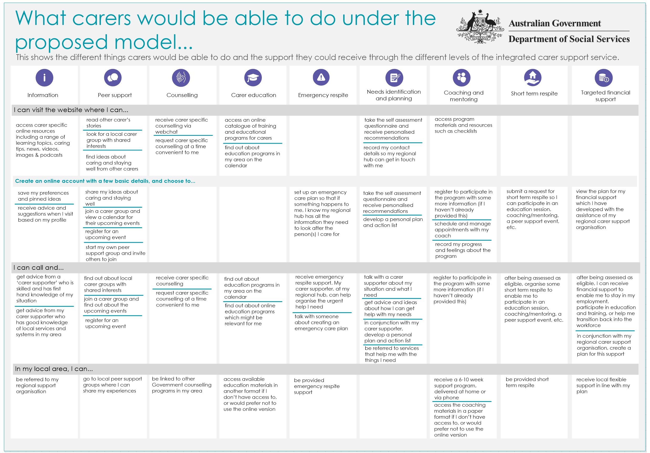

Discussion Questions
- It has been identified that outcomes measurement will be essential for a future model. Outcomes measurement involves identifying how effective services are in achieving a particular objective. This commonly takes the form of a questionnaire which helps to assess aspects the carers role. However, there will be a careful balance in measuring outcomes, whilst not placing undue burden on a carer to answer multiple questionnaires, particularly where they may be accessing more than one service. What are some ways that outcomes could be measured and these issues addressed?
- While this model will seek to help more carers, it will be important to ensure that quality services are being delivered. What would you view as the essential components of a future quality framework?

6 Implementing a new model
Subject to Government approval, implementation would commence from 1 July 2018. As the foundation of the model, the National Service Infrastructure and Regional Hub programs would likely form the basis of the first phase of implementation. If Government agrees to implement the model, a range of activities would need to be undertaken prior to commencement of services including:
- development of program/operational guidelines;
- a funding/procurement process for infrastructure and services required; and
- transition and change management activities (e.g. communications, staff training, etc.).

Transition
The model has not been finalised, nor agreed for implementation by Government. However, the following existing programs are in scope for transition in full, or in part** to a new integrated carer support service.
- The former National Respite for Carers Program encompassing the following sub-programs:
  - The National Carer Counselling Program
  - Carer Information and Support Service
  - Short term and emergency respite (delivered by Commonwealth Respite and Carelink Centres)
  - Consumer Directed Respite Care
- Young Carers Program **
- Mental Health Respite: Carer Support**
- The Young Carer Bursary Program
- Respite Support for Carers of Young People with Severe and Profound Disability **
- Dementia and Aged Care Services grants - carer projects
- Dementia Education and Training for Carers
- Counselling, Support Information and Advocacy - carer support
A full transition plan to support an effective implementation would be developed and subject to Government approval. In principle, transition would:
- be managed to provide continuity of service for carers receiving support through existing programs;
- involve targeted change management and communication activities and tools for carers, the sector and the broader community;
- be supported through careful monitoring during operationalisation.

Ensuring a sustainable and viable sector
While the way in which transition to any such model would need to be carefully managed, it would also be crucial to ensure that the future service sector is supported and managed effectively throughout its operation.
To that end, a number of principles have been developed in conjunction with co-design participants. These principles would guide the management, support and operation of the sector, to ensure it remains viable and sustainable in the longer term.

Principle | Description
Strategic direction | The sector and its services would be guided by a clear strategic direction to enable providers to plan for improvement initiatives and optimise services over time.
Funding and operational continuity | The sector would be supported by effective and timely contract management processes and mechanisms, to provide certainty regarding funding decisions.
Outcomes and evidence based practice | The sector would supported in its service delivery and improvement through collection of outcome data.
Effective connections | The sector would be supported to help carers through effective connections with other service systems and with other key Government departments.
Collaborative consistent and efficient service delivery | The sector would be supported to collaborate effectively to deliver services consistently and efficiently through the sharing of resources and tools.
A shared, promoted brand for carer supports | The sector would operate under a shared, promoted brand, which would ensure the services are recognisable to carers and the broader community.
Legislative support | The services delivered by the sector would have links to legislative frameworks, such as the Carer Recognition Act 2010.

7 Next Steps
Once consultation on the draft Service Delivery Model has been completed, DSS will review and analyse all feedback received. A report will be developed outlining the feedback received through the consultation process and provided to the Minister for Social Services.
Revisions to the model will be undertaken, with final options for the model to be provided to Government for consideration.
DSS will provide updates on the progress of the Integrated Plan for Carer Support Services, including the draft Service Delivery Model, at www.dss.gov.au.

8 Frequently Asked Questions

Why is a regional hub model being proposed?
There was mixed feedback from providers as part of the public consultation on the Draft Service Concept as to the structure of the model. Many organisations and carers highlighted the importance of receiving support from an organisation familiar with their area, and who could build relationships with other organisations and communities (e.g. Aboriginal and Torres Strait Islander and Culturally and Linguistically Diverse communities). Some providers pointed out that economies of scale could be realised through:
- a centralised model;
- consolidation of existing services into larger regional hubs; or
- tighter integration with other sectors (e.g. delivery of supports through My Aged Care, mental health and other counselling services).
While centralised points of contact, such as a centralised contact centre, can bring efficiencies, this may not represent an optimum experience for all carers. This model seeks to deliver supports for carers early in their caring journey. Therefore, a good service experience is critical to ensure that carers will want to access the service. If carers were required to speak with a centralised contact centre prior to accessing support, they may view this as a barrier. Carers have told us as part of our research that they want to talk to a skilled, knowledgeable person with whom they can build a relationship, and not have to repeat their story.
This model has been designed to minimise barriers by enabling carers to:
- connect with many supports directly (without assessments or eligibility tests); and
- where eligibility does need to be tested, through a single interaction.
There are some centralised services retained in the model, such as counselling. This is because counselling services (delivered online or by telephone) have been proven to be an effective way of delivering counselling in the mental health sector and can be effectively delivered as a centralised service.

What sort of teams will the regional hubs have?
Feedback received on the Draft Service Concept highlighted that support services such as those outlined in the model, are most effective when teams include staff from different backgrounds.
This was supported by findings from engagement with both the mental health and current carer support sector.
It is expected that the regional hubs would have staff with basic qualifications (e.g. Certificate III in Disability, Community Care, etc.) and relevant experience. It would also be expected that each regional hub would have a clinically trained staff member e.g. counsellor or social worker, to provide a clinical skillset which can be drawn on. They would also provide clinical oversight for carer coaches and other staff within the hub.
There will be a careful balance in ensuring that the service remains affordable so as to direct as much funding as possible towards actual service delivery, while ensuring staff are able to deliver a quality and safe service for carers.

How many regional hubs would be established?
DSS is undertaking analysis work to inform this decision.

What role would Carer Gateway play in a future model?
Carer Gateway is an information and advice service, consisting of a national website and telephone line. It is envisioned that the national website platform would be expanded to include the additional digital service and information offerings described in this model. As outlined in the model, telephone based information and advice will remain a service available for carers.

How is this model different to the carer support services DSS funds today?
As outlined in the Draft Service Concept, the current programs are not currently reaching, and supporting carers who may require support and there are gaps in the service types offered nationally. In addition, the current service model leans towards the provision of reactive service responses, with many carers only presenting and seeking support at the time of immediate need. This model seeks to reach carers earlier in their caring journey and deliver supports which have been shown to be effective in achieving longer term outcomes.
The current system has limited digital service delivery available. Given the significant shifts in the way that people communicate and interact with services and technology, there is scope to deliver more services online and therefore reach more carers, particularly certain cohorts such as young carers.
There is also limited sharing of information, and overarching coordination of a carer’s case within the carer support system today. The National Service Infrastructure Program would support a more coordinated approach to assisting carers through shared information and proactive and ongoing monitoring of carers’ strain.

How will this model be funded? Block funding, fee for service, or a combination of both?
It is proposed that four programs will be required to support the future system (one of which refers to a support program to be delivered by DSS). Two of the programs (the National Education Initiative and National Carer Counselling) program could be delivered as a fee for service arrangement (noting this would be dependent on the certainty of service demand forecasts). The final program (the Regional Hub Program) however, would likely be delivered on a block funding basis (at least initially). The rationale being that this would provide the regional hubs with increased flexibility to tailor operations in response to their service mapping and needs analysis. Further analysis will be required to ensure that an appropriate funding and commissioning approach is applied.

Could the regional hubs be delivered by existing services?
As part of the public consultation on the Draft Service Concept, some providers and carers gave feedback that consideration should be given to leveraging existing services in regions across the country such as the National Disability Insurance Agency’s Local Area Coordinators, existing Carer Associations and Commonwealth Respite and Carelink Centres (CRCCs), or My Aged Care Regional Assessment Services. It is intended that any approach to market would be through an open, contestable and competitive process, supported by an appropriate commissioning framework.

Does DSS plan to build the information technology (IT) infrastructure to support the service?
Decisions about the procurement or development of IT infrastructure have not yet been made. Changes may need to be made to the model based on the information received through the consultation process, and this may impact the IT capabilities as currently outlined.
If Government decides to proceed with implementing the service, a decision will be taken at that time with regards to any IT strategy.

Digital service options play a large part in the model? Why?
The way in which we are communicating and interacting with services is changing. In 2012, just 52% of Australians used a smart phone, compared with 77% in 2015. In contrast, use of computers has declined 6% over this period (Google, 2016). Ninety-five per cent of people aged 45-54 years of age access the internet. As sectors such as banking, travel and even healthcare shift towards more digital services, Government has not matched consumer trends and expectations.
The Carer Service Development Research, which surveyed 1300 carers across Australia, found that 70% of carers search for information and services using Google (AMR Australia, 2015).
Currently, there is limited digital service delivery for carers under the programs being funded by DSS. If we are to reach more carers, we will need to consider how to make the best use of available resources and move towards assisting people in line with the ways in which they are seeking and interacting with services now. Incorporating digital service delivery, as part of
multi-channel service, is one of a number of ways to achieve this.
There are a number of organisations, particularly in the mental health sector who are successfully delivering human focussed services through technology which have demonstrated positive outcomes for users.
It is essential that digital service delivery forms part of the future service model to ensure that DSS is meeting expectations of citizens accessing the service and using cost-effective means to support them.
It is important to note that not all carers will want to utilise digital support services. Alternate methods of contact and access will be provided for people where digital channels are not preferred or cannot be utilised.

How would the digital carer account help carers?
The digital carer account could be accessed by carers on their phones, computers or tablets.
It would be expected to have a number of functions that would assist carers. This would include:
- the ability to create and manage an emergency care plan;
- the ability to undertake a self-assessment and track carer strain over time; and
- the ability to make recommendations based on the information carers provide in their account.
It is envisioned that staff from the regional hubs would to proactively contact carers:
- where carers have completed the self-assessment and it has been identified that there is a need for follow up based on their level of strain or where they have requested contact; and
- where carers already using a digital carer account report that they are beginning to experience a high degree of strain.
Contact with carers by regional hubs would only occur where a carer had consented to either the initial or ongoing information sharing and contact.

Are the services going to be generic i.e. will all carers get the same type of support?
Many of the services in this model involve a degree of personalisation. For example, there may be many different peer support activities and groups, and carers will be able to choose which to participate based on their relevance and preference.
In addition, services such as counselling, carer coaching and needs assessment all involve degrees of relevance for the carer, and target areas of particular concern or need for the carer. In this way, services are relevant and tailored to what individual carers are seeking.

How will the service work with My Aged Care and the NDIS to support carers?
It is proposed that there would be the ability to refer between both services for carer related supports. Opportunities for information sharing are also being explored to prevent carers from having to repeat their information.
It is envisioned that the digital carer account would provide a mechanism for linking between these services. DSS is currently exploring opportunities to leverage workforces such as assessors and planners, who are engaging with carers and the people they are caring for. This workforce could promote the digital carer account for carers to use themselves or encourage them to use the tools to conduct a short assessment at that time so that they are registered for carer support services. This would be subject to consent from the carer to participate and receive contact from their regional hub.

How will the services work with the mental health sector?
Mental health services are predominantly funded by State Governments. As a result, the integrated carer support service will need to link with mental health services and their governing bodies in their regions.
The proposed mechanisms by which this would work, would need further exploration and co-design in the event the Government decided to implement the integrated carer support service.

How would carers be supported in emergencies?
Carers will continue to have access to emergency respite in a similar way as the current service system arrangements. Carers currently call a national 1800 number and are connected to their local CRCC who can assist with arranging short term and emergency respite. Under the model, carers would be able to call a national number and be connected to a regional hub, who would assist with organising emergency and/or short term respite for the person(s) they are caring for.

Will carers have to go through a national contact centre before they get help?
No, carers would be able to access many supports directly, without a formal registration and assessment process. Carers would also be able to engage with a regional hub directly in order to find supports in their area.

How will carers access support if they do not have access to the internet or relevant equipment (i.e. phone or computer)?
Carers in Australia can be found in almost every age group, gender, culture and socio-economic group. Therefore, the integrated carer support service will need to support a diverse set of preferences and communication styles. For this reason, for almost all services, more than one way is provided to access support.
Carers will be able to access most supports through contact with a regional hub. While online supports and capabilities would be made available, contact with a regional hub would increase access to support for many carers.

Will carers get different support based on where they are in their caring journey?
Carers have different needs for information and types of support, depending on their immediate circumstance, where they are in their caring journey and the condition(s) of the person they care for. Carers will be able to access supports throughout their caring journey and in accordance with their needs.

How will carers or those with a lived experience as a carer be involved in the service?
Feedback from public consultation indicated a strong preference for carers or those with a lived experience as a carer, to be involved in delivering the service. Given the benefits this can offer, it would be preferable to enable opportunities for carers to participate where they choose to.

How would carers be assured of a quality service?
All services will be subject to national quality assurance program to ensure appropriate safeguards and controls. Regional hubs and services delivered under the National Counselling program will be required to have appropriate clinical governance procedures in place.
Carers would also be able to submit complaints about any service, either directly to a national provider, a regional hub or DSS.

ANNEX A: Draft service delivery model (accessible version)
The draft service delivery model overview reflects the services the integrated carer support service would offer. Information regarding how each of these services would be delivered can be found under the detailed service descriptions.
Core to the delivery model would be a number of features including:
- Carer choice: carers would be able to choose the supports they wish to access
- No wrong door: carers would be able to access supports through contact at a regional or national level, through an available channel of their choosing
- Strong links with other government services: links and information sharing between agencies would support ease of access to services for carers
- Outcome driven support: supports delivered would be relevant to the needs of the carer, and to the outcomes sought to be achieved
- Support through the entire caring journey: carers should be supported to access services throughout their caring journey, not just at the time of crisis.
A national program framework would support the delivery of these services and would include:
- Regional funding allocation
- Quality assurance
- Program evaluation
- National reporting
- Provision of centralised ICT system
Regional hubs would be responsible for:
- Service mapping and demand forecasting
- Management of respite brokerage funds
- Outcomes measurement
 | Awareness | Information | Peer support | Education and Training | Counselling | Needs Assessment and Planning | Coaching and mentoring | Respite | Targeted Financial Support
At a national level… | 1.1 Branding and Awareness  Delivery of national awareness campaigns and development of materials for local awareness raising and outreach activities.  Promotion of the self-assessment and support tools through existing networks. | 2.1 Information and Advice (Tier 1)  In addition to carer-specific online resources, provide functionality to support the cataloguing of ideas and advice from people with lived experiences.  E.g. Pinterest, Dribble | 3.1 Peer Support (Online)  www.carergateway.gov.au functionality to support both online and offline peer support groups.  e.g. SANE’s support forums, Meetup and Google’s Who’s Down | 4.1 Education and Training (Online)  Establish the Carer Academy at www.carergateway.gov.au – a catalogue of online training and educational programs for carers. | 5.1 Counselling  Telephone and web-based formal counselling support for all carers to reduce symptoms of depression and other stresses.  Moderation of online forums.  Request a counselling session function available on www.carergateway.gov.au | 6.1 Needs Assessment and Planning  A tool used by carers to self-identify their needs and provide suggestions for supports, create a crisis plan and measure level of carer strain. Available through a website (inc. mobile friendly format) i.e. www.carergateway.gov.au  Promotion of the self-assessment and support tools through other assessment workforces. | 7.2 Coaching and mentoring  Enrol carers in 6-10 week coaching/mentoring programs in their local area.  Regional hubs to coordinate coaching/mentoring appointments. | 8.1a Short-term Respite  Enable carers to request short term respite, following completion of their needs assessment via the app. | 9.1 Targeted Financial Support (trial)  Following completion of their needs assessment via the app, carers would be contacted by their regional hub to discuss access.
National channels | Online | Phone, Online | Online | Online | Phone, Online | Online | Online | Online | Online
At a regional level… | 1.2 Awareness and Community  Delivery of local awareness raising and outreach activities.  Building relationships with regional and local health networks, including through service mapping.  Support the establishment of local peer support groups. | 2.2a Information and Advice (Tier 2)  Regional hubs to establish and provide an information and advice service (accessible by a national 1800 number) about care and support in their area. E.g. service recommendations and how to access services.  2.2b Service Coordination Support  Provide carers with short term assistance to navigate, coordinate and access other supports. | 3.2 Peer Support  Targeted investment in peer support groups. | 4.2 Education and Training  Manage the online catalogue of training and education programs for carers. | 5.2 Counselling  Assistance with booking and accessing counselling, either through the integrated carer support service, or other means. | 6.2 Needs Assessment and Planning  Using the needs assessment and planning tools, assist carers to identify their support needs, create a crisis plan and measure their levels of strain (through access to a central data repository). | 7.2 Coaching and mentoring  Enrol carers in 6-10 week coaching/mentoring programs in their local area.  Regional hubs to coordinate coaching/mentoring appointments. | 8.2a Short-term Respite  Coordinate short term respite to enable carers to participate in peer support activities, education or coaching.  8.2b Emergency Respite  Coordinate access to flexible, short term respite in emergency situations using brokerage funds.  8.2c Planned Respite  Assistance to access planned respite (funded through other programs) | 9.2 Targeted Financial Support (trial)  Regional hubs to trial services targeted at specific carer outcomes/cohorts.  For example, helping carers to stay in education and/or enter or stay in the workforce, or remain in their caring role.
Regional channels | N/A | Phone, Online | Phone | Phone | Phone | Phone, Online | Phone | Phone | Phone, Face to face
At a local level… | 1.3 Awareness and Community  Existing services- provision of information and marketing collateral  The service will link to, but not fund these services | 2.3 Information and Advice (existing services)  - Provide information and advice to carers through:  - State and local government services  - Local providers  The service will link to but not fund these services. | 3.3 Peer Support  Establish and support the ongoing management of local peer support groups | 4.3a Education and Training  Provide additional support through investment(s) in the development of courses for high risk carer cohorts.  4.3b Education and Training  Deliver carer education and training.  This service would link to but not fund this service (4.3b) | 5.3 Counselling  Provide crisis support and other counselling services, including face to face counselling.  The service will link to, but not fund these services | 6.3 Needs Assessment and Planning  Using the needs assessment and planning tools, assist carers to identify their support needs, create a crisis plan and measure their levels of strain (through access to a central data repository).  ** Access to face to face needs assessment and targeted financial support would be limited to people with a specific need or cultural sensitivity. | 7.3 Coaching and mentoring  Local workforce delivering a 6-10 week (in-home and telephone) unique targeted and tailored skill building intervention program that empowers carers with the skills, tools and confidence to deliver care. | 8.3a Short-term Respite  Deliver flexible, short term respite.  8.3b Emergency Respite  Deliver flexible, short term respite in emergency situations.  8.3c Planned Respite  Deliver planned forms of respite.  The service will link to but not fund these services. | NA
Local channels | N/A | Phone, Online | Face to face | Face to face | Phone, Online, Face to face | Face to face | Face to face | Face to face, Phone | N/A

The integrated carer support service would link to, but not directly fund the following services:
- 2.3 Information and Advice (existing services)
- 4.3b Education and Training
- 5.3 Counselling
- 8.2c Planned Respite
- 8.3c Planned Respite

ANNEX B: Program overview (accessible version)
An overview of the proposed programs, and their objectives, outcomes and delivery principles.
 | National Education Initiative | Regional Hub Program | National Counselling Program
Program Objectives | The objectives of the National Education and Training Initiative would be to:  - Deliver high quality education and training programs for carers, aimed at helping carers build capacity and resilience to maintain their caring role  - Deliver high quality education and training programs for carers, aimed at providing practical care giving skills and confidence to care  - Deliver high quality education and training programs for carers for high risk carer cohorts | The objectives of the Regional Hub Program would be to:  - Identify carers early in their caring journey, through awareness raising activities across the health sector and general community, particularly those in high risk carer cohorts (i.e. young carers)  - Provide high quality information and advice for carers based on their circumstances and needs  - Provide carers short-term support to navigate, coordinate and access other services  - Support the establishment and ongoing access to peer support groups and events  - Support carers to access relevant education programs in their area through maintenance of the online catalogue of programs available  - Identify carers needs and support them to connect with supports relevant to their needs  - Provide proactive support through monitoring and follow up for carers experiencing strain  - Provide high quality coaching and mentoring for carers, relevant to their circumstances and needs  - Provide short-term respite to enable carers to participate in counselling, coaching, education or peer support activities  - Provide emergency respite where carers are unable to continue their caring role due to crisis, or an unforeseen event  - Support carers to access planned respite, through collaboration with organisations such as My Aged Care and the National Disability Insurance Agency (NDIA)  - Deliver targeted financial support to help carers to stay in education and/or enter the workforce  - Connect carers to complementary supports though the development of effective relationships with providers within the region  - Provide carer-centric individual, family and group therapeutic counselling  - Contribute to improved service development and individual carer outcomes through the recording and monitoring of the impact of supports provided | The objectives of the national counselling program would be to:  - deliver high quality, therapeutic counselling, specifically for carers, to assist with:  - emotional support, including coping skills and strategies;  - grief and loss;  - change; and  - practical advice and problem solving support  - Where appropriate, refer carers to other programs, such as the Regional Hub program for further support  - Manage online discussion forums for carers to ensure a safe support environment
Desired Outcomes | The intended outcomes of the National Education Initiative would be that:  - Carers are equipped with the skills and knowledge to assist them to provide quality care for the person’s they care for  - Carers are equipped with the skills and strategies for managing their strain and fatigue  - Carers are equipped with skills and training to return to the workforce, through recognition of their caring experience.  - Carers have improved access to education resources, including through technology | The outcomes of the Regional Hub Program would be that:  - People in the community and regional health systems identify and refer carers for support earlier in their caring journey  - Carers are supported to remain in their caring role  - Carers have increased social connections, including through the use of technology  - Carers who are at risk of ceasing their employment or education due to their caring responsibilities are supported to continue to participate in the workforce  - Carers who would like to return to the workforce are supported to do so | The intended outcomes of the integrated carer support service would be that:  - Carers are supported to remain in their caring role  - Carers are supported to maintain their own mental health  - Carers are equipped with strategies and skills to manage their strain and fatigue  - Carers are able to participate in everyday activities including family life, social activities, education and the workforce
Delivery Principles | In delivering supports under this program, there would be a need to:  - Provide an accessible service which supports access for carers at a time and place convenient to them  - Provide education that is appropriate and free from discrimination  - Provide assistance for carers in accessing or undergoing an education course | In delivering supports under this program, there would be a need to:  - Work with carers to provide services in accordance with their needs and stage in their caring journey  - Ensure the service delivery considers of the needs of particular cohorts of carers, including carers from Culturally and Linguistically Diverse Backgrounds, young carers, Aboriginal and Torres Strait Islander carers and Lesbian, Gay, Bisexual, Transgender and Intersex carers.  - Ensure supports and services are in line with carers’ choice  - Provide equity in access to services, that are appropriate and free from discrimination | In delivering supports under this program, there would need to:  - Provide a free, accessible service which supports contact from carers at a time and place convenient for them  - Ensure the service delivery considers of the needs of particular cohorts of carers, including carers from Culturally and Linguistically Diverse Backgrounds, young carers, Aboriginal and Torres Strait Islander carers and Lesbian, Gay, Bisexual, Transgender and Intersex carers  - Provide equity in access to services, that are appropriate and free from discrimination

The delivery of these programs would be supported by the National Service Infrastructure Program. The National Service Infrastructure Program would involve the procurement and/or development of:
- a national website;
- self-assessment and support tools (e.g. available through an app or mobile website); and
- a shared carer record, to retain information including:
  - basic demographic and contact information;
  - emergency care plan;
  - their use of support services, and outcomes measured; and/or
  - controls for any online account the carer may have.
The National Service Infrastructure Program would create linkages between the three primary programs through access to the shared carer record, a consistent approach to assessment and planning, and better access to relevant and accurate carer-specific support and information.

ANNEX C: Carer experience (accessible version)
The following table outlines the support carers could receive and the different ways they could interact with the service, through the channels supported by the different things carers would be able to do and the support they could receive through the different ways of accessing the integrated carer support service.
The following is written in first person language to express a user story for each interaction the carer could have with the service.
 | Information | Peer support | Counselling | Carer education | Emergency respite | Needs identification and planning | Coaching and mentoring | Short term respite | Targeted financial support
I can visit the website where I can… | - access carer specific online resources, including a range of learning topics, caring tips, news, videos, images and podcasts. | - read other carer’s stories  - look for a local carer group with shared interests  - find ideas about caring and staying well from other carers | - receive carer specific counselling via web chat  - request carer specific counselling at a time convenient to me | - access an online catalogue of training and educational programs for carers  - find out about education programs in my area on the calendar |  | - take the self-assessment questionnaire and receive personalised recommendations  - record my contact details so my regional hub can get in touch with me | - access program materials and resources such as checklists
…create an online account with a few basic details, and choose to… | - save my preferences and pinned ideas  - receive advice and suggestions when I visit, based on my profile | - share my ideas about caring and staying well  - join a carer group and view a calendar for their upcoming events  - register for an upcoming event  - start my own peer support group and invite others to join |  |  | - set up an emergency care plan so that if something happens to me, I know my regional hub has all the information they need to look after the person(s) I care for | - take the self-assessment questionnaire and receive personalised recommendations.  - develop a personal plan and action list | - register to participate in the program with some more information (if I haven’t already provided this)  - schedule and manage appointments with my coach  - record my progress and feelings about the program | - submit a request for short term respite so I can participate in an education sessions coaching/mentoring, a peer support event, etc. | - view the plan for my financial support which I have developed with the assistance of my regional carer support organisation
I can call and… | - get advice from a carer supporter who is skilled, and has first-hand knowledge of my situation  - get advice from my carer supporter who has good knowledge of local services and systems in my area | - find out about local carer groups with shared interest  - join a carer group and find out about the upcoming events  - register for an upcoming event | - receive carer specific counselling  - request carer specific counselling at a time convenient to me | - find out about education programs in my area on the calendar  - find out about online education programs which might be relevant for me | - receive emergency respite support, My carer supporter at my regional hub can help organise the urgent help I need  - talk with someone about creating an emergency care plan | - register to participate in the program with some more information (if I haven’t already provided this) | - register to participate in the program with some more information (if I haven’t already provided this) | - after being assessed as eligible, organise some short term respite to enable me to participate a peer support event, education, a coaching session, etc. | - after being assessed as eligible, I can receive financial support to enable me to stay in my employment, participate in education and training, or help me transition back into the workforce.  - in conjunction with my regional carer support organisation, create a plan for this support.
In my local area, I can… | - be referred to my regional support organisation | go to local peer support groups where I can share |  | - access available education materials in another format if I don’t have access to, or would prefer not to use, the online version | - be provided emergency respite support | - if I am not comfortable talking over the phone, or require assistance due to a cultural need or other sensitivity, receive a face to face needs identification | - be provided short term respite | - be provided short term respite | - receive local flexible support in line with my plan.

GLOSSARY
Term | Description
Channel | The way in which a consumer interacts with a service (e.g. via phone, online, in person)
Coaching | A one-on-one support program, where a coach assists a carer to achieve specific goals through the provision of advice and education
Cohort | Refers to a group of people with a shared characteristic or attribute
CRCC | Commonwealth Respite and Carelink Centre
DSS | Department of Social Services
Forecast | A prediction of future events or volumes
Integrated Carer Support Service | The integrated carer support service is the collective term for the set of supports proposed to be delivered for carers
My Aged Care | A clear entry point to the aged care system through a website and national 1800 phone number
Multi-channel | Refers to the ability for consumers to access a service more than one way (e.g. phone, online, in person)
NDIA | National Disability and Insurance Agency
NDIS | National Disability and Insurance Scheme
Needs Assessment | A method of identifying and addressing a person’s needs
Peer Support | A form of support, involving the giving and receiving of help, by individuals with shared experience or knowledge
Regional Carer Support Hub | The regional organisation responsible for delivering services at a regional level for the integrated carer support service
Sector development | Activities that support and improve service delivery for carers, and build the capacity of funded services and the broader sector.
Service mapping | Refers to an analysis of available services within a given region
The Plan | The Integrated Plan for Carer Support Services

WORKS CITED
AMR Australia. (2015). Carer Service Development Research. Retrieved from Department of Social Services: https://www.dss.gov.au/disability-and-carers/programmes-services/for-carers/national-carer-gateway-research/carer-service-development-research-report-2015-amr
Google. (2016, May 31). Trended Data- Australia. Retrieved from Consumer Barometer with Google: www.consumerbarometer.com/en/trending
Government Digital Office. (2012, November 6). Digital Efficiency Report. Retrieved from Gov.uk: https://www.gov.uk/government/publications/digital-efficiency-report/digital-efficiency-report

A service delivery model describes the essential infrastructure (i.e. the people, technology and processes) that would be required to support the future system.
Service mapping refers to an analysis of available services within a given region, including the types of services available, their coverage areas and eligible persons.
Planned respite is currently funded through programs outside the carer programs delivered by DSS. This model assumes these funding arrangements would remain unchanged in the future. Under this model, carers would be assisted with information on accessing appropriate planned respite.
Note that this may also include helping carers to link to services or supports that may not be directly funded by the integrated carer support service.
4.3a includes education and training delivered at a local level, which is funded by through the Regional Hub program. 4.3b refers to education and training available through other government funded programs and supports.

