Macintosh HD:Users:sigmund:Desktop:CDERP.pdf

Centre for Disability Employment Research and Practice.

Response to the New Disability Employment Services from 2018 Discussion Paper.

Level 24, 570 Bourke St., Melbourne 3000

Correspondence to: [peter.smith@cderp.com.au](mailto:peter.smith@cderp.com.au)

ABN 12 609 029 558

**Index. 3**

**Opinion** 5

**Chapter 1.**

**Introduction – Commentary.**

1. Choice and Control. 7

2. Driving Greater Competition. 7

3. Aligning Incentives. 8

4. Improving the Gateway. 9

5. Assistance in the Workplace. 9

Engaging Employers. 10

Measuring Success. 12

International Approaches. 12

What is out of Scope? 13

Streamlining Administrative Requirements. 13

**Chapter 2.**

The Case for Change. 14

Barriers to Employment. 14

National Disability Strategy. 16

The NDIS. 16

**Chapter 3.**

Improving Participant Choice and Control. 19

Flexibility in Service Delivery. 20

Job Plans. 21

Better Information to Improve Decision Making. 22

Participant Controlled Funding. 23

**Chapter 4.**

Competition and Contestability in DES. 25

Single DES Contracts and Competition. 27

Preventing Market Failure. 27

**Chapter 5.**

Aligning Incentives for Better Outcomes. 29

Short Term and Long Term Outcomes. 30

Improving Transition from School Outcomes. 31

**Chapter 6.**

Improved Gateway and Assessment Process. 32

**Chapter 7.**

Assisting Participants in the Workplace. 34

Jobs in Jeopardy. 35

**Chapter 8.**

Building Employer Demand. 36

**Chapter 9.**

Transitioning to a New Model. 37

**Chapter 10.**

Summary. 38

**References.** 39

**Opinion**:

The outcome of any research is dependent of the quality of the data, the quality of the questions being asked and in the case of the document under discussion, the assumptions that underpin the document. The DES 2018 Discussion paper contains a great number of valid assumptions and a considerable number that lack evidence and illustrate a bias that infers certain outcomes will be arrived at, irrespective of the evidence for practice in real life settings.

For example, in relation to star ratings the idea that all providers can achieve 5 star status based on the current process used to calculate ratings makes this proposition unachievable and to be honest defies description. If your intent is to simply continue the charade of star ratings, without regard to the quality of the outcome then it raises the question as to why? Current measures of quality against KPI 3 make little sense given that it is more a measure of compliance against the standards, with some weighting given to the amount of complaints, which seem to imply that lack of complaints indicates good service when in reality it could just as equally be a measure of apathy towards a failed system or more likely a result of filters that prevent any real resolution at a local level that leave participants discouraged from complaining.

The primary areas of concern identified by the taskforce failed to recognise that the DES system lacks a strong evidence base for practice, being built on a base of anecdote and a large measure of “we’ve been doing it this way for years, so were not changing” practices. Clearly despite over 40 years of evidence for disability employment practice both here and overseas, we still presume that nothing truly exists and that disability employment is only a recent phenomenon. Certainly if your starting point is 1986 that's true, but that simply ignores much of the evidence base that underpins sound evidence base practices, few of which have found there way into todays compliance driven system.

Clearly if you ignore the evidence base for practice, then it stands to reason that your starting point for the client and providers will be wrong, a point that current evidence and research illustrates to be true. This has lead to what we have today, a system largely predicated on staff keeping their jobs and service providers making money, all whilst satisfying compliance and audit needs at the expense of real quality meaningful employment for clients, a point highlighted by the taskforce and their description of provider viability based solely on service fees without the need to produce employment outcomes.

Similarly, the access point for services via assessments is simply a methodology for funds allocation and service exclusion. The idea that someone can assess work capacity without context and any real understanding – the idea that your disability determines your work capacity and ability – is without merit and flies in the face of all evidence.

The desire to improve on a flawed system has much to commend itself to, however without a proper pathway that starts before school ends, then we will continue to fall short of honouring not just the intent of the UNCRPD, but real outcomes that pay respect to and facilitate true citizenship for people with a disability.

**Chapter 1. Introduction - Commentary.**

1. Increasing Choice and Control.

The introduction of the National Disability Insurance Scheme (NDIS) has built up an expectation that people with a disability have the right and capacity to manage their own lives and this includes the management of their own finances to purchase the supports that they need. This expectation should and does extend to managing your employment supports. The taskforce highlights the benefits of increased choice and control in its referencing of the Productivity Commission 2011 report: Disability Care and Support: Productivity Commission Inquiry Report. The current system is weighted towards the provider who has a guaranteed source of income simply from service fees alone for as long as they can “glue” a client to them. The current discussion paper acknowledges this by stating:

*“The Taskforce found that the current funding arrangements do not provide the right incentives and do not adequately link provider performance to revenue. As a result, providers can generate enough revenues to sustain a viable operation by just having DES participants on their caseload, while achieving relatively few employment outcomes for them.”(P36)*

This makes no sense in a government policy setting of laissez faire capitalism where only the fit survive. Surely the cost of maintaining an $800,000,000 quasi market in order to prop up an industry exceeds the benefits obtained and is at odds with government competition policy?

2. Driving Greater Competition and Contestability in DES.

In recent years we have seen the introduction by stealth of the prime provider model, which favours providers who can successfully game the system (Senate Enquiry 2011), at the expense of providers who have more of a community client focus. This has had the unintended consequence of reducing real competition and client choice, although client choice has at best been a “Hobson’s” or nothing – redundant – proposition, a fact highlighted in the taskforce report and evidenced by the following example:

*“Most participants are required to attend a provider within their local ESA and cannot, for example, choose to attend a provider located across the road, because it is in a different ESA. This mechanism restricts the capacity of participants to choose their provider, reduces competition between providers, who have a captive market, and lessens the pressure to innovate and make attractive service delivery offers to prospective participants.”(P23)*

Supported by the peak bodies, competition in DES has really been about maintaining the status quo. Greater competition can be achieved by virtue of facilitating the arrival of smaller innovative agile providers in touch with their community. A registered provider system similar to the NDIS would facilitate this and support greater client opportunity to purchase services from a provider that is prepared to invest the time and effort into understanding who the client really is, something that can’t be done by repeatedly visiting an office. The taskforce has highlighted that the idea of ESA’s should simply be required as an internal administrative tool to provide structure for system management rather that restricting client choice.

The idea of a DES Provider Panel seems to me to be code for market regulation and an additional barrier to new smaller agile providers entering the market at the expense of the large providers. Again, a repeat of the quasi market system that has supported the growth of players with the best ability to manage the compliance nature of the system, rather than quality meaningful outcomes although I’m unable to fully quantify this aspect of meaningful outcomes as the program has no system in place to measure this.

3. Aligning Incentives to Support Better Outcomes.

If providers are honouring their commitment to the UNCRPD and Disability Service Standards, then the idea of further incentivising them for doing what they’re contracted to do makes no sense. If providers had an evidence-based process that was consistent across the board, then this wouldn’t be an issue. When 52-week outcomes were introduced it rapidly became apparent that many providers had calculated that their return on investment and star ratings would be affected by supporting clients beyond 26 weeks.

Any change to the incentives should see them weighted to ensure that long term quality outcomes that have meaning to the client, rather than a focus on what are effectively casualised employment based around “deemed” work capacity and reduce the opportunity to use staff to “assist” in client work to ensure they keep their job up to the claim periods of 13 and 26 weeks. Job matching does not improve simply because of incentives alone; it will only improve through the adoption of evidence-based practices. The idea of the difficult to place client is an industry invention as a result of the failure to adopt evidence based practices and an opportunity to park these clients in favour of easy placements. The evidence based Customised employment process was developed to place “difficult” clients in employment in disadvantaged rural communities illustrates what is possible. The report states that in relation to incentives for hard to place clients:

*“This removes financial incentives for providers to focus on those job seekers who are easier to place while putting less effort into more disadvantaged participants who are harder to place in a job. Complementary reforms include the introduction of pro-rated service fees, so funding follows the participant; and introducing 52-week outcome payments to help improve job matching.” (P10)*

I agree that the funding should follow the client, although I question whether 52 week outcome payments will be effective whilst providers have the capacity to exit participants as independent workers, when evidence suggests that providers are exiting clients at 26 weeks due to the slightly negative impact that 52 week outcomes have on their star ratings. A more comprehensive examination of the impact of 52-week outcomes on providers is required and this then sets up the possibility of changing the weighting towards long-term meaningful outcomes.

4. Improving the Gateway and Assessment Process for DES Participants.

With the adoption of individualised funding, the need for ESAt and JCA will be made redundant. Once a client enters the Centrelink system and has been deemed eligible for DES, it should be a simple matter to place those with life long disability into ESS and those with rehabilitation needs in DMS. Currently the system is mired in its desire to hang onto benchmark hours as a method of determining the level of support. Benchmark hours as method of determining whether someone has a certain work capacity flies in the face of evidence that so called deemed work capacity is an indicator of real work capacity.

It is however consistent with the idea that the DES is designed to assist a person to be “job ready”, a misnomer if there ever was one. Everyone is job ready, it simply requires a skilled person using evidence base practices to work with that person to discover their ideal conditions of employment, settings where their skills can be applied and the appropriate levels of support needed to achieve the clients desired outcome. Clearly this issue is one of lack of staff skills within DES and inadequately trained staff conducting flawed and unnecessary assessments that harm the clients’ capacity to achieve their goals, which are in turn hindered by a system and staff with shared levels of low expectation.

A better evidence based approach based on transition planning that consists of job exploration counselling, work based learning experiences and discovery would provide a better assessment of the individuals work capacity (Stevenson & Fowler, 2016). These processes are:

*Both transition assessment and the discovery process focus*

*on collecting information on an individual’s preferences,*

*interests, needs, and strengths to create an individualized*

*plan for achieving targeted goals. In both fields, the plan*

*should be comprehensive, meaning it identifies goals, services,*

*and accommodations. Within special education, transition*

*assessment drives the transition component of the*

*individualized education program (IEP), which includes*

*postsecondary goals, transition services, courses of study,*

*and annual instruction. Similarly, the information gathered*

*through the discovery process can drive the development of*

*the individualized plan for employment (IPE). The distinction*

*is that while the discovery process is focused on identifying*

*employment opportunities, transition assessment*

*focuses on all areas of postsecondary life including employment,*

*education, and independent living skills.(Stevenson & Fowler, 2016 (p58)*

These processes are clearly consistent with the idea of increased choice and control as they lead to the creation of a highly individualised plan that has the client at the centre and in control of the process, a process that also addresses the barriers to employment holistically and with a life goal approach.

5. Assistance in the Workplace.

This can be improved by investing in the development of natural supports in the workplace and by maintaining regular employer contacts to ensure that the employer and client are properly supported. The ability to purchase post placement support by a client with individualised funding possibly provides an opportunity to not just assist the client but their employer who may have the benefit of having a part time worker / support person in their workplace that could increase output. Co-worker or natural supports in the workplace is critical to the ongoing success of employment placement, as they facilitate skills development and acquisition and ultimately job retention (Griffin, Hammis & Geary, 2007).

**Engaging Employers.**

The idea of DES being a system that is designed to make people “Job Ready” surfaces again. Everyone is job ready and everyone is disabled by his or her environment. Placing people in environments that disable them can be mitigated by the use of evidence-based practices that discover who the real client is and their ideal conditions of employment. This requires an understanding of both the client and the employment setting.

The taskforce noted:

*“Unless there is sufficient demand for workers with (and without) disability, improvements in services and the job readiness of people with disability can yield only marginal improvements in employment outcomes.”(p11)*

Unless the employer can see a value proposition in employing someone, then there is no reason to employ. Employers employee people not programs and this is true whether they have a disability or not. Increasing the willingness of employers to employ someone with or without a disability is conditional on the employment consultant finding out about the employers business and discovering the gaps that can be filled by a new employee that in turn can increase productivity and output, resulting in a position that funds itself and improves the business bottom-line.

One aspect that has been missing in the employer / employment equation has been employer engagement with schools. Whilst we have made some progress towards employer engagement with the education system, a focus needs to be made on engaging with schools prior to a job seeker leaving that setting. The Ticket to Work model that is developing in Australia is one such method of creating engagement or community partnerships.

The ARTD Consultants 2016 evaluation of the program is statistically too small. The study authors concluded;

*The previous Ticket to Work evaluation (Wakeford, Waugh 2014) indicated that Ticket to Work found that 95% of young people involved believed that Ticket to Work would assist them to complete their schooling and source meaningful employment post-school. It also found that all of the parents/carers believed that Ticket to Work was improving the likelihood of the young person with disability moving into paid employment post-school.(p28)*

and;

*“The results from this study are promising, but the sample size for the quasi-experimental outcomes analysis is too small to be conclusive”. (p27)*

These outcomes however, whilst small are consistent with the evidence derived from Parmenter’s work prep trials in the late 70’s and 80’s and the Maryland Seamless Transition model (Luecking and Luecking, 2015) highlighted on page 13 of this report.

Whilst in it’s early days, it is one such model that could provide a pointer to future avenues for engaging with employers.

The evidence base for employer engagement and employer practices has significant gaps in it. Cornell University (2013) examined the literature on employer practices highlighting:

*“The literature suggests the possibility of a ‘knowing-doing gap’ among employers who, often lack tools and capacity to bring in new practices to implement them to support their workers, which perhaps point to a need for improved dissemination or knowledge translation of research around accommodation practices more broadly.”(P5)*

And;

*“Most of the literature was written for an audience of disability advocacy groups and rehabilitation service providers (state vocational rehabilitation and community-based), rather than managers, human resource staff, or policy makers. Even as researchers have begun to address the need to incorporate employer perspectives into disability employment research, they have continued to publish their work primarily in rehabilitation and advocacy journals. It is important that the field should also focus on disseminating knowledge to these groups, allowing the development of practical strategies for employers and/or HR practitioners to build their capacities in employing people with disabilities while supporting their organization’s development of a diverse and inclusive workforce.”(P5)*

Of course what is missing from this discussion is the fact that for many people self employment may be the answer, something that individualised funding will facilitate.

**Measuring Success.**

It is clear that our current measures are simply a measure of whether someone is in a job and how long stay in the job. They have served the purpose of highlighting the declining levels of employment at regular intervals, but to what end. Any measure of success should also examine the impact of the job on the client across a number of domains, such as inclusion, cohesion, empowerment etc.

Whilst this may appear to be outside of the interest of DES, it will quickly bring into focus the benefits of employment and the savings that are being achieved across a range of government outlays. This type of measurement is currently under development within our group using an evidence-based framework that has been adopted across a number of countries.

The taskforce focus on simply improving employment outcomes at defined periods, whist valid fails to recognise the impact of employment on the individual, society and government outlays across a number of expenditure areas, such as reduced hospital admissions, emergency service provision, health outcomes and other events funded by government across the life course of an individual. The National Disability Employment Framework – Discussion Paper November 2015 highlighted the impact across a number of domains stating:

*“International and national evidence suggests that, when compared to more traditional methods of service provision, individualised approaches are consistently related to positive outcomes for both the participant and their families and carers. Benefits associated with individualised funding occur across a range of measures including improved general wellbeing, increased feelings of empowerment, greater independence, increased participation in community life and improved personal relationships. For families and carers, benefits also extended to improved capacity to participate in the workforce.”(P16)*

**International Approaches to Disability Employment.**

This is worthwhile as evidence based practices stand the test of time. Whilst context is important, disability is the same with no borders and many of the evidence-based approaches used overseas having extensive histories. An examination of evidence based practices from overseas can highlight potential pathways that could be used by clients and providers, particularly if the government is intent on only funding evidence based practice as a norm.

**What is out of Scope of the Review?**

Whilst there needs to be limits, the idea that you can reframe disability employment services whilst ignoring the existing DES Performance Framework without making changes to it seems unrealistic. How do you intend to improve the system without changing how you calculate quality performance could be seen as an admission that there is still no interest in actually listening to the client and giving equal standing to KPI 3. Employment rates will not improve until real measures of the quality of the employment outcome are taken into account. The quality of the outcome matters to the client and provides a bulwark against jobs being in jeopardy, a program that could have its services reduced and consequent savings to the government if meaningful outcomes are taken into account.

**Streamlining Administrative Requirements.**

The streamlining of the DES-ESS and DES-DMS into one program has merit, although I question whether organisations are equipped with sufficient trained staff to undertake this? That said it seems like an admission that the current program has failed administratively and we are reverting to the previous VRS – DEN system.

**Chapter 2. The Case for Change.**

Irrespective of your view on disability employment there can be no argument that despite forty years of history, the passing of the Disability Services Act (1986), the development of the UNCRPD and the investment of tens of billions of dollars into disability employment services, the results are by any measure appalling. It would have been simpler in hindsight to save the time and effort and simply give everyone with a disability a full wage subsidy that they could use to buy job. That money may have had the effect of increasing productivity and GDP and benefiting the entire community rather than building large service providers whose impact is at best questionable. In a sense we've built a new quasi government bureaucracy that serves no purpose other than its own.

There can be no discussion on this, the system is broken and fails on so many measures, not the least of which is return on investment.

**Barriers to Employment.**

Many people accept the idea that disability resides not within the person, but within society and the setting that they are engaging with. Recruitment processes are often highlighted as a barrier to employment, along with employers being “afraid” of the cost of employing someone with a disability.

This is highlighted in the review document by the following statement:

*“In terms of employment, this can manifest during recruitment and in the workplace, from management, colleagues and clients. A survey by the Australian Human Resources Institute looked at negative perceptions and perceived risks associated with hiring people with disability. The survey found that nearly 75 per cent of employer respondents said that these perceptions and risks were a factor preventing them from employing people with disability” (p16).*

Whilst there has been some research recently into this that has simply replicated existing evidence for a small part of the employment process (Diversity Field Officer Project), on the whole, I question whether separating out disability from diversity has had any real effect. Clearly risk is seen as a barrier, which might suggest that an insurance case needs to be made to ally employers’ fears.

Disability can be lumped together with the idea of diversity in the workplace, something that whilst laudable, is not really a factor for most employers in the sense that the only person to hire for the job is the person who can do the job with the least employer inputs. As much as we campaign for diversity in the workplace, at the end of the day it comes down to dollars and sense. Whilst AHRI may produce some training and support for it’s members, we need to recognise that large business has some way to go to change their recruiting systems to accommodate people with a disability. Likewise we need to recognise that big business aren’t the largest employers and have little room to customise the workplace. Evidence shows us that small business is the largest employer body in Australia and the ones most likely to accept support physically and financially to accommodate someone with a disability. One possible method of dispelling some of the myths about disability and employment could be to take a community wide transition approach that amongst other things highlights aggregated post secondary success of students.

The focus on education as a barrier highlights the inability of the education system to properly support someone with a disability to achieve a better outcome consisting of employment skills. Whilst we have in recent years seen government focus on higher education outcomes and the idea that everyone has to go to university as prelude to building a smarter society, this simply ignores the fact that society needs trades people and semi skills workers. It also ignores the fact that employment is a progression as skills and knowledge are acquired, something that we generally don’t support people with a disability to enjoy as a matter of course. Until the education system is changed to be flexible enough to accommodate the development of work skills and work experiences as a way of developing a career plan for someone with a disability, we will continue to fail by isolating people with a disability to a series of silos; one for education, one for two years of post school support and then another that transitions them to either the couch, ADE’s, day respite or the perpetual DES cycle. Trevor Parmenter’s work prep centres in the 70’s and recently Luecking’s transition model (fig 1.) highlight the benefit of transition starting up to three years before formal high school education ends. This illustrates that despite over forty years of evidence, we don’t seem to learn from the evidence.

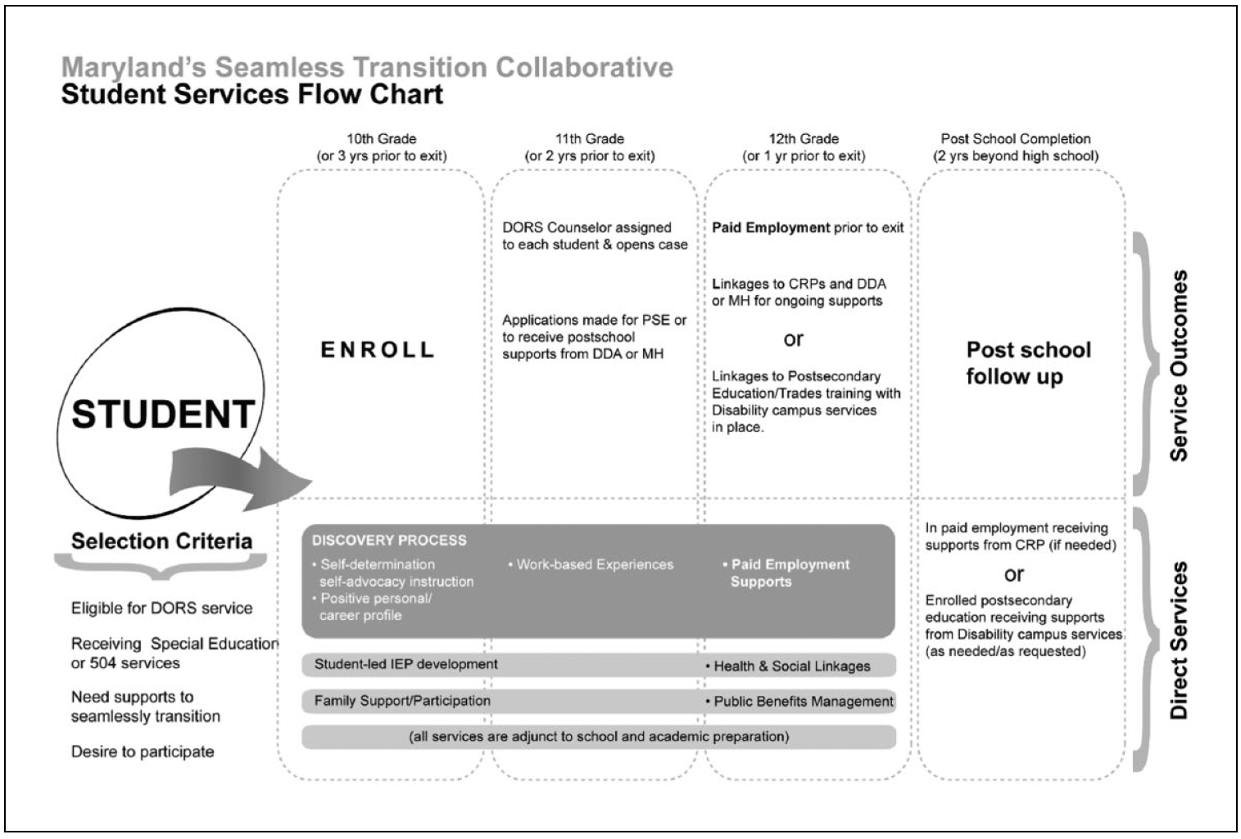

*Fig. 1.*

The proposition that partial work capacity increases vulnerability to job loss, whilst having merit, can be mitigated by pursuing other employment opportunities. Rather than simply the first open employment position available, employment organisations need to consider whether self-employment, which can be shaped around the individuals’ work capacity, is worth exploring. The work capacity distribution tables that accompany the DES Framework report illustrate an interesting set of bell curves, neither of which should surprise anyone familiar with disability. It stands to reason that DMS clients have a work capacity biased towards what are effectively permanent part time and permanent weekly work hours. ESS clients are naturally biased towards on call and casual work hours. With respect to assessed work capacity for clients in the ESS, the basis for determining capacity is a significant departure from evidence and is more in line with the notion that IQ determines success in life. Put simply, it has more relationship to chance or tarot when it comes to predicting success and I would suggest it is simply another barrier. Realistically it should be acknowledge for what it is, a tool for exclusion.

**National Disability Strategy.**

Given that we are six years into a ten-year strategy and levels of employment within the public sector have fallen, I have little faith that the current Taskforce will have an impact. Similarly whilst social entreprise models hold some possibility, there is concern for the growing trend for ADE’s to appropriate the term and rebadge their organisations as social entreprises without making any significant change to how they operate. Certainly it is difficult to find many that fit into the characteristics of true social entreprise highlighted by research (Smith, McVilly, Chan and McGillivray, 2016).

**The NDIS.**

There are some real issues with the current disability employment support system. The current system of supports that based on the simplistic assessment of capacity of less than 8 hours finds a person directed towards day services defies logic. Day services and ADE’s are anecdotally where NDIS planners are directing participants, essentially into a life of perpetual holding. Likewise the Transition to Work programs that commence after school is completed compound the problem of being deemed unemployable. This level of low expectation that pervades the system that should in fact be sponsoring engagement with employers and job preparation is dysfunctional and not working for the client only the system itself, which is predicated on the path of least resistance, needs to change. Much of this low expectation is in my view driven by the inability of the system to properly engage in the transition process at least two preferably three years pre school exit, in line with the evidence, something that we currently ignore and have done so for forty years.

Stevenson and Fowler (2016) mention that schools need to expect to engage with employment professionals. The current School Leaver Employment Supports (SLES) is predicated on an initial assessment by a school teacher, however this is questionable when you consider that school teachers may have limited labour market knowledge. This suggests that any systems that engage with schools need to develop an active collaboration with the school system.

The National Disability Employment Framework – Discussion Paper November 2015 highlighted a number of benefits of a more flexible system that facilitated early intervention as being:

* *more effectively transition young people from school to work;*
* *encourage participation from some people with disability who are currently not participating in the labour force;*
* *better assist those who acquire disability while engaged in the workforce and need support to retain employment or re-train for different roles; and*
* *provide early intervention and ongoing support to people with disability already in work, to strengthen support for long-term career goals.(p19)*

Clearly the NDIS needs to function as service that can support an individual, with the disability employment system shaped to support real client choice, not one that supports an industry that at present isn’t serving it clients or for that matter employers. It is this challenge that needs to be considered when considering the future of DES. Measured against the ongoing costs of providing the Disability Support Pension, there is a strong case to question whether DES has any real future in it current form. Certainly you should be questioning whether we need a separate DES when we have an NDIS that provides an opportunity to rewrite the disability employment system.

This report has highlighted the declining performance of DES since 2010, something that is unlikely to change whilst providers are rewarded in their current way. Clearly the focus needs to shift towards evidence-based practice and payment more closely aligned with client expectations, career planning and long term outcomes.

The idea that DES will effectively provide a pathway to employment should by now be seem for what it is, a furphy! This conversation wouldn’t be happening if DES had met its expectations. Current TTW programs only work to prepare clients to enter DES, something that a number of DES providers have manipulated to their own ends to achieve higher star ratings. On that sense they are simply using clients as fodder for their own bottom line.

The current system of outcome payments needs to be revamped to more closely reflect the actual input of the provider, not simply a payment based on what most of us would consider a short-term job. I find it interesting that this report excused DES outcome performance as something outside of its control. Whilst economic factors certainly influence labour markets, the larger influence on DES outcomes may simply be the providers inability to think outside of the box and actually pursue real long term employment opportunities rather than pursuing short term placement fees.

Of interest in the acknowledgement that the JSCI may have had an impact. Possibly this may also indicate that the DES providers lack staff with sufficient knowledge of disability types to actually properly service the clients. There is certainly evidence that a number of providers have eschewed disability knowledge in preference to sales and marketing ability as the preferred skill set.

**Chapter 3. Improving Participant Choice and Control.**

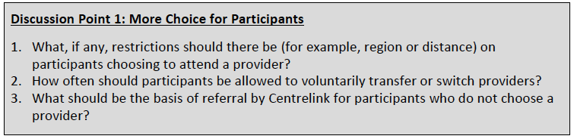

*“Most DES participants are restricted in choosing their provider and have limited awareness of the services they can receive and how they can receive them” (p23)*

This statement highlights something of a failing within the DES system and alludes to one of the major challenges to improving performance and choice within the system. Recent experiences with parents of children and young adults with a disability has highlighted to me that most have little knowledge of the DES system and the few that have recite poor experiences. Before we consider whether there should or shouldn’t be restrictions on choice (something at odds with DSA (1986) and UNCRPD obligations) we should consider what the real barriers are.

In my view there are two main barriers:

* Lack of communication and understanding of who is who and what they do and,
* Poor transition points or rather the inability to transition seamlessly from school to employment services

Clearly we have a broken system. Schools are inadequately equipped to handle school to work transitions, the transition point starts to late in the students’ life *(refer taskforce report chart p7)* and the system itself actually means transitioning from a state to a federal system. These aspects along with having to constantly justify your disability have been recurring themes in my thesis research into the DES system, participants and consultant experience. These have also appeared to some degree in my social entreprise / ADE research and have been regularly highlighted in the media.

Whilst restrictions on provider choice and participant movement have some merit from a system management perspective, in reality they simply serve to ensure that providers have a guaranteed income up to a certain level. Whilst this might promote a level of certainty for the providers, it also encourages sharp behaviour and in my view discourages real investment in the client. If the funding moved to the client and was portable, it would then be possible to reframe the services so that providers receive payment for providing specific services. For instance, on intake fee of $300, a Discovery fee of $2000 to encourage real understanding of who the client is, Client Prep fee $700, Work experience fee $200 per experience and so on. This would mean that providers would receive a commensurate fee for service and also allow the client to move to another provider if the relationship breaks down or the provider is not meeting the client expectations.

All services delivered would need to be evidence based and the client / service provider both agree to what is to be delivered and sign off as agreed services are delivered.

Quite simply providers would be exposed to true free market forces consistent with normal business practices and eliminate the need for the government to subsidise the quasi-free market that disability employment services have become.

**Flexibility in Service Delivery.**

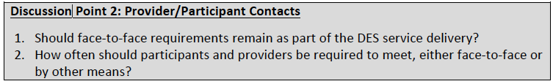

I believe that the question of face-to-face requirements is framed from the perspective of participants coming to the DES provider. This assumption is wrong. Evidence based practice requires that the provider goes to the client. Real customised employment, which has a forty-year evidence base, starts at the clients home, something that was a feature of the old PSP program. Unless you truly understand who the real client is, then you have at best a limited chance of achieving a long-term employment outcome or career pathway for the client.

The answer to the question doesn’t lay in prescribing the number of appointments, but in determining what needs to be done to ensure that the client reaches their employment goal. The question also assumes a certain position, which is false as the starting point for DES is wrong and flies against the established evidence base. Flexibility in service delivery is desirable and in the recent National Disability Employment Framework – Discussion Paper November 2015, on the subject of flexibility it stated:

*“As well as eligibility, broadening the pathways into disability employment services should be considered. This would include referrals from the NDIS, other existing service systems, such as health services, and also by contacting the service directly for assistance. In particular, there would seem to be scope for investigating streamlined planning and assessment processes with the NDIS for those in both systems under an individualised funding approach. In all cases, it would need to be determined if an individual is eligible and whether the disability employment services system is the most appropriate system to meet their needs. In particular, jobactive, plays an important role in supporting people with additional, non-vocational barriers to employment or that do not meet the 8 hours per week threshold.”*

*“Consideration should also be given to individuals remaining in the system over their working life, to ensure they can easily access employment support services if needed. The intention would be to build a system which reacts before an individual is at crisis point and in need of multiple supports, including income support. It would also allow more longitudinal tracking of individuals and their employment outcomes.”(p19)*

This process also included:

*A comprehensive career planning process once an individual enters the system. The process could be strengths based, focusing on the participant’s career goals and aspirations, while taking into account their capacity to work, local labour market conditions and their responsibilities to implement a career action plan.(p19)*

Clearly flexibility and early intervention have been considered as part of any system that is designed to meet the client need and address current system failings.

**Job Plans.**

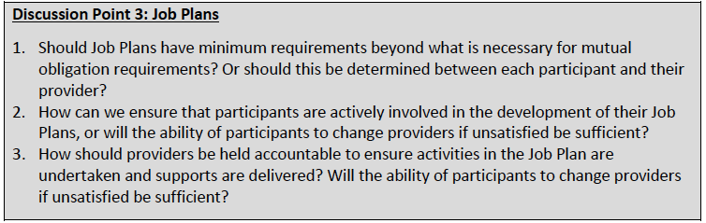

*“Participants have given feedback saying that they have little input into their Job Plan, and that Job Plans are used mainly to list a participant’s mutual obligation requirements, rather than the services a provider will supply to a participant to help them to achieve employment.” (p25)*

Point one of the discussion highlights how the system isn’t about being person centred or for that matter about real client outcomes. Clearly if you want clients to be actively involved in the process you need to develop a real understanding of who the client is. That isn’t something that is a feature of current practice, which as indicated by the above statement, appears to be about Job Plans, Mutual Obligation and EPP’s.

Surely by now providers will have realised that client activation will always be an issue when you disengage the client right at the start by having to formulate a Job Plan when the provider hasn’t invested any time in discovering who the real client is?

The first service to actually engage the client in the process beyond their office, gets outside and develops a real understanding of the client, their environment and natural supports will be inundated with clients. Relationships, trust and other personal factors are real and meaningful to client engagement and success. It isn’t possible to draw up a job plan simply by reviewing a JCA and spending an hour with the client.

The notion that increasing detail in the job plan will increase the provider obligation or as they like to refer to it “red tape” lacks validity. The current system doesn’t work because providers don’t engage properly with the client and job plans show little innovation in supporting the client to discover who they really are, their skills, supports and career aspirations.

There needs to be consideration for moving away from job plans and a focus on career development. Job Plans are currently used by providers to gauge employment success based on job longevity and placement rates, rather than focusing on client satisfaction which may simply be a reflection of low expectation by service providers (Wehman, Brooke & Inge, 2001). A shift to focus on career development may improve expectation and shift the balance in favour of the client and their aspirations.

**Better Information to Improve Decision Making.**

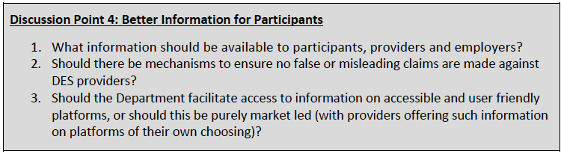

Information is the bedrock of informed decision making. As a starting point, disability employment service providers as recipients of taxpayer funding should as a condition of service provision provide full and transparent information about their business. It should detail ownership, management, services, full time locations, staff numbers, case load numbers, employment placement by industry, job title and longevity of employment numbers as a starting point.

The discussion paper has highlights a number of information options, most of which make sense. However the following suggestions have limited validity in that they presuppose knowledge about the client that isn’t apparent.

* *provide job search capability that matches a person’s work capacity and profile with jobs*
* *provide information on a participant’s barriers to employment, for example, ESAt information*
* *provide disability specific job search links and fact sheets (p26)*

Without a detailed understanding of the client, then these three suggestions lack both context and evidence. The additional comments regarding the quality of the service provider and their capacity are at best subjective and in the case of the star ratings, bear no relationship to quality and capacity.

*“By improving the information available to participants and the means of accessing that information, participants will be better able to take advantage of new initiatives like the participant-controlled funding and the greater choice available through the market reforms.”(p26)*

I’m not sure what market reforms alludes to, however I would suggest that any starting point for comparison of service provision would commence with providers using a mandated evidence based practice as a standard. At least if this were the case clients would be comparing apples and apples, rather than trying to guess what providers are offering. Success in employment outcomes would then come down to the ability of the provider service and leave little room for creaming and parking of clients.

**Participant Controlled Funding.**

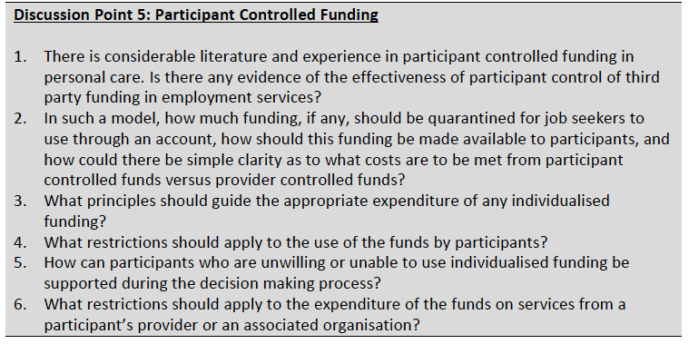

The question of participant controlled or client controlled funding has already been answered by the NDIS. However I recognise that unlike developmental disability, the capacity to work and employment success are difficult if not impossible to quantify with any degree of certainty, when you have to account for so many variables, such as environment, skills, supports, dexterity and so on.

Possibly the simplest proposition would be for all clients to have access to a set fee structure for services rendered by the provider, such as mentioned on page ten. This would be easy to implement with providers using standardised evidence based approaches and working to a fee schedule as per the NDIS payments schedule. Once certain points are realised in the approach, then the client based on industry types or field of endeavour would then have available pool of funds to support the client to enter and maintain employment in that chosen sector. This could be assessed in the same manner as prescribed in Chapter 3, Part 2, Division 2, Section 34 of the NDIS Act 2013 under Reasonable and Necessary Supports. Whilst there is propensity for fraudulent activity, these supports could be agreed to by the client and provider, with DSS providing agreement and compliance to ensure what is reasonable and necessary is appropriate to the individual.

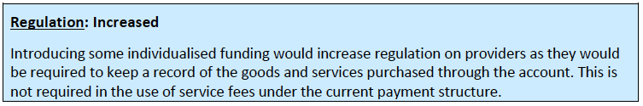

The idea that increased regulation would be a feature of this approach based on the comments in the above box seems inconsistent with tax regulations regarding to recording of expenses or are we to assume that providers currently have carte blanche to spend without recording expenses against clients and accounting for the spend?

Many of the points raised in the questions box could quite easily be adopted from the NDIS framework, which given the large numbers of DES providers who are moving into that space suggests that they don’t foresee any issues with accounting for spending.

**Chapter 4. Competition and Contestability in DES.**

Clearly there are issues within the DES market. Despite having providers supposedly contracted to deliver person centred services, there is little evidence of person centred practice truly being adopted. This I believe is a result of having a system of practice that favours those that can manage compliance best and act in a manner that favours short term results over long term career outcomes, which are more closely linked to person centred practices. Star ratings prevail at the expense of client centred practice.

Given that the performance framework isn’t part of this review, then it is unlikely that real reform can be achieved. The discussion referenced to page thirty of this review relating to capacity to be able to deliver services is heavily weighted towards existing and large-scale providers or services. There is little opportunity to attract smaller innovative providers, which is at odds with the provider system within the NDIS framework that allows for localisation and innovation.

If the government were truly about promoting competition and innovation in the marketplace, then they would adopt a simple registered provider system and let the market decide who stays and who goes.

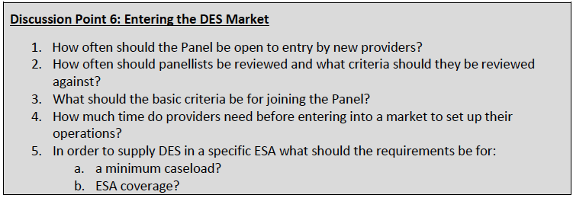

The National Disability Employment Framework – Discussion Paper November 2015 highlighted the need for increased competition, stating:

*“Another cornerstone of an individualised market-based approach is to deregulate the market and increase competition so that it can be responsive to consumer choice. The current approach provides for a controlled and regulated market with only one consumer in the marketplace, the Government, which only tests the marketplace periodically. There is an opportunity for a more open and less regulated market which could be achieved in a number of ways.”(p21)*

The provider panel should be open to everyone that meets the registration standards with no close off point. This would ensure continuous competition and force the larger providers to invest in innovation and focus on person centred services delivery. This approach would be consistent with the National Disability Employment Framework – Discussion Paper November 2015, which highlighted the following advantages of market-based service provision:

*“Consistent with the Harper Competition Policy Review and the evolution of disability employment support services over time, improvements to the current system could be made by adopting an approach that places individualised funding, consumer choice, and a more open and competitive market at the centre of disability employment services delivery.”*

*“It is anticipated that such an approach would link resources directly to participant need and dedicated to achieving specific individual outcomes. This would:*

*• empower individuals by giving them choice and control over where and how they receive services;*

*• make service providers more responsive and accountable to participants;*

*• encourage competition between providers which improves quality of service and fosters a diverse range of service providers which are better able to meet diverse needs;*

*• have a long-term effect of raising community expectations of people with disability; and*

*• align with other Government systems which provide individualised, market-based service provision, such as the NDIS.” (p15)*

The DES system like all taxpayer-funded services should be about delivering high quality personalised services that the client controls. Organisations that deliver personalised client driven services that meet the markets demands will prosper. Anything less than that will see services fail. It is not the governments’ responsibility to ensure that edifices to inefficiency and gaming exist. They are privately owned enterprises and as such should be subject to market forces.

By opening up the market to new players, smaller innovative organisations can prosper with minimal overhead and start up times, as if you remember in a modern economy with significant technology available, it is possible to operate from virtual offices and have reduced head office requirements. I make the point that this is an opportunity for more funding to be invested in the client and outcomes rather than supporting organisational bloat and overhead. This discussion is not to dissimilar to the one fostered by service providers when the NDIS was announced about how would they ever survive on $44 an hour for support staff, when they estimated an overhead of at least $70. The reality is that 60-70% of government money invested in service provision via third parties simply funds the overhead with little of the investment reaching the client.

This is an opportunity for the government to reverse this trend and see greater investment in the client. An open market system that forces providers to become lean, agile and evidence based will produce better outcomes.

ESA coverage and caseloads will find their own levels. In order to work to an evidence based framework and get quality long term meaningful results, consultants will have to invest considerable time with the client up front which over time will dictate case load sizes. This also highlights that fact that setting maximum and minimum caseloads is in effect a barrier to business. Caseloads should be determined by owners of the business and their business plans, not based on the flawed prime provider model. ESA coverage is largely redundant, however it may serve a purpose where there are to few or no providers in a geographic area and it may require government intervention to attract providers to that area. Similarly the framework noted that ESA’s prevent providers from working with large national employers, which highlights the unnecessary impediment that having ESA’s maintain.

**Single DES Contracts and Competition.**

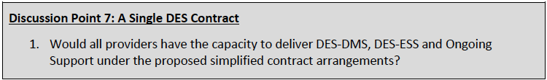

Overseas experience highlights that there is no sound reason why delivering DMS and ESS should be separated. The provision of services to people with a disability is the same whether the disability is life long or temporary. The current process is simply arbitrary without any clear logic. The combining of both into a single program would have the effect of creating more competition and opportunity for local businesses to combine and deliver services into areas that in the past they would not have contemplated. This can only be good for clients and local communities.

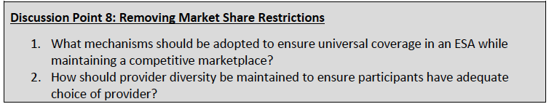

This will also go some way to addressing competition in local marketplaces and adequate choice. However markets aren’t necessarily perfect and it is likely that large providers with significant overheads will shy away from some locations that they don’t perceive as “profitable” to service. This may require the introduction of a tiered payment system to ensure providers enter these markets and appropriate levels of choice for system participants.

**Preventing Market Failure.**

Whilst market failure shouldn’t be something that the government seeks to intervene in, certainly not in a free market economy and certainly not based on our current government market driven philosophy, there may be a need to ensure that providers don’t simply flock to the high population high profit areas.

This can be simply addressed by reverting to limitations such as we have seen where a provider can be limited to a 25% market share, which would have the effect of forcing providers to service what could be described as low population areas. Again by tiering the payments you could ensure that providers are attracted to these areas. Similarly they could also present as opportunities for government to foster the development of local businesses to enter the market in their local area.

Simple solutions with minimal red tape!

**Chapter 5. Aligning Incentives for Better Outcomes.**

*“The Taskforce found that the current funding arrangements do not provide the right incentives and do not adequately link provider performance to revenue. As a result, providers can generate enough revenues to sustain a viable operation by just having DES participants on their caseload, while achieving relatively few employment outcomes for them.” (P36)*

There has never been a statement that perfectly summed up DES, as the above!

Aligned with the lack of evidence-based practices, creaming and parking is it little wonder that DES has progressively failed to deliver. There is no incentive to improve when you can build a profitable business based purely on being allocated clients and gaming the system, aided by the current performance framework that largely disregards the clients, meaningful employment and the quality and longevity of the outcome.

*“To ensure that all providers are seeking to maximise employment outcomes for DES participants, it is proposed that a new funding model be developed that does the following:*

*- continues to place employment outcomes at the centre of DES;*

*- gives participants more control over the supports they receive; and*

*- better aligns provider revenue with provider performance.”(p36)*

A new finding model based on the use of evidence based practices such as Customised Employment and the Discovery Process – something mandated into law in the USA will place the client firming at the front of the process and ensure that the clients receives both control and appropriate supports. These processes can be costed and a set fee applied to each stage of the Customised Employment process, as is the norm in the USA. Whilst unlikely to appeal to the providers, it does provide certainty to government funding, easily verified processes and forces the provider to actually invest real time in working with the client to get the best outcome. In other words they have to get out of their offices and into the clients neighbourhood. It will also satisfy the systems obligations to be person centred and meet our UNCRPD obligations.

The idea that providers can receive $15,000 just for having a client on their system is ludicrous, akin to being forced to pay money to visit a grocery shop to look at their products for sale.

Along with service fees for particular functions carried out, it is important to consider the impact of helping the client to find or create meaningful employment. As such it is important to measure the real impact of getting and maintaining job. Holding a job results in considerable cost savings to government across a wide range of community services and this impact should be part of the outcome measure. Factors such as inclusion, cohesion, employment and self-determination need to be measured to ensure that the employment outcome is having a net positive effect on the community and government spending. It is possible to create this type of measure which is currently being researched and along with this ensure that providers focus on the whole of the client, not just a self interested rush to any McJob that will earn them a fee (Smith, 2016).

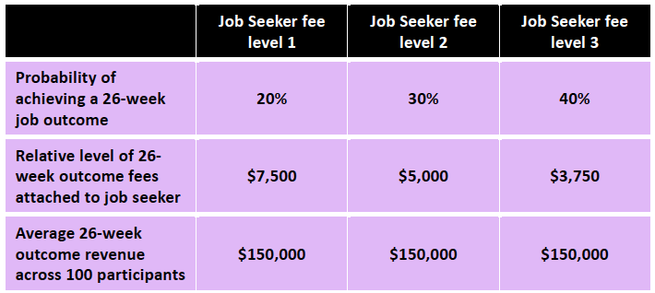

The risk-adjusted model of compensation illustrated above from the discussion paper highlights a good starting point, however how do you determine which client goes into which category without actually knowing anything about the client?

Clearly JCAs, ESAts and JSCI aren’t reliable indicators of employment capacity, particularly if you look at the evidence created by Marc Gold in the 70’s. My suggestion would be that you make no assessment of work capacity of benchmark hours until the client has been permitted to work through the full Discovery process, which will allow a far greater knowledge of the client and their capacities to be discovered. Only after this process has been completed and a true understanding of the client capacity and likely support needs has been determined can you then apply some sort of weighting. It won’t be difficult to develop a weighting scale based on this data, particularly given the extensive data on supports and accommodations that apply to specific disability types that the government would have based on the past DEN / DES experience which in turn could be validated against US experience with these processes. This is data that I work with regularly.

**Short Term and Long Term Outcomes.**

Whilst I acknowledge that the economy is changing and with it a strong case for self-employment, the changing nature of employment and the idea of casualisation in itself is simply another variable. Employment for DES clients should be shaped around their work capacity and importantly their work desire. Clearly this may present some issues in determining how much money to pay a provider, afterall what amount of effort is necessary to create an 8-hour opportunity versus a 25-hour opportunity? The solution to this is quite simple, the hours that client works is irrelevant to the outcome payment. More important is the longevity of the outcome and the net effect on government outlays via Newstart or DSP. Link outcome payments to government outlays with possible increased service fees to compensate for lower level income outcomes if those outcomes meet the client specified employment outcomes. These targets can be set and agreed to after the client has completed a proper Discovery process. The client can be the final arbiter of this process, which would also highlight how effective the provider was at building the right relationship to support the client’s journey.

This type of method also addresses the issue of aligning service fees to actual actions, something that the Discovery Staging Record could be used to evidence for proof of payment from the government (Smith, 2016).

**Improving Transition from School Outcomes.**

The flaw in the system is in denying full time school students to access DES. Whilst I have little faith that DES is the correct vehicle for this process, the process itself should begin at least three if not two years prior to exiting school. I refer you to my comments and charts on page seven of this document.

The current process is simply about determining whether students end up in DES or and ADE and have been exploited by providers who simply groom students for two to three threes before passing them into DES for additional payments and with the benefit of several years of prepping, better star ratings, once again highlighting the ineffectiveness of the star ratings as a predictor of real service and long term meaningful employment. Clearly self-interest on the part of providers will stifle real change in these areas.

Much of this has been covered in Chapters One and Two of this response, however I draw your attention to Stevenson and Fowler (2016) and their view on the benefit of Discovery in the school transition process.

*A final consideration is to emphasize the qualitative*

*methods of the discovery process in all areas of transition*

*assessment as they are applicable to employment, independent*

*living, and postsecondary education. For example, for*

*independent living, observations could be conducted in the*

*student’s place of residence and community settings to inform*

*plan development. Similarly, for postsecondary education, a*

*student could be observed sitting in on a lesson at a college or*

*interview the office of disability services to gather information*

*on skills needed for success in that setting. Although this*

*can be more resource intensive, it yields more student centered,*

*actionable information for planning (Neubert & Leconte, 2013). Furthermore, qualitative methods may provide*

*practitioners with an effective process for students with*

*more complex needs for whom identifying postsecondary*

*goals can be challenging (e.g., students with IDD).(p61)*

This simply highlights the effectiveness of qualitative methods and observation within the school system and their beneficial nature in developing post school options.

**Chapter 6. Improved Gateway and Assessment Process.**

Why assess at all?

*“Feedback from Taskforce consultations identified the administrative processes surrounding ESAts/JCAs as a focus of concern for DES providers. In particular, the assessment process was seen as time consuming, cumbersome and confusing for job seekers. A number of respondents complained about the lack of availability of appointments with DHS assessors to undertake ESAts/JCAs and that, even when available, appointments were often too far in the future.” (P47)*

Job seekers consistently complain about having to reprove their disability as they progress through the “system”(Smith, 2016). If you have cerebral palsy, it isn’t going to magically disappear, as you get older. What does change is your skill sets and career plans. This highlights the desire of the current system to put people in boxes without any regard for their condition and dreams. Likewise there is sufficient evidence to highlight the inability of ESAt and JCA to properly determine a client’s abilities and work capacities, a process that ignores forty years of evidence to the contrary. Given that the starting point is a diagnosis of your disability, it would be a simpler exercise to determine whether the disability falls into the categories as indicated below.

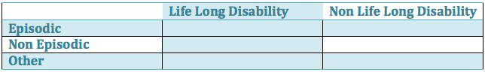

Whilst this is simply a concept, it does highlight that an alternative to the current costly, inaccurate and largely ineffective system is worth considering for development. Assessment for supports is appropriate, but not as is currently undertaken. Evidence highlights that school and community based work experience programs provide the ideal setting for assessing functional ability and limitations in work environments (West, 2001). Assessments would cover the full range of barriers to employment such as: work endurance, bathroom ability, eating and drinking, communication ability, grooming, mobility, hand use, medical needs, mobility, transportation ability, social interaction and academic skills. Many of these observable activities are accounted for in the process of Discovery.

Whilst much has been written about the current processes and it is apparent from the review document that ESAts and JCA assessments are something that the government or authors of the review are wedded too, if the review was serious then they would run a parallel project to develop the above suggestion and contrast it against the proposed review process highlighted below from Figure 7 (p46) of the document.

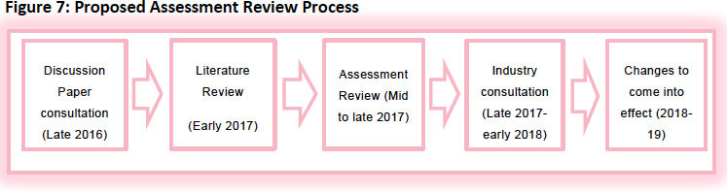

**Chapter 7. Assisting Participants in the Workplace.**

The idea of ongoing support is an interesting aspect of disability employment. Given that we know that natural supports in the workplace is a gold standard, it begs the question as to what is the DES doing to develop natural supports and in turn fade from the setting. To me this is evidence of the lack of adoption of Active Support in the DES setting and of course further evidence of the lack of evidence based practices in DES.

Ongoing support should be structured so that the DES provider supports the development of the employer staff to replace them. All organisations have go to people and it is these people that should be supported to develop the skills to support the client in the workplace. The development of co-worker and supervisors as natural supports could be part of the financial incentives available to employers to employ someone with a disability (Wehman et al., 2001; Griffin, Hammis & Geary, 2007; Wiegan, 2009).

In the event that no such person can assume this role, then it would be appropriate to have the DES enhance the employers’ skills so that they can assume this role. It also highlights the importance of the workplace relationship to the success of the placement long term and supports inclusion, cohesion and self-development factors. These in turn support meaning employment for the client.

Within the discussion paper it reference the AHRC’s *Willing to Work* Inquiry and in particular the following options:

* *better incentives for providers to deliver the right level of support by introducing a fee-for-service model for all levels of Ongoing Support;*
* *a skills review for participants at 12 months of Ongoing Support;*
* *better targeting of Ongoing Support by bringing forward the first independent Ongoing Support Assessment; and*
* *requiring the participant to be working a minimum number of hours to be eligible for Ongoing Support. (p49)*

What is missing from this discussion is the capacity of the employer to actively engage in supporting the client in the workplace through developing natural supports. Obviously business needs to be incentivised, so it may be appropriate for the ongoing support program to bring in employer development and develop a sliding payment scheme that reduces the provider payment as they activate the employer supports and fade. The DES could then be rewarded for longevity of the outcome, whilst the employer could also be rewarded for longevity and an ongoing support payment that cuts out at a predetermined point in time, subject to an independent assessment of the clients’ capacity and work outcomes.

Now this will require robust controls as it could and would be susceptible to rorting by both the employer and DES. Nonetheless it is a capacity building exercise and worth exploring. It would also go some way towards normalising disability in the workplace and enhance community cohesion and inclusion.

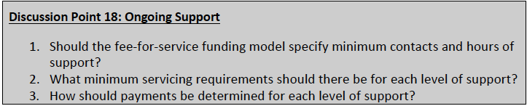

In response to the above questions, ongoing support, levels of support and payments determination should be set by agreement with the client and employer. Minimum support hours would be appropriate, as it would be inefficient and unprofitable to simply be at the employers’ request for ad hoc support. Minimum blocks of hours should apply, which in situations where the client doesn’t require a full block, that time could be utilised potentially by providing and supervising work experience for another client in that setting.

**Jobs in Jeopardy.**

The review notes that Jobs in Jeopardy participation has been declining and the DES complaints about the stigma attached to the name of the program. People and jobs are always going to be in jeopardy, however by utilising Customised Employment and Career Development strategies it may be possible to reduce this further by more accurate job placement. That said, Jobs in Jeopardy isn’t a feature of everyday work life, people loose their jobs regularly, so I question the necessity of this program. It would simply appear to be a social program, rather than an imperative in employment.

If it is imperative to retain said program, then it may be appropriate to build it into post placement support and possibly consider utilising a skills development program that takes the client out of the workplace and supports further skills acquisition to enhance job retention.

**Chapter 8. Building Employer Demand.**

Within the review document (p53) it references the Orima Research outcomes and states the following:

*“Perceived barriers relating to disability included: physical inability to perform the role, safety concerns and difficulties involved in adapting the physical work environment, such as installing lifts to make a worksite wheelchair accessible. Larger businesses were more likely than small and medium businesses to see benefits in employing people with disability, including the benefits of workplace diversity” (p53).*

This statement flies in the face of US experience with Customised Employment processes. Customised Employment and Discovery were a response to perceived lack of employment opportunities in rural areas with these processes producing significant results in small to medium sized business.

The idea that more business awareness activities are needed seems at odds with reality. It’s unlikely that there is anyone on the planet who isn’t disability aware after years of awareness programs. The simple reality is that the only reason to employ anyone is that they have skills that the employer can profit from. For me this highlights the inability of service providers to make a persuasive case for employment and a failure to adequately develop a profile of the real person.

Given that providers can make a good profit from service fees simply by parking people, then I’d question whether they actually have the necessary skills. Few providers these days employ staff with disability knowledge; indeed many five star providers only employ sales people.

Similarly the idea of highlighting the “benefits” of having a diverse workforce would be a stronger argument if it could be quantified into actual dollars and cents for employers. Most figures used are simply feel good warm and fuzzy reasons, which to be blunt don’t pay the bills.

It has been suggested that various employment awards can be used to highlight reasons for employing someone with a disability. Other than making a few employers and everyone attending the awards feel good, the tangible outcomes are difficult to define and I question what real impact awards have, as in a sense they’re preaching to the converted.

I’m not suggesting that employer demand programs don’t have a place, just that what we currently have and are offering is largely pointless to someone running a business without time to scratch themselves.

**Chapter 9. Transitioning to a New Model.**

Discussion point twenty is rhetorical. In light of the following statements within the review document:

*“The Taskforce highlighted views that providers were doing a poor job of matching participants to employers. As a result, some employers and participants report they are dissatisfied with DES because they churn through short-term placements that do not lead to long-term outcomes.” (P42)*

And

*“The Taskforce found that the current funding arrangements do not provide the right incentives and do not adequately link provider performance to revenue. As a result, providers can generate enough revenues to sustain a viable operation by just having DES participants on their caseload, while achieving relatively few employment outcomes for them.”(P36)*

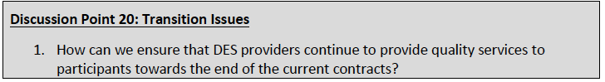

There’s a reasoned argument to be made that quality services currently aren’t evident across the system, so why invest in ensuring that something that isn’t generally the norm. In the event that the review opts to have DES providers fulfil their obligations under the UNCRPD, then by implementing client controlled funding model as per the NDIS prior to transition, with adequate notice and support clients are more likely to move slowly to new providers, hence any transition will be slow and unlikely to require incentivising DES providers for fulfilling their program obligations. Whilst this might provide an argument for installing some form of safeguards to ensure providers deliver services during a transition, the inability to deliver services that meet the clients’ needs would simply hasten the exit process and negatively affect the provider, incentive enough to deliver what they’re paid to do.

Quite simply, they’ve taken the service fees, now they just have to deliver what they’ve been paid for.

**Chapter 10. Summary.**

Moving to a new system that respects the clients and honours our UNCRPD and DSA (1986) obligations will require planning and a real commitment from government to deliver true citizenship for people with a disability. It will require a system that does more than use people first language, one that actually puts people first, not just as a commodity to support the provider industry and facilitate ABS data.

There area great many challenges, not just from those that wish to protect the status quo and their gravy train. It is incumbent on the government to develop a system that gives the client a voice and functions using evidence based practices and supports real ambition and full citizenship. In other word, a system that reflects an ordinary life in the community.

The question remains, does the government have the will to leave the past and vested interests and create real employment, real inclusion, real cohesion and real self-determination?

**References.**

Australian Human Rights Commission (AHRC). 2016. *Willing to Work: National Inquiry into Employment Discrimination Against Older Australians and Australians with Disability*. p.269-273. Available at: http://www.humanrights.gov.au/our-work/disability-rights/publications/willing-work-national-inquiry-employment-discrimination

Department of Social Services. 2015. *National Disability Employment Framework- Consultation Report*. p.6. Available at: https://engage.dss.gov.au/disability-employment-framework/consultation-report/

Department of Social Services. 2015. National Disability Employment Framework - Consultation Report. September 2015. Available at: <https://engage.dss.gov.au>

Disability Services Act 1986. <https://www.legislation.gov.au/Details/C2016C00953>. Accessed 1/12/16

Disability Service Standards. National Standards for Disability Services. <https://www.dss.gov.au/sites/default/files/documents/12_2013/nsds_web.pdf>. Accessed 1/12/16

Employer Practices and The Employment of People with Disabilities: Scoping the Literature. Cornell University, ILR School, Employment and Disability Institute, State of Science Conference, 2013.

Griffin, C., Hammis, D., & Geary, T. (2007). The Job Developers Handbook. Practical Tactics for Customised Employment. Paul H. Brookes Publishing Co. Baltimore, USA

Harper et al. March 2015. *The Australian Government Competition Policy Review*, *Final Report*. pp. 36-37. Available at: http://competitionpolicyreview.gov.au/final-report/

Luecking, D.M. & Luecking, R.G. (2015). Translating Research Into a Seamless

Transition Model. Career Development and Transition for Exceptional Individuals. 2015. Vol. 38(1) 4-13.

National Disability Insurance Scheme Act 2013. <https://www.legislation.gov.au/Details/C2013A00020>. Accessed 1/12/16

New Disability Employment Services from 2018 Discussion Paper, Commonwealth of Australia, Department of Social Services.

Orima Research Pty Ltd: *Business Use of Government Employment Services (Employer) Survey,* conducted by Orima Research on behalf of the then Department of Education, Employment and Workplace Relations

Productivity Commission. 2011. *Disability Care and Support: Productivity Commission Inquiry Report – Appendix E_*. Report Number 54, Canberra. Available at: http://www.pc.gov.au/inquiries/completed/disability-support/report

Senate Enquiry 2011

Smith, P. J. (2016). *A Systems Analysis of the Factors that Lead to the Employment of People with a Disability.* Doctor of Philospohy, University of Sydney.

Smith, P.J., McVilly,K.R., McGillivray, J.A., & ChanJ. (2016). Developing Open Employment Outcomes for People with an Intellectual Disability utilising a Social Enterprise Framework. Journal of Vocational Rehabilitation. Submitted for publication 2016.

Stevenson B.S. & Fowler, C.H. (2016). Collaborative Assessment for Employment Planning: Transition Assessment and the Discovery Process.. Career Development and Transition for Exceptional Individuals. 2016. Vol. 39(1) 57-62.

Ticket to Work pilot outcomes study. A quasi-experimental evaluation of pathways from school to economic and social inclusion. ARTD Consultants, 2016.

United Nations Convention on the Rights of Persons with Disabilities <http://www.un.org/disabilities/convention/conventionfull.shtml>. Accessed 1/12/16

Wehman, P., Brooke, V., & Inge, K.J. (2001) In: Life Beyond the Classroom, Wehman, P. (2001) Paul H. Brookes Publishing Co. Baltimore, USA

West, M.D. (2001). In: Life Beyond the Classroom, Wehman, P. (2001) Paul Brookes Publishing Co. Baltimore, USA

Wiegan, D.B. (2009) Job Success for Persons with Developmental Disabilities. Jessica Kingsley Publishers. London.