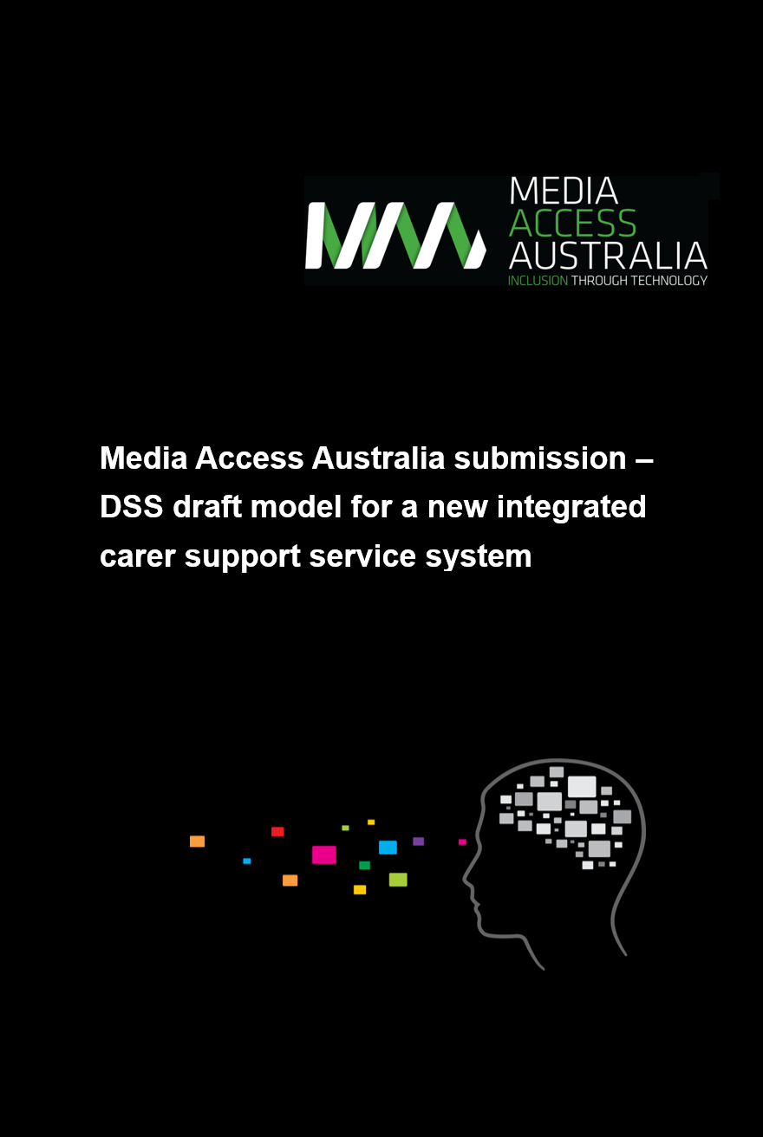

Media Access Australia submission – DSS draft model for a new integrated carer support service system.

Media Access Australia – who we are and what we stand for
Media Access Australia is the nation’s only independent Not-For-Profit devoted to increasing access to web and digital media for people with disabilities along with those who provide care and support. We believe that all Australians have the right to access all forms of media and information through technology, so that they can fully participate in this digital age.
At the core of our work is the understanding that exclusion from information and knowledge has profound effects on people’s educational outcomes, social inclusion, and levels of workforce participation. Inclusion is a critical issue, particularly for those with a disability and their carers, as the world becomes increasingly reliant on technology. Access to digitally-delivered media through technology can empower people to be independent, gain knowledge and make their own choices, so they can be active members of our society.

Table of Contents
Media Access Australia – who we are and what we stand for ……………………………. 2
Introduction ……………………………………………………………………………….…….. 2
Early intervention consumer technology support for carers and people with disabilities ……………………………………………………………………………………………………. 3
Accessibility of proposed online government services ………………………….…………. 5
Conclusion and recommendations …………………………………………………….…….. 6
Media Access Australia services ………………………………………………….…………. 6

Introduction
The purpose of this submission is to provide guidance to the Federal Coalition Government in regards to the access implications of the draft service delivery model for carers. Media Access Australia has identified some potential gaps in the provision of information as it relates to the draft plan’s outlined objectives, and some issues present in the current Carer Gateway portal.
This submission specifically focuses on how carers can be supported in the early intervention phase of the proposal and provide guidance on the effective use of disability-friendly consumer technologies. In addition, this submission assists government in preparing its proposed online resources in a way that can increase its benefit to carers and the people that they are supporting.

Early intervention consumer technology support for carers and people with disabilities
The draft service delivery model for a proposed new carer support service system emphasises that carers often don’t self-identify as a carer, but rather often view their role in the context as a parent or friend.
As such, carers are well placed to provide guidance to the people they are supporting, which in many cases includes people with disabilities, as to what consumer technologies are needed. This would also include identifying the best technology solutions for effective interaction and communication between the person requiring care and the carer.
The draft model notes that the following priorities are important goals for the provision of services going forward:
- Awareness and community linkages
- Information and advice
- Peer support
- Education and training
- Counselling
- Needs assessment and planning
- Carer coaching and mentoring
- Respite (emergency, short term and planned)
- Targeted financial support.
While these objectives are in themselves well selected, there is currently little content regarding their applicability as to how carers can provide support to people with disabilities in relation to technology choices. This includes the provision of information as to which of these technologies, such as smartphones and tablets, contain accessibility features.
The provision of mainstream consumer technologies to people with disabilities is critical in the role of a carer. By providing effective and accessible technologies to a person in need of care, it ensures that information can be obtained and shared by both parties and can be set up in a way that maximises communication and support between carer and the person receiving care. As such, the provision of information as to what accessibility features are available in popular mainstream products and how carers can provide guidance in this area is highly significant, yet does not currently appear to be considered in the draft model.
In relation to the first two points of awareness and information, Media Access Australia recommends that carers are provided with information and training as to what consumer technologies are most likely to benefit people with disabilities in their care. This would ultimately support the caring process through the use of assistive technologies built into the products and related apps that can provide disability-specific support.
As the availability of accessibility in popular products has changed rapidly in recent years, it’s imperative that carers and the people being supported by carers have access to the latest accessibility features available, especially given that with most of the accessibility features being built into everyday consumer products such as smartphones and tablets, such benefits can often be achieved at minimal cost. By contrast, not having such devices with accessibility features could significantly reduce the ability for carers to support people with disabilities or access the government information proposed in the draft.
Key questions that could be supported in the draft in the form of providing information and/or training to carers, includes guidance on:
- Will the individual with a disability require multiple input methods if the computer or mobile device supports it? For example, should a keyboard be plugged into an iPad or a Windows computer be supplied with a touch screen?
- Is one platform better than another for a specific individual’s needs?
- Are there free or low-cost apps available that can assist a carer?
- If additional support is required, are there specialist products that can help?
- Which products contain accessibility features that can maximise access to associated government online resources?
Devices such as the Apple iPhone, Apple iPad, Microsoft Windows-based computers and tablets, along with recent Google Android-based smartphones and tablets, all contain a wealth of accessibility features. Examples include:
- Screen reader: A text-to-speech application that reads out computer and internet-related information to assist people who are blind or vision impaired.
- Screen magnifier: A magnification tool for enlarging screen content for those with a vision impairment.
- Themes: High-contrast themes allow people with visual impairments to change the colours to a more comfortable setting (such as white-on-black), and increase the size of mouse pointers and text.
- On-screen keyboard: Enables people with mobility impairments to ‘type’ by using a pointing device to select letters and words on the screen.
- On-screen alerts: Visual messages can appear in place of audible sounds to help people who are Deaf or hearing impaired.
As noted in the draft proposal, the key role of the integrated carer support service would be to proactively support carers earlier, and build their capacity to sustain their caring role; provide support where carers are in, or at risk of, a crisis, which might adversely affect their caring role; provide support for carers to improve their long term social and financial outcomes; and support carers to be able to participate in everyday activities such as education and the workforce.
By equipping carers with the knowledge on which consumer-based technologies are best for both carer and the person being supported, carers will be in a better position to provide care earlier and can then use the devices to gain access to apps and the proposed government services such as websites and social media. This would ensure that there is a consistent technology baseline from which carers can then engage with the other online government services proposed in the draft.
As such, Media Access Australia recommends that, as part of the new service delivery model, carers are provided at an early stage with information or resources relating to affordable and accessible consumer-based devices such as computers, smartphones and tablets. This will then allow them to make informed choices about how to support people in their care and how best to engage with the government information and services which are provided as part of this initiative.

Accessibility of proposed online government services
The draft model lists a number of technologies that will be used as part of its service delivery. Some examples discussed in the draft model include:
- National website
- An ideas and inspiration wall for carers to read and post carer-related content (similar to Pinterest)
- National marketing and mailing system
- Social media.
While Media Access Australia agrees and supports the government in the implementation of these technology-based solutions, there is a concern that little discussion features in the draft relating to the accessibility of these services.
In the previous section it was discussed that carers and the people that are being supported by carers require consumer devices with accessibility features to be able to effectively access information and communication resources. However, it is unlikely that people with disabilities will be able to access this information, nor carers with disabilities, if the associated web portals and information services are not created based on the World Wide Web Consortium (W3C) Web Content Accessibility Guideline’s (WCAG) 2.0 standard.
The Federal government has stated that the WCAG 2.0 standard is a mandatory requirement up to the implementation Level AA. While it may be the case that this was not specifically highlighted due to the presumption that the standard will be implemented across all associated content, current initiatives to date suggest that the WCAG 2.0 standard has not been effectively implemented in some key areas such as the Carer Gateway portal.
The portal states that it is WCAG 2.0 compliant, but doesn’t currently state to which level. An assessment of the website by Media Access Australia suggests that, while it is likely that accessibity was considered during its initial build, a number of accessibility issues are currently present when tested to the mandatory Level “AA” requirement.
Issues identified include:
- Colour contrast: the two “Start here” buttons on the homepage use white text on a blue background which doesn’t pass WCAG 2.0 “AA” colour contrast requirements.
- Images on text: The image promoting the service delivery model contains text in the image which assistive technology users cannot access.
- Keyboard navigation issues: people who use a keyboard to navigate sites such as those who are blind or vision-impaired, are unable to access all website elements.
- Link purpose: several links need to be more descriptive so that people using assistive technologies can understand the context of the words when they are read out.
As a result, it is likely that key information on the Carer Gateway website cannot be accessed by the one in five Australians with a permanent disability. Given the significance of proving support to people with disabilities in the service model, it’s critical that any web portal designed to support carers and people being supported by carers are effectively able to access the web, social media content and any other web, app, or document-based electronic information available as part of the proposed service model.

Conclusion and recommendations
In conclusion, Media Access Australia supports the current draft proposal. In order to strengthen it, we recommend the following additions to the model:
- Information and training to be provided to carers regarding the availability and affordability of consumer products such as low-cost smartphones and tablets so that people being supported by carers can have the accessibility features they need, which will in turn maximise access to the proposed online resources.
- All websites, apps and documents should adhere to the mandatory WCAG 2.0 Level “AA” requirement, with checks made periodically to ensure that the accessibility level is maintained.
- The accessibility issues that are currently present on Carer Gateway should be addressed as soon as possible, with clear information regarding its WCAG compliance and the testing processes published.

Media Access Australia services
Media Access Australia provides a wide-range of training, consulting services, task-specific guides and technical information covering the main areas of accessibility. As the nation’s only independent Not-For-Profit devoted to increasing access to web and digital media for people with disabilities along with those who provide care and support, we believe that all Australians have the right to access all forms of media and information through technology, so that they can fully participate in this digital age.
We work with federal, state and local government agencies in Australia to ensure that online communications are accessible to people of all abilities. Our services include:
Digital Accessibility Maturity Assessment (DAMA) – an extensive low-cost review of your current methods and processes assessed according to management best practice, against a clear set of external benchmarks. The detailed report examines the risk associated with these levels and puts forward key priority actions.
Auditing existing web and app content – for a formal audit of existing websites and apps, across a range of browsers and devices, testing against international WCAG 2.0 standards (‘A’, ‘AA’, ‘AAA’) and looking at key processes, as well as static content on the website.
Training – we offer programs that are practically-based and use real-world situations. This includes creating accessible content in Word, PDF and InDesign. There are specific modules for accessible social media, video content, Excel and forms. For web professionals, we offer our higher-level six-week online Professional Certificate in Web Accessibility course.
Document accessibility – for documents, forms and maps that need to be made accessible, we provide document remediation in a range of formats that meet benchmark accessibility standards. We can also help you create accessible templates for documents and forms.
For more information, call 02 9212 6242, email accessibleservices@mediaaccess.org.au or visit http://www.mediaaccess.org.au/digitalaccessibilityservices for our full range of services.

