Prepared by
Nicole Hitchens, Silvia Rosenstreich and Megan Butt
Disability Advocates
Our Mission:
We partner with individuals and organisations to promote independence, strength and wellbeing in our community through support, advocacy and education.
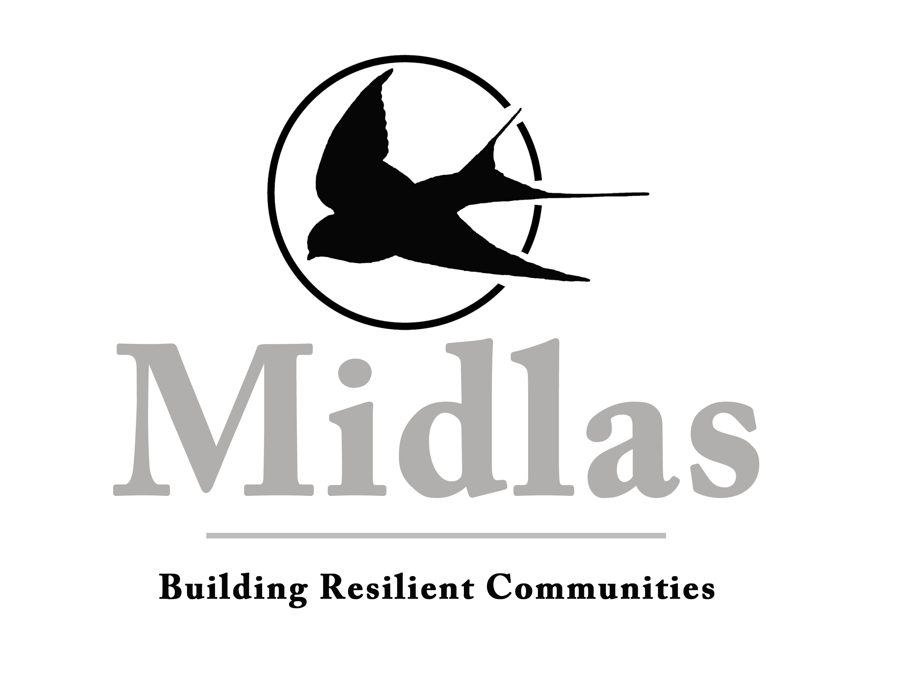
Delivering an integrated carer support service - Submission

Response to Discussion Paper
“Delivering an integrated carer support service”
Midlas Submission
Prepared by
Nicole Hitchens, Silvia Rosenstreich and Megan Butt
Disability Advocates

Introduction
Midland Information Debt and Legal Advocacy Service Inc. (Midlas) is a not-for-profit community organisation based in Midland, Western Australia. Midlas provides individual disability advocacy for people with disabilities living in the City of Swan, Town of Bassendean, Shire of Mundaring and Shire of Kalamunda. We assist clients with disability, carers and guardians to ensure they understand their rights and responsibilities and can participate fully in their community.
Midlas assists people with disability in relation to accessing disability and mainstream services, providing linkages and referrals, support through the National Disability Insurance Scheme (NDIS) and assistance going through the appeal processes, assisting clients to access income support payments and communicate with Centrelink.
Below is the response to the questions raised in the Discussion Paper.
Program Overview
Midlas supports the idea of a proactive rather than reactive/crisis response for carers which recognises the importance of their caring role and what support the family needs in order for this relationship to be sustained. Although Midlas are funded for individual disability advocacy, part of this support is often providing assistance and advocacy for and with the family to which the person with disability belongs. We recognise that many carers do not know what resources and assistance is available and how to access this information. In particular, ageing carers may experience additional barriers navigating online resources and within the changing disability landscape under NDIS this is constantly evolving. The development of easy English information which is available in a range of languages will also assist carers who may have a disability themselves or come from a Culturally and Linguistically Diverse (CaLD) background.
The development of peer-to-peer networks is something to be encouraged/explored where carers as well as people with disability have the opportunity to share stories, resources and support with those that have lived experiences. There needs to be a focus on not just online resourcing, but face-to-face localised support for carers.
The “no wrong door” principle is paramount in ensuring that carers are offered support regardless of who or how they ask for it and that “bureaucratic red tape” is reduced as much as possible. It is vital that the primary points of contact for many carers – GP, school staff, church groups, community organisations, chemists and the like – are well versed on what services are available to support carers and how to connect to these services. This would assist so that even the most isolated carer can be supported in linking with appropriate services. At the very least, having readily available information for these primary points of contacts to pass on to carers should be resourced.
Working in the sector, many gaps are apparent in the support of carers – particularly in the era of NDIS which focuses its support on the person with the disability. Although it is hoped that the Information, Linkages and Capacity Building (ILC) component of the NDIS will help in this area, there needs to be discussion around how these two systems can work together and complement each other in support of carers to ensure that the “no wrong door” principle is upheld and carers are not bounced from one system to another.
In regards to the National Education and Training Initiative, recognition needs to be given in this area of the array of skills, knowledge and experience carers bring to the caring role. It is imperative to include carer experience and insight into the development of any programs offered as part of this initiative. Carers (if they wish to) should be given opportunities to be trainers themselves as well as offer peer to peer support to those that need it. Training should also be catered to the individual – cultural sensitivities need to be considered in the delivering of any training to ensure that the targeted audience is assisted rather than insulted.
The National Counselling Program is an important component of the model in preventing crisis by supporting carers emotionally – however Midlas questions the term “therapeutic counselling.” Would this be by trained therapists/psychologists, counsellors with lived experience, volunteers who go on a short counselling course? Would there be time/session restrictions on the counselling or would it be on a “as need” basis? At a local level, it is proposed that face to face counselling would be available or carers referred out as needed. Consideration for how the program will operate in more rural and remote areas?
Midlas supports the collaboration of Regional Hub Program and NDIS/My Aged Care supports to ensure that carers are recognised and supported – so in turn the person with disability is supported. It is important that (if the carer consents) information can be shared to ensure that the family does not reach a point of crisis and the objectives of the Hub Program complement and support the objectives of the other organisations involved. Identification of more systemic issues facing carers with other organisations would also be important in ensuring that these can be addressed.
It is also important to ensure that the national 1800 number proposed as the initial contact for the regional hub is sufficiently staffed and does not become a barrier to engagement in services. Carers have consistently provided negative feedback regarding contacting other government agencies such as Centrelink and NDIS on national call centre phone lines and it is imperative that this is not experienced again here. Midlas questions the needs assessment and planning measures. Although there are some benefits to creating a “carer account” online (would this be through myGov?) such as not having to retell the carer story each time a carer makes contact, Midlas questions how confidentiality will be maintained including what parties can access the information and is consent to share with other carer services implied? Further exploration of what safeguards will be in place to ensure the carer’s confidentiality is maintained.
Midlas fully supports the concept of assisting carers in formulating an emergency care plan to ensure local services support the person with disability when carers are unable to, in the best possible manner. The interconnectedness of services supporting carers and people with disability is vitally important to guarantee that an emergency care plan is functional.

Outcome Measures
Midlas supports obtaining feedback from service users (carers) as to their level of satisfaction with the service provision. This should include information on the mode of delivery (internet/phone/face-to-face) and type of support they found to be of the most benefit.
It is important that services are aware that outcome measurement does not necessarily point to causality – the changes that take place may not be a direct result of the program. Some of the outcomes that are difficult to measure are building relationships between people, organisations and creating community. These are an important result of what services do and an important component of carers’ lives.
Evaluation of the program should investigate:
- The number of carers actively using and engaging with the online forums and resources;
- The number of contacts made with the 1800 number and local services and resources;
- Carer/family demographics (which would indicate if certain carers have been targeted/catered for appropriately or not);
- Whether the number of carers returning to paid employment/study has increased as a result of the program;
- The use of crisis accommodation/supports and whether that has decreased;
- Whether needs and goals of carers are being met through individualised service responses by ensuring that there is in-depth assessment at intake of carer’s goals and continuous record made throughout service;
- Carer wellbeing that is able to be recorded in a standardised manner across services and collected regularly;
- Efficiency and effectiveness of strategies and interventions used in service model;
- Carer feedback that is both quantitative and qualitative;
- Carer experience of supports and services based on number of dimensions of service quality;
- If carer resilience and capacity to sustain carer role has improved;
- Number of carers linked to supports from other systems (e.g. health care);
- Number of people who do not identify as carers recognised as carers when come in contact with other systems, and who are then linked to supports;
- Ease of access to support and any gaps in process uncovered by carers;
- Opportunities for contextual practice and networking between community services and supports;
- Community level outcomes and service outcomes;
- Themes regarding events/situations leading to crisis in caring arrangements.

Future Quality Framework
Midlas views carer feedback as the most important component of the quality framework. Carers need to be at the centre of the program development, the way in which it is implemented and the way it is assessed and improved over time. There needs to be constant monitoring on how many carers are utilising the programs, their demographics and what their feedback and personal experience is of the programs.

