Priority Group – Young carers
Table of Contents
Introduction 1
Who is this priority group? 1
Why are young carers a priority group? 1
Carers in Australia 2
2015 Priority Investment Approach Baseline Valuation 4
Carer Payment 5
What is Carer Payment? 5
How much is Carer Payment? 5

Introduction

Who is this priority group?
Young people aged under 25 who are in receipt of Carer Payment or at immediate risk of going onto the payment.

Why are young carers a priority group?
The Australian Priority Investment Approach to Welfare aims to improve the lifetime wellbeing of individuals by increasing their capacity to live independently of welfare, addressing the risk of intergenerational welfare reliance, and decreasing Australia’s long-term social security costs.
The Priority Investment Approach allows the Australian Government to review the Australian population as a whole and identify groups of people at risk of welfare dependence and disadvantage. This new way of looking at the social security system will help the Government target funding towards programs and policies that help people move into education or employment, and evaluate the effectiveness of these programs over time.
The actuarial analysis undertaken for the Priority Investment Approach Baseline Valuation identified a number of groups of young people, including young carers, who were at risk of long-term welfare dependency who would benefit from additional assistance through the Try, Test and Learn Fund.
Being a carer can impact on a person’s ability to participate fully in education, training and employment with potential consequences for long term employment prospects.
Analysis of young carers indicates that people who begin to receive Carer Payment before the age of 25 are at risk of long-term welfare dependency.
Issues faced by young carers may include:
- missing school because of their caring responsibilities,
- having limited time to complete homework and limited ‘spare time’,
- feeling worried and distracted,
- experiencing limited connectedness with their school and community,
- being at risk of poor physical and psychological health due to factors such as stress, limited sleep and inappropriate or incorrect lifting and carrying,
- short and long-term mental health impacts such as impaired psychosocial development or low self-esteem,
- families’ limited income,
- experiencing difficulty in accessing employment and their families may be dependent on social security benefits,
- future opportunities may be limited by a person’s caring role, and carers may face difficulties leaving the family home, gaining employment and/or achieving financial independence.

Carers in Australia
In 2015 there were 855,900 primary carers and of these 20,700 were young carers aged under 25. The Australian Bureau of Statistics defines a carer as a person who is aged 15 years and over, who is the main provider of care for people of all ages with a disability.
Most primary carers (86 per cent) have been providing care for two or more years with many of these for substantially longer periods. Carers have a higher unemployment rate and lower participation rate than individuals without caring responsibilities and participation is impacted by how many hours of care they provide. As a result, 51 per cent of carers in Australia rely on government payments as their main source of income.
Chart 1 – Carers by age and gender 2015
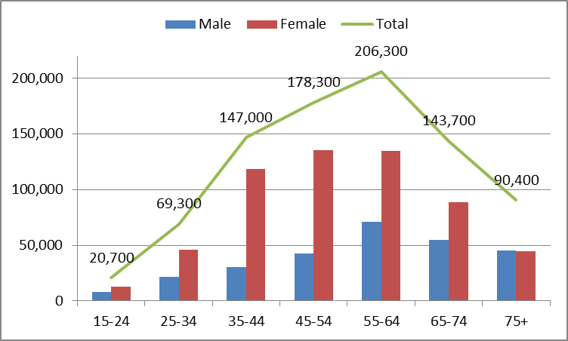
Primary carers are predominantly female – 68 per cent. Chart 1 shows that most carers in Australia are aged between 35 and 64 (with the number of carers peaking between the ages of 55 and 64). Chart 1 also shows that most carers in Australia are female, but that the proportion of male and female carers is relatively equal for carers aged under 25 or 75 and over.
Chart 2 – Incidence of negative impacts on physical and emotional wellbeing by age of carer in 2012
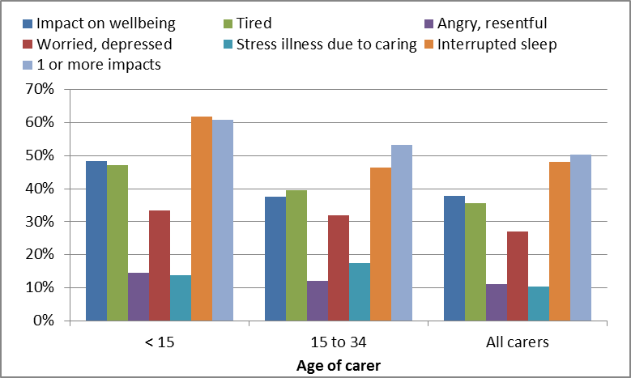
Being a carer can have an impact on an individual. According to ABS data most primary carers (68 per cent) advised their overall wellbeing was not impacted by their caring role, however, Chart 2 shows that 50 per cent did indicate they had one or more negative impacts on their physical and/or emotional wellbeing as a result of being a carer.
Young carers appear to have the highest incidence of negative impacts due to a caring role with 48 per cent reporting a negative impact (compared to 38 per cent for all carers), 47 per cent indicated they were weary and lacked energy (compared with 36 per cent for all carers), 15 per cent frequently felt angry and resentful (compared with 11 per cent for all carers), 62 per cent reported having interrupted sleep (compared with 48 per cent of all carers) and 61 per cent reported having one or more impacts (compared with 50 per cent for all carers).
Chart 3 – Medical condition of recipients of care 2012
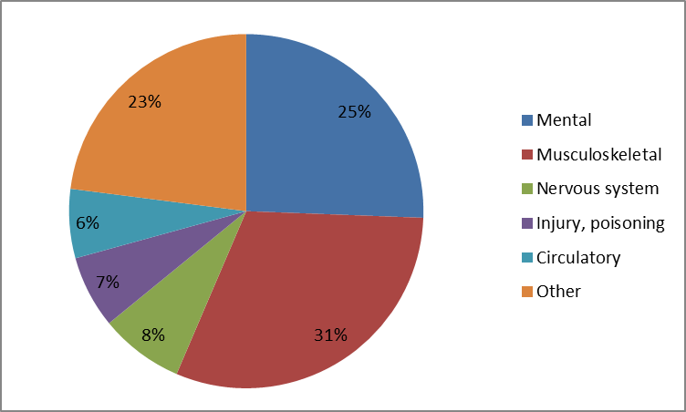
Chart 3 shows the main health conditions of care recipients. Thirty-one per cent of care receivers have a musculoskeletal condition, 25 per cent have a mental or behavioural disorder, 23 per cent from a range of conditions (for example, tumours or cancers, diseases of the eye, ear, respiratory system, disgestive system, congenital malformations), 8 per cent had a disease of the nervous system, 7 per cent had an injury or poisoning, and 6 per cent had a disease of the circulatory system.
Chart 4 – Carers by relationship to care receiver 2012
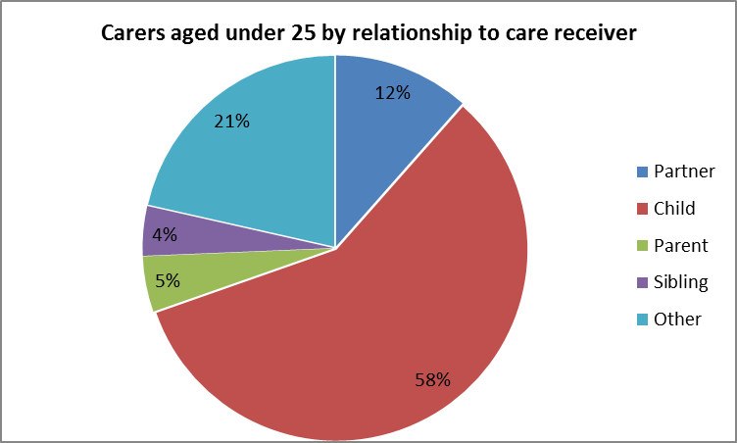
Chart 4 shows the relationship of the carer to the care receiver. For carers aged 15 to 24, it is most common for the carer to be the child of the care recipient, followed by ‘other’ (young carers are the most likely age group to be caring for a person with an ‘other’ relationship to them), partner, carer and sibling. Only 5 per cent of young carers are caring for their own child, compared with 55 per cent of carers aged 25 to 44.

2015 Priority Investment Approach Baseline Valuation
In 2014-15, 11,200 (4.2 per cent of total carers) young people aged under 25 received Carer Payment. The average future lifetime cost for each young carer in this priority group is $464,000. This consists of:
- Carer Payment - $144,000 (31 per cent)
- Pre-retirement Income Support - $97,500 (21 per cent)
- Retirement - $83,500 (18 per cent)
- Family Assistance - $69,500 (15 per cent)
- Other supplements - $69,500 (15 per cent).
In 2014-15 the average age a young person started receiving Carer Payment was 20. Sixty-one per cent of young carers were female and 39 per cent were male, 23 per cent reported earnings in the year before going onto Carer Payment. Fourteen per cent of young carers were Indigenous.
Before moving onto Carer Payment, 43 per cent were on a working age payment, 21 per cent received a student payment and 23 per cent were not receiving an income support payment.
If nothing changes 60 per cent will be receiving income support payments in 10 years, and 50 per cent will be receiving income support payments in 20 years.
Chart 5 – Carer Payment recipients aged under 25 at June 2005 – ten year welfare pathway
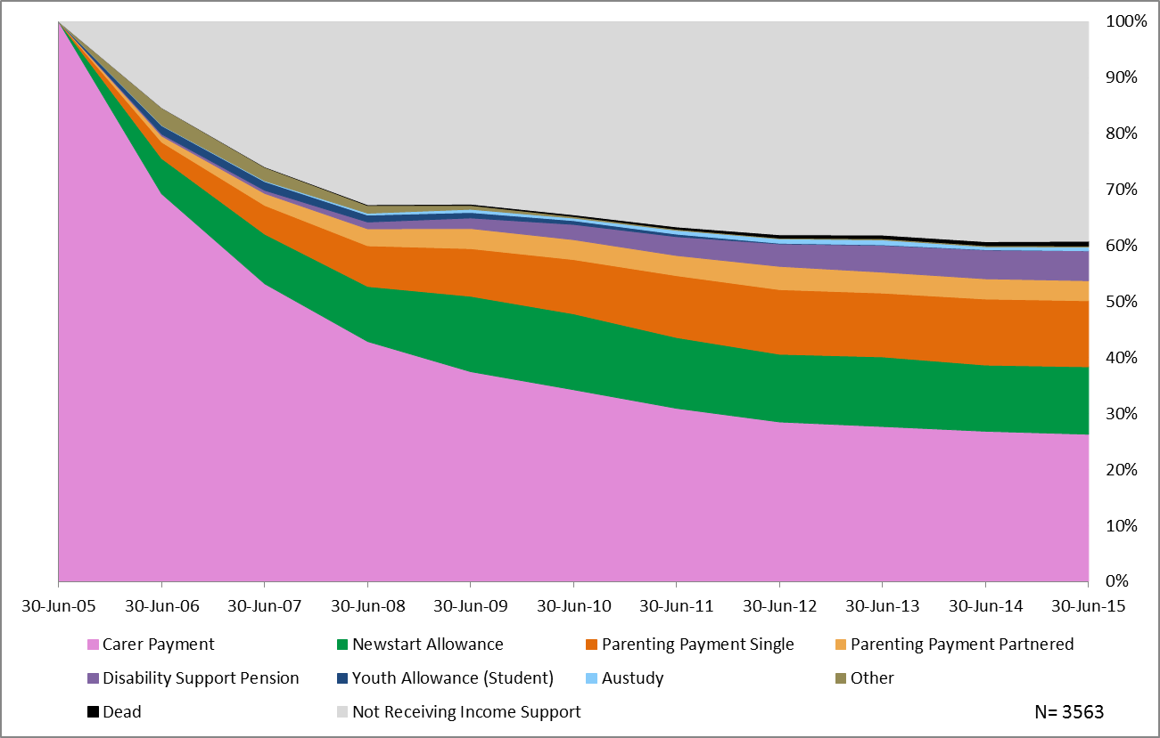
Chart 5 shows the ten year pathway for young carers aged under 25 at June 2005 who were receiving Carer Payment.
After ten years, 39 per cent were no longer receiving income support, 26 per cent still claimed Carer Payment, 15 per cent were receiving Parenting Payment, 12 per cent were receiving an unemployment payment and 5 per cent were receiving Disability Support Pension.

Carer Payment

What is Carer Payment?
Carer Payment is an income support payment paid to individuals who are providing constant care on a daily basis for another person with a disability or medical condition. The level of care must be high enough that it prevents the person from undertaking substantial employment.
To be eligible for Carer Payment, the carer must be caring for someone for a significant period, usually a minimum of 6 months, meet an income and assets test, be living in Australia, and meet residence requirements.
Young carers under 18 years of age will require a referral to a Department of Human Services social worker to ensure they are able to provide the care required.

How much is Carer Payment?
- Single carers are eligible for a fortnightly rate of $877.10 (includes supplements), and
- Partnered carers are eligible for a fortnightly rate of $661.20 (includes supplements).

Further data on the young carer cohort is under development and will be posted on the website in the near future.

Australian Bureau of Statistics, 4436.0 Caring in the Community, Australia, 2012
Australian Bureau of Statistics, 4430.0 Disability, Ageing and Carers, Australia, 2015
Carer Payment information is publically available at Department of Human Services

