Priority Group – Young parents
Table of Contents
Introduction 1
Who is this priority group? 1
Why are young parents a priority group? 1
Births data 2
2015 Priority Investment Approach Baseline Valuation 2
Parenting Payment 3
What is Parenting Payment? 3
How much is Parenting Payment? 3

Introduction

Who is this priority group?
Young people aged under 25 who claimed Parenting Payment when they were aged under 19 and are still receiving an income support payment.

Why are young parents a priority group?
The Australian Priority Investment Approach to Welfare aims to improve the lifetime wellbeing of individuals by increasing their capacity to live independently of welfare, addressing the risk of intergenerational welfare reliance, and decreasing Australia’s long-term social security costs.
The Priority Investment Approach allows the Australian Government to review the Australian population as a whole and identify groups of people at risk of welfare dependence and disadvantage. This new way of looking at the social security system will help the Government target funding towards programs and policies that help people move into education or employment, and evaluate the effectiveness of these programs over time.
The actuarial analysis undertaken for the Priority Investment Approach Baseline Valuation identified a number of groups of young people, including young parents, who are at risk of long-term welfare dependency who would benefit from additional assistance through the Try, Test and Learn Fund.
Having a baby at a young age can disrupt education and increase the barriers to finding and keeping a job. This can lead to long-term welfare dependency and poorer life outcomes for young parents and their children. It is important to help young parents for their wellbeing and the wellbeing of their children.

Intergenerational influences can play a signficant role in the cycle of welfare dependency. Actuarial analysis undertaken as part of the Priority Investment Approach shows that since 2008, 80 per cent of young mothers new to Parenting Payment had a parent or guardian who was on income support at some stage during their upbringing.
Statistics show that children of young parents are more likely to grow up without a father, be of low birth weight, have lower levels of emotional support and cognitive stimulation, show lower academic achievement later on including a higher risk of repeating a grade at school, and be less prepared to enter school. They also have a greater risk of socio-emotional problems, have higher rates of foster care placement, be more likely to be incarcerated at some time during adolescence, have lower educational achievement or leave school early, be a teen parent themselves and be unemployed or underemployed as an adult.

Births data
There were 305,377 births in Australia in 2015 of which 8,574 (2.8 per cent) were to mothers aged 15-19. Over 25 per cent (2,203) of these births were to Indigenous mothers. The fertility rate of Australian women is steady and teenage fertility has dropped to its lowest rate on record.
Chart 1 shows that in 2015, most births were to mothers aged between 25 and 39, with a peak for mothers aged 30 to 34. Birth rates of Indigenous mothers are sigificantly higher than rates for non-Indigenous mothers in the younger age ranges.
Chart 1 – Births by age and indigeneity of mother 2015

2015 Priority Investment Approach Baseline Valuation
In 2014-15 there were 4,370 (1 per cent) parents aged under 19 receiving Parenting Payment. The average future lifetime cost for each young parent in this priority group is $547,000. This consists of:
- Parenting Payment - $120,500 (22 per cent)
- Pre-retirement Income Support - $109,500 (20 per cent)
- Retirement - $82,000 (15 per cent)
- Family Assistance - $186,000 (34 per cent)
- Other supplements - $49,000 (9 per cent)

In 2014-15, 77 per cent of young parents aged under 19 were single and 23 per cent were partnered. Each year 1,000 new parents under age 19 enter the welfare system.

If nothing changes for this priority group 70 per cent will be receiving income support payments in 10 years, and 40 per cent will be receiving income support payments in 20 years.
Chart 2 below shows the ten year welfare pathway of Parenting Payment Single recipients aged 19 and under in June 2005. The chart shows that after ten years, 27 per cent of recipients were no longer receiving an income support, 47 per cent were still receiving Parenting Payment (40 per cent receiving a single rate and 7 per cent receiving a partnered rate), 17 per cent were receiving Newstart Allowance, 5 per cent were receiving Carer Payment and 3 per cent were receiving Disability Support Pension.
Chart 2 - Parenting Payment Single recipients aged 19 and under in June 2005
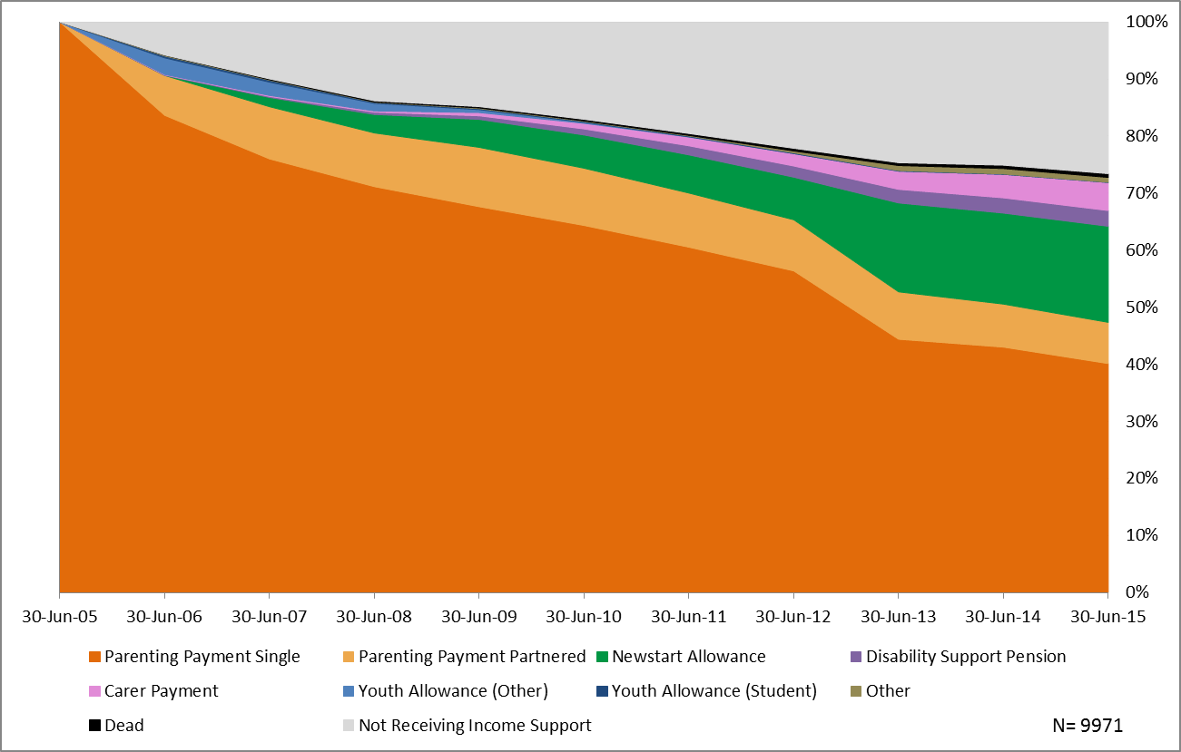

Parenting Payment

What is Parenting Payment?
Parenting Payment is an income support payment for parents or guardians who have no or little other income. Parenting Payment can only be paid to one member of a couple.
To be eligible for Parenting Payment, an individual must have a child under eight years of age if single and under six years of age if partnered. Income, assets and residency tests apply to the payment. Some Parenting Payment recipients are subject to mutual obligation requirements, including single parents whose youngest child is aged six or seven, and parents participating in the ParentsNext program.

How much is Parenting Payment?
- Single parents: $738.50 maximum per fortnight
- Partnered parents: $477.40 per fortnight
Families may also receive income support supplements such as the Energy Supplement, Family Tax Benefit, Rent Assistance and child care fee assistance – these payments are also paid to low and middle income working families.

Further data on the young parent cohort is under development and will be posted on the website in the near future.

3301.0 – Australian Bureau of Statistics, Births, Australia, 2015
Parenting Payment information is publically available at Department of Human Services

