Priority Group – Young students
Table of Contents
Introduction 1
Who is this priority group? 1
Why are young students at risk of unemployment a priority group? 1
Labour Force Data 2
2015 Priority Investment Approach Baseline Valuation 4
Student Payments 5
What are student payments? 5
What are student payment rates? 6

Introduction

Who is this priority group?
Young people aged under 25 who have moved, or are at risk of moving, from study (post-secondary or tertiary and have been in receipt or receiving a student payment) to an extended period on an unemployment payment.

Why are young students at risk of unemployment a priority group?
The Australian Priority Investment Approach to Welfare aims to improve the lifetime wellbeing of individuals by increasing their capacity to live independently of welfare, addressing the risk of intergenerational welfare reliance, and decreasing Australia’s long-term social security costs.
The Priority Investment Approach allows the Australian Government to review the Australian population as a whole and identify groups of people at risk of welfare dependence and disadvantage. This new way of looking at the social security system will help the Government target funding towards programs and policies that help people move into education or employment, and evaluate the effectiveness of these programs over time.
The actuarial analysis undertaken for the Priority Investment Approach Baseline Valuation identified a number of groups of young people, including young students, who are at risk of long-term weflare dependency who would benefit from additional assistance through the Try, Test and Learn Fund.
Young people who do not finish their education and who are subsequently unemployed or not in the labour force have a higher risk of poor life outcomes. Low educational attainment is an important driver of a young person not being in employment, education or training (NEET). The reasons people are NEET can differ greatly, and may be a consequence of their family and socioeconomic background, their personal characteristics and aspirations, educational opportunities and barriers to securing work. According to the OECD ‘the negative long-term consequences of joblessness are likely to be greatest for young people who remain NEET for long periods’.
There are many reasons why some young students struggle to complete their studies and later find and keep long-term jobs. Risk factors can include:
- Family and community factors – poverty, parental unemployment and/or low educational attainment, homelessness, living out-of-home, being Indigenous, refugee status, family breakdown and/or domestic violence,
- Personal factors – mental health issues, disability, behavioural issues, offending behaviour, contact with police or the justice system, substance misuse or dependency, pregnancy and parenting, caring responsibilities and learning difficulties, and
- Subject choice and progression.
Nationally, lower university completion rates were evident for students who:
- Had a lower tertiary entrance score,
- Studied part-time or were an external student,
- Aged 25 and over, and male,
- Lower SES students,
- From a non-metropolitan area,
- Indigenous.

Labour Force Data
Labour force data
At May 2016, 94 per cent of young people aged 15 to 19 were engaged fully or partly in work and/or study. In the 20 to 24 year age range this percentage dropped to 87 per cent with 13 per cent not engaged in work or study. In the 15 to 19 year age range, 84 per cent were engaged in education with this figure dropping to 43 per cent for the 20 to 24 year old group. The level of engagement in study and/or employment varies by state/territory, gender and location as can be seen in the charts below.
Chart 1 – 15 to 19 year old Australians by level of engagement in work and/or study 2015
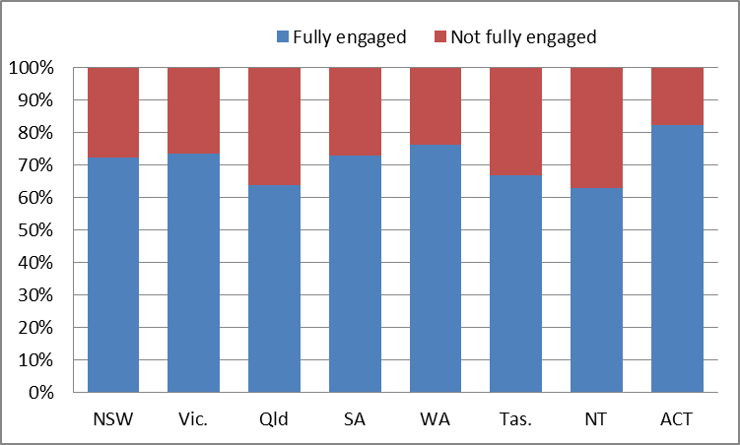
Young people in the Australian Capital Territory have the highest level of engagement, with 82 per cent of 15 to 19 year olds fully engaged. Around 72 to 76 per cent of young people from New South Wales, Victoria, South Australia and Western Australia are fully engaged. Between 63 and 67 per cent of young people aged 15 to 19 in Queensland, Tasmania and the Northern Territory were fully engaged in 2015.
Chart 2 – 20 to 24 year old Australians by level of engagement in work and/or study 2015
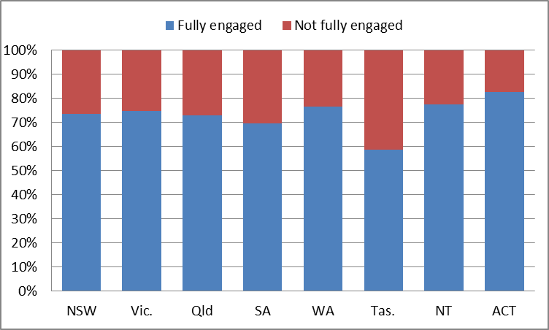
Levels of engagement change with age, with the level of young people aged 20 to 24 fully engaged increasing or decreasing in different states.
Young people in New South Wales, Victoria, Queensland, Western Australia, Northern Territory and the Australian Capital Territory demonstrated an increased proportion of those who are fully engaged (between 70 and 83 percent). The increase was marked in the Northern Territory with 63 per cent of young people aged 15 to 19 fully engaged and 77 per cent of young people aged 20 to 24 fully engaged.
However, young people in Tasmania and South Australia showed a declining rate of full engagement. In South Australia, 73 per cent of young people aged 15 to 19 were fully engaged, while 70 per cent were fully engaged when aged 20 to 24. In Tasmania, 70 per cent of young people aged 15 to 19 were fully engaged, while 59 per cent of young people aged 20 to 24 were fully engaged.
Chart 3 – level of engagement by gender and age 2015
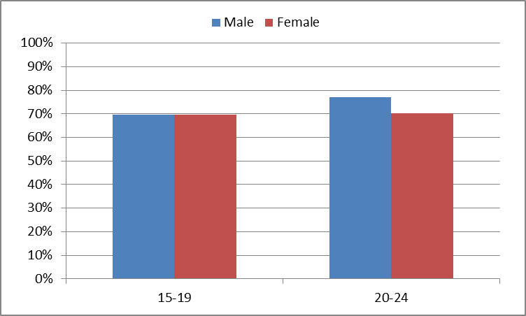
Seventy per cent of females and 70 per cent of males aged 15 to 19 in Australia were fully engaged in 2015. The proportion of females fully engaged stayed the same for young people aged 20 to 24, however, the proportion of males fully engaged, increased to 77% when aged 20 to 24.
Chart 4 – level of engagement by age and remoteness 2015
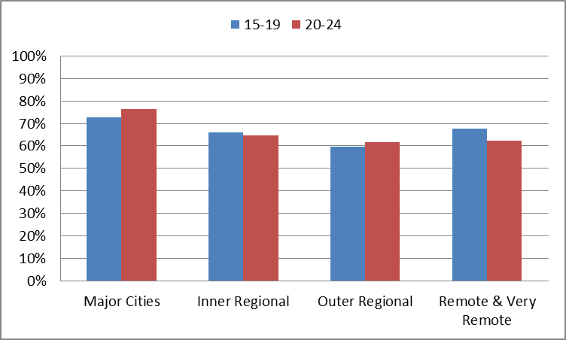
Young people aged 15 to 19 living in major cities have the highest levels of engagement (73 per cent), remote and very remote areas (67 per cent), inner regional areas (66 per cent) and lowest engagement in outer regional areas (60 per cent).
Young people aged 20 to 24 living in major cities also have highest levels of engagement (77 per cent), inner regional (65 per cent), remote and very remote areas (62 per cent) and lowest levels of engagement in outer regional areas (62 per cent).

2015 Priority Investment Approach Baseline Valuation
In 2014-15, there were 392,000 people receiving a Study Payment. The average future lifetime cost for each student who claims a study payment is $247,000. The average age for a young person to claim a study payment is 17 (around 30,000 young people make a claim each year and 74 per cent have not received income support prior to that claim). Seventy-six per cent of claimants had completed Year 12 before entering payment.
The actuarial analysis undertaken for the Baseline Valuation identified a group of 13,400 young people who started receiving a student payment when aged 17 to 19 for vocational (post-secondary) or tertiary study, who later experienced a long-term period on an unemployment payment. The average future lifetime cost per person was $304,000 for those who completed their course and $318,000 for those who did not complete their course (75 per cent had not completed their course of study).
Of this population, 4 per cent had identified as Indigenous (compared to 10 per cent of all welfare recipients aged 17 to 19) and 58 per cent were female.
If nothing changes 45 per cent will be receiving income support payments in 10 years, and more than one third will be receiving income support payments in 20 years.
Chart 5 below shows the ten year welfare pathway of 164,500 Youth Allowance (student) recipients aged under 25 in June 2005 who were undertaking post-secondary study. The chart shows that after ten years, 91 per cent (149,199) of recipients were no longer receiving an income support payment, 3 per cent (5,394) were receiving Newstart Allowance, 3 per cent (4,915) were receiving Parenting Payment, 2 per cent (2,497) were receiving a disability or carer payment, and 1 per cent (2,016) were still engaged in study.
Chart 5 – Ten year welfare pathway of post-secondary Youth Allowance (student) recipients June 2005
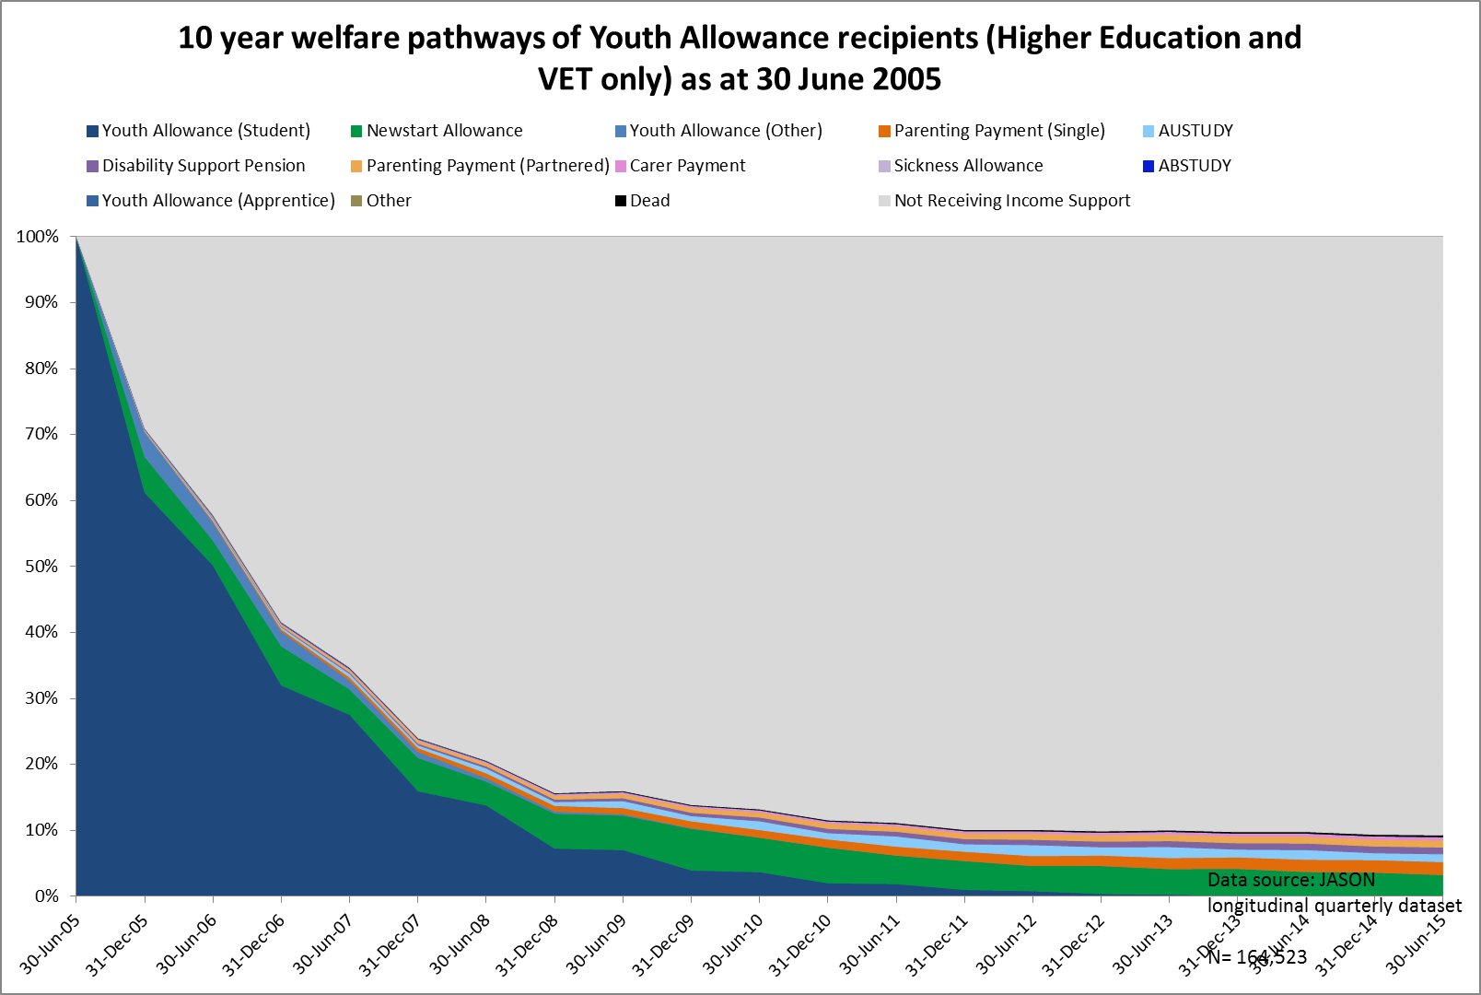

Student Payments

What are student payments?
Student Payments include Youth Allowance (student), Youth Allowance (apprentice), ABSTUDY (Living Allowance) and Austudy. These payments are income support payments for individuals who are undertaking study. To receive a student payment, the student must be studying full-time, meet the income and assets tests, be living in Australia, and meet residency requirements.

What are student payment rates?
Student payment rates are based on the age of the young person and whether or not they live at home or away from home. The rate for young students living at home and aged under 18 is $237.10 per fortnight or $285.20 per fortnight if they are aged 18 and over. Where a student is living away from home, or aged 25 and over, their fortnightly rate is $433.20. Students may also be eligible for additional supplements and/or Rent Assistance.

Further data on the young student cohort is under development and will be posted on the website in the near future.

OECD (2016), Society at a Glance 2016: OECD Social Indicators, OECD Publishing Paris,
Australian Bureau of Statistics, 6202.0 Labour Force, Australia October 2016
Student payment information is publically available at Department of Human Services

