Australian Priority Investment Approach
to Welfare

Try, Test and Learn Fund
Tranche 1 Handbook

Version 6 (12 April 2017)

Version history
 | Date | Reason for update
Version 1 | 9 December 2016
Version 2 | 21 December 2016 | Added definition of capital funding. Correction of minor typographical errors.
Version 3 | 20 February 2017 | Added clarifications regarding processes for publishing and shortlisting eligible ideas.
Version 4 | 24 February 2017 | Added clarifications regarding the criteria for assessment and shortlisting of initial ideas for co-development.
Version 5 | 3 March 2017 | Updated key dates to reflect current timelines.
Version 6 | 12 April 2017 | Added clarifications regarding co-development planning, the role of the probity advisor, and the timing and nature of supplementary information that will be issued.

Contents
1 Preface 1
2 Background 2
2.1 The Australian Priority Investment Approach to Welfare 2
2.2 The Try, Test and Learn Fund 2
2.3 Priority groups for Tranche 1 3
2.4 What does this Handbook cover? 3
3 How will the Try, Test and Learn Fund work? 4
3.1 When will the Fund open? 5
3.2 What are the key dates for Tranche 1? 5
3.3 How can I be involved? 5
3.4 Funding available 6
4 Ideas generation 7
4.1 Can I submit an idea? 7
4.2 What kind of ideas can I submit? 7
4.2.1 Eligibility criteria 8
4.3 How to submit an idea 9
4.3.1 Process for submitting through DSS Engage 9
4.3.2 Collaboration 12
4.4 Legal issues 13
4.5 Assessment and shortlisting of initial ideas for co-development 13
4.5.1 Assessment criteria 13
4.5.2 Assessment and shortlisting process 14
4.5.3 Notification of shortlisted ideas 14
4.5.4 Feedback 15
5 Co-development, funding and delivery 16
5.1 Overview 16
5.2 Co-development 16
5.2.1 What topics will co-development cover? 17
5.2.2 Probity and fairness 17
5.3 Funding selection process 17
5.3.1 Choice of selection process 18
5.3.2 Funding applications 18
5.3.3 Funding applicant eligibility 19
5.4 Delivery and evaluation 19
5.4.1 Monitoring and evaluation at the centre of design 20
5.4.2 Outcomes-focused funding agreements 20
5.4.3 Performance review milestones 20
6 Contact information 21
7 Questions and Answers 21
8 Glossary 21

Preface
This Handbook has been developed to support the submission of ideas to the Try, Test and Learn Fund. It provides an overview of the Fund including detailed information that will guide submitters through the generation and submission of ideas. It also outlines the processes for the co-development, funding and delivery of ideas.
The Try, Test and Learn Fund will support trials of new or innovative policy responses to help people live independently of welfare. The Fund will seek to support groups who have the capacity to work and are at risk of long-term welfare dependence. It will also help to ensure that Australia’s safety net remains sustainable for future generations.
As announced in the 2016-17 Federal Budget, the Try, Test and Learn Fund is the Government’s first response to the Australian Priority Investment Approach to Welfare. It will help to achieve the objectives of welfare reform and the Priority Investment Approach in developing a modern, relevant and flexible welfare system. For more information see Section 2 Background.
The Try, Test and Learn Fund is unlike a standard Government funding round and has been driven by an outcomes-based approach to designing and implementing policy responses. The Fund’s submission process has been designed to be accessible, transparent, collaborative, and supportive of new and innovative approaches. Ideas will be welcomed from community groups, government, academics, business, other groups and the general public, including partnerships between these stakeholders. Shortlisted ideas will progress to a co-development stage, after which the most promising will be selected for funding, delivery and evaluation. Users and communities will be central to the design and delivery of Try, Test and Learn Fund policies.
A central focus of the Try, Test and Learn Fund is the generation of new insights and empirical evidence into ‘what works’ to reduce long-term welfare dependence. The delivery of each Try, Test and Learn Fund policy will test an hypothesis about how we can change behaviours, pathways or systems to improve workforce participation. The impact of policy responses will be monitored using a range of evaluation methods to garner these insights. The lessons learned will be used to inform and improve Government policy.
The Fund is expected to open for ideas submission several times over the next few years, allowing organisations and individuals additional opportunities to submit proposals. These multiple opportunities for submission will be part of a flexible and iterative policy design process that aligns with the Government’s innovation agenda.
The Department of Social Services may amend this document and Try, Test and Learn Fund processes prior to Tranche 2, which is expected to open in mid-2017.

Background

The Australian Priority Investment Approach to Welfare
The Australian Priority Investment Approach to Welfare was a recommendation of the 2015 review of Australia’s welfare system, A New System for Better Employment and Social Outcomes, led by Patrick McClure. The review recommended that Australia adopt an investment approach to help ensure that funds are invested in people most at risk of long-term welfare dependence and that they receive targeted support that is timely and tailored to their needs.
The Priority Investment Approach was established by the Department of Social Services in 2015. As recommended by the McClure Review, the Priority Investment Approach is underpinned by annual actuarial valuations. The valuations estimate the future lifetime cost of welfare payments to the Australian population and groups within it. This method is similar to the way that insurance companies estimate their future costs.
The objectives of the Priority Investment Approach are to improve lifetime wellbeing by:
- increasing the capacity of individuals to participate in social and economic life and to live independently of welfare
- reducing the risk of welfare dependence
- reducing long-term social security costs in the interests of maintaining a sustainable support system for vulnerable Australians.
For more information about the Priority Investment Approach go to the Department of Social Services website.

The Try, Test and Learn Fund
The Try, Test and Learn Fund is the Government’s first response to the Priority Investment Approach and will support its goals by funding new or innovative policy responses to improve workforce participation or capacity to work for key groups. The 2016-17 Budget allocated $96.1 million to the Fund over four years. This allocation comprises $80 million for the delivery and evaluation of policy responses and $16 million for other implementation costs including ICT and data analytics, stakeholder consultations, proposal assessments and improved public data access.
The Fund uses Priority Investment Approach analysis to identify groups who would benefit from investment to improve their workforce participation or capacity to work. It will seek innovative ideas for services or supports for these priority groups and select ideas to be co-developed and funded. The Fund will test how well these ideas work through rigorous evaluation and use the lessons learned to inform and improve Government policy.
The Try, Test and Learn Fund will be supported by collaboration and co-development processes as well as expert input, including from an Expert Advisory Group. The Expert Advisory Group will include leading academics and policy experts and play an advisory role in understanding priority groups, risk factors, and links to intergenerational welfare, as well as in the monitoring, empirical measurement and evaluation work of policies financed by the Try, Test and Learn Fund.
The Fund is guided by the following core principles, which reflect a commissioning approach to policy development:
- new ideas, innovative approaches, experimentation and flexibility
- accessibility, collaboration, co-development (including with members of the priority groups) and user-focused design
- a focus on outcomes and responsiveness to evaluation, data and stakeholders.

Priority groups for Tranche 1
The Priority Investment Approach provides annual valuations and analysis which help us to build a better understanding of the characteristics of different groups and their transition pathways through the welfare system. Each time the Try, Test and Learn Fund opens, it will have a defined focus on particular priority groups or areas. This focus may change over time through consultation with stakeholders and as the Priority Investment Approach analysis is updated and refined.
The priority groups for Tranche 1 of the Try, Test and Learn Fund were informed by the 2015 Priority Investment Approach Baseline Valuation Report and additional analysis of Priority Investment Approach data. The initial priority groups are:
- young people aged under 25 who started receiving Parenting Payment at age 18 or under and who are still receiving an income support payment
- young people aged under 25 who are in receipt of Carer Payment or at immediate risk of going onto the payment
- young people aged under 25 who have moved, or are at risk of moving, from study (post-secondary or tertiary and been in receipt or receiving a student payment) to an extended period on an unemployment payment.
More information about the priority groups is available on DSS Engage.

What does this Handbook cover?
This Handbook provides an overview of the Try, Test and Learn Fund. It includes detailed information on the ideas generation stage, and outlines the co-development, funding, delivery and evaluation stages. More detailed information on co-development, funding, delivery and evaluation will be provided as required as the Fund progresses.

How will the Try, Test and Learn Fund work?
The Try, Test and Learn Fund is unlike a standard Government funding round and has been driven by an outcomes-based approach to designing and implementing policy responses. It will seek ideas first, and then source the appropriate delivery partner to deliver each selected idea. This will allow the generation of ideas from a broad range of stakeholders and will support consultation and co-development to prepare ideas for delivery. The stages are explained further below.
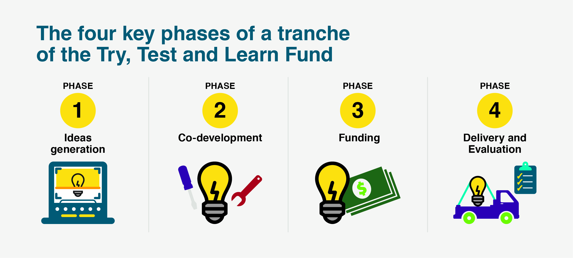
- Ideas generation: this phase will involve generating new or innovative ideas to help priority groups to improve their workforce participation or capacity to work. Ideas can come from individuals or organisations or through collaboration between different groups. A shortlist of ideas will be selected to continue to the co-development phase. More information is provided in Section 4 Ideas generation phase.
- Co-development: this phase will involve co-development of shortlisted ideas, including consultation with the priority groups and other stakeholders. At the conclusion of the co-development stage, the most promising initiatives will be selected for funding. More information is provided in Section 5 Co-development, funding and delivery.
- Funding: following the final selection of initiatives, a delivery partner will be chosen through a funding selection process. This funding selection process will consider potential delivery partners’ capability and capacity to effectively deliver the services. More information is provided in Section 5 Co-development, funding and delivery.
- Delivery and evaluation: this phase will involve the implementation of ideas by the delivery partners selected in the funding selection process. Evaluation will be an important element of this process. More information is provided in Section 5.4 Delivery and evaluation.

When will the Fund open?
Ideas will be sought, and funding released, in three tranches a year commencing in December 2016. Future tranches are expected to commence in June, October and February. The Try, Test and Learn Fund will operate approximately six tranches.

What are the key dates for Tranche 1?
Tranche 1 of the Try, Test and Learn Fund commenced on 9 December 2016. Key dates for Tranche 1 are:
- 9 December 2016: submission of ideas opens.
- 24 February 2017, 5.00 pm Canberra time (AEDT): submission of ideas closes. The Department recommends submission prior to this deadline to allow time for collaboration (see Section 4.3.1.5 for more information).
- Late-March 2017: initial ideas shortlisted for co-development. The Department will notify submitters of the outcome of the idea assessment process and which ideas will progress to co-development.
- Late-March to late-April 2017: co-development of ideas with Proposers and other stakeholders as appropriate.
- Mid-May 2017: ideas selected for funding.
- May 2017: funding process to select delivery partner.
- June 2017: Tranche 1 policy responses commence delivery.

How can I be involved?
The Department welcomes submissions of ideas to the Try, Test and Learn Fund. Proposers of ideas do not need to have the capability or capacity to deliver the ideas they propose. For more information on how to get started see Section 7 Ideas generation.
If an idea is shortlisted, its Proposer/s will be invited to be involved in its co-development. For more information on co-development see Section 5.2 Co-development.
If, after co-development, an idea is selected for delivery then the Department will use a funding selection process to assess the capability of potential delivery partners. This will include considering potential delivery partners capacity to deliver services effectively, including within timeframes and budget. In many cases, the idea Proposer will be a suitable provider to deliver their idea and may be approached individually through a direct selection process to assess their capability and capacity. The Department reserves the right to invite other potential providers to take part in a funding selection process or to approach a service provider other than the idea Proposer via a direct selection process.
See Section 5.3 Funding selection process for more information.

Funding available
In the first tranche, it is expected that up to ten ideas will be selected for delivery. The financing process for an idea will involve a funding round to seek an appropriate delivery partner. For more information on funding see Section 5 Funding selection process.
It is expected that a total funding envelope of up to $10 million will be allocated for funding ideas in Tranche 1, including evaluation funding. The Department welcomes ideas of different sizes and scopes, and ideas may be expanded or adjusted in the co-development phase. In Tranche 1, the Department anticipates that individual ideas will receive between $50,000 and $2 million, depending on their size and scale.
Proposers of ideas may indicate an approximate amount that they believe is required for the delivery of their idea if they wish, but this is not required. Funding allocations will be considered and decided during the co-development phase.

Ideas generation
Each tranche of the Try, Test and Learn Fund will begin with an ideas generation stage. Proposers should submit their ideas for policy responses through the online form on DSS Engage.
The Department will check the eligibility of each submission using the criteria in Section 4.2.1 before it is accepted and published. If an idea is eligible, information about it will be published on DSS Engage. Proposers may choose to publish their responses to questions in the form or to write a separate public summary of their idea. Proposers will be able to collaborate and refine their ideas using DSS Engage to share their ideas and find partners.
At the close of the submission process, the Department will assess eligible ideas to determine which should progress to co-development. Ideas will be selected based on their strength and not on the capacity of Proposers to deliver their ideas. For more information on ideas submission, see Section 4.3 How to submit an idea.

Can I submit an idea?
The Try, Test and Learn Fund is seeking ideas from a very broad range of stakeholders. Everyone who has an eligible idea is welcome to contribute, even those who are not willing or able to deliver policy responses resulting from their ideas.
For example, ideas can be submitted by:
- members of the general public
- community services and other professionals
- academics
- non-government and community organisations
- businesses including social enterprises, service providers and others
- Commonwealth, state and local government agencies.
Collaboration between interested stakeholders is encouraged.

What kind of ideas can I submit?
The Try, Test and Learn Fund is looking for innovative ideas that improve workforce participation or capacity to work for priority groups (see Section 2.3 Priority groups for Tranche 1). Ideas may cover a wide range of services or supports which may include, but are not limited to:
- structured programs to support priority groups’ workforce participation
- apps or other technology solutions to support priority groups’ workforce participation
- employer-side programs that support priority groups’ workforce participation
- use of behavioural insights to improve existing programs
- conditionality or mutual obligation requirements (i.e. changes to the obligations that people need to meet to receive payments or Government services)
- other innovative approaches to supporting priority groups.
An idea may propose a service or support that is to be delivered in a specific geographic location or region. Detailed information about idea eligibility is provided in Section 4.2.1 Eligibility criteria.

Eligibility criteria
For ideas to be eligible for consideration under the Try, Test and Learn Fund, they must meet the criteria set out below. Eligible ideas will be made public through DSS Engage and will be assessed for shortlisting to the co-development stage.
The submission form will capture all the information the Department needs to determine eligibility. Proposers do not need to directly respond to the eligibility criteria. However, the criteria may guide Proposers as they develop their ideas.
Further information about the eligibility criteria is provided in the Questions and Answers document.
The eligibility criteria are:
- The submission is written in English, does not use language which is likely to offend, and completes all mandatory fields
The idea must meet the above criterion. This includes agreement with the Terms and Conditions for submission, which is mandatory.
- The idea provides services or support for one or more of the three priority groups: young parents, young carers, and young students at risk of long-term unemployment (see Section 2.3. for full definitions of the three priority groups)
The idea must propose a service or support or propose changes to an existing service or support. The idea cannot include capital funding (see Glossary) nor can it propose funding solely for research without funding for a service or support.
The service or support proposed by the idea must aim to directly assist one or more of the priority groups. See Section 2.3. for full definitions of the three priority groups – it is important that you carefully consider the full definitions. The idea may involve working with individuals in the priority groups or with others, such as with employers.
- The idea seeks to improve workforce participation or capacity to work
The idea must be intended to improve workforce participation or to reduce the risk of welfare dependence for those it supports. Improving workforce participation may involve increasing an individual’s capacity to work or supporting outcomes closely related to job readiness, such as undertaking study or training. Ideas may involve working with individuals in the priority groups or with others such as employers.

- The idea provides new and useful policy evidence
The idea must provide new and useful policy evidence for the Government. This means that the idea has not been trialled before in Australia, or is a reinvention of a former or existing program that offers a point of difference to the original.
- The idea will generate measurable outcomes within a reasonable timeframe
The idea must have the potential to generate measurable outcomes within 12 months. These could be the idea’s goals, or interim outcomes that can reasonably be expected to lead to future success. The outcomes generated may be quantitative or qualitative.
- The idea is not unethical or illegal, nor does it pose other unreasonable risks
The idea must not propose an illegal or unethical intervention, nor pose other unreasonable risks (including financial and implementation risks).
Your submission must not breach the privacy of others, including by relating their personal details, history, etc.

How to submit an idea
Tranche 1 of the Try, Test and Learn Fund will be open for ideas between 9 December 2016 and 24 February 2017. This section outlines how stakeholders can participate.

Process for submitting through DSS Engage
This section explains how ideas can be submitted to the Try, Test and Learn Fund. The submission process is summarised in the diagram on the next page.

Online form
Ideas can be submitted through an online form on DSS Engage between 9 December 2016 and 24 February 2017.
The Department encourages the early submission of ideas. Submitting ideas by around 3 February 2017 will allow Proposers time to review one another’s ideas and, if desired, to submit new or refined ideas on the basis of collaboration. For more information, see Section 4.3.2.
Proposers of ideas will need to register for an account on DSS Engage before submitting an idea. Registration is quick and easy, and you only need to provide basic contact information to create an account.
The submission form is designed to be straightforward and includes questions about the idea, who it targets, and why it is needed. Only one idea can be provided per submission. The answers provided in the submission form will be used to assess your idea. For more information about assessment see Section 4.5.1 Assessment criteria.
Tip: Remember to answer the questions on the submission form. You do not need to respond directly to the assessment criteria in Section 4.5.1 but these should guide the development of your submission.

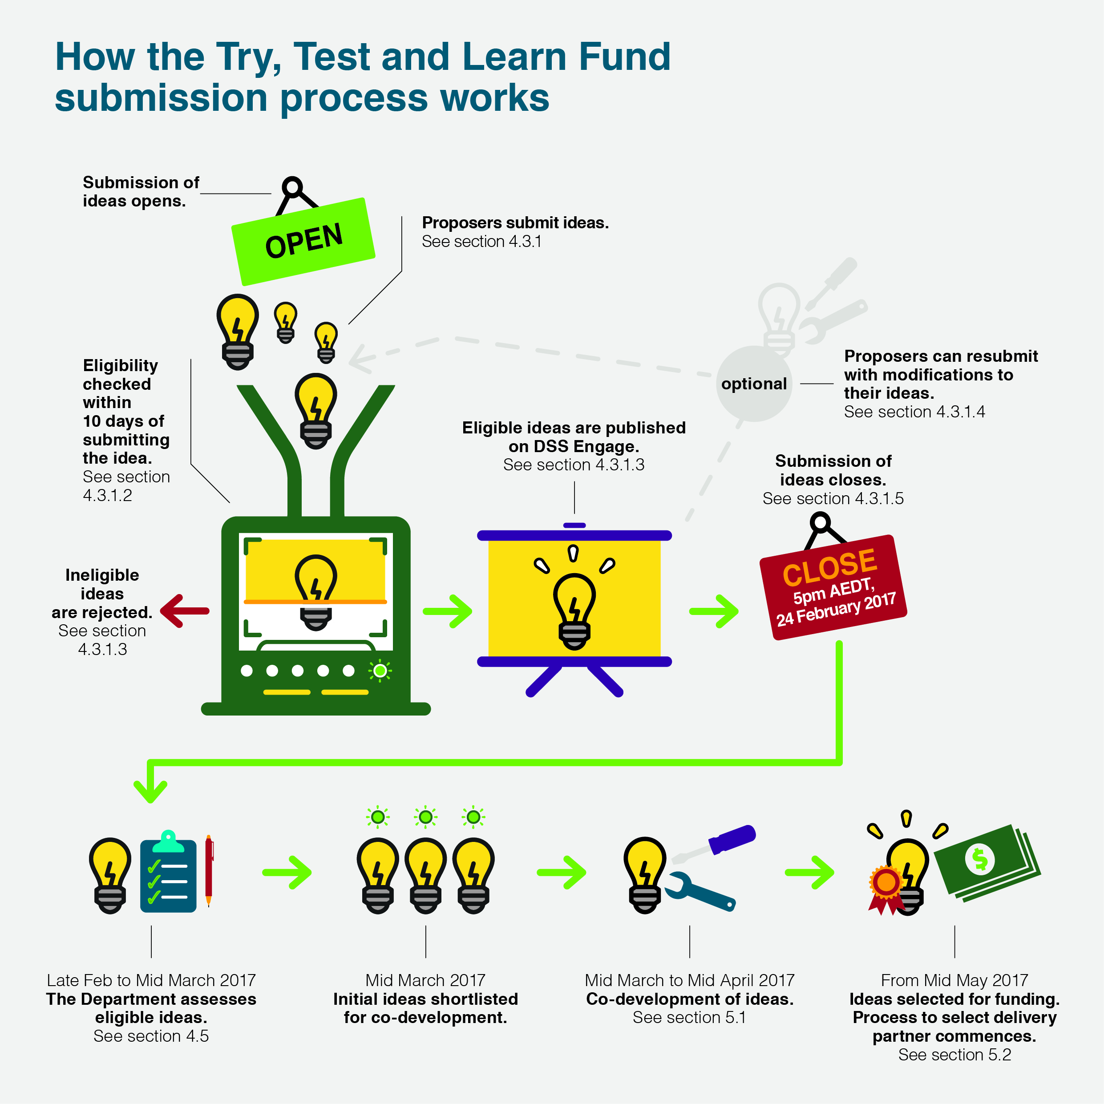

Checking eligibility
Once forms are submitted, they will be sent to the Department for checking against the eligibility criteria. Ideas must be found eligible to be published and considered for shortlisting. A confirmation email will be sent to the Proposer with a copy of their submission and a unique identification number. For more information see Section 4.2 What kind of ideas can I submit?
The Department will review submissions for eligibility within 10 business days of the idea being submitted. The Department will notify Proposers regarding the eligibility of their submissions as soon as they have been reviewed. At the end of the ideas generation phase, general feedback regarding idea eligibility will be provided to all those who submitted ideas. Individual feedback will not be provided.
Tip: If you are concerned about whether your idea is eligible for publishing and assessment, make sure you submit early. This will give you an opportunity to modify your idea or submit another if your first idea is ineligible.

Publication on DSS Engage
Information about each eligible idea will be published on DSS Engage as part of the Try, Test and Learn Fund’s collaborative approach. This will allow public viewing of submissions and will encourage the sharing of ideas and collaboration between their Proposers. If a submission is ineligible, it will not be published on DSS Engage.
Proposers will have the option of choosing to write a public summary of their idea, which will be published on DSS Engage. Alternatively, submitters can opt for their responses to questions 1, 2, and 3 in the online submission form to be published. These questions cover the priority group that the idea supports, the need that the idea addresses, and a description of the idea.
Detailed information about options for the publication of information about ideas is provided in the submission form.
The Department reserves the right to make minor edits to, or remove small sections of, an idea submission or public summary to make it suitable for publication on DSS Engage.

Modification of ideas
The Try, Test and Learn Fund encourages the sharing of ideas and collaboration on new ideas. Proposers may be inspired to submit several ideas, or to refine their existing ideas, after working with others or reviewing ideas on DSS Engage. Until 24 February, Proposers are able to:
- Submit additional ideas: Additional ideas can be submitted by completing the original submission form. These new ideas may be developed individually by Proposers, or through collaborations supported by DSS Engage.
- Modify and replace existing ideas: Modifications of existing, published ideas can be submitted by completing the original submission form. These modified ideas may be developed individually by Proposers, or through collaborations supported by DSS Engage.
Tip: You do not have to submit new ideas or modify your existing idea if you do not want to. If you do not add new or modified ideas, we will consider your original submission.

Idea submission closing date
Ideas must be submitted by 5.00 pm Canberra time (AEDT) on 24 February 2017 to be considered for shortlisting under the Try, Test and Learn Fund (see Section 4.5 Assessment and shortlisting of initial ideas).
The Department encourages the early submission of ideas. Submitting ideas by around 3 February 2017 will allow Proposers time to review one another’s ideas and, if desired, to submit new or refined ideas on the basis of collaboration. For more information, see Section 4.3.2.

Collaboration
The Try, Test and Learn Fund has been designed to enable stakeholders to work collaboratively to develop new or innovative approaches to improving workforce participation or capacity to work for priority groups.
While submissions are open, Proposers have the opportunity to refine and develop ideas in partnership with others. Proposers of ideas are encouraged to review DSS Engage to identify other submissions that present an opportunity for collaboration. Collaboration may result in refinements to original ideas, a new idea that replaces an original idea, or a new idea in addition to an original idea.
If contact details have been published on DSS Engage, Proposers may contact each other directly to suggest collaboration on ideas.
If contact details have not been published on DSS Engage, an interested Proposer can contact the Department who will pass on their message to the Proposer they wish to contact. Interested Proposers should email InvestmentApproach@dss.gov.au with the title and unique identification number of the submission they are interested in, their contact details and a message to the Proposer.
The Department will forward the message to the relevant Proposer who will be encouraged to respond to the interested Proposer directly. The Department is not responsible for whether a response is received. Only messages that relate to collaboration on Try, Test and Learn Fund ideas will be forwarded.

Policy Hack
The Department is expecting to hold a Policy Hack in February 2017. The purpose of the Hack is to bring together stakeholders including service users, government, academics, business and community sector experts to generate new ideas based around particular policy themes relating to the priority groups. This will be in parallel to the ideas generated via written submissions. While some ideas may be further developed and potentially funded from these activities, it is expected that the majority of ideas will be submitted and assessed through the submission form.
The Policy Hack event may also be used to broker collaboration and workshopping of ideas between different idea Proposers. Invitation of idea Proposers to workshop their ideas at the Policy Hack will be entirely at the Department’s discretion.

Legal issues
The online form contains terms and conditions which Proposers must agree to before submitting ideas. These terms and conditions are available at DSS Engage. Proposers should read the terms and conditions carefully before completing the submission form.
The terms and conditions allow the Department to use a submitted idea for the purpose of assessing it against the assessment criteria. They also allow the Department to publish selected parts of the submitted idea on DSS Engage according to the Proposer’s preference. Proposers can choose which details about their ideas will be made public. They can choose whether to publish answers to some of the questions in the submission form or a public summary that they write specifically for DSS Engage. The Government cannot use or implement your idea for any other purpose outside of the Try, Test and Learn Fund.
If an idea is shortlisted, then the terms and conditions allow the Department to continue to use it throughout a co-development process. This will be subject to wider licence rights, consistent with the wider use that the Department will need to make of the idea to co-develop and, potentially, deliver it. The Proposer of a shortlisted idea will be invited, but not obliged, to participate in this co-development process and help to shape and develop the idea.
If a Proposer is interested in delivering their idea after co-development, then the Department may directly approach them to apply for funding by demonstrating their capability and capacity to be a delivery partner. However, the Department reserves the right to invite other potential providers to take part in a funding selection process, or to approach a service provider other than the idea Proposer via a direct selection process. For more information on the funding process, see Section 5.3 Funding selection process.
More detailed information is provided in the terms and conditions available on DSS Engage.

Assessment and shortlisting of initial ideas for co-development

Assessment criteria
Once final submissions have closed on 24 February 2017, the Department will consider each eligible idea against the criteria below to identify those which will progress for further co-development.
Submissions do not need to directly respond to these criteria. The submission form is designed to capture all the information that the Department needs to assess an idea. However, these criteria should be considered by Proposers in designing their ideas.
If the Department considers, at any time, that an eligible idea will not have an adequate level of effectiveness and impact or is not sufficiently new or innovative, it may set aside that idea from further consideration and assessment.
- Effectiveness and impact of the idea
The idea will be assessed on its anticipated effectiveness and the impact it is expected to have if implemented. In assessing this criterion the Department may have regard to the value proposition that an idea offers to individuals, the community and/or government.
While it may not be possible to predict exactly how effective an idea will be, the Department is looking for ideas that identify a clear and significant need or problem, and offer a logical and promising solution. This criterion will also consider whether there is a well-considered and plausible link between the proposed project or service and better outcomes for the target group. For example, the link may be a change to participant behaviour or pathways that leads to better outcomes.
Presenting research or other evidence is not required, however it can strengthen any statements about an idea’s expected effectiveness and impact.
- Appropriateness for trial and evaluation
The idea will be assessed on its potential for a robust evaluation of its outcomes and how suitable it is to be run as a trial.
In assessing ideas against this criterion, the Department may consider whether the idea:
- offers a testable hypothesis that could be empirically evaluated, including whether it is suitable for best practice methods including randomised controlled trials
- has the potential to be delivered to a sufficient number of participants for statistically significant analysis of program outcomes
- has the potential to be scaled up or replicated and delivered to more individuals or communities if they are successful — they should also have the potential to be discontinued after an initial trial period if they are not
- would be overly complex, impractical or expensive to implement and evaluate.
- A new or innovative approach
An idea will be assessed on its points of difference and whether it is unique, special or innovative, in the sense that it can provide the Government with new and useful policy evidence.
An idea that meets this criterion may be a new policy idea that has not been trialled before in Australia, or it may be a reinvention of a former or existing program. Any reinvention of a program must have a point of difference that will provide new and useful policy evidence. The Try, Test and Learn Fund will not fund the continuation of an existing program.

Assessment and shortlisting process
The initial selection process for Tranche 1 will occur between late February and mid-March 2017. Departmental staff will assess eligible ideas in the manner described in section 4.5.1 and will present their assessments to the Priority Investment Approach Inter-Departmental Committee (see glossary) for review. The Committee or the Department may contact the Proposers of ideas for further information or to answer additional questions.

Notification of shortlisted ideas
Once the Department has finalised which ideas will progress to further co-development, all Proposers will be contacted regarding the outcome of their idea. Proposers of ideas shortlisted for the co-development phase will be given detailed instructions on next steps. More information on the co-development phase is also available in Section 5 Co-development, funding and delivery.

Feedback
After shortlisted ideas are finalised, the Department will provide all submitters with a general feedback summary on the assessment of ideas received in Tranche 1. Feedback on individual submissions will not be provided.

Co-development, funding and delivery

Overview
Shortlisted ideas will enter a co-development phase in which their Proposers will be encouraged, but not obliged, to participate. This phase will develop and refine the idea through a partnership between the Proposer, the Department, potential service users and other collaborators including members of the Expert Advisory Group. The co-development phase will develop detailed idea proposals with a defined evaluation plan and indicative costing estimates. For more information on the scope of the co-development stage, see Section 5.2 Co-development.
At the end of co-development, the Inter-departmental Committee (see glossary) will review each idea proposal for value for money and effectiveness. The Committee will make recommendations to the Minister for Social Services. The Minister will make the final selection of ideas to proceed to funding in consultation with the Prime Minister, the Treasurer and the Minister for Finance.
For each idea selected by the Minister, the Department will undertake a funding selection process to assess potential delivery partners’ capability and capacity to deliver the idea. Following this, the successful delivery partner will be engaged and a funding agreement will be negotiated. In many cases, the idea Proposer may be a suitable provider to deliver their idea and may be approached individually through a direct selection process to assess their capability and capacity. However, the Department reserves the right to invite other entities to take part in a funding selection process or to exclude the Proposer of an idea from a funding selection process. For more information on the scope of the co-development stage, see Section 5.3 Funding selection process.
Once a delivery partner has been selected for an idea and a funding agreement has been finalised, the idea will move into the delivery and evaluation phase. As well as ensuring implementation proceeds within timeframes and budget, the delivery phase will have a strong focus on outcomes and robust evaluation.
Supplementary information describing these processes in more detail will be published at the time of co-development.

Co-development
The co-development stage will run from late-March to late-April 2017 and is intended to develop and refine the selected ideas. The participants, processes and activities required for co-development will vary according to the nature and complexity of each idea. The Department will use a consistent framework to determine what co-development activities are required for different types of ideas, and how these activities will be carried out.
The Proposers of selected ideas will be encouraged, but not obliged, to take part in this co-development stage. If the idea was prepared collaboratively by a number of co-proposers, then all of the co-proposers will be invited to participate.
Other stakeholders may also be invited to participate, ranging from service users and advocacy bodies to evaluation specialists and the Expert Advisory Group. The selection of participants will be driven by the principles of the Fund including collaboration and user-focused design. Co-development will bring together a wide range of perspectives to maximise the efficacy and efficiency of each idea. To this end, the involvement of service users through expert organisations will be a key priority.
The activities conducted to co-develop an idea may include meetings, creative design workshops, community forums, focus groups and other consultations. These activities will be structured to allow maximum involvement while making careful use of participants’ time. Independent facilitators and design experts may be included to support the co-development stage as required.

What topics will co-development cover?
The scope of co-development will be directed by the co-development framework and may entail a number of design issues.
One focus of co-development will be considering the hypothesis that the idea will test and how it can be empirically assessed. Working with the Expert Advisory Group, an evaluation approach will be determined for each idea. This process will consider:
- the most appropriate empirical design for evaluation. There will be a focus on best practice methods, including developing ideas into randomised controlled trials where appropriate
- program design requirements to support the chosen empirical design and robust, statistically significant analysis. This will include consideration of a range of issues, including the size and composition of participant groups and whether control groups are required.
The co-development stage will also contemplate:
- how an idea could better reflect the needs, ideas and perspectives of service users
- further consideration of partnerships or collaboration opportunities. Where co-funders are involved, the co-development stage would define what aspects of the project will be supported through the Try, Test and Learn Fund
- how an idea may be enhanced or adjusted considering other factors such as the funding available, alignment with broader needs or other initiatives, etc.
- any implementation risks and how these could be mitigated.

Probity and fairness
The Department will publish supplementary information outlining further details on the co-development stage and the funding selection process that will follow.
An independent probity advisor appointed by the Department will oversee key decisions and activities during the co-development and funding processes to ensure fairness, transparency and equity are maintained.

Funding selection process
Once ideas are selected for funding by mid-May 2017, funding processes for each idea will begin. In Tranche 1, funding will be delivered via direct, restricted or open selection processes (see glossary). Supplementary information with more detail about funding selection processes will be published at the time of co-development.
As outlined earlier in this Handbook, a key feature of the Try, Test and Learn Fund is that ideas will be selected based on the quality of the idea. This will occur before assessing the capability and capacity of potential delivery partners to deliver that idea.

Choice of selection process
Where an idea Proposer is interested in delivering their idea it is anticipated that they would be solely approached through a direct selection process following the co-development stage. This direct selection process would test their capacity to deliver the idea. In other cases, the Department may invite other potential providers to take part in a competitive funding selection process or directly approach a service provider other than the idea Proposer.
Where an idea Proposer is not interested in delivering their idea, other service providers would be approached via a funding selection process following the co-development stage. Service providers participating in the co-development stage (where they are not also the idea Proposer) would not be eligible to apply for funding during the funding stage.
Decisions regarding the selection process for each idea will be made in keeping with the Commonwealth Grant Rules and Guidelines and the rationale for each decision will be clearly documented.
In some cases, alternative funding arrangements may be adopted if the delivery of an idea requires payments to a federal government agency.

Funding applications
All funding applicants will need to provide a detailed proposal which demonstrates their capacity to deliver the service and provide detailed costing estimates. A focus of assessing applicants will be considering their capability and capacity to deliver within required timeframes and budget.

Funding applicant eligibility
Eligibility of applicants for funding may differ depending on the nature of the idea being funded. In general, the following entity types may be eligible to be invited to apply for funding under the Try, Test and Learn Fund:
- Incorporated Associations (incorporated under state/territory legislation, commonly have ‘Association’ or ‘Incorporated’ or ‘Inc’ in their legal name)
- Incorporated Cooperatives (also incorporated under state/territory legislation, commonly have ‘Cooperative’ in their legal name)
- Companies (incorporated under the Corporations Act 2001 – may be a proprietary company (limited by shares or by guarantee) or public companies
- Aboriginal Corporations (incorporated under the Corporations (Aboriginal and Torres Strait Islander) Act 2006)
- Organisations established through a specific piece of Commonwealth or state/territory legislation (public benevolent institutions, churches, universities, unions etc.)
- Partnerships
- Trustees on behalf of a Trust
- Local governments
- Where there is no suitable alternative, an individual or – jointly or separately – individuals.
Combined funding applications from multiple eligible organisations will be eligible.
In Tranche 1 of the Try, Test and Learn Fund, state and territory government agencies will not be directly funded for their own service delivery or current projects. However, the Department anticipates that governments may work with eligible funding applicants on Try, Test and Learn Fund projects. The Department will continue to consult with state and territory governments regarding these arrangements.
A similar principle will apply to federal government agencies. However, funding may be provided to Commonwealth agencies that have a direct service delivery role where their support is required for the delivery of an idea.

Delivery and evaluation
Once a delivery partner has been selected for an idea, the Department will work with them to finalise a funding agreement. The idea will then move into the delivery phase.
During the delivery phase, the Department will work with delivery partners to ensure implementation proceeds within budget and reasonable timeframes. The Department will work closely with delivery partners to ensure the Fund’s innovative ideas can be delivered flexibly and with a strong outcomes focus. More detail on processes underpinning this approach is provided below.

Monitoring and evaluation at the centre of design
Monitoring and evaluation will be integral during the delivery and management of Try, Test and Learn initiatives. Prior to the delivery of initiatives, the evaluation approach will be finalised. Unless already agreed, an appropriate independent evaluation partner will be sourced through the Department’s research and evaluation procurement processes.
Delivery partners will be required to support evaluation partners and also to capture performance data. What performance data is needed and how it will be captured will be agreed during funding agreement negotiations. The collection of performance data will include entering information in the Department’s Data Exchange.

Outcomes-focused funding agreements
To support innovation and learning, the Department will work with delivery partners to develop flexible and responsive funding agreements based on mutually agreed broad outcomes. These agreements will deal with standard matters such as ensuring delivery within agreed timeframes and budgets. They will also allow delivery partners to respond to their evolving understanding of how best to deliver their programs, rather than being locked into pre-determined key performance indicators.

Performance review milestones
The Try, Test and Learn Fund will be responsive to evidence. Funding agreements will include points in time to review progress using monitoring, evaluation and program reporting data. Milestones and review processes will be agreed in funding agreement negotiations. Reviews will occur in close consultation between the Department, delivery partners and other experts including the Expert Advisory Group. If agreed indicators are not being met, these milestones will allow review and adjustments. In some cases, where it is clear that the idea will not succeed despite adjustments to expected indicators or changes to the delivery approach, funding may be discontinued.

Contact information
If you have questions about the material contained in this Handbook you may contact the Department via email at InvestmentApproach@dss.gov.au.

Questions and Answers
Questions and Answers are provided in a separate document. This document will be regularly updated throughout the submission process with additional questions and answers.

Glossary
Capital funding
Capital funding is funding for capital items as defined in the DSS Capital Works Policy. A capital item is any item of real estate or infrastructure valued at $10,000 or more (including GST). Capital items include, but are not limited to:
- land
- new and existing buildings, including demountable buildings that are a fixture to the land
- building renovations, and
- roads, pipelines and airstrips.
Co-development
The process of developing ideas for the Try, Test and Learn Fund before they are delivered. See Section 5 for more information.
Delivery partner
The organisation selected during the funding process to deliver the policy response resulting from a successful idea. The delivery partner will work with the Department and other stakeholders as part of ongoing co-development.
The Department
The Australian Government Department of Social Services, unless otherwise stated.
DSS Engage
The Department of Social Services’ online platform for submitting ideas and discussing policy issues.
Eligible
Meeting the basic criteria for an idea to be accepted for the Try, Test and Learn Fund.
Expert Advisory Group
The Expert Advisory Group will include leading academic experts and play an advisory role in understanding priority groups, risk factors, and links to intergenerational welfare, as well as in the monitoring, empirical measurement and evaluation work of policies funded under the Try, Test and Learn Fund.
Funding applicant
An eligible entity applying to be the delivery partner for an idea during the funding process.
Funding selection process (open, restricted or direct)
In Tranche 1, funding will be delivered via direct, restricted or open selection process. When undertaking a selection process, the Department will consider the proportionality of scale, nature, funding amount, complexity and risks involved in the funding round.
An open competitive selection process is open to all providers operating in the market place.
A restricted (or targeted) selection process is used where there are few providers available due to highly specialised services being required, there are geographical considerations, specific expertise is required, or there are time constraints.
A direct selection process is a closed, non-competitive process, where an approach is made directly to an existing, high performing provider to expand their current service delivery activities or deliver new services.
Priority Investment Approach Inter-Departmental Committee
A Committee of Australian Government departments which provides governance for the Priority Investment Approach, including the Try, Test and Learn Fund. The Committee includes the Departments of Social Services, Human Services, Employment, Education and Training, Health, Prime Minister and Cabinet, and Finance; the Treasury; the Australian Bureau of Statistics; and the Australian Government Actuary.
Priority group
A section of the Australian population that is one of the groups of focus of the Try, Test and Learn Fund. The priority groups for Tranche 1 are young parents, young carers and young students at risk of long-term unemployment. More information about the priority groups can be found in Section 2.3.
Proposer
An individual or organisation putting forward an idea to the Try, Test and Learn Fund.
Service or support
Ideas submitted to the Fund must provide a service or support to members of at least one priority group with the aim of improving workforce participation or capacity to work. This means that they must propose a package of activities or resources (such as apps, assets, reading materials or the like) that assist those people. Services or supports may involve working with individuals in the priority groups or with others, such as with employers.
Service user
A potential user of services financed by the Try, Test and Learn Fund and a member of a priority group.
Tranche
A round of the Try, Test and Learn Fund, consisting of ideas generation, co-development and funding. Tranche 1 opened in December 2016.

