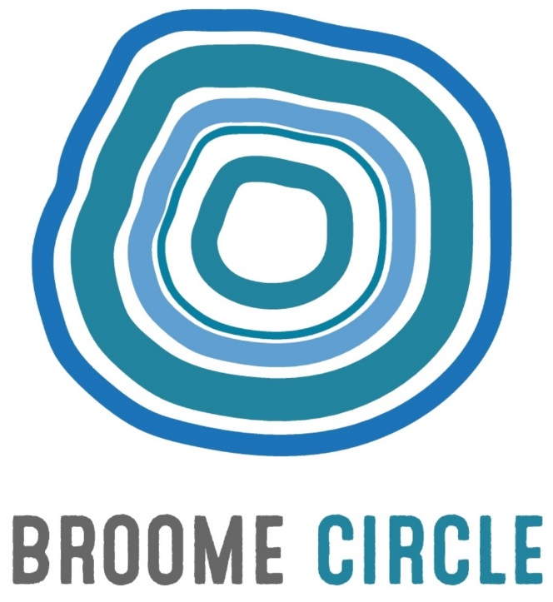

Please contact Sandy Joffe on sandy.joffe@broome circle.org.au or (08) 91936425 for more information.

27 Frederick St, Broome 6725
P: (08) 9193 6425
E: sandy.joffe@broomecircle.org.au
W: www.broomecircle.org.au

Response to Discussion Paper

Broome CIRCLE appreciates the opportunity to respond to the Financial Wellbeing and Capability Activity (FWCA) Discussion Paper. Broome CIRCLE’s Financial Management Program (FMP) delivers an integrated financial counselling and financial capability service to individuals and through education activities in Broome and to remote communities in the Shire.
Overall, Broome CIRCLE supports the Discussion Paper’s position on increasing service integration and supporting client outcomes, especially regarding early intervention and prevention. In the experience of our team early intervention is key to effectively addressing the financial issues facing our clients. The concern of our service is that increased targeting of services could serve to undermine early intervention as described below.
Strategies to improve the targeting of services:
1.1 Stricter targeting of services raises a number of concerns for the Broome CIRCLE FMP team:
In almost every case, the earlier a financial counsellor can intervene to respond to client needs, the better the outcomes. By limiting services to those at imminent risk of not being able to pay their debts, people will be encouraged to delay seeking the advice of a financial counsellor. Our team has case studies where, for example, people have lost their homes because action was not taken early enough. Our aim is therefore to encourage early intervention whenever a potential financial crisis looms, rather than delaying until debt default is imminent. A second concern is that this restriction would exclude some of the other work done by Financial Counsellors including working with deceased estates, insurance, superannuation and disability claims. In many instances, this assistance will reduce the reliance on social support payments such as NSA, DSP and Aged Pension.This is important as it enables the financial counsellor to work in an holistic manner.
The case study of Client A demonstrates the value of Financial Counselling even when a client is not at imminent risk of not being able to pay their debts.
Case Study 1:
Client A is an Indigenous women receiving a disability pension. When she first engaged with the Broome CIRCLE Financial Management Program she was homeless and living out of her car. She had been on the HomesWest waiting list for 7 years. Her disability contributed to her difficulty managing her finances in an organised manner and she explained that lack of schooling had resulted in low financial literacy.
Client A’s first concern was a credit card debt she had accrued over the years with Coles / Myer. The Financial Counsellor (FC) developed an inclusive budget giving consideration to the possibility that she might be awarded a HomesWest home in the near future. Actually, Client A’s financial situation was in good order with just her credit card debt and a Centrelink advance in the debts and repayment section.
On behalf of Client A, and with her permission, the Broome CIRCLE FC negotiated a realistic payment plan to pay off this debt. Previously, she had only been paying interest and was making no progress on the debt. With the new agreement in place, Client A could slowly repay the debt through B-pay to ensure adherence to the agreement.
A week after the FC contacted HomesWest to enquire about her housing, a house became available for Client A. The FC assisted her to set up fortnightly Centrepay payments for her rent, water and electricity and made sure she was signed up to Horizon power so that she had electricity when she moved into the house.
As client A had been homeless for 7 years she had no furniture or white goods for her new home. The FC assisted her with an application for a WA NILS loan to purchase a fridge and washing mashing. The application was successful and she was granted the loan.
The FC worked with Client A for four months. During this period, she encountered a range of personal issues for which the FC provided appropriate referrals to other agencies to provide additional support. Client A is extremely happy with her outcome. She feels more organised and her financial affairs are creating less stress and more happiness. She is pleased that she no longer has to jump up and down in her bath to do the washing anymore and has referred two other clients to Broome Circle Financial Management Program.

Regarding restriction of access to Financial Capability workers, this limitation would deny access to about 25% of Broome CIRCLE’s current clients. Since the mining downturn in WA, many people on previously high incomes are facing financial crises and would benefit from capability worker‘s support in reorganising their finances. A sudden drop in income requires enormous lifestyle changes. Without the support of a worker, people easily fall into debt and depression often followed by family breakdown, loss of all assets and mental illness. Broome CIRCLE contend that a Social Return on Investment analysis would demonstrate that in the long run, restricting service to a specified group results in increased cost to the State and additional distress for clients.
Further, it is often the household member who earns an income from employment who seeks Capability worker support; they can be managing increased financial commitments such as high car loan repayments; pressure from family members who rely on help from working family to supplement inadequate incomes; managing increased cost of private rent as the household is no longer eligible for public housing.
Finally, targeting is likely to increase stigma around seeking financial assistance and discourage people in need from seeking this assistance. Ultimately this will result in more defaults and greater hardship for people in crisis.
1.2 To ensure that services are accessible to those who need them the most, in the experience of Broome CIRCLE, stigma around seeking support from an FWC Hub should be minimised and the service should be delivered from a community accessible site.

Strategies to increase service integration:
Efficiently and effectively contacting government departments such as Department of Human Services and the ] Office of Housing. FCs and CW’s spend long periods on hold, this is time that could be used more productively. A dedicated Centrelink line for financial counsellors would make a significant difference to the effectiveness of FCs.
2.1 Networks, collaborative projects and sharing of resources are all helpful in strengthening cooperation between services. At Broome CIRCLE this has taken the form of
- An Emergency Relief (ER) network of seven ER providers,
- Developing new projects such as an innovative social enterprise, and a food labelling project,
- Sharing transport to remote communities with Boab Health and Cancer Council,
- Facilitating outreach at ER agencies to offer to support to repeat users of the service
In a small town like Broome, financial counsellors are well aware of other services and resources in the region and refer to them regularly. The challenge for financial counsellors is finding time to attend meetings and network with other providers.
2.2 Strong inter-agency relationships depend largely on the openness to and experience of collaboration among workers and management. Formalising these relationships may be helpful in some instances but there is a possibility that formal relationships become an additional bureaucratic formality rather than a mechanism for enhancing working relationships. Additionally, some agencies may prefer not to be tied into a formal relationship. For example, the Broome Emergency Relief Network Project has developed formal collaboration protocols for members. However, while member services continue to work collaboratively, they prefer the existing informal networks, especially regarding ER where availability fluctuates. Practical mechanisms for enhancing collaboration could include:
- Regular agency visits by workers
- Written material for distribution to workers and clients
- Interagency network meetings with an ongoing agenda item around referrals
- Regular assessment of the effectiveness of referrals
It is worth noting that requirements around confidentiality make data sharing complex.
2.3 Broome CIRCLE supports volunteers to provide No Interest Loan Services to clients in Broome. This is a popular service that could be better supported by funding for the delivery of the program. Currently Broome CIRCLE uses volunteers to work with clients applying for NILS loans.
2.4 A Hub model is already established and working well in Broome Shire. Internal referrals between FC and Capability Worker (CW) and where relevant other service providers allow for continued engagement and ongoing financial literacy support for clients once the initial presenting need or crisis has been resolved with the FC. This continuity of care type model increases the likelihood of adherence to agreed budgets and financial plans, reducing the likelihood of re-presentations. There is currently more demand for service than can be met in the Shire due to the distance that is covered by FC and CW staff travelling to remote Aboriginal Communities.
2.5 Broome Circle’s Financial Counselling, Capability and Resilience Hub (FCCRH) works closely with the Committees of the Aboriginal Communities which we visit. Embedded workers or community liaison workers would increase access for people in remote areas and increase the efficiency and productivity of financial counsellors on outreach to remote communities. Consistency is a key to working well with people in remote communities. Certainty of funding and retention of staff who can build rapport with their clients are the basis of successful outcomes for clients. Open days have been found to be an effective mechanism for building collaboration with government agencies.
2.6 Integration of services can enable efficient service delivery. However in a small town like Broome, we need to be mindful of matters of stigma and confidentiality when people are accessing services. There are some simple mechanisms for sharing costs, such as allowing DSS service to use Prime Minister and Cabinet buildings in remote communities free of charge.

Strategies to support client outcomes
3.1 Broome CIRCLE works closely with employment services Kularri Regional Communities Incorporated (KRCI), Kimberley Employment Services and Kimberley Personnel and refers to these services regularly where appropriate. In the current economic climate, high unemployment rates, especially for Aboriginal people, makes finding a job extremely challenging. For many clients in crisis, the issue of insufficient income is matched by uncontrolled outgoings. In remote communities, issues of elder abuse, gambling and exploitation by consumer lease and other unscrupulous businesses contribute to people experiencing financial crises. Community development projects that address these issues would make a significant difference to people in remote communities.
Making budgeting or measuring of assistance sought part of the jobseeker Mutual Obligation with compliance measured by Employment Services Provider.
3.2 Regarding Emergency Relief (ER), Case management provides better long term outcomes for the majority of people in financial crisis than the quick fix of ER. While there may be some circumstances where ER is appropriate, and some clients for whom a chronic inadequate income causes them to rely on ER, it should, whenever possible be provided in conjunction with case management. This enables workers to identify issues such as domestic violence or elder abuse that would not be identified through brief encounters of ER provision.
Emergency Relief (ER) is considered a tool of financial counselling at Broome CIRCLE. ER at this service is only provided to clients with open cases who are working with a financial counsellor or financial capability worker, and where assessment demonstrates that ER (funded by Lotterywest) would assist the client through a crisis. Our service complements the work of other services in Broome who provide ER vouchers and food and have a client group whose mental illness and substance dependency reduces their suitability for case management. Broome CIRCLE FMP team visits these ER services fortnightly to facilitate referrals, build relationships and encourage clients to use their ER responsibly. ER is often seen and used by clients as a supplement to an inadequate income, rather than a once off to get through an emergency situation. Case management can assist people to live within their means, however, in some cases, their income is simply inadequate and ER is one of their coping strategies.
This model works extremely well in that each service’s role is well defined, there is strong collaboration and clients have access to different types of ER as required.

3.3 Prevention and early intervention is the goal of Broome CIRCLE’s Financial Management Program. Financial Health Check clinics where people with concerns about their financial wellbeing can meet with a financial capability worker to complete a budget and understand what payments and deductions are coming out of their bank account offer a useful model for early intervention for individuals as do community development programs that increase financial literacy and awareness of scams for groups within the community. Unfortunately this stands in direct contrast to the aim of increasing targeting of this service.
Many of Broome Circle’s FMP clients are impacted by intergenerational poverty, limited financial literacy and have not had the experience of seeing a member of their family in full time or ongoing employment. Increased funding to support CW’s delivery of financial literacy programs and support for existing transition to work programs are vital for early intervention and prevention.
Strategies to build a strong workforce
4.1 Capability workers and Financial Counsellors always benefit from well run network meetings to share experiences and in this regard, conferences and network meetings are enormously helpful. Provision of ER by volunteers remains problematic as without appropriate training, they are more likely to be judgemental in their ER provision. Funding for supervision of volunteers would be useful in this regard, as would the provision of training in remote areas.
4.2 Broome CIRCLE FMP program recommends training for all staff in cultural awareness, non-judgemental approaches and mental health, alongside financial counselling specific training. FCW services would benefit from specialised training in areas such as working with people experiencing problem gambling, supporting people in family violence situations and working with people of Aboriginal and Torres Strait Islander background. Tools that are simple, easy to read and culturally appropriate are very useful.

Strategies to strengthen evidence improve practice and measure outcomes.
5.1 The key issues involved in evaluating the FWC Activity
Outcomes of the FWC Activity are both quantitative and qualitative, long term and short term, obvious and subtle. Measuring this through quantitative data alone cannot capture the real outcomes of the activity. Additionally, once a crisis has been dealt with or averted, clients are less likely to participate in evaluation. Nonetheless, participatory methodologies together with a Social Return on Investment (SROI) or impact evaluation would be helpful in understanding what would have happened without the service. Evaluation should include the context of service provision and include cultural responses and challenges to the service.

5.2 Evaluation should focus on how the activity has contributed to the financial, social and emotional wellbeing of clients as well as the extent to which financial capability clients and workshop or project participants have changed behaviours relating to their financial affairs.

