Submission On Department Of Social Services Discussion Paper: Financial Wellbeing and Capability Activity
To | Financial Wellbeing and Capability Team, DSS
From | Keith Besgrove, Senior Policy Adviser
cc | Rosemary Sinclair, Lynne Gallagher, Kerry Connors
Date | 7 April 2017

Energy Consumers Australia is the national voice for residential and small
business energy consumers. Established by the Council of Australian Governments’ Energy Ministers Council in January 2015, its objective is to promote the long-term interests of energy consumers with respect to price, quality, reliability, safety and security of supply. Its remit encompasses the interests of all consumers, including those who encounter difficulty in paying for their consumption.

Related to this objective Energy Consumers Australia has also been tasked with understanding differences in energy markets and the implications across jurisdictions and building the knowledge and capacity of advocates through evidence and research

Energy Consumers Australia is not a direct service provider but is involved in many policy and regulatory decisions affecting consumers experiencing financial hardship. It also undertakes, and has supported research which is relevant to the issues raised in the discussion paper.

We recognise that energy is an essential service – without it households cannot easily heat their homes, cook meals, study, apply for jobs, or any of the many activities that most Australians take for granted.

A key strategic project for ECA therefore is its work (called Keeping People Connected) on assessing ways to reduce household and small business disconnections from electricity and gas in Australia. About 160,000 households and 11,000 small businesses are disconnected each year. The attachment provides summary detail of this project. In the course of this work, Energy Consumers Australia has encountered repeated evidence of the critical role which emergency relief organisations and financial counsellors play, and of the importance of early intervention.

Energy Consumers Australia welcomes the opportunity to provide comments against the issues and questions raised in the discussion paper. As a general observation, Energy Consumers Australia concurs that financial distress is an increasingly complex issue which best responds to integrated service provision. We have observed the benefits which can arise from energy retailers developing partnerships with integrated community service provider organisations to streamline hardship assessment processes and to engage early with consumers to enable them to manage their way out of difficulty.

Energy Consumers Australia supports the themes identified in the discussion paper including
- Strengthen client centred and wrap around approaches to service delivery;
- Explore opportunities to better support clients with entrenched disadvantage particularly those who may be repeat users of ER services;
- Expand opportunities for early intervention and prevention; and
- Build organizational workforce capability

- Strategies to improve the targeting of services

The discussion paper asserts that ER and Commonwealth Financial Counselling Services would be restricted to those at imminent risk of not being able to pay their debts. This begs the question of how, and by whom, such judgements will be made. Energy Consumers Australia believes that ultimately, service providers are best placed to make these sorts of judgements.

Due to the essential nature of the service, electricity and gas retailers in the National Energy Market are required to establish policies and procedures to minimise the potential for disconnection due to an inability to pay bills. The National Energy Retail Rules outline a range of obligations on energy retailers in relation to billing cycles, frequency of bills and payment difficulties. Energy retailers are also required to develop, maintain and implement a hardship policy, to address the needs of customers in financial hardship. The Australian Energy Regulator oversights the operations of those programs, and develops guidance to energy retailers through a guideline that outlines minimum requirements . One of those is that retailers must have processes in place to identify “appropriate financial counselling services and to notify hardship customers of those programs and services” (p7).

We recommend the Commonwealth consider how its formulation sits with the above approach, to ensure that customers at risk are given the right assistance, and that energy retailers are not providing conflicting advice to consumers seeking help.

Energy Consumers Australia’s observation from its work on Keeping People Connected is that early intervention appears to make a significant difference to what happens to consumers in financial difficulty. That is also acknowledged in other sectors. Anecdotal evidence strongly indicates that suggests that clients of financial counsellors retain connection to the service, and secure more realistic payment plans to address accrued debt. We believe that one of the key strategies which DSS should pursue is to be finding ways to enable service providers to identify people at risk as early as possible. We know that large energy retailers are beginning to use data analytics for this purpose and we believe that this promising area of information should be developed further.

The discussion paper also suggests that as a complement to the income support safety net, Financial Capability would be restricted towards people in receipt of an Australia Government social welfare allowance, pension or benefit. This seems to us to be something of a blunt instrument which has the potential to reduce access to services for a range of consumers who could clearly be in need of these services. As the attachment shows, the incidence of disconnections arising from financial hardship impacts people across many parts of the community including many people who are not recipients of Commonwealth benefits. A far preferable method in our view is better targeting through the use of data analytics.

Energy Consumers Australia believes that allowing access to financial counselling systems by all members of the community ensures that those in the early stages of financial crisis seek help before reaching the point of being at imminent risk. The provision of education material and advice to those proactively seeking help (or to their support people and family) in the early stages of a crisis should remain a priority for financial counselling services. Ultimately preventing deterioration in a client’s circumstances will help them return to a more stable situation and potentially be in a position to make good financial decisions and possibly secure employment in the future.

- Strategies to increase service integration

Energy Consumers Australia is not a direct service provider, but our observations of service providers leads us to strongly support the concept of increased service integration. Groups that we interact with such as Care Financial Counselling Uniting Communities and Kildonan Uniting Care demonstrate the value to client groups of being able to bring an integrated range of services to bear to help solve a range of problems confronting people in financial distress. Feedback from energy retailers also supports this view.

In this context, re-shaping service provider models needs to take account of existing linkages between financial counsellors and other sources of support such as community lawyers as well the depth of their relationships with major retailers and banks, since these have well developed strategies and programs in place to deal with consumers in difficulty.

As the discussion paper indicates, establishing integrated service provision is a greater challenge in rural and remote areas of Australia. Here there seems little alternative in practice than to rely largely on virtual service provision. This approach has been utilised successfully in other fields of service in remote locations. For example, telehealth services, including tele-psychiatry, have been used effectively in Australia for some years now.

- Strategies to support client outcomes

The discussion paper flags a future design feature where financial counsellors and capability workers are to address work readiness and employability skills alongside financial literacy skills. Energy Consumers Australia accepts that helping people back into work is important but counsels caution in the implementation of this idea since it carries some dangers. Financial Counsellors are frequently already stretched very thinly with some anecdotal evidence of backlogs in demand for their services. Adding to the complexity of a financial counsellor’s role is not necessarily likely to lead to more successful employment outcomes unless the counsellors have some clear guidance and discretion as to when it will be appropriate to refer clients to employment support services.

As previously stated, Energy Consumers Australia supports initiatives which reinforce the work of existing integrated service providers and encourage the growth of new, integrated service providers. We note that in rural and remote communities this approach will need to be implemented flexibly given the difficulties which these communities can encounter in accessing the full range of Financial Wellbeing services.
- Building a strong workforce

The discussion paper notes the aging service provider workforce and the need to raise professional standards. Energy Consumers Australia believes that addressing these issues will be pivotal to achieving sustainable Financial Wellbeing services over time. In this context, we are aware that Financial Counselling Australia currently produces a range of highly regarded tools for training and professional development and this work should be built upon and made sustainable. A major impediment to this work has been funding uncertainty. The financial counselling service providers often live on the edge of continuing funding uncertainty by jurisdictional and Commonwealth governments and this impedes their ability to plan for the medium and longer term. It also hinders the production of these tools to keep them up to date and ensure they are relevant and accessible.

Provision of an accessible platform for all workers to access and share relevant information via Financial Counselling Australia would facilitate the development of skills across the FWC services sector. This would include the opportunity to present webinars of interest and to network more readily with other service providers from around the country.

- Strategies to strengthen evidence, improve practice and measure outcomes

Energy Consumers Australia supports proposals to enhance data collection and evaluation of the outcomes from the work of service providers in this important area. For far too long it has not been possible to assess the national levels of activity and the degree of unmet demand which may exist. This has been due to a lack of consistent nation-wide data recording by service provider organisations. We understand that such a consistent, data evaluation framework has recently been developed by Financial Counselling Australia and suggest that this should be used as the basis for enhanced data collection from now on.

Energy Consumers Australia’s Keeping People Connected Project Attachment

Energy Consumers Australia’s approach

Energy Consumers Australia seeks to reduce or even eliminate the incidence of disconnections in Australia. It is conducting this work in collaboration with industry, consumer advocates, regulators and government agencies. It seeks new approaches to hardship and disconnection which improve outcomes for consumers without disadvantaging industry.

ECA commissioned KPMG to estimate the total costs of existing financial and other measures to support consumers with energy affordability difficulties, to remain connected to their energy supply.

The 2016 KPMG report shows there are around 160,000 households and 11,000 small businesses being disconnected from electricity and gas each year across Australia. These numbers had increased rapidly over several years but have plateaued in the past three years. In several jurisdictions, the number of people entering retailers’ hardship programs has also escalated over the past five years but also now, appears to have plateaued. The Australian Energy Regulator (AER) obliges energy retailers to have hardship programs to support consumers who encounter difficulties in paying for their energy, and develops guidance to energy retailers through a guideline that outlines minimum requirements . One of those is that retailers must have processes in place to identify “appropriate financial counselling services and to notify hardship customers of those programs and services” (p7).

The KPMG report indicates that between 4 to 7 per cent of consumers find themselves encountering difficulty in paying for their energy consumption at various times. Most of these people are able to manage their own way out of difficulty and the diagram below illustrates the various processes people go through in managing energy payment difficulties. These include the use of payment plans, various forms of intervention from service providers, and retailers’ hardship programs. But roughly 1 per cent of consumers do not succeed, and find themselves disconnected.

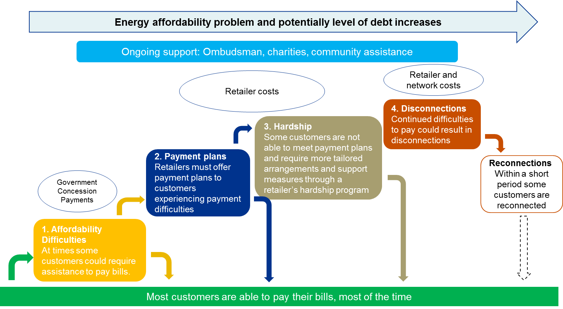

The scale of disconnections is indicative of financial distress across a range of demographics but focused in the poorest sections of the community. The 2016 St Vincent de Paul study Households in the Dark(funded through an Energy Consumers Australia grant) demonstrated that the incidence of disconnections is geographically dispersed and includes populations within advantaged post codes, as well as many disadvantaged ones. We also know from that study that over a four-year period, a significant number of households are disconnected more than once. This is well illustrated by the diagram below, which represents numbers of households disconnected at least twice over a three year period in the Sydney region.

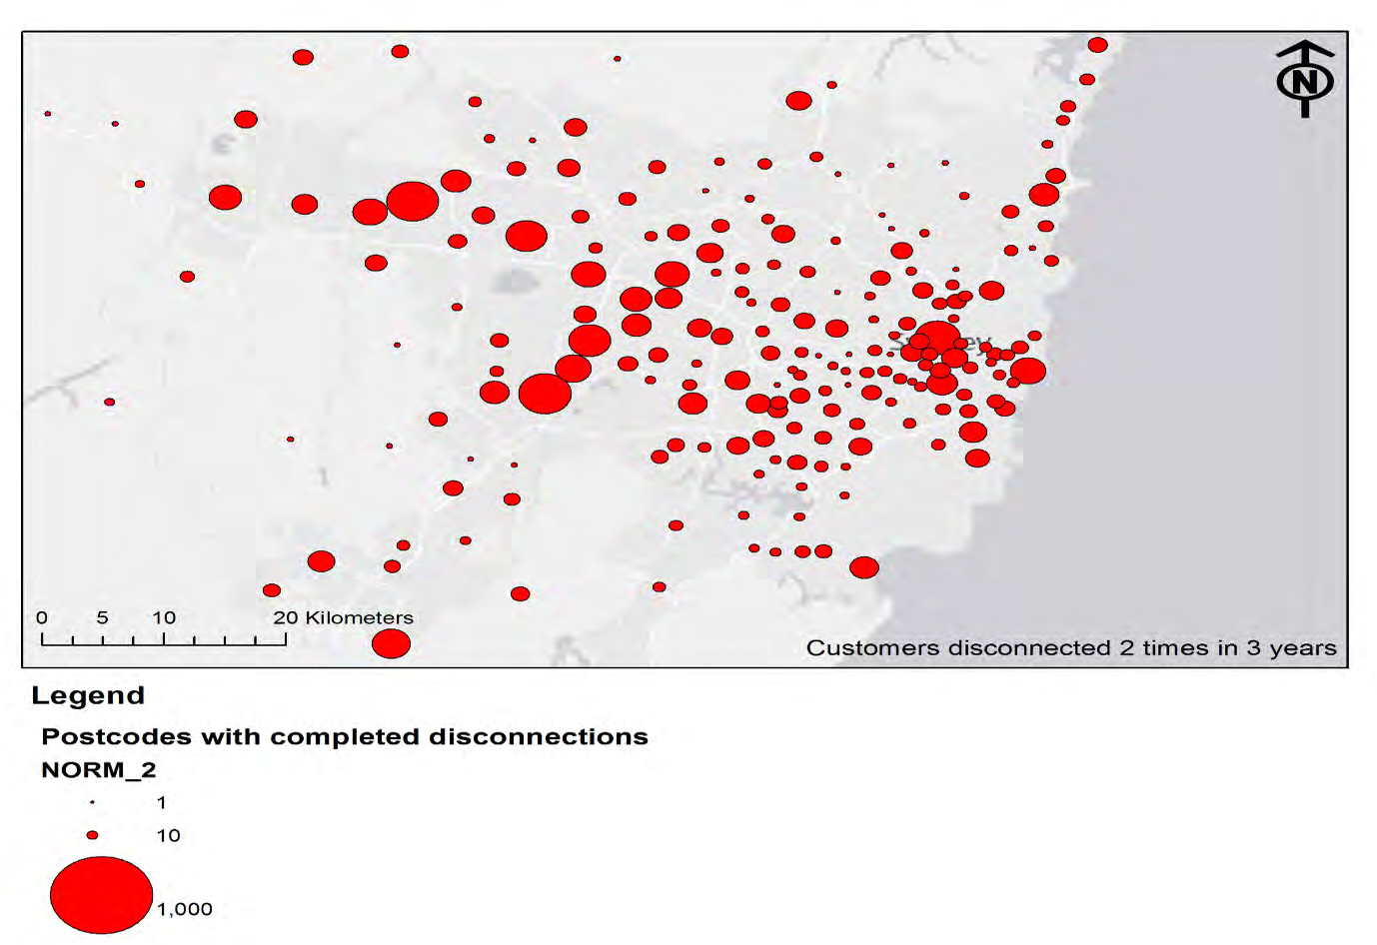

The KPMG study found published data indicating that the current costs to state and territory governments of energy affordability related schemes are around $820 million per annum, while ombudsmen schemes spent close to a further $10 million each year assisting customers with complaints relating to energy affordability issues. KPMG estimated that industry was spending at least another $280 million per annum on hardship schemes and other mechanisms related to energy affordability, as well as the cost of physical disconnections.

Through its Grants Program and related research activities, Energy Consumers Australia and other consumer advocates are identifying the factors and methods which have reduced disconnections in some jurisdictions, and also better models of retailer/consumer behaviour. There is extensive evidence to suggest that early intervention makes a real difference to whether people enter hardship programs and ultimately end up being disconnected. We also know that some retailers in some jurisdictions (e.g. Tasmania) have dramatically reduced the incidence of disconnection by thinking differently about how to handle hardship clients. They have used different techniques to help people, through one on one programs of support, to manage their energy usage and their finances. In the process, these companies have reduced their associated debt levels.

Energy Consumers Australia is exploring alternative approaches to reduce the incidence of disconnections and where possible costs to government and industry. In conducting this work, Energy Consumers Australia is drawing upon the lessons from earlier work by a range of consumer advocate organisations.

Energy Consumers Australia has identified six inter-related areas for further work by all stakeholders in this sector, which it believes would have a strongly beneficial impact in reducing the incidence of disconnections in Australia. These are:

- Better targeted, consistent and easily accessible energy concessions and emergency relief programs.

- Concessions schemes have not kept pace with increases in energy bills, and some programs are unnecessarily complex and difficult to access. If these schemes could be more suitable and accessible to consumers in distress, we believe it could make a real difference. Collaborative work between industry and consumer advocates is well underway in this area.

- Explore mechanisms to address income shortfalls for that group of consumers who can never pay their energy bills

- The number of multiple disconnections of the same consumers, together with anecdotal evidence from the major retailers about consumers who remain in hardship programs for many years, indicates a small group of consumers who are unlikely to ever be able to pay for their energy consumption. We are researching options through the Power Shift program which focuses on energy efficiency measures, the Grants Program which is researching behavioural Insights and technologies such as smart phones and apps, and commissioned research to explore approaches and experiences in other countries.

- Identify and promulgate better retail practices

- There are more than 30 energy retailers in Australia and their treatment of consumers in difficulty varies widely. Promulgating better practices would have real benefits. These could include adoption of streamlined retailer hardship assessment processes; improved communications strategies for culturally and linguistically diverse consumers; and structured, integrated early intervention strategies including use of financial counsellors.

- Build stronger capacity for early intervention

- The major energy retailers have demonstrated that using integrated community sector services providers is paying dividends in helping consumers in financial difficulty to manage their way out of trouble. The Energy Australia/Kildonan partnership is a case in point. In addition, Energy Consumers Australia’s research activities, including its Powershift project, are building an evidence base to identify more successful specific forms of early intervention.

- Improve the energy efficiency of rental properties and public housing

- People who rent both private and public housing have little or no control over the energy efficiency of their dwellings. As a result, these people often have much higher levels of energy consumption than people who own their own dwellings, which compounds the financial challenges they may already be confronting. While some jurisdictions are working on this issue, much more needs to be done, and the Commonwealth government has a clear and important role to play.

- Develop mechanisms to enable people who want to donate to the community their surplus renewable energy

- We know from discussions with a wide range of stakeholders that a proportion of consumers with solar panels on their houses would be willing to donate some of their power to deserving groups within the community. Energy Consumers Australia is currently working with retailers and with Kildonan to make this happen.

The Guideline is available at https://www.aer.gov.au/system/files/Final%20Guidance%20on%20AER%20approval%20of%20customer%20hardship%20policies%20-%20May%202011.pdf
See for example: Telecommunications Industry Ombudsman Responding to customers in financial hardship: principles and practices for telecommunications providers (2014); ASIC’s guide Helping home borrowers in financial hardship (2009);
FCRC Rank the Energy Retailer (2016) noted the difficulty in clients trying to negotiate directly with a retailer, where respondents felt that the threat of disconnection was used to pressure clients into unaffordable payment plans.
KPMG report “Quantifying The Costs Of Customers Experiencing Difficulties In Paying Energy Bills”, October 2016 p1.
The Guideline is available at https://www.aer.gov.au/system/files/Final%20Guidance%20on%20AER%20approval%20of%20customer%20hardship%20policies%20-%20May%202011.pdf
St Vincent De Paul Society and Alvis Consulting, “Households in the dark -- Mapping electricity disconnections in South Australia, Victoria, New South Wales and South East Queensland”May 2016, p 43.

