Discussion paper
Ensuring a strong future for supported employment
December 2017

Copyright notice
This document Ensuring a strong future for supported employment is licensed under the Creative Commons Attribution 4.0 International Licence
Licence URL: https://creativecommons.org/licenses/by/4.0/legalcode
Please attribute: © Commonwealth of Australia (Department of Social Services) 2016
Notice:
- If you create a derivative of this document, the Department of Social Services requests the following notice be placed on your derivative: Based on Commonwealth of Australia (Department of Social Services) data.
- Inquiries regarding this licence or any other use of this document are welcome. Please contact: Branch Manager, Communication Services Branch, Department of Social Services.
Phone: 1300 653 227. Email: communications@dss.gov.au
Notice identifying other material or rights in this publication:
- Australian Commonwealth Coat of Arms — not Licensed under Creative Commons, see https://www.itsanhonour.gov.au/coat-arms/index.cfm
- Certain images and photographs (as marked) — not licensed under Creative Commons

Ministers’ Preface

Supported employment has a strong legacy in Australian communities, providing real social benefit to people with disability, their families and carers. Across Australia, there are around 20,000 supported employees, predominantly with moderate to severe disability.
The economy also benefits from their employment. Deloitte Access Economics in 2011 found that closing the employment gap between people with disability and people without, by as much as a third, could boost Australia’s Gross Domestic Product by $43 billion over the decade.
During the financial years 2015-16 to 2019-20, the Government has built on our commitment to supported employment, providing more than $1.3 billion in funding. This includes funding to assist Australian Disability Enterprises (ADEs) during a period of significant adjustment. ADEs have been supported to respond to a changing industrial relations environment, while also preparing to take advantage of the National Disability Insurance Scheme (NDIS).
Within the NDIS, there are opportunities for the more than 170 existing ADEs, and new and emerging providers, to offer employment support and provide greater access to Disability Employment Services.
In 2016-17, the National Disability Insurance Agency (NDIA) reported that 16 per cent of NDIS participants aged 15 to 24 years and 26 per cent of NDIS participants aged 25 years and over were in paid employment. We expect more NDIS participants will aspire to work and can be supported to do so in the future.
As the Minister for Social Services and Assistant Minister for Social Services and Disability Services, we want to ensure future Government policy allows for supported employment, while also meeting Australia’s commitment under international law to promote the rights of persons with disabilities to work.
This Discussion Paper is a chance for you to have your say. It builds on the work of the Disability Employment Taskforce in 2015 and complements reforms to Disability Employment Services that we announced in May 2017 to increase the employment of people with disability.
We invite you to continue working with us to ensure a strong future in supported employment for people with disability.

The Hon Christian Porter MP  Minister for Social Services | The Hon Jane Prentice MP  Assistant Minister for Social Services and Disability Services
7 December 2017

Table of Contents

Introduction 5
Purpose of the discussion paper 6
What is the landscape for employment of people with disability in Australia? 7
Commonwealth employment services for people with disability 9
Profile of DES Participants 10
Supported employment and Australian Disability Enterprises 11
Profile of supported employees 12
Supported employment sector funding 13
Key differences between the current operation of open and supported employment in Australia 16
Challenges faced by the supported employment sector 17
Opportunities for the supported employment sector 18
What will the supported employment landscape look like at full scheme roll out of the NDIS? 19
Have your say on the guiding principles 19
Transition to the future landscape 20
Discussion Topics 21
Strategies to support employment participation for people with disability 21
Have your say - Discussion questions 22
Strategies to support employer/providers to offer effective employment opportunities 23
Have your say - Discussion questions 24
Strategies to facilitate greater choice and control for NDIS participants 25
Have your say - Discussion questions 26
Next steps 27
Consultation timeline 28

Introduction

Supported employment plays a vital role in improving the social and economic participation of many people with disability in Australia.
A greater quality of life is enjoyed by people who experience a sense of economic contribution and earn their own discretionary income from employment.
The 2011 Deloitte Access Economics report, ‘The Economic Benefits of Increasing Employment for People with Disability’ concluded that Australia would increase its Gross Domestic Product by $43 billion if the employment gap between people with disability and people without were reduced by one third.
The Australian Government spends over $220 million each year to support around 20,000 people, with moderate to severe disability, to receive employment support in their workplace.
Funding to support these employees is transitioning to the National Disability Insurance Scheme (NDIS). The NDIS re-envisages how people with disability receive support, allowing more choice and control over how, when and where supports are provided, and gives people with disability certainty they will receive the supports they need over a lifetime. This presents new opportunities for people with disability to choose their supports, and for providers of employment supports to operate in the growing open market of the NDIS.
While the disability employment landscape is changing, the Government is committed to supporting people with disability to work where they have the capacity to do so. The number of people with disability receiving ‘employment supports’ in full scheme NDIS is expected to grow significantly beyond the existing cohort of 20,000 supported employees.
This is good news for people with disability and good news for the Australian economy. It provides current Australian Disability Enterprises (ADEs) an opportunity to continue supporting employees in a new NDIS market.

Purpose of the discussion paper

This discussion paper describes the future landscape for supported employment and asks how the sector can position itself to transition to the full scheme of the NDIS.
It intends to continue a conversation with supported employees, their families and carers, services providers and advocates about how the Government can support people with disability to work. It builds on the work of the 2015 Disability Employment Taskforce and the May 2017 announcements to reform Disability Employment Services (DES).
This discussion paper invites input from interested stakeholders on the following areas:
- principles to guide the Government’s future policy direction for supported employment
- strategies to support employment participation for people with disability
- strategies to support employers and service providers to provide effective employment opportunities
- strategies to facilitate greater choice and control for NDIS participants.

People with disability and their families and carers, ADEs, employers of people with disability, peak bodies and other interested stakeholders are invited to make a written submission on any or all of the questions raised in this discussion paper.
All submissions will be considered in future policy development.
Submissions are to be uploaded on engage.dss.gov.au by 9 March 2018.
The Department of Social Services (DSS) will treat all submissions as
non-confidential, unless clearly indicated. Please keep your responses succinct where possible. You may choose to respond to all or a selection of the questions within this paper.

What is the landscape for employment of people with disability in Australia?

According to the Survey of Disability, Ageing and Carers (SDAC), in 2015 there were over 2.1 million Australians with disability of working age. Of this group, only 53.4 per cent were in the workforce or actively seeking work, compared to 83.2 per cent for people with no disability. Furthermore, only 25 per cent of people with a profound or severe core activity limitation were active participants in the labour market. This means that over a million Australians of working age with disability were outside the workforce and there is significant scope to support more people with disability into employment.
The Australian Government is committed to its obligations under the United Nations Convention on the Rights of Persons with Disabilities to provide equitable access to work. To fully support and enable the right of people with disability to work, the Government is working to ensure that supports are available.
The National Disability Strategy 2010–2020 provides a ten-year national policy framework for all levels of government to improve the lives of people with disability. Outcome three of the Strategy focuses on economic security, a critical element of which is employment.
Despite significant investment by the Government in employment services, the labour force participation rates for people with disability have remained largely unchanged for the past 20 years. DSS estimates around 237,000 Disability Support Pension (DSP) recipients of working age may be eligible for employment assistance, and are not participating in employment, education or an employment assistance program.
The terms ‘open’ and ‘supported’ employment have been used to describe the different employment settings and employment supports available to people with disability to enable them to participate in work, or to build capacity for work.

‘Supported’ employment generally refers to employment in enterprises that have as their primary purpose employment of people with disability, and where the majority of employees have disability. There are often mixed industries within enterprises to cater for their employees, and there are higher levels of job customisation.
‘Open’ employment refers to employment where the jobs are open to all people, with or without disability. People with disability who wish to receive assistance to find employment in the open labour market can register with a DES provider.
Funding for ‘supported’ employment is transitioning to the NDIS. Many NDIS participants are, and will be, eligible for employment services to achieve or remain in employment. The shift to open employment may increase over time as NDIS participants take advantage of new opportunities through the NDIS to address their immediate support needs and build capacity to find, trial and maintain open employment.
The Government will invest around $5 billion in employment services and supports for people with disability over the next four years through DES and ADEs as they transition to the NDIS.
For the purposes of this discussion paper, the key focus is supported employment. Its interface with open employment services and settings is important to fully understand the options available to supported employees as NDIS participants.

Commonwealth employment services for people with disability
jobactive is the Government program supporting more Australians into work, including people with disability. It connects job seekers with employers and is delivered by a network of jobactive providers in over 1,700 locations across Australia. Through a jobactive provider, people with disability can access the same range of supports that are available to all Australians, to assist them to find and keep a job. jobactive providers offer flexible and tailored services to meet a job seeker’s assessed needs. There are currently around 800,000 job seekers receiving assistance in jobactive, of which around 200,000 are registered as having a disability.

Disability Employment Services (DES) is the Government’s specialist open employment program for people with disability whose disability is assessed as the main impediment to them gaining employment.
There are two separate sub-programs within DES. These are:
- Employment Support Services for job seekers with permanent disability and an assessed need for regular ongoing support in the workplace, and
- Disability Management Services for job seekers with disability, injury or health conditions who are not expected to need long-term support in the workplace but may need irregular flexible support to keep a job.
The program in its current form was introduced on 1 March 2010. Through DES providers, the program delivers a suite of employment services to people with disability, injury or health condition, in the open labour market.
Services provided through DES include: allied health services to assist people to improve their work capacity, assistance with job search, résumé preparation, and support for education and training. Related initiatives in open employment provide wage subsidies and targeted employer engagement. These supports are tailored to each individual to help them into long-term, sustainable work. Participating in DES also satisfies mutual obligation requirements for people on some types of income support who are required to actively look for work in order to receive their payments.
There are currently around 189,000 participants in DES. DSS currently contracts 117 DES providers in around 2,000 sites, across 110 non-remote geographical areas nationally. Since March 2010, there have been over 375,000 job placements.
DES providers are not funded to employ the people with disability who they support to seek employment. Rather DES providers offer support to enable participants to prepare to access and maintain work in open employment. Following community consultation, key changes will be implemented from 1 July 2018, to improve DES performance.

Profile of DES Participants
- 44 per cent of DES participants have a physical disability
- 38 per cent have a psychiatric disability
- Four per cent have an intellectual disability
- DES participants must have an assessed current or future work capacity of eight hours per week as determined by an allied health professional via an Employment Services Assessment or a Job Capacity Assessment (ESAt/JCA)
- DES participant ages range from under 20, to over 65, with an average age of 43
- 78 per cent of DES participants are accessing Newstart or Youth Allowance
- 11 per cent are accessing the DSP
- Over 95 percent of DES participants are paid a full award wage, and
- At any given time there are 189,000 DES participants accessing support through DES providers that are collectively paid up to $800 million annually.

DES funding
From financial years 2017-18 to 2021-22, the Government will invest over $3.4 billion in DES and associated services to assist people with disability to gain employment in the open labour market.
Under the banner of DES, the Government also funds a range of services targeted to support employers to employ people with disability, referred to as Employment Assistance and Other Services, which includes the Employment Assistance Fund, the Supported Wage System, the Wage Subsidy Scheme and the National Disability Recruitment Coordinator.
Service fees are paid to DES Providers to cover the services delivered to DES participants while receiving employment assistance.
DES Outcome Fees are paid in recognition of the amount of work DES Providers do to assist each participant to find quality employment that suits their individual skills and interests.
Ongoing support for DES participants in the workplace can be provided in a range of ways:
- flexible ongoing support is paid at $400 for each instance of support, up to six instances in any six-month period
- moderate and high ongoing support in the workplace attracts fees of up to $13,200 annually. Moderate ongoing support may include 12 instances over six months and high ongoing support up to 24 instances in a six-month period. The modes of contact and time supporting a participant are not prescribed.

Work Based Personal Assistance
Work Based Personal Assistance is predominantly accessed through the NDIS. However, DES providers also offer Work Based Personal Assistance with fees paid at $35 per hour for Work Based Personal Assistance provided by the DES Provider and $45 per hour for assistance purchased from another provider.

Supported employment and Australian Disability Enterprises
The Government’s supported employment program for people with disability is the Disability Employment Assistance (DEA) program.
DEA funding for existing supported employees who are eligible for the NDIS is transitioning to the NDIS. Under the DEA program, case-based funding, which has been in place since 2004, is provided according to an online assessment used by ADEs to record the work-related support needs of a supported employee to maintain their employment.
ADEs employ and deliver support to around 20,000 supported employees. ADEs employ people with moderate to severe disability to engage in a wide variety of work and offer: social, behavioural and cognitive assistance; physical and personal care; communication and workplace environment assistance and adjustment; special medical assistance and other assistance to connect with other services.
ADEs have historically operated with funding for a capped number of clients.
With opportunities for market expansion under the NDIS, ADEs are well positioned to attract more employees, where their commercial businesses provide opportunity to do so.
The NDIS transforms the way in which the disability services market operates.
Participant choice and control is a central pillar of the NDIS, which will change the nature of the relationship between consumers and service providers. Due to the scale of the reform, the maturing of the new NDIS disability services market is expected to take up to ten years.
By the end of 2017, over 8,000 supported employees are expected to have transitioned to the NDIS. In total, around 19,000 supported employees of the existing 20,000 will be transitioned by the time the NDIS is at full scheme.
The NDIS is expected to reach full scheme by mid-2020 with the number of people receiving ‘employment support’ in full scheme expected to grow significantly beyond the existing number of people working in supported employment.
The National Disability Insurance Agency (NDIA) is currently mirroring the ADE
case-based funding model and is considering whether pricing controls for employment support are required.

Profile of supported employees
- 70-75 per cent of supported employees have an intellectual disability
- The average weekly wage for a supported employee is $121.72
- The average hourly rate is $5.61, with wages ranging from $1.00 per hour to full award wage
- All supported employees qualify for DSP
- The pension income test free area (including for DSP) from 1 July 2017 is $168 per fortnight for singles and $300 per fortnight for couples combined
- Supported employees must be able to work a minimum of eight hours of work per week as determined by employer, employee and family and carers
- The average hours worked are 23 per week
- Supported employee ages range from under 20, to over 65, with 41 the average age, and
- The average cost of employment support from the Government per supported employee is $11,800.

Supported employment sector funding
For existing supported employees in ADEs, over $1.3 billion in funding is allocated between 2015-16 and 2019-20. Over $220 million per year is available through the DEA Program and associated initiatives, which deliver employment supports. Over $180 million has been made available in transitional funding support to assist the sector to adjust to higher wages, and undertake business planning for the future and the transition to the NDIS.
Funds supporting ADEs to access business improvement advice have been fully committed. Use of wage supplementation has been low while industrial relations issues associated with wage assessment are under consideration by the Fair Work Commission.
 | 2015-16  $m | 2016-17  $m | 2017-18  $m | 2018-19  $m | 2019-20  $m | Total  $m
Service Delivery funding
Disability Employment Assistance (CBF) | 221.817 | 211.263 | 221.271 | 227.177 | 232.173 | 1,113.701
Quality Assurance Payments | 1.047 | 1.096 | 1.077 | 1.052 | 1.076 | 5.348
CBF Program Support | 10.415 | 0.78 | 3.000 | 0.000 | 0.000 | 14.195
Total |  |  |  |  |  | 1,133.24
Transitional support funding
BSWAT Wage Supplementation and Case Management | 6.861 | 2.400 | 26.390 | 52.807 | 42.737 | 131.195
New Wage Tool (Varied SWS) | 0.978 | 15.322 | 7.754 | 7.777 | 0.000 | 31.831
Business Improvement | 8.986 | 6.014 | 1.008 | 1.014 | 0.000 | 17.022
Total |  |  |  |  |  | 180.048
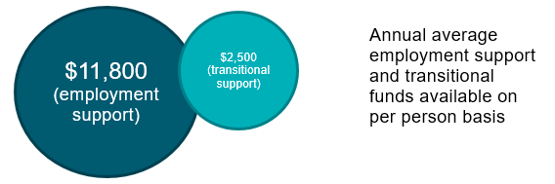

Supported employment funding
Currently ADEs are funded for a capped number of places, with a price per place for each person with a disability. This case-based funding is paid monthly in arrears to the ADE while the supported employee remains in employment.
Current case-based funding core fees – 2017-18 | Amount (GST exclusive)
Intake Fee | $634
Employment Assistance Fee (or Pre-DMI Fee)  (per month, for up to 12 months) | $634  (up to a maximum of $7,608)
Employment Maintenance Fee | Amount Per Month | Amount Per Annum
DMI Level 1 | $375 | $4,500
DMI Level 2 | $634 | $7,608
DMI Level 3 | $953 | $11,436
DMI Level 4 | $1,264 | $15,168
There are a number of supplementary payments to ADEs, which are additional to
case-based funding.
Current Rural and Remote Service Supplement | ARIA Classification: | Amount Per Month | Amount Per Annum
 | Highly Accessible: | Nil. | Nil.
 | Accessible: | $1,509 | $18,108
 | Moderately Accessible: | $3,017 | $36,204
 | Remote: | $4,526 | $54,312
 | Very Remote: | $6,029 | $72,348
Work-based personal assistance also attracts an additional fee for services.
Work Based Personal Assistance (2015-2018) | Either:  - $35 per hour where the work based personal assistance is provided by an Approved Support Worker from within the Outlet  or  - $45 per hour where the work based personal assistance is purchased from a second agency, and is provided up to a maximum of 10 hours per week.

Key differences between the current operation of open and supported employment in Australia

Supported Employment – Australian Disability Enterprises
ADEs receive funding to assist directly employing people with disability and particularly to provide the supports those people need at work.
ADEs act as a link, helping people with moderate to severe disability gain training and experience to confidently step into open employment or to continue in supported employment if they choose.
ADEs create employment opportunities through designing jobs around the individual abilities of people with disability. ADEs provide significant workplace modifications to accommodate the abilities of their workforce. The majority of an ADE’s workforce has a disability.
Once placed in an ADE, a supported employee generally immediately commences in a job role.
An ADE will adjust a supported employee’s daily job tasks to suit their abilities, meaning an equivalent open employment job role may not be completed by one ADE employee.
A supported employee will often receive daily access to employment and personal care supports by support staff embedded within (and employed by) the ADE. This allows for a greater intensity and frequency of support that can be provided to individuals.
Open Employment –
Disability Employment Services
DES providers are not funded to directly employ people with disabilities looking for work; rather they are funded to help those people gain employment readiness, to then gain employment with employers looking for workers in the open labour market.
Generally a job will not be redesigned for a DES participant, rather a DES provider will focus on finding a ‘good job match’ for the participant’s abilities. A DES participant may also access wage subsidies available through jobactive.
A DES participant is generally not working with a majority of staff with disability, but rather in a mainstream workplace.
On entry to DES, a participant is generally not yet employed.
A participant can receive services and assistance to prepare for work, build workplace skills, undertake training, find work, change jobs, and access workplace modifications. Most DES participants who achieve employment exit the program as independent workers.
Once a DES employment placement has been made, a DES provider may provide varying levels of ongoing employment support and personal assistance to DES participants (i.e. flexible, moderate or high ongoing support). Support contacts are usually not provided on a daily basis.

Challenges faced by the supported employment sector
The current disability employment landscape presents three challenges for supported employees and the businesses that employ and support them.
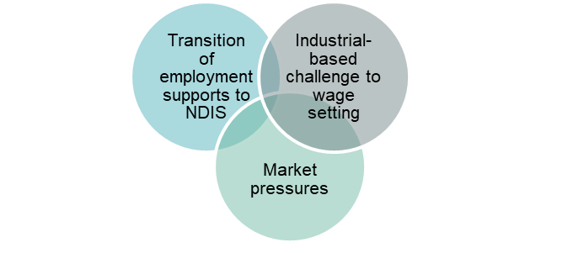

Transition of employment supports to the NDIS
The NDIA is currently replicating DSS case-based funding for assessed support levels for existing ADE workers, regardless of hours worked. The allocation of funds in individual participant plans does not yet accommodate all case-based costs (e.g. remote services delivery).
The future market will be ‘demand driven’ meaning ADEs and other organisations must market themselves as providers of employment for all NDIS participants who have a component in their package to purchase employment supports.
The Government envisages a more open market in a mature NDIS, and stronger pathways may be established between ‘open’ and ‘supported’ employment.
In an open NDIS market, the need for supported employment pricing controls is not yet resolved.

Industrial relations based challenge to wage setting
In recent years, ADEs have experienced uncertainty about the way they calculate wages due to the ceasing of the use of the Business Services Wage Assessment Tool (BSWAT) in 2015.
The finding of the Full Federal Court of Australia in December 2012, of indirect discrimination in the use of the BSWAT for two supported employees in Nojin v the Commonwealth may have implications for the use of other wage tools.
The Fair Work Commission is considering the removal of all competency-based wage tools through the Modern Award Review to the Supported Employment Services Award 2010, the relevant industrial award for enterprises offering supported employment.

Business pressures
ADEs are subject to significant challenges apart from wage pressures. Some ADEs are engaged in declining industries at risk of digitalisation, off-shore processing, and mechanisation and automation, while many ADEs operate with small profit margins.
Regional and remote ADEs are likely to be at greater risk of viability challenges from other locational economic factors, including unemployment, participation rates, local industry concentration, and relative economic disadvantage.

Opportunities for the supported employment sector
The rollout of the NDIS to full scheme presents opportunities for existing and new businesses to expand and diversify, as they offer greater choice in employment settings and supports available to NDIS participants.
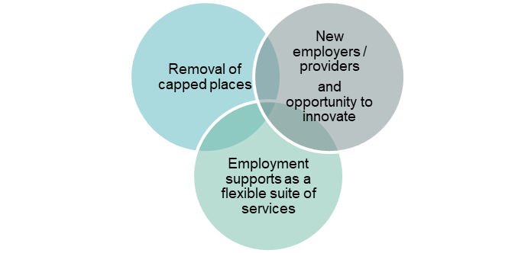

Removal of capped places
Supported employment places will no longer be capped under the NDIS. This means increased opportunities for businesses wishing to offer employment to more participants and/or specialise in delivering employment supports for this growing cohort.

New employers/providers and opportunity to innovate
There will be increased opportunity for new providers to offer employment and deliver employment supports. Employers and support providers will not be constrained by the employment settings and support models that operated under case-based funding.
Existing and new providers will have opportunities to engage in innovative service delivery.

Employment supports as a flexible suite of services
Opportunities to deliver an expanded suite of services to supported employees will be possible, acknowledging many ADEs already offer a broad range of services.
Some businesses may choose to explore the provision of more seamless service transition between supported and open employment, as a person’s capacity to work improves.

What will the supported employment landscape look like at full scheme roll out of the NDIS?
In consultation with supported employees, their families and carers, employers, advocates and other interested stakeholders, the Government will consider policy options to underpin a strong future for supported employment, guided by the following foundational principles:
- An ‘employment first’ approach for all NDIS participants of working age – strengthening employment outcomes for people with disability, with support from their families and carers, educators and NDIS Local Area Coordinators and planners, so that employment opportunities are available through a range of pathways which suit their working preferences.

- A diversity of employers providing employment supports – building market capacity for new employers in the market offering labour-hire, social enterprise cooperatives and other diverse employment models.

- Strong and viable disability enterprises – with ADE transition and reform supported through sustainable NDIS funding in participant plans and pricing controls for employment supports.

- Employees and employers have certainty about industrial wage setting – resolution of matters before the Fair Work Commission provides confidence to ADE businesses and new employers in the market when accessing available industrial provisions designed to promote the employment of people with disability.

Have your say on the guiding principles
- Are there other principles, which should guide the Government’s policy direction for supported employment?

Transition to the future landscape
The diagram below shows the expected movement of employees, including the increase of employees accessing employment supports in the NDIS and the expected opportunities for employer/providers. These examples demonstrate what is already occurring in the NDIS, and where there is real opportunity for growth and diversification among current businesses and for new employer/providers in the market. Consultation will assist to refine what the transition to the future landscape could look like.
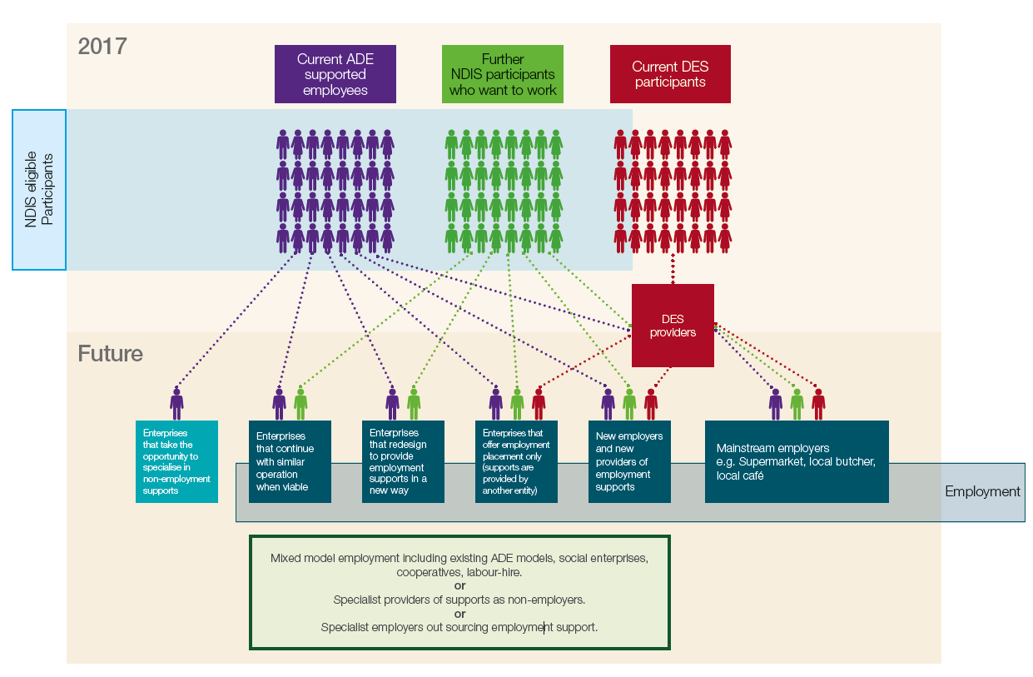

Discussion Topics

Strategies to support employment participation for people with disability

What employee experiences may look like in the future
At full scheme NDIS, participants who are in supported employment are both a consumer of employment-related supports and an employee of a business. However, the NDIS also allows participants of the scheme ‘choice and control’ over who they work for, and which employer best supports them to reach their maximum potential in work. Where ADEs continue to operate a similar model, supported employees may continue to access those supports from their employers. However, in an emerging market, it is also likely that some employees will choose to access their supports from other providers.
In the early stages of NDIS transition, employee experiences have included:
- current ADE employees who choose to remain in their current employment

- current ADE employees who transition to new employment opportunities (either supported employment or open employment), because of their preference or because the ADE no longer provides employment supports in the NDIS

- current ADE employees who transition to non-employment options

- NDIS participants who are not currently employed and have approached the NDIS for employment supports, and

- a modest number of ADE employees have commenced in DES and participate concurrently in both programs.

Challenges in getting there
How people with disability understand and are best able to exercise choice and control is a key challenge for the NDIS. Understanding the intersections between the employment relationship and the consumer relationship is crucial.
While ADEs actively support and promote employee transition to open employment, the number of supported employees that move into open employment is small. The number of supported employees that remain after moving into open employment is smaller still.
Allowing flexible complementary servicing between DES and ADEs has provided some employees with the security of maintaining ADE employment while they look for open employment. To ensure participation in DES is appropriate, ADE employees must meet the usual eligibility requirements for DES including having an Employment Services Assessment (ESAt) or Job Capacity Assessment (JCA) which confirms they have the capacity to work for at least eight hours per week in open employment with support from a DES provider. The take-up of complementary servicing has been modest, suggesting work could be done to better promote or target this option more effectively for eligible supported employees.
Work could also be done to look at transitional options to support participants who may not be DES eligible but would like support to explore open employment options.

Have your say - Discussion questions
- What is a ‘good’ participation outcome for a supported employee and how can good outcomes be measured?

- What do supported employees most value about working in an ADE?

- Why do most supported employees transition back to supported employment from open employment?

- How can more supported employees be provided the opportunity to choose open employment?

- Why is participant access to concurrent DES and ADE support services so low?

- What is the role a supported employer can play in building employee capacity for transition to open employment?

- What will attract NDIS participants to employment opportunities in the future?

Strategies to support employer/providers to offer effective employment opportunities

What employer/provider experiences may look like in the future
In the future there will continue to be opportunities for current ADEs and new NDIS sector market entrants to employ people with disability and/or offer the supports that enable them to participate in employment.
ADE experience in the NDIS to date shows that not all ADEs will choose to operate as they have done in the past.

ADE Reform
Some ADEs have accessed funds to seek business improvement advice, including advice on how to reform their businesses. For example, some ADEs have created labour-hire arrangements where groups of supported employees are placed in other commercial businesses.
In a growing market, there are also opportunities for ADEs to leverage procurement opportunities, and with uncapped places, expand or change their business model.
Some ADEs have taken the opportunity to capitalise on marketing to offer
non-employment supports and attract associated funding available through the NDIS, allowing continued support to NDIS participants and ongoing business viability.
There is also opportunity for ADEs to specialise as providers of employment supports for people with disability, as supported employees are ‘placed’ in other commercial businesses.
Some ADEs have accessed funds to assist in making independent business decisions to exit the employment market and close their businesses. New providers of employment and employment supports
It is expected market forces will provide opportunities for new, viable organisations to develop and offer supports, with participants accessing sustainable NDIS funding for employment supports.
Options to encourage new providers or start-ups offering these supports, and testing of innovative employment models, could be considered by Government for future development.

Challenges in getting there - existing employers and providers
ADEs continue to face a range of challenges relating to wage pressures, declining industries, locational economic factors and small profit margins.
Strategies have been implemented in the past to encourage ADEs to reform their business models and address other viability challenges, with mixed success. Any future support would need to be carefully developed to provide a clear pathway for transformation, over a defined period, and tied to future DES or NDIS funding models.

The experience of social enterprises and other entities established to support people with disability at work, could inform future possible strategies. Government investment, or industry adjustment, could be targeted to capitalise on successful models, which provide good outcomes for supported employees.
Wage supplementation has been made available for ADEs that choose to transition to a productivity-based wage assessment tool, being the Supported Wage System (SWS) or varied SWS, once in effect. However, use of the supplementation has been limited and wage uncertainty continues to undermine ADE confidence and business planning.
Consideration is being given to whether pricing controls for ‘employment supports’ for existing supported employees and new market entrants will be needed, and how providers can navigate the NDIS and DES funding system when supporting participants who choose to transition between supported and open employment.

Have your say - Discussion questions
9. How are ADEs marketing their services to an expanded market of potential NDIS participants?

10. What is the range of NDIS supports that ADEs currently offer?

11. What costs would be involved for ADEs that choose to:
a) reform to more open employment models?
b) redevelop as service providers offering other NDIS supports?
c) specialise in the provision of employment support as a
non-employer?

12. Should the Government have a role in supporting new market entrants and start-ups in the short-term?

13. What investment, or industry adjustment will promote viable expansion in the employer/provider market?

14. How could employer/providers share learnings of their success and failures within a competitive market?

15. How can wage supplementation be better targeted?

Strategies to facilitate greater choice and control for NDIS participants

The role of the NDIA into the future
The NDIS provides support and assistance, including financial assistance, to people with disability to aid them in exercising choice and control in pursuit of their goals.
This includes supporting people with disability to participate in and contribute to social and economic life to the extent of their ability. Reasonable and necessary supports for people with disability can be provided to develop and support their capacity to undertake activities that enable them to participate in the community and maintain employment.
People with disability should also be supported to receive assistance outside the NDIS, including support to coordinate services accessed under the NDIS and with mainstream employment services, such as DES.

Challenges in getting there
In the initial transition phase for existing supported employees that are eligible for the NDIS, participants’ employment supports are generally reflecting the supports they currently receive in their ADE, with funding mirroring case-based funding.
The NDIA has a market stewardship role to encourage providers to invest in delivering NDIS services including employment services. However, the NDIA does not find work for participants.
In order for businesses of all sizes and types to sustainably grow and innovate under the NDIS, and promote their services to existing and future NDIS participants, there needs to be clarity about market development.
Different planning approaches for various age cohorts may present opportunities for greater choice in employment to suit a range of working preferences and life stages.
For example, for younger people and those entering the workforce (including options available through School Leaver Employment Support (SLES)), for established or mature aged workers, and for employees transitioning to retirement.

Have your say - Discussion questions
- How can the NDIS enable an employment first approach in planning?

- How do current assessment processes drive the inclusion of employment supports in an NDIS participant’s plan?
a) Are existing employment assessment processes appropriate for NDIS participants?

- Are there different approaches to planning that could be explored for different groups of supported employees (e.g. younger workers, established workers, retirement transition)?
a) How could SLES better support school leavers to build skills and confidence in order to move from school to employment?

- What role could or should an NDIA Local Area Coordinator or planner have in linking participants to an employment opportunity?

- What role could or should NDIA market stewardship have in developing a market with a range of employment, other support, or participation options for existing supported employees?

Next steps

The discussion paper invites you to have your say.

DSS intends to undertake a range of consultation activities to engage directly with:
- Australian Disability Enterprises
- Supported employees
- Families and carers of current supported employees
- Disability Employment Services Providers
- The National Disability Insurance Agency (NDIA)
- Providers of employment supports, registered with the NDIA
- Peak organisations representing disability services
- Advocates representing people with disability and lived experience of disability, and
- Other stakeholders identified in consultation with the Department.
Your input will help inform policy development. Workshops and interviews will allow for exchange of information, experiences and insights to ensure a better understanding of the needs of around 20,000 supported employees and future NDIS participants seeking employment across Australia.
The Government and DSS understand the importance of ensuring that any future changes to supported employment policy are fair, thoroughly discussed, planned and smoothly implemented for employees, their families and carers, and ADEs.

The consultation period
The consultation period for this discussion paper is open from:
7 December 2017 to 9 March 2018.
Interested individuals and organisations are invited to provide written submissions to DSS through engage.dss.gov.au by 9 March 2018.
The closing date for uploading submissions is 5:00pm Friday 9 March 2018 (AEDT).

Consultation timeline

December 2017 | Discussion paper released for consultation until 9 March 2018
January / February / March 2018 | Targeted consultation workshops
February / March 2018 | Interviews with supported employees – subject to ethical approval for engaging with vulnerable people
March / April 2018 | Review of submissions to the discussion paper

The Disability Maintenance Instrument (DMI) is an online assessment used by ADEs to record the work-related support needs of a supported employee to maintain their employment. The DMI provides a score for a supported employee, which translates into one of four funding levels for support with ‘DMI Level 1’ being the lowest funding level (representing lower support needs) and ‘DMI Level 4’ the highest (representing higher support needs). The DMI is not aligned to the number of hours worked. For example, an employee working eight hours who is assessed at a ‘DMI Level 4’ will receive the same funding as a supported employee working 25 hours who is also assessed at a ‘DMI Level 4’.

