16 March 2018

The Department of Social Services (DSS)
Via website: engage.dss.gov.au

Response to Discussion Paper: A Strong Future for Supported Employment

Disabled People’s Organisations Australia (DPO Australia) welcomes the opportunity to provide feedback to DSS on its Discussion Paper, Ensuring a strong future for supported employment.

DPO Australia is an alliance of national disabled people’s organisations (DPOs), which are organisations constituted, led and governed by people with disability. Our key purpose is to promote, protect and advance the human rights and freedoms of people with disability by working collaboratively on areas of shared interests, purposes and strategic priorities and opportunities. DPO Australia is made up of First Peoples Disability Network Australia (FPDN); Women With Disabilities Australia (WWDA); National Ethnic Disability Alliance (NEDA); and People with Disability Australia (PWDA).

Member organisations of DPO Australia have extensive expertise relating to the functioning and effectiveness of the disability employment system. DPO Australia provided input into the review of Disability Employment Framework, participated on the Australian Human Rights Commission’s (AHRC) Willing to Work Inquiry Reference Group, and we are represented on the Disability Employment Services (DES) reform reference groups.

In response to the Discussion Paper, we address our key overarching issues:

Australia’s human rights obligations
Article 27 of the Convention on the Rights of Persons with Disabilities (CRPD) articulates the rights of people with disability to work “on an equal basis with others” in a “work environment that is open, inclusive and accessible to persons with disabilities”.

The National Disability Strategy 2010-2020 (NDS) provides the implementation mechanism for Australia’s obligations under the CRPD, and the Second NDS Implementation Plan, ‘Driving Action 2015-2018’, emphasises areas of increased national effort, including improving employment outcomes for people with disability.

The Discussion Paper affirms the Australian Government’s commitment “to its obligations under the United Nations Convention on the Rights of Persons with Disabilities to provide equitable access to work”.

Despite this, we are concerned that Australian Government continues to inaccurately view supported employment, as provided in segregated environments by Australian Disability Enterprises (ADEs) as compatible with its obligations under the Convention on the Rights of Persons with Disabilities (CRPD):
“we want to ensure future Government policy allows for supported employment, while also meeting Australia’s commitment under international law to promote the rights of persons with disabilities to work”.

The Discussion Paper also positions the National Disability Insurance Scheme (NDIS) as an opportunity for ADEs to strengthen their role in “a new NDIS market”. However, the NDIS Act gives effect to obligations under the CRPD, which means that the NDIS should be directed at achieving human rights for people with disability, not used to facilitate non-compliance.

Overall, the information and questions in the Discussion Paper do not provide the means to genuinely engage with or identify outcomes to support the human rights of people with disability.

We argue that any discussion about the future of supported employment needs to be based in a human rights framework, and in particular the right to work articulated in CRPD article 27. This would enable strategies and measures for the future of supported employment to be identified that would be consistent with the CRPD and that would enable Australia to meet its international human rights obligations.

The need for comprehensive systemic reform
As the Discussion Paper points out, there is a significant need to improve economic participation for people with disability in Australia. We rank 21 out of 29 OECD nations when it comes to employment of people with disability. The participation of people with disability in the Australian labour force remains low, with recent data reporting only 53.4% of working age people with disability in the labour force, compared to 82.3% of people without disability. Subsequently, rates of unemployment and underemployment of people with disability are high.

As a result of pervasive barriers to education, training and employment, an increasing number of people with disability are struggling to survive on social security payments. The rate of poverty amongst people with disability in Australia is the highest in the OECD.

People with disability face pervasive low expectations and discrimination relating to education and employment, which undermine their potential to find and keep meaningful job opportunities in the open employment market. Disability employment reform cannot be viewed in isolation, but must actively address these structural systemic barriers. This includes inclusive education, post-school transition support, work experience or part time employment, and job skills training focused on providing genuine pathways for students with disability that support and encourage their potential in open employment.

Segregated educational settings (including special schools and segregated units within mainstream school) do not offer young people with disability the same opportunities as their peers. This segregated educational environment limits aspiration and potential towards open employment, instead setting up a pathway to further segregation, often in ADEs.

Discrimination and systemic barriers to education and employment result in many people with disability being dependent on the social security system. The interaction between social security and pathways to open employment cannot be under-estimated. Whilst the social security system can provide some financial support to people wishing to participate in employment, the system can also act as a disincentive and barrier to people with disability seeking open employment.

The significant discrimination and systemic barriers to employment experienced by people with disability requires comprehensive systemic reform and action. However, reform to date has been piecemeal, and only focused on elements of the current disability employment framework. While reform of DES and the supported employment program is needed, these reforms will not, in isolation address the systemic action needed to increase economic participation in inclusive environments for people with disability. The Discussion Paper creates an expectation that DES and supported employment reforms within the market based environment of the NDIS will facilitate the reform required.

In this respect, DPO Australia is concerned that there appears to be little action to implement the recommendations from the AHRC’s Willing to Work Inquiry. These recommendations comprehensively outline a framework to address a diversity of systemic employment barriers, such as a national workforce strategy, statutory oversight and support, national education campaigns, leadership training, social security reform, transition from school to work, transition to open employment, DES reforms, government and employer initiatives, accessible ICT, universal design and reforms to federal discrimination laws and the Fair Work Act.

In 2017, the UN Committee on Economic, Social and Cultural Rights recommended to Australia that it consider the recommendations from the AHRC Willing to Work Inquiry to address the poor employment situation of people with disability. Such comprehensive reform is critical for people with disability in realising their right to work.

Rethinking supported employment
The roll out of the National Disability Insurance scheme (NDIS) will transform the current disability support system, providing people with disability the tailored support they need to better engage in employment and economic participation. These opportunities will be missed if employment reform fails to deliver the shift in the employment landscape that is required.

However, it is of great concern to DPO Australia that the Discussion Paper appears to link the NDIS as a means of securing ADEs as a viable long-term employment pathway for people with disability. Once employed, very few ADEs provide genuine pathways for people with disability to move to open employment or earn a full wage, despite a person’s potential to do so with adequate support, and ADEs do not provide the necessary skills building, career progression, professional development and training to assist in moving into open employment.

The supported employment model is an alternative to open employment, where people with disability are segregated and renumerated on the basis of their disability contrary to human rights obligations. To this end the Australian Government must have a clear strategy for shifting away from this model.

DPO Australia strongly argues that a key element of the comprehensive systemic reform required to increase economic participation of people with disability, is the need for a national strategy to phase out segregated employment that contains measures to support people with disability to transition to mainstream employment. Such measures would include increasing the skills and availability of supports to provide job training ‘in place’ and ongoing job support for maintaining employment.

DPO Australia would be happy to provide further information regarding the views expressed here and we thank you for the opportunity to provide input into this process.

Yours sincerely
THERESE SANDS
Co-Chief Executive Officer,
People with Disability Australia
(on behalf of DPO Australia)

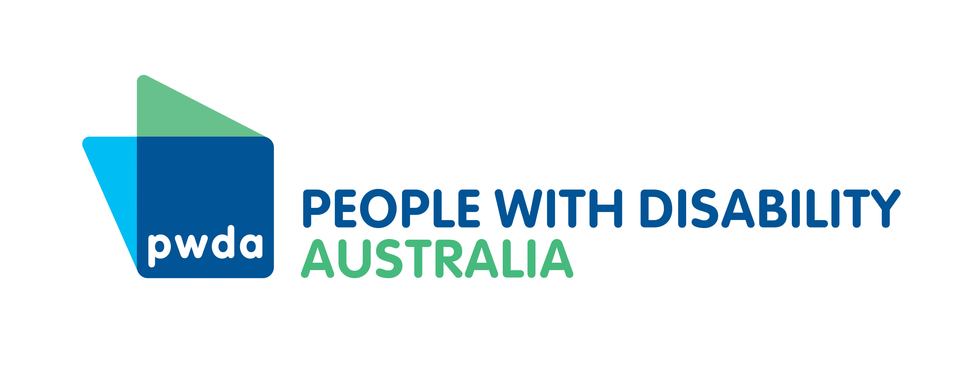

Australian Human Rights Commission’s Willing to Work National Inquiry into Employment Discrimination Against Older Australians and Australians with Disability.
United Nations Convention on the Rights of Persons with Disabilities (CRPD) https://www.un.org/development/desa/disabilities/convention-on-the-rights-of-persons-with-disabilities/article-27-work-and-employment.html
Australian Department of Social Services National Disability Strategy 2010-2020 (NDS) https://www.dss.gov.au/our-responsibilities/disability-and-carers/publications-articles/policy-research/national-disability-strategy-2010-2020
The NDS Second Implementation Plan Driving Action 2015-2018 https://www.dss.gov.au/disability-and-carers/programs-services/government-international/national-disability-strategy-second-implementation-plan
Department of Social Services, op. cit., p.7
Ibid, p. 3
Ibid, p. 5
Department of Social Services, Ensuring a strong future for supported employment, Commonwealth of Australia, December 2017, p.7
Parliament of Australia (2011) Disability Employment in Australia and the OECD https://www.aph.gov.au/About_Parliament/Parliamentary_Departments/Parliamentary_Library/FlagPost/2011/December/Disability_employment_in_Australia_and_the_OECD
Australia Bureau of Statistics 2016 ‘Disability, Ageing and Carers, Australia: Summary of Findings 2015 http://www.abs.gov.au/ausstats/abs@.nsf/Lookup/4430.0main+features202015 Accessed 7 March 2018
ibid
Parliament of Australia (2011) Disability Employment in Australia and the OECD https://www.aph.gov.au/About_Parliament/Parliamentary_Departments/Parliamentary_Library/FlagPost/2011/December/Disability_employment_in_Australia_and_the_OECD
The 2017 Concluding Observations of the Committee on Social, Economic and Cultural Rights recommends that the Australian Government implement the 2016 report of the Senate Education and Employment References Committee Access to real learning: the impacts of policy, funding and culture on students with disability. This report can be accessed here https://www.aph.gov.au/Parliamentary_Business/Committees/Senate/Education_and_Employment/students_with_disability/Report
For example, currently a person who participates in the supported wage system automatically qualifies for the Disability Support Pension.
Australian Human Rights Commission, Willing to Work – National Inquiry into Employment Discrimination Against Older Australians and Australians with Disability, 2016 http://www.humanrights.gov.au/our-work/disability-rights/publications/willing-work-national-inquiry-employment-discrimination
Committee on Social, Economic and Cultural Rights Concluding Observations on the fifth periodic report of Australia (2017) http://tbinternet.ohchr.org/_layouts/treatybodyexternal/Download.aspx?symbolno=E%2fC.12%2fAUS%2fCO%2f5&Lang=en Accessed March 7, 2018
Australian Human Rights Commission, op. cit., p.213

