

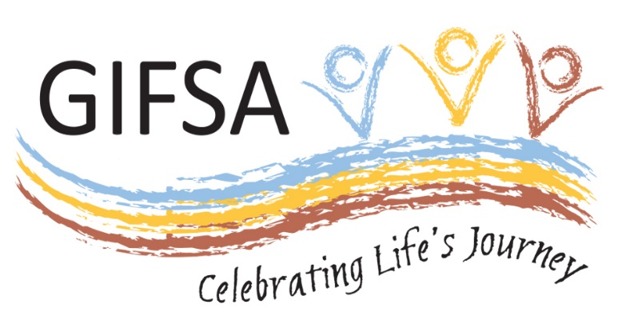

**Submission**

**To**

**Department of Social Services**

**In response to document-**

**Integrated Carer Support Service: Regional Delivery Partners**

**A draft on the regional delivery model**

**May 2018**

**EXECUTIVE SUMMARY**

GIFSA appreciates the opportunity to lodge this submission and to share our thoughts on the Integrated Carer Support Service (ICSS) Regional Delivery Model.

We are very pleased that the Australian Government continues to be committed to supporting and sustaining the vital work of unpaid carers. Moreover, we applaud the Government’s focus to work with the sector and carers to design a service delivery model for the ICSS.

GIFSA is well placed to support and add value to the establishment of a network of Regional Delivery Partners across Australia, providing carers with access to new and improved local services such as information and advice, needs assessments, targeted financial support, tailored counselling and coaching, and crisis support where required. Indeed we have a strong local presence in the Goldfields-Esperance region of Western Australia as indicated on the map below. Importantly, we currently provide carer support in the Ngaanyatjarra Lands courtesy of funding support from the Department of Social Services.

**ABOUT GIFSA**



GIFSA staffed locations

Goldfields-Esperance region of Western Australia

(3 sub-regions circled)

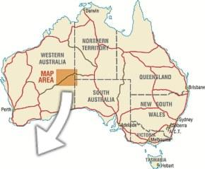

Ngaanyatjarra (NG) lands

GIFSA is a significant regional community development not-for-profit (NFP) benevolent charity organisation employing more than 100 local residents and supporting over 250 people with disability, their families and carers. The organisation has been delivering services across the region for 26 years, that is, we know the region very well.

Headquartered in the City of Kalgoorlie-Boulder WA, GIFSA’s operational area covers the vast 771,000km2 Goldfields-Esperance region of WA. Within the region there are three distinct sub-regions, The Ngaanyatjarra Lands, Goldfields and Esperance (see diagram above).

The Goldfields-Esperance region is unique in that it is three times the size of Victoria, 2.4 times the size of the Barkly (NT) region and with a population of only 65,000 people.

As the only regionally headquartered Disability Service Provider with staff located across this vast region, the communities we service and people we support are intrinsically connected to the organisation.

Providing services across such a large region, within the bounds of the of Australia’s largest State or Territory, needs to be better appreciated and considered and we firmly believe, based on lived experience, that a one-size-fits-all approach will not meet the needs of participants and service provision.

GIFSA’s geographic coverage area includes the large and very remote Ngaanyatjarra (NG) lands which comprises twelve(12) aboriginal communities in the Western Desert region of WA /NT. Warburton is the largest community and main service centre in the NG lands, located over 1000km’s from the nearest large towns of Kalgoorlie-Boulder and Alice Springs.

The NG lands comprise approximately 3% of the land mass of Australia with a highly mobile indigenous Yarnangu population who experience very high levels of socio-economic disadvantage, poor health outcomes, unemployment and scarcity of social services.

Currently GIFSA provides a mobile respite and carer support service throughout the NG lands through funding provided by the Mental Health Respite: Carer Support (MHR: CS) program.

Traditional carer relationships are very fluid and flexible individuals may be cared for by several persons in a community and periodically move to different communities with or without a carer, which then requires another set of carer arrangements. Breakdown in carer / recipient relationships are common, particularly for persons experiencing mental illness or psycho-social disability. This fluid traditional carer arraignment means few carers are receiving the DSS carer’s benefit.

Traditional culture is strong throughout NG Lands people speak Ngaanyatjarra as a first language with English at best a second or third language. The perception of disability in traditional Yarnangu culture is especially negative, Yarnangu people do not wish to be identified as different or disabled, as it is often thought to be shameful and weak or even seen as punishment. As such carers and carer recipients often do not engage with support services, frequently carer relationships deteriorate to crisis point before they become apparent to clinic or service providers in the community.

Traditionally Yarnangu people do not plan beyond their immediate need for basics and don’t perceive planning as important, it is highly unlikely that a Yarnangu carer would be aware of, or would seek support without ‘in-person’ assistance.

Culturally a high value is placed in personal relationships whichare imperative to forming a trust based relationship with Yarnangu people, whether they be clients, carers, and staff or community members. For community service workers it takes time to adjust and also to be accepted before any effective progress can be made, irreparable damage can be done by trying to enforce deadlines or taking a one-size fits-all approach to Yarnangu people.

Support services utilising the visiting outreach model, comprising service delivery staff and programs based centrally in another physical location with scheduled visits to communities has a history of being inadequate. This model is reactive and unable to provide emergency support and respite when it is most required, poorly identifies or engages with carers who are experiencing stress, and fails to build meaningful culturally safe relationships with Yarnangu people. It has been GIFSA’s experience providing carer support services in the NG lands that the physical presence of a coordinator in a community and the employment of local people as community liaison officers in other communities in the NG lands increases Yarnangu acceptance of providers, enriches the connection to Yarnangu carers and ensures carer support is delivered in a manner that is culturally acceptable.

The realities of operating carer support and respite services in the remote and sparely populated Goldfields- Esperance Ngaanyatjarra sub-region of WA has challenges that we at GIFSA feel need careful consideration in the design, transition and activation of the ICSS.

***“The first stage was the design and implementation of Carer Gateway. The Carer Gateway was launched in December 2015, and established a website (***[***www.carergateway.gov.au***](http://www.carergateway.gov.au)***) and national contact centre, dedicated to the delivery of carer-specific information. Its purpose is to provide carers with a recognisable source of clear, consistent and reliable information, to help them navigate the system of support and services.”* (DSS 2018. ICSS: RDP draft pg 4)\***

The level of private internet connectivity is minimal to non-existent among the Yarnangu population, there is no easily accessible public internet ready computers available and the level of computer skills is extremely low. Yarnangu people do not typically access the internet, understand its capacity or have experience using an internet device. Internet access is generally through the assistance of service provider, council office or other organisational staff present in the community on behalf of the individual.

How are Yarnangu carers made aware of, let alone able to access the carer gateway website without direct assistance?

Does the phone service provide an easily accessible Indigenous interpreter service?

**Discussion point 1-** Key issues with the approach to structuring the service area.

The premise that the economy of scale will allow RDP’s to maintain carer support service and “**ensures a more equitable access and consistent service experience across regions”** (DSS, 2018 ICSS: RDP draft pg 8) has merit. The extent to which metropolitan regions of a service area alone could subsidise remote and very remote indigenous communities is an issue that needs specific attention.

What mechanisms are planned to ensure equal access and experience throughout the service areas and across regions? Will the funded contract fully take into account the added expense of very remote area carer support services?

Internet only services will not be effective and it is an expensive proposition for the RDP to establish or maintain a staff member in remote areas with high costs, limited infrastructure, and a carer population dispersed over a 200,000 km2 extremely isolated area.

GIFSA’s experience delivering Mental Health Respite: Carer Support (MHR: CS) program in the very remote Ngaanyatjarra lands has shown that Yarnangu carers do not seek out and engage with service providers unless trust has been established on a personal level, this takes time and needs to involve more than just the immediate individual carer alone due to traditional flexibility in the carer role.

**\*“Ensure a more equitable access and consistent service experience across regions” as per (DSS, 2018 ICSS: RDP draft pg 8)**

**Discussion point 2-** Capacity and capability of organisations to establish and manage a regional presence throughout a large service area, including the ability lead a consortia-based model, and undertake service area planning.

There is significant additional expense in establishing and maintaining a presence in remote and very remote areas like the Ngaanyatjarra lands. Provision of staff housing, retention, recruitment and high turnover of staff. No regular air services, frequent long distance travel on unsealed road requires a fit-for-purpose 4WD vehicle, increased wear, tear & maintenance. Limited infrastructure and economy of scale. All consumables such as fuel, food and programme materials are significantly more expensive to purchase, or the added cost of freight for items unable to be purchased.

The ability of the RDP to deliver an equitable carer support service across these proposed service areas will hinge on their ability to provide information and access to carers who are often not currently engaged with any form of carer support and often unaware that these services exist. This is the scenario in remote indigenous communities, a pervasive lack of access to services is a compounding factor for many carers and their families.

**\*An undertaking to ensure additional remote and very remote operating expenses are taken into account by the department and RDP’s when funding is allocated?**

**Discussion point 3-** How to ensure the breadth and reach of services provided under the proposed service area models, including the incorporation of local service providers.

The initial service provider contact with Yarnangu carers in the very remote NG lands is frequently when emergency support and/or respite is required. That is a ‘in person’ support response to a crisis and breakdown in care for a disabled person who is vulnerable without assistance. It can often involve transporting the vulnerable person several hundred kilometres so they can reconnect with family in a different community or a similar unique support action that rectifies the carer situation in the short, medium and long term, it requires flexibility and cultural sensitivity. Once the crisis has passed the carer is offered ongoing carer respite (bush trips), support with accessing mainstream services and the situation is monitored periodically.

It is difficult to ensure support is accessible and universal in service experience when Yarnangu people including carers and care recipients are frequently mobile and carer phone numbers regularly change. Carer support service that are also mobile are more able to maintain contact with carers through talking to Yarnangu people in the communities they service, and become an important link between carers and recipients in various communities.

**\*An understanding that Yarnangu and very remote aboriginal carers require a higher level of “in-person” delivered carer support which is mobile, flexible and provides support appropriate to the carer’s culture.**

**\*A realistic level of funding for remote and very remote regions with difficult to engage carers and limited infrastructure.**

**\*A regular review of carer support services needs to occur specifically looking into the remote and very remote areas of Australia and also develop strategies to further engage indigenous people in all levels of the process.**

**Discussion point 4-** Are there any alternate RDP service area models that you think the Department should consider? If so, on what basis?

GIFSA is unable to provide any statistical analysis and/or evidence however we are able to provide anecdotal evidence gleaned from the lived experience of our mobile respite coordinator who is permanently based on Ngaanyatjarra lands in the very remote community of Jameson or Mantamaru.

The department should firstly identify the most difficult to engage carers and the most difficult to service regions across all service areas.

Once identified where and who meets the departments criteria, formulate a strategy to improve carer outcomes specific to the location or cohort of carers. A government led RDP and stakeholder inclusive task forces can oversee, advise implementation and monitor progress towards improvement. Flexibility, creativity and adequate funding are required to target carers most in need of support, these are often carers who do not realise that support is available to them.

*“Through its commissioning of the ICSS, the Australian Government’s objective is to:*

***Improve carer wellbeing, increase their capacity and support their participation, socially and economically.”*** (Appendix A ICSS Service Blueprint; pg. 5)

Author: Greg Bryan, Mobile Respite Coordinator, GIFSA

Authorised by: Robert Hicks, CEO GIFSA

Signed off: 11 May 2018