Summary Modelling Results of the New Means Test Rules for Pooled Lifetime Retirement Income Streams
July 2018
The results in this paper have been provided to indicate the broad impacts of the new means test rules for pooled lifetime income streams. They are general in nature and do not take into account specific individual circumstances. This paper does not constitute professional or expert advice.
The Department of Social Services disclaims all liability to any person in respect of anything, and of the consequences of anything, done or omitted to be done, by any such person in reliance, whether wholly or partially, upon any information presented in this paper.
This paper is made available on the understanding that the Department of Social Services is not providing professional financial advice. When making decisions around financial products, purchasers or providers should not rely on this paper and should obtain appropriate professional financial advice.

Overview
The Government announced new means test rules for pooled lifetime retirement income streams (lifetime products) in the 2018-19 Budget.
The Department of Social Services previously released a position paper for public comment on 16 January 2018, which detailed proposed new means test rules for lifetime products. An attachment to the position paper provided scenario modelling showing retirement outcomes under the proposed means test rules, drawing on modelling prepared by the Australian Government Actuary.
The new rules announced in the 2018-19 Budget varied from those put forward in the position paper. This document presents modelling of the final rules, with updated modelling assumptions. It also provides modelling of additional scenarios involving people purchasing products at later ages.
The modelling in this document was prepared by the Australian Government Actuary (AGA).
Updates to the assumptions about the modelling of account-based income streams and the additional modelling of those retiring at later ages reflect feedback received on the modelling presented in the position paper.
Please note that the changes in assumptions means that the results presented in this document are not directly comparable to those presented in the position paper.
Each scenario presents the Age Pension and product income that may be received over retirement, based on a consistent set of modelling assumptions. It presents results for a range of product options involving a pooled lifetime retirement income stream. It also presents outcomes for an account-based income stream, which is the most common form of retirement income product.
This information is provided for both single pensioners and pensioner couples with different levels of retirement savings to highlight elements of the means test rules.
People with lower levels of assessable retirement savings (excluding their home) are likely to be either receiving the maximum rate of Age Pension, or assessed under the income test. Those with higher levels of savings are likely to be assessed by the assets test for a period of time. They may then shift to the income test as the value of their assessable assets reduces over time. An example for a non-homeowner is also provided. Non-homeowners receive a larger free area before assets are assessed by the assets test. This means they are more likely to be income tested.

Changes to new rules from position paper
The position paper outlined proposed new rules that would assess lifetime products as follows:
- a fixed 70 per cent of payments to an individual from a lifetime product as income under the income test; and
- a consistent value of 70 per cent of the nominal purchase price until life expectancy, and then 35 per cent for the remainder of life, under the assets test.
The final rules include changes to the proportion of payments from lifetime products to be assessed as income, along with other minor improvements to enhance the simplicity and integrity of the proposed new rules.
The final rules will assess:
- a fixed 60 per cent of payments to an individual from a lifetime product as income under the income test; and
- a consistent asset value of 60 per cent of the nominal purchase price, stepping down later in life to 30 per cent for the rest of a person’s life, under the assets test.
To simplify the assessment under the proposed rules, the age at which the parameter ‘steps down’ will be based on the life expectancy of a 65 year old male (currently 84 years), instead of an individual’s life expectancy at time of purchase.
Lifetime products held as an investment inside an account-based income stream will be assessed under the new rules.

Changes to modelling assumptions
The Australian Government Actuary have updated the assumptions used to model the new means test rules. The new assumptions used for the modelling presented in this document can be found at Attachment A. They can be compared to the assumptions used for the modelling in the position paper at Attachment B.
One change of note is the assumptions around the rate at which retirees draw down on their savings. The position paper assumed that retirees would draw down on their account-based income streams each year at the minimum rate required by superannuation regulations. These are presented in the table below.
Age | 65-74 | 75-79 | 80-84 | 85-89 | 90-94 | Over 95
Minimum % withdrawal  (position paper) | 5% | 6% | 7% | 9% | 11% | 14%

Responses to the position paper noted that this assumption may not be representative of behavior for some retirees, including those with lower superannuation balances and in the earlier years of retirement. To reflect this feedback, the assumptions about retiree draw down behavior have been changed to reflect a slightly faster draw down in the first 10 years of retirement.
These updated assumptions may better reflect outcomes if retirees draw down more of their savings in the early years of retirement. They are presented in the table below:
Age | 65-74 | 75-79 | 80-84 | 85-89 | 90-94 | Over 95
Revised % withdrawal  (this document) | 6% | 6% | 7% | 9% | 11% | 14%
These updated assumptions have been used in this document when modelling the final new rules. All scenarios involving a combination of an immediate lifetime product and an account-based income stream use these updated assumptions with respect to the account-based income stream component.

Scenarios presented
The scenarios previously presented in the position paper were:
- a single homeowner with $300,000 in superannuation;
- a single homeowner with $400,000 in superannuation;
- a single homeowner with $600,000 in superannuation;
- a coupled homeowner with $400,000 in superannuation;
- a coupled homeowner with $800,000 in superannuation; and,
- a single non-homeowner with $400,000 in superannuation.
These scenarios have been presented again in this document, using the final rules and the updated modelling assumptions.
Each of these scenarios assumes that the recipient retires at age 65, and has no other assessable assets or income.
This document also provides modelling results for additional scenarios recommended by stakeholders during the consultation process. Responses to the position paper suggested modelling outcomes for those who purchase lifetime retirement products later in life. The following additional scenarios have been modelled under the final rules.
- a single homeowner with $300,000 in superannuation, retiring at age 70;
- a single homeowner with $600,000 in superannuation, retiring at age 70;
- a single homeowner with $300,000 in superannuation, retiring at age 75; and
- a single homeowner with $600,000 in superannuation, retiring at age 75.
This analysis shows that under the final rules, those purchasing lifetime products later in life receive broadly neutral treatment when compared to an ABIS.
All these scenarios assume that the recipient has no other assessable assets or income.

Explanation of modelling results

Charts of annual retirement outcomes
These charts show a person’s outcomes (or couple’s outcomes) in each year of retirement, assuming that they retire at age 65. All amounts have been converted into current dollars. This allows results in each year to be directly compared.
Five charts have been prepared for each scenario.
Charts 1 and 2 show the outcomes for immediate products. Charts 3 and 4 show the outcomes for deferred products. Charts 1 and 3 show the amount of Age Pension received in each year of retirement, while charts 2 and 4 show total income
(i.e. Age Pension plus product income) for each year of retirement. These charts show outcomes for a selection of possible retirement scenarios involving a pooled lifetime product, as well as outcomes for an account-based income stream.
Chart 5 shows the difference between:
- a person holding 30 per cent of their superannuation savings in an immediate pooled lifetime product (a lifetime annuity), with the remainder held in an account-based income stream; and
- the same person investing all of their superannuation in an account-based income stream.
Investing 30 per cent of savings in a lifetime product provides a reasonable representation of outcomes if a person was to invest a significant, but realistic, proportion of their savings in a pooled lifetime product in order to manage longevity risk. Account-based income streams are the ‘default’ retirement income product for many retirees, making up over 94 per cent of retirement superannuation assets.
Therefore, comparing the outcomes for a person investing a portion of their savings in a lifetime product to an account-based income stream shows whether the person is better or worse off if they use a pooled lifetime product.
The horizontal axis of the chart represents the ‘baseline’ of someone investing all their savings in an account-based income stream. If the line is above the horizontal axis of this chart, they are better off in that year having invested in the lifetime product. If the line is below, they are worse off.
It can also be thought of as showing the difference between the red (ABIS) and purple (30% LA / 70 % ABIS) lines in charts 1 and 2.
Results are shown for the Age Pension received in each year of retirement, along with the total income received in a given year. It is important to consider the appropriateness of the broad pattern across retirement.

Tables showing the actuarial value of total retirement outcomes
Each scenario also shows the total actuarial value of Age Pension, product income and total retirement income. These amounts are for the whole of retirement.
They are the ‘expected present value’ of sum of the modelled outcomes in each year of retirement in current dollars. They have been adjusted to account for expected mortality patterns.
This means that outcomes in early years count more towards the total than in later years, when fewer people are expected to be alive.
This approach provides a single figure that can be used to compare outcomes for different types of products and as an assessment of the overall effect of the rules.

Products and investment combinations included in the modelling results
The results below show outcomes for the following types of investment products.
Product Combination | Description
Account-based income stream (ABIS (6%)) | An individual investment account set up with superannuation benefits from which a retiree draws a regular income. Retirees are able to select different investments, and have flexible access to their investment capital. Superannuation regulations require a minimum amount to be drawn down each year, which increases with age. This modelling assumes that 6% of the total amount is drawn down each year up to age 74 (an increase from the minimum of 5%), with the minimum amount drawn down from age 75 onwards.
Life annuity (LA) | An annuity product that provides regular payments for the full period of a person’s lifetime after purchase. Some products may cover a person and their partner for both their lifetimes.
Group self-annuity (GSA) | An annuity product where participants contribute funds to a pool that is invested in assets. Regular payments from the pool are made to surviving members. GSAs allow members to share, but not completely eliminate, the risk of outliving their savings.
Deferred lifetime annuity (DLA) | An annuity product where payments are delayed for a set amount of time. It provides payments for life once a person reaches a particular age.
Deferred group self-annuity (DGSA) | A group self-annuity product that commences making payments when a person reaches a certain age.
Most retirees who use a pooled lifetime product are expected to do so in combination with a more flexible type of investment. For people within superannuation, this is likely to be an account-based income stream.

1. Outcomes for a single homeowner with $300,000 in superannuation and no other assessable assets

Chart 1: Immediate products - Age Pension
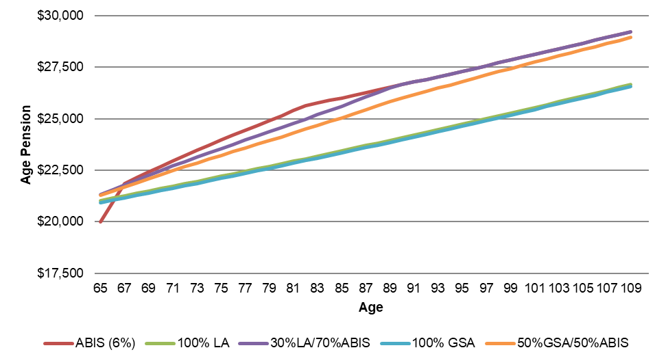

Chart 2: Immediate products - Total income (Age Pension + Product Income)
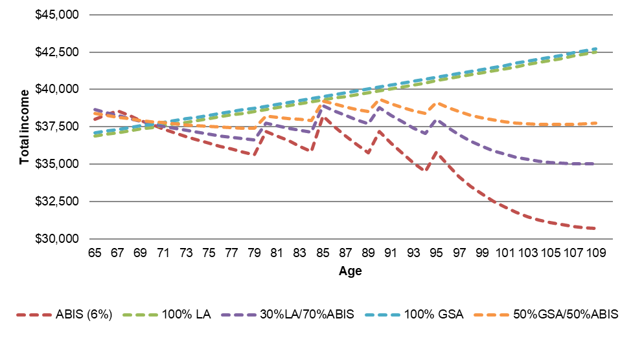

Chart 3: Deferred products - Age Pension
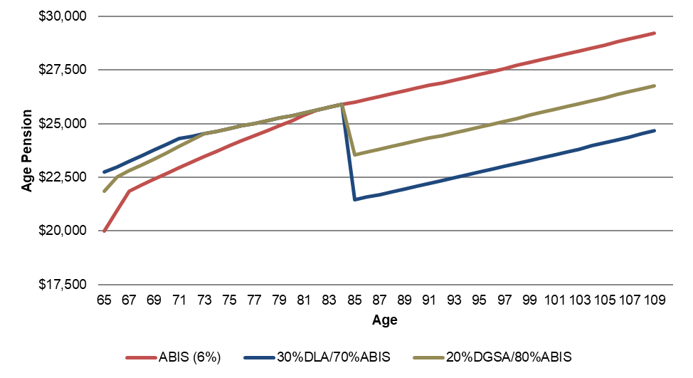

Chart 4: Deferred products - Total income (Age Pension + Product Income)
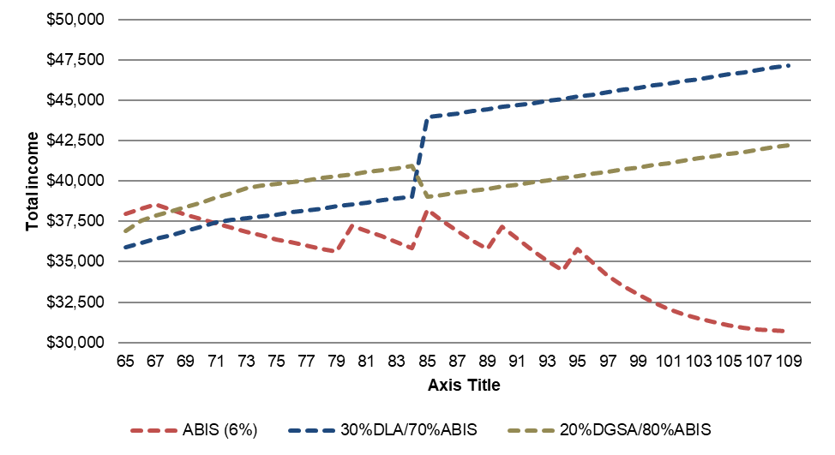

Chart 5: Difference in Age Pension and total income when 30 per cent is invested in a lifetime annuity, compared to if all funds were invested in an ABIS
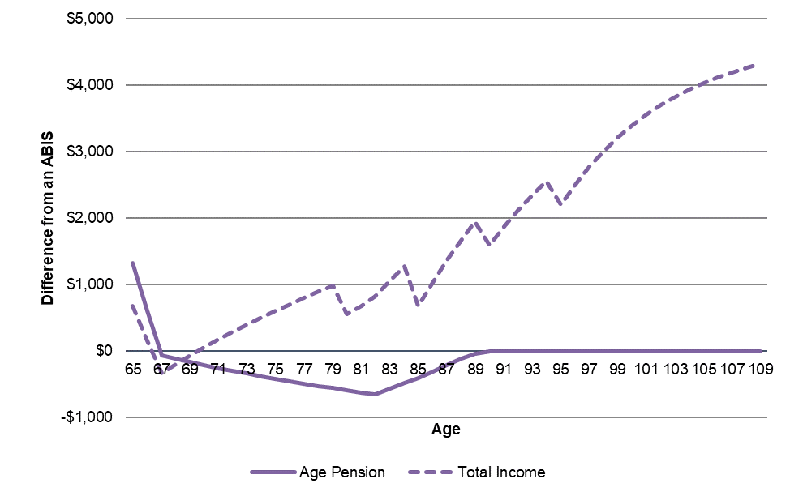

Total retirement outcomes
 |  | Life Annuity Products |  | Group Self-Annuity Products |  | Deferred Products
 | ABIS (6%) | 100% LA | 30% LA / 70% ABIS | 100% GSA | 50% GSA / 50% ABIS | 30% DLA / 70% ABIS | 20% DGSA / 80% ABIS
Age Pension | 406,432 | 380,371 | 403,697 | 378,734 | 398,234 | 406,582 | 410,112
Product Income | 222,286 | 269,410 | 236,423 | 274,866 | 248,576 | 253,693 | 257,090
Total Income | 628,718 | 649,781 | 640,120 | 653,600 | 646,810 | 660,274 | 667,201
Death Benefit / Bequest | 58,491 | 19,378 | 46,757 | - | 29,246 | 24,070 | 20,865
Total (including bequest) | 687,209 | 669,159 | 686,878 | 653,600 | 676,056 | 684,345 | 688,066

2. Outcomes for a single homeowner with $400,000 in superannuation and no other assessable assets

Chart 1: Immediate products - Age Pension
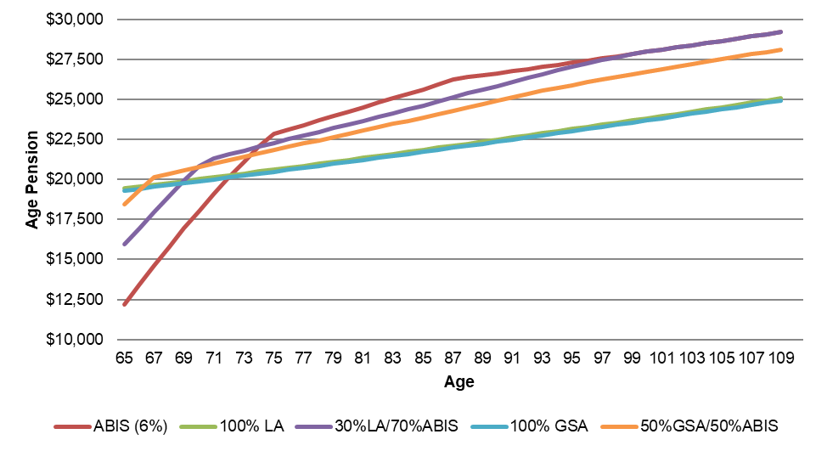

Chart 2: Immediate products - Total income (Age Pension + Product Income)
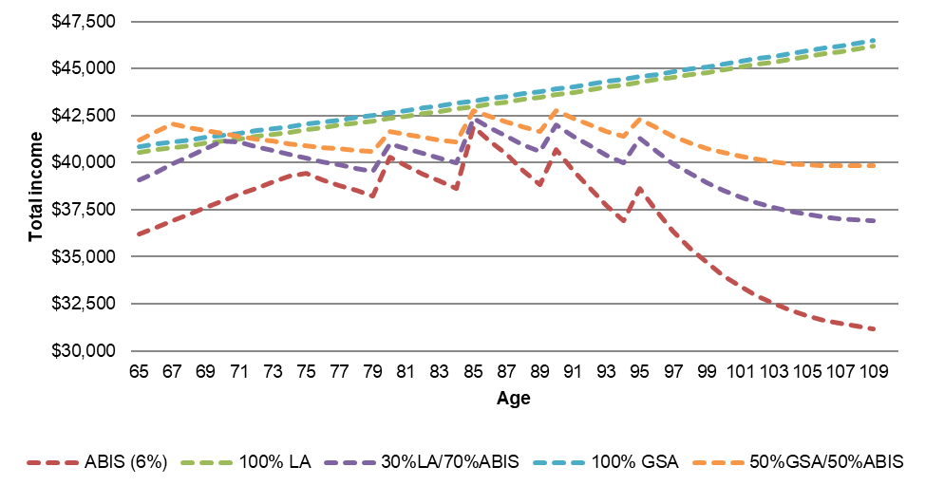

Chart 3: Deferred products - Age Pension
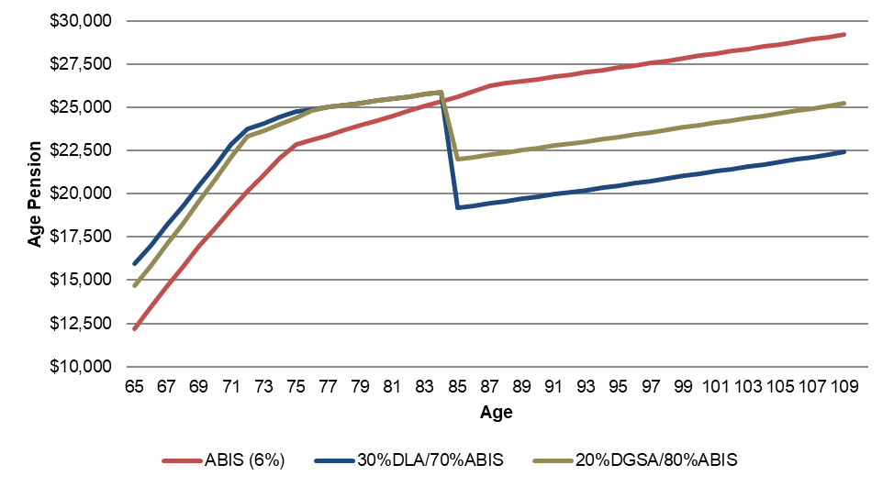

Chart 4: Deferred products - Total income (Age Pension + Product Income)
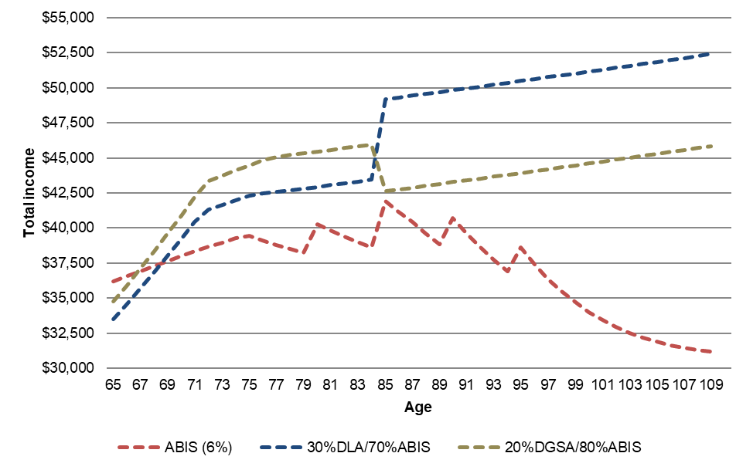

Chart 5: Difference in Age Pension and total income when 30 per cent is invested in a lifetime annuity, compared to if all funds were invested in an ABIS
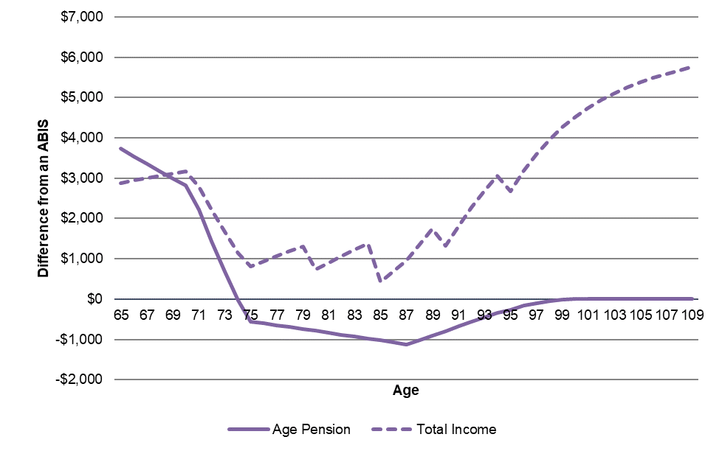

Total retirement outcomes
 |  | Life Annuity Products |  | Group Self-Annuity Products |  | Deferred Products
 | ABIS (6%) | 100% LA | 30% LA / 70% ABIS | 100% GSA | 50% GSA / 50% ABIS | 30% DLA / 70% ABIS | 20% DGSA / 80% ABIS
Age Pension | 357,187 | 353,430 | 371,988 | 351,248 | 373,471 | 371,556 | 373,027
Product Income | 296,382 | 359,213 | 315,231 | 366,488 | 331,435 | 338,257 | 342,786
Total Income | 653,568 | 712,643 | 687,219 | 717,735 | 704,906 | 709,812 | 715,813
Death Benefit / Bequest | 77,988 | 25,837 | 62,343 | - | 38,994 | 32,094 | 27,820
Total (including bequest) | 731,556 | 738,480 | 749,562 | 717,735 | 743,900 | 741,906 | 743,633

3. Outcomes for a single homeowner with $600,000 in superannuation and no other assessable assets

Chart 1: Immediate products - Age Pension
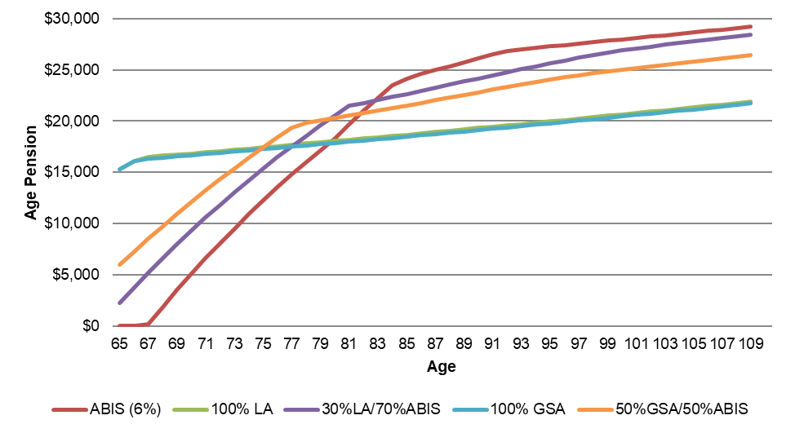

Chart 2: Immediate products - Total income (Age Pension + Product Income)
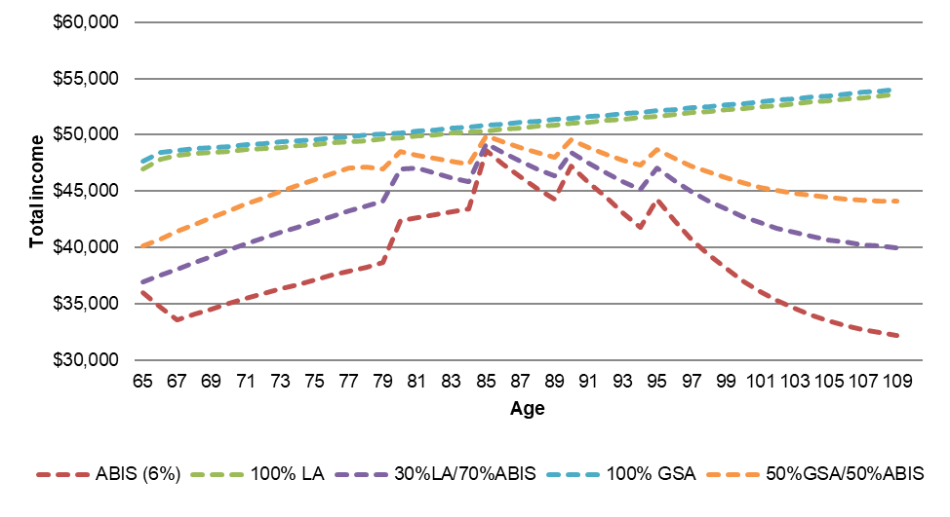

Chart 3: Deferred products - Age Pension
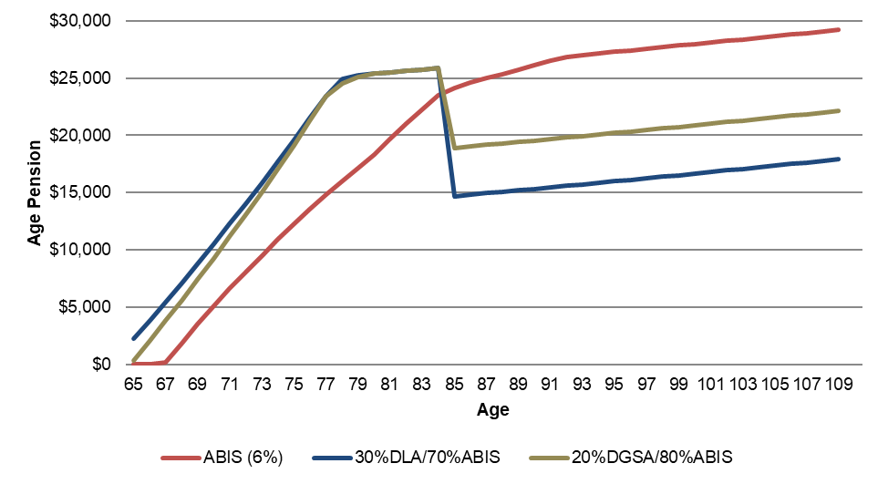

Chart 4: Deferred products - Total income (Age Pension + Product Income)
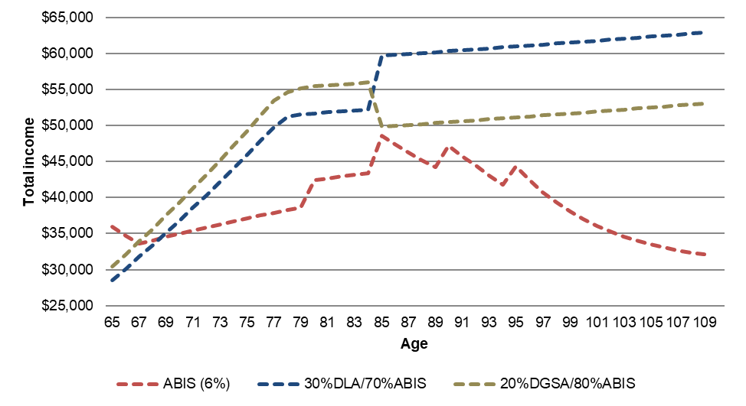

Chart 5: Difference in Age Pension and total income when 30 per cent is invested in a lifetime annuity, compared to if all funds were invested in an ABIS
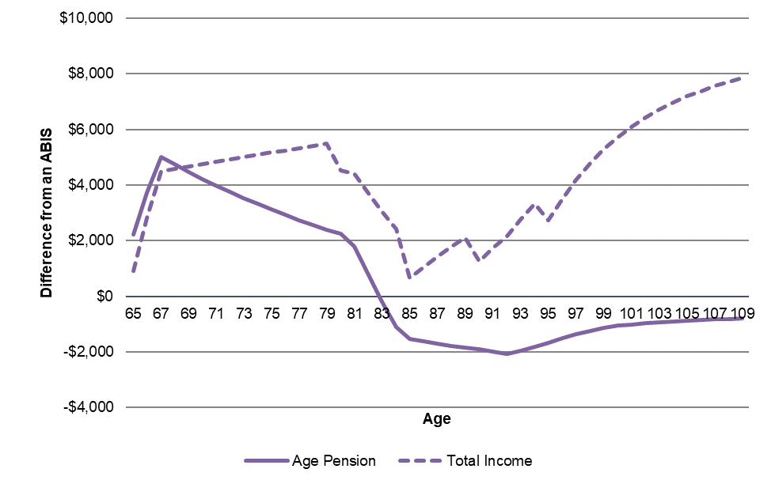

Total retirement outcomes
 |  | Life Annuity Products |  | Group Self-Annuity Products |  | Deferred Products
 | ABIS (6%) | 100% LA | 30% LA / 70% ABIS | 100% GSA | 50% GSA / 50% ABIS | 30% DLA / 70% ABIS | 20% DGSA / 80% ABIS
Age Pension | 210,957 | 298,319 | 248,478 | 295,424 | 271,963 | 255,873 | 257,408
Product Income | 444,572 | 538,819 | 472,846 | 549,732 | 497,152 | 507,385 | 514,179
Total Income | 655,529 | 837,139 | 721,324 | 845,155 | 769,115 | 763,258 | 771,587
Death Benefit / Bequest | 116,982 | 38,756 | 93,514 | - | 58,491 | 48,140 | 41,730
Total (including bequest) | 772,511 | 875,895 | 814,838 | 845,155 | 827,606 | 811,399 | 813,317

4. Outcomes for a homeowner couple with $400,000 in superannuation and no other assessable assets

Chart 1: Immediate products - Age Pension
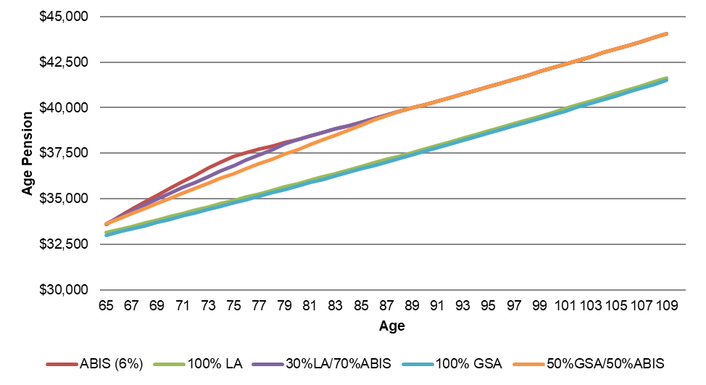

Chart 2: Immediate products - Total income (Age Pension + Product Income)
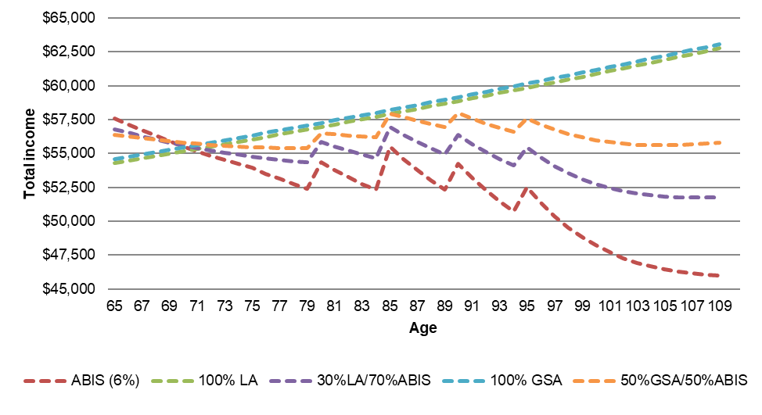

Chart 3: Deferred products - Age Pension
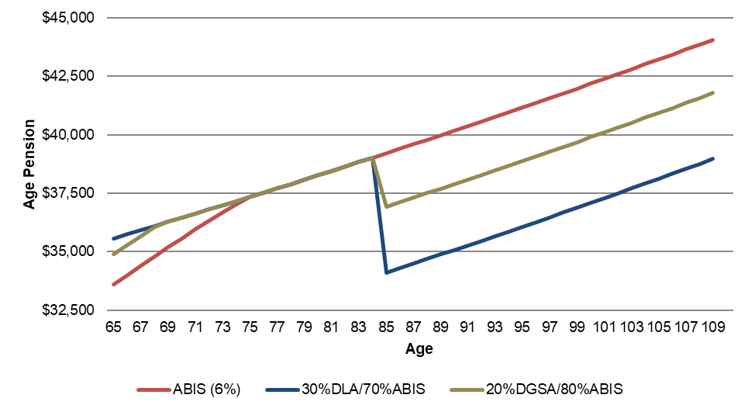

Chart 4: Deferred products - Total income (Age Pension + Product Income)
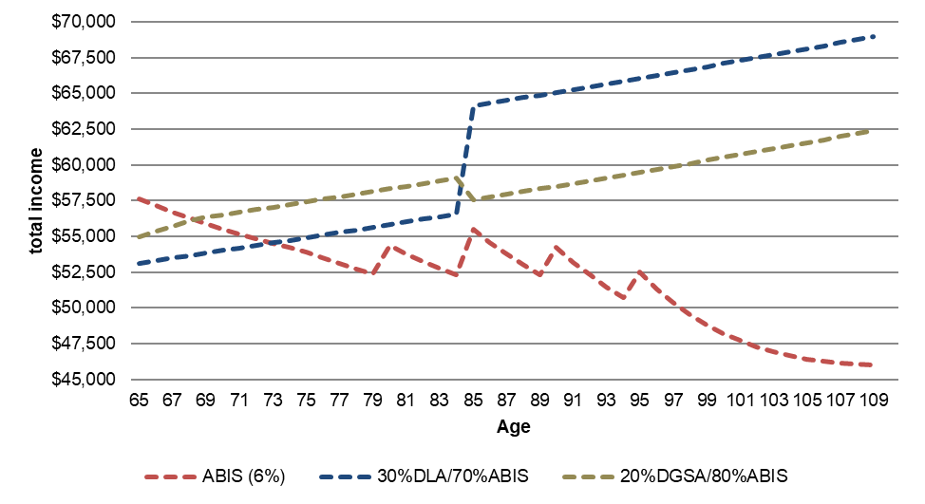

Chart 5: Difference in Age Pension and total income when 30 per cent is invested in a lifetime annuity, compared to if all funds were invested in an ABIS
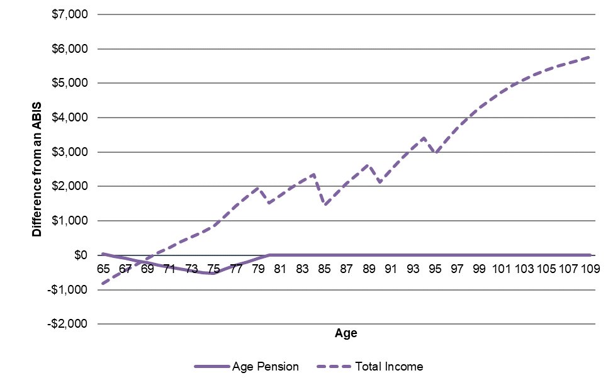

Total retirement outcomes
 |  | Life Annuity Products |  | Group Self-Annuity Products |  | Deferred Products
 | ABIS (6%) | 100% LA | 30% LA / 70% ABIS | 100% GSA | 50% GSA / 50% ABIS | 30% DLA / 70% ABIS | 20% DGSA / 80% ABIS
Age Pension | 630,223 | 597,811 | 627,425 | 595,629 | 623,059 | 622,911 | 630,537
Product Income | 296,382 | 359,213 | 315,231 | 366,488 | 331,435 | 338,257 | 342,786
Total Income | 926,605 | 957,024 | 942,656 | 962,117 | 954,493 | 961,167 | 973,323
Death Benefit / Bequest | 77,988 | 25,837 | 62,343 | - | 38,994 | 32,094 | 27,820
Total (including bequest) | 1,004,593 | 982,862 | 1,004,999 | 962,117 | 993,487 | 993,261 | 1,001,143

5. Outcomes for a homeowner couple with $800,000 in superannuation and no other assessable assets

Chart 1: Immediate products - Age Pension
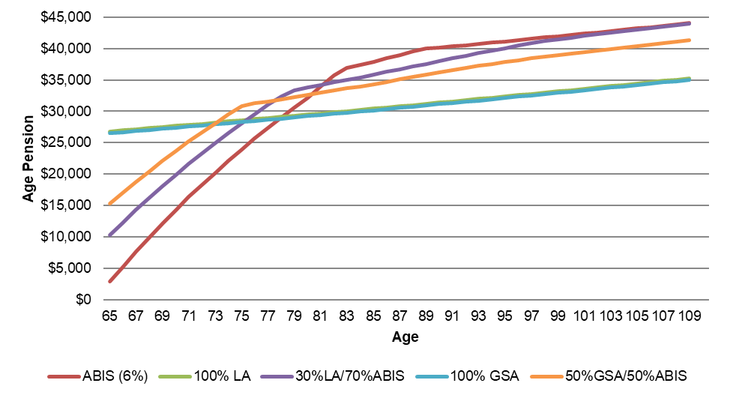

Chart 2: Immediate products - Total income (Age Pension + Product Income)
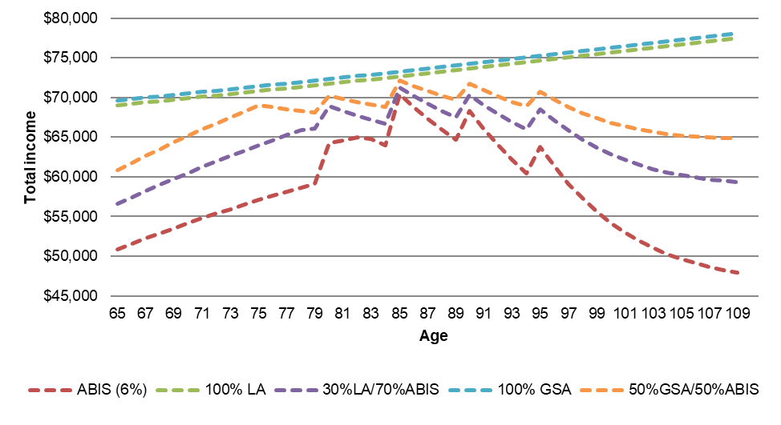

Chart 3: Deferred products - Age Pension
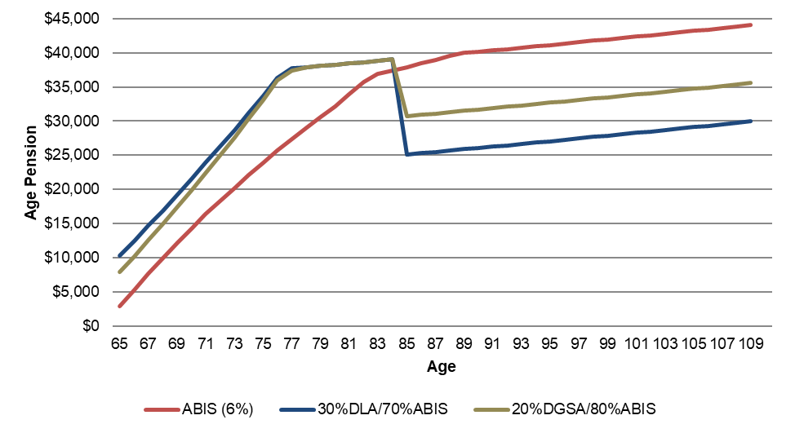

Chart 4: Deferred products - Total income (Age Pension + Product Income)
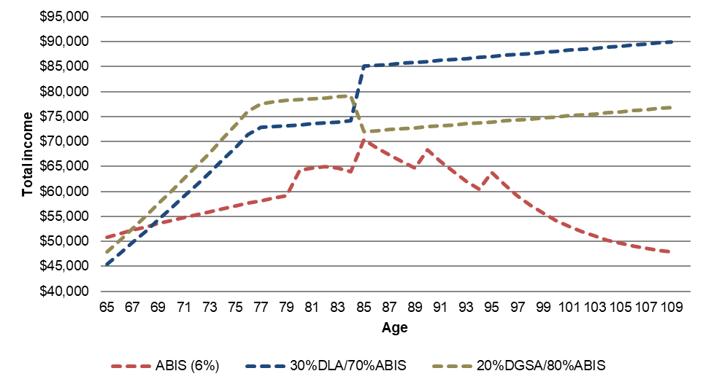

Chart 5: Difference in Age Pension and total income when 30 per cent is invested in a lifetime annuity, compared to if all funds were invested in an ABIS
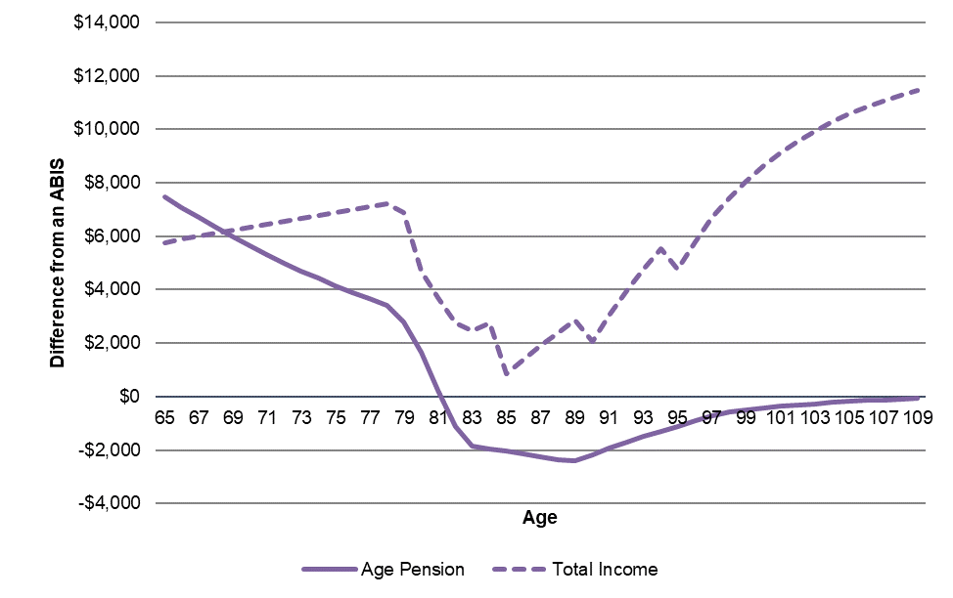

Total retirement outcomes
 |  | Life Annuity Products |  | Group Self-Annuity Products |  | Deferred Products
 | ABIS (6%) | 100% LA | 30% LA / 70% ABIS | 100% GSA | 50% GSA / 50% ABIS | 30% DLA / 70% ABIS | 20% DGSA / 80% ABIS
Age Pension | 395,072 | 490,048 | 449,162 | 485,683 | 476,075 | 451,543 | 453,937
Product Income | 592,763 | 718,426 | 630,462 | 732,975 | 662,869 | 676,514 | 685,572
Total Income | 987,835 | 1,208,474 | 1,079,623 | 1,218,658 | 1,138,945 | 1,128,056 | 1,139,509
Death Benefit / Bequest | 155,976 | 51,675 | 124,686 | - | 77,988 | 64,187 | 55,640
Total (including bequest) | 1,143,811 | 1,260,148 | 1,204,309 | 1,218,658 | 1,216,933 | 1,192,244 | 1,195,149

6. Outcomes for a single non-homeowner with $400,000 in superannuation and no other assessable assets

Chart 1: Immediate products - Age Pension
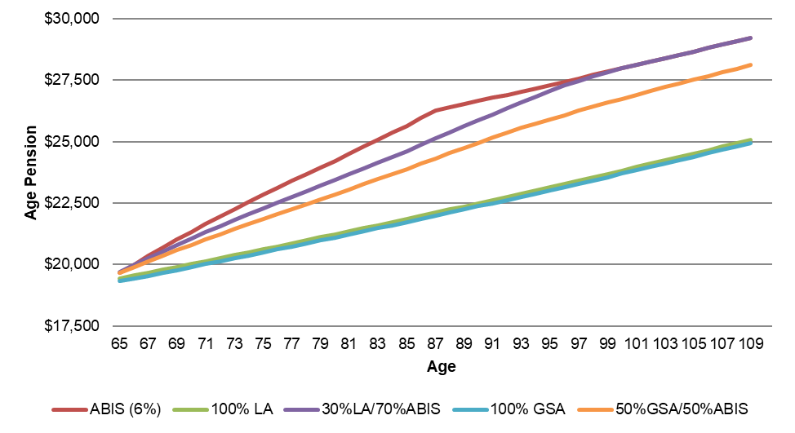

Chart 2: Immediate products - Total income (Age Pension + Product Income)
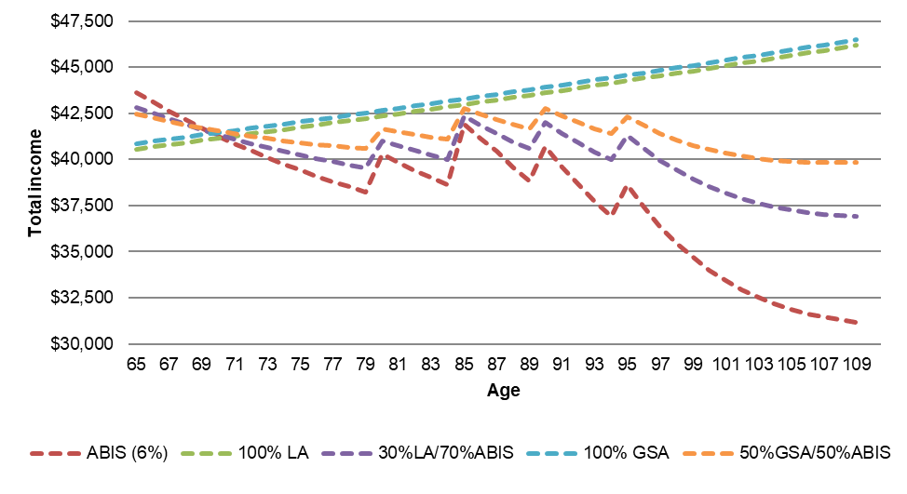

Chart 3: Deferred products - Age Pension
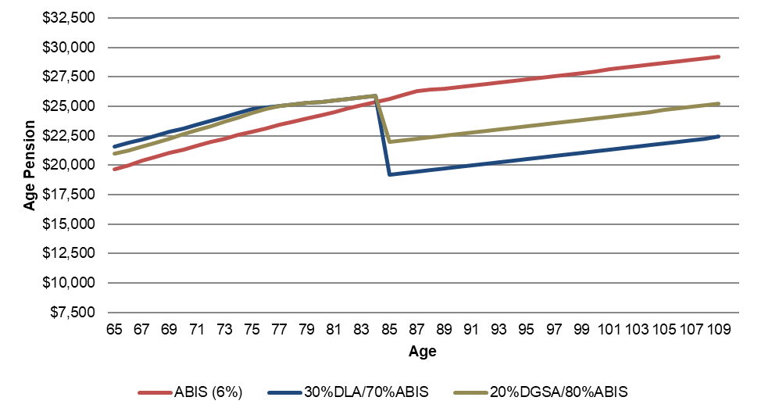

Chart 4: Deferred products - Total income (Age Pension + Product Income)
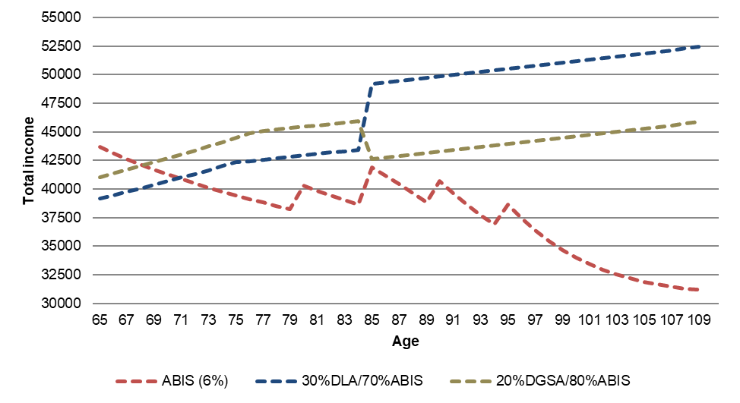

Chart 5: Difference in Age Pension and total income when 30 per cent is invested in a lifetime annuity, compared to if all funds were invested in an ABIS
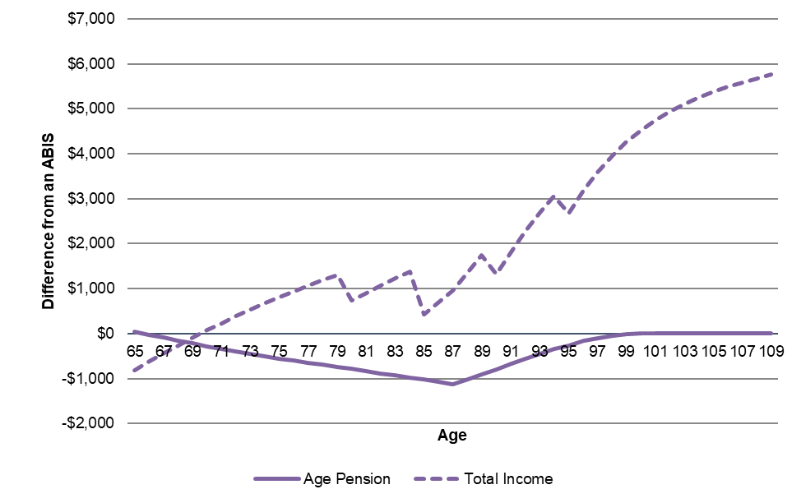

Total retirement outcomes
 |  | Life Annuity Products |  | Group Self-Annuity Products |  | Deferred Products
 | ABIS (6%) | 100% LA | 30% LA / 70% ABIS | 100% GSA | 50% GSA / 50% ABIS | 30% DLA / 70% ABIS | 20% DGSA / 80% ABIS
Age Pension | 391,312 | 353,430 | 383,037 | 351,248 | 375,261 | 392,141 | 396,338
Product Income | 296,382 | 359,213 | 315,231 | 366,488 | 331,435 | 338,257 | 342,786
Total Income | 687,694 | 712,643 | 698,268 | 717,735 | 706,695 | 730,398 | 739,124
Death Benefit / Bequest | 77,988 | 25,837 | 62,343 | - | 38,994 | 32,094 | 27,820
Total (including bequest) | 765,682 | 738,480 | 760,611 | 717,735 | 745,689 | 762,491 | 766,944

7. Outcomes for a single homeowner retiring at 70 with $300,000 in superannuation and no other assessable assets

Chart 1: Immediate products - Age Pension
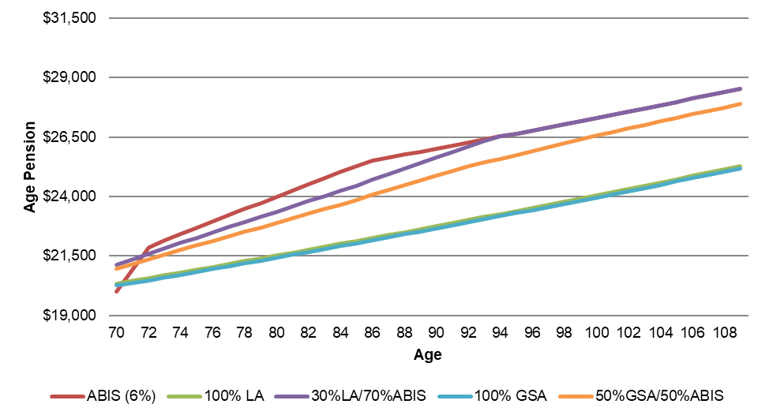

Chart 2: Immediate products - Total income (Age Pension + Product Income)
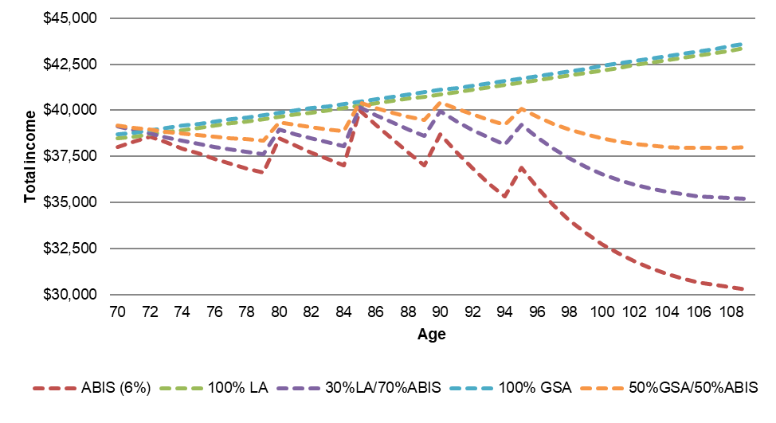

Chart 3: Deferred products - Age Pension
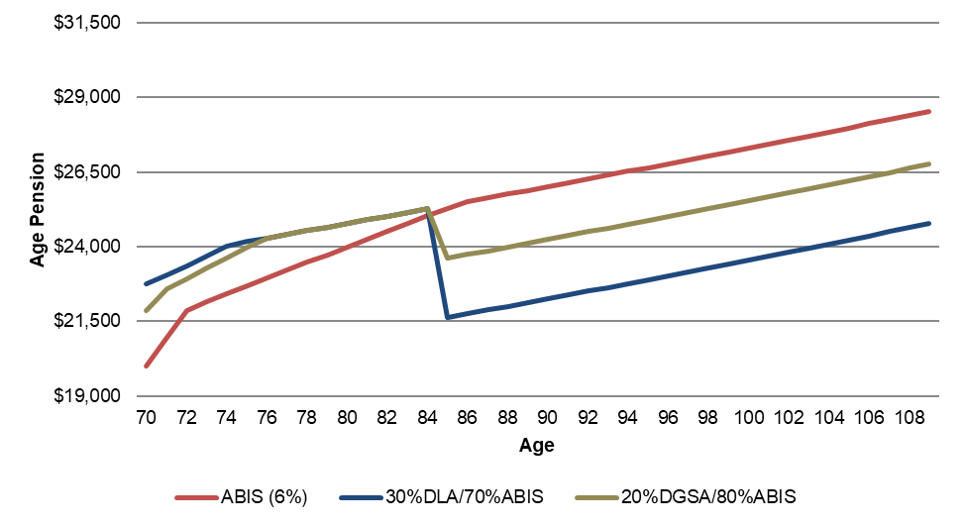

Chart 4: Deferred products - Total income (Age Pension + Product Income)
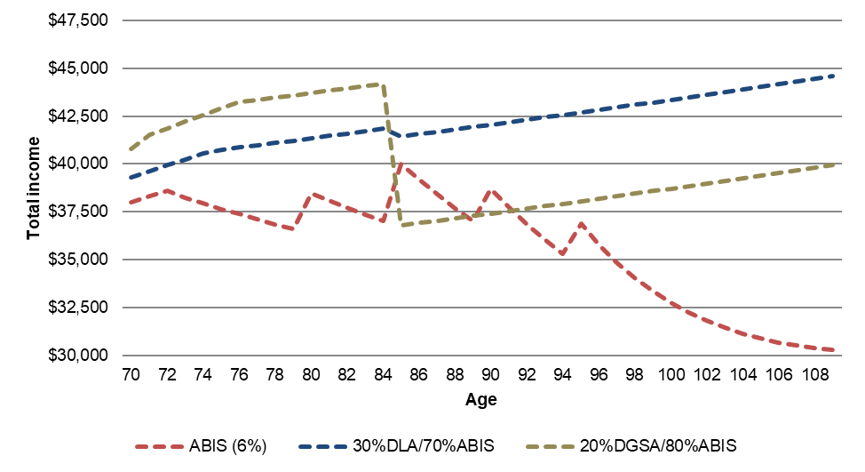

Chart 5: Difference in Age Pension and total income when 30 per cent is invested in a lifetime annuity, compared to if all funds were invested in an ABIS
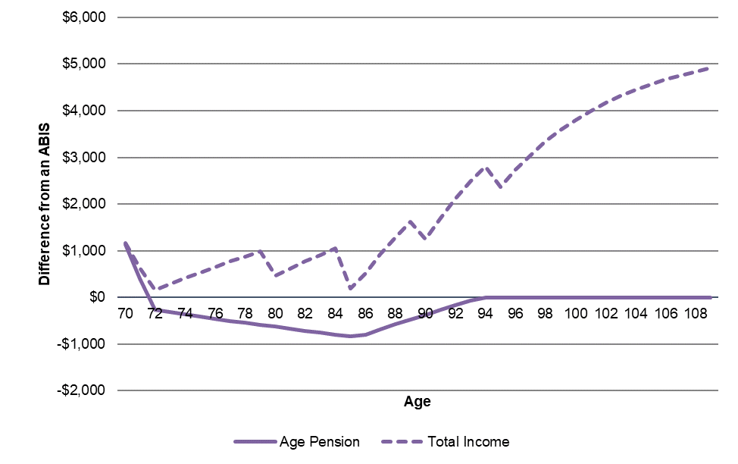

Total retirement outcomes
 |  | Life Annuity Products |  | Group Self-Annuity Products |  | Deferred Products
 | ABIS (6%) | 100% LA | 30% LA / 70% ABIS | 100% GSA | 50% GSA / 50% ABIS | 30% DLA / 70% ABIS | 20% DGSA / 80% ABIS
Age Pension | 356,331 | 324,377 | 351,462 | 322,932 | 344,625 | 356,553 | 361,768
Product Income | 212,094 | 273,341 | 230,468 | 278,159 | 245,126 | 262,518 | 263,060
Total Income | 568,425 | 597,718 | 581,931 | 601,090 | 589,751 | 619,071 | 624,828
Death Benefit / Bequest | 72,294 | 22,041 | 57,218 | - | 36,147 | 24,840 | 20,832
Total (including bequest) | 640,719 | 619,759 | 639,149 | 601,090 | 625,898 | 643,911 | 645,660

8. Outcomes for a single homeowner retiring at 70 with $600,000 in superannuation and no other assessable assets

Chart 1: Immediate products - Age Pension
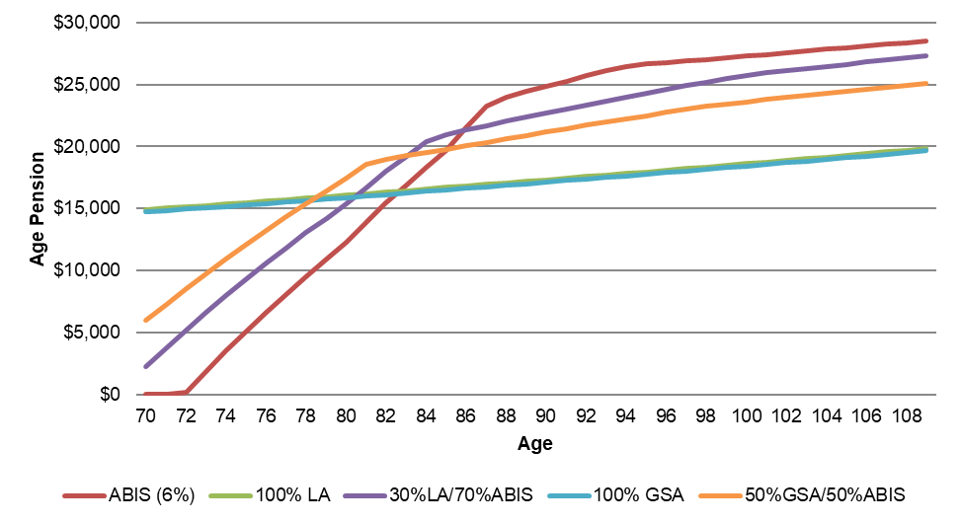

Chart 2: Immediate products - Total income (Age Pension + Product Income)
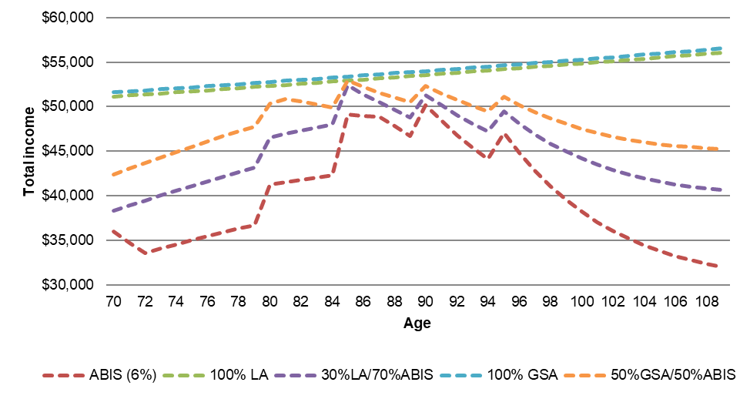

Chart 3: Deferred products - Age Pension
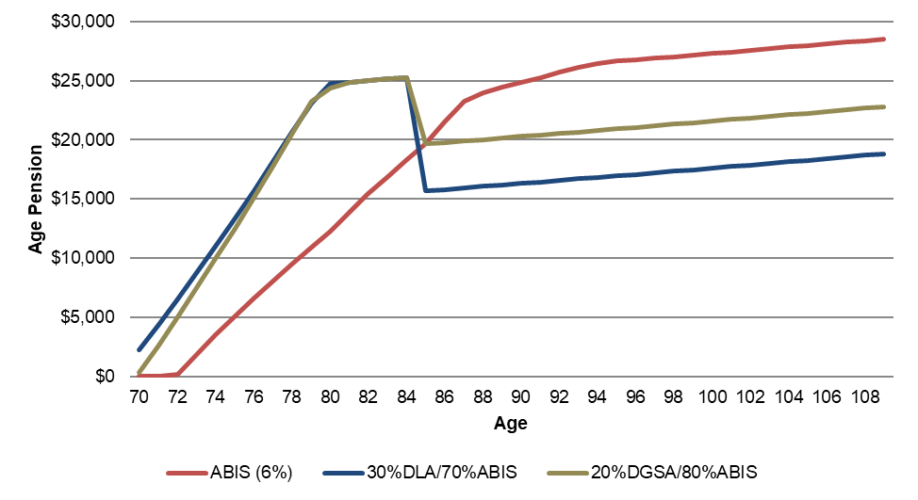

Chart 4: Deferred products - Total income (Age Pension + Product Income)
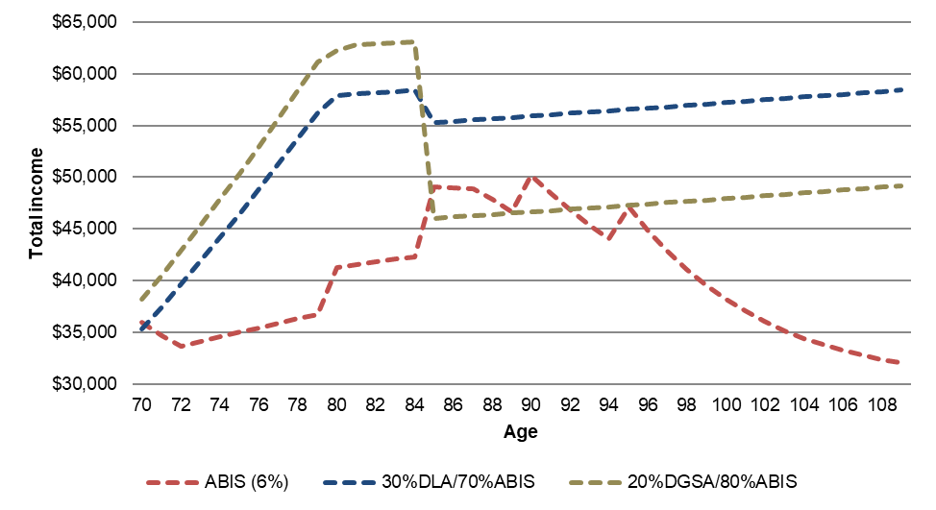

Chart 5: Difference in Age Pension and total income when 30 per cent is invested in a lifetime annuity, compared to if all funds were invested in an ABIS
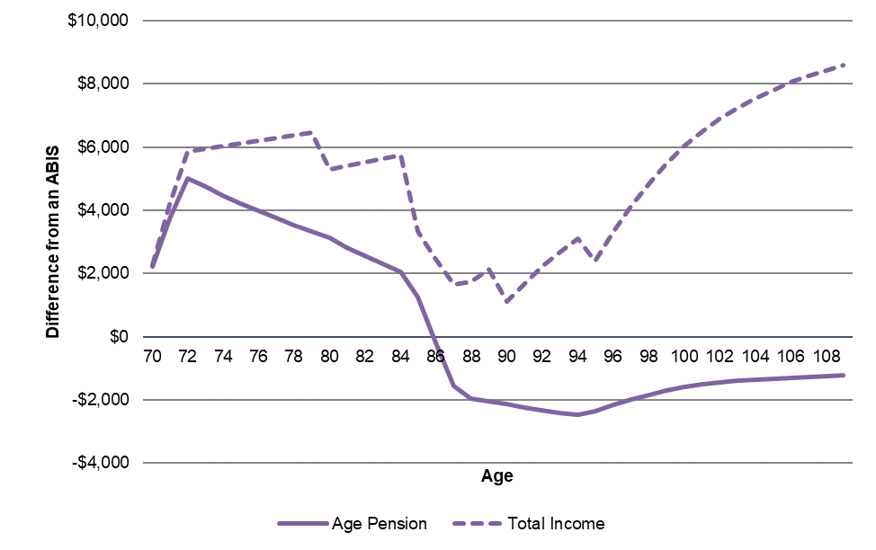

Total retirement outcomes
 |  | Life Annuity Products |  | Group Self-Annuity Products |  | Deferred Products
 | ABIS (6%) | 100% LA | 30% LA / 70% ABIS | 100% GSA | 50% GSA / 50% ABIS | 30% DLA / 70% ABIS | 20% DGSA / 80% ABIS
Age Pension | 171,772 | 242,375 | 205,933 | 239,484 | 227,479 | 231,400 | 238,505
Product Income | 424,188 | 546,682 | 460,937 | 556,317 | 490,253 | 525,036 | 526,121
Total Income | 595,960 | 789,057 | 666,870 | 795,801 | 717,731 | 756,436 | 764,626
Death Benefit / Bequest | 144,588 | 44,082 | 114,436 | - | 72,294 | 49,680 | 41,664
Total (including bequest) | 740,548 | 833,138 | 781,306 | 795,801 | 790,025 | 806,117 | 806,290

9. Outcomes for a single homeowner retiring at 75 with $300,000 in superannuation and no other assessable assets

Chart 1: Immediate products - Age Pension
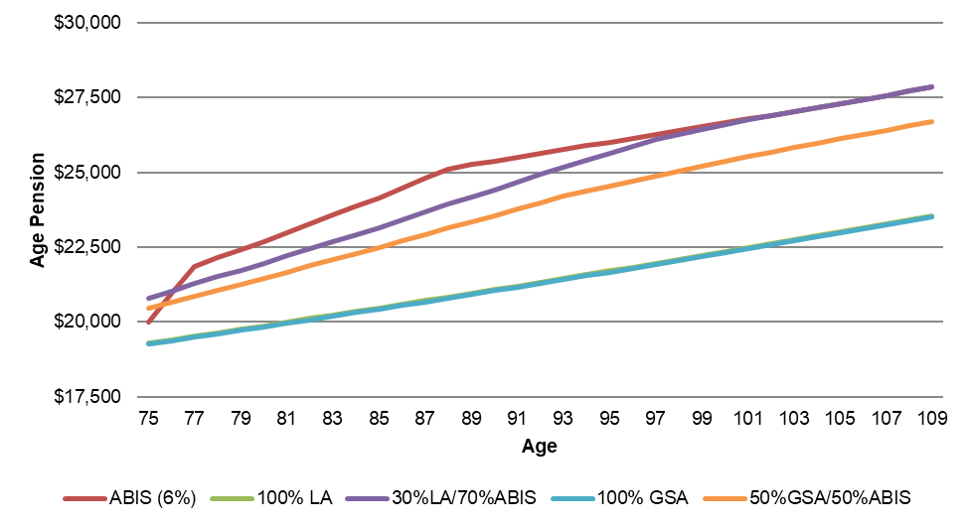

Chart 2: Immediate products - Total income (Age Pension + Product Income)
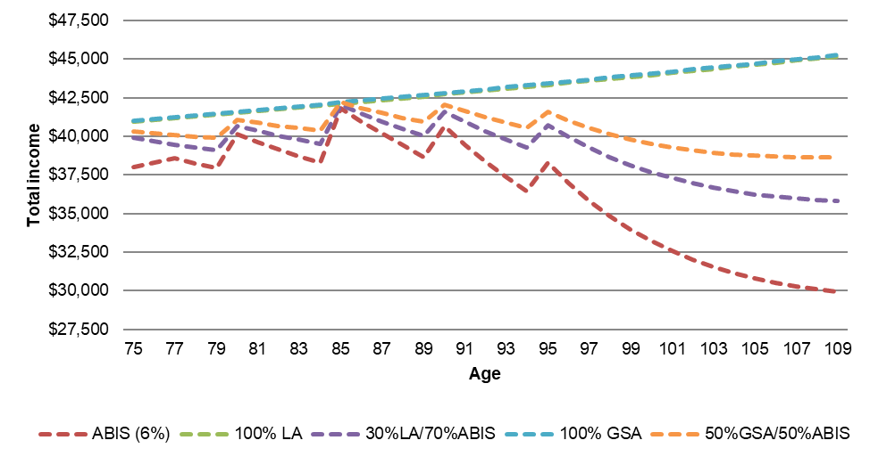

Chart 3: Deferred products - Age Pension
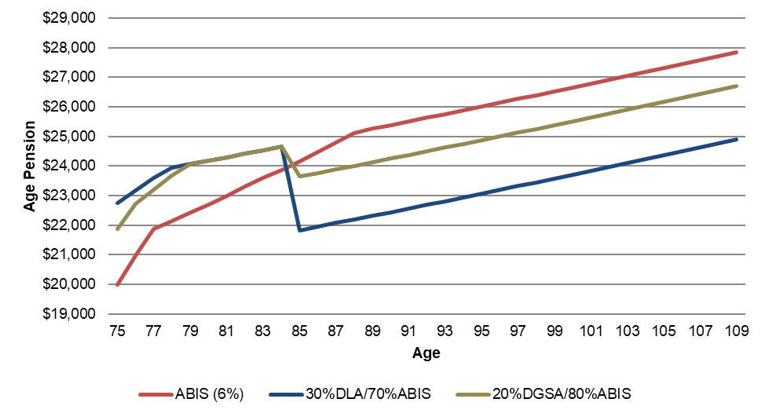

Chart 4: Deferred products - Total income (Age Pension + Product Income)
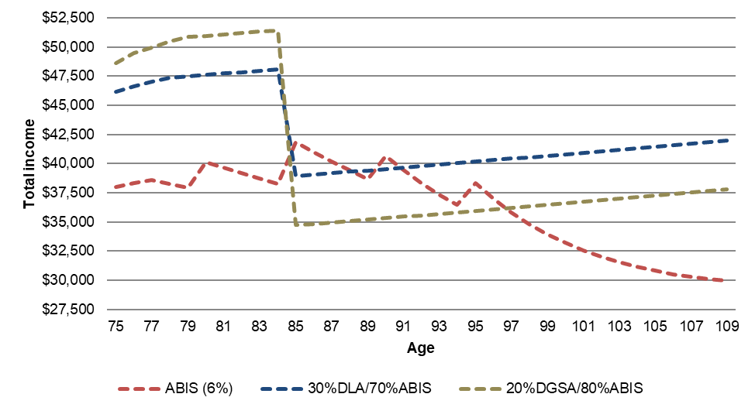

Chart 5: Difference in Age Pension and total income when 30 per cent is invested in a lifetime annuity, compared to if all funds were invested in an ABIS
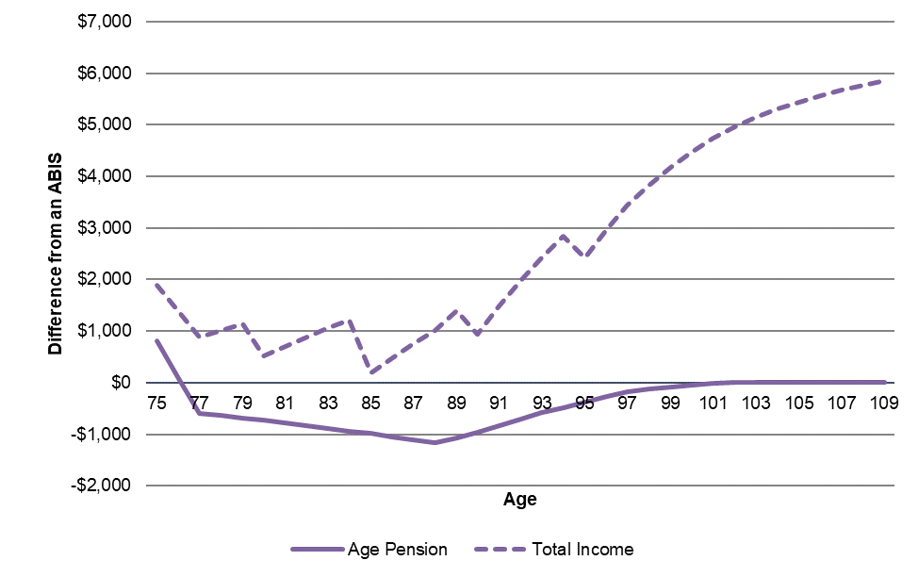

Total retirement outcomes
 |  | Life Annuity Products |  | Group Self-Annuity Products |  | Deferred Products
 | ABIS (6%) | 100% LA | 30% LA / 70% ABIS | 100% GSA | 50% GSA / 50% ABIS | 30% DLA / 70% ABIS | 20% DGSA / 80% ABIS
Age Pension | 302,150 | 262,218 | 294,406 | 261,716 | 286,282 | 302,110 | 308,933
Product Income | 200,249 | 279,903 | 224,145 | 281,577 | 240,913 | 272,615 | 270,662
Total Income | 502,399 | 542,121 | 518,551 | 543,293 | 527,195 | 574,726 | 579,595
Death Benefit / Bequest | 88,916 | 25,971 | 70,032 | - | 44,458 | 25,122 | 19,806
Total (including bequest) | 591,314 | 568,091 | 588,583 | 543,293 | 571,652 | 599,847 | 599,401

10. Outcomes for a single homeowner retiring at 75 with $600,000 in superannuation and no other assessable assets

Chart 1: Immediate products - Age Pension
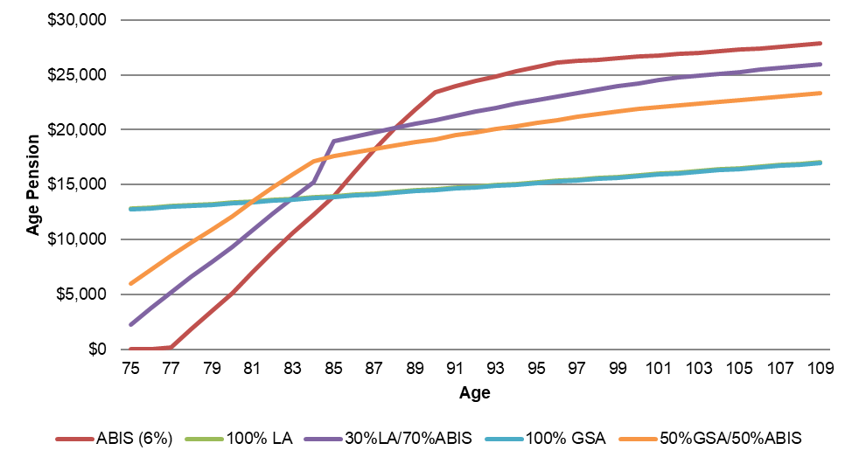

Chart 2: Immediate products - Total income (Age Pension + Product Income)
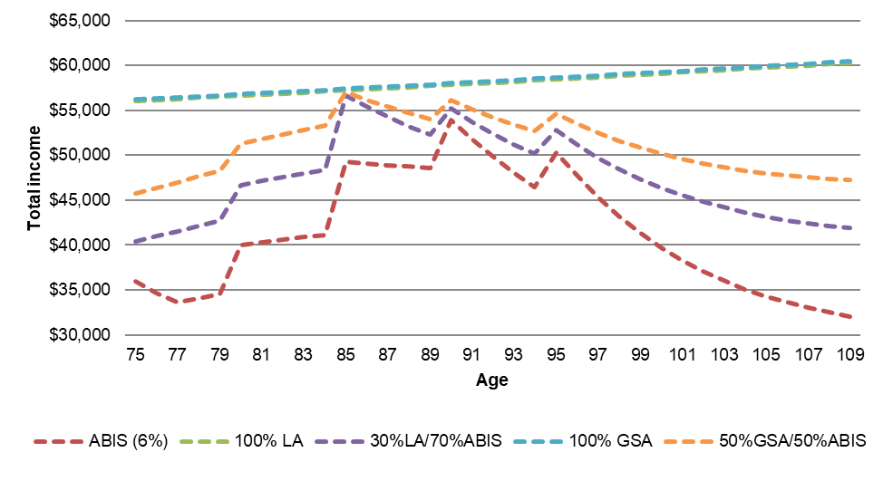

Chart 3: Deferred products - Age Pension
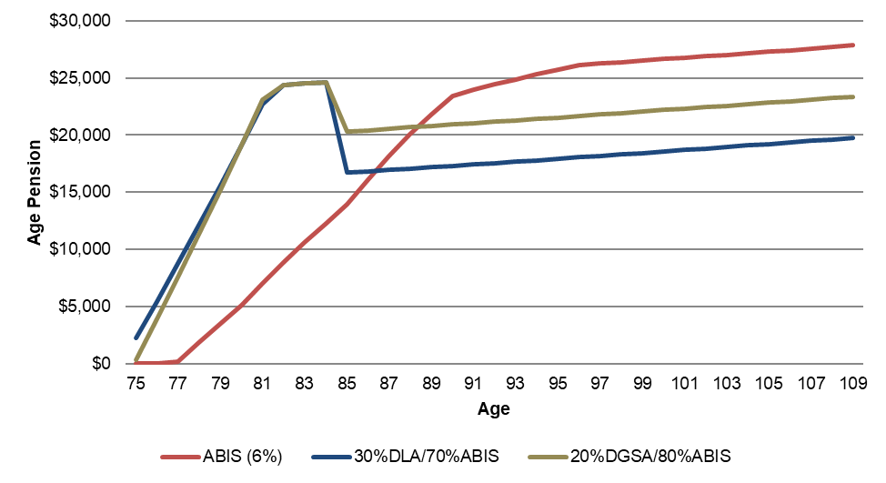

Chart 4: Deferred products - Total income (Age Pension + Product Income)
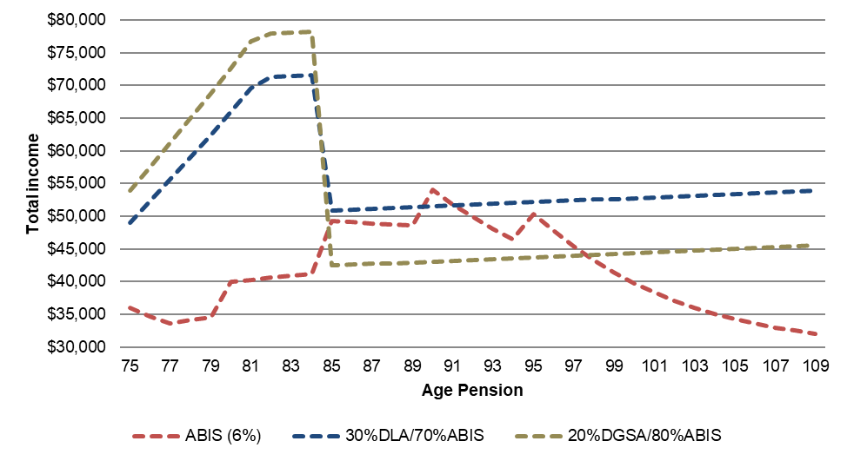

Chart 5: Difference in Age Pension and total income when 30 per cent is invested in a lifetime annuity, compared to if all funds were invested in an ABIS
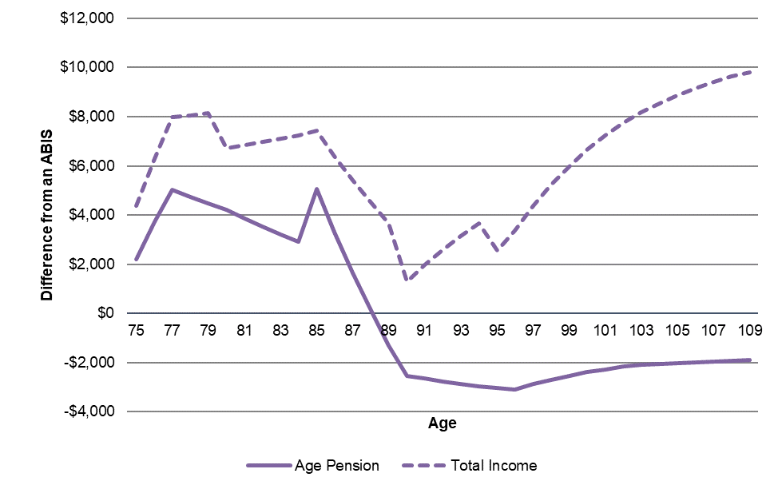

Total retirement outcomes
 |  | Life Annuity Products |  | Group Self-Annuity Products |  | Deferred Products
 | ABIS (6%) | 100% LA | 30% LA / 70% ABIS | 100% GSA | 50% GSA / 50% ABIS | 30% DLA / 70% ABIS | 20% DGSA / 80% ABIS
Age Pension | 137,051 | 178,247 | 166,724 | 177,242 | 182,240 | 203,847 | 216,201
Product Income | 400,498 | 559,806 | 448,290 | 563,154 | 481,826 | 545,231 | 541,324
Total Income | 537,549 | 738,053 | 615,014 | 740,397 | 664,066 | 749,078 | 757,525
Death Benefit / Bequest | 177,831 | 51,942 | 140,064 | - | 88,916 | 50,243 | 39,612
Total (including bequest) | 715,380 | 789,994 | 755,078 | 740,397 | 752,982 | 799,321 | 797,137

Attachment A – Key Assumptions – Updated for this document
Figures followed by an asterisk (*) have changed from the assumptions used for the position paper (Attachment B).

Product Assumptions
Item |  | Assumption
Real earnings rate (gross of fees) |  | 3.30%
Inflation |  | 2.50%
Real discount Rate |  | 3.30%
Age Pension indexation |  | 3.00%
Mortality | ALT2010-12, with 25 yr imp. Rated down 3 years
Pricing
Inflation indexed immediate life annuity price (purchased at 65) |  | 5.30%*
Inflation indexed deferred life annuity price (20 year deferral, purchased at 65) |  | 25.0%
Fees
Account based pension |  | 0.80%*
GSA/DGSA |  | 0.80%

Note for deferred products, the account-based income stream (ABIS) component is assumed to be drawn down to zero at the deferral age e.g. for a deferred life annuity vesting at age 85, the ABIS component is drawn down completely from age 65 to age 85 when the deferred life annuity begins payment.

Age Pension Assumptions
Rate
 | Single | Couple (combined)
Annual Max Rate | $23,598* | $35,573*

Asset Test
 | Homeowner |  | Non-Homeowner
 | Single | Couple (combined) | Single | Couple (combined)
Free Area Threshold | $253,750 | $380,500 | $456,750 | $583,500
Cut-out | $556,283* | $836,667* | $759,283* | $1,039,567*
Taper | $3 per fortnight for every $1,000 above the free area

Income Test
 | Single | Couple (combined)
Annual Free Area | $4,368 | $7,800
Cut-out | $51,563* | $78,946*
Taper | 50%

Deeming
 | Single | Couple (combined)
Threshold | $50,200 | $83,400
Rate – below threshold | 1.75%
Rate – above threshold | 3.25%

Attachment B – Key Assumptions – Used for position paper

Product Assumptions
Item |  | Assumption
Real earnings rate (gross of fees) |  | 3.3%
Inflation |  | 2.5%
Real discount Rate |  | 3.3%
Age Pension indexation |  | 3.0%
Mortality | ALT2010-12, with 25 yr imp. Rated down 3 years
Pricing
Inflation indexed immediate life annuity price (purchased at 65) |  | 4.70%
Inflation indexed deferred life annuity price (20 year deferral, purchased at 65) |  | 25.0%
Fees
Account based pension |  | 1.00%
GSA/DGSA |  | 0.80%

Note for deferred products, the account-based income stream (ABIS) component is assumed to be drawn down to zero at the deferral age e.g. for a deferred life annuity vesting at age 85, the ABIS component is drawn down completely from age 65 to age 85 when the deferred life annuity begins payment.

Age Pension Assumptions
Rate
 | Single | Couple (combined)
Annual Max Rate | $23,254 | $35,058

Asset Test
 | Homeowner |  | Non-Homeowner
 | Single | Couple (combined) | Single | Couple (combined)
Free Area Threshold | $253,750 | $380,500 | $456,750 | $583,500
Cut-out | $551,883 | $829,967 | $754,883 | $1,032,967
Taper | $3 per fortnight for every $1,000 above the free area

Income Test
 | Single | Couple (combined)
Annual Free Area | $4,368 | $7,800
Cut-out | $50,887 | $77,917
Taper | 50%

Deeming
 | Single | Couple (combined)
Threshold | $50,200 | $83,400
Rate – below threshold | 1.75%
Rate – above threshold | 3.25%

