NDIS Thin Markets Project
Discussion paper to inform consultation
April 2019

Table of contents
1. Introduction 1
1.1 Project background 1
1.2 Purpose of this document 1
1.3 This consultation 2
2. What ‘thin markets’ are, and why are they important? 3
2.1 The NDIS vision 3
2.2 What are thin markets? 3
2.3 Thin market challenges 4
2.4 Potential responses to thin markets 4
3. Consultation participation 7
3.1 Consultation objectives 7
3.2 Consultation process – how to have your say 8
3.3 Questions to guide submissions 8
Appendix A Precedent programs reviewed to date 10
© 2019 Ernst & Young Australia
This discussion paper was prepared at the request the Commonwealth Department of Social Services (hereafter “the Client”) solely for the purposes of facilitating consultations on National Disability Insurance Scheme (NDIS) Thin Markets and it is not appropriate for use for other purposes. The information is current as at April 2019.
The Client and any other party other than the Client who access this discussion paper shall only do so for their general information, and this discussion paper should not be taken as providing specific advice to those parties on any issue, nor may this discussion paper be relied upon in any way by any party other than the Client. A party other than the Client accessing this discussion paper should exercise its own skill and care with respect to use of this discussion paper, and obtain independent advice on any specific issues concerning it.
In carrying out our work and preparing this discussion paper, Ernst & Young has worked solely on the instructions of the Client, and has not taken into account the interests of any party other than the Client. The discussion paper has been constructed based on information current as of April 2019. Since this date, material events may have occurred since completion which is not reflected in the discussion paper.
Except in respect of the Client, neither Ernst & Young, nor the parties which have endorsed or been involved in the development of the discussion paper, accept any responsibility for use of the information contained in the discussion paper and make no guarantee nor accept any liability whatsoever arising from or connected to the accuracy, reliability, currency or completeness of any material contained in the discussion paper. Ernst & Young and all other parties involved in the preparation and publication of this discussion paper expressly disclaim all liability for any costs, loss, damage, injury or other consequence which may arise directly or indirectly from use of, or reliance on, the discussion paper.
- No claim or demand or any actions or proceedings may be brought against Ernst & Young arising from or connected with the contents of the discussion paper or the provision of the discussion paper to the Third Parties. Ernst & Young will be released and forever discharged from any such claims, demands, actions or proceedings.
        - Ernst & Young have consented to the discussion paper being published electronically on the engage.dss.gov.au website for informational purposes only. Ernst & Young have not consented to distribution or disclosure beyond this. The material contained in the discussion paper, including the Ernst & Young logo, is copyright and copyright in the discussion paper itself vests in the Client. The discussion paper, including the Ernst & Young logo, cannot be altered without prior written permission from Ernst & Young.
        - Ernst & Young’s liability is limited by a scheme approved under Professional Standards Legislation.
This discussion paper (or any part of it) may not be copied or otherwise reproduced except with the written consent of
Ernst & Young.

- Introduction
  - Project background
The Department of Social Services (DSS) and the National Disability Insurance Agency (NDIA) have commissioned the NDIS Thin Markets Project (the “Project”) to develop a structured approach to responding to thin market challenges in the NDIS. The Project will consider the full suite of options to inform next steps. Noting that there is not necessarily a one-size-fits-all approach to addressing thin markets and related challenges, the ultimate focus of the Project is on making sure NDIS participants affected by ‘thin market’ challenges have access to the supports they require.
The outputs of the Project will include (summarised in figure 1 below):
- A framework for addressing thin market challenges.
- A roadmap for developing and implementing reforms.
Figure 1: The NDIS Thin Markets Project
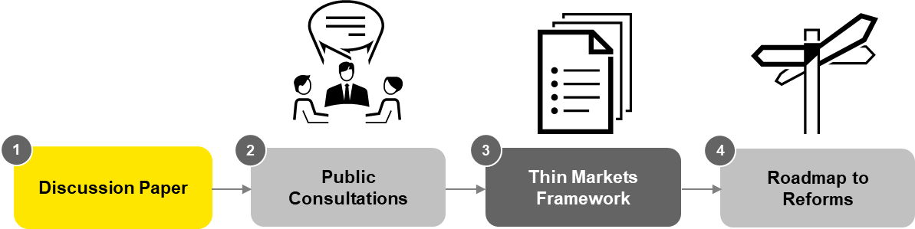

  - Purpose of this document
This discussion paper is the first step in a broad, national consultation on ‘thin market’ issues – how to identify them and what should be done to address market gaps to meet participants’ needs. It includes:
- A summary of the purpose of this Project, key stages, and the consultation process.
- How thin markets are being defined for this Project, and why and how this Project is looking at them.
- The broad suite of options available to address thin markets, for discussion and consultation through the first stage of this Project.
  - This consultation
There have already been a number of inquiries and reviews of the NDIS that have considered the challenges with the NDIS, and the issue of thin markets have been raised. This consultation process is about:
- Checking that the full range of thin market challenges, including diversity across different service types, regions and cohorts of people, are understood by government.
- Consulting on which solutions can work to meet those challenges, in a way that meets the legislative objectives of the NDIS and the diverse needs of NDIS participants.
The insights gathered through consultation will inform the framework and the implementation of initial reforms to be rolled out by the NDIA progressively in 2019.
- What ‘thin markets’ are, and why are they important?
  - The NDIS vision
The NDIS represents transformational change for service providers, government, participants and their carers through the reform of disability services that places participants – the people who need disability services – at the centre of the system. Among the legislative objectives of the reforms are to:
- Ensure access to reasonable and necessary supports for all Australians with a permanent and significant disability.
- Enable people with disability to exercise choice and control in the pursuit of their goals and the planning and delivery of their supports.
- Deliver the reforms with regard to the financial sustainability of the NDIS.
Delivering on that vision requires both a significant ramp-up in the level of services delivered nationally, as well as national reform of how they are delivered. The persistence of ‘thin markets’ can constrain the achievement of this vision.
  - What are thin markets?
For the purposes of this Project, ‘thin markets’ are quite broadly defined. This keeps the focus on meeting NDIS participant needs, rather than particular causes for needs not being met (such as geographic isolation, population dispersion, lack of provider market depth).
Figure 2: Defining thin markets
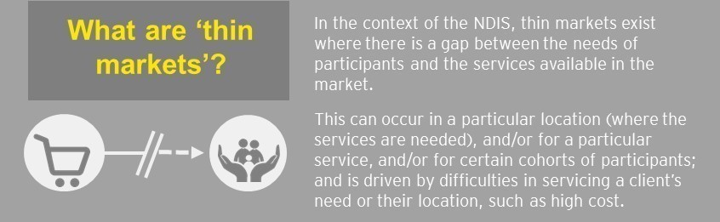

  - Thin market challenges
A number of consultation processes have already been undertaken to consider the challenges and issues associated with the transition to the NDIS including ongoing consultation by the NDIS Joint Standing Committee and the Productivity Commission’s 2017 NDIS Costs Report. Many of these issues are not new – they have been faced by service providers prior to the NDIS reforms, and are ongoing challenges in other sectors such as health and education. However, the shift to participant-directed funding has exacerbated some of these challenges (for example, in areas where providers have said there is not enough participant demand to support them to maintain a trained, skilled workforce). Figure 3 summarises the challenges and issues identified in these consultations, which can lead to participants facing service gaps.
Figure 3: Particular thin market challenges
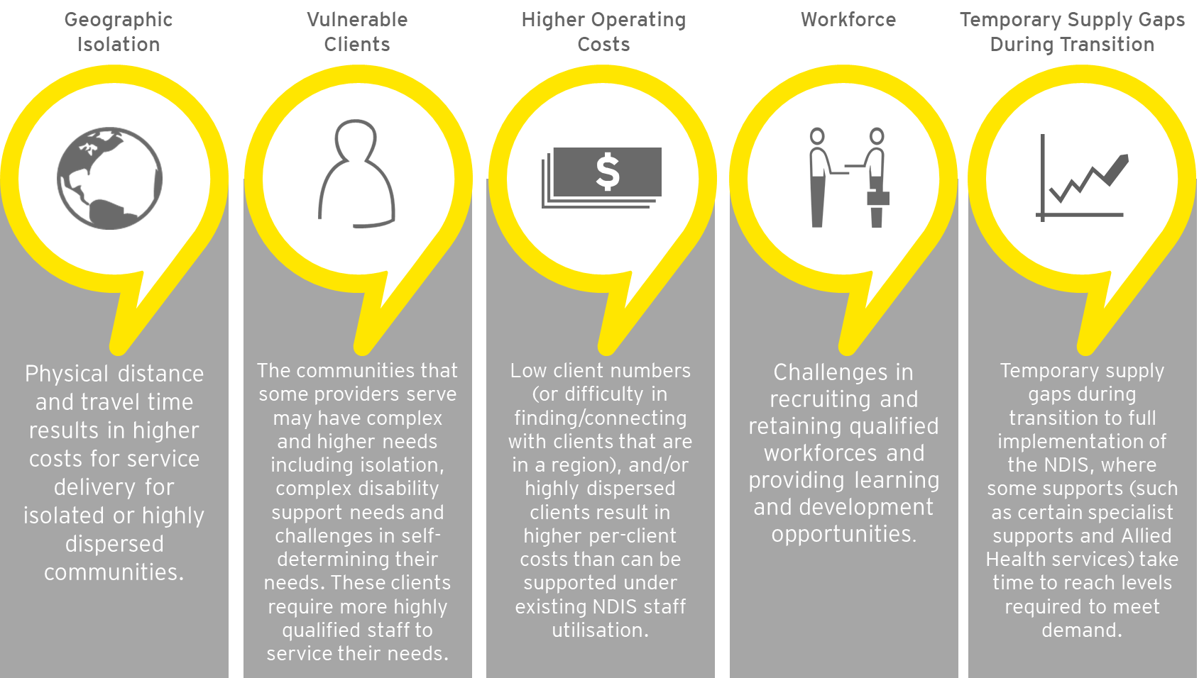

These issues not only present barriers to new providers entering the NDIS, they may also constrain the ability of current providers to deliver services.
  - Potential responses to thin markets
Based on a review of the literature on thin markets and the NDIS, as well as the views offered in submissions to previous consultation processes, a range of high level response options to address thin markets have been identified. These are highlighted in figure 4.
The spectrum illustrates the range of government involvement that is associated with the response options from limited government involvement on the left, to substantial on the right. All responses should aim to encourage positive market behaviour and development, and they must reflect the financial sustainability objective of the NDIS.
Figure 4: Grouping possible policy and implementation responses to address thin markets

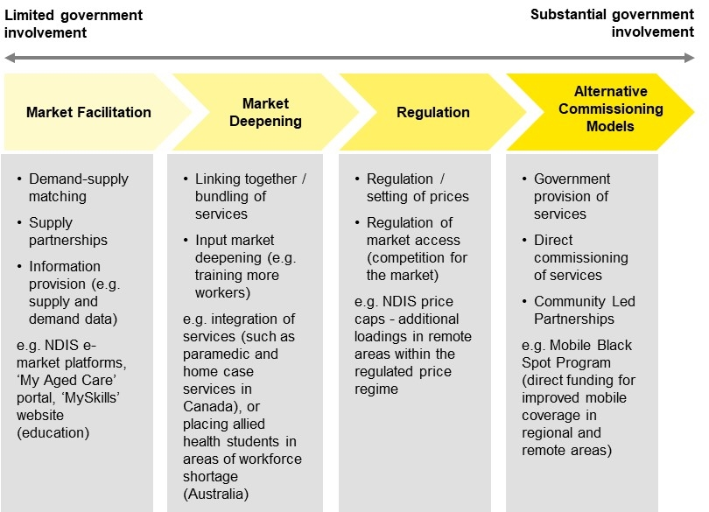

Response options can be broadly categorised into four types of responses (the full list of precedent programs reviewed to date is shown at Appendix A):
- Market Facilitation: These responses seek to enable competitive markets, for example by giving participants information about the service options or providers available to them, or matching supply and demand through electronic platforms. Supply partnerships, such as place-based collaborative models, alternative business models, co-operatives or sharing infrastructure between providers, can also support providers to overcome their service delivery challenges.
  - Examples that fall under this approach include the facilitation or provision of e-markets platforms (e.g. myAgedCare), or programs that aim to facilitate the growth or transition of the sector (e.g. the Sector Development Fund).
- Market Deepening: These responses seek to encourage supply to meet needs, including by ‘bundling’ together demand for different services to enhance efficiency, where supplying one of the services is inefficient; by pooling individualised funding to ensure economies of scale for a provider; or by stimulating or providing direct supply inputs, such as by encouraging skilled workers into markets in need.
  - Examples that fall under this approach include the mechanism used in the Multi-Purpose Services model to bundle aged care, disability and health services, or programs that encourage skilled workers to move to regional or remote areas (e.g. the Bonded Medical Places Scheme, or the National Rural Health Student Network).
- Regulation: These responses may control market operation to varying degrees through regulating or setting prices, controlling market access, or otherwise governing the operation of the markets to ensure it achieves service objectives.
  - Examples that fall under this approach include: adding or modifying regional loadings within the regulated price regime (e.g. changes accepted as part of the Independent Pricing Review); or selection of service providers who can deliver services within certain catchments.
- Alternative commissioning models (incl. community led responses): This includes options that involve direct commissioning or government provision of services, for example regulated monopoly (one service provider) or oligopoly (few service providers) models. Options would also include commissioning of community led responses (whether or not the financing would come from government).
  - Examples that would fall under this approach include: directly contracting with a provider, or number of providers, to provide access to services; or providing seed funding for a community-led partnership.
- Consultation participation
This section sets out the objectives of the consultation, the consultation process, and some key questions for each stakeholder group, to guide your feedback.
  - Consultation objectives
- Agree on the problem definition for thin markets in the context of the NDIS
  - Agree on how to identify ‘thin markets’ and understand how they are perceived and/or understood by providers, participants and peak bodies including key characteristics and market segments.
  - Understand the key causes, challenges and/or barriers that produce thin markets and whether these are temporary or persistent.
  - Identify the implications of thin market characteristics for achieving effective, efficient and equitable outcomes.
- Gather meaningful input on where and when the government should take a different approach to NDIS delivery
  - Identify where providers, participants and peak bodies are observing and/or experiencing thin markets most acutely and where responses should be prioritised.
  - Understand how thin markets are affecting people with disability.
  - Establish indicators that signal when responses are required, including where corrective action may be an urgent priority.
- Explore how the government should respond to address thin markets
  - Identify response options or models that could encourage the development of a functioning market.
  - Explore what is working in other sectors or community initiatives that could be leveraged to create a functioning market.
  - Discuss the trade-offs inherent in different responses, including how to maintain financial sustainability.
  - Considering the most viable and appropriate option/s to address different thin markets.
  - Understand how responses should be tailored based on the market segment.

  - Consultation process – how to have your say
- Send a written submission by 31 May 2019 through the DSS engage website. Submissions will be made public, unless you ask us to keep your submission confidential.
- Fill in the survey on the DSS Engage Website by 31 May 2019. The survey is aimed at collecting more detailed information from two groups:
  - NDIS Participants and peak bodies representing participants. The survey focuses on where participants and peak bodies believe thin markets exist; what the drivers of thin markets are; views on different response options; and views on services not perceived to be experiencing thin markets.
  - Providers (and peak bodies representing providers). The survey focuses on the types of thin markets providers operate in; the factors influencing their decision to operate in a thin market; and the potential options for assisting providers to deliver services in thin markets.
If you are one of these groups, you can access the survey tailored to you at https://engage.dss.gov.au/
- From April 2019 to July 2019, face-to-face workshops and meetings will be occurring around the country with service providers, as well as peak bodies and representative groups. If you will not be attending a session, you can make your views known to your peak body representative.

  - Questions to guide submissions
NDIS Scheme Participants (remember, you can ask for your submission to be kept confidential):
- Where do you live, and what are your support needs?
- How is your NDIS Plan managed?
- Are you able to access the services you need where you live? If not,
  - Are you travelling to receive the services? If you are travelling, how far are you travelling?
  - Are the services travelling to you?
  - Are you unable to access services you need or would use, if they were available?
    - For any of these three cases, please be as specific as possible about the services you are describing and the situation.
- What short-term and long-term approaches do you believe would best address thin market issues for you?
(e.g. provision of more information to participants and providers about supply and demand, government directly paying a provider to make sure supports are available, bundling of services, different approach to pricing, establishment of an effective e-market etc.)? Are there approaches you would not support?
Providers/peak bodies representing providers
- What role does your organisation undertake in the sector?
- Where does your organisation operate and what services does it provide?
- Has your organisation recently entered, expanded or ceased service a thin market?
- What information does your organisation require to assess the merits of entering a thin market?
- What are the most important factors which impact on your organisation’s ability to operate in a thin market, (including barriers you currently face)?
- What short-term and long-term approaches do you believe would best address thin market issues for you?
(e.g. provision of more information to participants and providers about supply and demand, government directly paying a provider to make sure supports are available, bundling of services, different approach to pricing, establishment of an effective e-market etc.)? Are there approaches you would not support?
Peak bodies representing participants
- What role does your organisation undertake in the sector?
- Has your organisation recently supported participants who are affected by thin markets?
- Where do you anticipate your constituents will experience thin markets issues in the future? (by location and/or service type)?
- In your organisation’s experience, what barriers are affecting the availability of services, and the ability of participants to access services? (e.g. access to information, diversity of services, location and travel, plan budget etc.)?
- What short-term and long-term approaches do you believe would best address thin market issues for you?
(e.g. provision of more information to participants and providers about supply and demand, government directly paying a provider to make sure supports are available, bundling of services, different approach to pricing, establishment of an effective e-market etc.)? Are there approaches you would not support?

- Precedent programs reviewed to date
Table A.1 below shows the precedent programs that have been reviewed to date, in informing the spectrum of response options
Table A1: Precedents reviewed to date
Program | Response Type (General categorisation)
Education – MySkills and MyFuture (Australia) | Market facilitation
My Aged Care website (Australia) | Market facilitation
Multi-Purpose Services Program (Australia) | Market deepening
Social Care (UK Aged Care) | Market deepening
Integration of senior and disability services in (New Brunswick, Canada) | Market deepening
Long-term care in Alberta (Canada) | Market deepening
Preschool Readiness Program (PRP) (Australia) | Market deepening
Integrating Preschool with the First Years of School (IPWS) trial (Australia) | Market deepening
Teach for Australia (TFA) Program (Australia) | Market deepening
Distance Education Centres (Australia) | Market deepening
Remote Teaching Service (WA, Australia) | Market deepening
Medical Intervention Support Program (VIC, Australia) | Market deepening
Teacher Flying Squad (WA, Australia) | Market deepening
Schoolcare Program (VIC, Australia) | Market deepening
Activity Based Funding (hospitals, Australia) | Regulation
Schooling Resource Standard (Australia) | Regulation
Department of Veterans’ Affairs (DVA) Gold Card (Australia) | Regulation
Vocational Education and Training (VET) FEE HELP – now VET Student Loans, and NSW Government VET Provision (Australia) | Regulation
General Practice healthcare (Australia) | Alternative commissioning
National Health Services – integrated personal budgets (England) | Alternative commissioning
Royal Flying Doctor Service (Australia) | Alternative commissioning
Local government services (US) | Alternative commissioning
Comprehensive case management pilot program in Toronto (Canada) | Alternative commissioning
Community Based Rehabilitation Programs (global, developing nations) | Alternative commissioning
National Broadband Network (NBN) Australia | Alternative commissioning
Mobile Black Spot Program (MBSP) Australia | Alternative commissioning

EY | Assurance | Tax | Transactions | Advisory

About EY
EY is a global leader in assurance, tax, transaction and advisory services. The insights and quality services we deliver help build trust and confidence in the capital markets and in economies the world over. We develop outstanding leaders who team to deliver on our promises to all of our stakeholders. In so doing, we play a critical role in building a better working world for our people, for our clients and for our communities.
EY refers to the global organisation and may refer to one or more of the member firms of Ernst & Young Global Limited, each of which is a separate legal entity. Ernst & Young Global Limited, a UK company limited by guarantee, does not provide services to clients. For more information about our organisation, please visit ey.com.
© 2019 Ernst & Young, Australia
All Rights Reserved.
In line with EY’s commitment to minimize its impact on the environment, this document has been printed on paper with a high recycled content.
Ernst & Young is a registered trademark. This document may be relied upon for the purpose of the consulting on NDIS thin markets, pursuant to the terms of our engagement letter. We disclaim all responsibility to any other party for any loss or liability that the other party may suffer or incur arising from or relating to or in any way connected with the contents of our report, the provision of our report to the other party or the reliance upon our report by the other party.
Liability limited by a scheme approved under Professional Standards Legislation.
ey.com

Refer section 2.2 of this discussion paper for the definition of thin markets applies for the purpose of this Project
Productivity Commission (2017), NDIS Costs Report
Joint Standing Committee on the National Disability Insurance Scheme, Market Readiness (2018) and General Issues Consultations (2018).
Productivity Commission (2017), NDIS Costs Report.
Productivity Commission (2017), NDIS Costs Report, House of Representatives Joint Standing Committee on the National Disability Insurance Scheme, Market Readiness (2018) and General Issues Consultations (2018), and McKinsey & Company (2018), ‘Independent Pricing Review’, National Disability Insurance Agency.
Note that there are exceptions to the general categorisation of intervention types along a ‘spectrum of government involvement’. For example, there are potentially lighter touch regulatory responses.

