Consultation to shape a national disability strategy for beyond 2020
Public forums – Guide to registering using Eventbrite
Starting on the first page after clicking “register your interest” on the DSS Engage page:
1.
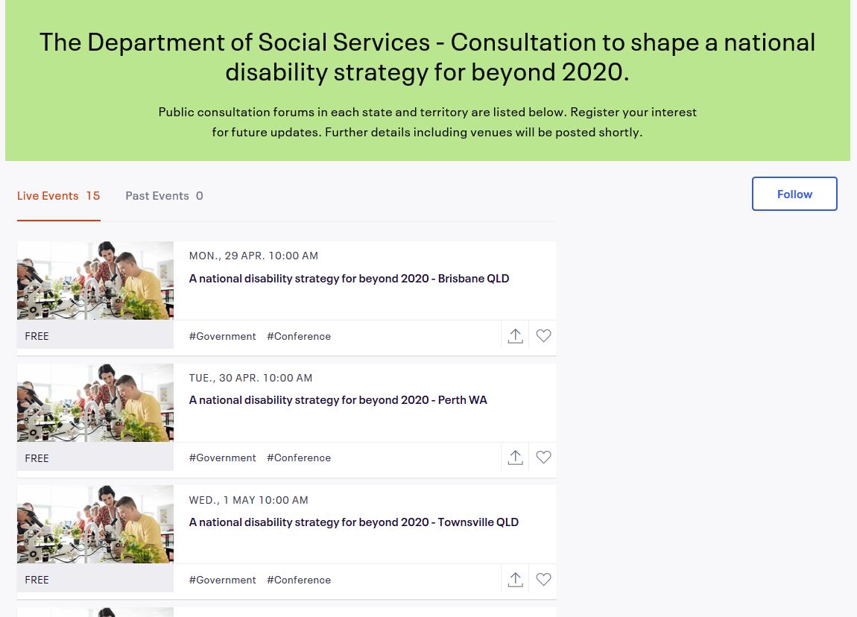
- You will see a list of public workshops, ordered from the first workshop on 29 April to the last on 30 May.
- The workshop events are named “A national disability strategy for beyond 2020 – (City) (State)”.
- Each event has a picture attached to it, which is of people using microscopes in a classroom.
- Click on either the picture for your chosen event or the name of the event.

2.
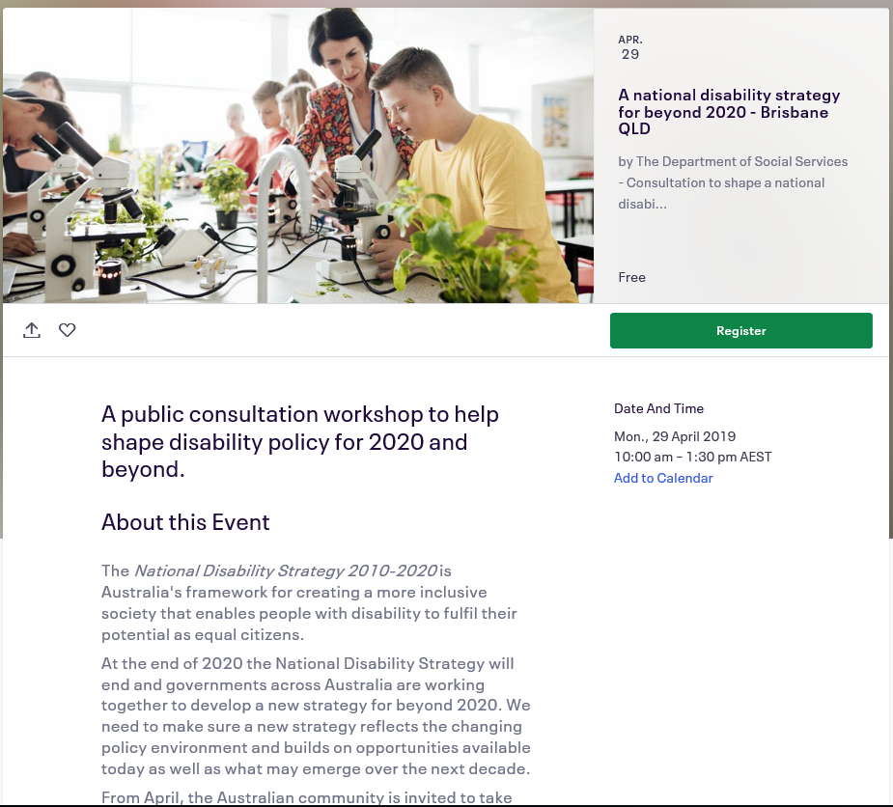
- This will bring you to the individual page for your chosen event, which has further information.
- There will be a green button labelled “Register”.
- Click the green “Checkout” button to take you to a new page where you will complete your registration.

3.
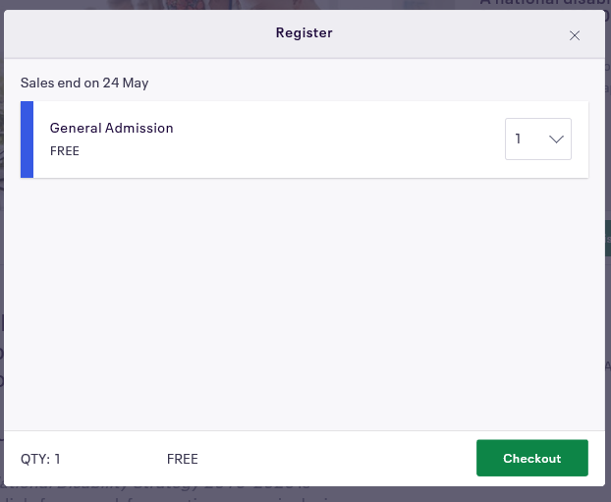
- The workshop event you have chosen and its date and time will be listed at the top of the page along with the amount of tickets you are registering for.

4.
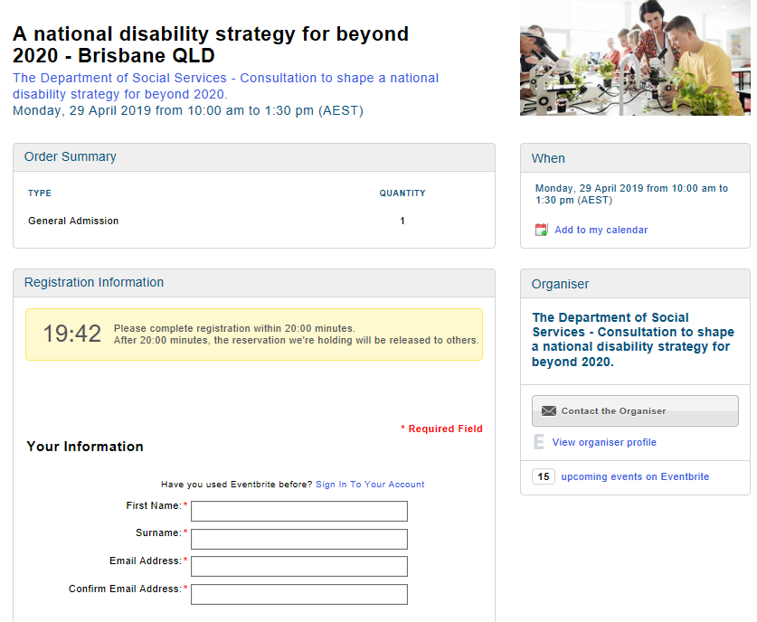
- There will be a timer counting down from 20 minutes, this tells you the time you have remaining to complete your registration before you have to start the process again.
- There will be a box near the top of the screen where you will be asked to fill in details about yourself to create an account with the Eventbrite platform, which will require your first and last names and an email address.
- Below the account creation box there will be another box which asks for details about you for the specific event you have chosen.

5.
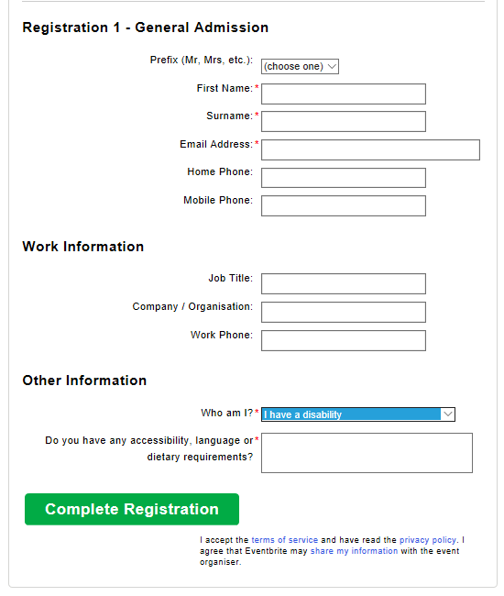
- Details you have used to create your account in the first box will automatically fill in the corresponding details in the second box, such as your name and email address.
- Other details such as home and mobile phone numbers and your work/employment information are not mandatory.
- The final detail you will need to include is answering a drop-down menu asking “Who am I?” This helps us to understand the likely needs and interests of participants at the workshops.
- If you select “other” an additional box will appear asking you for information on why you would like to attend.
- Regardless of which option you choose, a new box will appear below asking for any details on your special requirements, whether that is in terms of physical or communication accessibility, dietary requirements or any other issues you think we should be aware of.
- Once you have finished entering your details click the green box labelled “Complete Registration”.
6.
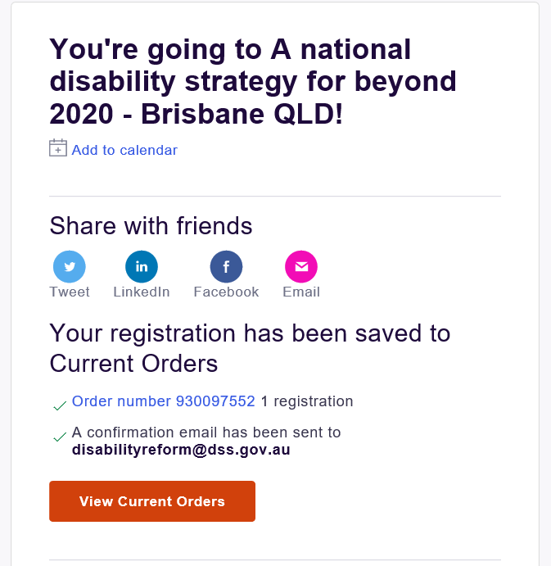
- You will then be taken to a page where you will be told your order is complete. A confirmation email will be sent to the email address you provided.
- When venues have been confirmed you will receive an email with these details.

