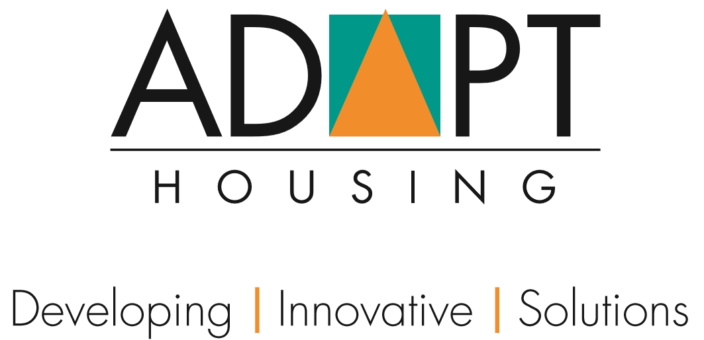

ADAPT Housing Pty Ltd (ADAPT) has been established to deliver significant investment for the provision of new build housing in the Specialist Disability Accommodation (SDA) market. ADAPT is affiliated with Affordable Management Corporation Pty Ltd, which has under its management over $1Bn in properties under the National Rental Affordability Scheme (NRAS) (with around 280
0 properties owned by in excess of 2000 investors). ADAPT is positioned to leverage off these investors to deliver significant funding into this emerging sector.
Over the past 12 months ADAPT has been engaging with numerous parties in the sector with a view to investing in construction of new housing. Our initial focus has been in the suburban and regional areas of northern NSW and SE Queensland. Whilst remaining confident of the long-term potential of the sector, ADAPT remains frustrated by the speed of progress. During this period of engagement ADAPT has identified a number of current issues surrounding the framework for delivery of SDA and welcomes the opportunity to share these.
The KPMG brief noted that this is the third year of funding and that the sector is still not mature. This is consistent with the industry view. It also indicated that it is evolving and should be mature by 2019-20. ADAPT fears that is unlikely given the low number of current SDA approvals for new builds currently in the pipeline. Most SDA providers are not prepared to adopt the “build and they will come” approach due to the current commercial risks.
ADAPT believes it is in a strong position to provide the required investment once the issues are addressed. It notes the initial registration of many organisations as SDA providers under the NDIS, from care organisations to community housing providers, and believes that very few of these have the capability or financial capacity to deliver the required housing, particularly in the volumes required. These organisations generally have no expertise in housing, no ability to raise equity and attract little interest from the banks to provide finance. ADAPT can provide the capital and therefore is well positioned to deliver the volumes needed to meet the macro-demand.
Based on the areas of the Terms of Reference of the KPMG review, we have attached our detailed comments. These can be summarised as follows:
- There is too much system uncertainty and commercial risk to expect accommodation to be built in advance of specific long-term tenancy commitments.
- There are very few new participants receiving SDA approval, so there is no market for new housing at present.
- The few approvals that have been given (beyond those grandfathered and in existing, often unsatisfactory, accommodation), are unclear as to what such SDA approval specifically means.
We recognise that the maturity level of the system is at its early stages and look forward to further participating in the process to develop a commercially attractive and sustainable industry to deliver the outcomes required to meet the vision of the NDIS.
We welcome further engagement when the opportunity arises.

Yours sincerely

David Whitelaw
(Chief Executive Officer – ADAPT Housing)

