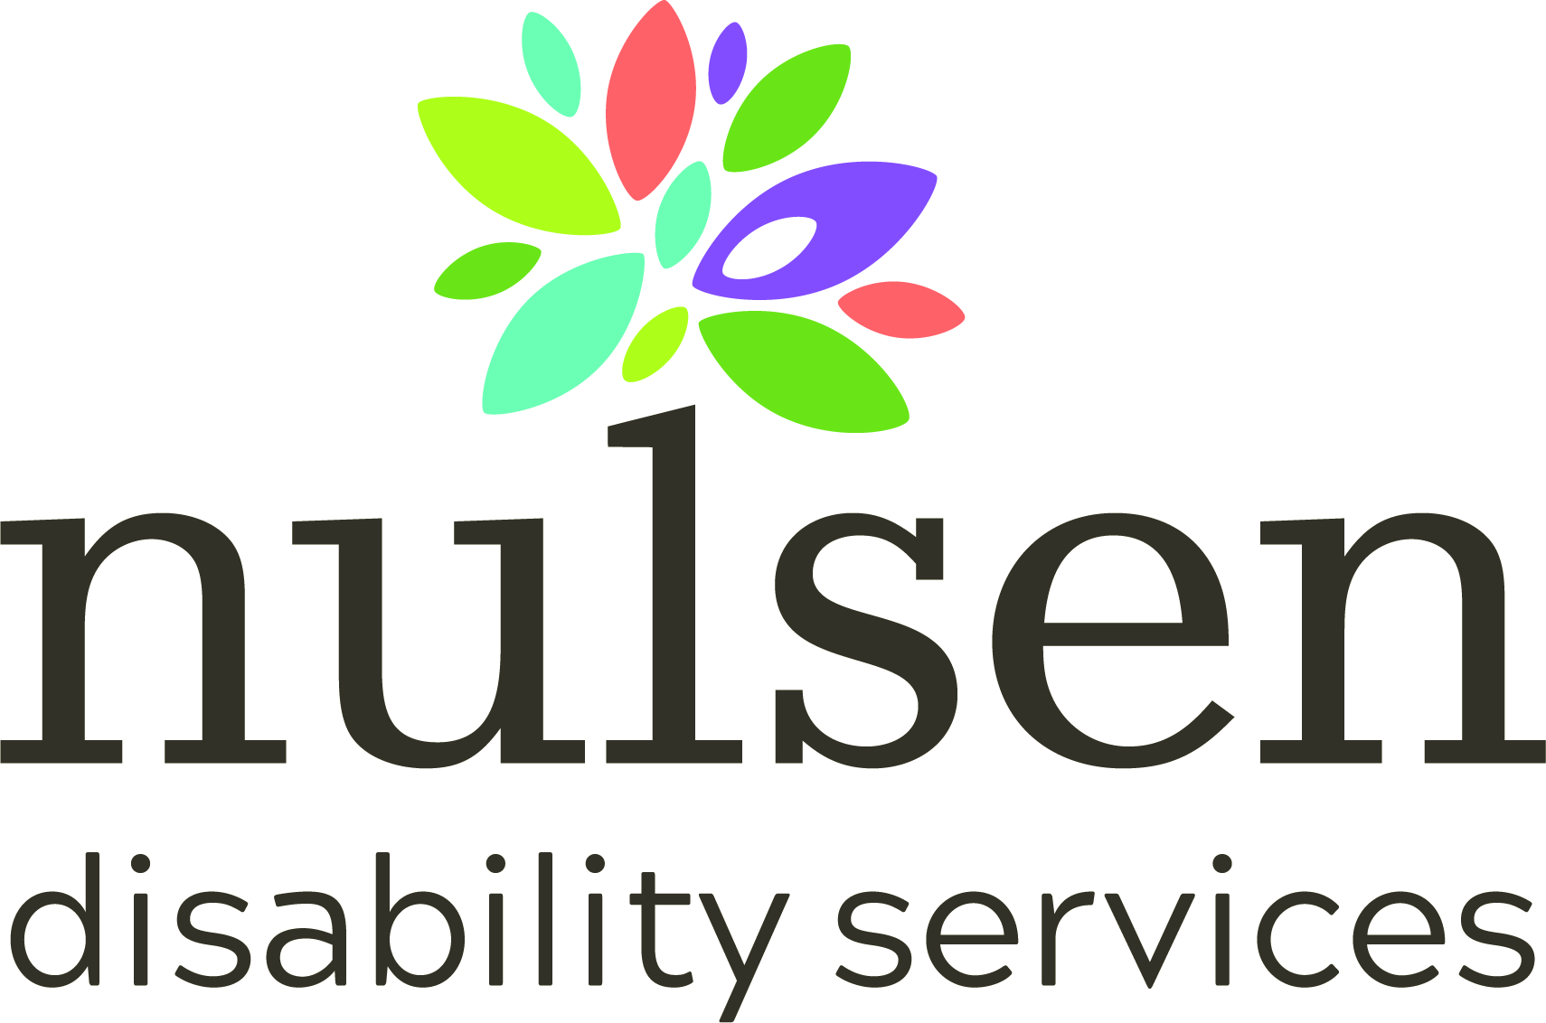

Briefing Paper
Record No DOC18/8498
To Department of Social Services
Subject Specialist Disability Accommodation Pricing and Payments Framework Review
Date 24/06/2018

Background and History in Western Australia (WA)
During the 1990’s the Disability Services Commission (DSC) developed an interagency agreement with the then state government Department of Housing to provide up to 80 housing units per year for disability related housing. This agreement was linked to and used to support the successive five-year business plans to provide accommodation support options for people living with disabilities funded by the Commission.
This arrangement eventually morphed into the Community Disability Housing Program (CDHP) that was managed successfully by the Department of Housing over a number of years in consultation with the DSC with the majority of services provided by the non-government sector.
The advantages of this approach were that the potential allocations and sources of housing were identified years in advance and mitigated the risks both for people living with disabilities, their families and carers, the disability sector organisations and community housing providers. Long-term planning proceeded with the security that the five year business plans were directly linked to an identified state housing strategy providing a reasonable degree of certainty and assurance for key stakeholders, including people with disabilities, their families and carers.
The Current Situation and the Challenges in WA
In the current environment there is little certainty of planning and there is no clear mechanism to encourage disability sector organisations and community housing providers to invest in housing without taking a major speculative financial risk. Houses will need to be planned and constructed without detailed knowledge of the specifications required by the future potential residents. There is also no guarantee that people with disability provided with individual funding will choose to live in the actual housing options constructed. The SDA advise that planning with the participant occurs before any SDA design can commence. The participant does not need to commit to the property and may change service provider at any point in time. This may compromise any long-term planning and construction process.
In essence, the risks have been transferred from the government agency responsible for providing housing to the disability sector organisation and/or to the community housing provider. It is highly unlikely that many will take the financial risk and choose invest at a significant level under these circumstances.
Under the current schedule to June 2023 it is anticipated that about 19,000 additional people living with disabilities (47,941 minus 29,000 in June 2017) will enter into the WA disability system over the next five years (Heads of Agreement between the Commonwealth and Western Australian Governments on the National Disability Insurance Scheme, December 2017). Disability Sector Organisations would estimate that up to six percent of these (or over 1,100) people will require support and housing options for their complex disability needs.
These figures are comparable to the Summer Foundation/ SGS Economic and Planning document entitled Specialist Disability Accommodation: Market Insights March 2018. This document reports that in Western Australia: Existing residents 1,590 Per capita distribution of SDA 2,980 Shortfall 1,390 (see page 2)
The major potential shortfall occurs in the Perth metropolitan area with 864 potential residents and in Bunbury and district where the potential shortfall is 135 residents (Summer Foundation, pages 48 - 49).
Participants will need to demonstrate an “extreme functional impairment” to live in SDA and also not able to live in public housing or private rental (Bosher 2018). Disability may occur across a wide range of functional impairments. A flexible approach will provide a range of responsive options, across a range of disabilities types in diverse geographic areas. This will likely lead to the best outcomes for the people living with disabilities.The current indications are that the government will need to stimulate the development of hundreds of housing options over the next five years to 2023. There is no indication that a comprehensive planning and funding strategy is in place or even being seriously considered. If these people are not provided with appropriate housing options within the disability sector they may drift to other options including rehabilitation hospitals, nursing homes, correction facilities, mental health facilities or remain homeless. If so many of these persons will continue to remain a responsibility of the relevant state government agencies and the state government will eventually bear the cost.
A Response to the Scope of the Review
- Does the SDA Framework support funding adequacy, sufficient supply in volume and form, innovation and quality of design, participant choice and control and inclusion, value for money for participants, and appropriate levels of flexibility to meet changes in quality and safeguarding arrangements?
The base framework provides a structured process to identify potential income for each property. In principle, the current values appear to be adequate to stimulate investment in the SDA area. Some properties and locations will likely fall outside the parameters set, so there is still a need for flexibility to go outside the benchmark price caps, if and when required.
The biggest disincentives to investments are:
SDA funding is received on actual usage and not on potential capacity:
Income modelling is optimally based on all tenants being eligible to receive SDA funding and the housing provider being able to access that funding. Eligibility is based on SDA funding being built into a participant’s person centred plan, something that is outside of the control of the housing provider. Even if a tenant has SDA funding at the commencement of the tenancy, if that funding ceases, the housing provider will have a sitting tenant, but no direct access to SDA funds for that individual.

If a vacancy occurs (through death, or person changing homes or interstate transfer), there is no guarantee that the replacement tenant will have access to SDA funds. The replacement tenant will need to be a customer of a service provider, who will have an imperative to fill the vacancy with someone in receipt of service delivery funds, but will not necessarily have access to the SDA funds. This will create a tension between the housing provider and the service provider where the first may insist on SDA funded clients only, and the other only being concerned with getting anyone with service provision funding.

Modelling is usually done over 15 plus years, but the SDA rules are only guaranteed for five years.
Bank finance modelling requires a sufficient length of secure income to justify the risk profile of the investment. Given the vagaries of who may be a tenant, the additional insecurity of having the scheme reviewed every five (5) years adds another unnecessary level of uncertainty. Unless there is a “grandfather” clause built into the SDA contract where access to funding at the current level is maintained over a 15 plus year period, financers will build in a higher risk return premium which may make many projects non-viable as an investment choice.

Landlords may need to interact with a multitude of service providers as tenants.
Choice and control over service provider is a keystone of the NDIS philosophy. One unintended consequence is that each tenant may be in receipt of service supports from a different service provider. If the tenant needs support with communication from their service provider, any communication with tenants may require multiple repetitions across the multiple service providers. While this is fine with standard tenancy issues, should a support worker from any of those service providers be responsible for any damage to the tenancy, there will be additional administration activity and cost in trying to determine which service provider will be responsible for any additional costs involved. This additional administration is another disincentive to investing in SDA properties.
The concept of encouraging investment in disability accommodation with SDA funding may put too much emphasis on the investment side of the equation and may take away from participant’s choice and control, value for money and flexibility. It may support an increase in supply, but not equal or appropriate variations of form (across the different design categories). Given the large difference in financial returns of the various design categories against a comparatively small difference in the cost of construction of the various design categories, this could lead to an oversupply of the high return design categories, as an unintended consequence.
It may be argued that the market will encourage investors to deliver SDA accommodation in areas and categories where there is a need through the mechanisms of supply and demand, but given it could take several years to plan and build an SDA eligible home coupled with potentially only five years of pricing certainty. Two years of construction time only leaves three years of relatively certain returns, and it would take a very brave investor to build a $900K home with only three years of guaranteed returns and no certainty after that.

Benchmarks

The establishment of appropriate and well-designed housing has a long lead time and clarity about the future regulatory and funding policy is required. The disability sector considers that it is important that the National Disability Insurance Agency (NDIA) meets the timeframes for developing the benchmark prices and implementing the ‘Specialist Disability Accommodation Pricing and Payments Framework’ and ensure the prices provided are adequate.

Benchmarks must also be subject to the application of appropriate annual indexation, otherwise over time the benchmarks will be eroded and lose their relevance. A consultative and open approach by the NDIA to the ongoing resolution of these issues will assist to allay any concerns.

Owner/ Operator Models
The NDIA should seriously consider allowing disability service providers to both own and operate specialist disability accommodation options. Disability housing providers will wish to retain equity in their current housing capacity. This equity will be required so that the provider can leverage their current equity in order to contribute to the housing developments of the future. The disability sector organisation could outline how the housing section will liaise with the internal direct care service to ensure that the potential for any perceived conflict of interest is minimised. The person living with disability can also nominate an advocate to assist with the planning and negotiations in this area.

To artificially reduce the capacity of service providers through government policy to own and operate disability related accommodation could severely reduce the development of potential housing options in an era where demand will significantly exceed supply. All endeavours should be made to maintain the current level of supply and to find new options to increase supply into the future. This is particularly the situation if the accommodation options support for people who live with complex and/or challenging behaviours. These people will not readily find accommodation in the open and private rental market.

Some disability sector organisations (DSO) have considerable experience in both areas. Many organisations may have designed and constructed a range of flexible accommodation models in the past, incorporating universal design principles. A deep level of understanding, experience and expertise in this area justifies why disability service providers should be allowed to continue to own and operate specialist disability accommodation.

Investment Timelines
Governments and the NDIA could provide coordinated and combined commitments on the amount of capital funding that will be available to stimulate new housing developments for people living with disability. It would be extremely useful if this information could be provided in three to four years forward estimates so that the disability sector organisations can plan long-term, taking into account the extended periods required for the planning, construction and completion of housing developments.

It is important to note who wears the prime risk with the major housing developments; namely the housing provider, the disability sector organisation, the people living with disability or the government? In reality, the only stakeholder with the funding required to underwrite such large investments for the disability sector as a whole would be the government agency responsible for the provision of housing.

- What arrangements are required to stimulate investor interest in SDA, and impact on investor decisions to participate in SDA?

Establish Partnerships Involving Developers, Financers, the Disability and the Community Housing Sectors.
At a local level, both the Commonwealth and NDIA can play an important role in coordinating the establishment of partnerships with the aim of exploring and putting in place methods to scale up effective housing developments for people living with disability.
The responsibility to address longstanding disability housing challenges goes beyond the ambit of the State Government. The Commonwealth can play a key role in facilitating collaboration between all three levels of government, land developers, planners, housing providers, disability services providers, families, banks and superannuation funds. There is a need for alliances to canvas a wide range of approaches for financing, such as shared equity and social investment options, as well as the more traditional commercial return and government funded options.
The disability sector requires a “notice board’ of potential players in this field, which could be registered by NDIA and linked to their website. Programs such as the successful Western Australian Housing Authority ‘Key Start’ program and home ownership sales programs should also be leveraged as much as feasible.

Disseminate Relevant and Timely Information on Housing Demand and Supply. Disability Sector Organisations consider that it is critical to recognise and promote the wide continuum of housing arrangements and financing options. Major investors, as well as individuals and families, need to understand the full range of possibilities in order to make good investment decisions. To make an investment in housing, investors need to have access to detailed demand, supply and trend data. It is important to increase knowledge across all stakeholders of the diverse range of housing models, such as share houses, networks, tenant managed co-operatives and shared equity arrangements.
There is a need for more locally based and relevant data on disability housing needs across the whole of WA. This is currently lacking and would enable better and more coordinated planning of housing options and developments.

Vacancy Management
The NDIA in consultation with the state government will need to fund the co-ordination of a state wide vacancy management program for the diverse housing options. This will assist some people to find the most appropriate accommodation and ensure service providers do not carry unfunded vacancy costs. These costs could impact the providers’ cash flow in an era where cash flow will be challenged by many other administrative processes of the NDIA.

To support this particular concept, there could be a ‘clearing house’ function developed where all vacancies in disability accommodation support services and all people seeking an accommodation option could be placed on an electronic noticeboard and the required movements could be coordinated. This function has existed in the past in WA and the ‘clearing house’ is best placed within a peak body such as the National Disability Service, or a private organisation that is funded to perform this function. This would assist to maintain an impartial and systematic process in order to minimise any favouritism or potential for a perceived conflict of interest.

Choice and control is a key feature of the NDIS. In developing group housing options, the compatibility of the potential residents may be crucial to the maintenance of the housing arrangements and safeguarding the rights of residents. The sensitive investigation of compatibility issues may take some time and the service provider should not bear the cost during this process. In principle, a non-government service provider should not bear the cost of the implementation of government legislation and policy.

Discussions with Growth Providers regarding the ability to identify tenants prior to the completion of new developments in order to minimise vacancy rates would be an effective strategy. New projects could also be added to the ‘clearing house’ function to assist in the planning and implementation of the early occupation of new housing options.

Regulate Adaptability Standards in the National Construction Code. All new and extensively modified housing should be required to meet national access and adaptability standards. The proposed minimum access and adaptability standards are defined by the Australian Network for Universal Housing Design (Liveable Housing Design Guidelines). These types of accommodation options are ready or will be readily adaptable to the needs of an aging population.
Revise Local Government Planning Regulation to Require all New Housing Developments to Include Affordable Housing Options. The State Labor Government could encourage all levels of government to play their part in addressing an enduring national shortage of affordable housing. This can be achieved through ensuring approvals for new housing developments include affordable housing components of up to ten percent.
Every jurisdiction and relevant local government area could release sufficient land in order to stimulate and support the proposed housing developments with incentives to encourage and enable local planners and council requirements to be as flexible as possible to stimulate the development of appropriate housing options for people living with disability.

- Are there changes to the SDA Framework that would better enable market development?
Better planning and clearer policy directions The SDA as it is currently proposed will not provide the best outcome for participants, The rules and regulations are not clear enough to provide housing developers certainty and in another way too prescriptive and narrow when it comes to participants accessing the SDA. The SDA appears to be designed to encourage more investment in disability housing. Alternatively, if you try to design an SDA system with the best interests of people with disabilities in mind as the primary outcome, you might have ended up with a totally different process.
It is like a planning and policy step was missed in the beginning and it was just assumed that the best thing for people with disabilities was to increase the amount of investment in disability accommodation. The primary aim of SDA is seen to be to increase the amount of investment in disability accommodation, rather than to provide people with disabilities with appropriate and accessible accommodation. What type of system would we have if the key driver was the best outcome for participants rather than jumping over that step and assuming that developer investment in accommodation would deliver the best outcome for people with disabilities?
Establish National Funding Streams to Stimulate the Construction of Affordable and Accessible Community Housing for People Living with Disability. The disability sector encourages the State Government and the NDIA to investigate innovative ways to improve the availability of affordable housing. Improving access to affordable housing for people with disability is a key plank of the National Disability Strategy and is essential for the success of the NDIS.

To complement the NDIS, the Commonwealth Government could introduce a national scheme that offers financial incentives to the banking sector, business sectors and community organisations to build and rent dwellings for low and moderate income households. To stimulate the housing market the following strategies could be considered and adopted:
- incentives may be indexed annually and provided for each approved dwelling as a partial tax offset;
- to complement any contributions or investments from state or territory governments;
- to enable investors in the scheme to benefit from annual incentives as well as through rental yields and potential capital gains;
- that only apply to approved schemes that meet quality and probity standards subject to external monitoring.

- Is the SDA Framework the most effective mechanism to continue supporting participant funding arrangements and ongoing funding certainty, and other market settings for SDA?
On balance the answer to this question is no, not at the present time. There are a number of positive elements to the current proposal and there are a number of risks that could potentially impact the financial viability of any housing strategy should be considered prior to any final investment decision at the appropriate time. These risks include:
- SDA Rules not allowing SDA services and supported independent living services to be provided to the same NDIS participant by the same organisation;
- ongoing payments not being provided to SDA owners for new builds if they do not display an ongoing commitment to continually develop new SDA housing stock throughout the community;
- future changes to the SDA pricing framework such as payments being cut short for new builds and being provided for less than the currently stated 20 year period;

- regular and uncoordinated policy changes that do not support the long-term timelines required by this strategy;
- insufficient knowledge regarding demand due to inadequate planning and SDA funding not being appropriately included in the plans of the participants who require SDA services; and
- The provision of SDA services requiring a substantial increase in internal administrative functions and responsibilities.

An ideal strategy for the future
As stated, the largest financing challenge facing the accommodation market is long-term access to equity and funding. This organisation has developed a high level financial model to provide an indication of the sustainability, the funding commitment and resources potentially required for full implementation. The time period modelled is between 2018-19 and 2043-44, which allows for new SDA housing stock developed by the organisation to receive new housing stock payments for the maximum allowed time period stated in the SDA Decision Paper on Pricing and Payments 2016, of more than 20 years. If a shorter time period was modelled, it would not accurately reflect the minimum useful life and financial returns over the useful lifespan of any newly developed housing stock.
As stated previously a Disability Sector Organisation currently may have access to housing properties and be registered as a tiered service provider. With sufficient planning and capital funding my organisation considers it could provide at least five and up to 10 housing options per year. Other disability sector organisations may be in similar circumstances or better circumstances (Nulsen Disability Services, Strategic Plan 2018-2023, Nurturing Potential for a Better Future, March 2018).
In order to achieve this outcome, my organisation would need to be eligible for up to $50,000 payment per house per annum. As stated previously this would assist to develop a sustainable long-term funding base to maintain current housing and to invest in the development of new housing properties. The organisation could then engage in planning with certainty and with the mitigation of risk for both itself and for the people it serves.
Summary and Conclusion

There is a need to implement comprehensive, collaborative, coordinated and innovative policy and implementation solutions to increase the amount of appropriate and accessible housing supply for people living with disability in the most efficient and cost effective manner.
The stability of policy and investment terms will be a major factor in increasing confidence in the scheme, which will lead to an increased appetite to invest.

The expertise and contribution that disability sector organisations currently make in this area of focus should not be underestimated. In any change and transition environment the opportunity to consult is welcomed by service providers, however, serious consideration should be given to previous and current strategies undertaken by service organisations and Housing Developers to combat the ongoing lack of suitable housing models for people with disability. These issues cannot be resolved by a centralised government agency working in isolation from the key stakeholders.

References

Luke Bosher SDA: A Maturing Market? Disability Services Consulting, 25 March 2018.
Heads of Agreement between the Commonwealth and Western Australian Governments on the National Disability Insurance Scheme, December 2017.
Joint Standing Committee on the NDIS, Accommodation for people with disabilities and the NDIS, 2016.
National Disability Insurance Agency, NDIS Price Guide Supported Disability Accommodation (SDA), 2017.
National Disability Insurance Agency, Supported Disability Accommodation Decision Paper on Pricing and Payment, 2016
Nulsen Disability Services, Strategic Plan 2018-2023, Nurturing Potential for a Better Future, March 2018
Productivity Commission, Disability Care and Support Volume 2, 2011.

Summer Foundation/ SGS Economic and Planning, Specialist Disability Accommodation: Market Insights, March 2018

