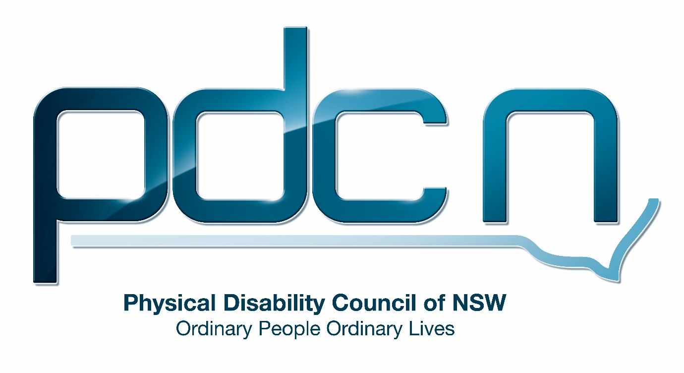

Submission for KPMG

Specialist Disability Accommodation Pricing and Payments Framework Review

25th June 2018

Ellen Small

Physical Disability Council of NSW
3/184 Glebe Point Road, Glebe NSW 2037

02 9552 1606
www.pdcnsw.org.au
ellen.small@pdcnsw.org.au

Who is the Physical Disability Council of NSW?
The Physical Disability Council of NSW (PDCN) is the peak body representing people with physical disabilities across New South Wales. This includes people with a range of physical disability issues, from young children and their representatives to aged people, who are from a wide range of socio-economic circumstances and live in metropolitan, rural and regional areas of NSW.

Our core function to is influence and advocate for the achievement of systemic change to ensure the rights of all people with a physical disability are improved and upheld.

The objectives of PDCN are:
- To educate, inform and assist people with physical disabilities in NSW about the range of services, structure and programs available that enable their full participation, equality of opportunity and equality of citizenship.
- To develop the capacity of people with physical disability in NSW to identify their own goals, and the confidence to develop a pathway to achieving their goals (i.e: self-advocate).
- To educate and inform stakeholders (i.e: about the needs of people with a physical disability) so they are able to achieve and maintain full participation, equality of opportunity and equality of citizenship.

Introduction:
The Physical Disability Council of NSW (PDCN) appreciates the opportunity to provide feedback to KPMG on the review of the Specialist Disability Accommodation Pricing and Payments Framework. PDCN will provide feedback, where we have relevant expertise on the following stakeholder consultation questions;
Investment: Does the SDA framework support investor decision making and provide sufficient market certainty?
Innovation and quality: Is the SDA framework facilitating high quality and innovative SDA models and design?
Choice and Control: Does the SDA framework enable choice, control, independence and inclusion?

Discussion

PDCN believes Specialist Disability Accommodation (SDA) under the National Disability Insurance Scheme (NDIS) is a vital mode of providing capital funding for NDIS participants who require specialist housing solutions. PDCN is highly supportive of the overarching vision of the framework which champions greater community inclusion for people with disability and providing flexible accommodation choices that meet the needs of NDIS participants with high support requirements. PDCN believes moving away from the current fragmented market of disability accommodation, which features segregated and institutionalised disability housing is a positive change for people with disabilities and will ensure their greater inclusion in Australian society.

As this is a relatively new framework and the transition to the NDIS is still proceeding across Australia many issues such as supply have not been thoroughly tested and therefore we feel in some aspects of this review we will not be able to provide comment. PDCN believes that for people with disability to achieve real community inclusion, as outlined in the National Disability Strategy, it is essential that the original vision of SDA providing participants with individual accommodation i.e. self-contained independent living, rather than group supported accommodation is achieved.

Investment: Does the SDA framework support investor decision making and provide sufficient market certainty?

PDCN suggests that the funding model proposed for robust housing will not be workable and will not provide sufficient market supply of this accommodation type. Investors may find that building robust accommodation is not financially worthwhile if the most profitable SDA type entails the cohabitation of multiple SDA funded participants.

In this situation, it is unreasonable for participants to live together due to their different and complex support needs and therefore this model may also be less appealing to investors due to the potential for substantial maintenance costs that may be necessary for the upkeep of the property if residents are disposed to destructive behaviour.

In addition, PDCN is concerned about a lack of accommodation options for individuals who, due to high support needs such as challenging behaviours, may find themselves removed from private SDA housing; and as the NSW Department of Ageing Disability and Home Care (ADHC) leaves this domain, may be left without a provider of last resort.

Innovation and Quality- Is the SDA framework facilitating high quality and innovative SDA models and design?

It is difficult to examine the SDA pricing and payments framework in isolation without looking at the broader implementation of the NDIS. Prior to the NDIS roll out it had been anticipated that under the scheme SDA would provide an opportunity for parents, families or carers to establish an SDA dwelling for a person with disability to live independently. Although this is technically possible under the framework in reality it is not financially viable and there is a lack of guidance on how this could be achieved. PDCN recommends the framework provide more choice and control for people with disability and their families by explicitly stating the options for parents or family members to take up SDA as an investor or provider.

PDCN is concerned about the quality of SDA models currently in use, due to a growth in the number of existing disability housing being utilised as SDA for participants. As this existing accommodation is not registered it may be poorly kept and maintained and PDCN would like to see its ongoing maintenance addressed in the framework.

Furthermore, PDCN has received reports that SDA providers are not aware of their ongoing responsibilities for home modifications. We recommend that the framework allow for SDA funds to be administered through other plan management options such as plan managed or self-managed. If SDA funding is provided directly to the NDIS participant this would afford greater choice and control and give the participant a greater ability to hold the SDA provider accountable, especially in situations where SDA providers are not meeting their responsibilities around repairs or home modifications.

PDCN believes the SDA framework should facilitate innovative design through a budget that allows for construction of SDA to meet the highest level Australian Liveable Housing Design Guidelines. This would ensure the independence and inclusion of SDA participants is fully supported while easily allowing for changes where residents have varying needs. Furthermore, it would minimise the cost of continual home modifications for SDA providers when there are changes in tenancy.

Choice and control - Does the SDA framework enable choice, control, independence and inclusion?

PDCN believes it is essential the SDA framework is consistent with the values that underpin the NDIS, giving participants the ability to exercise choice and control over their living situation and support arrangements, both individually or if they are pooling support with others. PDCN is concerned the pricing arrangements in the SDA framework will see a perpetuation of the ‘group homes’ models where individuals have little or no choice over who they live with. An example is SDA that requires up to five bedrooms be tenanted by five participants receiving SDA funding.

In addition, PDCN is concerned that the SDA framework supports having a cluster of SDA participants and it may be difficult for participants to secure an arrangement where a supported independent living (SIL) provider takes on one contract with an individual SDA participant living in an individual home.

PDCN recommends decoupling the link between the number of bedrooms and the number of SDA participants required by a provider to better allow for home share arrangements or families living together. The SDA framework is grounded on the assumption that the person with a disability eligible for SDA is a single person without family. The framework could more explicitly state examples of different living arrangements. PDCN recommends the framework ensure the financial viability of mixed models, including homes where people with disability share with persons who do not have a disability.

Furthermore, participant eligibility and approval for SDA funding has been identified as a significant issue. The process of securing a house with an SDA provider is problematic as participants do not know if they will be SDA eligible but must find an SDA place in order to be assessed by the NDIA. PDCN recommends the SDA framework provide further clarity around eligibility and who can receive SDA.

NDIS support coordinators would benefit from more information to provide participants greater advice regarding their eligibility for SDA and PDCN would like to see improvements in the length of the assessment process with greater transparency of the criteria used to assess SDA eligibility. PDCN believes the cyclical nature of the current process makes it difficult for both participants and SDA providers to plan. Therefore, a more deliberate approach where participants have greater notice that they will receive SDA funding would be beneficial to both SDA providers and participants.

Under the continuity of support arrangements for people currently living in existing supported accommodation PDCN is apprehensive that some individuals will be locked into existing housing models for fear of losing their SDA funding. Many individuals who are currently residents of supported accommodation may not be eligible for the NDIS or have a reasonable and necessary need for SDA. PDCN is troubled by the lack of support to find suitable homes or other options for rehousing these individuals. Many people with disability will be in a situation where they do not have other housing options and may not leave their current situation even if it is unsuitable. This situation leaves people with disability more vulnerable to abuse, neglect and exploitation.

Furthermore, many individuals currently living in residential facilities or supported accommodation have been institutionalised for a significant period and may have a reduced capacity to exercise choice and control.

Conclusion

In conclusion, it is crucial the SDA pricing and payments framework ensures people with disabilities and high support needs are no longer segregated from the community and consigned to previous disability housing models. PDCN believes the framework must provide people with disabilities true choice and control over their accommodation options, including opportunities for a variety of different living arrangements such as residing independently in the community, or with family or friends.

PDCN would also like to comment on the inadequacy of the public consultation undertaken as part of this review. The release of the discussion paper five days after the opening of the consultation period, the short consultation period and the difficulty we experienced in obtaining details to attend the roundtable event held in Sydney, despite registering in advance of the review period has negatively impacted on our engagement in this review.

PDCN recommends both the Department of Social Services and KPMG address these issues in the organisation of future reviews or consultations to ensure a wide range of community members and organisations are able to provide feedback.

