Discussion Paper
Considerations for the future of the Volunteer Management Activity
DSS February 2020

Contents
1. Introduction 2
1.1 Purpose of the Discussion Paper 2
1.2 Independent Review of the Volunteer Management Activity 2
2. Redesigning the Volunteer Management Activity 3
2.1 Proposed Aim 3
2.2 Key Principles for Redesign 3
3. Recommendations from the Report on the Review of the Volunteer Management Activity 5
3.1 Focusing on capacity building 5
3.2 National Management Databases 6
3.3 Revised performance framework 7
4. Next Steps 7
5. Glossary 8
6. Appendix A: History of the Volunteer Management Activity 10
7. Appendix B: Australian Government volunteering initiatives 11
8. Appendix C: State and Territory government volunteering initiatives 12

1. Introduction
Volunteering plays a critical role in building strong and resilient communities by supporting local community organisations in their efforts to overcome disadvantage and solve complex social problems. Research has shown that the economic value of volunteering has increased to $290 billion per year, which is in addition to the invaluable contribution volunteers make to Australian society.
Volunteering participation and hours have both increased over the decade from 2005 to 2016. An estimated 8.7 million people, or about 43.7 per cent of adult Australians, volunteered a total of 932 million hours in the 12 months prior to September 2016. On average, this equals 134 hours, or about 2.5 hours per week, per volunteer.
The Australian Government currently provides a total of $18.8 million (excluding GST) in funding from 1 January 2018 until 30 June 2021 for the Volunteer Management Activity (VMA), plus indexation.
The VMA provides support through Volunteer Support Services to individual volunteers, volunteer leaders and managers, and Volunteer Involving Organisations to encourage, support and increase participation in volunteering. It does this through:
- Promoting volunteer participation
- Matching potential volunteers with a volunteering role
- Providing information on volunteering
- Promoting innovation in volunteering
- Providing access to the training and resources which volunteers and Volunteer Involving Organisations (VIOs) need
- Building effective volunteering practices and opportunities within organisations and communities.

1.1 Purpose of the Discussion Paper
In 2016, the Australian Government indicated the VMA must be redesigned (see Appendix A for a history of the VMA). The purpose of this Discussion Paper is to outline and seek views on the key issues for consideration when thinking about the future of volunteer management and the role of the Australian Government.

1.2 Independent Review of the Volunteer Management Activity
In November 2017, the Department of Social Services (DSS) contracted Matthews Pegg Consulting (mpconsulting) to undertake an independent program performance review into the appropriateness, effectiveness and efficiency of the VMA. The Review provides recommendations on ways to significantly improve volunteer management across Australia.
As part of the Review process, mpconsulting engaged with a range of stakeholders involved in volunteering, volunteer management and delivery of the VMA. This included face-to-face meetings and teleconferences with Volunteer Support Services, VIOs, peak organisations, representatives from DSS and other government agencies.

The recommendations from this Review have informed this Discussion Paper.

2. Redesigning the Volunteer Management Activity

2.1 Proposed Aim
A redesigned Volunteer Management Activity will aim to encourage and support Volunteer Involving Organisations to support volunteers to participate in volunteering opportunities. Volunteer Management involves the delivery of volunteering support services to people who lead and manage volunteers, such as improving access to volunteering information, training, resources and building effective volunteering practices.
The volunteer landscape in Australia has undergone some change, such as technological advancements, and there is a need for better volunteer matching and training. This presents new opportunities for organisations to adapt the way they connect with and support volunteers. With these changes, it is critical that Government investment in volunteering is well targeted, aligned with best practice and designed to address emerging need.

2.2 Key Principles for Redesign
The following principles will need to be addressed in the redesign of the VMA:

Constitutional validity
The Australian Government recognises the importance of volunteer management and its role in providing national leadership in this space.
The Government has a responsibility to ensure that all activities undertaken by organisations funded under the VMA are aligned to a head of power in the Australian constitution. Without that connection, the Government may not be able to continue funding the VMA in its current form.
A range of constitutional powers may be relevant to any redesign of VMA. For example, the communications power might be considered in relation to funding for an online VMA delivery model.

Efficiency of service delivery and effective use of resources
The Review notes that, in its current state, the funding model lends itself to duplication of effort, inconsistent use of resources and inefficiencies in service delivery.
The redesign should focus on finding ways to ensure the funding model encourages greater cooperation and collaboration between service providers through partnerships, effective sharing of resources and reducing the inefficiencies in service delivery.
Further, accessibility requirements, such as for people with disability or culturally and linguistically diverse Australians, needs to be considered and maintained.

Reduced duplication of cross jurisdictional efforts and funding
The Review notes that recognition and investment in volunteer management varies across jurisdictions. A redesigned VMA should seek to minimise the risk of duplication of efforts and funding between levels of government. Appendix B outlines a selection of Commonwealth, state and territory and local government volunteer management initiatives.
As shown in Figure 1 below, VMA service outlets are currently heavily concentrated in major metropolitan areas across Australia, with a noticeable gap in direct service delivery to rural and remote areas. A redesign would need to consider this gap and recognise that there are alternative means of service delivery, such as online platforms.
Figure 1: Map of current Volunteer Support Service outlets funded under the VMA
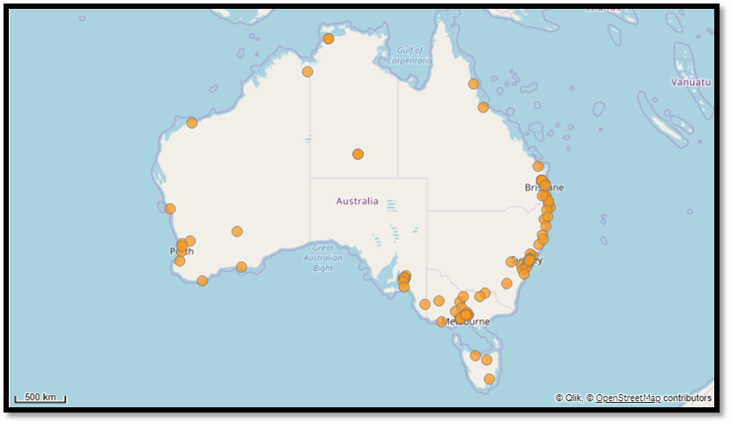

Best value for funding available
Current VMA funding agreements cease on 30 June 2021, with funding of a similar quantum provisioned over the forward estimates. The Australian Government is committed to continuing to provide funding for volunteer management activities; however, there is a need to ensure the aim of the funding is to allow the sector to continue to build capacity and maintain a focus on volunteer management and leadership.
The funding needs to ensure volunteers, Volunteering Involving Organisations, the Australian Government and the wider sector are getting the best value for the funding available, while also ensuring the Australian Government has the constitutional power to administer and fund the VMA.

3. Recommendations from the Report on the Review of the Volunteer Management Activity
This paper seeks to explore and solicit the views of stakeholders on how a new VMA model could best meet the needs of volunteers and Volunteer Involving Organisations, in the context of the Review recommendations and the key principles noted above.
Recommendation 1
The Review recommends that the Australian Government continue to invest in volunteer management, but clarify its interest in volunteer management including the focus and objective of its investment.

Discussion Questions
Within the current funding envelope (approximately $18.8 million, excluding GST, over three and a half years), what do you think should be the Australian Government’s focus in volunteer management?
Is this focus different to state and territory governments?
How could the Australian Government work across all levels of government to align efforts, ensure consistency, and minimise the risk of duplication in effort and funding to better support volunteer management in Australia?
Ideas could include:
- A National Volunteer Management Statement, which outlines strategic objectives for volunteer management with a set of key action items across Australian and State and Territory Governments
- An Australian Government National Statement on Volunteer Management
- Australian Government leadership of and funding for a specific type of volunteer management for which a national approach is required, such as emergency volunteering
- Other?

3.1 Focusing on capacity building
The VMA currently funds 52 organisations to deliver 72 Volunteer Support Services across Australia.
The Review notes that national coverage of Volunteer Support Services is not possible through the currently funded 52 organisations. The Review further states that place-based services are not an efficient way to assist large numbers of volunteers, or to build the capacity of Australia’s vast and diverse network of Volunteer Involving Organisations.
The Review suggests that the Australian Government provide sustainable funding to a limited number of professional organisations (up to 20) to provide capacity building, support and training for Volunteer Involving Organisations.
Recommendation 2
The Review recommends that the Australian Government work with stakeholders over the coming 12 months to co-design a new program (including the performance framework) that focuses the Australian Government’s investment on building the capacity of Volunteer Involving Organisations to effectively recruit and manage volunteers.

Discussion Questions
On what basis could the Australian Government select a limited number of providers?
How could selected providers ensure national coverage and leverage the capability of the sector, including Volunteer Involving Organisations?
Ideas could include:
- Funding state and territory peak bodies to develop, manage, and deliver state and territory based service approaches. This could involve partnering with local organisations to ensure state/territory coverage of VMA services
- Funding up to 20 organisations to deliver VMA, while ensuring national coverage (including peak organisations)
- Other?

3.2 National Management Databases
The Review suggests that the Australian Government invest in enhancements to existing national, web-based volunteer management databases.
Volunteering Western Australia manages the VIKTOR web-based volunteer management system. VIKTOR is supported by VIRA, which is used by Volunteer Involving Organisations to manage volunteers within their organisation.
VIKTOR currently lists 95 per cent of volunteering opportunities and it is recognised as the leading web-based volunteer management system for client data recording and referral purposes. VIKTOR supports 35 websites and applications that facilitate volunteering, such as SEEK Volunteer, Volunteer Profile and the GoVolunteer application.

Discussion Questions
How could the Australian Government ensure the accessibility of volunteering support services, for example, for people with disability or culturally and linguistically diverse Australians, through an online approach?
How could an online volunteer management service delivery model operate?
Given that VIKTOR is used widely across the sector, how could VIKTOR (or an alternative database) be adapted to reflect the changing needs of the sector? Is VIKTOR an appropriate option to support an online approach? What would be the role of VIRA?

3.3 Revised performance framework
The Review notes that the current VMA performance framework provides limited capacity to measure the effectiveness of the VMA, presenting challenges in terms of demonstrating the value of the program, performance assessment, or driving continuous improvement.
The Data Exchange is the DSS program performance reporting approach for client-facing programs and is intended to shift the focus of performance measurement from outputs to service delivery outcomes.
DSS is aware of issues raised with current Data Exchange reporting requirements and is working with Volunteering Australia, the national peak body for volunteering, to address these issues.
The Review notes that there are inconsistencies between reporting on outcomes between each Volunteer Support Service.
Discussion Questions
How could the Australian Government better measure the outcomes and successes of a future VMA program?
What could be the key short-term (up to 12 months), medium-term (12 months to 5 years) and long-term (over 5 years) indicators of success?

4. Next Steps
This Discussion Paper seeks to foster discussion on what needs to be done to improve volunteer management, and address the constitutional validity with the current program, and to hear ideas about how this can be best achieved.
This Discussion Paper has been developed in consultation with Volunteering Australia and all seven state and territory volunteering peak body organisations.
There will be targeted consultations across Australia to provide feedback on the proposed direction of the new VMA program.
People will be able to provide written submissions on this paper via email and Australia Post, from mid-February 2020 to March 2020.
Milestone | Timeframe
Public release of the Report on the Review of the Volunteer Management Activity and the Departmental Discussion Paper | Thursday 13 February 2020
Discussion Paper open for submissions | Thursday 13 February 2020 – Friday 27 March 2020
Targeted consultations on the Discussion Paper | Early March 2020

5. Glossary

Data Exchange
The Data Exchange is the Department of Social Services’ new approach to program performance reporting, introduced on 1 July 2014.
The Data Exchange shifts the focus of performance measurement from outputs to more meaningful information about service delivery outcomes.
Outcomes in this context refer to the results being achieved for clients over time and across programs, recognising that clients often have complex needs requiring the intervention of multiple services and organisations.
The Data Exchange collects outcomes information through the Standard Client/Community Outcomes Reporting, known as SCORE. This data is collected from organisations that opt into the partnership approach. This outcomes-focused information contributes to the evidence-base and provides context around service delivery.
The Data Exchange reflects the two-way partnership of information sharing between funding agencies and service providers, which enables both to find smarter and more efficient ways of improving service delivery and understand the overall outcomes being achieved for individuals, families and their communities.

GoVolunteer
GoVolunteer is an initiative of Volunteering Australia, in partnership with SEEK and Boston Consulting Group.
The aim of the GoVolunteer website is to match people who are interested in volunteering with appropriate volunteering opportunities. The website uses a national database of volunteering opportunities. These are listed by Volunteering Involving Organisations, Volunteer Resource Centres (also known as Volunteer Support Services) and State Volunteer Centres.

SEEK Volunteer
SEEK Volunteer is a Social Enterprise, with all revenue generated from the licence fee for the Employee Volunteer Portal reinvested back in to helping SEEK Volunteer realise the social purpose of growing the impact of volunteering in Australia.
SEEK Volunteer works in partnership with the peak national body, Volunteering Australia and its site GoVolunteer, who work to advance volunteering in the Australian community.

VIKTOR
VIKTOR is a national volunteering recruitment database, developed and managed by Volunteering WA. VIKTOR collects and stores information on position listing, customisation options, referral information and reporting. VIRA is an additional add-on option to VIKTOR (see below).

VIO (Volunteer Involving Organisations)
VIOs refer to any organisation that incorporates or involves volunteers in the delivery or management of their services, including corporate businesses, not-for-profit and community organisations.

VIRA (Volunteer Information Records Administrator)
VIRA is Volunteering WA’s purpose-designed volunteer management system, designed by volunteer coordinators for volunteer coordinators. VIRA aims to simplify and streamline every facet of volunteer management, from recruitment and administration, to mobilisation and reporting.

VSS (Volunteer Support Service)
VSS, also known as Volunteer Resource Centres, promote, resource and support volunteering in local communities across Australia. VSS also assist VIOs across Australia to recruit, retain and manage their volunteers.

6. Appendix A: History of the Volunteer Management Activity
Volunteer management was first funded by the Australian Government in 1992. Known as the Volunteer Management Strategy, its primary function was to provide referral and placement services. Since this period, volunteer management has continued to be supported by the Australian Government.
Figure 1 below provides a breakdown of the key milestones of the VMA program since its inception in 1992.
Figure 1: History of the VMA
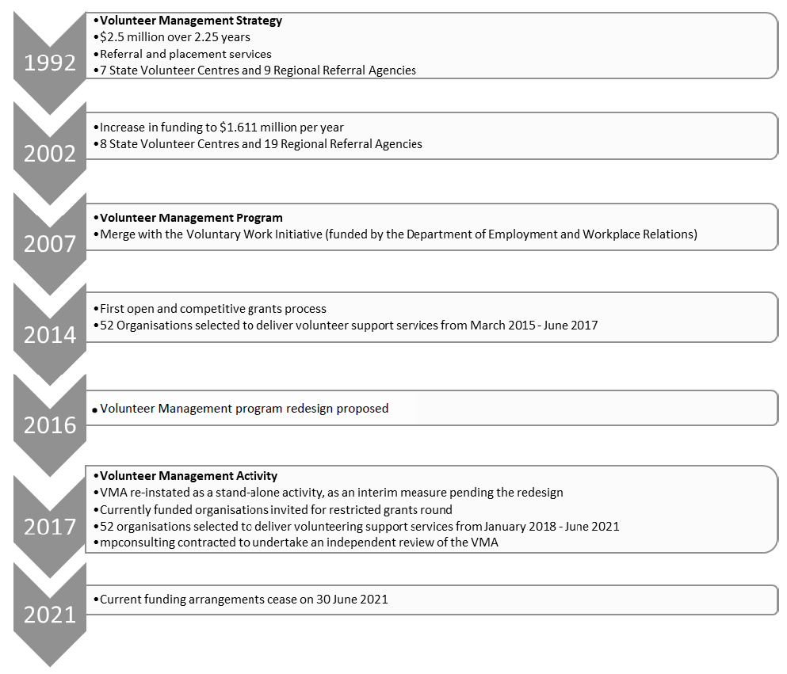

7. Appendix B: Australian Government volunteering initiatives
Volunteering and volunteer management is a whole-of-community and a whole-of-government issue. There are a number of volunteering programs and initiatives that occur at all levels of government, including the selection below.
Please note this is not an exhaustive list.

The Volunteer Management Activity (Department of Social Services)
The Volunteer Management Activity (VMA) aims to encourage, support and increase participation in volunteering through the delivery of Volunteer Support Services (VSS) and one-off innovation and collaboration projects.

Australian Volunteers Program (Department of Foreign Affairs and Trade)
The Australian Volunteers Program provides opportunities for skilled Australians to contribute to the Australian Government's aid program.
In 2018–19, the Australian Volunteers Program:
- supported more than 1,100 volunteers in 26 countries
- placed at least 97% of volunteers in the Indo-Pacific region with 40% of assignments in the Pacific
- created space to innovate and pilot new approaches to volunteering through the Innovation Fund and strategic partnerships
- empowered volunteers to tell their stories through a range of digital platforms, encouraging a broader group of Australians to volunteer and to raise awareness of the program.

Volunteer Search Dog Framework (Department of Home Affairs)
Emergency Management Australia has developed a strategic framework to recognise and coordinate volunteer search dogs in emergency response. It helps emergency service organisations understand the work of volunteer search dog associations and how they can assist during emergencies. It also provides guidance on how these two sectors can cooperate and collaborate during disaster response.

8. Appendix C: State and Territory government volunteering initiatives
The table below provides a summary of state and territory government initiatives and programs relating to volunteering, as well as examples of local government initiatives.
Please note this is not an exhaustive list and not all initiatives are funded.
State, territory, and local government volunteering initiatives
Jurisdiction | Volunteering Initiative
NSW | Department of Family and Community Services – NSW Volunteering Strategy (2016-2020)  *The NSW Government is currently open for comments on the new Volunteering Strategy post-2020.
Willoughby City Council | Volunteer Strategy (2016-2021)
Berrigan Shire Council | Volunteer Strategy (2012-2016)
VIC | Department of Health and Human Services – Volunteer Strategy (Currently in development)
Maribyrnong City Council | Volunteer Strategy (2018-2021)
Brimbank City Council | Brimbank Volunteer Strategy 2018-2022
Yarra City Council | Volunteer Strategy (2019-2023)
QLD | Queensland Fire and Emergency Services – Volunteerism Strategy (since 2018)
Sunshine Coast | Volunteer Sector Action Plan (2016-2018)
Toowoomba Regional Council | Volunteer Portal
Cairns Shire Council | Cultural Services Volunteer Program
WA | Department of Local Government and Communities – WA Volunteering Strategy (since 2018)
City of Stirling | Strategic Community Plan (2016-2026)  See theme 3: Active Participation and Volunteering
City of Armadale | Volunteer Strategy (2010-2013)
SA | Department of Human Services – Volunteering Strategy for SA (2014-2020)
City of Tea Tree Gully | Volunteer Strategy (2014-2018)
Renmark Paringa Council | Volunteer Strategy 2019
TAS | Nil.
Devonport City Council | Volunteer Strategy (2015-2019)
ACT | Community Services – Volunteering Statement and Action Plan (2018-2021)
NT | NT Government are currently developing a Volunteering Position Statement

Volunteering Australia (2017) ‘The Value of Volunteering Support Services’.
Giving Australia (2017) ‘Individual giving and volunteering report’, Commonwealth of Australia (Department of Social Services)
2018-19 Data Exchange data extracted on 28 November 2019

