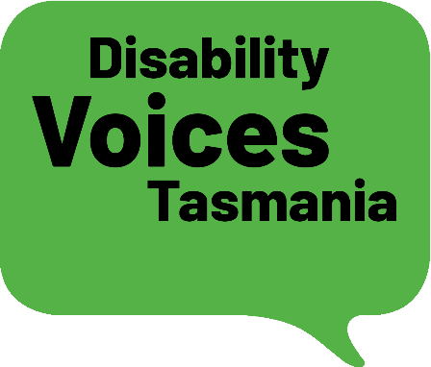

National Disability Strategy
Department of Social Services
GPO Box 9820
ACT 2601

27 October 2020

Thank you for the opportunity to make a submission on the consultation paper on a new National Disability Strategy (NDS).

Disability Voices Tasmania is a new organisation working to develop an across disability voice on issues of concern to Tasmanians’ with disability.

The purpose of Disability Voices Tasmania is to:

- Strengthen and promote the individual and collective voices of people with disability.
- Work together to ensure all people with disabilities can participate in and contribute to our community as equal and active citizens.
- Be an inclusive, diverse, transparent and democratic organisation led by and for people with disability.
Disability Voices Tasmania makes the following submissions:

- The vision, principles and outcome areas are still relevant and should remain unchanged.

- The new NDS should commit to establishing an Office of National Disability Strategy to provide the mechanism to work across all governments and sectors to develop, monitor and report annually on measurable Targeted Action Plans. The proposed Office should be placed where it can deliver leadership across all portfolios at all levels of government. Ideally, it would be empowered by and report to the Disability Reform Council or a body with similar remit and membership. If its scope is to be limited to the Commonwealth only, it should sit in a location which is inherently whole - of - government in scope, such as the Department of Prime Minister and Cabinet. In this regard, the proposed Office of National Disability Strategy might take the Office for Women as a model.

- The new NDS should commit to funding independent disability advocacy organisations to provide alternative reports on NDS compliance and call those responsible to account when they fail to act on their commitments.

- The new NDS should set out a timetable for the adoption of accessible housing requirements in all new housing and make an immediate commitment to apply Gold level Livable Housing Guideline requirements in all publicly funded or supporting housing.

- The new NDS should establish a commitment from all levels of government that all procurement contracts include accessibility requirements.

- The new NDS should establish a commitment from all levels of government that any public money spent on events or approvals for events such as festivals or cultural events require the organisers to develop and implement an accessibility statement.

- The new NDS should establish a timetable for the adoption of an Australian Charter of Human Rights.

- The new NDS should establish a timetable to develop and adopt a mandatory ‘disability lens’ to be applied to all levels of government policies, procedures, programs and legislative change. A disability lens could include a checklist of actions to be taken to ensure the actions of any government assess the impact of any policies, procedures, programs and legislative change on people with disability.

- The new NDS should commit to establishing an accessibility standards development and monitoring mechanism similar to that established by the Accessible Canada Act https://laws-lois.justice.gc.ca/eng/acts/A-0.6/

Accessible Canada Act
The Act outlines how to identify and remove accessibility barriers and prevent new barriers, in areas subject to federal jurisdiction, including in:
    - built environments (buildings and public spaces)
    - employment (job opportunities and employment policies and practices)
    - information and communication technologies (digital content and technologies used to access it)
    - procurement of goods and services
    - delivering programs and services; and
    - transportation (by air as well as by rail, ferry and bus carriers that operate across a provincial or international border)

Canadian Accessibility Standards Development Organisation
The Canadian Accessibility Standards Development Organisation will be responsible for developing the new accessibility standards to be integrated into federal regulations. A board of directors will lead the organisation, the majority of whom will be people with disability.

Within this organisation, technical committees will be formed to help develop accessibility standards. These committees will include accessibility experts, persons with disabilities, and representatives from organizations that would be required to meet the new standards.

Chief Accessibility Officer
The Chief Accessibility Officer will advise the Minister presiding over the ACA and oversee the implementation of the act across all organisations and sectors to which the act applies.

Accessibility Commissioner
The Accessibility Commissioner will join the Canadian Human Rights Commission, a commission which is in place to ensure the protection of human rights for Canadians, including Canadians with disabilities.

The Accessibility Commissioner will be supported by an accessibility unit which will help to perform compliance measures under the ACA. Compliance activities will include:
    - Inspections
    - Audits
    - Compliance orders
    - Notices of violation
    - Monetary penalties

- The new NDS should clarify the focus for the transferred NDIA ILC funding program and allow for ongoing core funding of across disability bodies in each state and territory responsible for engaging with governments on areas of common interest.

- Any focus on public awareness campaigns should be based on a rigorous assessment of the effectiveness of previous campaigns and learn from the study undertaken by the Council of Europe in its publication Awareness raising on the rights of persons with disabilities https://rm.coe.int/final-study-awareness-raising/168072b421
‘The best way to raise awareness and avoid discrimination is for persons with disabilities to be fully included as part of mainstream society, by living in the community, following class in mainstream schools and being employed in mainstream jobs. This will educate society to recognise persons with disabilities as full members and partners.
Yours sincerely

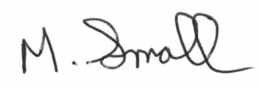

Michael Small
Convenor

