National Memorial for Victims and Survivors of Institutional Child Sexual Abuse

#### Information Paper

**Content Warning:**

**This information paper and associated survey are about institutional child sexual abuse. The documents may contain themes, information and questions that people, particularly those with lived experience of child sexual abuse, may find confronting and distressing. If you need support at any time please contact:**

* In an emergency call Triple Zero (000)
* [Lifeline](https://www.lifeline.org.au/) – visit [www.lifeline.org.au/](http://www.lifeline.org.au/) or call 13 11 14
* [Beyond Blue](https://www.beyondblue.org.au/) – visit [www.beyondblue.org.au/](http://www.beyondblue.org.au/) or call 1300 224 636
* [Mensline](https://mensline.org.au/) – visit <https://mensline.org.au/> or call 1300 789 978
* [Suicide Call Back Service](https://www.suicidecallbackservice.org.au/) – visit [www.suicidecallbackservice.org.au/](http://www.suicidecallbackservice.org.au/) or call 1300 659 467
* [1800 Respect](https://www.1800respect.org.au/) – visit [www.1800respect.org.au/](http://www.1800respect.org.au/) or call 1800 737 732

# If you need support from a Redress or Find and Connect service provider, you can reach them via the following links:

* [Redress](https://www.nationalredress.gov.au/) – [www.nationalredress.gov.au/](http://www.nationalredress.gov.au/)
* [Find and Connect](https://www.findandconnect.gov.au/contact/) - [www.findandconnect.gov.au/contact/](http://www.findandconnect.gov.au/contact/)

**Acknowledgements**

The Department of Social Services acknowledges the significant efforts of all those, including National Memorial Advisory Group members, and state, territory and Commonwealth officials, who have contributed to the development of this information paper and survey to inform the design of the National Memorial for Victims and Survivors of Institutional Child Sexual Abuse.

Contents

If you need support from a Redress or Find and Connect service provider, you can reach them via the following links: 2

Part One: Introduction 4

Opening statement 4

Background to the National Memorial 5

The Royal Commission into Institutional Responses to Child Sexual Abuse 5

The National Apology to Victims and Survivors of Child Sexual Abuse 5

National Apology Reference Group 6

Establishing the National Memorial 6

Your opportunity to contribute to the National Memorial 7

Part Two: Designing the National Memorial 8

Intent 8

Site 8

Features 9

Functional elements 9

Key attributes 9

Educative element 9

Part Three: Australian and International Memorials 10

Australian Examples 10

The Loud Fence Movement (2016) 10

Emergency Services Memorial, Canberra (NCA July 2004) 11

Reconciliation Place, Canberra (NCA 2002) 12

National Workers Memorial, Canberra (NCA April 2019) 13

International Example 14

Minneapolis Survivors of Sexual Violence Memorial, USA (2020) 14

Part Four: Next Steps 15

Timeframes 15

Further information 15

Link to the Survey 15

Appendix A: Glossary of Terms 16

# Part One: Introduction

## Opening statement

‘Memorials can provide symbolic reparation[1] and public recognition to victims and survivors in ways that can contribute to healing. Memorials honour those who have suffered and provide opportunities to remember the past and think about the future. They provide a specific place for families and wider society to reflect on the trauma of survivors and mourn the victims lost.

They may also serve to educate future generations about what occurred in society’s history and provide a space for public awareness and remembrance. We heard in private sessions that some survivors felt that remembering was one way to help prevent child sexual abuse and protect children in the future.

To that end, we recommend that the Australian government fund a national memorial in consultation with victims and survivors of child sexual abuse in institutional contexts.’

Royal Commission into Institutional Responses to Child Sexual Abuse, Volume 17, page 65.

In Australian society, every memorial is unique and can serve many functions. They can be places to visit, grieve and remember. Their physical presence keeps past events alive in the collective memory, and gives future generations opportunities to acknowledge, understand, and learn from past wrongs.

As recommended by the *Royal Commission into Institutional Responses to Child Sexual Abuse* (Royal Commission), the Australian Government is committed to establishing a National Memorial for Victims and Survivors of Institutional Child Sexual Abuse (National Memorial). In responding to the Royal Commission’s recommendations, the Government is committed to remembering the mistakes of the past to prevent child sexual abuse in all settings in the future.

People with lived experience of institutional and other forms of child sexual abuse, their families, and advocates are key stakeholders in the design and implementation of the National Memorial. Other stakeholders including representative organisations, service providers, and memorial design/construction industry experts are also welcome to contribute to shaping the form and function of the National Memorial.

This Information Paper supports the National Online Survey (the survey), which can be accessed via [www.engage.dss.gov.au](http://www.engage.dss.gov.au).

## Background to the National Memorial

### The Royal Commission into Institutional Responses to Child Sexual Abuse

Established in 2012, the Royal Commission inquired into institutional responses to allegations and incidents of child sexual abuse. During its five-year inquiry, the Royal Commission conducted public hearings, held private sessions and delivered a policy and research program. More than 16,000 people contacted the Royal Commission, which heard over 8,000 personal stories in private sessions. The Royal Commission’s Final Report, handed down in December 2017, contained 409 recommendations. Recommendation 17.6 called for the establishment of a national memorial.

The Royal Commission recommended that:

**Recommendation 17.6**

A national memorial should be commissioned by the Australian Government for victims and survivors of child sexual abuse in institutional contexts. Victims and survivors should be consulted on the memorial design and it should be located in Canberra.

### The National Apology to Victims and Survivors of Child Sexual Abuse

In delivering the National Apology to Victims and Survivors of Institutional Child Sexual Abuse on 22 October 2018, the Prime Minister, the Hon Scott Morrison MP, committed to establishing:

‘a place of truth and commemoration, to raise awareness and understanding of the impacts of child sexual abuse.’

He emphasised that:

‘We will work with survivor groups to ensure your [experiences] are recorded, that your truth is told, that our nation does not turn from our shame and that our nation will never forget the untold horrors you experienced.

Through this, we will endeavour to bring some healing to our nation and learn from our past horrors.’

The Prime Minister’s speech honoured the courage and strength of those with lived experience of institutional child sexual abuse, and apologised for the abuse endured by children over many generations. The National Apology was an important step following the Royal Commission to raise community awareness about the lifelong impact of child sexual abuse and to help protect children now and in the future.

### National Apology Reference Group

In the lead up to the National Apology, a National Apology Reference Group (Reference Group) was established. The Reference Group conducted 58 consultation sessions across all Australian states and territories, including some regional areas, and received more than 360 online responses. The key focus of this work was to provide advice to the Government to ensure the preparation and delivery of the National Apology reflected survivor’s experiences and wishes for the occasion. The Reference Group advised on a range of recommendations, including the National Memorial.

Although there was no clear consensus reached on the memorial design, key findings from the Reference Group consultations included general support for:

* a national memorial in Canberra and some support for memorials in each state and territory
* an enduring memorial, to reflect the life-long journey of survivors, such as incorporating gardens or some form of moving sculpture
* an educative tool to raise awareness of the issues and impacts of child sexual abuse.

## Establishing the National Memorial

The steps to establish the National Memorial will broadly include:

* Consultation, particularly with people with lived experience of institutional and other forms of child sexual abuse, on the intent and key attributes of the National Memorial.
* A national design competition open to relevant professionals to submit proposals that address the intent of the National Memorial.
* Judging of the design submissions and selection of the preferred design by a mixed panel including people with lived experience and other experts.
* Construction of the National Memorial.
* Unveiling of the National Memorial at a formal dedication event in 2022.

The Department of Social Services (the department) has partnered with the National Capital Authority (NCA) and established a National Memorial Advisory Group (Advisory Group) to advise on the establishment of the National Memorial in Canberra.

The NCA is a Commonwealth statutory authority that oversees the design and construction of all national memorials in Canberra.

The Advisory Group, appointed by the Minister for Families and Social Services, Senator the Hon Anne Ruston in October 2020, consists of the following members:

* Caroline Carroll OAM, Chair of The Alliance for Forgotten Australians
* Christine Foster AM, advocate for people impacted by child sexual abuse
* Craig Hughes-Cashmore, Chief Executive Officer of Survivors and Mates Support Network (SAMSN)
* Robert House, President of Care Leavers Australasia Network (CLAN)
* Rob Ryan, Chair of the Forde Foundation
* Richard Weston, Chief Executive Officer of the Secretariat of National Aboriginal and Islander Child Care (SNAICC).

The role of the Advisory Group is to represent people with lived experience of institutional child sexual abuse, their families and advocates, to:

* develop and agree the purpose and themes (memorial intent) of the National Memorial
* endorse a preferred site for the National Memorial
* provide representation as members of the selection panel for the national design competition
* endorse the final National Memorial design
* oversee key stages of the National Memorial’s development to ensure the design concept is consistent with the original intent, and
* advise on the National Memorial dedication ceremony and invitees.

Final key decisions, such as the site, design brief, and design selection of the National Memorial will be approved by the Canberra National Memorials Committee (CNMC) in accordance with the *National Memorials Ordinance 1928*. Membership of the CNMC comprises the leaders of the Government and Opposition in both houses of Parliament, the Territories Minister, and Secretary with responsibility for Territories (or their delegates).

## Your opportunity to contribute to the National Memorial

The department is seeking feedback from people with lived experience of institutional and other forms of child sexual abuse, their families and advocates, as well as other stakeholders to inform the design of the National Memorial.

The online survey will be available from **9:00am on Monday 2 November 2020** and will close at **11:59pm AEDT on Monday 30 November 2020**.

To find out more visit [www.engage.dss.gov.au](http://www.engage.dss.gov.au/) or you can contact the department at [RCMemorial@dss.gov.au](mailto:RCMemorial@dss.gov.au)

Definitions for a number of key words used in this paper and the survey are in the glossary on page 16.

**Have your say - please participate in the survey**[www.engage.dss.gov.au](http://www.engage.dss.gov.au/)

# Part Two: Designing the National Memorial

A broad range of people have been affected by institutional child sexual abuse including Stolen Generations and other Aboriginal and Torres Strait Islander people, Forgotten Australians, Care Leavers and Former Child Migrants, culturally and linguistically diverse people, people of diverse sex, gender and sexuality, people with disability, and older Australians. The National Memorial is required to hold meaning for all groups and should be sensitive to cultural inclusiveness.

This consultation is intended to canvass the views of people with lived experience, their families and advocates, as well as other stakeholders on a number of core themes that will inform the design, site selection and features of the National Memorial.

## Intent

The development of the National Memorial’s intent[2] is critically important to the success of the design competition. It will guide designers in developing their designs for the National Memorial to ensure it is a place that resonates with people with lived experience and the general public, and can educate future generations.

The survey will ask you about the values the National Memorial should reflect and the feelings it should convey.

## 

## Site

The National Memorial will be located in Canberra. The site will be selected from available options on National Capital Land, which is managed by the NCA.

A decision on the preferred site for the National Memorial will be informed by the Advisory Group’s consideration of available site options and responses to this survey. The preferred site must be approved by the CNMC.

**Please note**: the department and NCA is aware that religious institutions should not be visible from the National Memorial, and this will be an important consideration when selecting a suitable site.

The survey will ask you about site considerations such as accessibility and privacy.

## 

## Features

The survey will ask you about the functional elements and key attributes of the National Memorial.

### Functional elements

Functional elements are practical and useful features such as paving, ramps, seating, shelter, weather protection, walkways, paths, walls and fences.

These features will influence how the National Memorial is accessed and used by visitors, including whether the memorial could be a place where events can be held.

### Key attributes

Key attributes are used to communicate the intent and may evoke particular feelings or provide important symbolism. The Reference Group heard that some people with lived experience suggested the memorial should incorporate an evolving element, for example, some form of kinetic/moving sculpture. It was noted this could reflect the life-long journey of survivors.

Other design elements that could be considered include:

* + Plaques and messages
  + Interactive elements such as a place for visitors to tie a ribbon, leave a tribute or interact with features of the memorial such as lighting or sounds.
  + Natural/landscape elements
  + A three-dimensional sculpture or artwork.

**Please note**: a water feature will be out of scope due to sustainability regarding long-term maintenance and environmental factors.

### Educative element

The Reference Group heard from people with lived experience that there should be an educative element[3] to raise awareness of the issues and impacts of institutional child sexual abuse.

The survey will ask you about what educative elements could be incorporated into the design of the National Memorial or included on an associated website.

# Part Three: Australian and International Memorials

The building of memorials is a way of commemorating loss and trauma, to acknowledge the experiences people have had and to raise awareness and educate the public for future generations. Memorials can ensure an issue forms part of our public memory and can provide symbolic reparation.

In this section are some examples of Australian and international memorials of significance. This is not an exhaustive list and intends to provide some information about similar memorials that may be useful when responding to this survey.

## Australian Examples

### The Loud Fence Movement (2016)

The Loud Fence Movement (the Movement), which began in Ballarat and spread worldwide, encourages individuals to tie brightly coloured ribbons on the fences of religious buildings and institutions to show support for people with lived experience of institutional child sexual abuse. The Movement started from hearing the experiences of people who gave evidence during the Royal Commission.



More information about the Movement is available online.

### Emergency Services Memorial, Canberra (NCA July 2004)

Opened in July 2004, the Emergency Services Memorial is a place of celebration, reflection and contemplation. It provides a national focus for organised special events to commemorate emergencies to which emergency services have responded. The memorial is designed to invite still moments of engagement and hold the visitor in contemplation and reflection.

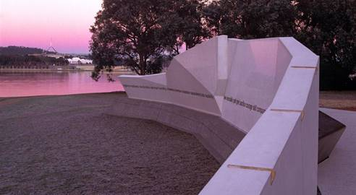

For more information, please visit the NCA website at [www.nca.gov.au/attractions-and-memorials](http://www.nca.gov.au/attractions-and-memorials).

### Reconciliation Place, Canberra (NCA 2002)

Opened in 2002, Reconciliation Place is a symbol of the Government’s ongoing commitment to the reconciliation process. Judy Watson’s *fire and water* (pictured below) is one of 17 artworks that comprises Reconciliation Place, located in the Parliamentary Zone in Canberra. The artwork represents a place to gather, shelter, listen, and share. The curved vertical poles bend ‘towards each other in a gesture of Reconciliation, like two hands cupping the distance between them.’

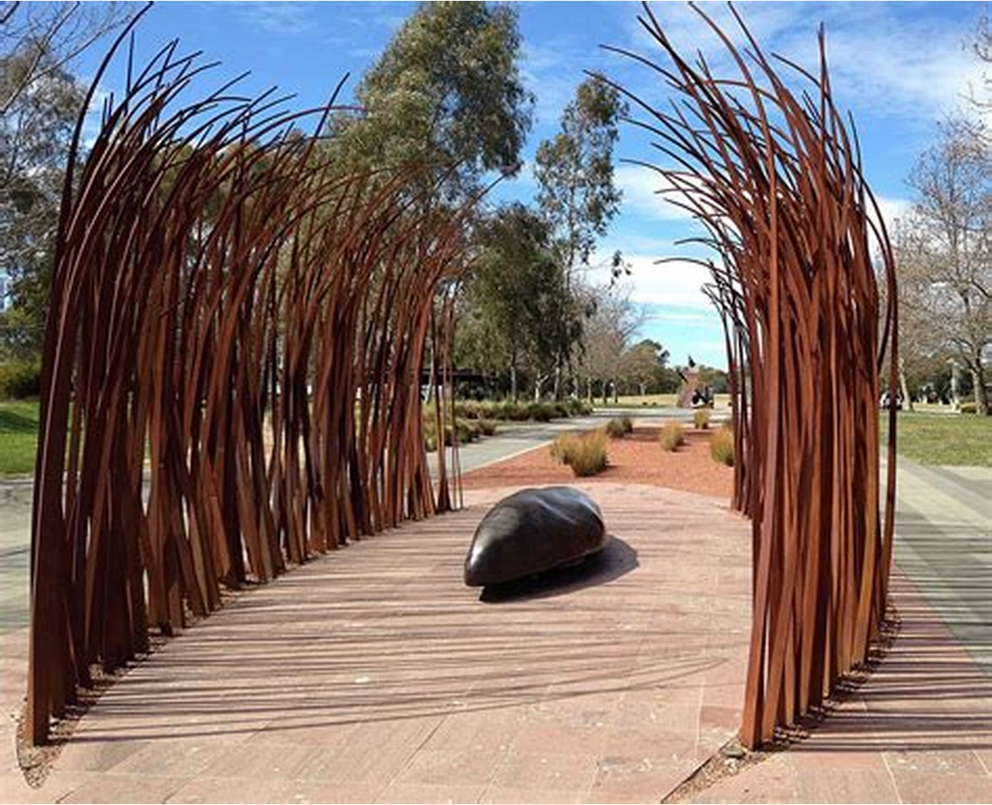

*fire and water*, Judy Watson

For more information, please visit the NCA website at [www.nca.gov.au/attractions-and-memorials](http://www.nca.gov.au/attractions-and-memorials).

### National Workers Memorial, Canberra (NCA April 2019)

The National Workers Memorial serves as a reminder of the importance of work health and safety and the need for a determined and continued effort by all to prevent work-related accidents and disease. It is also a place to reflect on the evolving values, ideas and aspirations of the Australian community in relation to work health and safety. The Memorial provides a place for visitors to lay a tribute for a loved one, a location to pause and reflect within earshot of the National Carillon’s bells, as well as allowing a space for congregation, interaction and ceremony.

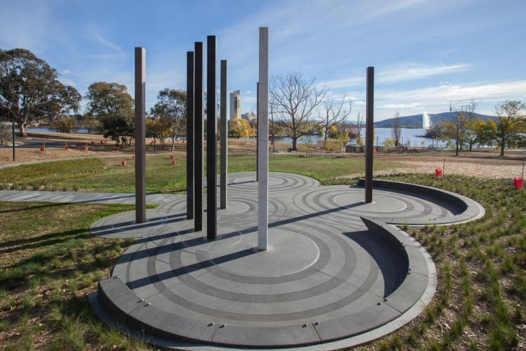

For more information, please visit the Memorial website at [www.nationalworkersmemorial.gov.au/](http://www.nationalworkersmemorial.gov.au/).

## International Example

### Minneapolis Survivors of Sexual Violence Memorial, USA (2020)

This Memorial is designed to honour the courage and strength of survivors, and bring awareness to the prevalence of sexual violence. It lets survivors know that the community believes them, supports them, and stands with them in solidarity.

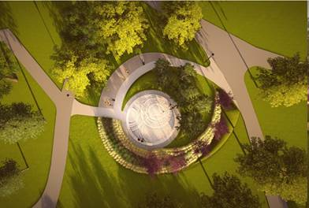

For more information, please visit the Memorial website at [www.survivorsmemorial.org/](http://www.survivorsmemorial.org/).

# Part Four: Next Steps

## Timeframes

Following this online consultation, the department will work with the NCA and the Advisory Group to progress development of the design brief for the National Memorial.

Responses will be accepted by no later than **11:59pm AEDT on Monday 30 November 2020** via DSS engage at [www.engage.dss.gov.au](http://www.engage.dss.gov.au/).

## Further information

To find out more visit [www.engage.dss.gov.au](http://www.engage.dss.gov.au/) or you can contact the department at [RCMemorial@dss.gov.au](mailto:RCMemorial@dss.gov.au).

## Link to the Survey

**Have your say - please participate in the survey**[www.engage.dss.gov.au](http://www.engage.dss.gov.au/)

# Appendix A: Glossary of Terms

| Acronyms/Abbreviations | Definition |
| --- | --- |
| CNMC | Canberra National Memorials Committee |
| department | Department of Social Services |
| Reference Group | National Apology Reference Group |
| NCA | National Capital Authority |
| Advisory Group | National Memorial Advisory Group |

| Word/term | Definition |
| --- | --- |
| Educative element | A feature that provides people with information about an issue. |
| Institutional child sexual abuse | Child sexual abuse specifically refers to the abuse of a person under the age of 18.This includes adults who were abused as children.  Institutional child sexual abuse is a form of child sexual abuse that occurs in the context of an institution such as a school, church, club, orphanage or children’s care home. |
| Memorial | A place established to collectively or individually recognise and remember a unique event, cause, and/or person/s, typically holding cultural significance. |
| National Memorial intent | A statement or set of principles that outlines the purpose of the National Memorial and its national significance. |
| Symbolic reparation | Refers to measures that facilitate acknowledgment, remembrance and commemoration of the pain of past abuses, which can assist people with lived experience in the healing process. |

1. Symbolic reparation refers to measures that facilitate acknowledgment, remembrance and commemoration of the pain of past abuses, which can assist people with lived experience in the healing process.
2. National Memorial intent refers to a statement or set of principles that outlines the purpose of the National Memorial and its national significance.
3. An educative element is a feature that provides people with information about an issue.