National DisabilityNational Disability Employment Stratey consultation paper april 2021 National Disability Employment Stratey consultation paper april 2021 Employment Stratey consultation paper april 2021 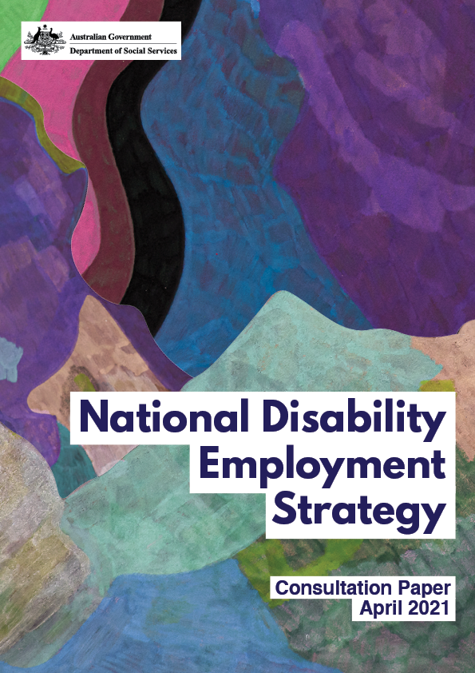



**Artist: Robin Warren**

Robin Warren (b 1971, London) has developed his artistic practice for over 20 years and continues to explore brightly coloured and organically shaped abstract imagery. Warren’s works in Copic marker, oil pastel and texta are reminiscent of cellular organisms in bloom that often radiates from a central focal point. Warren often renders multiple layers of colour that create a dream-like state as they reverberate across the paper. Though soothing, his works can have a strangely unsettling visceral or viral quality that is enhanced by his use of unreal and unlikely colour combinations. His work has been exhibited widely and appears in private collections throughout Australia.

Contents

Introduction 2

How this paper has been developed 4

We want your feedback 4

Proposed Employment Strategy vision 6

Proposed Employment Strategy priority areas 6

Lifting employer engagement and capability 7

What we think could help 10

Building employment skills, experience and confidence of young people with disability 11

What we think could help 12

Improving systems and services for jobseekers and employers 13

What we think could help 15

Changing community attitudes 17

What we think could help 18

Appendix 1 - Key disability employment initiatives 19

Appendix 2 - Research List 21

Introduction

One in five Australians, around 4.4 million people, live with disability[1].

Since 2010, the National Disability Strategy (NDS) has provided a policy framework for disability reform and inclusive policy and program design across Australia.

Over the last two years, the Australian Government, through the Department of Social Services (DSS), has been working with states and territories to develop a new NDS for 2021-2031. More than 3,000 people with disability, their families, carers, friends, advocacy organisations, peak bodies and service providers have shared their views to help inform the new NDS.

Feedback has clearly shown employment and financial security continues to be an important issue for people with disability, and should be a priority for the 2021‑2031 NDS.

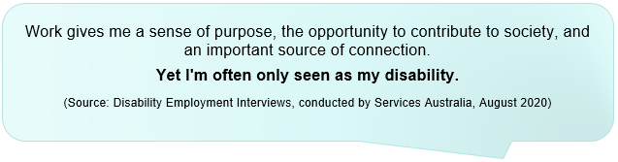

In response to this feedback, the Australian Government, through DSS, is developing a National Disability Employment Strategy (the Employment Strategy). The Employment Strategy will sit under the NDS and outline a pathway for increasing the number of people with disability in meaningful work. It will take a holistic approach to disability employment and consider the roles of all stakeholders, including:

* people with disability
* employers
* informal support networks like families and carers
* formal support networks like employment service providers, teachers and career advisors
* mainstream services, particularly recruitment providers
* disability service providers
* governments
* the broader community.

Increasing employment opportunities improves the financial security and personal wellbeing of people with disability, their families and carers. Employment enables people to plan for their future and exercise greater choice and control over their lives. It can also contribute to a sense of identity and bring social, health and wellbeing benefits to individuals, families and carers.

Inclusive and diverse organisations are able to recruit from a broader talent pool and have reported improved productivity, performance and innovation, as well as an improved organisational reputation[2]. Research also suggests employing people with disability can lead to increased revenue[3].

At a national level, there is a broad economic imperative to support people with disability to work, with greater workforce participation being a key driving factor for economic growth.

The development of the Employment Strategy underscores Australia’s commitment to the United Nations Convention on the Rights of Persons with Disabilities (UN CRPD), which recognises the right of persons with disability to work, on an equal basis with others[4].

Despite significant investment by successive governments (existing strategies, programs and initiatives are outlined at **Appendix 1 – Key disability employment initiatives)**, the unemployment rate for people with disability has remained stagnant over the last two decades.

In 2018, the unemployment rate for people with disability was 10.3 per cent, more than double the unemployment rate of people without disability (4.6 per cent) – and only around half of people with disability were in the labour force (53.4 per cent) compared to 84.1 per cent of people without disability[5].

The economic impacts caused by the COVID-19 pandemic has created a more competitive job market, which will likely be an additional challenge for people with disability as demonstrated through previous economic shocks such as the Global Financial Crisis. However, COVID-19 has also highlighted possibilities and opportunities for a more flexible approach to work (e.g. remote working, improved technology) which can minimise the impact of daily barriers for people with disability, such as a lack of suitable transport or accessible buildings[6].

The changing nature of work poses both challenges and opportunities for people with disability. As noted in the 2018 Senate Select Committee report on the Future of Work and Workers, the definition of an employee is changing and non‑standard employment is becoming more prevalent (e.g. gig economy, self‑employment, freelance etc.)[7].

The Employment Strategy will provide a framework to address these and other challenges and explore new and innovative approaches to improving employment outcomes for people with disability.

How this paper has been developed

This paper has been informed by:

* findings from the 2019 and 2020 NDS consultation processes
* discussion with the Disability Employment Advisory Committee (the Committee). The Committee includes people with disability, employers, service providers and peak bodies, and is focussed on ensuring the Employment Strategy addresses the barriers preventing people with disability from securing and retaining meaningful employment
* discussion with key stakeholders including disability peak bodies, disability service providers and mainstream recruitment agencies
* targeted interviews conducted with people with disability through Services Australia
* various research papers and reports.

We want your feedback

Your feedback will further inform the development of the Employment Strategy, which is expected to be released later in 2021. Feedback will help us ensure the Employment Strategy focuses on the issues that matter most, and is well designed to achieve positive outcomes.

You may wish to provide a general submission, or answer some or all of the questions below.

**Questions for consideration**

You may wish to consider the following questions when responding to the paper.

* Are there barriers or concerns for jobseekers with disability (jobseekers) not covered in this consultation paper?
* Are there barriers or concerns for employers not covered in this consultation paper?
* Do you have any feedback on the proposed vision or priority areas?
* Which actions or initiatives would best create positive change for people with disability and employers?
* How should we report against the Employment Strategy?
* How do we measure success of the Employment Strategy?

**How you can provide feedback**

* Visit the consultation website at [DSS Engage](http://www.engage.dss.gov.au).
* Email a written submission to [dep@dss.gov.au](mailto:dep@dss.gov.au)
* Send us a written submission at:

Disability Employment Policy

GPO Box 9820

Department of Social Services

Canberra ACT 2601

If you provide a submission online via DSS Engage, you will be asked to specify whether you would like your submission published on the DSS website.

If you send your submission via email or post, please specify whether you would like your submission to be published online.

The closing date for submissions is **17 May 2021.**

Proposed Employment Strategy vision

| **Vision** | **An inclusive Australian society where all people have access to meaningful work opportunities.** |
| --- | --- |

Proposed Employment Strategy priority areas

Our research and stakeholder feedback to date suggests the Employment Strategy should focus on four priority areas.

1. **Lifting employer engagement, capability and demand**: providing employers with the tools and abilities to confidently hire, support and develop more people with disability.
2. **Building employment skills, experience and confidence of young people with disability:** ensuring youngpeople with disability are supported to obtain meaningful work and careers of their choice.
3. **Improving systems and services for jobseekers and employers:** making it simpler for job seekers with disability and employers to navigate and utilise government services, and driving better performance from service providers.
4. **Changing community attitudes**: changing people’s perception and expectation about the capability of people with disability in the workplace.

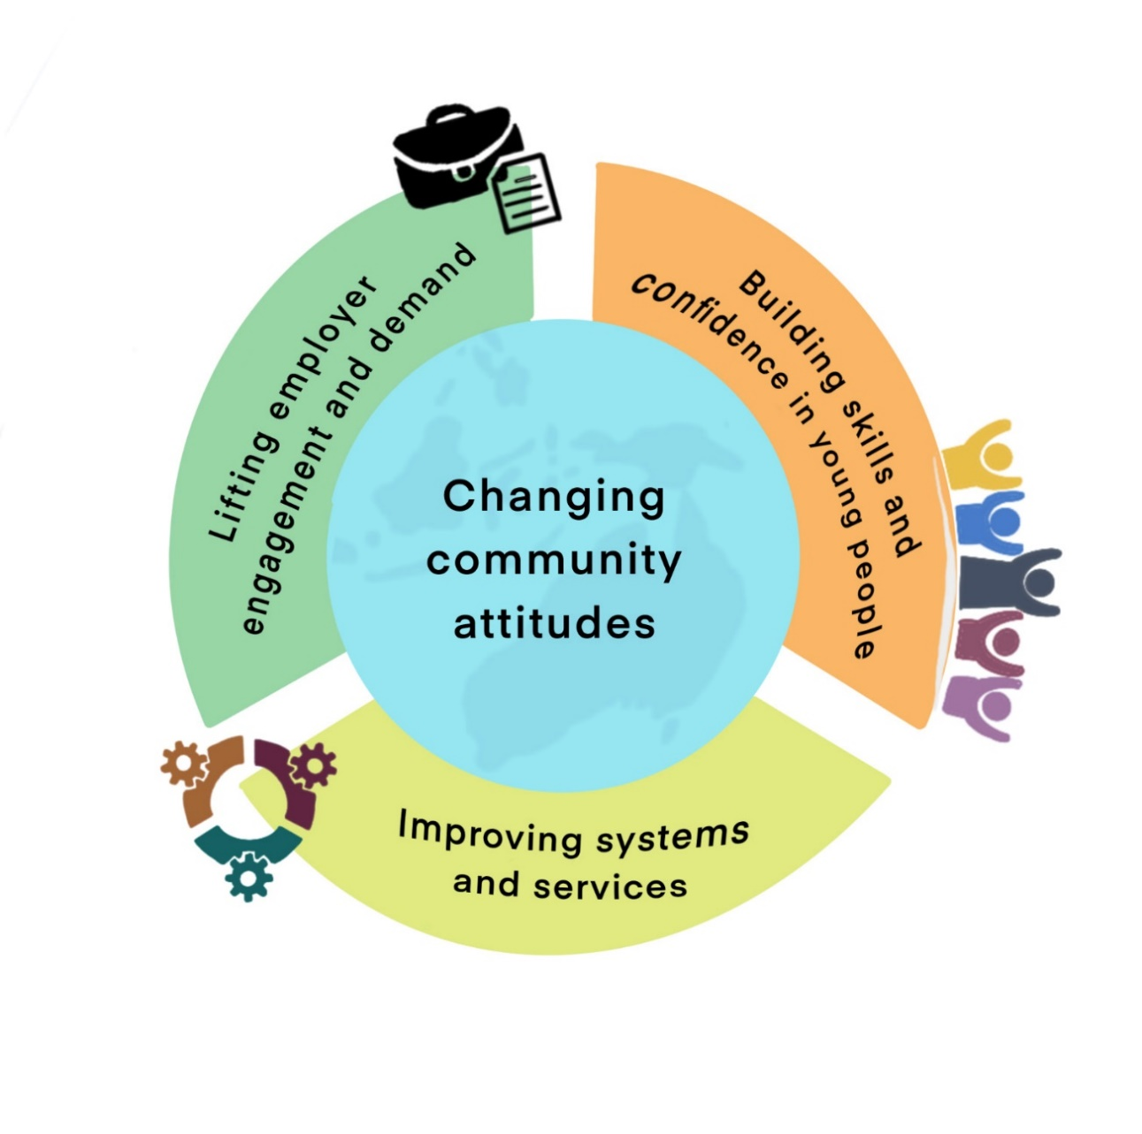

Lifting employer engagement and capability

People with disability can be a strong asset to any business. Research[8] has outlined a range of benefits for employing people with disability, including:

* increased revenue – organisations who champion disability employment demonstrate above-average financial performance
* improved productivity and lower staff turnover
* increased innovation – “*people with disability often demonstrate strengths such as problem-solving skills, agility, persistence, forethought and a willingness to experiment—all of which are essential for innovation”*
* a corporate image more reflective of the community– which can be beneficial both in terms of attracting potential future employees and projecting an inclusive, diverse culture to clients and customers
* improved workplace cohesion and harmony, understanding of, and respect for, individuality and difference
* access to a broader pool of talent, which can help to meet skills shortages across a wide-range of industries.

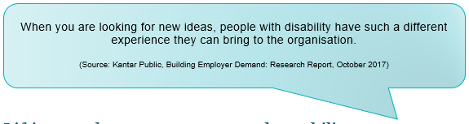

The Diversity Council of Australia reinforced these findings, noting “*effective management of workplace diversity is clearly linked to improvements in organisational performance, effectiveness, profitability and revenue generation”*[9].

Studies show that employees with disability[10]:

* have reduced rates of absenteeism
* are less likely to be represented in workplace health and safety incidents
* have often been reported to have a positive impact on other staff, as well as organisational culture, and
* represent the business well, and promote a positive public image.

Research also indicates the vast majority of people with disability require no additional support in the workplace[11].

**Employer confidence**

While the overwhelming majority of employers (93 per cent of large businesses and 89 per cent of medium sized businesses) indicate openness to hiring people with disability, only around a third of businesses show behavioural commitment to doing so[12].

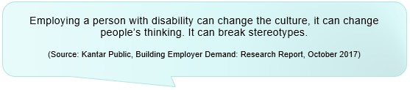

Research shows many employers lack the knowledge, confidence and experience to hire and support a person with disability. Only half of employers are confident in their businesses’ ability to support people with a disability. Further, more than 53 per cent believe their workplace culture is not supportive of people with disability[13].

This situation is intensified by a perceived lack of information and support, and, in some cases, a reluctance to have person‑focused conversations or ask questions for fear of seeming discriminatory or intrusive. More needs to be done to build disability confidence and awareness at all levels, including for management, team leaders, supervisors and peers.

Research conducted in 2018[14] noted small to medium businesses are often time poor and overloaded with expectations. They also often have limited resources and lack the formal HR processes many larger businesses may have. As such, any initiatives that are seen to add further administrative or supervisory functions are unlikely to attract interest.

Despite these concerns, the majority of small to medium employers surveyed (69 per cent) stated that employing someone with a disability delivered a positive employment outcome for their business, and more than half of those surveyed indicated they were open to employing a person with disability in the future[15].

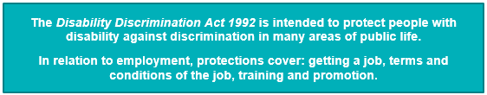

**Information and support**

A consistent theme throughout the research and stakeholder feedback was a perceived lack of information, advice and guidance about hiring, re-engaging or providing ongoing support for a person with a disability. Employers are not accessing the information and support they need to build their confidence and make their workplace accessible. Awareness of existing Government initiatives, including [JobAccess](https://www.jobaccess.gov.au/) and the [Employment Assistance Fund](https://www.jobaccess.gov.au/node/77746), is fairly low. More needs to be done to promote the range of programs and services available to employers.

Feedback indicated employers need simple and easily accessible advice, strategies and resources, developed by people with disability. Further, employers prefer accessing information from trusted sources they already access, including their peers and industry and peak bodies.

*Small to medium business*

The main reason small to medium business owners gave for not employing a person with disability was a lack of applications, with most recruitment activity occurring through word of mouth, social media or traditional recruitment channels.

Providing a single point of contact for employers to receive all of the information and supports required to design and administer recruitment processes, fill vacancies and provide ongoing workplace supports to people with disability could support small to medium business to employ more people with disability.

**Returning to work after a newly acquired disability**

Research and stakeholder engagement indicates returning to work can be a complex and lengthy journey for people who acquire a disability during their working lives. Complicating this process is the presence of multiple systems of support that create different pathways back to work depending on the person’s situation (e.g. worker’s compensation, private insurance, social security etc.).

Stakeholders identified that support providers (e.g. medical professionals) do not always recognise employment as an important part of a person’s rehabilitation. This can exacerbate the significant delays people with a newly acquired disability may experience in receiving appropriate return to work supports and data shows that the longer a person is off work, the less likely they are to return[16].

Employers have an important role in supporting a person with a newly acquired disability to return to work, regardless of how their disability was acquired. However, research and stakeholder feedback suggests that many do not have the policies or processes in place to effectively do so.

Stakeholder feedback also indicates that while employer capabilities and attitudes are critical to the success of a person’s return to work, people with a newly acquired disability know themselves best and must be empowered to control their own journey (e.g. flexible hours, responsibilities, location).

**Procurement**

Inclusive procurement policies and practices can be a powerful motivator to change behaviour and attitudes. Awarding contracts to suppliers that employ people with disability creates more work for those businesses, and also sends a strong message to stakeholders that companies employing people with disability can perform well and compete in the marketplace.

**Leadership buy-in**

Leadership buy-in is critical to creating an inclusive workplace culture. Research shows only 27 per cent of employers agree that leadership in their organisation has a strong voice about inclusion of people with different abilities[17].

Blue rectangle with the following quote - You can't be what you can't see.

Feedback from people with disability, the disability sector and employers suggests the level of confidence around disability inclusion within an organisation has the most impact when it is coming from the top-down. Such an approach sends a clear message that organisations value the contribution of people with disability, including in leadership and decision-making roles. Having more people with disability in leadership positions builds understanding and inclusion, as well as providing role models for others.

Further, Government needs to demonstrate leadership and be a role model in its own employment practices for disability employment in order to influence private sector organisations to replicate similar behaviour and practices. In December 2020, the Government released its [*Australian Public Service Disability Employment Strategy 2020-25*](https://www.apsc.gov.au/sites/default/files/apsc_-_disability_strategy.pdf), demonstrating its ongoing commitment to improving employment outcomes for people with disability.

What we think could help

* Use role models, mentoring, story-telling and case studies to build employer confidence and normalise employment of people with disability.
* Develop and promote information, tools and resources to:
  + build employer capability and confidence to hire people with disability
  + provide on-the-job support for employers and people with disability
  + support employers to assist people with a newly acquired disability to return to work
  + influence emerging sectors to establish inclusive business practices from the start
  + encourage inclusive procurement practices.

Building employment skills, experience and confidence of young people with disability

Research shows that delayed or unsuccessful transitions from school to work can lead to economic, social and personal disadvantage for young people (regardless of disability)[18]. Studies also indicate that young people are more likely to be successful post-school, if they receive support to develop their employment skills and aspirations early in life[19] [20].

A survey of young people with disability (aged 15 to 24) found that this cohort are generally positive about their future in employment, and over 90 per cent want to work. However, survey feedback also indicated the employment journey can be complex and noted there are still many opportunities for improvement[21].

**Early and inclusive career development**

Research and stakeholder feedback highlighted a number of key concerns around the provision of career development and transition to work activities in schools.

Broadly, there is a concern that appropriate career support is not provided early enough for young people with disability, if at all.

Transition to work activities, such as work experience, are important in developing skills and confidence, and helping young people set goals for the future. However, young people with disability are often excluded from participating on an equal basis as students without disability. There are a variety of reasons for this exclusion, including perceptions that it is too difficult or expensive, and a lack of appropriate supports while they are ‘on‑the‑job’.

Another concern raised by stakeholders is that young people with disability are not being prepared for the jobs that will exist in the coming years.

**Confident and informed support networks**

Young people with disability may receive support from a number of formal or informal support networks throughout their journey into work, including from their families and carers, school careers staff, and disability/employment support services.

Stakeholder feedback indicates there is a need for better education, as well as increased access to appropriate resources, tools and information, for these support networks. Educating support networks will counter low expectations of employment capabilities of people with disability and build knowledge of available employment options (e.g. apprenticeships, self-employment).

**Role models**

Similar to feedback across all the priority areas, a consistent message from stakeholders, including young people with disability, is that there is a need for more visible role models with disability, particularly within mainstream career resources (e.g. career expos, website and industry pamphlets), to help build their employment aspirations.

It is important that these role models are showcased across different industries and job types to demonstrate the variety of careers that a young person can have.

What we think could help

* Improve career development opportunities (e.g. tools to understand potential career interest areas, work experience, volunteering or job readiness programs) for young people with disability while they are at school.
* Find ways to challenge assumptions and change attitudes of support networks including parents, carers, teachers, career advisors, disability support workers and medical professionals.
  + This could include developing and promoting information, tools and resources to build the capacity and confidence of support networks to assist young people with disability on their employment journey.

Improving systems and services for jobseekers and employers

**Making the system easier to navigate**

Feedback indicates people with disability can struggle to navigate the disability employment and welfare system.

Key issues include:

* a lack of clear, easily accessible and culturally appropriate information
* a requirement to undertake multiple assessments, where they provide the same information
* lack of support to understand assessments, including what will happen next
* confusion about why they are being referred to an employment services program (such as the Disability Employment Services (DES) program) following an application for income support
* a lack of clarity and flexibility around the connection between the National Disability Insurance Scheme, DES and jobactive
* multiple, overlapping reporting requirements about changes in circumstances.

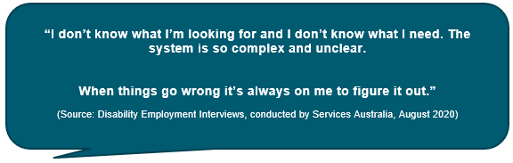

Employers also have concerns about the complexity of the system and can be hesitant to invest time navigating and utilising available supports and services.

This is a particular issue for small to medium size businesses, who often lack the formal HR resources and processes that larger businesses may have. Sixty‑four per cent of small business owners agreed that the time and complexities involved in applying for funding (i.e. for workplace modifications or wage subsidies) is a barrier to employing a person with disability[22].

Support networks such as families and carers, employment service providers, support workers, teachers, career advisors and medical/health professionals, would also benefit from a simpler system, where they can easily access information and resources to support people with disability on their employment journey.

Overall, the systems must be simplified to enable jobseekers, employers and support networks to confidently navigate and access supports and services.

**Driving better performance from disability employment service providers**

The disability employment support system must shift to focus more on jobseekers as individuals, taking into account their strengths, ability, rights and aspirations.

Feedback indicates the program design of the Government’s flagship disability employment program, DES, with its emphasis on employment outcomes, does not adequately support either jobseekers or employers.

Jobseekers report being put forward for jobs they are not suitable for or have no interest in, or being placed into education courses that have little bearing on their employment prospects. In addition, concerns have been raised about:

* assessment processes, such as Employment Services Assessments, which largely focus on barriers rather than strengths
* restrictive eligibility criteria and mutual obligation requirements, which can make it difficult for people to explore options like self‑employment, gig economy work or mainstream recruitment companies.

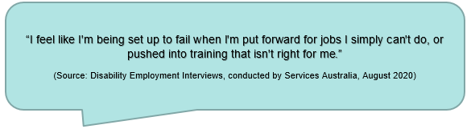Employers also have concerns with the current design of DES, noting it does not effectively match jobseekers to vacancies, involves significant administrative burden and does not encourage providers to build relationships with employers.

Some employers, who are engaged in the employment of people with disability, use intermediaries or develop their own programs and pathways rather than using government funded employment service providers.

More broadly, the current system does not always provide the holistic support people need in order to be job‑ready. It can be difficult for jobseekers to prioritise employment when also trying to meet basic needs such as housing, food and health, and/or dealing with issues of violence and abuse.

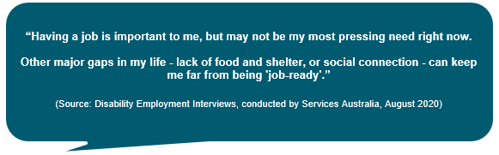

Some employment settings, such as Australian Disability Enterprises (ADEs), may provide a more holistic support system for a subset of people with disability.

The ADE model, generally referred to as supported employment, provides economic and social benefits to approximately 20,000 people with moderate to severe disability who face significant barriers to obtaining mainstream open employment.

Historically, funding for supported employment was provided directly to ADEs. The ADE program commenced transition to the National Disability Insurance Scheme (NDIS) in 2013 and the majority of supported employees are now paying providers for their on the job supports from their NDIS plan. Enabling NDIS participants to purchase supports in a variety of employment settings will expand options for both participants and service providers, including those who have transitioned from the ADE program. Employment settings could include:

* corporate
* government
* not for profit
* social enterprises (commercially viable businesses which also prioritise social good)
* self-employment.

Stakeholders have diverse and varying views about the nature of work and employment conditions in ADEs. Some consider ADEs provide meaningful and valuable employment opportunities that enable people with disability to contribute and connect to their local community. Other stakeholders voice concerns with ADEs, and suggest all people with disability should be supported to work in a setting of their choice, with equitable employment conditions.

In order to be successful, all disability employment supports and services will need to:

* become more person-centred
* recognise the multiple challenges faced by people with disability
* build meaningful relationships with employers
* proactively focus on emerging industries and employment trends.

What we think could help

* Reconsider the design of Government disability employment programs to ensure they meet the needs of both jobseekers and employers.
  + Provide opportunities for people to access mainstream services to support their employment journey (e.g. mainstream recruitment companies, volunteering and self-employment)
* Reform and streamline existing services and supports to make them easier to use and more person‑centred. For example, improve linkages between key systems/agencies to reduce duplication and ensure a person only needs to tell their story once.
* Develop more streamlined sources of information about disability employment and promote through well known, trusted sources.
* Explore opportunities within the ADE model e.g. providing work experiences and training as part of a pathway to other employment settings.

Changing community attitudes

Many people with disability face barriers as a result of discrimination, prejudice and negative stereotypes. Some people with disability face additional barriers caused by discrimination based on gender, gender identity, age, sexuality, race, cultural background and/or socio‑economic status. These factors can further impact a person’s ability to participate in society, including employment.

Changing community attitudes is a pre-requisite for overcoming the barriers to participation faced by people with disability in their daily lives. None more so than in the context of finding and retaining meaningful employment, with a recent study[23] showing that fewer than half of survey participants agreed that workplaces are accepting of people with disability.

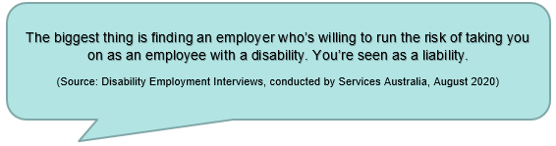

A reoccurring theme throughout the research and consultation is that discrimination, prejudice and negative stereotypes continue to present significant barriers for people with disability. Feedback indicates the greatest barriers faced are not related to communication or physical access, but rather to stigma, unconscious bias and lack of understanding of disability.

The Willing to Work report[24], published by the Australian Human Rights Commission in 2016, notes that:

*“Employment discrimination against people with disability is ongoing and systemic. At the recruitment stage, bias, inaccessibility and exclusion are recurring issues. People with disability face a conundrum regarding if, when and how to disclose their disability and can experience barriers in accessing necessary workplace adjustments and opportunities for career progression.*

*Discrimination is underpinned by negative assumptions and attitudes that are held by many employers and throughout the community about the productivity and capability of people with disability and perceptions that they present a higher work health and safety risk”.*

Research[25] conducted in 2017 suggests that this prejudice stems from a lack of familiarity with people with disability, noting that *“limited knowledge and understanding around disability has been found to perpetuate negative assumptions about, and attitudes towards, people with disability, reinforcing a perception that they are not as capable in the workforce”*.

On a more promising note, research conducted in 2018 indicates that once people have experience hiring a person with a health condition or disability, they become more open to recruiting people experiencing similar conditions in the future. This shows that “*actual experiences in hiring and supporting staff members with serious conditions and disability can help to break down the barriers of conscious or unconscious biases that so often accompany employer perspectives on health conditions and disability. It also shows on average that the experience is positive*” [26].

Working to reduce discrimination, prejudice and negative stereotypes will be critical in improving employment opportunities for people with disability, and in improving their lives more broadly.

What we think could help

* Change community attitudes to reduce discrimination, prejudice and negative stereotypes. Possible actions include:
  + a public communications campaign that challenges stereotypes and emphasises the value of diversity
  + encouraging mainstream media outlets to develop and air content that is produced by, and or showcasing, people with disability. These would not focus solely on those who are considered ‘exceptional’, but also people with disability enjoying an ‘ordinary life’
  + using “myth-busting” approaches to challenge existing views
  + building disability employment awareness training into relevant tertiary qualifications for professionals (e.g. career advisory staff, rehabilitation case managers).

Appendix 1 - Key disability employment initiatives

Improving employment outcomes for people with disability is a clear focus for the Australian Government and is reflected through investment in a range of strategies, programs and initiatives. There are also a range of initiatives being taken by state, territory and local governments, as well as by some industry groups and employers.

**Figure 1 – Key strategies**

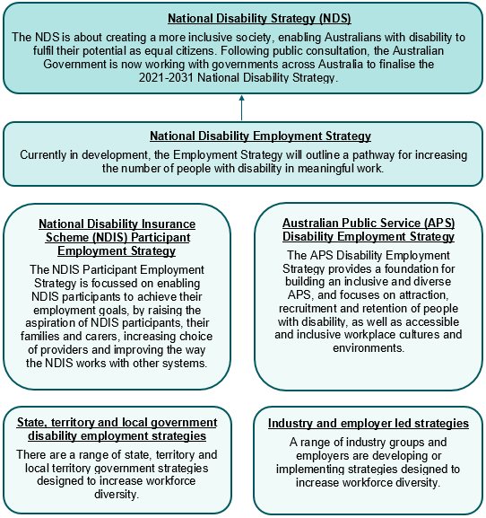

Figure 1 shows some of Australia’s key strategies and initiatives to improve workforce diversity. The Australian Government’s overarching disability policy is the [National Disability Strategy](https://www.dss.gov.au/our-responsibilities/disability-and-carers/publications-articles/policy-research/national-disability-strategy-2010-2020), and a new [2021-2031 National Disability Strategy](https://www.dss.gov.au/disability-and-carers/a-new-national-disability-strategy) (NDS) is currently being finalised. An important component of the new NDS is the National Disability Employment Strategy, which is under development. The Government has also developed the [National Disability Insurance Scheme (NDIS) Participant Employment Strategy](https://www.ndis.gov.au/about-us/strategies/participant-employment-strategy), which enables NDIS participants to achieve their employment goals, and the [Australian Public Service (APS) Disability Employment Strategy](https://www.apsc.gov.au/publication/australian-public-service-disability-employment-strategy-2020-25) 2020‑2025, which supports an inclusive and diverse APS. There are also state, territory and local government disability employment strategies, as well as industry and employer led strategies.

**Key Australian Government programs, supports and services**

The Australian Government funds programs and supports across a number of portfolios to help Australians, including those with a disability to gain employment. The below list is not exhaustive, but rather a selection of key programs, supports and services.

*Disability specific employment programs and services*

* [Disability Employment Services](https://www.dss.gov.au/our-responsibilities/disability-and-carers/programmes-services/disability-employment-services) - assists people with disability to prepare for, find and keep a job.
* [JobAccess](https://www.jobaccess.gov.au/) - the national hub for disability employment that includes a suite of supports including a website and contact centre, Employment Assistance Fund (EAF) and the National Disability Recruitment Coordinator.
* [NDIS Participant Plans](https://www.ndis.gov.au/) - provide reasonable and necessary supports for people with disability to participate in the community, including in employment.
* [Information, Linkages and Capacity Building: Economic and Community Participation Grants](https://www.dss.gov.au/disability-and-carers-programs-services-for-people-with-disability/economic-and-community-participation) - focusses on improving pathways to employment and increasing participation by people with disability.
* [Individual Placement and Support Program](https://www.dss.gov.au/mental-health-programs-services/individual-placement-support-program) - aims to improve the educational and employment outcomes of young people aged up to 25 with mental illness.

*Mainstream employment programs and services*

* [jobactive](https://jobactive.gov.au/) - connects jobseekers with employers to get more Australians into work.
* [Transition to Work](https://jobsearch.gov.au/transition-to-work) - provides intensive, pre-employment support to improve the job readiness of young people and help them into work or education.
* [Youth Jobs PaTH](https://www.employment.gov.au/youth-jobs-path) - supports young people to gain skills and work experience to get and keep a job (e.g. skills training, internships). This includes PaTH Internships, PaTH Industry Pilots and PaTH Employability Skills Training (the latter is not currently available to people with disability outside of jobactive).
* [New Enterprise Incentive Scheme](https://www.employment.gov.au/self-employment-new-business-assistance-neis) - helps jobseekers realise their self-employment aspirations (e.g. training, mentoring and income assistance).
* [National Work Experience Program](https://www.employment.gov.au/national-work-experience-programme) - offers work experience and employment opportunities for jobseekers by providing unpaid placements with businesses.
* [Community Development Program](https://www.niaa.gov.au/indigenous-affairs/employment/cdp) - supports jobseekers in remote Australia to build skills, address barriers and contribute to their communities through a range of flexible activities.

Appendix 2 - Research List

A wide range of research was considered in the development of this paper. Key reports are listed below:

Accenture, *Getting to equal: The Disability Inclusion Advantage*, 2018.

Australian Bureau of Statistics, *Disability, Ageing and Carers, Australia: 2018 Summary of Findings*, 24 October 2019.

Australian Bureau of Statistics, *Labour Force, Australia*, 17 December 2020.

Australian Human Rights Commission, *Willing to Work: National Inquiry into Employment Discrimination against Older Australians and Australians with Disability*, 2 May 2016.

Australian Institute of Health and Welfare, *People with disability in Australia 2020*, 2 October 2020.

Business Council of Australia, *Recognising Ability: Business and the Employment of People with Disability*, October 2015.

Centre of Research Excellence in Disability and Health, *Submission on Employment Issues for the Royal Commission into Violence, Abuse Neglect and Exploitation of People with Disability*, August 2020.

Children and Young People with Disability Australia, *Post School Transition: The Experiences of Students with Disability*, 2015.

Colmar Brunton, *Evaluation of JobAccess Service Report*, July 2019.

Comcare, *Return to Work: Information Sheet.*

Council of Small Business Organisations Australia, *Making it Easier for Small Business to Employ People with Disability*, 13 September 2018.

Darcy, S., Collins, J., & Stronach, M., *Australia’s Disability Entrepreneurial Ecosystem: Experiences of People with Disability with microenterprises, self-employment and Entrepreneurship*, University of Technology Sydney, March 2020.

Darcy, S., Taylor, T., Green, J., ‘*But I can do the job’: examining disability employment practice through human rights complaint cases*, Disability & Society, 31:9, p.1242-1274, December 2016.

Deloitte Access Economics, *The economic benefits of increasing employment for people with disability*, August 2011.

Department of Social Services, *National Disability Strategy: Position Paper,* July 2020.

Diversity Council Australia, *Business Case for Diversity and Inclusion.*

House of Representatives Standing Committee on Employment, Education and Training, Parliament of the Commonwealth of Australia, *Unique Individuals, Broad Skills: Inquiry into school to work transition*, May 2018.

Inclusion Australia, *Designing Evidence Based Transition-to-Work and Open Employment Support for People with Intellectual Disability*, 24 June 2015.

Kantar Public, *Building Employer Demand: Literature Review*, February 2017.

Kantar Public, *Building Employer Demand: Research Report*, October 2017.

Monash University, *Employee Awareness and Empowerment Research Report*, December 2019.

Monash University, *The Cross Sector Project: Mapping Australian Systems of Income Support for People with Health-Related Work Incapacity*, January 2018.

Murfitt, K, et al., *Employer engagement in disability employment: A missing link for small and medium organisations – a review of the literature*, Journal of Vocational Rehabilitation, 48:3, p 417-431, June 2018.

OECD, *Strengthening Public Employment Services*, April 2015.

Royal Commission into Violence, Abuse, Neglect and Exploitation of People with Disability, *Employment Issues Paper*, 12 May 2020.

Royal Commission into Violence, Abuse, Neglect and Exploitation of People with Disability, *Public Hearing Report – Public hearing 5: Experiences of people with disability during the ongoing COVID-19 pandemic*, November 2020.

Scherer, Jennifer, “Australians with disability say working from home should be possible after the pandemic.” *SBS News*, 18 August 2020.

Senate Select Committee on the Future of Work and Workers, Parliament of Australia, *Hope is not a strategy – our shared responsibility for the future of work and workers*, September 2018.

Skattebol, J., Hill, T., Griffiths, A., & Wong, M., *Unpacking Youth Unemployment: Final Report*, Social Policy Research Centre, University of New South Wales, September 2015.

St Guillaume, Louise, *Newstart, Poverty, Disability and the National Disability Insurance Scheme*, Whitlam Institute, Western Sydney University, 26 February 2020.

The Social Deck, *Right to Opportunity, Consultation report to help shape the next National Disability Strategy,* December 2019.

United Nations, *International Covenant on Economic, Social and Cultural Rights*, 1966.

United Nations, *Convention on the Rights of Persons with Disabilities (CRPD): Article 27*, 2008.

University of Melbourne, *Survey of Community Attitudes toward People with Disability*, 13 August 2018.

Victoria Government, *Every Opportunity: Victorian economic participation plan for people with disability 2018-2020*, 2018.

Whereto, *Employer Mobilisation Final Research Report*, 10 September 2018.

Whereto, *Employer Mobilisation Research: Report – Snapshot*, December 2018.

Year13, Disability & Career Advice Survey, Research Results & Findings, January 2021.

1. Australian Bureau of Statistics, *Disability, Ageing and Carers, Australia: Summary of Findings, 2018*,24 October 2019 <https://www.abs.gov.au/statistics/health/disability/disability-ageing-and-carers-australia-summary-findings/latest-release> [accessed 6 January 2021].
2. Australian Human Rights Commission, *Willing to Work: National Inquiry into Employment Discrimination against Older Australians and Australians with Disability*, 2 May 2016, p.13.
3. Accenture, *Getting to Equal: The Disability Inclusion Advantage*, 2018.
4. United Nations, *Convention on the Rights of Persons with Disabilities (CRPD): Article 27* <https://www.un.org/development/desa/disabilities/convention-on-the-rights-of-persons-with-disabilities/article-27-work-and-employment.html> [accessed 6 January 2021].
5. Australian Bureau of Statistics, *Disability, Ageing and Carers, Australia: Summary of Findings, 2018*,24 October 2019 <https://www.abs.gov.au/statistics/health/disability/disability-ageing-and-carers-australia-summary-findings/latest-release> [accessed 6 January 2021].
6. Scherer, Jennifer “Australians with disability say working from home should be possible after the pandemic.” *SBS News*, 18 August 2020 <https://www.sbs.com.au/news/australians-with-disability-say-working-from-home-should-be-possible-after-the-pandemic> [accessed 11 January 2021].
7. Senate Select Committee on the Future of Work and Workers, Parliament of Australia, *Hope is not a strategy – our shared responsibility for the future of work and workers*, September 2018.
8. Accenture, *Getting to equal: The Disability Inclusion Advantage*, 2018.
9. Diversity Council Australia, *Business Case for Diversity and Inclusion*, <https://www.dca.org.au/di-planning/getting-started-di/business-case-diversity-inclusion> [accessed 19 January 2021].
10. Kantar Public, *Building Employer Demand: Literature Review*, February 2017, p.6.
11. Australian Institute of Health and Welfare, *People with disability in Australia 2020*, 2 October 2020, <https://www.aihw.gov.au/reports/disability/people-with-disability-in-australia-2020-in-brief/contents/employment> [Accessed 21 January 2021].
12. Kantar Public, *Building Employer Demand: Research Report*, October 2017, p. 1 & 17.
13. Whereto, *Employer Mobilisation Research: Report – Snapshot*, December 2018, p.2.
14. Council of Small Business Organisations Australia, *Making it Easier for Small Business to Employ People with Disability*, 13 September 2018.
15. Ibid.
16. Comcare, *Return to Work: Information Sheet*, p.1 <https://www.comcare.gov.au/about/forms-publications/documents/publications/rehabilitation/return-to-work-information-sheet.pdf> [accessed 12 January 2021].
17. Whereto, *Employer Mobilisation Final Research Report*, 10 September 2018, p.47.
18. Skattebol, J, Hill, T, Griffiths, A & Wong, M, *Unpacking Youth Unemployment: Final Report*, Social Policy Research Centre, University of New South Wales, September 2015, p.8.
19. Ibid.
20. European Lifelong Guidance Policy Network (ELGPN), *The Evidence Base on Lifelong Guidance: A guide to Key Findings for Effective Policy and Practice*, ELGPN, 2014.
21. Year13 (2021) Disability and Career Advice Survey Report, available at: <https://www.dss.gov.au/disability-and-career-advice-survey-report>.
22. Council of Small Business Organisations Australia, *Making it Easier for Small Business to Employ People with Disability*, 13 September 2018, p.24.
23. University of Melbourne, *Survey of Community Attitudes towards People with a Disability*, 13 August 2018, p.7.
24. Australian Human Rights Commission, *Willing to Work: National Inquiry into Employment Discrimination against Older Australians and Australians with Disability*, 2 May 2016, p.12.
25. Kantar Public, *Building Employer Demand: Literature Review*, February 2017, p.4.
26. Whereto, *Employer Mobilisation Final Research Report*, 10 September 2018, p.6.