**SUBMISSION**

**NATIONAL DISABILITY IN EMPLOYMENT STRATEGY**

**May 2021**

**Thank you for including Aspergers Victoria in your invitations to submit to this forum.**

**ABOUT ASPERGERS VICTORIA (AV)**

For 30 years, Aspergers Victoria Incorporated (AV) has provided lived experience community support to Aspergers individuals and their families in Victoria and across Australia. We focus on creating an inclusive and empowering community for all our Asperger stakeholders whatever the age or gender through a strengths-building approach. We are the only non-profit/ for purpose organisation dedicated to supporting the estimated autistics with neurology that our community prefer to call ‘Aspergers’ (currently), as well as their parents/carers/families and professionals who support them. Our primary goal is empowerment through listening to lived experience and building a strengths mindset in our community.

We provide a range of services to support Aspergers - from kids to adults, parents/carers, professionals and employers – to discover their strengths and empower them to flourish through:

1. Employment supports
2. Community inclusion initiatives

Our Board all have lived experience as do all of our staff (70% autistic) and volunteers. Their contribution to our way of working and program design is essential to our success in supporting our autistics.

Our autistics have strong intellectual capacity and often high cognitive functioning– and evidence in our Programs and Autistic research shows how a strengths’ based approach, with a few supportive/preventative health supports for their challenges, can put them on the right life path. Autistic economic and social exclusion impacts their entire lives as well as their whole family.

With support of our Aspergers Members we co-created innovative employment support programs. Our programs derive from the real stories and feedback that we hear every day from our autistic jobseekers, members families as well as our lived experience team.Our programs are proven to help employment outcomes including:

* WORK KNOWHOW PROGRAM providing work experience for Teens at secondary school and young adults which includes work readiness workshops and job coaching through to a supported work experience placement where the employer and staff are briefed and educated in autism understanding. This builds school/tertiary success and engagement as well as foundational career pathways and understanding.
* WORK READY
  + Specialised pre-employment assessments adapted for the specific requirements of each autisticindividual that help them identify their strengths and challenges and best potential career pathways
  + Evidence-based workshops to build our Aspergers understanding of the requirements of preparing and applying for the world of work, while creating self-awareness and specific skill development. These have particular emphasis on supporting Aspergers to flourish in social and work situations e.g. our Social Skills Toolkit (evidence based), emotional understanding (Perdekamp Emotional Method) and self-understanding
* JOB COACHING: lived experience coaches support autistic transition to work or when they are facing employment issues with an employer
* EMPLOYER TRAINING:
* employer training and coaching so they are more autistic-ready including communication approaches/resources, employee training, workplace assessment and appropriate accommodations
* HR advice to businesses to ensure inclusive diversity practices and assist with issues that may arise managing autistic staff to achieve their best. This also includes attraction, screening, assessment, recruitment, on-boarding and ongoing support and development.
* DIVERSITY ADVOCACY teaching business, managers/co-workers, government organisations, schools and teachers - we are part of the Victorian Government Autism Advisory Group (AAG), and collaborate regularly with a wide network of Autism organisations locally, nationally and sometimes internationally
* PEER NETWORK MEET-UPS for autistic to catch up with peers and peer mentors who ‘get them’ and learn about themselves: including employee networks. This includes our Job Network Group where autistics gather to share, compare employment issues.

We also provide ongoing community inclusion supports such as our help and information portal, peer meetings and education events and workshops on key community issues and topics for our 700 member families. Australia has no other specialist, lived experience employment programs available specifically designed with our community to support Aspergers/ASD-1 to flourish.

We strive to be interpreters in supporting Asperger autistic individuals to negotiate and manage their world- a go-between and empowering support for them in a system that frequently fails to understand Aspergers. AV’s understanding is derived from our basis of lived experience which is an imperative prerequisite for learning to ‘speak Aspie’ and then being able to translate autistic needs and requirements to a system that really fails to comprehend our intricacies and differences.

**LINKS TO OUR RECENT GOVERNMENT SUBMISSIONS**

* [Inquiry into Services for People with Autism (Vic)](https://www.parliament.vic.gov.au/400-fcdc/inquiry-into-services-for-people-with-autism-spectrum-disorder)
* [Inquiry into Sustainable Employment for Disadvantaged Jobseekers](https://www.parliament.vic.gov.au/964-eic-la/inquiry-into-sustainable-employment-for-disadvantaged-jobseekers) 2019 (Vic)
* [Jobactive Inquiry](https://www.aph.gov.au/Parliamentary_Business/Committees/Senate/Education_and_Employment/JobActive2018/Submissions)
* [Senate Select Committee on Autism](https://aspergersvic.org.au/resources/Documents/Select%20Committee%20on%20Autism%20submission%20FINAL%20July%202020.pdf)

**WHAT IS ASPERGERS AUTISM?**

Aspergers is now known as Autism Spectrum Disorder Level 1 or 2 or ASD-1 or some now come under Social Communication Disorder under the DSM5, with many of our community still preferring the Aspergers term and association. Aspergers and autism fall under the umbrella term of neurodiversity of cognitive function and is considered to be in **three percent** of the population in Australia (Amaze 2021).

Generally, many of our members say they find the broader community have a better understanding of Aspergers as a term and how this implies their capabilities and needs. (However we continue to check our community views on our organisation name and this may evolve with our community views.)

Aspergers autistics have an average or above IQ, specialised knowledge, and often extraordinary creative talent, focus and productivity. We do not have an intellectual disability and have high cognitively capability. Our minds create a mainly hidden or quirky difference so people misunderstand and misjudge us and our behaviours.

Our autistic cohort are intelligent and capable and if given the right supports and the right environment for our individual needs we can manage school and employment and thrive. We are highly productive, loyal, creative, innovative, analytical-driven, specialist thinkers with phenomenal attention to detail.

**ISSUES**

As the school model is changing and becoming less flexible, especially in VCE years, and employers becoming more prescriptive in their recruitment; many Aspergers autistics are facing barriers to inclusion in normal life of school and work. Due to misunderstanding of our communication and social differences, many people assume disability and total incompetence. Autistics without the right supports in life develop higher anxiety and are often traumatised, and co-morbid mental health issues. The key theme is autistics present with high anxiety due to **issues with our communication, lack of others’ understanding and lack of suitable simple supports.** Many of our adults are discovering their own Autism following their child’s diagnosis and have managed okay with some basic self-insight and the right supports but with a few unrecognised struggles and often anxiety.

Many Members who have key strengths and capabilities, also have a wide and differing range of individual hidden challenges with social communication, executive function and sensory challenges that are misunderstood by others - or seen as non-compliance - and that misunderstanding limits our successful study, completion of school and especially employment. **Without understanding** with system adaptations, acceptance and accommodations, we often experience anxiety, isolation, bullying and trauma at school and then in the employment system, ending up with chronic unemployment, anxiety and other mental health issues and social and economic isolation.

Our community’s **parents and carers** have been found in [research](https://www.researchgate.net/publication/336161522_Battle_WearyBattle_Ready_A_Phenomenological_Study_of_Parents%27_Lived_Experiences_Caring_for_Children_with_Autism_and_Their_Safety_Concerns) to have a level of fatigue and overwhelm similar to that in military campaign soldiers. Many have some of autistic characteristics themselves, or find they are caring for an isolated autistic adult with mental health trauma. Our peer groups and help team being a key support that understands their lived experience.

Our Members extreme concerns about our autistic’s growing unemployment and underemployment with the evident lack of adequate resources for their specialist issues, lead us to co-design employment programs with our community’s involvement. We have mentioned some of their specific concerns and comments in this submission.

**This resulting economic and social exclusion impacts their entire lives as well as their whole family.**

Autistic unemployment rates grow to be the **highest** of NDIS disabilities and the fastest growing unemployment group, even though they are capable, loyal, intelligent, productive and creative employees once employed (Curtin Research 2018). In 2015, unemployment for ASD was 31.6% over three-times rates for people with disability (10.0%) and almost six-times non-disabled (5.3%) (ABS) and this is growing with structural job market evolution.

|  |  |
| --- | --- |
| UNEMPLOYMENT RATE (ABS 2017) | |
| ASD | 40.8% |
| People with a disability | 10% |
| People without a disability | 5.3% |
| Costs of Autism (est.) | $8.1 - $11.2bn |

This lack of employment inclusion is a missed opportunity for our economy as recent research by Curtin University WA has proven that with minor work adjustments and appropriate education and support, Aspergers and Autistics make contributions beyond average employees including:

* higher productivity
* high attention to detail
* strong work ethic
* high quality work

Workplaces AV has supported have benefited from employing Aspergers autistics individual. The impacts our AV supports deliver include:

* Trained/coached staff become better managers for all workers
* Better work atmosphere, engagement and improved team thinking
* Increased innovation from different perspectives allowing the team to think outside the box?
* Improved work systems and processes quickly analysed by our Aspergers autistics minds
* Improved business reputation internally and externally
* Increased understanding of co-workers to personal life
* Proven productivity: This was evidenced in 2019 by one new Aspergers autistics employee in being promoted to another role and being replaced by **two** new workers.

Australia has **no specialist employment programs that suit Aspergers autistics** specialist **needs.** We identified that our vulnerable autistic cohort experience extreme discrimination without structured and autistic informed development programs that create sustainable job pathways.

Also we have been advocating and building understanding to extend opportunities for successful and ongoing employment for autistic individuals. Marginalisation, serious economic hardship and mental health issues result from the lack of knowledge and misunderstanding of Aspergers by employers, co-workers, school staff, and their unsuited environments:

* **Only 6%** of Aspergers employed (Amaze): highest of all disabilities and Autistics are biggest group in NDIS. Unemployment and underemployment is a key issue for our Aspergers individuals.
* Systemic barriers due to social differences mean failure at recruitment/interviewing for employment. Although many have strong job skills, work relationships frequently fail resulting in unemployment and traumatisation.
* Barriers created by assumption that differences mean Aspergers autistics are incapable of participating in school or work.
* Work and school environments and approaches focus on **neuro-normal**: employ same type of people, cater to one type of student or employee.
* Job application processes designed to eliminate differences, including social & communication differences, not assessing true job skills, strengths and capabilities. Video applications and interview processes which assess **social competency**, not knowledge or ability to deliver the role – and increase autistic anxiety and overload
* Parents & families unable to work to capacity due to care-giving supports required or funding adult Aspergers
* Unemployment creates serious and debilitating mental health issues, risks of extreme poverty and even homelessness with significant economic cost to mental health services and social welfare payments and other support required.
* Wasted government funding provided to inexperienced and inadequately educated Jobactive and DES services who lack lived experience and real understanding of the personal and neurological differences and challenges of Aspergers individuals. High agency turnover and lack of specialist training mean they assume inability and misunderstand autistics. Specialised training could change this.
* Misunderstanding by Employment Agencies and Job seeking experiences traumatizes Aspergers/ASD1 resulting in:
  + withdraw from the job seeking market and/or
  + eventually end up on the Disability Support Pension (DSP) due to mental health problems and Aspies fall through the cracks.

The Barriers to employment: It is well documented that individual Aspergers jobseekers encounter significant barriers to entering the mainstream workforce.

* Lack of transition supports from school to tertiary and from tertiary to employment. lack of autistic transition supports to create self-awareness and understanding of their abilities and challenges: often told they are incapable
* Autistic lack of readiness and misunderstanding of job requirements as well as a tendency to interpret job requirements strictly and literally: therefore they tend not to apply when fully capable for the role
* interview processes which assess **social competency**, and increase autistic anxiety and overload
* networking requirements which create disadvantage for autistics.
* disclosure leads to discrimination (not support) through misunderstanding of Autism and assumptions incapable/disabled.
* current assessments used in the system direct them to apply for the wrong type of roles and miss their key strengths

Research confirms our autistics **barriers to employment** are growing combined with the increasing prevalence of autism spectrum disorder faster than any other disability (Autism Spectrum Australia) putting the rate at around 1 in 70. A key part of this is evidently due to **employer attitudes** we need to change with support and training: We have attached in our schedule Dr Pillay’s recent research mentioned here: ‘A [new study](https://www.hcamag.com/au/specialisation/diversity-inclusion/neurodiverse-jobseekers-still-facing-significant-barriers-from-entering-workforce-study/252767?utm_source=GA&utm_medium=20210420&utm_campaign=HRDW-Newsletter-20210421&utm_content=2B56327A-1111-48EA-ACC8-E63F81AAE630&tu=2B56327A-1111-48EA-ACC8-E63F81AAE630) by the University of Southern Queensland (USQ) has found **employers** are still failing to see the benefits of hiring neurodiverse workers, despite widespread evidence of the unique strengths possessed by those on the autism spectrum. The research looked at the barriers facing adults on the autism spectrum trying to enter the workforce and found significant obstacles still exist. The study’s lead author Dr Yosheen Pillay, a lecturer in educational counselling at USQ says the situation facing autistic jobseekers is alarming. The unemployment rate for Australian adults on the autism spectrum is more than three times the rate of people with a disability and almost six times the rate of neurotypical adults. Combine this with the fact

**WHAT OUR AV MEMBERS TOLD US**

We surveyed our AV community to support our submissions. Our Members told us:

1. Of those responders who are currently looking for employment, several reasons were cited for why they could not find employment with the following key themes:
   * Not having the right supports to get a job, including managing the interview/screening process
   * Finding jobs that match skills/strengths, nor employers that appreciate those skills/strengths
   * Difficulty in managing office or work environments with little available reasonable accomodations
   * Lack of understanding and being treated as if intellectually handicapped by employment support agencies and being placed in the wrong kind of roles which almost traumatise them and so lose the role
2. Although a few responders are leveraging existing supports like NDIS, Jobactive and DES, 45% of responders are not leveraging any supports at all.
3. Many in our community are mostly capable with some communication challenges so do not regard themselves as ‘disabled’ and refuse to go down the route of those ‘disability’ supports until they are traumatised and desperate. However, they would use ‘neurodiversity supports’. They ‘mask’ their issues and try to fit in – causing mental health problems until they find our supports.
4. Parents and carers as well as our autistics find our peer meet-ups an essential support for their wellbeing.
5. The current job seeking systems and process increases their anxiety and mental health challenges, disempowering them from realising their capabilities and strengths.

Our Aspergers autistics are the specialist minds in a world of generalist thinkers and provide a currently unappreciated **competitive advantage** to organisations in the future world of work.  Our strengths make our Aspies unique employment prospects for companies that engage in specialist industries, often with the need for innovative or highly technical skills including numerical, systems, computing, data, research, design, or the arts.

Instead many of our capable Members have suffered extreme and debilitating psychological trauma because of their experiences in the school, job seeking and employment arenas.  They come to us feeling broken, misunderstood and unappreciated seeking help. They try and mask their difficulties with communication to fit in with the cultures at their work which cause burnout and mental health issues that impact their longer term employment and inclusion.

The reality is the majority of our community refuse the inadequate DES and other demoralising system supports and try and do it themselves or bow out of the system all together. AV is on the Autism Advisory Group for the Victorian State government and will actively and loudly promote the cause and culture of Asperger individuals.

**We have included the results of our survey of our autistic Members to support this Submission and some of the comments or experiences from our Members. This is to help you hear their voices in a united way.**

So much Aspergers employment talent goes **unidentified and under-utilised** in our economy**.**  This unrealised potential to enhance and contribute to business is ignored and the individual remains unemployed and in the ‘too hard basket’ frequently being shunted to the DSP or in roles that bypass their IQ or short term roles that fill quotas. This creates serious mental health implicationss

**SOLUTIONS**

In our survey to support this submission the following supports were stated by our responders to be the most beneficial in helping to find a job:

1. Majority of respondents stated a job coach with Aspergers experience
2. 70% stated work readiness training programs
3. 60% stated having a mentor at work and/or ongoing training

For those responders who were successfully able to get a job, majority responded that they found the job through their own personal networks (family, friends, etc). Very few have found success with either broad online platforms (SEEK, LinkedIn, Ethical Jobs, etc.) or specialist services (a disability recruitment service, supported government services). Additional ways mentioned that helped in finding employment included:

* Volunteering activities: AV offers this to our members
* Networks: AV has the JobSeeker Network with peer mentors
* Training courses: AV provides work readiness training
* TAFE study

For those **in work** the key requests were:

* More training of employers/staff to understand Aspergers, suitable accomodations and inclusion
* More work readiness training programs to support my Aspergers needs, i.e. from a Aspergers trained employment organisation
* Peer networks or mentors to discuss options
* Accessibility and accomodations in workplaces to suit their individual needs

**AV does not want to compete with or duplicate existing employment services.**

* We listen to our Aspergers autistics expertise and involve them in program design to make the existing services more closely adapted and effective for our Neurodiverse jobseekers.
* It is more efficient and cost effective to **educate and train existing service** **providers and employers** to enable them to assist Aspergers to effectively transition to the world of work and gain and maintain employment.
* AV’s key focus is to provide education and support to improve the success in our Aspergers’ journey through the education system and transition to and inclusion at work.
* **This impacts them, their families, their employer – as well as government and their local community**

**OUR KEY TARGETED OUTCOMES AND IMPACTS**

|  |  |  |
| --- | --- | --- |
| **ASPERGERS AUTISTICS** | **GOVERNMENT** | **EMPLOYERS** |
| • Increased employment rate and success   * Increased self-confidence/self-esteem * Employment at the level of capability not underemployment * Utilise the creative intellect contributing to business success   • Increased level of social skills and social networks  • Acceptance and inclusion in the social world  • Improved economic independence, mental health, social wellbeing and life satisfaction | • Less Centrelink/Jobactive/DES involvement resulting in huge saving to government  • Employment results in decreased welfare dependency and increased tax contribution.  • Improved community participation  • Reduced demands on mental health/ health systems  • Increased employment participation for family instead of being full time carer,   * Seen as the Innovation State/Nation | • More productive, innovative and creative staff  • Opportunities for greater productivity and efficiency  • Improved processes  • Dedicated and loyal workers  • Improved capacity, effectiveness and efficiency of HR to manage all neurodiverse staff  • More inclusive work environment for all workers, which promotes greater understanding and appreciation of difference with flow on effect to wider community |

There is one model used previously to show the benefits of employment of Autistics created by & copyright of PWC:

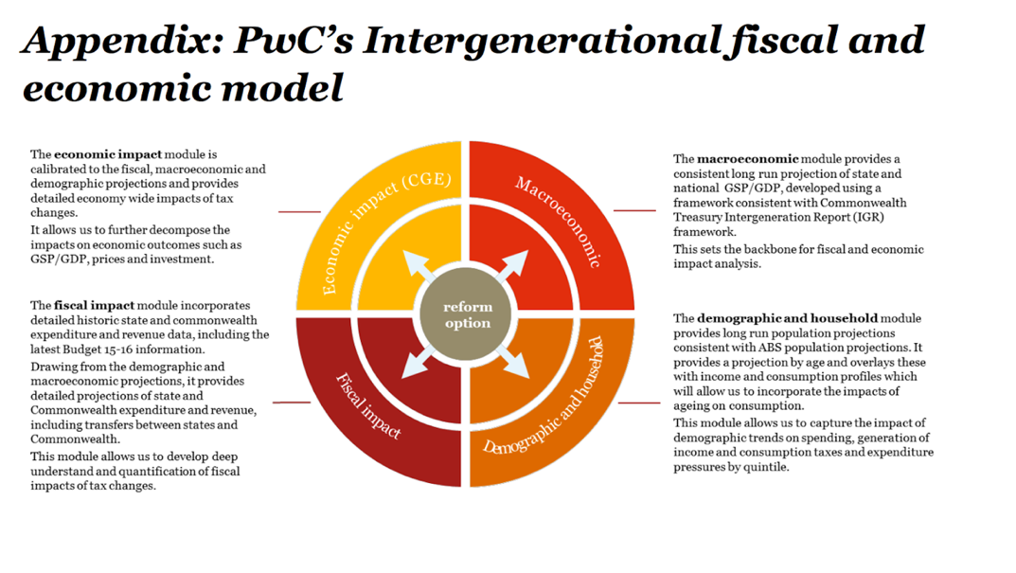

Employment is the most important way that neuro-diverse people can be included in Australian society and so given the opportunity to using our autistic’s unique strengths to make meaningful contributions, rather than subsisting on welfare.

**AV would welcome the opportunity to attend any public hearing and request we are involved in consultations about future employment support initiatives. Our members would like to speak and be heard.**

**OUR RECOMMENDATIONS (20)**

**INCREASE APPRECIATION AND UNDERSTANDING OF AUTISM**

**RECOMMENDATION 1: BUILD NATIONWIDE GOVERNMENT & EMPLOYER UNDERSTANDING & ACCEPTANCE OF DIFFERENT MINDS INCLUDING AUTISTICS, MOVING AWAY FROM THE DEFICIT DISABILITY VIEW**

The current deficit view used under the psychological model impacts our community from school through to adulthood. It means many are lead (wrongly) to believe that without intense therapy our Aspergers will never fit in. However, with a strengths based approach to difference, promoting acceptance, APPRECIATION and understanding and where others understand our sensory and communication needs, then it is far easier for our community to feel included and less isolated. This moves away from systems that promote and based on the fear-promoting model of differences and where autistics are ostracised automatically, seen as incapable, without seeing the value of difference.

The mental health heritage theory that we all must be “normalised” to be able to work needs to be re-considered. Inclusion and a strengths view of self and by others leads overall to greater productivity, improved mental health and community contribution. **UNDERSTANDING and appreciation of differences would help Autistics nationwide and all levels of capability, together with more accessible approaches to their employment needs.** This has been done for gender and indigenous – and now autism and other neurodiverse minds requires this inclusion.

Australia is required to comply with **the Convention on the Rights of Persons with Disability 2006** : ***“****Reaffirming the universality, indivisibility, interdependence and interrelatedness of all human rights and fundamental freedoms and the need for persons with disabilities to be guaranteed their full enjoyment without discrimination,”*

***with Article 27 stating****: “Parties recognise the right of persons with disabilities to work, on an equal basis with others; this includes the right to the opportunity to gain a living by work freely chosen or accepted in a labour market and work environment that is open, inclusive and accessible to persons with disabilities.”*

If we moved our national employment strategy more towards a **humanistic model of disability**, in contrast to the current medical and deficit based model, that would help change the incorrect view that difference = inability. Growing understanding that differences in thinking can be a strength and often don't require much change in approach would help accommodate the variety of autistic needs, mainly broken into sensory, movement, executive function, language, and social interaction – and move towards realising and accommodating the fact that everyone does not think or work the same way, or require the same environment.

Many Australian societal norms and systems are based on expectation that everyone can network in a loud, fluorescent lit-office, or can comfortably make eye contact during interview conversations, or can keep their body completely still during a boring presentation. This needs to change as society is changing.

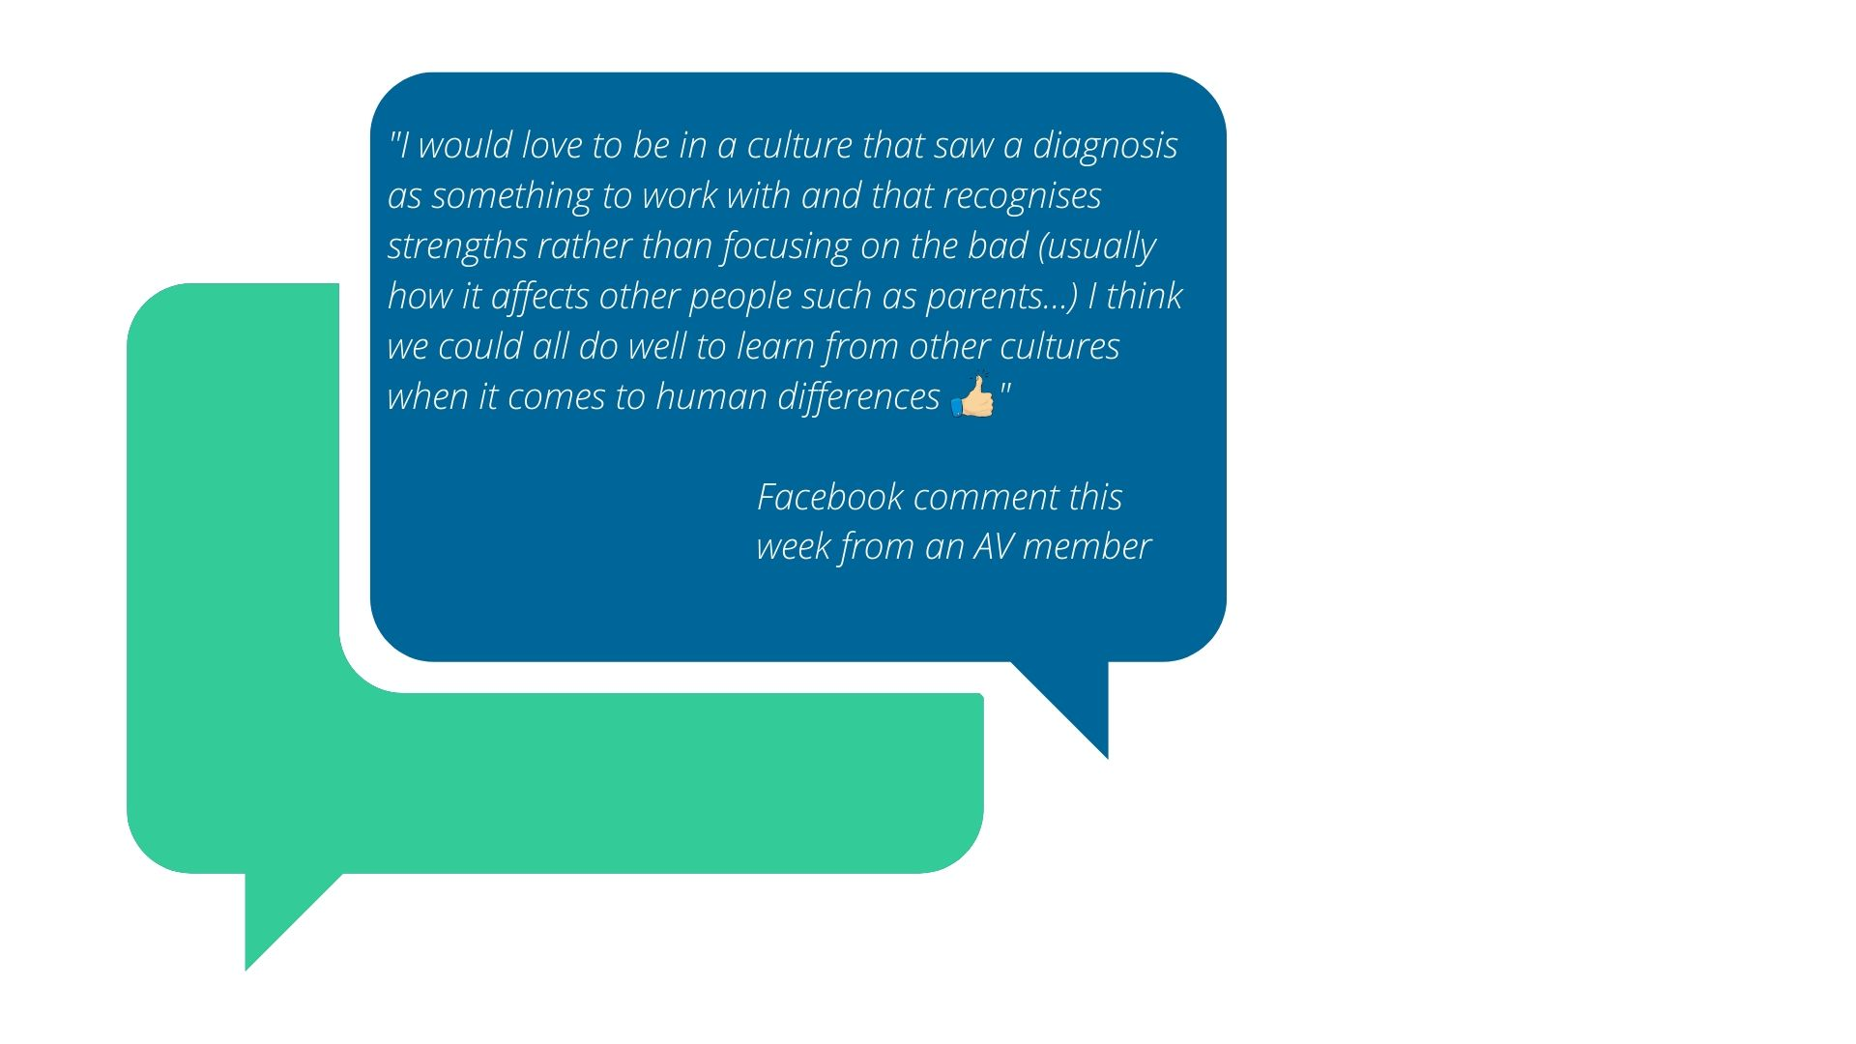

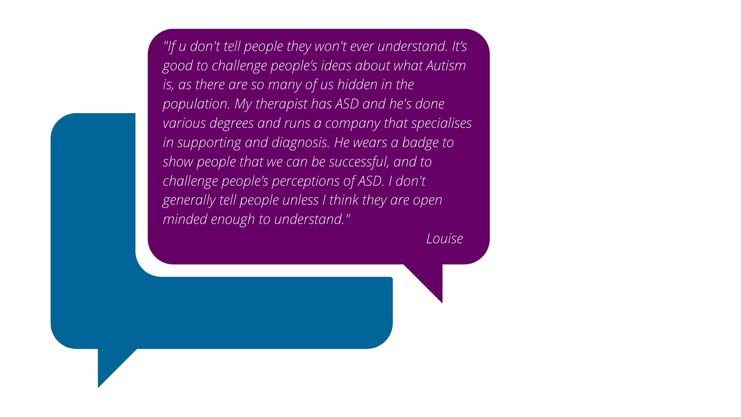

**RECOMMENDATION 2: DO NOT HOMOGENISE EMPLOYMENT SUPPORTS**

The famous quote from Stephen Shore, a late diagnosed autistic researcher and advocate is*:* ***“If you meet one person with Autism you have met one person with Autism.”***

Every autistic is different: every individual is different. AV prides ourselves on being interpreters in supporting Aspergers autistics individuals to negotiate and manage their wider world – we provide a lived experience go-between for them and the systems culture that all too frequently fails to understand autistic strengths and challenges. The system homogenises disabilities.

We must move away from homogenising Autism needs so services and employers realise its more economically beneficial to specifically address the individual needs of our capable Asperger individuals: which are often quite a simple adjustment in approach based on understanding.

AV’s understanding is derived from lived experience which is an imperative prerequisite for learning to speak ‘Aspie’ and then being able to understand and translate Asperger needs and requirements into a system that really fails to comprehend their intricacies and differences. We have specialised knowledge in how to best support our part of the Autism community. The Autism community includes our Autistics, parents/families, allies and professional supporters – and they all need a voice. We need a balance of voices to be heard at government levels (see research box below).

Our Government and employers need a strategy to ensure we build understanding, acceptance and recognise the needs of our diverse and heterogeneous autistic community and that we require a variety of supports – not one size fits all. One organisation and one approach cannot cover the diverse interests in sufficient detail or speak for the many different voices including autistics.

**below).** 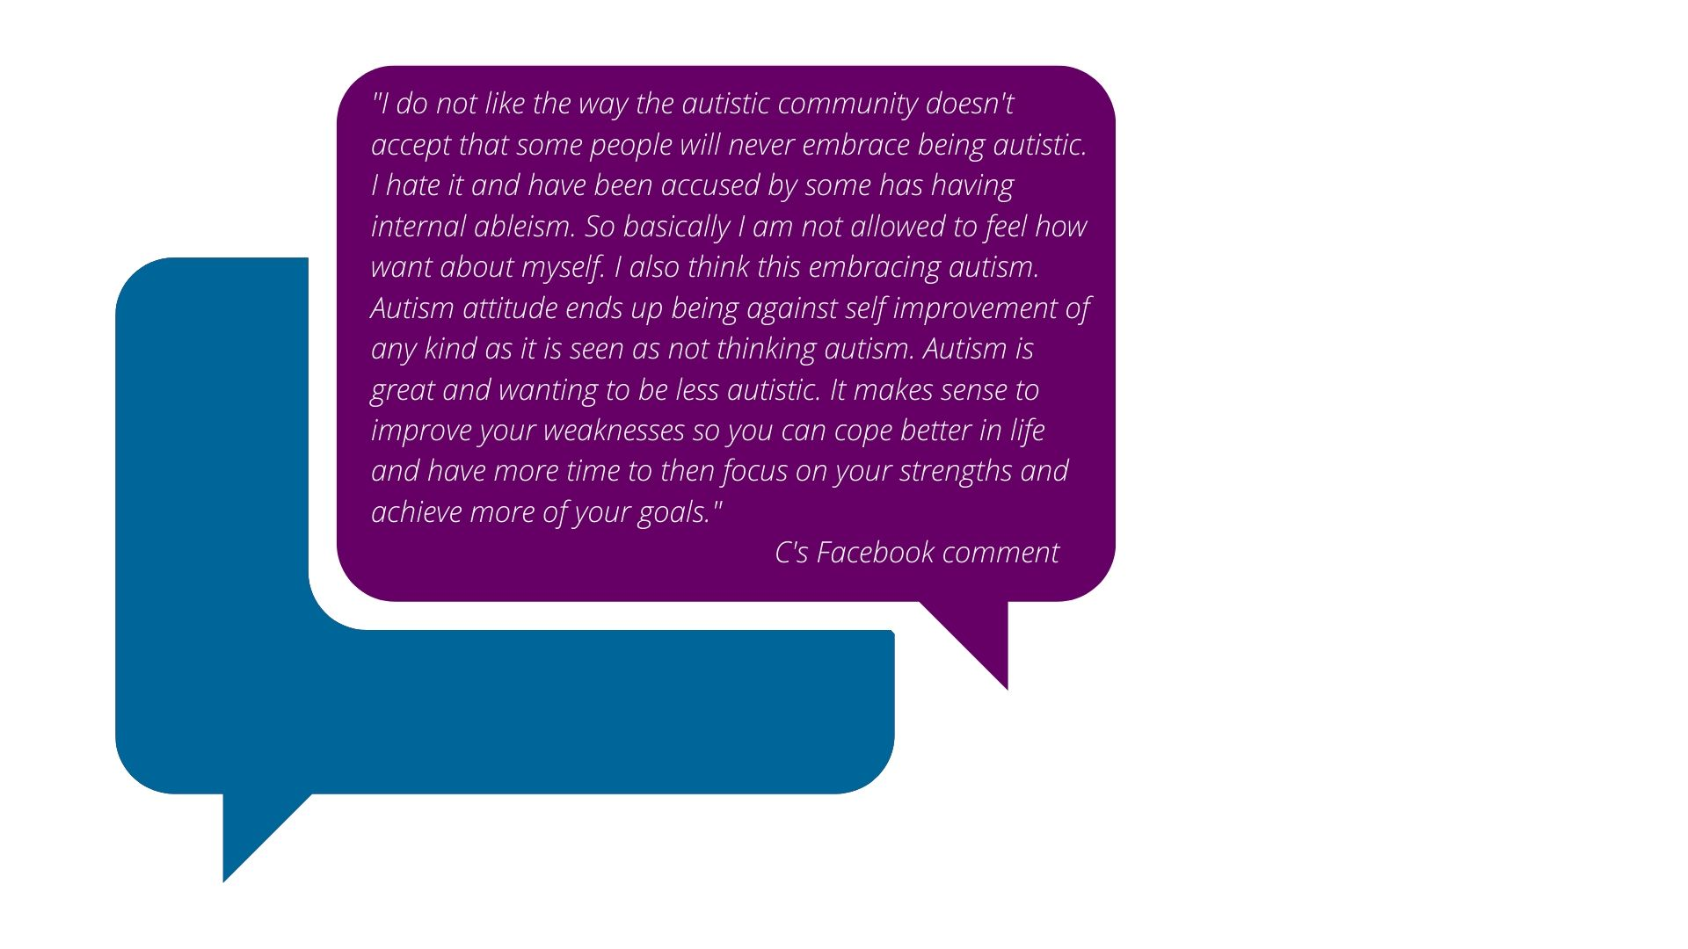

[**RESEARCH:**](https://www.researchgate.net/profile/Dominic_Sisti/publication/340146860_Ethical_Advocacy_Across_the_Autism_Spectrum_Beyond_Partial_Representation/links/5eb05c9b45851592d6b8bcbf/Ethical-Advocacy-Across-the-Autism-Spectrum-Beyond-Partial-Representation.pdf?origin=publication_detail) ***‘An important question for any theory of political representation involves balancing a representative’s justified partiality in advocating for policies that would help its constituents with its general obligations not to impose certain harms on others. Though moderating representative claims can address the particular problem of partial representation it does not eliminate this latter question.  
In practice, representatives need not choose categorically between these two approaches to dealing with partial representation. Instead, they might pursue a federated model of representation where representatives of particular subgroups speak on behalf of their smaller constituency when addressing certain issues but come together with other representatives, either under the auspices of an umbrella organization or as part of an ad hoc coalition, to speak as one about issues affecting a broader group of people. There are examples of this type of federated model in health advocacy.***

***A similar approach to representation may ultimately be well suited to the autism community. As we began this article by noting, people with ASD have widely varied characteristics, skills, and abilities. That they share a common diagnostic label is largely a product of the way that ASD has been defined by psychiatrists. Indeed, the creation of ASD as a formal diagnostic category is a relatively recent development, which followed several decades of attempts to “categorize the heterogeneity in autism spectrum disorders” (Grzadzinski et al. 2013). It was not until 2013 when the fifth edition of the Diagnostic and Statistical Manual of Mental Disorders (DSM-5) removed Rett syndrome and combined autistic disorder, Aspergers disorder, pervasive developmental disorder not otherwise specified, and childhood disintegrative disorder into the single category.’***

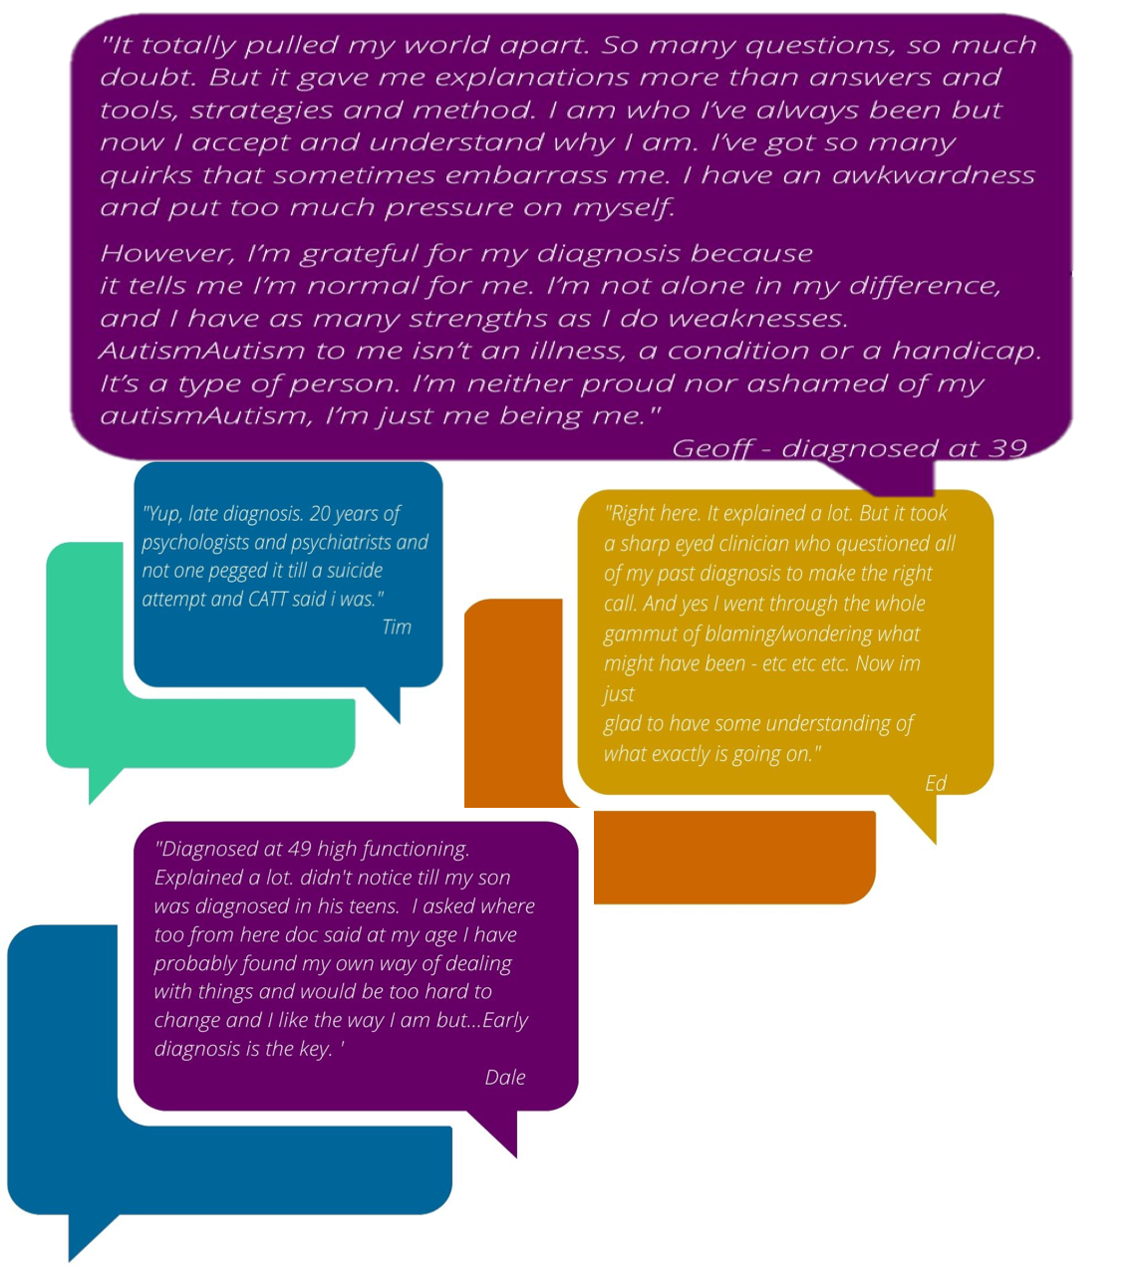

**RECOMMENDATION 4: ADOPT THE GLOBAL MOVE TOWARDS THE PRINCIPLES OF UNIVERSAL DESIGN IN LINE WITH THE HUMAN RIGHTS CONVENTION**

We support the accessibility principles evolving elsewhere in the world of **Universal Design** which means taking a person-centred approach to accessibility of employment as described in this image by Professor Kirby in the UK (image below). For this to be a long term strategy you need to include consideration of this thinking

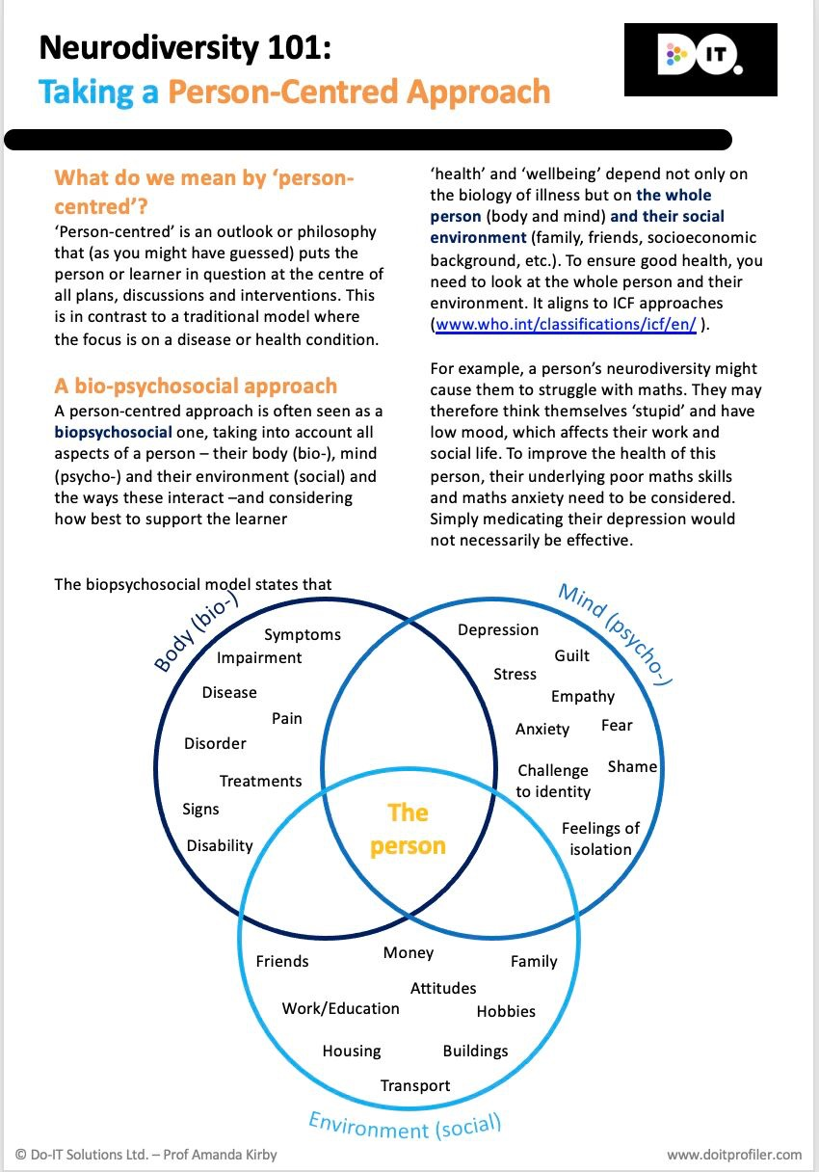

**RECOMMENDATION 5: UPDATE GOVERNMENT TERMINOLOGY OF “DIVERSITY” TO INCLUDE NEURODIVERSITY SO AUTISTICS ARE INCLUDED IN GOVERNMENT REQUIREMENTS INCLUDING TENDER PRE-REQUISITES**

We are aware of government terminology that **diversity** includes gender, indigenous/race – and sometimes very broad “disability”.

This means that in government tenders, corporate contractors are required as part of contract to employ people from a range of diversity backgrounds. If this was changed so this tender terminology specifically included “autism” or “neurodiversity”you will more effectively capture our capable Autistics in this employment opportunity.

This has been done for gender and indigenous – and now autism requires this inclusion.

**RECOMMENDATION 6: GOVERNMENT LEADS BY EXAMPLE MANDATING EMPLOYMENT OF AUTISTICS INCLUDING IN GOVERNMENT AGENCIES SO EMPLOYERS SEE BENEFITS OF NEUROLOGICAL DIVERSITY**

The government has disability-based staff quotas and needs a strategy for Australia-wide government employment programs for autistics and other neuro-differences that are designed for success. This leading by example will help normalise and demonstrate the benefits of different thinking in workplaces. The government can be a key leader in building societal change in attitude by employers and business leaders.

Such programs should also be required in government agencies such as Centrelink, Jobactive which would then have more effective lived experience to support autistics. The Department of Defence has seen this in its Cyber-security programs already to date. We worked with the Department of Education Vic, DWELP and know several MPs who also saw the benefits of autistics in their teams.

**This will assist with building business leader understanding and engagement through seeing government direct experience.**

**RECOMMENDATION 7: EDUCATE AND SUPPORT EMPLOYERS TO UNDERSTAND NEUROLOGICAL DIVERSITY IN THE WORKPLACE TO ENSURE WE REALISE THE DIVERSE CAPABILITIES AND INDIVIDUAL NEEDS OF AUTISTIC EMPLOYEES**

Many employers fail to understand autism and the benefits of neurodiversity. A key part of this is when we talk to employers we focus on **leadership understanding**, not simply inclusion, which means we speak directly with those behind business strategy and delivery, as it is often **not** an HR imperative. With government support lead by demonstration of the right approach, we believe we can offer a compelling business case to business leaders.

A key aspect to support this route to employment is the amount **of on-the-job support and training** provided for business leaders to ensure their staff and HR can deliver autistic success. This builds momentum for change.

This is achieved through a two-pronged approach for the first few months of transition or when we are called in once issues arise: The main focus of our AV coaching support

Training of leaders, staff and managers working with individual autistic team members (and HR): must educate the employer and co-workers about Aspergers in their workplace;

* AV’s team has been delivering coaching in a range of employment settings and our main learning: to successfully place Aspies into appropriate ongoing successful employment, the employer, including staff, must effectively better **understand and communicate** with their Aspie employee - they need to learn to ‘*speak Aspie’* in order to understand the autistic’s needs.
* Even better: to also train and allocate a trained **internal mentor** for communication support

On-the-job employment coaching and support for the autistic employee: we **also** ensure that the Aspergers autistic employee has appropriate understanding of the job requirements and the expectations of this business environment.

Most support agencies don’t particularly do this well unless they are specifically trained/experienced in working with Aspies.  In particular, most employment agencies or non-specialist job coaches don’t comprehend the critical impact that sensory sensitivities have on our ability to maintain employment, with difficulties interpreting instructions due to challenges understanding some communication approaches (we are literal and often process words differently).

One manager at Medibank stated to AV that since she ‘had learned to speak Aspie’ from our lived experience team and understand the needs of her Aspie employee she had become **a much better manager, not just for the Aspie but for ALL her staff**. They can also then see which of their available team positions suit Asperger autistic strengths and then knowing they have AV’s specialist support, they become more open to taking on more neurodiverse staff.

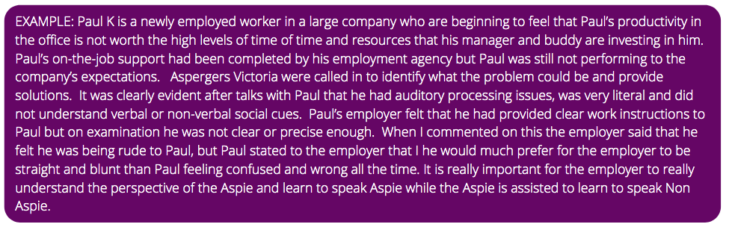

**RECOMMENDATION 8: IMPROVE UNDERSTANDING & CO-ORDINATION AND CONSISTENCY BETWEEN GOVERNMENT AGENCIES SUPPORTING AUTISTICS INCLUDING NDIS, CENTRELINK, DES AND JOB SUPPORTS**

Improve the autistic understanding as well as the co-ordinated interaction between services supporting autistics provided by the Commonwealth, state and local governments, including:

* health and mental health,
* education,
* **employment,**
* justice, and
* housing;

The needs of neurodiverse people including Aspergers people should be specifically considered in the redesign of government programs including Jobactive AND DES.  Our Aspergers autistics needs are unique and need either a specialist sub program within Jobactive or ideally a dedicated ongoing national program established and funded to support our unique and valuable people and allow us the opportunity of self-fulfilment and to contribute.

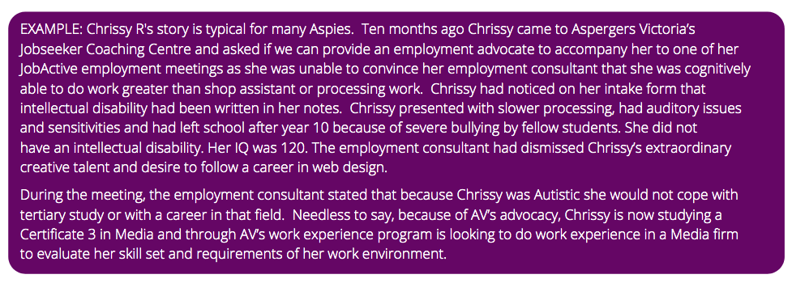

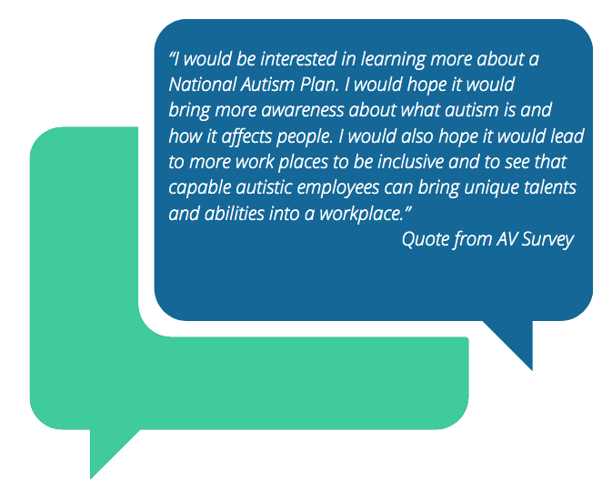

**RECOMMENDATION 9: MORE SUPPORT FOR SELF EMPLOYMENT OPTIONS**

As we see with autistic entrepreneurs and innovators such as Elon Musk and Bill Gates, our community has a large propensity for business ideas. In our evolving economy this kind of innovative thinking needs to be encouraged and supported by our national disability employment strategy.

**RECOMMENDATION 10: NDIS SUPPORT**

NDIS offers our employment strategy and opportunity to have a national impact on employment and supports available. There is inconsistency in how NDIS funding can support building employment skills including self employment and entrepreneurship. One autistic members created his own business that employed other autistics and was penalised with NDIS alleging as he could run a business, he then did not require the essential yet basic communication supports that were the foundation to help him manage a business.

We agree with the submission by Autism Advisory Support Service to Victorian State inquiries on the improvements required for NDIS supports and request the Inquiry consider these thoroughly.

**RECOMMENDATION 11: GRANTS PROGRAM FOR SPECIALIST ORGANISATIONS TO CREATE CO-DESIGNED EMPLOYMENT PROGRAMS**

Instead of funding large commercial operators without lived experience, create dedicated approach to support lived experience organisations supporting grassroots employment initiatives such as AV. Such funding that will allow us to provide a range of employment based support services directly.

Our World of Work programs provide:

* Our Work KnowHow program for Aspergers school students which we have developed under the DET program umbrella and require funding to progress further. Our research shows this will deliver work readiness skills in the most effective approach: preparing both the Asperger as well as the employer and requiring less job matching services by independent parties:
* Specialist career advice to gain the most suited & sustainable employment, including required support.
* Communication building program “Social Skills Toolkit” for pre-work students and applicants: On the Jobactive website front page it highlights that “Employers want good communication skills” so Aspergers autistic need to be given supports to build these skills earlier. Our program includes this by building it prior and on the job.
* Preparation and train more employers to understand autistics
* Coaching and mentoring by lived experience to support autistics into and on the job

This will all result in improved employment skills, improved life skills, growing self-advocacy and awareness of neurodiverse contribution through actual delivery of outcomes, abilities and contribution

**RECOMMENDATION 12: PROVIDE SPECIALIST RECRUITMENT SUPPORTS FOR AUTISTICS CAPABLE OF WORKING IN EXISTING ORGANISATIONS BUT DISADVANTAGED BY THE CURRENT RECRUITMENT SYSTEMS (OR CHANGE RECRUITMENT PRACTICES)**

Jobs Victoria recognised and attempted to address this issue when they were recruiting for two of their head office cadetship positions at Department of Education and Training (DET) Victoria.  With AV, the Jobs Victoria representatives created a specialised application and interview process to suit autistic applicants and they recruited very successfully. Often such opportunities are missed- employers seek guidance on recruiting autistics from recruitment agencies who simply do not understand the alternative processes required to build inclusive recruitment. AV can provide such specialist advice so this opportunity is not missed.

Our AV World of Work supports include:

* Supporting employers to fine-tune their recruitment and HR processes
* specialist individual assessments and interpretation to support individuals towards more suited employment roles: Autistics then have realistic expectations and self-understanding
* coaching support to help autistics assess roles, prepare their CV and for interviews
* communication skills building program “Social Skills Toolkit” to help them prepare for interviews and the recruitment process and self advocate for their needs

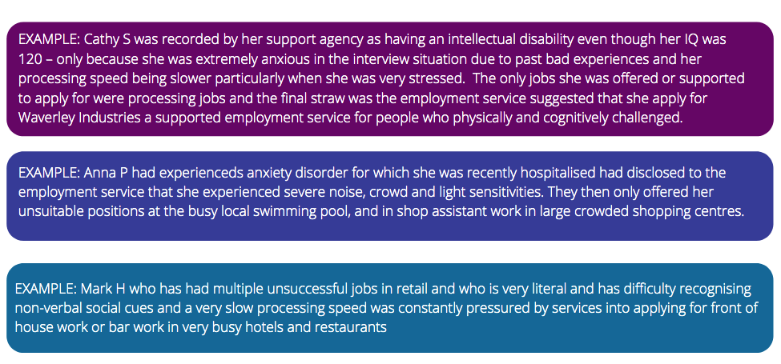

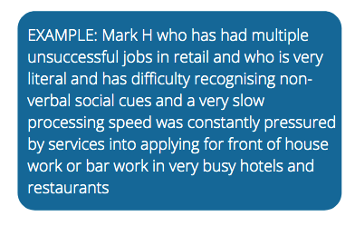 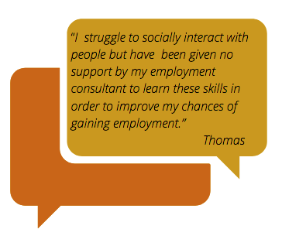

These are only a few of the stories that have been shared with AV regarding their experiences of accessing employment services. AV Members would be very happy to provide additional personal experiences at any Senate meetings.

**From this strategy to grow understanding with business leaders we can then ensure we create systems that incentivise and encourage employers to use hands-one recruitment programs such as those where the applicant completes work trials or specific tasks.**

**RECOMMENDATION 13: SPECIALIST WORK PREPARATION AND TRANSITION SUPPORTS**

Many of our Members who had undertaken pre-employment job application and interview training through their disability or other employment service commented that this training and support was ineffectual and inappropriate as it was not tailored to suit the particular challenges and requirements of Asperger jobseekers. It was broader disability training often assuming intellectual challenges and without the **insight of lived experience**.

Our capable Aspergers autistics need specialist career supports that related to their strengths and support their specific challenges which are often a myriad to decipher- needing specialist insights. Our knowledgeable and intelligent jobseekers specific challenges include the inability to read between the lines with regard to interview questions, inability to understand verbal and non-verbal cues, difficulty with eye contact, mind blindness and failure to read contextual cues.

Our job readiness training resulted from the many Aspies who have presented to our various AV meet-up groups and previous Drop-in-Centre who have **never** been employed and have lived very isolated lives, some developing mental health conditions.  Existing DES and other providers have not given them adequate supports or any understanding of the expectations of a work environment.  This issue was also evidenced through our interactions with autistic employees seeking our support who were in precarious employment situations, often with their role in jeopardy due to simple employer misunderstanding.

To be able to make the most of recruitment services, such as Jobactive and DES, students need a better self-awareness and readiness for the employment world. Improvement in career guidance/readiness of students is a key priority in line with the recommendations in the report from the Inquiry into Career Advice Activities in Victorian Schools (22/8/2018) (with the added requirement that the training of Career Guidance teachers). Our World of Work program is designed to provide this through our Workshops and trained coaches.

This work readiness needs to start earlier for Aspergers.  Early intervention for employability skills should get priority funding if you wish to reduce reliance on government supports later in their career process. Without such intervention Jobactive supports will not succeed.

In 2019 AV developed and has been using:

**Social Skills Toolkit -** this social support program which uses an evidence-based model to provide communication skills and personal insights for autistic Teens and Adults so that they can understand and learn communication and social requirements for their life and work worlds. This work readiness workshops prepares Aspie individuals to understand the social nuances required for the world of work.

**Work Knowhow Program** - this AV work experience program is for school students. Preparation for work for Aspergers needs to begin as early as late primary school.  If education was made more relevant for the current job market and includes communication and social skills supports, enterprise building focus with a work readiness focus for Aspergers earlier in the current education and the DET support systems.

**RECOMMENDATION 14: START EARLIER- IMPROVE SCHOOL STUDENT CAREER INSIGHT & WORK READINESS**

AV has seen how our education systems do not suit many of our autistics and they often drop out not seeing the point of the education system. They have minimal career readiness and understanding even in the private schooL systems. This is not a priority in our education system currently. The **Foundation of Young Australians** various reports confirm work readiness needs to start much earlier in student lives – even before secondary school.

If education was made more relevant for the current job market and included communication and social learning supports, enterprise building focus with a work readiness focus earlier in the current education and the DET support systems we would be having less issues once our Members leave school.

To cater for this issue and to improve engagement at school AV developed the AV Work KnowHow Program for autistics eligible for the DET work experience program. This is a customised support to assist autistics build work readiness, self understanding as well as career insight and pathways. This has transformed the students view of work and work experience – as well as benefiting employers who directly grow their autistic understanding supported by AV’s expertise, get to see what it is like to employ autistics and how valuable they can be. It is a success for all the parties involved.

**Transition systems** to employment are under-resourced and this program partly fills this gap. Your strategy needs to address this issue.

**RECOMMENDATION 15: PROVIDE SPECIALIST ON-THE-JOB SUPPORT COACHING TO MAINTAIN EMPLOYMENT FOR AT-RISK AUTISTIC WORKERS**

Social supports for our autistics at work is critical to their engagement and retention. Through our work providing employment coaching to autistic employees in jobs, it is very evident that assisting Aspie employees to **maintain their job** was equally vital as assisting the jobseeker to find employment.  Few agencies do this well as they are often more focused on getting the autistic person into a quota-role and lack experience and specialist training/understanding in working with Aspergers.

In particular, most employment agencies or job coaches don’t comprehend the critical impact that sensory sensitivities and mis-communication can have on an autistic’s ability to maintain their employment.

AV’s World of Work Program has delivered on-the-job specialist employment coaching for Aspergers in a range of employment settings including Medibank, the Rise program at Department of Health and Human Services (DHHS), Department of Environment, Land, Water and Planning (DELWP), DET, Linfox, Infosys and Our Watch. Critical to this was coaches with specialist training and lived experience of Aspergers autism who support autistic communication and integration, coaching those around the autistic as much as them.

The main focus of this specialist coaching support is also to educate the employer, HR, managers and co-workers about Aspergers autism in the workplace and also to ensure that the Aspie employee has appropriate understanding of the job requirements and the social and work expectations of a business environment.  AV’s program is currently developing a **Coach Training program** to teach employment coaches how to successfully coach Aspies in finding and keeping employment.

Again AV is very happy to share more of their member’s stories about the lack of and the critical need for Aspie savvy employment coaches.

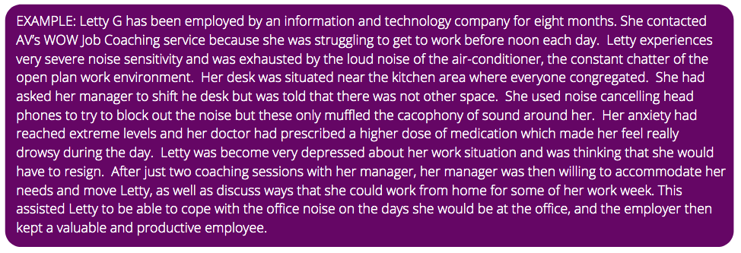

From the multitude of stories just like the two above what AV has learned is that for our employment coaches to successfully place Aspies into appropriate ongoing successful employment, the coach as well as the employer’s team need to **truly understand autism** in order to understand the Aspie’s needs, and to be able to teach the employer to effectively understand and communicate with their Aspie employee.

Again AV is very happy to share more of many member’s stories about the paucity of and the critical need for Aspie savvy employment coaches.

**RECOMMENDATION 16: SYSTEM CHANGE & MANDATED AUTISM TRAINING IN EMPLOYMENT SUPPORT AGENCIES’ MANAGEMENT AND STAFF NATIONWIDE TO RETAIN LICENCE**

The **loudest** story which is told over and over from our Members is that the government funded agencies such as DES, and those managing Transition-To-Work programs, **FAIL to understand the abilities and nuanced challenges** of our capable Aspergers autism population. This leads to a low retention rate. The employment services need specific mandated requirements about building their agency and staff understanding of autistic strengths and challenges. This has been done for gender and indigenous – and now autism requires this inclusion.

DES assume incompetence and disability and treat them as if incapable, providing poorly designed supports. This leads to autistics put into the wrong jobs with inadequate supports and low retention rates – with **no support** once the government subsidies run out. This system fails our autistics.

Whatever the autistic’s age the story is the same. The repeating themes include**:**

* not understanding or misunderstanding the characteristics of Aspergers autism: **predicated on expectations of disability due to our autistic social & communication differences**
* undervaluing the skills sets of the Aspie jobseeker or employee: assuming they are incapable and intellectually challenged
* employment Agencies don’t understand that Aspergers is a different mind with challenges that often can be accommodated very easily
* not realising the simple support needs that help our Aspergers flourish and
* lack of appreciation for their ‘intellectual capacity and high cognitive functioning’: not seeing past their differences or co-morbid anxiety the job seeking process **exaggerates.**

The lack of suitable training and **high turnover** of employment staff in government funded employment agencies is the other problem most frequently cited by our Members and survey respondents. Generalised disability training is inadequate and actually damaging and disempowering for the Asperger jobseeker who has report that the services are frequently useless in providing realistic employment opportunities for them. This mismanagement and putting ASD-1 into the wrong roles to meet quotas creates additional trauma and mental health issues with likelihood of lifelong unemployment.

With such turnover, training in managing capable Autistics is a priority and regular and updated training of these agencies and their staff must be mandatory. AV has created training with our lived experience team which improves real understanding of our community. The other option is fund specialist agencies instead.

On-going funding support needs to be based on outcomes as well as user feedback surveys – as it is for other funded organisations.

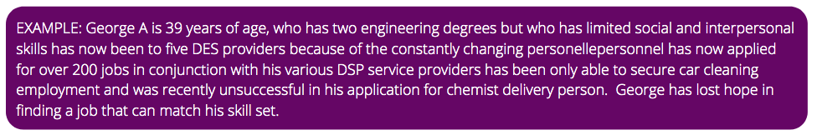

**RECOMMENDATION 17: MONITORING OF EMPLOYMENT PRACTICES - AV ENDORSES JOBWATCH’S SUBMISSION TO JOBSEEKER INQUIRY VICTORIA**

Specifically, these [Jobwatch Submission Recommendations](https://www.parliament.vic.gov.au/images/stories/committees/eic-LA/Submissions/059_JobWatch_2019.07.31_Redacted.pdf) nationally:

* Expand the definition of Employment Activity discrimination in the *Equal Opportunity Act 2010* to expressly make it unlawful for employers to:  
  a) dismiss an employee for the purpose of preventing the employee from becoming protected against unfair dismissal: and  
  b) dismiss an employee because their employment subsidy expires.
* Reverse the onus of proof in relation to Employment Activity discrimination so that the onus of proof rests with the employer to prove that it didn’t unlawfully discriminate against its employee.
* Require annual reporting by certain employers regarding autistic employee statistics, e.g., length of service, employment subsidies, employees with disabilities and other neurodiversity etc.
* Make employers who systematically abuse Government subsidies **ineligible** to benefit from further subsidies.

**RECOMMENDATION 18: EDUCATE PARENTS SO THEY UNDERSTAND BEST WAY THEY SUPPORT AUTISTIC JOBSEEKERS**

Our models are based on research from Canada and internationally about how a ‘Circle of Support’ is critical to achieve autistic employment success. Our programs include educating and empowering parents. Parents often lose work capacity if they have to provide mental health and other supports without recognition of this in our employment systems.

Our AV Work KnowHow Program and other educational events also cover these topics for parents and alloe. This should be considered in our government employment strategies.

**RECOMMENDATION 19: SUPPORT MORE AUTISTIC-COMMUNITY-LED RESEARCH INTO EMPLOYMENT NEEDS**

More research is needed:

* about autistics in employment and specialist supports that they say help
* into specific challenges so research learnings build knowledge and suitable approaches for specific challenges across Autism
* nationwide measurements of autism in the population We need a consistent measure to track this including capability levels under the diagnostic system and in employment. This should also include Social and Communication Disorder which many in our community are diagnosed under instead.

Build understanding of the heterogeneity of Autism and the variety of approaches that support common challenges. The autistic community can tell us what they need more information about. The Autism CRC has made a start on this approach and should be supported and broadened. Funding needs to also be provided to the issues of our more capable Autistics – as well as the more severely challenged.

**RECOMMENDATION 20: DIAGNOSIS & DISCLOSURE SHOULD NOT BE NECESSARY FOR GAINING EMPLOYMENT SUPPORTS OR EASIER TO GAIN**

Many of our adults Members are coming to AV realising their neurology later in life often through a child being diagnosed or job loss or similar difficulties. They then seek our support in understanding their accomodations required and how to approach employment. We do not receive funding to provide these supports for their employment and that could change their ability to retain their employment.

Diagnosis is expensive and the diagnostic tools available/used do not suit adults so many supports are unavailable without full diagnosis – and often employers will not provide suitable accomodations without disclosure. The other option is for there to be an avenue through Medicare for reimbursements for adult diagnosis. **The current Mental Health Plan offered through GPs is critical to supporting our undiagnosed** **Autistics.**

**WHAT AV DELIVERS**

In the world of more commercially based services, having a lived experience not for profit provides our community with an organisation **they feel they can trust** and an organisation that understands them at its core – and most importantly, speaks their language. Lived experience organisations needs to be supported as well as Autistic-led organisations.

Our Programss have been designed by our Aspergers peers and provide unique opportunities for connection with those dealing with similar challenges and growing similar strengths. During COVID our online groups have expanded nationwide and many of the attendees are appreciating this support and peer community gathering. We had a teen from Alice Springs join our Teen Discord Group this week and his parents joined our Teen Parent Group with such relief to find others who share their experience.

Many Aspergers/ASD-1 Members continue to tell us our groups and events are their **only community activity** each month and how they look forward to it. With our Teens Groups, our isolated teens have requested twice monthly, as there are many who cannot manage the social demands of school yet want to have friends and feel included. For some teens and also young adults, this provided their first true friendships and first birthday party/dinner invitations.

Our lived experience organisation’s peer groups continue to expand to provide essential peer support including for:

* Parent and Carers (Carers Victoria cannot provide the specific understanding and support our parents are seeking)
* Partners
* Teens: Dungeons and Dragons, Minecraft servers, social activities such as bowling
* Young adults
* Adults
* LGBTQIA
* all of whom have different issues to share and grow together

**It is imperative that AV be consulted with regard to understanding AUTISTICS and developing programs and training as we are the only organisation that is specifically dedicated to understanding and representing Asperger individuals.  We are an organisation that is for Aspergers and by Aspergers WITH ASPERGERS.**

**Thank you very much for inviting our submission.**

**We welcome feedback and insights that are helpful for our community.**

**Schedule:**

