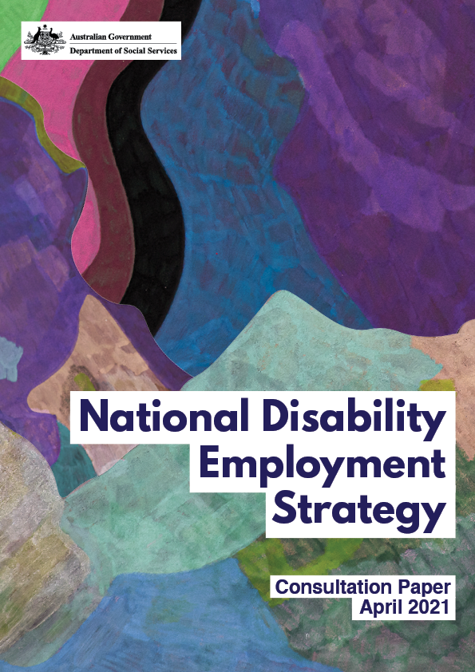

Consultation Report

September 2021

Artist: Robin Warren
Robin Warren (b 1971, London) has developed his artistic practice for over 20 years and continues to explore brightly coloured and organically shaped abstract imagery. Warren’s works in Copic marker, oil pastel and texta are reminiscent of cellular organisms in bloom that often radiates from a central focal point. Warren often renders multiple layers of colour that create a dream-like state as they reverberate across the paper. Though soothing, his works can have a strangely unsettling visceral or viral quality that is enhanced by his use of unreal and unlikely colour combinations. His work has been exhibited widely and appears in private collections throughout Australia.

Contents
Introduction 4
Key issues 5
Priority Area One – Employers 6
Building Employer Capability 6
Workplaces 8
Incentivising and holding employers to account 11
Hiring processes and pathways 12
Promoting employment of people with disability to employers 13
Supporting people to return to work 14
Government as an employer 15
Priority Area Two – Young people 16
The role of families and carers 17
Transition from school or further education to work 17
Experiences in tertiary education 21
Priority Area Three – Systems and services 23
Employment Service Providers / Disability Employment Services (DES) 24
Feedback on other programs and supports 30
Connections between government systems and services 32
The role of industry peak bodies 33
The changing nature of work 33
Priority Area Four – Community attitudes 36
Incremental change 36
Storytelling 37
Other feedback 38
Feedback on the proposed Vision Statement 38
Support for all people with disability to build employment skills 38
Procurement 39
Reporting and implementation 40
Additional information 41
Breakdown of public consultation submissions 41
Disability Employment Advisory Committee 46
Targeted consultations 46

Introduction
The Australian Government recognises that people with disability can face barriers to employment, preventing their full social and economic participation in Australian society. As at 2018, people with disability were more than twice as likely to be unemployed compared to those without a disability.
While there has been significant Government investment to increase employment for people with disability, more needs to be done.
Recognising this, the Minister for Families and Social Services and Minister for Women’s Safety, Senator the Hon Anne Ruston, has tasked the Department of Social Services (the Department) with developing a National Disability Employment Strategy (Employment Strategy).
The Employment Strategy will seek to increase employment opportunities for people with disability by providing a guiding framework for Government, employers, and the broader community. The Employment Strategy is expected to be finalised in late 2021.
Purpose of this document
Between August 2020 and June 2021, the Department undertook consultation with a broad range of stakeholders to inform the development of the Employment Strategy.
This report summarises consultation feedback from the following:
- 133 submissions received in response to the National Disability Employment Strategy Consultation Paper, published on DSS Engage in April 2021
- discussion with the Disability Employment Advisory Committee, which includes representation from people with disability, employers, peak bodies and community organisations
- more than 30 targeted meetings with key stakeholders, including employers, disability peak bodies, disability service providers and recruitment agencies, and
- targeted interviews conducted with people with disability through Services Australia.
Further detail on the consultation process is provided at Additional Information.
The Department would like to thank everyone who provided a submission, engaged in meetings or participated in interviews. Your input will contribute to the development, as well as any program improvements or new initiatives implemented under, the Employment Strategy.

Key issues
Overall, there was a very positive response to the development of the Employment Strategy and support for the four proposed priority areas:
- Lifting employer engagement, capability and demand
- Building employment skills, experience and confidence of young people with disability
- Improving systems and services for jobseekers and employers
- Changing community attitudes
The most common issues raised across all forms of consultation were:
- the need to invest in building capability of employers
- views on the efficacy of the Disability Employment Services (DES) program
- the availability of disability employment resources, particularly for employers
- the need for better work experience opportunities for people with disability
- barriers created by recruitment and human resourcing practices
- the need for inclusive training and skill development opportunities at different stages of employment
- attitudinal barriers to employing people with disability, and
- views on the efficacy of National Disability Insurance Scheme (NDIS) supports.
Feedback also emphasised the need to continue to include people with disability in the development and implementation of the Employment Strategy.
This report is structure around the four priority areas, with relevant feedback summarised under each one.

Priority Area One – Employers
Lifting employer engagement, capability and demand: providing employers with the tools and abilities to confidently hire, support and develop more people with disability.
Feedback clearly and consistently indicated that employer engagement is critical to improving the employment opportunities and outcomes for people with disability.
Enhancing the disability confidence of employers was seen as a key mechanism to minimising abuse and exploitation of people with disability in employment settings, and reducing discrimination in recruitment. Emphasis was placed on the social model of disability (over the medical model), which supports the idea of everyone having a role in removing barriers faced by people with disability.

Building Employer Capability
The need to build the capability of employers to confidently hire and support people with disability was the most referenced theme throughout all forms of consultation.
“It's important to support business to understand and employ individuals with a disability because everyone has a right to work.”
Feedback from employers detailed that they:
- aren’t always sure where to start or how to embed inclusive recruitment practices in their business
- aren’t always aware of the type of supports and assistance available, or find available supports unsuited to their business needs
- want dedicated, easy to find supports and services that are specific to their business needs with one point of contact
- face challenges focusing on disability employment, when they are also trying to drive multiple inclusion agendas (i.e. First Nations, Culturally and Linguistically Diverse, LGBTQIA+)
- can be fearful of ‘saying the wrong thing’ when asking questions and trying to understand the needs of an employee with disability
- are unsure of the resource investment and potential risks, and
- will need long term engagement/support to embed and actualise real change.
Feedback signposted the varied needs of business. Depending on their size, this ranged from practical, small-scale, business focused solutions, up to requiring an intermediary to facilitate national employment processes.
Supports currently accessed by organisations include:
- the Australian Network on Disability (AND), which is working to increase the disability confidence of large organisations
- the Business Inclusion and Diversity Service, which is supporting Small to Medium Enterprises to build their disability confidence and employ people with disability, and
- the National Disability Recruitment Coordinator (NDRC), which supports large employers to access the skills and talents of people with disability.
  - The NDRC was only referenced by employment service providers, who highlighted the need to raise employer awareness of this service.
A number of stakeholders also flagged the importance of providing ongoing support to people with disability once they are in a job.
Information, resources and training for employers
Feedback strongly indicated that employers require fit-for-purpose information and resources. It was consistently stated that information and resources must be easy to understand, engaging, accurate and accessible.
Reference was made to many employers being unaware of available resources, indicating a need for better promotion of existing resources and supports including JobAccess, the Employment Assistance Fund and Work Assist.
It was suggested that information and resources should show what it looks like to hire someone with disability, including information on:
- workplace adjustments (including technology-based)
- how to make workplaces safe and inclusive (step-by-step guide)
- using inclusive language
- how to have difficult conversations
- disability types, and
- the tools and resources available for employers and support networks to become disability confident.
The positive impact of providing disability confidence training within organisations was referenced consistently. It was noted that resources and training should be made available at all levels within an organisation, including for team members, middle management, and senior management, as well as human resource areas (where applicable). Suggested training topics included:
- building disability confidence
- inclusive language
- recruitment practices
- workplace adjustments, and
- accessible information and communication.
Feedback also suggested that training be made available in a range of formats, including, in person, through webinars, videos and online training modules. Training delivered by people with lived experience of disability was noted as being particularly powerful.

Workplaces
Accessibility
The accessibility of workplaces for people with disability was consistently raised, as an accessible environment creates greater employment opportunities.
“All our employment-related research has identified the lack of workplace accessibility as a significant barrier, suggesting that there has been little systemic change in the past decade. For example, 43% of Australian respondents in the 2018 [International Employment] survey ranked this as one of the four main barriers they experienced when seeking or trying to maintain work.”
Employers also spoke to the challenges associated with older buildings, as well as legacy IT systems, where the cost of moving to more accessible options is high (i.e. involves a complete system overhaul or significant renovations). The result is that people with disability can miss out on jobs they have the skills for because the employer can’t effectively meet accessibility requirements.
There was recognition that, while both are important, creating accessible workplaces in new organisations was often easier than trying to alter existing ones, which required more targeted, intensive investment. It was noted that emerging sectors and new businesses have particular opportunities to build inclusive business models and workplaces from the start.
The importance of accessible IT, including having access to other assistive technologies in the workplace, was flagged as critical.

“If systems or processes are inaccessible because they do not comply with accessibility standards or guidelines, then no amount of work preparation, skill, or experience on the part of the employee will make those systems accessible and usable.”
It was also asserted that qualified professionals, including workplace assessors, should be readily available to help employers identify potential barriers, and to implement reasonable workplace adjustments.
Leadership
There was strong consensus that support from executives and senior management is critical to improving the inclusion of people with disability in the workplace. The role of senior leadership in setting the strategic direction of the organisation, pushing for change and promoting disability inclusion was emphasised.
The presence of role models with disability from diverse backgrounds and at all levels, including in leadership positions, was also referenced as important. However, people with disability emphasised that this needs to be a matter of choice for the individual, noting that it is unfair to expect all people with disability to be the drivers of change within organisations.
While the role of leaders was noted as important, middle management and co-workers were also seen as being key to the success of a person with disability in employment.
Creating inclusive workplaces
Feedback called attention to the fact that people with disability still experience discrimination both finding work and within the workplace, and that this needs to change.
“I wish the mantra ‘bring your whole self to work’ applied to us. We’re welcome as long as we act like everyone else.”
People with disability and their representative organisations highlighted the widespread discrimination and negative workplace practices they experience because of their disability. Consistent across all forms of consultation was the need for employers to be educated and uphold their obligations to prevent all forms of workplace discrimination, harassment and bullying.
“Employers or work colleagues represent one of the top three sources of discrimination experienced by people with a psychosocial disability.”
Employers referred to the challenges in supporting people to feel comfortable and confident to identify/self-report their disability. Feedback from people with disability and representative organisations supported this by highlighting that many people with disability, particularly those with invisible disabilities, do not disclose during the recruitment process or while at work due to fear of discrimination.
Conversely, MS Australia noted that people who disclose their disability are often better supported in their workplace:
“Employees who disclosed their diagnosis were more likely to be employed, and more likely to be employed for longer periods of time, most likely due to receiving more assistance with workplace accommodations, social support and possibly more effective symptom management.”
One employer strongly asserted the “need to break down the ignorance of employers”, providing an example of their own limiting beliefs before they realised the broad opportunities available. Other submissions noted that real conversations and real experiences are the key to changing employer attitudes.
The positive impact of diversity and inclusion was agreed by all stakeholders, with the Diversity Council of Australia pointing to their findings that inclusive teams result in significantly lower levels of discrimination and harassment.
It was noted that businesses need to have the right knowledge, resources and attitude in order to create an inclusive workplace. Training for senior leaders, managers and co-workers as well as human resources teams was seen as essential to creating inclusive workplaces, with inclusive language training cited as having considerable potential to change attitudes. Submissions also noted that increasing awareness of workplace rights and improving confidence of people with disability to negotiate workplace adjustments would be beneficial.
People with disability consistently asserted that they should not be made responsible for creating the cultural change that improve their employment outcomes. There was a clear theme that employers need to do better in creating access to, and inclusion within, workplaces.
It was suggested that Employee Resource Groups (ERGs) can play an important role in shaping workplace culture. ERGs are groups of employees who join together in their workplace based on shared characteristics or life experience, for example an internal Disability and Carers Committee. ERGs were pointed to as an effective vehicle for change and raising disability awareness within organisations. The voice of employees with disability, and access to leadership to ensure their voices are heard, is seen as an essential and effective way to build organisational engagement and action.

Incentivising and holding employers to account
The need to better incentivise employers, as well as holding them to account, was a key theme in submissions.
Incentives
Several DES providers, as well as some people with disability, raised the benefits of incentives. Incentive options suggested included:
- providing subsidies for long term employment outcomes
- aligning employer subsidies for DES and jobactive (currently $1,650 vs $10,000)
- tax incentives
- financial incentives to support flexible work practices and attendance until the person is embedded in the organisation, and
- providing incentives to host graduates.
Other than direct financial incentives for organisations, other mechanisms raised included:
- preferred procurement
- providing training rebates
- increasing funded supports to people with disability (and employers) in their transition period, and
- subsidies to make accessibility changes in the workplace.
Accountability
Making employers accountable for employing people with disability was a consistent theme across all cohorts, even from employers.
Tools such as Disability Action Plans and AND’s Access and Inclusion Index were referenced as effective methods to drive awareness, accountability and commitment.
Obtaining a benchmark by which to measure progress in relation to access and inclusion practices was stated as important to increase disability awareness across businesses. The impact of implementing targets was also raised as a way to increase accountability and action of employers, with data providing an effective measure for leadership and increasing organisational accountability.
Some submissions (primarily from disability representative organisations) asserted that employers should be held to account through legislative compliance. Suggestions included:
- establishing a Workplace Disability Equality Agency, and
- amending the Disability Discrimination Act 1992 to:
  - introduce subordinate legislation on Disability Standards for Employment, similar to the Disability Standards for Education 2005
  - give the Australian Human Rights Commission greater powers and resources to support disability employment complaints (including through legal representation)
  - mandate the requirement to provide flexible ways of working and/or highlight existing legal obligations of employers, and
  - clearly define reasonable adjustments (inherent requirements vs reasonable adjustments).

Hiring processes and pathways
Feedback relating to the recruitment of people with disability emphasised that standard ‘mainstream’ recruitment processes are not always effective for a range of reasons, including:
- inaccessibility of recruitment platforms and processes, including job advertisements and interview processes
- experiences of discrimination
- fear of disclosing disability, and
- unconscious bias of recruiters/assessors.
“I have written thousands of job applications and have rarely gotten interviews. When I do get an interview, I generally do poorly and this can be attributed to the NT (neurotypical) bias that exists in interviews.”
There was agreement that effective recruitment and job matching strategies are required to create a positive experience for people with disability and employers.
One employer stated:
“Recruitment processes rule people out rather than in - to be genuine, employers can look at the person to see if they fit their business then find the right role for them.”
Reference was made to the potential impact of making small changes to the way jobs are advertised and promoted.
“I once applied for a job ... The job ad said, “If you feel you meet most, but not all, of the key criteria, please do not be dissuaded from applying. We actively promote a diverse workplace. NSW parliament is an accessible workplace and accommodations can be made where needed.
That was an advertisement that actively invited me to apply and gave me confidence that I wouldn't be put in the “too hard basket” as soon as we needed to discuss possible adjustments, including adjustments to the job itself.”
Suggestions were made around developing resources to support accessible recruitment processes, which could include:
- guidance on how to provide material in multiple accessible formats
- the need to avoid psychometric testing and video interviews for some candidates (instead providing alternatives), and
- providing reasonable adjustments in the recruitment process.
AND’s Disability Confident Recruiter program was referenced by people with disability and employers alike as an effective model to ensure recruitment processes are appropriate and inclusive.
One submission cited the Integrated Employment Success Tool, created by the Autism Cooperative Research Centre, noting it is an evidence-based comprehensive tool that supports end-to-end recruitment processes, on-boarding and retention of jobseekers with disability.
Other programs like Hotel Etico’s on-site 12-month employment and training program for people with intellectual disability and Specialisterne programs for people with autism were also referenced as successful recruitment processes.

Promoting employment of people with disability to employers
Feedback cautioned promoting people with disability to employers as exemplary employees who need little assistance and have high productivity and low absenteeism.
“I’m looking forward to the day when disabled workers are comfortable being as mediocre as the neurotypical and able-bodied ones who take their jobs for granted.”
It was questioned as to why people with disability should be held to a higher standard than other employees. It was noted that this approach could contribute to employees with disability not being empowered to ask for the supports they need to do their job, as well as being hesitant to take advantage of workplace flexibility or taking time off if they are unwell.
“The last thing we want is for employers to feel disillusioned when their disabled recruit isn’t absolutely fantastic, and swear off hiring any more like them.”
Submissions also emphasised that the focus should not be about employer perceptions of people with disability in the workplace, rather it should be about people with disability being competitive in the job market, as well as the better performance of diverse and inclusive organisations.
There was agreement that showcasing successful case studies of employers hiring and retaining people with disability can play an important role in normalising the concept of employment for people with disability.
It was also noted that stories should highlight little wins so they feel achievable i.e. altering start and finish times to provide flexibility for an employee with disability.

Supporting people to return to work
A small amount of consultation feedback referenced the return to work after acquiring a disability. Feedback on return to work covered employer attitudes and obligations, as well as the experiences of people with disability.
Feedback suggested there should be a focus on keeping a person engaged with work as much as possible, as the effectiveness of interventions to support people to return to work after acquiring a disability reduce over time. As part of this, work needs to be done around changing employer attitudes towards disability in the workplace, as well as building the expectation that employers have an obligation to their employee, no matter how a disability is acquired.
“Many people with acquired disabilities have felt particularly disadvantaged when attempting to re-enter the workforce due to attitudinal and operational barriers they encounter with former and new employers.”
Support for employers was also raised, with reference made to the need to be able to access to a consolidated suite of resources and assistance that enables employers to act quickly and appropriately when a person acquires a disability. Reference was also made to employers using the Work Assist program, with the restrictive eligibility requirements of the program pointed to as a barrier to potential success.

Government as an employer
The need for Government to lead by example was also raised by stakeholders, suggested actions included:
- increasing the representation of people with disability in the public service, and
- having people with disability represented in leadership positions.

Priority Area Two – Young people
Building employment skills, experience and confidence of young people with disability: ensuring young people with disability are supported to obtain meaningful work and careers of their choice.
There was a strong theme across all forms of consultation that employment supports for young people with disability need to be improved.
There was acknowledgement that employment readiness starts at school, with feedback asserting that information, skills development and supports for young people need to start early (i.e. from 14 years old) and should include:
- building soft skills (e.g. communication, teamwork, time management) and independence
- increasing awareness of career pathways and viable employment opportunities (including through career exploration processes), supported by career counsellors
- work experience, including after school jobs and fit for purpose vocational exploration
- increasing understanding of post-school vocational training and tertiary education options and pathways
- enhancing awareness of disability apprenticeship and traineeship programs
- learning about workplace rights and responsibilities (i.e. reasonable adjustments and discrimination), and
- a consistent, national approach to disability programs in schools, supported by state and territory governments.
Equitable access to high quality and inclusive education was seen as necessary to supporting people with disability in obtaining employment. It was also noted that inclusive education contributes to a change in attitudes toward people with disability.
Some feedback suggested that consideration should be given to ensuring young people with disability have the skills and capability for jobs of the future. Similar to this, others commented that if education was made more relevant to the current job market, and included communication and social learning supports, more young people with disability would gain employment when leaving school.
Showcasing the successful career stories of people with disability was pointed out as a way of providing important role models for young people. This will normalise the concept of employment and create a desire to work. The importance of having visible role models was also emphasised, for example having a teacher with a disability.
Further, some of feedback suggested that young people with disability need to be engaged in a way that is relevant to them, for example, through the use of social media and virtual network communities.

The role of families and carers
Stakeholders agreed on the important role of families and carers in supporting people with disability into employment. Feedback pointed to frequent feelings of fatigue and being overwhelmed experienced by families and carers and the subsequent need for more support, noting they are one of the biggest contributors to employment outcomes for people with disability.
“Family as agents of positive social change with and on behalf of their family member with disability must be recognised and supported.”
Parental engagement in a young person’s employment journey was noted as essential for success. Responses signalled that families/carers:
- should be empowered to encourage and support their child’s career aspirations
- can require assistance in finding employment opportunities for their children, and
- may feel better supported and build aspirations on behalf of their children if communities of practice were available.

Transition from school or further education to work
There was agreement that the transition from school to employment or tertiary education was a challenge for people with disability. It was also recognised that educational attainment has a significant impact on employment outcomes.
“Attaining a higher level of education is generally associated with better employment outcomes and higher income, which are key factors in attaining economic security and independence.”
Feedback indicated there is a lack of employment/career information and support for people with disability in schools and vocational and tertiary institutions.
A need for more appropriate career counselling was also raised. It was asserted that career conversations need to:
- begin early to build the expectations and aspirations of young people with disability for a future in employment of their choice, and
- have a focus on the different pathways and options a young person can take (for example, tertiary studies or traineeships). This could include employers visiting schools to speak with students about employment options, and starting to build relationships with careers counsellors to provide work experience opportunities.
It was suggested that career planning and employment exploration should be a key component of these conversations, and that career counsellors should be engaging more with employers.
Feedback also indicated there is a need for career counsellors, as well as teachers and academics, to build their disability awareness and confidence through training.
This could include practical tools and resources, which provide the skills to understand students with disability, the options available and how to support them to pursue a career of their choice (for example, through peer-to-peer learning networks).
Another point frequently raised was that a one-size-fits-all approach is not suitable, as people with different types of disability have different needs. It was put forward that developing individual employment/vocational plans would support building employment aspiration. To achieve success in employment, these plans should be accompanied by a coach/mentor that works directly with the employer to negotiate work tasks and alongside the young person until they are proficient in their role.
Trial projects under the National Disability Coordination Officer Program are seeking to better support this transitioning cohort. These projects are:
- the University Specialist Employment Partnerships, and
- TAFE Specialist Employment Partnerships.
Under these projects, DES providers allocate a suitably qualified staff member to work on campus (or via a method that suits the student) with students in their final year before graduation (Higher Education), or in the transitional time of their VET qualification.
Additionally, mental health support for young people with disability transitioning into the workforce was cited as critical for long-term sustainable employment.

First Nations students with disability
There was a clear theme that young Aboriginal and Torres Strait Islander people with disability disproportionately obtain low levels of education, which negatively impacts their employment prospects.
Feedback suggested there are very low expectations set in school for this cohort, which leads to extremely low literacy levels and early school drop-out. Emphasis was placed on the need for employment supports to start earlier for this cohort, preferably at the transition from primary to secondary education. This will build motivation and aspiration, and contribute to achieving outcomes of the National Agreement on Closing the Gap.
Work experience
Young people with disability want access to training, volunteering, work experience and casual work while they are at school, but this is often difficult to obtain.
Case Study - Carole (parent of a young person with disability)
There is generally a lack of supported and flexible work experience and this impacts a young person’s knowledge of career planning and employment prospects. For my son, I had to advocate rigorously to get the school to give permission for my child to have a flexible work experience as it was not practical for him to do it every day for 2 weeks. Instead, the school gave us permission to go once a week for 2 hours for a few months.
As it was well thought through and the right supports were put in place; this has led to future employment for my son. He now runs his own business as a mail courier. At the same time, I received a letter from the National Disability Insurance Agency assuming the only option for my son was for a day program for work experience. If I did not have a clear vision for my son to have an inclusive life, and the support of Family Advocacy, his life would be on a very different path. I feel lucky to be educated and have English as my first language. What about those families that are not and do not know any better and do not have the support?
There was consensus that greater emphasis needs to be placed on providing people with disability opportunities to gain paid work experience and that adequate supports need to be funded to facilitate these opportunities. Benefits of facilitating work activities were referenced, including:
- making people with disability more competitive when applying for jobs
- building skills and capacity to organise personal lives around work responsibilities
- increased interpersonal skills
- understanding behavioural expectations within the workplace, and
- developing career aspirations and goals.
It was noted that unpaid internships for people with disability can be problematic, with the Melbourne Disability Institute highlighting that young people with disability looking for entry-level jobs “are vulnerable to exploitation in competing for precarious, poorly paid jobs or unpaid work experience.”
However, some work based training programs were referenced as highly successful, particularly for people with autism. One example provided was the Integrated Practical Placement program.
Case Study - Integrated Practical Placement (IPP) program
The IPP program provides structured learning through assisted work placements for young people with disability who are also enrolled in Cert I Work Education. Students undertake their training while based at host industry partners in two sectors (Royal Children’s Hospital, Royal Melbourne Hospital and Active Monash). On site assistance for both the student and industry partner is provided by TAFE staff and DES providers.
Results to date show that 80 per cent of graduates gained mainstream employment (compared to 35 per cent without assistance). Of those who gained employment, 100 per cent were still employed six months later.
Feedback on existing programs and supports
A range of existing transition supports available to young people with disability were referenced across all forms of consultation, with varied views on their success.
Some providers suggested that existing services, such as DES and jobactive, could play a more active role with students (e.g. in career discussions and by brokering part‑time employment for students with disability).
Changing DES program eligibility to support people with disability at younger age was proposed as a way to create more successful outcomes, including financial independence and greater self-esteem.
It was suggested that eligible jobseekers could be linked to the DES system early in their secondary school lives to better support the transition to work.
Employers and people with disability referenced AND’s PACE mentoring program and Stepping Into Internships, noting these create mutual benefit to jobseekers with disability and employers.
Vision Australia’s Career Start Program was also pointed to as a way to assist graduates who are blind or have low vision to obtain work experience in a professional workplace.
Feedback on the School Leaver Employment Supports (SLES), an NDIS program, asserted that support needs to start earlier. There was criticism that SLES programs tend to focus on group-based activities rather than practical job support, and as a result are not increasing job-readiness or leading to employment outcomes.
The Department of Education, Skills and Employment’s Transition to Work program was cited as preferable to young people, with feedback that young people with disability don’t want to use DES, instead they want to use a youth service alongside their mainstream peers. It was suggested that the capability of Transition to Work providers could be strengthened by learning from programs like Youth Worx NT’s Career Launchpad and National Disability Services’ Ticket to Work.

Experiences in tertiary education
A range of issues experienced by young people with disability in tertiary education, as well as opportunities for improving employment outcomes post-education were raised.
Submissions detailed the following experiences of young people with disability when undertaking tertiary education:
- a fear of disclosing disability
- reluctance to ask for assistance
- accessibility barriers resulting from online learning systems
- a lack of knowledge about disability, including support requirements
- unwillingness of lecturers to change the design of course content to improve accessibility, and
- high drop-out rates.
Further, for young people with disability who have completed tertiary education, feedback highlighted that they often do not have experience working in their field of study, which makes them less competitive in the job market.

“People with disability represent a rapidly growing cohort of graduates across Australian Universities, TAFE, and other VET providers, and are emerging as capable talent - ready to begin their careers. However, these individuals are not attaining qualification related work on an equal basis as peers without disability.”
Feedback noted that there are significant opportunities available to support the growing cohort of people with disability who have tertiary qualifications into employment. It was suggested that more opportunities should be created for students with a disability to obtain practical experience in earlier years of their tertiary education to allow for a smoother transition to employment. There was also reference to the employment outcomes that could be achieved by recognising and targeting graduates with disability organisations strategic and corporate plans.
The submission from Untapped Holdings highlighted the success of the Neurodiversity Hub, which supports neurodiverse university students through their studies with the goal of increasing chances of employment. The Hub also develops resources to assist universities and employers become neurodiverse-friendly.
A case study within Amaze’s submission referenced the Australian Catholic University’s Autism Inclusion Program as showing early signs of success. The Autism Inclusion Program seeks to work individually with students through academic, social and wellbeing supports while also addressing structural barriers to inclusion.

Priority Area Three – Systems and services
Improving systems and services for jobseekers and employers: making it simpler for job seekers with disability and employers to navigate and utilise government services, and driving better performance from service providers.
Across all forms of consultation, there was agreement that the system needs to be easier for both jobseekers and employers. People with disability clearly expressed that they want to work and emphasised that current systems and services do not adequately support them to do so. Reasons for this included:
- systems being too complex and hard to navigate – people with disability want a single point of contact
- providers not accounting for individual difference and circumstances, instead being more focused on ensuring compliance
- the need for employment consultants to be upskilled and have a stronger understanding of how to effectively work with people with disability and employers
- the need for better communication between service providers and people with disability
- a lack of ongoing and appropriate support, and
- the stress and subsequent mental health issues experienced as a result of trying to navigate systems and services.
Feedback consistently spoke to the need to take a holistic approach to lifelong support, of which employment is part. Reference was made to success in employment being more than just getting a job, people need stable housing, access to transport etc.
There were also submissions highlighting that people with disability age out of the system waiting for adequate supports to help them find and keep a job – expressing relief when they can apply for the aged pension.
People with disability felt that disability should be a secondary consideration for employment and their skills and suitability for a role should be primary.
Organisations representing people with disability asserted that the system should empower people with disability to have choice and control over their employment journey and how they receive employment services and supports.
“I think job services often push people into industries and jobs that don't actually suit them and don't actually support the individual. They put words in my mouth telling me what capacity I had instead of listening.”
Suggestions were also made around the need to move away from a deficits based approach to disability employment (i.e. providing incentives to hire people) and instead embed a strengths based economic model (i.e. highlighting that employers are hiring people with disability because it makes good business sense).

Employment Service Providers / Disability Employment Services (DES)
There was strong feedback that DES is not fit for purpose, with many providers unable to effectively work with jobseekers and employers whilst also fulfilling reporting obligations. There were many issues and opportunities for improvement raised, with a clear desire from the disability sector for a complete overhaul of the program, citing that the current structure (which focuses on key performance indicators) acts as a disincentive for providers to support those who need it most.
Further, a handful of submissions spoke to DES moving away from assisting its original intended cohort of people with disability, especially people with intellectual disability.
People with disability and their families indicate that they are often put forward for unsuitable roles by DES providers. Employers agreed, noting they are often referred unsuitable candidates. Feedback suggested this could be driven by the desire for short-term employment outcomes at the expense of long-term sustainable employment.
Some submissions and feedback referenced a perception that DES providers tend to limit positions to menial roles and low-skilled jobs, ineffectively matching jobseekers with significant qualifications (tertiary and otherwise) to employment opportunities that are unrelated to their expertise. Others emphasised that education and skills development should be aligned with direct employment opportunities to make people with disability more competitive in the job market.
“I have had many jobs recommended to me that are too far away from home; don't match my skills, experience and interests. This is despite stating my preferences up front.”
Others highlighted that a lot of people with disability who are working with a DES provider find jobs themselves. Some suggested it would be helpful to increase flexibility of DES funding so that other organisations, that already have links with families and people with disability, can access incentive payments to support people into work.
“Families are finding and managing employment opportunities for their children because DES doesn't work.”
Feedback also highlighted that some businesses are becoming frustrated as they are unable to use DES providers to fill vacancies with jobseekers with a disability, even in organisations and sectors with high levels of disability confidence and inclusion. It was suggested that employment service providers tend not have people with post-secondary education or specific professional skills engaging with their services, which may be why these providers have trouble filling particular vacancies.
Professionalising employment services
The need to professionalise and upskill employment services and the consultants who work in them was a strong theme in feedback received, with a focus on DES.
Of particular focus was training for employment service providers to gain a better understanding of working with people with disability in general. It was also suggested that service providers would benefit from training in:
- skills to support career development
- the ability to place qualified people with disability in appropriate roles and/or matching skills and abilities to available jobs
- understanding how to work with people with varying disability types and from various communities (e.g. First Nations, culturally and linguistically diverse (CALD) etc.)
- understanding the interaction of employment with other systems like mental health and housing
- being able to advocate for the needs of their clients with employers i.e. negotiating flexible working arrangements and work tasks with employers, and
- professional registration requirements.

“I've spent many years in the DES system as a job seeker and never had DES provider who carefully considered my opportunities for employment, considered my opportunities, the barriers I faced and worked with me to develop strategies for how they might be overcome.”
Additionally, feedback from individuals, disability representative organisations and employers emphasised the need for DES providers to actively and productively engage with employers and human resources personnel.
“DES providers do not actively promote jobseekers to employers, they are compliance officers who ensure jobseekers have applied for the appropriate amount of jobs rather than actively supporting job seekers to promote them to employers.”
Experience of employers
Experiences of employers in their interactions with DES providers were mixed, with employers reporting inconsistent quality of DES providers and difficulties navigating the system. Employers said they want to work with skilled employment consultants who can deliver quality and effective job matching which meets employer needs, as well as the skills and ambitions of jobseekers with disability. Employers also cited the need for a single point of contact within DES providers that understand their business. National coverage was also referenced as desirable.
Employers needs differ depending on their industry, both in terms of the type of information and supports they require, as well as the nature of work and skills needed for available jobs. Employers expressed a desire for industry-aligned employment services with a strengths based approach to job matching rather than disability alignment so that common skills that are transferable across jobs types can be capitalised to increase employment outcomes.
Some employers asserted that they avoid using DES providers due to previous experiences that act as disincentives, including:
- lack of understanding of the roles they are trying to fill
- lack of understanding of the skills and capability required to perform a role/job
- varied level of job readiness in jobseekers, particularly relating to soft skills (non-vocational)
- perception that the providers are more interested in the funding they receive rather than making a good job match, and
- inability to fill roles because of benchmarking or the short-term nature of opportunities.
In their submission, the Melbourne Disability Institute highlighted that, in general, employers underutilise and/or bypass all forms of Government funded employment services because they are overwhelmed by multiple providers trying to fill vacancies. This was emphasised through the findings of the Education and Employment References Committee’s report, jobactive: failing those it is intended to serve, demonstrating that only four per cent of employers used the jobactive system in 2018.
Other employers (generally large employers) prefer to use their own channels and promotion to attract employees with disability.
Employers suggested that benefits could be realised by having a single point of contact (an intermediary) who could:
- work with employers to understand their organisation,
- find the right person for a job, and
- help the organisation understand how to best support that employee (i.e. what adjustments/supports are required).
It was noted that a trusted intermediary can also play important roles in facilitating challenging conversations and ensuring the right supports are in place.
Experience of Employment Service Providers
Employment service providers raised a number of challenges they experience in trying to deliver fit for purpose services and supports.
Feedback highlighted that the way the DES program is currently structured doesn’t provide the capacity for consultants to engage in career planning and development of their clients, or support employment avenues of choice like self-employment.
Across all organisation types providing feedback, the high volume of reporting, administration and compliance undertaken by employment service providers was emphasised. This was identified as a key factor limiting the capacity of providers to meet the needs of jobseekers and employers. The large caseload of consultants was frequently cited as “too large to be effective.”
Employment service providers, particularly those operating in remote locations like Community Development Program (CDP) providers, report the large caseload combined with the intensity of general health and wellbeing support required to address barriers for clients before employment is even considered, is a challenge. Additionally, CDP does not have a disability specific stream, with many participants having undiagnosed disability, further inhibiting the ability of providers to adequately support them in employment.
Staff retention was raised as a significant challenge for the employment services sector by service providers, industry bodies and employers. It was noted that consultants need a broad range of skills including people skills, administration, negotiation, compliance, stakeholder engagement etc, in order to be effective in their roles. It was also noted consultants need a broad range of knowledge, including a holistic understanding of the disability/social services and employment sectors, but that remuneration does not favour the mastery of this skillset.
In the Centre of Research Excellence in Disability and Health’s submission, their research found:
“Critically, DES was often reported as not being able to provide the level of on-the-job support that participants required. This is reflective of a broader issue of a limited supply of employment support practitioners (within and external to DES) that have the skills, expertise and resources to provide effective on-the-job supports.”
Despite the challenges experienced by employment service providers, the achievements of the DES program were also signposted, with reference made to the more than 159,000 26-week outcomes achieved since July 2018, as well as the successful employment outcomes that can be achieved when DES providers and community based service providers work together (which may not have been possible independently).
The need for a person-centred approach
Across all forms of feedback relating to employment services, the need for a person centred and individualised approach was consistently referenced, both for jobseekers and employers.
Comments were made around the restrictive eligibility of the DES program limiting the ability for people with disability to build long-term career options through work experience and part time work. This was particularly relevant in the context of young people with disability, including those not on income support or those still at school.
Another theme within feedback was the lack of focus on soft skills development – with respondents emphasising the importance of acknowledging and building them as they are essential for work-readiness and success in employment.
A former DES consultant asserted:
“…job services lacked developing social skills, working as a team, sharing, communicating. The services wrote these things in people’s cover letters without the person having these skills at a work place level. Without these, people with disabilities fail and lose jobs and develop employer’s greater resistance to employ a person with a disability.”
Assessments
Across all forms of consultation there was a consistent theme that capacity assessments should be focused on ability instead of assuming fixed capacity, and should account for the potential variance in capacity across different types of work and across one’s work life (i.e. a person may have a higher work capacity in a data entry role than in retail).
Further, benchmarking (the minimum hours a jobseeker must work for an employment service provider to receive an outcome payment from the Government) was raised as problematic by organisations as well as employers. It was noted that benchmarking:
- doesn’t support gradual capacity building
  - moderate disability support loadings don’t activate until a capacity to work of 15 hours, which doesn’t support those who may need to build capacity over time (i.e. 4 to 8 to 12 hours per week).
- doesn’t support short-term/low work hour opportunities to build work experience (partly due to the way outcomes payments work)
- disqualifies people with disability who may only want to work a few hours a week from receiving help from DES or jobactive, consequently funnelling them to Australian Disability Enterprises (ADEs), and
- makes it harder for NDIS participants and supported employees to enter or transition into open employment.
Overall, there was consensus that assessments and benchmarking in their current form limit the ability of people with disability to find employment opportunities that suit them.

Feedback on other programs and supports
Employee Assistance Fund (EAF) and Workplace Assessments
General feedback indicated that there is an awareness of the EAF and that it can be a useful resource for people with disability and employers in some circumstances.
However, all stakeholders who referenced the EAF expressed that it should be reviewed and improved, both in terms of processes and service offering. In particular, employers noted that they tend not to use the EAF, as it is a very slow process that is not fit for the purpose of their business. Feedback emphasised the need for greater flexibility in the use of the EAF throughout recruitment and on boarding processes, including for casual staff. It was also suggested that EAF should be made available for general accessibility upgrades (i.e. grab rails in the kitchen).
“At present, the EAF does not work with job seekers. They will only offer assistance after an offer of employment has been made. Employers will not make an offer of employment if they are not confident that the employee will be able to do the job. I have missed out on several job opportunities in the past because I was unable to layout a clear strategy for reasonable adjustments that would enable me to do the job. It's difficult for me to do that without support from someone who is familiar with what the options might be.”
Wage subsidies
Some feedback highlighted the significant variation in wage subsidy amounts, as well as funding to support employment pathways and training across programs – most notably that funding available under the DES program is lower than under jobactive even though needs are generally higher. It was also suggested this leads to employers being encouraged to work with other programs before DES.
Post-placement supports
Feedback consistently asserted that the success and sustainability of employment is dependent on post-placement, on-the-job supports. Further, it was highlighted that these supports need to be tailored to the needs of the individual and the employer.
It was acknowledged that jobseekers have varying on-the-job needs and that these needs may change at any point in their employment. There was a consensus that these varying needs should be supported.
Specific to the DES program, the ongoing support component of DES was cited as insufficient and too inflexible to meet the needs of people with disability and employers. It was also raised that post-placement supports don’t adequately capture the need for training supports to be able to perform a job (i.e. one person may take three weeks of one-on-one training, whereas another may only take two days) and that the employer generally has to cover the additional cost/resource investment which can act as a deterrent.
The need for comprehensive case management (of both the jobseeker and employer) was noted as an important factor for success, with the current employment service caseloads not allowing for this.
Supported employment
Feedback relating to supported employment was mixed.
Most submissions from peak disability organisations emphasised the need to end segregated employment, asserting that segregated settings limit opportunities for people with disability and perpetuate attitudes that people with disability are different/other.
These submissions asserted the belief that supported employment settings generally do not provide opportunities to develop transferable skills that lead to open employment or full wage.
Other submissions highlighted the right for people with disability to choose the employment setting that is right for them, with case studies cited of supported employees who have transitioned to open employment, only to find themselves isolated, excluded and unsupported.
Feedback has highlighted the opportunity for supported employment to act as a stepping stone for people with disability to transition to open employment. Further, ADEs were referenced as ‘disability confident employers’ who could partner with mainstream employers to enhance their disability employment awareness and confidence, and provide ongoing support in open employment settings.
A key system interface issue raised was the lack of integration between the DES program and supported employment options. This is resulting in people who are in supported employment settings not adequately using employment services to assist them to explore possible options for transitioning to open employment, or they are excluded from accessing employment services because of their assessed job capacity.
Feedback was also provided in relation to the Supported Wage System (SWS), with views expressed around the need to phase out or review the SWS in order to provide fair pay to people with disability. Commentary around wages included a point that “work done for less than the minimum wage is a hobby.”
Customised employment
Job creation through customised employment was pointed to in many submissions and other forms of consultation as a contributor to increasing employment of people with disability. However, it was noted that any efforts in this space need to be underpinned by evidence-based approaches to ensure success.
Individual Placement and Support
Individual Placement and Support models were also frequently referenced as having potential for success in the disability employment landscape.

Connections between government systems and services
National Disability Insurance Scheme (NDIS)
The interface between the NDIS and DES was described as disconnected and complex to navigate, with a clear theme coming from feedback that this needs to be addressed.
Further, a range of areas of opportunity and improvement pertaining to employment support in NDIS plans were also raised. These included:
- providing funding for customised employment approaches
- addressing inconsistencies in funding support for ‘finding and keeping a job’ in NDIS plans
- encouraging more NDIS participants to include employment supports in their NDIS plans and raising awareness of employment related activities
- ensuring NDIS participants who may not be eligible or attached to DES have choice and access to skilled on-the-job supports to maintain work through other services and supports
- providing more flexible funding to help people access services that are not strictly work related but would help employability (e.g. driving lessons), and
- providing employment support to NDIS participants seeking to engage in self-employment.

Centrelink and income support
Some submissions raised the interplay between employment services and the welfare/income support system as a problem. These submissions highlighted that being on income support or the Disability Support Pension (DSP) can act as barriers to employment due to a lack of clarity around the role of mutual obligations and reluctance to take on employment for fear of the impact of earnings on income supports, healthcare and concessions. Feedback signposted that people should be confident to engage in the employment process without fearing for their financial security.
“The system of reporting income to Centrelink is a time consuming, complicated and difficult process that in its current form is a real barrier to people with disability remaining independent and employed, particularly those employed in ad hoc or flexible working arrangements.”
The inability to contact Government services due to technology that is inaccessible to some people with disability and the lack of disability awareness from staff was raised as in issue in the development of Australian Communications Consumer Action Networks Ideal Accessible Communications Roadmap. Further, the need for Centrelink staff to take a person centred approach to engagement and assessments was consistently reflected in feedback.
While out of scope for the Employment Strategy, around 10 per cent of public submission received referenced raising the rates of JobSeeker and DSP payments to increase standard of living, and consequently employability.

The role of industry peak bodies
It was asserted that industry peaks have a key role to play in promoting people with disability to employers. This could involve training people with disability for industry specific roles then facilitating a match between jobseeker and employer.
The Australian Retailers Association’s Retail Ready Program was referenced as a successful model, which includes industry specific training, followed by work experience and mentoring, leading to successful employment outcomes. A key aspect of the program is that it takes some of the risk away from the employer, where they get to meet potential employees while they are undertaking training and then engage in a work trial period building employer trust in the process, resulting in an employment outcome rate of over 90 per cent.

The changing nature of work
The changing nature of work for people with disability was a clear theme in consultation, which included the consensus that the Employment Strategy should capture “non-standard employment,” including self-employment, micro-enterprise, the gig economy, freelance work and casual work as employment options.
As part of this, the need for more information and training for people with disability to set up and run a micro-business, as well as providing support to build sustainable careers and vocation was emphasised, particularly for rural and remote areas. The benefits of developing soft skills and work skills through different ventures was also highlighted.
“A microenterprise is a very small business, owned and run by an individual. It’s simple to start, and needs minimal capital. It can have a vital purpose in improving people’s quality of life and sense of contribution to society. It can give a person a valued role in their local community providing a service or goods, and be based around the person’s passions, interests and skills. It is highly individual – able to happen at whatever level best suits a person. Microenterprises create independence and empower people to make a contribution while using skills and talents.”
The importance of employment service providers acknowledging non-standard employment pathways as viable employment options was raised by stakeholders, with one example provided by Valued Lives Foundation of a microenterprise owner who was a DES participant feeling pressured by their provider to take a paid position.
“The lack of tailored employment support, lack of creativity, as well as the wider policy and funding constraints that DES providers work within, equate to poor employment outcomes for people with disability.”
Funding for reasonable adjustments and employment supports (for self-employment), including providing self-employment supports in NDIS plans, was also raised as an avenue to get more people with disability into employment.
The University of Technology Sydney cited the Entrepreneurs with Disability report, which aimed to better understand the pathways of people with disability to entrepreneurship found that valuable outcomes can be achieved by careful targeting and support programs for people with disability to generate self-employment.
Challenge Community Services referenced their Start Up program as leading to successful self-employment outcomes through:
- being peer led
- being strengths based
- generating support through building employer and business networks
- showcasing skills and ideas, and
- including mentorship
Some submissions raised that providing the opportunity to pursue self-employment with appropriate support was central to giving choice and control to people with disability.

Priority Area Four – Community attitudes
Changing community attitudes: changing people’s perception and expectation about the capability of people with disability in the workplace.
Across all forms of consultation, changing community attitudes was recognised as essential. It was also acknowledged that to truly change community attitudes there needs to be a culture shift for all Australians, which will take time and is likely to be generational.
Inclusive education was flagged as an important element for changing community attitudes, with some feedback asserting that segregation in schools perpetuates the problem.
“Disability needs to be normalised in early childhood experiences. Education is the first formal introduction a child has to a society that either embraces diversity and welcomes people with disability through models of inclusion or marginalises people with disability and differentiates people based upon their diagnosis.”

Incremental change
Responses highlighted that change will be incremental and that everyone needs to play their part in making conscious and deliberate efforts.
Positive feedback was provided on the ABC’s Employable Me and Love on the Spectrum, as well as the New South Wales Government funded Don’t DIS my ABILITY campaign and the Victorian Government funded Change your ReActions campaign.
Increasing the employment of people with disability was recognised as an important driver to shift community attitudes. There was a strong theme that direct engagement and contact with people with disability changes attitudes.
“The more visible people with disability are in employment settings, the more organisational culture changes, consequently changing attitudes of people who access services organisations provide.”
Some submissions pointed to the increased visibility of work produced by people with disability in the arts sector, which has a powerful role in promoting social cohesion and challenging misconceptions about disability.
“[art] engenders dialogue, empathy and understanding, and can shift perceptions of disability through authentic insights.”
Education and information was also raised as critical to changing community and employer attitudes.

Storytelling
It was suggested that storytelling is a powerful tool to share and connect to the experiences of others, which can help to challenging stereotypes and misconceptions. An example of this is Telstra’s ‘What our people with disability want you to know’ video.
Stakeholders consistently asserted that mainstream media should be reflective of Australia’s diverse population across all platforms. This includes embedding inclusive practices into all forms of media by including descriptive text for images, captioning videos and hiring people with disability to portray characters with disabilities.
Feedback suggested that any efforts in this space must have a strong, evidence-based theory of change, be specific, and use appropriate language to avoid unintended negative consequences.
It was suggested storytelling could:
- be led by everyday people with disability
- provide a mechanism for people with disability to tell their career stories (where they started, where they are now and what was helpful to get them onto their career pathway)
- include mature age people with disability, as well as people with mental health issues
- champion businesses that are progressive in the disability employment space – creating competition and inciting cultural change
- showcase simple stories of success, and
- have a focused connection between people with disability and those in leadership positions with influence to change and authority to make decisions.
Employers and organisations representing people with disability also supported the inclusion of a “call to action” alongside any awareness raising activities.

Other feedback
Feedback suggested that the Employment Strategy should link to the ‘right to work’ as outlined in the United Nations Convention on the Rights of Person with Disabilities (UNCRPD), the new National Disability Strategy and findings from the Willing to Work Report and Royal Commission into Violence, Abuse, Neglect and Exploitation of People with Disability.

Feedback on the proposed Vision Statement
An inclusive Australian society where all people have access to meaningful work opportunities.
Feedback on the vision statement related to:
- wording, including suggestions to use plain language and consider including words like:
  - secure
  - stable
  - fairly paid
  - choice
  - decent work
  - disability
  - engaging
  - thriving
- focussing on outcomes (gaining employment), rather than on opportunities
- linking the vision to the UNCRPD, and
- the need for the vision to clearly state what the Employment Strategy is trying to achieve/ having a focus on closing the workforce participation gap.

Support for all people with disability to build employment skills
Feedback was received that the Employment Strategy should explicitly reference/acknowledge disability types that experience underrepresentation in employment. In particular:
- people with intellectual disability
- people on the autism spectrum, and
- people with psychosocial disability.
Feedback also identified the multiple barriers that people with disability may face when seeking employment, with multiple recommendations suggesting this be acknowledged and addressed.
Additional barriers referenced in the submissions included:
- LGBTQIA+ status and gender diversity
- gender
- CALD status
- Aboriginal and Torres Strait Islander status
- age
- socio-economic status
- access to stable housing
- living in rural and remote locations, and
- having a degenerative disability or mental ill health.
Some submissions noted that a broad range of people with disability (not only young people) may need to build their employment skills, experience and confidence and receive greater supports in their transition to work.
Feedback also highlighted there can be limited work aspiration in remote communities due to a lack of working role models and high levels of intergenerational welfare dependence.

Procurement
The power of procurement policies and practices was consistently emphasised. Submissions stressed that Government needs to lead in this space, referencing the success of approaches taken by both the Victorian and New South Wales state governments.
Procurement feedback focussed on two areas:
- General Procurement: It was suggested procurement policies should be broadened to focus on prioritising organisations that employ people with disability across mainstream settings and within social enterprises (rather than targeted solely toward ADEs). Suggestions were also made around awarding contracts to suppliers who demonstrate a commitment to diversity of the workforce.
- Information and Communications Technology (ICT) Procurement: Submissions encouraged mandating accessibility criteria in ICT procurement (for example, any new ICT equipment or software purchased must be WCAG 2.0 compliant and compatible with assistive technology devices). In this regard the role of accessible and assistive technologies in supporting people with disability to succeed in employment was also raised.

Reporting and implementation
There was agreement on the need for sustained reporting over the life of the Employment Strategy in order to measure success against each of the four priority areas.
Improving data collection and management was raised - this included reference to the need for better cross-agency collaboration, data sharing, monitoring and reporting.
Overall, there was consensus that transparent and ongoing reporting against outcome targets and milestones is vital. It was suggested that outcome targets should:
- be clearly defined to enable assessment of success
- be disaggregated across distinct disability types to ensure all types are represented
- distinguish between different types of employment i.e. open employment vs. ADE’s
- include measurement of long-term employment of people with disability
- capture how employers are using support services
- measure employer confidence over time, and
- report on instances of workplace discrimination.
It was also suggested that any measurement tools developed should be co-designed with people with disability.

Additional information
This section provides further information on the consultation process informing development of the Employment Strategy, including:
- the public consultation paper and submissions
- Disability Employment Advisory Committee meetings, and
- targeted consultations.

Breakdown of public consultation submissions
On 12 April 2021, the Department published the National Disability Employment Strategy Consultation Paper on DSS Engage, seeking feedback and ideas on how to improve employment outcomes for people with disability. The public consultation process closed on 17 May 2021.
The Department received 133 submissions in response to the consultation paper. Individuals accounted for approximately 47 per cent of responses and organisations for approximately 53 per cent. A breakdown of submissions by stakeholder group is outlined in the table below:
Table 1: Number of submissions received from stakeholder groups
Stakeholder group | Number of submissions
Person with disability | 30
Family member or carer of a person with disability | 27
Organisations representing people with disability  Disability peak bodies | 26
Disability service providers  Disability service provider peak bodies | 23
Private organisation (including employers) | 11
Other (including university bodies) | 7
Government | 4
Not identified | 3
Non-disability peak bodies | 2
Total Submissions | 133
Figure 1: Submissions received from stakeholder groups (as a percentage of total submissions received)
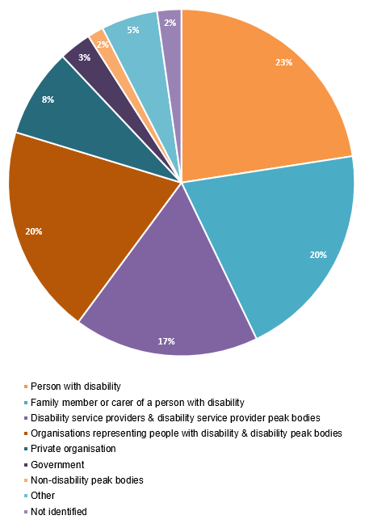
Public consultation questions
The consultation paper included several ‘questions for consideration’ that the public could consider in providing a response:
- Are there barriers or concerns for jobseekers with disability (jobseekers) not covered in this consultation paper?
- Are there barriers or concerns for employers not covered in this consultation paper?
- Do you have any feedback on the proposed vision or priority areas?
- Which actions or initiatives would best create positive change for people with disability and employers?
- How should we report against the Employment Strategy?
- How do we measure success of the Employment Strategy?
Key topics from public consultation submissions
The graphs below highlight the key issues from the public consultation process. These do not represent all of the information provided, only the most common issues across all submissions.
Figure 2: Common issues across submissions received
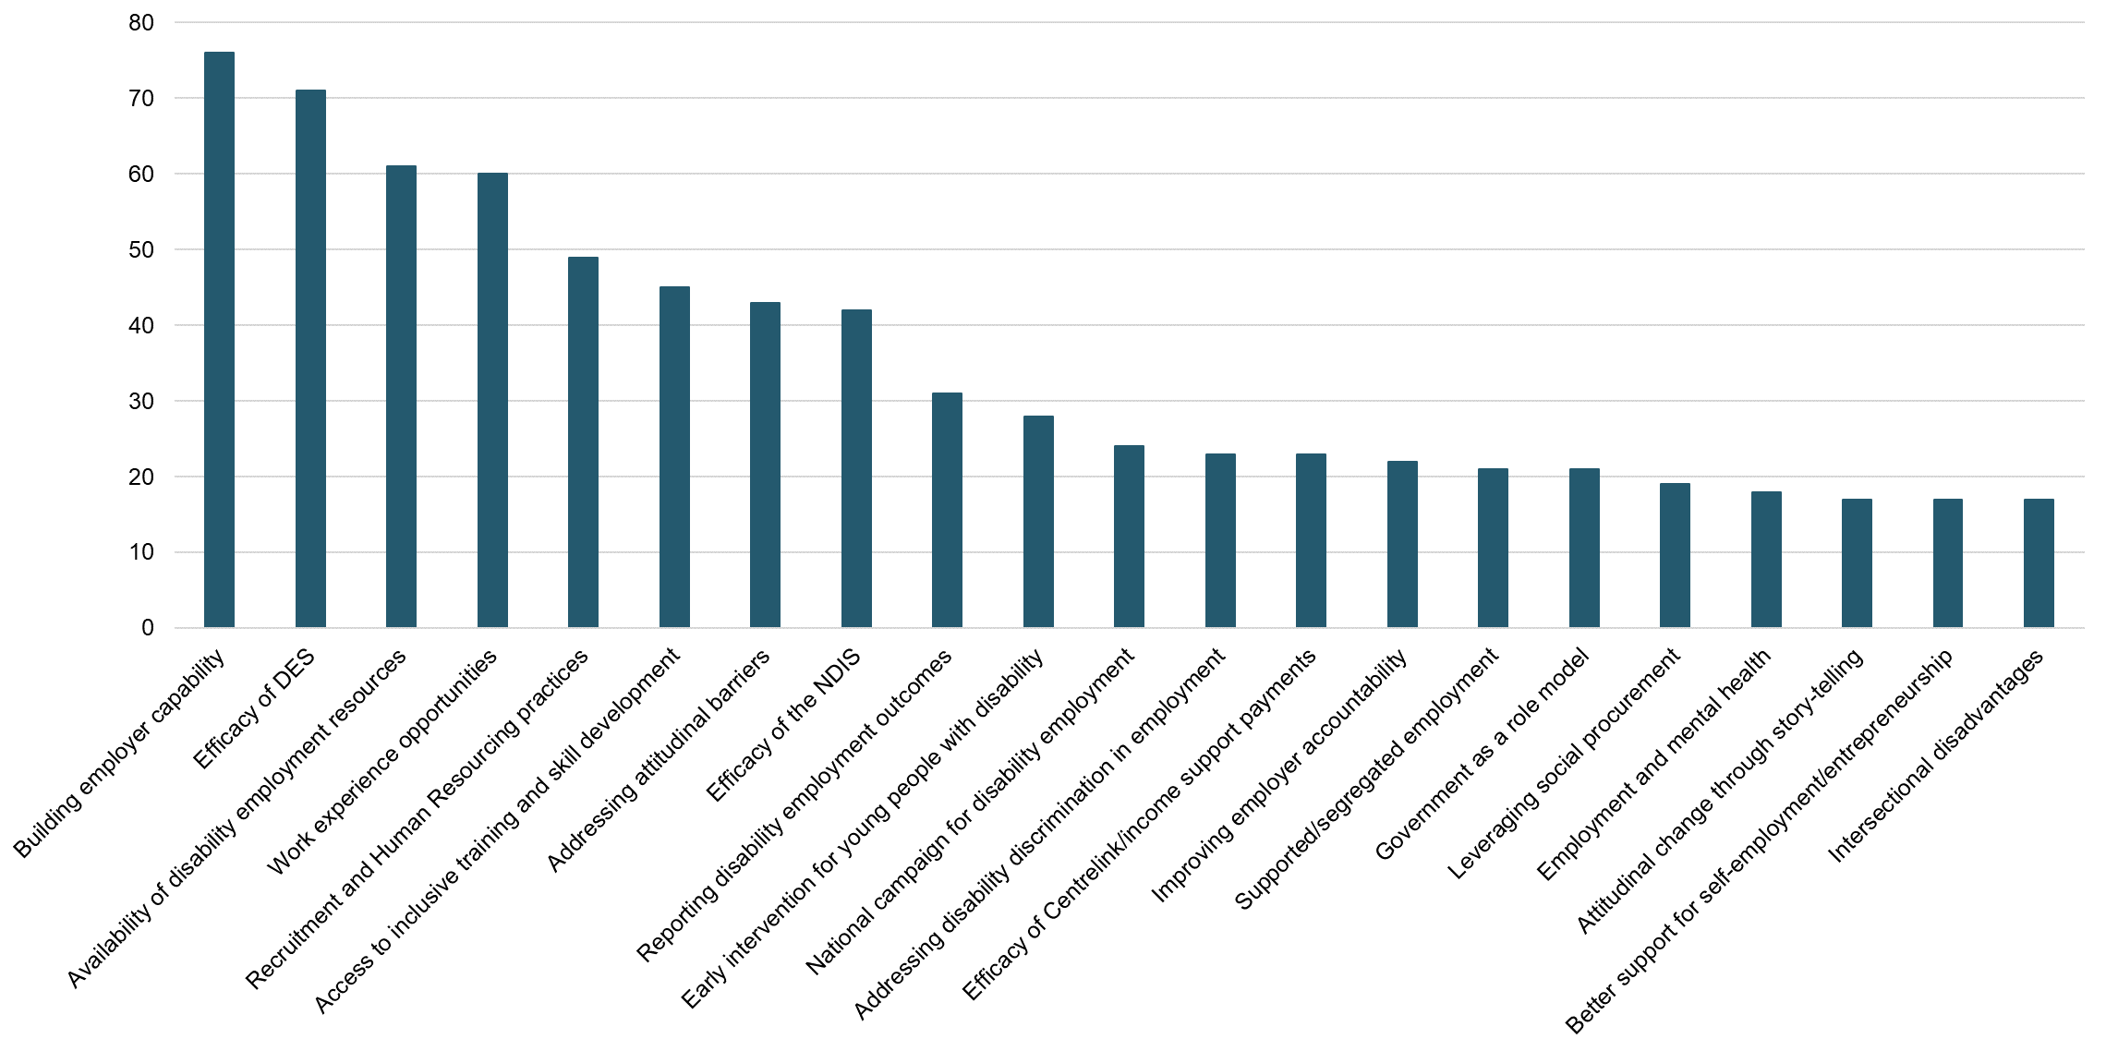

Figure 3: Common issues across submissions received, broken down by stakeholder group
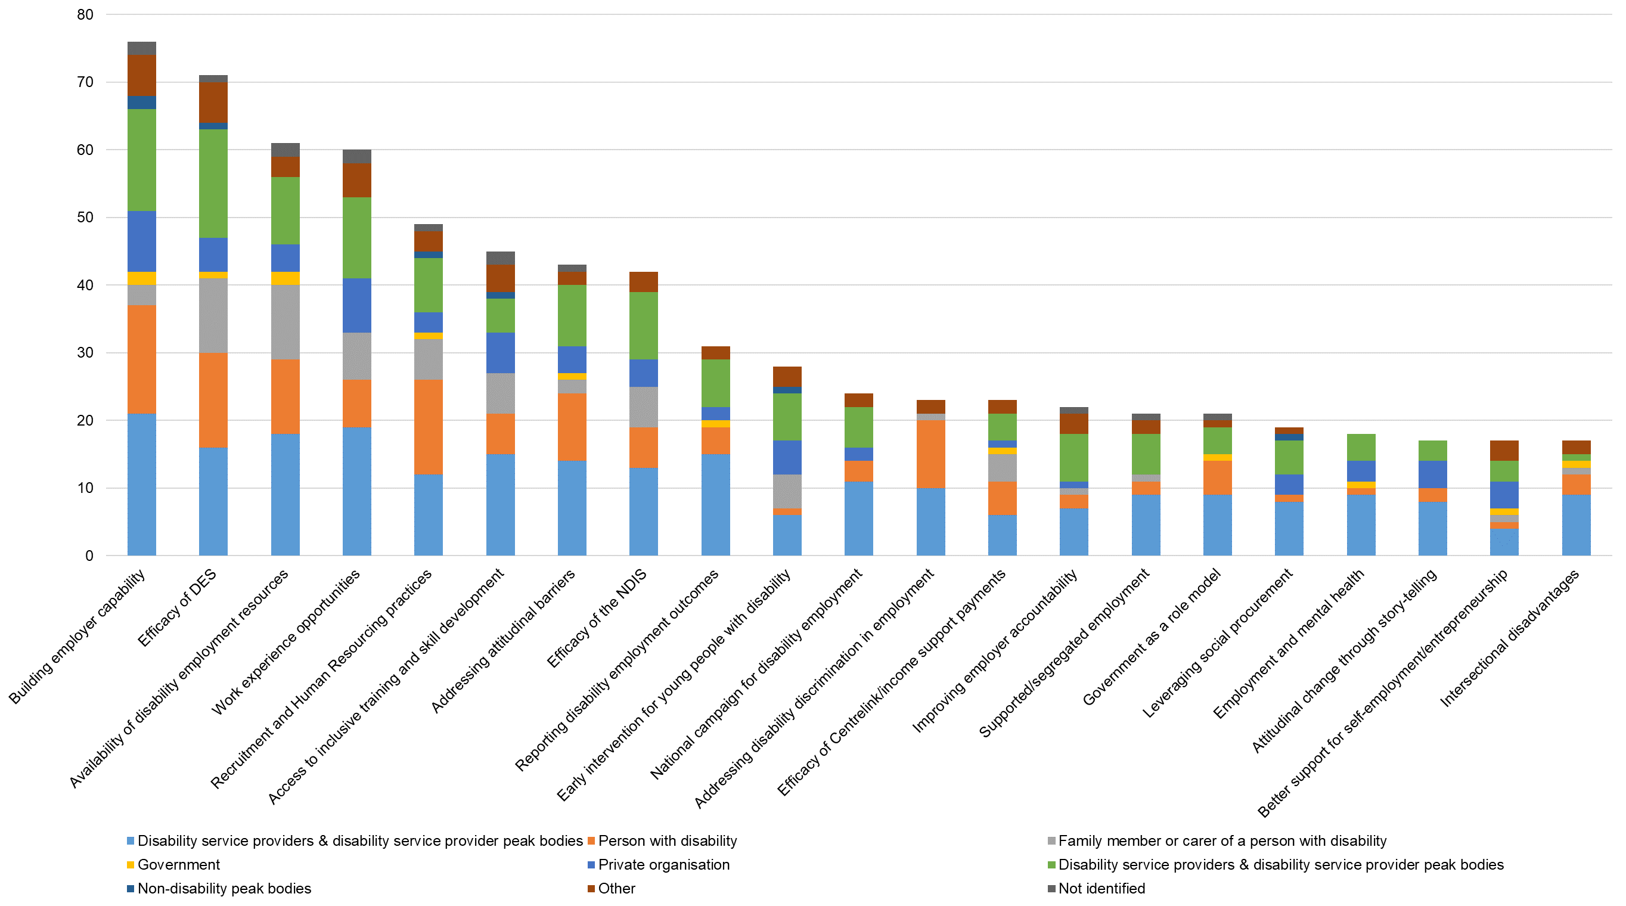

Disability Employment Advisory Committee
In September 2020, the Department established the Disability Employment Advisory Committee (the Committee). The Committee, which includes representation from people with disability, employers, peak bodies, and community organisations, has provided advice on key issues and barriers to improving employment outcomes for people with disability, as well as potential initiatives under the National Disability Employment Strategy.

Targeted consultations
From December 2020 to June 2021, the Department undertook targeted consultations with a variety of stakeholders. These took the form of:
- Roundtables, reference groups and workshops
- one-on-one meetings, and
- targeted interviews with people with disability.
There was a particular focus on cohorts that are harder to reach or experience additional vulnerabilities (for example: young people, First Nations people, culturally diverse people, women and LGBTQIA+ people with disability).
Roundtables, reference groups and workshops
The Department organised a LGBTQIA+ focused roundtable with seven participants, including LBTQIA+ people with lived experience of disability, as well as representatives from LGBTQIA+ support services. The Disability Discrimination Commissioner, Dr Ben Gauntlett, facilitated and chaired the roundtable.
The Department participated in an employer workshop led by the Australian Network on Disability on 18 May 2021, which had 25 employer representatives from 21 organisations in attendance.
The Department also convened a special Disability Employment Services Reference Group meeting on 23 April 2021 with eight attendees from service provider and industry peak bodies and disability representative organisations.

Table 2: Number of stakeholders involved in roundtables, reference groups and workshops, broken down by stakeholder group
Stakeholder group | Number of attendees
Government Employers | 10
Private Employers | 15
Non-government organisations | 5
Disability representative organisations | 3
Disability employment peak bodies | 4
Industry peak bodies | 1
Other | 3
Total | 41
One-on-one meetings
The one-on-one discussions with stakeholders focused on issues and barriers around disability employment and what the Employment Strategy should do to improve employment outcomes for people with disability.
The table below outlines the different stakeholder groups involved in these meetings:
Table 3: Number of stakeholders involved in one-on-one meetings, broken down by stakeholder group
Stakeholder group | Number of meetings
Non-government organisations | 8
Disability representative organisations | 7
Government agencies | 4
Private organisations (including employers) | 4
Universities | 1
Disability employment peak bodies | 1
Industry peak bodies | 1
Total | 26
Targeted interviews with people with disability
In mid-2020 and mid-2021, Services Australia, on behalf of the Department, conducted paid in-depth interviews with people with disability regarding their employment experiences.
The research projects involved 64 people with disability across Australia. A snapshot of participant demographics is included below:
Figure 4: Participant gender
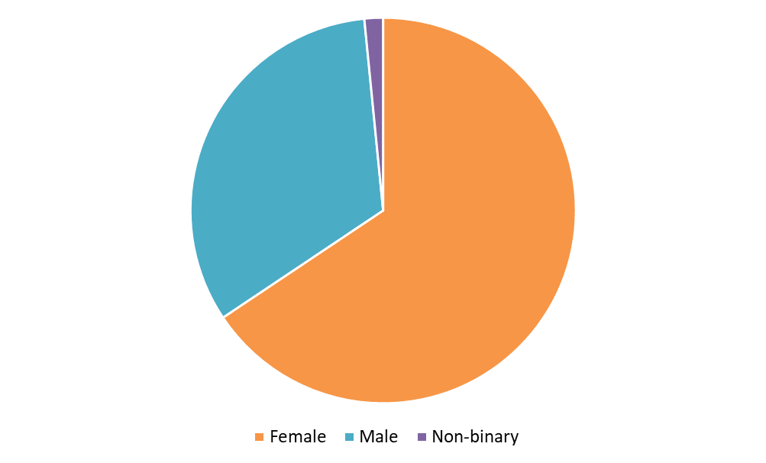
- 6 participants identified as Aboriginal and Torres Strait Islander
- 5 participants identified as Culturally and Linguistically Diverse
- 4 participants identified as LGBTQIA+
Figure 5: Participant age range – 2020 interviews
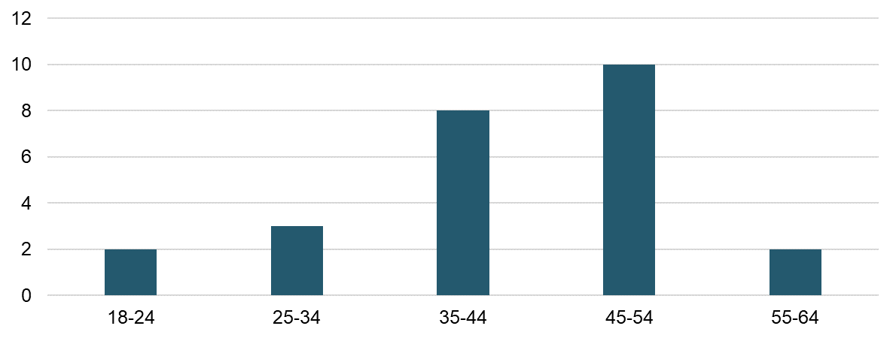

Figure 6: Participant age range – 2021 interviews
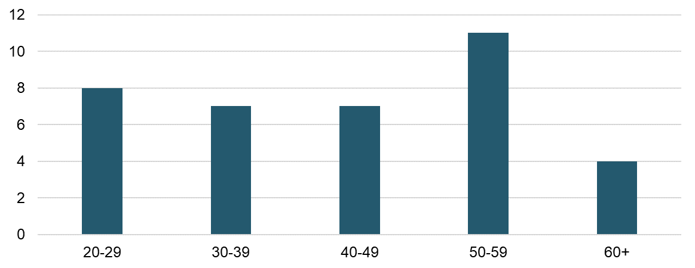
*Note: two participants in the 2021 interviews did not disclose their age
Figure 7: Participant primary disability – 2020 interviews
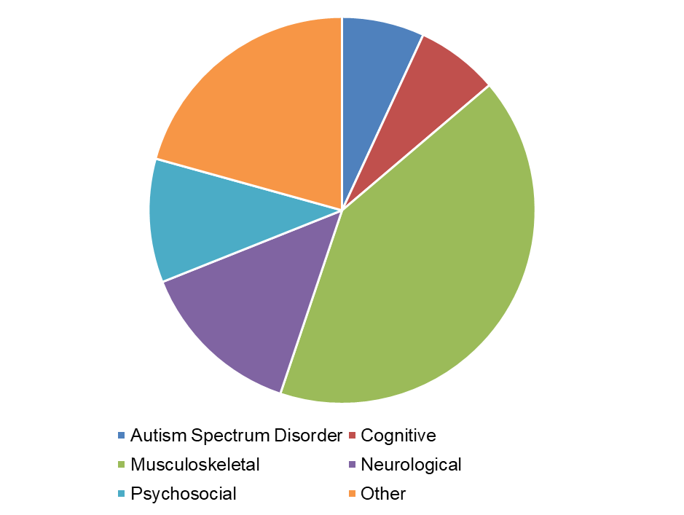

Figure 8: Participant primary disability – 2021 interviews
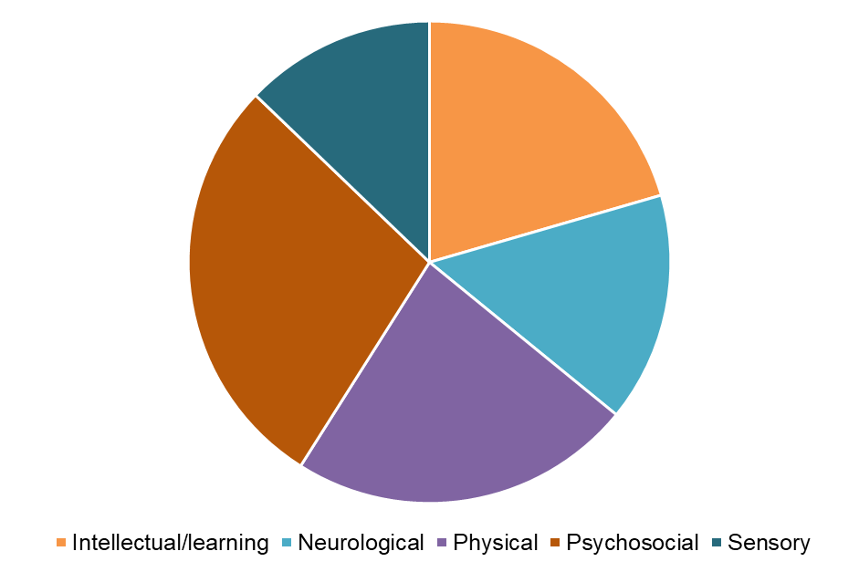

Australian Bureau of Statistics (ABS) data shows people with a disability have an unemployment rate of 10.5 per cent compared to 4.6 per cent for people without a reported disability.
Submission from person with disability to National Disability Employment Strategy Public Consultation Process, April 2021.
Vision Australia submission to National Disability Employment Strategy Public Consultation Process, April 2021.
Vision Australia submission to National Disability Employment Strategy Public Consultation Process, April 2021.
Amaze submission to National Disability Employment Strategy Public Consultation Process, April 2021.
National Mental Health Commission submission to National Disability Employment Strategy Public Consultation Process, April 2021.
MS Australia submission to National Disability Employment Strategy Public Consultation Process, April 2021.
Anonymous employer from the construction industry in direct engagement with Department of Social Services, April 2021.
Diversity Council of Australia in direct engagement with Department of Social Services, April 2021.
Anonymous submission to National Disability Employment Strategy Public Consultation Process, April 2021.
Anonymous employer from construction industry in direct engagement with the Department of Social Services, April 2021.
Submission from person with disability to National Disability Employment Strategy Public Consultation Process, April 2021.
Amaze submission to National Disability Employment Strategy Public Consultation Process, April 2021.
Anonymous submission to National Disability Employment Strategy Public Consultation Process, April 2021.
Anonymous submission to National Disability Employment Strategy Public Consultation Process, April 2021.
Spinal Cord Injuries Australia submission to National Disability Employment Strategy Public Consultation Process, April 2021.
Family Advocacy submission to National Disability Employment Strategy Public Consultation Process, April 2021.
Transition support and career counselling, while referenced under this priority area were consistently referenced as important for all people with disability, regardless of age or disability type.
University of Technology Sydney submission to National Disability Employment Strategy Public Consultation Process, April 2021.
Family Advocacy submission to National Disability Employment Strategy Public Consultation Process, April 2021.
Melbourne Disability Institute submission to National Disability Employment Strategy Public Consultation Process, April 2021.
Amaze submission to National Disability Employment Strategy Public Consultation Process, April 2021.
Steps Group Australia and National Disability Coordination Officer Program submission to National Disability Employment Strategy Public Consultation Process, April 2021.
Untapped Holdings submission to National Disability Employment Strategy Public Consultation Process, April 2021.
Amaze submission to National Disability Employment Strategy Public Consultation Process, April 2021.
Person with disability in direct engagement with Department of Social Services, February 2021.
Employment service providers deliver supports under a range of government programs including jobactive, DES and the Community Development Program. Further information is available at https://jobsearch.gov.au/serviceproviders
Anonymous submission to National Disability Employment Strategy Public Consultation Process, April 2021.
Submission from parent of person with disability to National Disability Employment Strategy Public Consultation Process, April 2021.
Submission from person with disability to National Disability Employment Strategy Public Consultation Process, April 2021.
Submission from person with disability to National Disability Employment Strategy Public Consultation Process, April 2021.
Melbourne Disability Institute submission to National Disability Employment Strategy Public Consultation Process, April 2021.
Centre of Research Excellence in Disability and Health submission to National Disability Employment Strategy Public Consultation Process, April 2021.
WDEA Works submission to National Disability Employment Strategy Public Consultation Process, April 2021.
Submission from person with professional experience in Disability Employment Services to National Disability Employment Strategy Public Consultation Process, April 2021.
Submission from person with disability to National Disability Employment Strategy Public Consultation Process, April 2021.
Submission from person with disability to National Disability Employment Strategy Public Consultation Process, April 2021.
Submission from carer of person with disability to National Disability Employment Strategy Public Consultation Process, April 2021.
Australian Communications Consumer Action Network submission to National Disability Employment Strategy Public Consultation Process, April 2021.
Family Advocacy submission to National Disability Employment Strategy Public Consultation Process, April 2021.
Valued Lives Foundation submission Services to National Disability Employment Strategy Public Consultation Process, April 2021.
Ibid.
University of Technology Sydney submission to National Disability Employment Strategy Public Consultation Process, April 2021.
Challenge Community Services submission to National Disability Employment Strategy Public Consultation Process, April 2021.
Queensland Advocacy Incorporated submission to National Disability Employment Strategy Public Consultation Process, April 2021.
Disability Employment Advisory Committee member, Meeting Five, Tuesday 15 December 2020.
Art Access Australia submission to National Disability Employment Strategy Public Consultation Process, April 2021.

