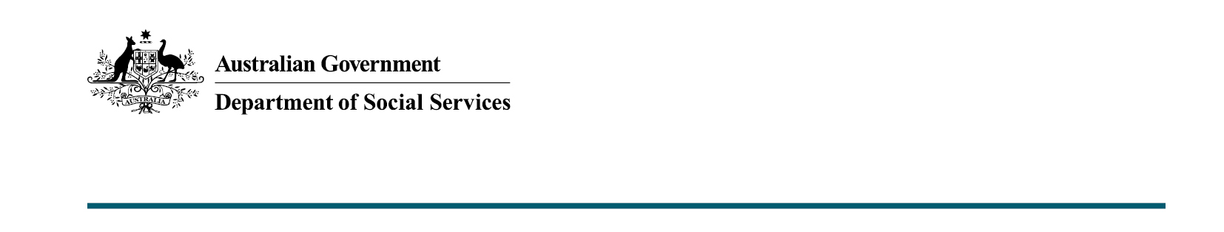
DSS 23.11.2021

Frequently Asked Questions
  - New Disability Employment Support Model Consultation

Why is the department developing a new disability employment support model?
The Australian Government is committed to improving employment support services for people with disability to ensure they are sustainable into the future and can support those who need it most. People with disability and employers need a system that meets their needs and provides appropriate supports to get and retain the right people in the right roles.
There has been significant investment by the Government to address these barriers and, while supports are working for some, more could be done to improve employment outcomes for people with disability.
That is why the department is designing options for a new disability employment support model for commencement from July 2023, following the conclusion of the current Disability Employment Services (DES) program on 30 June 2023.
The new model will address the issues that matter most and respond to the changing the economic and labour market to improve employment outcomes for people with disability.

How do I make a submission to the consultation?
To make a submission to the consultation, visit DSS Engage. You can provide a written comment in the space provided or upload a separate document with your submission.
Submissions can also be provided via email at DESConsultation@dss.gov.au or sent by post to:
Disability Employment Reform Branch
Department of Social Services
GPO Box 9820
Canberra ACT 2601
Please consider postal delivery times if sending a written submission via post.
If you send your submission via email or post, please specify whether you would like your submission to be published (either anonymously or under your name/organisation).

Can I discuss topics in my submission that are not included in the Consultation Paper?
The New Disability Employment Support Program Consultation Paper sets out the topics that people with disability, employers and other stakeholders have said are important to consider in reforming disability employment support.
The Consultation Paper is intended to act as a broad guideline for submissions, and the topics covered are not exhaustive. The department wants to hear feedback and ideas on ways to improve how disability employment support is delivered. You are welcome to include any information in your submission that you feel is relevant to the design of the new program.
You may wish to provide a general submission the paper, or to answer some or all of the questions.

Will the deadline for submissions be extended past 4 January 2022? Will late submissions be accepted?
Public consultation will be open from 5 November 2021 to 4 January 2022.
Unfortunately, it is not possible to extend the closing date due to our tight timeframe for developing and implementing the new model by July 2023.
Closing the consultation on 4 January 2022 will allow the department the time to appropriately consider each submission. Any extension beyond this date, however, will not allow us the time to show the submissions the respect they deserve.
We will not be able to accept any late submissions.

How will the consultation findings be used and will they be released publically? How can I stay updated on the consultation?
Responses to this paper will help the department design the new disability employment support model. Following the close of the consultation period, the department intends to publish a high-level summary of the submissions outlining what we have heard from stakeholders. Individual submissions may be published, anonymously where requested, on engage.dss.gov.au.
The department will update the DSS website throughout the design and transition process to keep people up to date.

Does the Consultation Paper consider previous consultation?
Reforming disability employment is one piece of the Australian Government’s ongoing commitment to improving outcomes for people with disability. This public consultation is the next step in a growing body of work. It is crucial that we learn from the experiences of people with disability and their carers to inform the design process.
The new disability employment model will be informed by the cumulative knowledge gained through engagement sought in concurrent bodies of work including:
- the Australian Disability Strategy
- the Disability Employment Strategy
- the Disability Royal Commission
- the National Disability Insurance Scheme.

Who is involved in the consultation process for the new model?
We know it is crucial that we learn from the experiences of people with disability and their carers to inform the design process. This is why we have established multiple modes and channels of consultation. The department is already engaging with a range of organisations as part of the work to reform disability employment support.
The Disability Discrimination Commissioner, Dr Ben Gauntlett, chairs the Disability Employment Services (DES) Reference Group, whose membership includes disability representative organisations, employer and employment service peak bodies, and academics. It was established to provide independent advice and guidance to the department.
The department has been engaging with disability representative organisations, DES providers and many other stakeholders through the six designated working group meetings designed to work through issues for a range of disability cohorts and topics. Working groups will develop recommendations for consideration by the DES Reference Group.
PricewaterhouseCoopers (PwC) has also been engaged to run a consultation process consisting of a series of workshops with people with disability and their carers across Australia, in-depth interviews with individuals, and employer surveys that will directly inform the design process.
This Consultation Paper is the next stage of the process and will build on all of the engagement to date.

When will we know what the new model will be?
Decisions on the design and the announcement of the final model are a matter for Government.
The new model will commence from July 2023, following the expiration of the current Disability Employment Services (DES) program on 30 June 2023.
The department will update the DSS website throughout the design and transition process to keep people up to date.

If you have any further questions about the consultation process, please contact us at DESConsultation@dss.gov.au.

