A new disability employment support program
We want to know what you think

An Easy Read paper
How to use this paper

The Australian Government Department of Social Services (DSS) wrote this paper.
When you see the word ‘we’, it means DSS.
 | We wrote this paper in an easy to read way. We use pictures to explain some ideas.
We have written some words in bold.
This means the letters are thicker and darker.
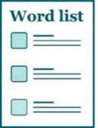 | We explain what these words mean. There is a list of these words on page 50.
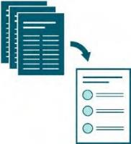 | This Easy Read paper is a summary of another paper. This means it only includes the most important ideas.
You can find more information on our website at
www.engage.dss.gov.au

This paper is very long.

You don’t have to read it all at once.
You can ask for help to read this paper.
A friend, family member or support person may be able to help you.
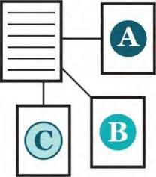 | We have split this paper up into sections. Each section is about a different idea.
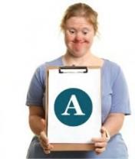 | You can work through 1 section at a time.
 | If you choose to write your answers in this paper, you should save it to your computer before you start.
 | It might take you about 1–2 hours to finish reading this paper.

What’s in this paper?
What is this paper about? 5
How to tell us what you think 7
- Who can use DES 9
- Making it easier to get employment support 13
- Employment support to help people with disability 18
- Employment support to help young people 23
- Support for employers 27
- Rules to get support payments when you don’t have a job 31
- Funding for service providers 34
- Better services and support 39
- Making sure the new program works well 46
Word list 50

What is this paper about?

We know that people with disability can find it hard to get a job.
We want to make it easier for people with disability to find employment.
Employment means you:

- have a job

- do work

- get paid.
We also want to help employers hire more people with disability.
An employer is a person who hires other people to work for them.

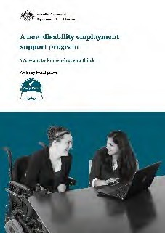 | That is why we are making a new disability employment support program.  In this paper, we call it a program.
 | At the moment we have the Disability Employment Services (DES) program.
 | DES:
 | - is run by the Australian Government
 | - helps people with disability find and keep jobs.
 | Before we make a new program, we want to find out what people think.
This includes what:

- works well now

- needs to work better.

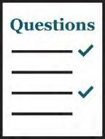
How to tell us what you think

In this paper we:

- talk about our ideas

- ask questions.
We want to know what you think about our ideas. There is no right or wrong answer.
You don’t have to answer all the questions.
There is a box below each question where you can write your answer.
Or you can write your answers in another document, such as a Word document or an email.

You can also record a:
- video
- voice recording.
You can send us your answers by:
- visiting our website at
www.engage.dss.gov.au
- sending us an email
DESConsultation@dss.gov.au
- sending us a letter to
Attn: Disability Employment Reforms Branch GPO Box 9820
Canberra ACT 2601.
Please tell us what you think before 4 January 2022.

Who can use DES

 | 1 in 5 Australian people live with disability. That’s about 4.4 million people.
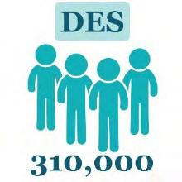 | In September 2021, more than 310,000 people were using DES.
People with disability can find it hard to:

- find a job

- keep a job.
 | So we need to:
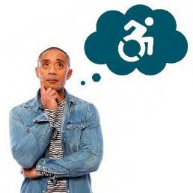 | - think about what people with disability need
 | - make sure everyone can get employment.

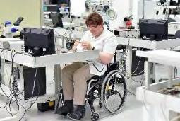 | For example, many people with disability  do not need as much support in a workplace if it is accessible.
A workplace is any place you might work, such as:

- an office

- a factory

- a hospital.
 | When something is accessible, everyone can use it.
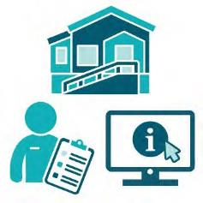 | This might be:  - a place or a building  - a service  - a website.
People with disability might need employers to make changes at work to:
- meet their needs

- give them more support.

Questions to think about

Who should be able to use DES?

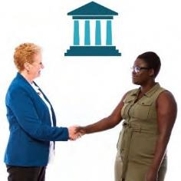
How can the new program work better with other government programs?
For example, with other employment services.

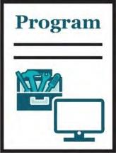

Should the new program only be about employment?
Should the new program think about other types of work, such as when you:

- only work a few hours a week?

- help others and don’t get paid?

- do work experience and don’t get paid?

Making it easier to get employment support

People with disability need employment support that can:
- meet their needs
- help them find and keep a job.
Some people told us it is hard to:

- apply for DES

- take part in DES.
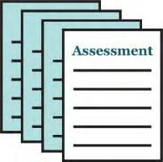 | When someone applies for DES, we do an assessment.
 | Assessments help us work out:
 | - what skills you have
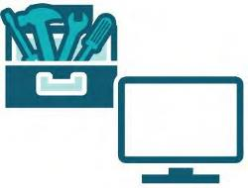 | - what work you could do

- how many hours of work you could do each week
- what support you might need.
Assessments should help people with disability find the right job for them.
At the moment assessments are about what support people need.
But they could look more at what skills people have.

Questions to think about

How can we make it easier for people with disability to get employment support?

What should we think about when we do assessments?

How can we make assessments just about what each person needs?

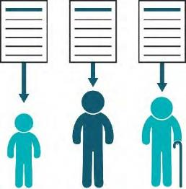 | Do we need different assessments for different times in people’s lives?
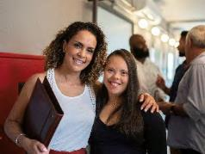 | For example, when they:  - are younger or older  - are getting ready for work  - want to keep the job they have  - want to build their career.

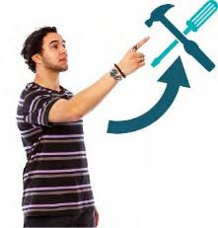 | Your career is the path you take in the area of work you choose.

Employment support to help people with disability

Services and support should meet the needs of people with disability.
Services and support should also help them:
- get ready to work
- find and keep a job
- build their career.
Some people with disability need:

- different support

- support for a longer time to keep their job.

 | Some people might:
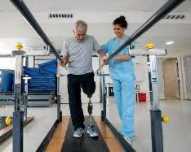 | - get a disability
 | - lose their job later in life.
So they might need different services and support:

- in a new job

- for a new career.

Questions to think about

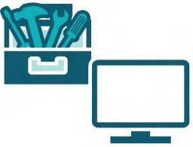 | What was your experience when you got employment support from:  - DES?  - other employment support services?
 | What worked well?

What could be better?

What type of services and support can help a person with disability:
  - find and keep a job?

  - build their career?

Who should provide this support?

What can help people with disability when something makes it hard for them to get a job?
For example, could education or training help?

How can people with disability get support to deal with things that make it hard for them to get a job?

What employment support do older people with disability need to:
  - build their career?

  - get a new job or career?

Employment support to help young people

Leaving school is an important time for young people with disability.
A job can help young people with disability:

- earn their own money

- feel like they belong

- do more on their own.
They need different types of support at this time.
Young people with disability can find it hard to:

- find and keep a job

- get work experience.

But they can have a long career if they get help early in life to:
- build their skills
- set goals.
The Government has a Transition to Work program.
This program supports some students with disability to learn how to get a job before they
leave school.
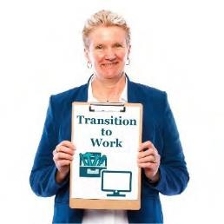

Questions to think about

What supports do young people with disability need to get ready for a job while they are still at school?

How can we help young people with disability find and keep jobs?

Should young people with disability get more support to get ready for a job while they are still at school?

How can the new program work well with education to help young people with disability to find and keep jobs?

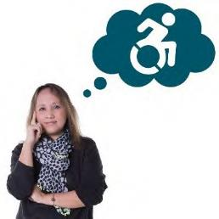
Support for employers

For the DES program to work well, we need employers who will:
- hire people with disability
- help keep people with disability in their jobs.
But some employers might not know:
- how to support workers with disability
- what help they can get to support workers with disability.

DES can help employers:
- find workers with disability that suit their business
- support workers with disability who are new to a job.
There is also a program called the Employment Assistance Fund.
It helps pay for the changes and support
employers need at work.

Questions to think about

How can we help employers hire more people with disability?

How can the new program help employers:
- hire more people with disability?
- keep them in their jobs?
- support them to build their skills?

How do employers already help people with disability at work?
How can we use these ideas in the new program?

What do employers need to support workers with disability?
For example, do employers need more:

  - information?

  - support?

Rules to get support payments when you don’t have a job

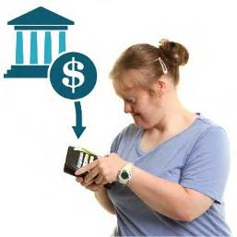 | When someone doesn’t have a job, they can get support payments from the government.
 | But they need to show they are trying to get work.
 | For example, they might:
 | - do some training
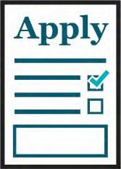 | - apply for jobs.

We want to think about other things people with disability could do to show they are trying to get work.
We also want to think about how this affects employers.

Questions to think about

How can we support people with disability to do things that show they are trying to get work?

How could we include things like:
- helping others when you don’t get paid?
- working with the community?

Funding for service providers

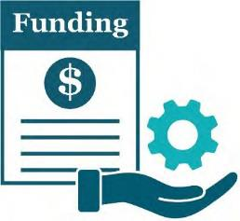 | Funding is money from the government to pay for services.
Part of the DES program gives funding to
service providers.
 | Service providers support people with disability.
 | This funding is to help people with disability find and keep jobs.
They can help you:

- find training
- do training
- find a job
- keep a job.

Service providers get funding when:

- they help someone find a job

- that person keeps their job

- they help someone do training

- they support them to stay at work.
Sometimes service providers get people with disability any job.
Service providers don’t always think about:

- what kind of job they really want

- their skills.
We want service providers to support people with disability to find and keep a job that:
- they like

- uses their skills

- helps them build a career.

We want funding to encourage service providers to offer:
- good services and supports
- new types of services and supports.
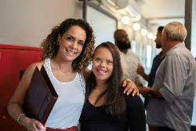 | We also want service providers to support people with disability to build careers.

Questions to think about

What are the most helpful ways for service providers to support people with disability to find and keep jobs?

How can funding make sure service providers support people with disability and employers to help people with disability:
  - find a job

  - keep a job

  - build a career.

How should funding work so it can change as the types of jobs in Australia change?

How can we reward service providers who are good at supporting people with disability to find and keep jobs that are right for them?

How should funding work for supports that focus on what each person with disability needs?

Better services and support

We want service providers to offer good services and support.
We want the new program to make it easier for service providers to work with employers.
This will help more people with disability:

- get a job

- have a career.
We want to have agreements with different service providers who can provide employment supports as part of the new program.

 | Service providers can have an agreement with us if they:
 | - get funding from the government to provide employment services
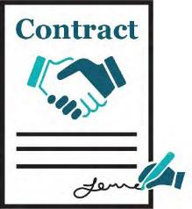 | - sign a contract with us.  A contract is a written agreement between two people or organisations.
We want to work out:

- the best way to make these agreements

- what we should think about when we make an agreement.
We also want to make sure people with disability get support from service providers with the
right skills.

Not all service providers:
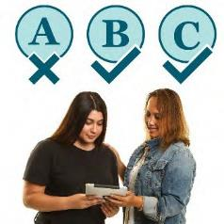 | - offer every service to all people with disability
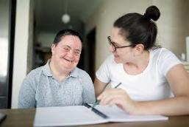 | - have the right skills to support people with certain needs.
People also told us that some people with disability might not know:
 | - what services they can expect
 | - how to choose a service provider.

Questions to think about

How should we choose which service providers can provide employment supports as part of DES?

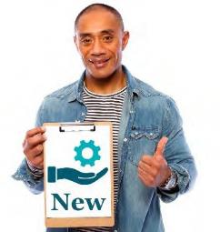
How can we encourage service providers to:

  - offer new services?

  - make their services better?

How should we make sure:

- service providers do the right thing?

- services work well?

What rules should we include when we make an agreement with a service provider?
For example, when we sign a contract.

How can we make sure people who offer employment support understand:
- what makes it hard for people with disability to find jobs?
- what employers need?
- how to match people with jobs?

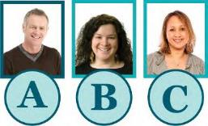

Do we need different service providers for different services?
For example, for:

- different types of employment

- older or younger people with disability

- finding workers for certain employers.

Making sure the new program works well

We want to make sure the new program works well.
We need to know what people think is important to include in the new program.
This will help us check if the new program:
- works well
- needs to be better.

Questions to think about

What would good disability employment support look like for everyone?
This includes:

- people with disability

- the community

- employers

- service providers

- the government.

What information do we need so we can check if the new program works well for everyone?

How can other people help us make sure the new program works well?
For example:

- people with disability?

- employers?

- service providers?

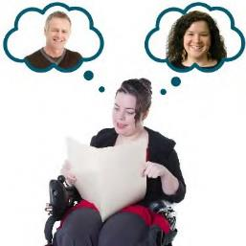 | What do people with disability need to know so they can choose the right service provider for them?
 | How should they get this information?

Word list

 | This list explains what the bold words in this document mean.
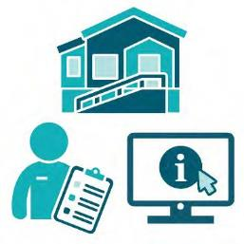 | Accessible  When something is accessible, everyone can use it. This might be:  - a place or a building  - a service  - a website.
Assessments

An assessment is a way to work out what:

- skills you have

- work you could do

- hours of work you could do each week

- support you might need.
Career

Your career is the path you take in the area of work you choose.

Disability Employment Services (DES)

DES is run by the Australian Government.

DES helps people with disability find and keep jobs.
Employer

An employer is a person who hires other people to work for them.
Employment

Employment means you:

- have a job
- do work
- get paid.
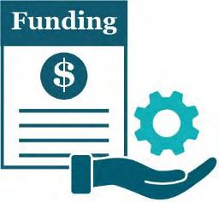 | Funding  Funding is money from the government to pay for services.
NDIS
The NDIS is a way the Australian Government supports people with disability.

Service providers

Service providers support people with disability. They can help you:
- find training

- do training

- find a job

- keep a job.
Workplace

A workplace is any place you might work, such as:

- an office

- a factory

- a hospital.

This Easy Read document was created by the Information Access Group using stock photography and custom images. The images may not be reused without permission. For any enquiries about the images, please visit www.informationaccessgroup.com.
Quote job number 4345.

