Information Paper

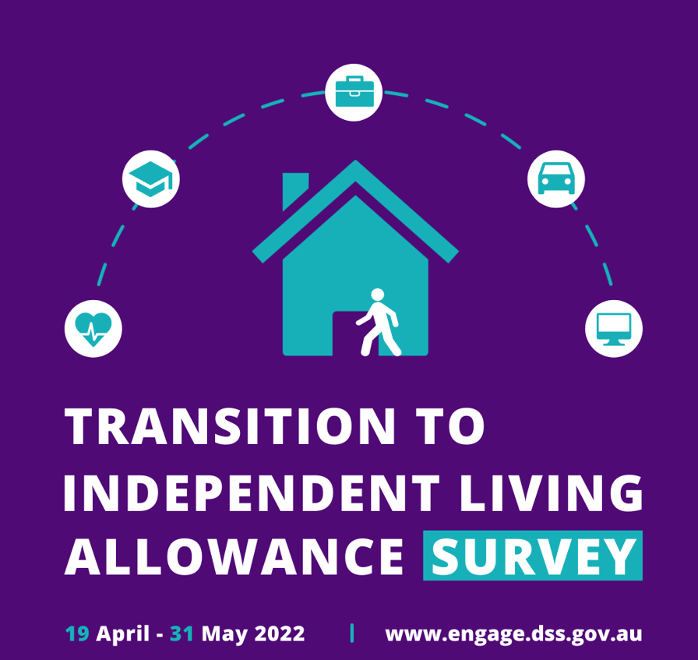

Copyright notice
This document Information Paper: Transition to Independent Living Allowance (TILA) Survey, is licensed under the Creative Commons Attribution 4.0 International Licence
Licence URL: https://creativecommons.org/licenses/by/4.0/legalcode
Please attribute: © Commonwealth of Australia (Department of Social Services) 2022
Notice:
- If you create a derivative of this document, the Department of Social Services requests the following notice be placed on your derivative: Based on Commonwealth of Australia (Department of Social Services) data.
- Inquiries regarding this licence or any other use of this document are welcome. Please contact: Branch Manager, Communication Services Branch, Department of Social Services. Phone: 1300 653 227. Email: communications@dss.gov.au
Notice identifying other material or rights in this publication:
- Australian Commonwealth Coat of Arms — not Licensed under Creative Commons, see https://www.itsanhonour.gov.au/coat-arms/index.cfm
- Certain images and photographs (as marked) — not licensed under Creative Commons

Table of Contents
Acknowledgement of Country 1
Introduction 1
Purpose of the survey 1
Survey questions 2
Timeframes for the survey 2
Consultation for this survey 3
Complaints and feedback process 3
Survey insights 3
Further information 3
Link to the survey 3
Appendix A 4
History of TILA 4
What can TILA be used for? 4
What does ‘transitioning from’ or ‘leaving care’ mean 4
TILA application and payment process 5
Appendix B 6
Linkages to other strategies and plans 6
Safe and Supported: the National Framework for Protecting Australia’s Children 2021-2031 (Safe and Supported: the National Framework) 6
Closing the Gap 7
National Out-Of-Home Care Standards 7

Acknowledgement of Country
The Department of Social Services (the department) acknowledges the traditional owners of Country throughout Australia on which we gather, live, work and stand. We acknowledge all traditional custodians, their Elders past, present and emerging and we pay our respect to their continuing connection to their culture, community, land, sea and water.

Introduction
This document provides information on the purpose and process of the survey for young people, caseworkers and non-parent carers regarding their experience and views of the Transition to Independent Living Allowance (TILA).

Purpose of the survey
Young people living in or leaving out-of-home care (OOHC) are a priority group in the Australian Government’s Safe and Supported: the National Framework for Protecting Australia’s Children 2021-2031. TILA is a $1,500.00 payment to eligible young people leaving OOHC to assist them cover the basic costs while they transition to independence.
The TILA survey is designed to gain an understanding of the TILA payment from the view of young people transitioning from out-of-home care, gather information on how young people engage with the payment and how we can better improve this to meet their needs.
Some of the themes we would like to gather information on are:
- Awareness of the payment.
- Access to and information on the payment.
- Reflections on the application and payment process.
- Impact of using the payment.
The survey is also designed for caseworkers, agency workers and non-parent carers to share their experiences in the awareness of the payment, and ease of the application and payment process.
The results of this survey will help inform government’s future policy on the administrative and payment process for TILA. A findings report will be published on the DSS website once results have been analysed by the department.

Survey questions
The TILA survey will include questions based on the following themes:

Young people who have used TILA
        - Your TILA knowledge
        - Your TILA application experience
        - How TILA helped you
        - Your ideas for improving TILA
        - Some information about yourself

Young people who have not applied for TILA
        - Your TILA knowledge
        - Your experience with TILA
        - Some information about yourself

Caseworker or agency worker
        - Some information about yourself
        - Your TILA knowledge
        - Your experience with TILA
        - Sharing your TILA experiences with us
Non-parent Carers
        - Your TILA knowledge
        - Sharing your TILA experiences with us

Timeframes for the survey
The online survey will be available from 26 April 2022 to 7 June 2022.
A translation of the survey in a language other than English or a paper copy of the survey can be requested by emailing the TILA Team at tila@dss.gov.au
Completed surveys are to be returned no later than 7 June 2022.
Please take note of delivery times or delays in the postal service when mailing a paper copy back to DSS.

Consultation for this survey
Extensive consultation has been undertaken for this survey. This includes discussions and feedback obtained from:
- states and territories departments responsible for child protection
- young people with lived experience.

Complaints and feedback process
To provide feedback on the TILA survey, email complaints@dss.gov.au. We will provide a response to your email within 21 days.

Survey insights
A report detailing the insights from the survey will be made available on the DSS website once the results have been analysed by the department.
Your responses to the survey questions will be treated in confidence and in accordance with the DSS Privacy Policy.

Further information
More information on TILA can be found at Appendix A and on the DSS website. To find out more about this survey go to engage.dss.gov.au or you can contact the TILA team at tila@dss.gov.au

Link to the survey
Have your say by completing the TILA survey at engage.dss.gov.au. We look forward to your responses.

Appendix A

History of TILA
TILA was established in 2003 in response to the Prime Minister’s Youth Pathways Action Plan Taskforce 2001, Footprint to the Future Report.
From 2004 and 2011 policy responsibility for the TILA payment moved across Commonwealth agencies due to changes in portfolio responsibilities. In 2011 a review of the payment was undertaken by Colmar Brunton, which recommended some changes to the eligibility criteria and simplifying the payment process. In 2014 the department reviewed the extent these recommendations had been implemented and took steps to implement any remaining actions.

What can TILA be used for?
TILA is a one-off payment of up to $1,500 provided to eligible young people leaving statutory or formal care arrangements, to help them purchase goods and services to assist them transition to independent living. This transition to independent living could mean the young person continues to live with their non-parent carers after their care order expires or they could leave the foster care home. Unaccompanied Humanitarian Minors (UHM) are eligible for TILA. Young people leaving informal care are not eligible for TILA.
TILA can be used for a variety of different goods and services to assist a young person transition from care and move to adulthood. The following table provides more information on what TILA can be used for:

What does ‘transitioning from’ or ‘leaving care’ mean
Transitioning from or leaving care means that a young person is developing the skills and knowledge required to become an independent adult. This can include being able to make important life decisions in areas such as employment, education, finances and relationships. Transitioning from or leaving care does not necessarily mean that a young person moves out of the accommodation or living arrangements that they were in when under formal care arrangements, especially if they are in home-based care. A young person can continue to live with their non-parent carers and still be eligible and apply for TILA.

TILA application and payment process
A young person must have a caseworker and a current leaving care plan to receive TILA. This plan is tailored to the young person’s needs and outlines required supports to assist them transition to their future independence. The leaving care plan should commence when the young person is 15 years of age, and should be reviewed and updated regularly. The leaving care plan can cover any of the relevant life domains including; housing, health, education and training, financial security, social relationships and support networks, life skills, identity and culture and legal matters, as detailed in the Transitioning from out-of-home care to independence: A nationally consistent approach to planning document and mentioned in Section 2.3 National Out-Of-Home Care Standards.
The department oversees TILA policy. Services Australia manages the payment of TILA to eligible young people through the Unified Government Gateway (UGG) portal. The TILA application process has been designed to support young people leaving care and to ensure they are connected and referred to supports and services that can assist them to successfully transition to independence.
A child protection caseworker or relevant support worker (worker) assists an eligible young person apply for TILA. The worker submits the TILA application in the UGG portal, and the payment is deposited in the workers organisation’s bank account. The worker then manages the purchase of the goods and services that have been agreed on by the worker and the young person to support the young person as they transition from care.

Appendix B

Linkages to other strategies and plans

Safe and Supported: the National Framework for Protecting Australia’s Children 2021-2031 (Safe and Supported: the National Framework)
The Australian Government is committed to reducing barriers to employment and education to ensure young people with a care experience can move into adulthood and beyond with improved life outcomes.

Nationally, 56,456 children and young people were in out-of-home care in 2019-20. Of this 11, 227 children and young people were discharged from out-of-home care.

There has been significant Government investment provided to protect Australia’s children, and while supports are working for some, more needs to be done.
To help achieve change, the Australian Government through the Department of Social Services is developing action plans under Safe and Supported: the National Framework for Protecting Australia’s Children 2021-2031.
Young people leaving out-of-home care and transitioning to adulthood are one of the priority groups of Safe and Supported: the National Framework.
The four priority groups under Safe and Supported: the National Framework are:
- children and families with multiple and complex needs
- Aboriginal and Torres Strait Islander children and young people experiencing disadvantage or who are vulnerable
- children and young people and/or parents/carers with disability, experiencing disadvantage or who are vulnerable
- children and young people who have experienced abuse and/or neglect including children in out-of-home care, and young people leaving out-of-home care and transitioning to adulthood.
The four focus areas under Safe and Supported: the National Framework are:
- a national approach to early intervention and targeted support for children and families experiencing vulnerability or disadvantage
  - this includes strengthening the interface between services across jurisdictions including disability, early childhood education and care, health and mental health, drug and alcohol, domestic violence, justice, housing, and employment service systems
- addressing the over-representation of Aboriginal and Torres Strait Islander children in child protection systems
- improved information sharing, data development and analysis
- strengthening the child and family sector including workforce capability.

The Safe and Supported: National Framework will include two 5-year action plans which are due to be finalised in 2022.

This online consultation will focus on gathering intelligence on how to improve the TILA payment to better support young people in their transition to independence, and will contribute to key efforts under The Safe and Supported: National Framework, for the fourth priority group as outlined above.

Closing the Gap
Safe and Supported: the National Framework is a key element of Commonwealth’s implementation of three targets under the National Agreement on Closing the Gap (National Agreement); Targets 9 (housing), 12 (out-of-home care), 13 (family violence).
Target 12 has a key focus on reducing the over-representation of Aboriginal and Torres Strait Islander children in out-of-home care and will set out actions to achieve this in an Indigenous-specific action plan, developed in partnership with the Aboriginal and Torres Strait Islander Leadership Group. Key actions are expected to be determined in March 2022, with the completed Action Plans to be agreed in mid-late 2022.

National Out-Of-Home Care Standards
The National Out-Of-Home Care Standards (National Standards or NOOHCS) were developed under the National Framework in 2011, and are designed to deliver consistency and drive improvements in the quality of care provided to children and young people. The 13 National Standards focus on the key factors that directly influence better outcomes for those living in out-of-home care.
NOOHCS Standard 13: Children and young people have transitioned from care plan commencing at 15 years old which details support to be provided after care, is an important standard for young people leaving care. This standard is designed to ensure that young people leaving care are best equipped for their transition to independence. Table 1 details the indicators that specifically relate to young people leaving care.
The future of the NOOHCS are being considered in the development of the Action Plans to support Safe and Supported: the National Framework.

Table 1 - NOOHCS standard 13 indicators
Domain | Indicator No. | Indicator
Leaving care plan | 13.1 | Proportion of young people aged 15–17 who have a leaving care plan
Leaving care | 13.2 | Proportion of young people aged 15-17 who, at the time of exit from out-of-home care, report they are receiving adequate assistance to prepare for adult life  (a) Make decisions about your future  (b) Education, training and work  (c) Managing money  (d) Keeping healthy  (e) Learning household skills  (f) Staying in touch with family and friends  (g) Staying in touch with culture and religion  (h) Housing/accommodation  (i) Accessing legal services
Source: Adapted from the National Out-of-Home Care Standards and Indicators. Accessed via pac_national_standard.pdf (dss.gov.au) on 14 March 2022.

Department of Education, Training and Youth Affairs, 2001, https://catalogue.nla.gov.au/Record/1006143
Department of Families, Housing, Community Services and indigenous Affairs and the National Framework Implementation Working Group, Transitioning from out-of-home care to independence: A nationally consistent approach to planning, 2011, out_of_home_care_rpt.pdf (dss.gov.au)
Must be from an approved organisation approved by the relevant state or territory Child Protection authority or agency to submit TILA applications using the Unified Government Gateway.
AIHW (2021) Child Protection Australia 2019-20 accessed via https://www.aihw.gov.au/getmedia/c3b0e267-bd63-4b91-9ea6-9fa4d14c688c/aihw-cws-78.pdf.aspx?inline=true on 14 March 2022.

