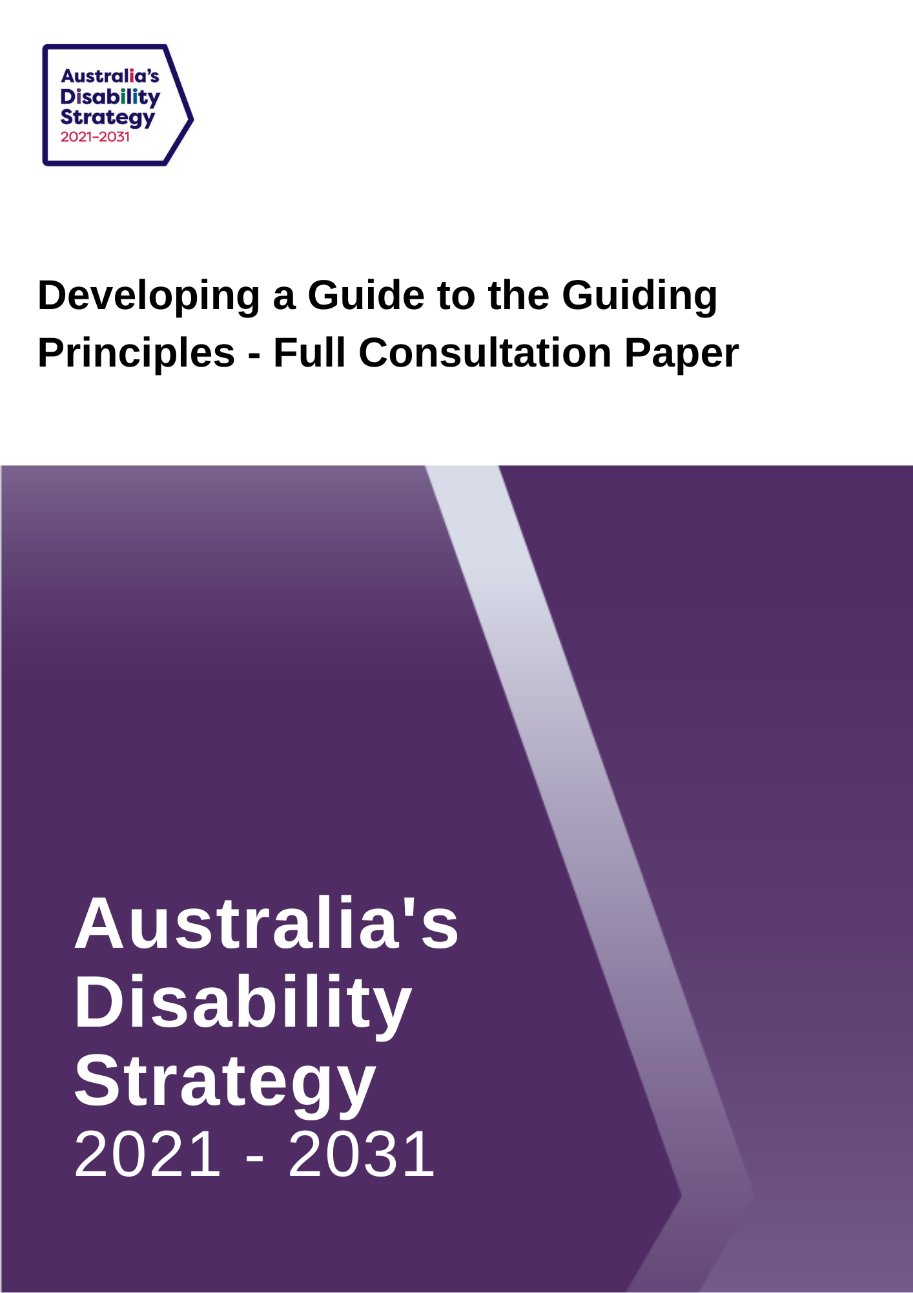

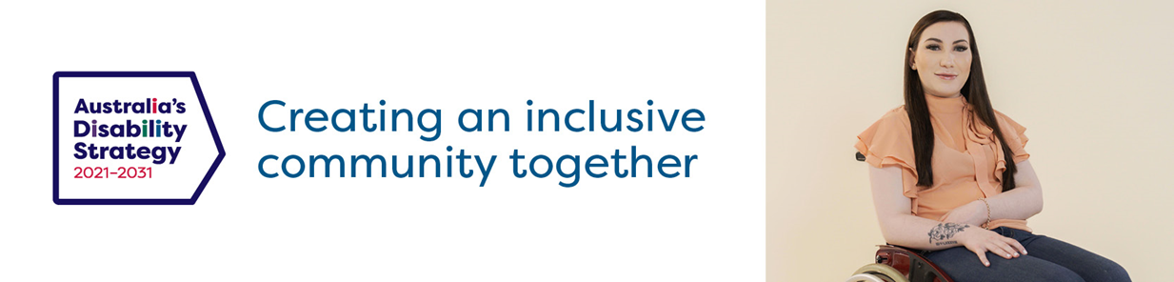

Developing a Guide to the Guiding Principles under Australia’s Disability Strategy 2021-2031 – Consultation Paper

Australia’s Disability Strategy 2021-2031
Australia’s Disability Strategy 2021-2031 (‘the Strategy’) is a ten-year plan to improve the lives of people with disability in Australia. The Strategy will play an important role in protecting, promoting and realising the human rights of people with disability.
The Strategy was developed by all levels of government and with people with disability, their families, carers and representatives through more than two years of consultations and is available on the Disability Gateway.
The Strategy’s vision is for an inclusive Australian society that ensures people with disability can fulfil their potential as equal members of the community.
The seven Outcome Areas in the Strategy set out where governments, working with the community, business, and people with disability, will focus on driving improvements for people with disability. The Outcome Areas represent the areas people with disability have said need to improve to achieve an inclusive Australian society.
One of the ways governments have committed to deliver on the vision is by using Guiding Principles in the development and implementation of policies, programs, services and systems.
The Guiding Principles
The Guiding Principles are based on Article 3 of the United Nations Convention on the Rights of Persons with Disability (UN CRPD). The UN CRPD is an important international agreement that makes sure people with disability have the same rights as everybody else and that the human rights of people with disability are protected.
To help governments, business and the community apply these Guiding Principles, the Strategy includes prompting questions under each Guiding Principle. The prompting questions point to issues which may need to be addressed so the policy, program, service or system is appropriate and accessible for people with disability.
The Strategy’s eight Guiding Principles are:
- Principle 1: Respect for inherent dignity, individual autonomy including the freedom to make one’s own choices, and independence of persons
- Principle 2: Non-discrimination
- Principle 3: Full and effective participation and inclusion in society
- Principle 4: Respect for difference and acceptance of persons with disabilities as part of human diversity and humanity
- Principle 5: Equality of opportunity
- Principle 6: Accessibility
- Principle 7: Equality of people
- Principle 8: Respect for the evolving capacities of children with disabilities and respect for the right of children with disabilities to preserve their identities.

How will the Guide to the Guiding Principles be used?
All governments in Australia have committed to use the Guiding Principles when developing new policies, programs, services or systems.
To help people apply these principles governments have also committed to developing a Guide to the Guiding Principles (the Guide). The Guide will supplement the prompting questions and may include examples and case studies to help people understand the meaning of each of the Guiding Principles. The Guide will be published on the Strategy’s website in 2023. Business and the community will be encouraged to use the Guide.
The Guide will help governments, business, and the community consider whether their new policy, program, system or service upholds the rights of people with disability in accordance with the UN CRPD. The Guide, like the Strategy will recognise intersectionality – that a person or group of people can be affected by multiple forms of discrimination and disadvantage. This can occur due to factors such as a person’s race, sex, gender identity, sexual orientation, impairment, religion, age, social origin, and geographical location.
The Guide aims to be culturally appropriate, gender sensitive, place-based, trauma-aware and use healing informed approaches for First Nations people with disability their families, communities and carers.
Input is sought on how the Guide to the Guiding Principles can best help governments, business and the community make sure its work is appropriate and accessible for people with disability.
We appreciate the time taken to provide feedback on this paper.
The Government invites the community, people with disability, their families, carers, representatives, policymakers, academics and service providers to have their say in the development of the Guide to the Guiding Principles.
You can contribute by answering the questions in this paper. Please refer to page 14 in this paper to find out how to make a submission. Submissions close on Wednesday 30 November 2022.

Questions for Feedback
Below are the eight Guiding Principles and their prompting questions for your consideration, along with nine questions for which we invite your response.
To assist you in understanding the intent and key terms of the eight Guiding Principles, please refer to the table on pages 10-13.
Principle 1 - Respect for inherent dignity, individual autonomy including the freedom to make one’s own choices, and independence of persons
Existing prompting questions in the Strategy:
- Does the policy/program/service/system (proposal) allow people with disability to make their own choices in the same way as people without disability?
- Does the proposal give access to supported decision making as required?
Question 1:
What other information do you think is needed to help people understand Principle 1?
Things you could include in your answer are:
- What is most important to you when thinking about this principle?
- What do you need to understand about disability and people with disability in order to help you apply this principle to your work?
- How can policymakers, academics and service providers make sure the voices of people with disability are heard and their rights protected using this principle?
- Do you have examples of how the principle has been applied in real-life situations?
- Any other prompting questions that could be included?

Principle 2 - Non-discrimination
Existing prompting questions in the Strategy:
- Does the proposal avoid both direct and indirect discrimination?
- Are reasonable adjustments available that meet the needs of each individual, so people with disability can exercise the same rights and freedoms as other Australians?
- Is the proposal compliant with the Disability Discrimination Act 1992, the UN CRPD and with state and territory anti-discrimination legislation?
In Australia, this principle is covered by the Disability Discrimination Act 1992 (DDA), which makes it unlawful to discriminate against a person because of their disability in many areas of public life, including employment, education, getting or using services, renting or buying a house or unit, and accessing public places. Additionally, each state and territory has their own anti-discrimination legislation.

Question 2:
What other information do you think is needed to help people understand Principle 2?
Things you could include in your answer are:
- What is most important to you when thinking about this principle?
- What do you need to understand about disability and people with disability in order to help you apply this principle to your work?
- How should intersectional factors be considered in order to better understand discrimination?
- How can policymakers, academics and service providers make sure the voices of people with disability are heard and their rights protected using this principle?
- Do you have examples of how the principle has been applied in real-life situations?
- Any other prompting questions that could be included?

Principle 3 - Full and effective participation and inclusion in society
Existing prompting questions in the Strategy:
- Will the proposal support people to fulfil their potential?
- Will the proposal provide for a person’s inclusion and participation in all aspects of community life?
Question 3:
What other information do you think is needed to help people understand Principle 3?
Things you could include in your answer are:
- What is most important to you when thinking about this principle?
- What do you need to understand about disability and people with disability in order to help you apply this principle to your work?
- How can policymakers, academics and service providers make sure the voices of people with disability are heard and their rights protected using this principle?
- Do you have examples of how the principle has been applied in real-life situations?
- Any other prompting questions that could be included?

Principle 4 - Respect for difference and acceptance of persons with disabilities as part of human diversity and humanity
Existing prompting question in the Strategy:
- Does the proposal respect and recognise the equal value, worth and dignity of all people with disability?
Question 4:
What other information do you think is needed help people understand Principle 4?
Things you could include in your answer are:
- What is most important to you when thinking about this principle?
- What do you need to understand about disability and people with disability in order to help you apply this principle to your work?
- How can policymakers, academics and service providers make sure the voices of people with disability are heard and their rights protected using this principle?
- Do you have examples of how the principle has been applied in real-life situations?
- Any other prompting questions that could be included?

Principle 5 - Equality of opportunity
Existing prompting questions in the Strategy:
- Does the proposal provide for people (including people facing multiple forms of discrimination) to be treated fairly, including by taking positive actions to accommodate differences?
- Are there any barriers or processes in the proposal that unfairly limit people with disability from achieving their goals?
Question 5:
What other information do you think is needed to help people understand Principle 5?
Things you could include in your answer are:
- What is most important to you when thinking about this principle?
- What do you need to understand about disability and people with disability in order to help you apply this principle to your work?
- How can policymakers, academics and service providers make sure the voices of people with disability are heard and their rights protected using this principle?
- Do you have examples of how the principle has been applied in real-life situations?
- Any other prompting questions that could be included?

Principle 6 – Accessibility
Existing prompting questions in the Strategy:
- Can people with disability access all aspects of the proposal, including the information, technology, services and location?
- Have the principles of universal design been applied?
Question 6:
What other information do you think is needed to help people understand Principle 6?
Things you could include in your answer are:
- What is most important to you when thinking about this principle?
- What do you need to understand about disability and people with disability in order to help you apply this principle to your work?
- How can policymakers, academics and service providers make sure the voices of people with disability are heard and their rights protected using this principle?
- Do you have examples of how the principle has been applied in real-life situations?
- Any other prompting questions that could be included?
Principle 7 - Equality of people
Existing prompting questions in the Strategy:
- Does the proposal support the full development, advancement, empowerment and equality of all people irrespective of differences and identities, including in relation to gender, age, sexuality, race, or cultural background?
- Has consideration been given to ensure policies/programs/services/systems are culturally safe and appropriate?
Question 7:
What other information do you think is needed to help people understand Principle 7?
Things you could include in your answer are:
- What is most important to you when thinking about this principle?
- What do you need to understand about disability and people with disability in order to help you apply this principle to your work?
- How can policymakers, academics and service providers make sure the voices of people with disability are heard and their rights protected using this principle?
- Do you have examples of how the principle has been applied in real-life situations?
- Any other prompting questions that could be included?

Principle 8 - Respect for the evolving capacities of children with disabilities and respect for the right of children with disabilities to preserve their identities
Existing prompting questions in the Strategy:
- Are children with disability being treated equally to children without disability?
- Is the best interest of the child a primary consideration?
- Are children with disability being given the opportunity to participate in decisions based on their age and maturity, and on an equal basis with other children?
- Do children with disability have access to appropriate supports to make or participate in making decisions?
Question 8:
What other information do you think is needed to help people understand Principle 8?
Things you could include in your answer are:
- What is most important to you when thinking about this principle?
- What do you need to understand about disability and people with disability in order to help you apply this principle to your work?
- How can policymakers, academics and service providers make sure the voices of people with disability are heard and their rights protected using this principle?
- Do you have examples of how the principle has been applied in real-life situations?
- Does the wording of this principle and prompting questions need adjusting to incorporate young people with disability?
- Any other prompting questions that could be included?

Other advice
Question 9:
Is there anything missing from the Guiding Principles that should be included in the Guide?
For example, are there any other guiding principles you think should be added and why?

Question 10:
Do you have any good examples of when the Guiding Principles have been used?

Question 11:
What length and format should the Guide be so that it is easy to apply?
For example, should it be a series of fact sheets with supporting videos?

Question 12:
How should the Guide be used when there are short timeframes for decisions?

Key principles of a human rights approach to disability (general principles of Article 3 of the United Nations Convention on the Rights of Persons with Disabilities)
Principle | Discussion
Respect for the inherent dignity and individual autonomy, including the freedom to make one’s own choices, and the independence of persons | Inherent dignity refers to the worth of every person. When the dignity of persons with disabilities is respected, their experiences and opinions are valued and are formed without fear of physical, psychological or emotional harm.  Individual autonomy means to be in charge of one’s own life and to have the freedom to make one’s own choices.  Respect for individual autonomy means that persons with disabilities have, on an equal basis with others, reasonable life choices, are subject to minimum interference with their private lives and can make their own decisions, with adequate support if required.
Non-discrimination | Non-discrimination is a fundamental principle of all human rights treaties and the basis of the Convention on the Rights of Persons with Disabilities. It essentially prohibits discrimination against anyone on the basis of disability, given that discrimination prevents people enjoying their rights on an equal basis with others.  However, today, non-discrimination is understood as a much broader principle which encompasses not only prohibiting discriminatory acts but also taking steps to protect against potential future discrimination and hidden discrimination and promoting equality.
Full and effective participation and inclusion in society | The concepts of full and effective participation and of inclusion mean that society, both in its public and in its private dimensions, is organised so as to enable all people to take part fully.  They mean that employers and other members of the community value persons with disabilities and recognise them as equal participants—for example, in processes related to decisions that affect their lives or in the freedom to run for public office.  Participation goes beyond consultation and includes meaningful involvement in activities and decision making processes, the possibility to voice opinions, to influence and to complain when participation is denied.  Inclusion requires an accessible, barrier-free physical and social environment. It is a two-way process that promotes the acceptance of persons with disabilities and their participation, and encourages society to open up and be accessible to persons with disabilities.
Respect for difference and acceptance of persons with disabilities as part of human diversity and humanity | Respect for difference involves accepting others in a context of mutual understanding. Despite some visible and apparent differences between people, all have the same rights and dignity.  In relation to disability, it involves accepting persons with disabilities for who they are, rather than pitying them or seeing them as a problem that needs to be fixed.
Equality of opportunity | Equality of opportunity is closely linked with non-discrimination. It refers to a situation where society and the environment are made available to all, including persons with disabilities.  Equality of opportunity does not always mean that the exact same opportunities are made available to all, as treating everyone the same might result in inequalities. Rather it recognises difference between people and ensures that, despite this difference, everyone has the same opportunity to enjoy rights.
Accessibility | Making accessibility (and equality) a reality means dismantling the barriers that hinder the effective enjoyment of human rights by persons with disabilities.  Accessibility enables persons with disabilities to live independently and to participate fully in all aspects of life.  Accessibility is important in all areas of life, but in particular in the physical environment, such as buildings, roads, housing and so on, transport, information and communications, and other facilities and services open to or provided to the public.
Equality of people | The principle of equality of people indicates that the same rights should be expressly recognised on an equal footing for all people.  Despite the overlap with the principle of non-discrimination,  the reiteration of equality between men and women is expressly included in treaties, especially because there are still many prejudices preventing its full application. Suitable measures should be taken to ensure that all people irrespective of gender identity have the opportunity to exercise their rights.
Respect for the evolving capacities of children with disabilities and for their right to preserve their identities | Respect for the evolving capacities of children is a principle set out in the Convention on the Rights of the Child. It should be seen as a positive and enabling process that supports the child’s maturation, autonomy and self-expression.  Through this process, children progressively acquire knowledge, competences and understanding, including about their rights. Their participation in decision-making processes that affect them, including their right to preserve their identities, should be expanded over time in step with this evolution.

Glossary of key terms
Term | Explanation
Intersectionality | Intersectionality acknowledges that people with disability are not one homogenous group, but have different backgrounds, ages, cultural, and social identities, religions, gender and sexual identities, and communities. These factors intersect and can create higher levels of discrimination and disadvantage.
Supported decision making (principle 1 prompting question) | Supported decision making is where support is given to people with disability to help them make their own decisions.  This differs from substituted decision making where other people make decision on behalf of a person with disability.
Direct discrimination (principle 2 prompting question) | Direct discrimination is when you treat someone less favourably than others because of certain characteristics, such as disability.  For example, it would be direct discrimination if an employer does not hire a person they think is the best candidate for a job as they think the person will take a lot of sick leave.
Indirect discrimination (principle 2 prompting question) | Indirect discrimination is where rules or arrangements are in place that apply to everyone but have an unfair effect on people who share a particular attribute, such as disability. This unfair treatment may not be intended.  For example, it is indirect discrimination if the only way to enter a public building is by a set of stairs, because people with disability who use wheelchairs would be unable to enter the building.
Universal design (principle 6 prompting question) | Universal design allows everyone, to the greatest extent possible, and regardless of age or disability, to use buildings, transport, products and services without the need for specialised or adapted features.  Taking a universal design approach to programs, services and facilities is an effective way to remove barriers that exclude people with disability.
Best interest of the child (principle 8 prompting question) | The best interests of the child is a principle referring to a child’s general wellbeing and includes paying attention to a child’s view and opinion and making sure they have the things they need including: a safe environment, family and close relationships, development. The principle is used to help make decisions on what type of services, actions and directions are best for a child.

How you can provide feedback
Send us a written submission
You can send a submission in writing to:
Australia’s Disability Strategy Governance and Engagement Section
GPO Box 9820
Department of Social Services
Canberra, ACT 2601
Web
Via the consultation website at DSS Engage
Download this consultation paper
Download an Easy English version of this consultation paper
Enter or upload a written submission
Watch an Auslan video
Make a video or audio recording: if you want to send a video or audio recording of your submission, please visit DSS Engage to find out how.
If you upload your submission online, including via the online template, you will be asked to specify whether you would like your submission to be published on the DSS website.
If you send your submission via email or standard post, please specify whether you would like your submission to be published online.
Questions about the consultation process can be directed to disabilityreform@dss.gov.au
You can also call the Department of Social Services on 1800 334 505
The Closing Date for the Submission is Wednesday, 30 November 2022 at 11:59pm, AEST.

The Convention on the Rights of Persons with Disabilities. Training Guide. Professional Training Series No.19 CRPD_TrainingGuide_PTS19_EN Accessible.pdf (ohchr.org)
Note: principle 7 of the UN CRPD is ‘equality between men and women’. The change to ‘equality of people’ in this document and the Strategy is based on feedback DSS received during consultation to be more gender inclusive. ‘Equality of people’ embraces the full development, advancement, empowerment and equality of all people irrespective of differences and identities, including in relation to gender, age, sexuality, race, or cultural background, while also having a focus on equality between men and women.

