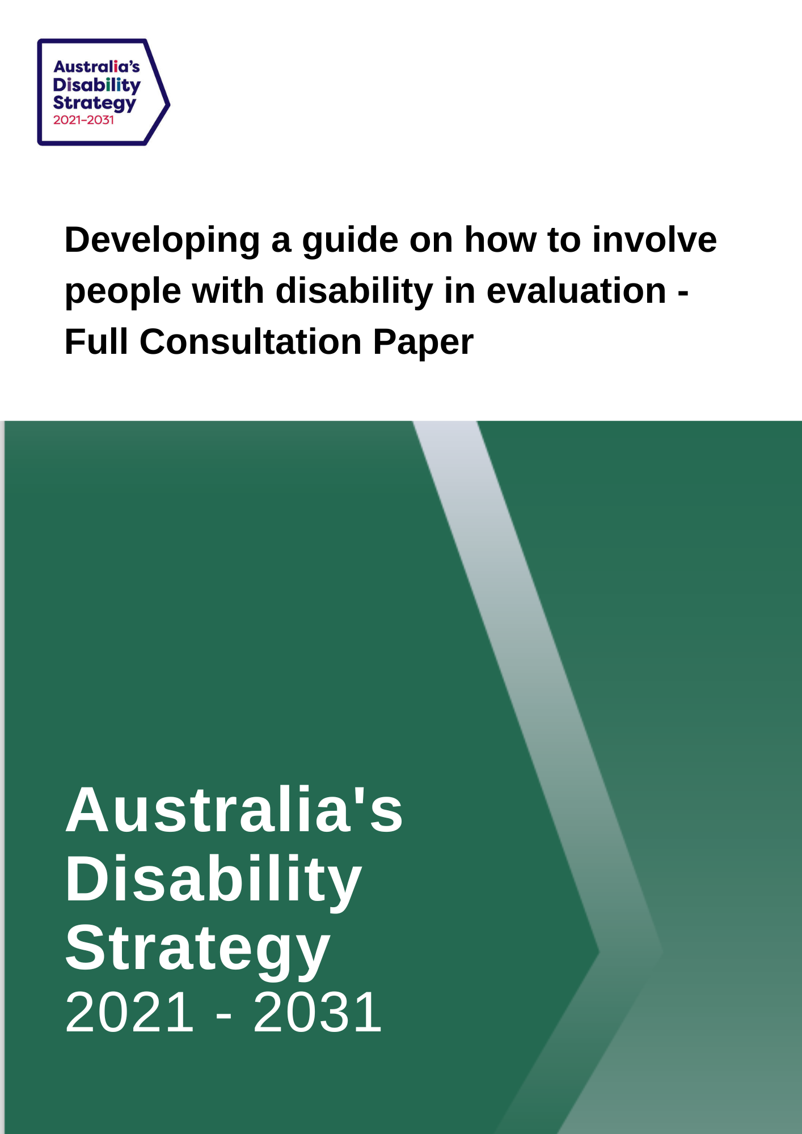

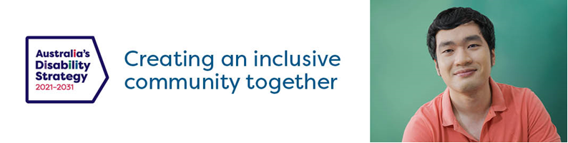

Developing a Guide on how to involve people with disability in evaluation – Consultation Paper

Australia’s Disability Strategy 2021-2031
Australia’s Disability Strategy 2021-2031 (‘the Strategy’) is a ten-year plan to improve the lives of people with disability in Australia. The Strategy will play an important role in protecting, promoting and realising the human rights of people with disability.
The Strategy was developed by all levels of government and with people with disability, their families, carers and representatives through more than two years of consultations and is available on the Disability Gateway.
The Strategy’s vision is for an inclusive Australian society that ensures people with disability can fulfil their potential as equal members of the community.
The seven Outcome Areas in the Strategy set out where governments, working with the community and business, and people with disability, will focus on driving improvements for people with disability. The Outcome Areas represent the areas people with disability have said need to improve to achieve an inclusive Australian society.
In the Strategy, all governments made a commitment to work together with people with disability to develop a guide on how to involve people with disability in evaluation (the Evaluation Guide). The Evaluation Guide will be published on the Strategy’s website in 2023.
Other government commitments to evaluation and consultation under the Strategy can be found in Appendix 1 of the Strategy.

Why is Evaluation important?
Evaluation is critical to knowing what is working well and what needs improvement for people with disability. Evaluations of policies, programs, and systems help us understand why current outcomes are being achieved and what the strengths and gaps are in these initiatives.
Guide to involving people with disability in evaluation
The Evaluation Guide will support governments’ commitments to evaluation in the Strategy set out in Appendix 1 and build on the Strategy’s Evaluation Good Practice Guide Checklist at Appendix 2.

The Evaluation Guide will take a human rights approach to engagement, inclusion, and accessibility. It will recognise the rights of people with disability to fully participate in evaluations on an equal basis with others.
The Guide is not a ‘one size fits all’ process and needs to consider the diversity of people with disability and how best to include them in evaluations.
It is proposed the Evaluation Guide has two parts:
A. Best practice principles for involving people with disability in evaluation
B. How to actively involve people with disability across the evaluation cycle (design, implementation and analysis, and actions flowing from recommendations).
The Government invites all Australians to have their say in the development of the Evaluation Guide. Please refer to page 8 in this paper to find out how. Submissions close on The Closing Date for the Submission is Wednesday 30 November 2022 at 11:59pm, AEST.

- Proposed Best Practice Principles for Evaluation
In the box below are proposed principles to support a consistent, ethical approach to evaluations. They will cover evaluations of the Strategy’s policies, programs, and systems.
The proposed best practice principles have been drawn from the United Nations and Organisation for Economic Co-operation and Development research protocols and recent work produced in Australia on inclusive research practices.
Principles of best practice for involving people with disability in evaluation,,
- Informed and transparent. Decisions and processes about evaluation are open and transparent and led or informed by people with disability.
- Promotes wellbeing. The evaluation contributes to the wellbeing of people with disability.
- Co-design. Co-production, collaboration, and joint-decision-making with people with disability are embedded throughout the evaluation process.
- Co-researchers. In addition to involving researchers and academics with disability, people with disability outside of academic or research institutions are included as active co-researchers (also known as participatory or community researchers).
- Relevance. Evaluations explore issues important to people with disability.
- Accessible. The evaluation process is accessible to people with disability.
- Diversity. The evaluation process includes people with disability across a range of experiences, cultural groups, gender, sexuality, ages, geographical location etc.
- Ownership. People with disability have a degree of ownership over evaluation design, implementation, dissemination, and actions flowing from recommendations.
- Co-presentation. People with disability are included in the presentation of evaluation findings.
Question 1 - Best practice principles
- What is important to you about these principles?
- Do you have any positive or negative comments about them?
- Is there anything you would add?

- Actively involving people with disability across the evaluation cycle
People with disability should be actively involved in all three stages of the evaluation cycle:
- Design
- Implementation and analysis
- Actions flowing from recommendations

- Design phase
The design phase of evaluations includes selection of the type of evaluation (process, impact, or summative), the research questions, and methodology. The Evaluation Guide will set out how to actively involve people with disability in the design phase to bring in their lived experience and knowledge. In the design phase this could include:
- Identifying and consulting with appropriate stakeholders in an inclusive and accessible manner.
- Developing research questions with people with disability, so the evaluation focuses on issues important to people with disability.
- Establishing co-researcher and leadership roles for people with disability.
- Designing the evaluation to be respectful and safe for people with disability. This includes gaining informed consent and using trauma-informed approaches with robust feedback and complaints procedures.
- Considering how the needs and perspectives of diverse and specific groups are part of the evaluation design.
- Designing the evaluation to have culturally appropriate representation and safety as core components
- Adopting flexible methods that are appropriate to people from various cohorts and ages, such as people with intellectual disability, Aboriginal and Torres Strait Islander peoples, people from culturally and linguistically diverse backgrounds, LGBTIQ, rural and remote communities.

Question 2 - Design phase
- What do you think of these points for the Design phase of the Evaluation Guide?
- Does anything else need to be included?

- Implementation and Analysis phase
The implementation and analysis phase of evaluations includes subject recruitment, data collection and interpretation, and sharing results. The Evaluation Guide will set out how to actively involve people with disability in the implementation phase. This could include:
- Making it easy for people with disability to participate through accessible communication about the evaluation. This includes allocating appropriate time and resources using accessible materials and formats.
- Consultations being guided by people with disability, such as co-facilitation by people with lived experience of disability.
- Adopting universal design methods for data collection. This means having flexible and accessible approaches to support people with different types of disability and circumstances.
- Respecting the time and effort of people with disability, including consideration of remuneration and/or incentives.
- Actively addressing barriers to participating in the evaluation.
- Capturing disaggregated data to give visibility on the impacts for people with disability with different backgrounds, situations, and experiences.
- Producing evaluation findings in a way that supports translation into real life improvements for people with disability.
- Providing opportunities for people with disability to co-present evaluation findings.
- Sharing the outcomes and findings with people with disability, including people directly involved, as well as the broader disability community.

Question 3 - Implementation and analysis phase
- Will these points make sure people with disability are appropriately included in an implementation and analysis phase of an evaluation?
- Are we missing any important issues?

- Actions flowing from the Recommendations phase
The actions flowing from recommendations is the final phase of evaluation. This phase covers the action and response governments and organisations take based on the findings of the evaluation. The Evaluation Guide will set out how to actively involve people with disability in actions flowing from recommendation phase. This will depend on why the evaluation was conducted, such as to understand the need for a government program or activity, identify good practice, improve design and performance, determine effects/impacts, or inform decisions about future policy development.
For this phase it is proposed the Evaluation Guide focuses on setting out approaches that can be used to actively engage with people with disability in the application of the findings. This could include:
- Recognising the expertise of people with disability in providing guidance on how to apply these findings to policies, programs and systems.
- Advising on the process that will be used to determine how evaluation findings will be considered.
- Providing opportunities, including adequate time and forums to consider or plan action from the evaluation.

Question 4 - Actions phase
- Do these points adequately encourage the involvement of people with disability in an action phase of evaluations?
- Would you like to see anything added?

Other advice

Question 5
Is there anything else you think should be included in the Evaluation Guide to support the involvement of people with disability in evaluations?

Additional resources of engaging people with disability
Alongside the development of the Evaluation Guide, a Good Practice Guide to Engaging People with Disability (The GPG) is being developed in 2022. These will be complementary documents intended to be used together. Both the GPG and Evaluation Guide will draw from the advice provided during consultations for the Strategy. The GPG will set out how governments and organisations can actively include all people with disability in consultations and engagement, and the Evaluation Guide will do the same for evaluations.

How you can provide feedback
Send us a written submission
You can send a submission in writing to:
Australia’s Disability Strategy Governance and Engagement Section
GPO Box 9820
Department of Social Services
Canberra, ACT 2601
Web
Via the consultation website at DSS Engage
Download this consultation paper
Download an Easy English version of this consultation paper
Enter or upload a written submission
Watch an Auslan video
Make a video or audio recording: if you want to send a video or audio recording of your submission, please visit DSS Engage to find out how.
If you upload your submission online, including via the online template, you will be asked to specify whether you would like your submission to be published on the DSS website.
If you send your submission via email or standard post, please specify whether you would like your submission to be published online.
Questions about the consultation process can be directed to disabilityreform@dss.gov.au
You can also call the Department of Social Services on 1800 334 505
The Closing Date for the Submission is Wednesday 30 November 2022 at 11:59pm, AEST.
Appendix 1

Evaluating what we do (from Australia’s Disability Strategy page 43)
Evaluation is critical to knowing what is working well and what needs improvement for people with disability. Evaluations of policies, programs and systems are key to understanding why current outcomes are being achieved and point to strengths and gaps in these interventions. The information and results provided by evaluation will inform investment decisions and the design of future policies and programs.
Evaluations will be able to show how policies, services and programs have contributed to the outcomes under the Strategy. A list of planned evaluations and links to published evaluation reports will be made available on the Strategy’s website.
Evaluations will enable a clear link to be drawn between the Outcomes Framework, Outcome Areas, Policy Priorities and their impact on the lives of people with disability.
The Strategy’s Evaluation Good Practice Guide Checklist, published on the Strategy’s website, will help governments to conduct evaluations for disability specific and mainstream policies and services.
Governments will work together with people with disability to develop a guide on how to involve people with disability in evaluation. This is expected to be completed by the end of 2022 and will be published on the Strategy’s website.
Under the Strategy, governments are making a commitment to:
- publicly list planned policy, program and system evaluations
- consider the Strategy’s Evaluation Good Practice Guide Checklist when conducting evaluations involving people with disability
- publish evaluation findings to build the evidence base and help inform policy decisions across Australia
- include key findings from evaluations in Strategy’s two-yearly Implementation Reports.

Appendix 2

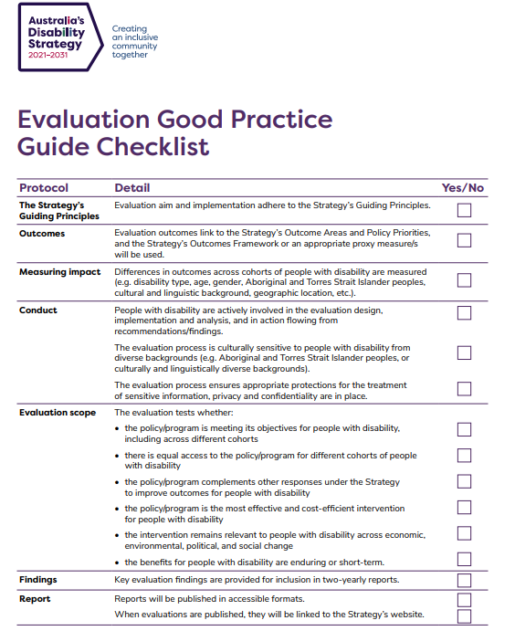

Strnadová, I., Dowse, L., & Watfern, C. (2020). Doing Research Inclusively: Guidelines for Co-Producing Research with People with Disability. DIIU UNSW Sydney.
RDI Network (2020). Research for all: Making Development Research Inclusive of People with Disabilities. Authored by CBM-Nossal Partnership for Disability-inclusive Development and Research for Development Impact Network.
Centre for Disability Studies, (2012) Quality Statement of Disability Inclusive Research Collaboration. Sydney.
Strnadová, I., Dowse, L., & Watfern, C. (2020). Doing Research Inclusively: Guidelines for Co-Producing Research with People with Disability. DIIU UNSW Sydney.
The Social Deck (2020) Best practice consultation and engagement of people with disability. Scoping study report
Rios, D., Magasi, S., Novak, C.,Harniss, M.(2016) Conducting Accessible Research: Including People with Disabilities in Public health, Epidemiological, and Outcome Studies, in Perspectives from the Social Sciences. Dec, Vol 106, No 12.
Centre for Disability Studies, (2012) Quality Statement of Disability Inclusive Research Collaboration. Sydney.
Ibid
Department of Finance (2021). Evaluation in the Commonwealth (RMG 130)

