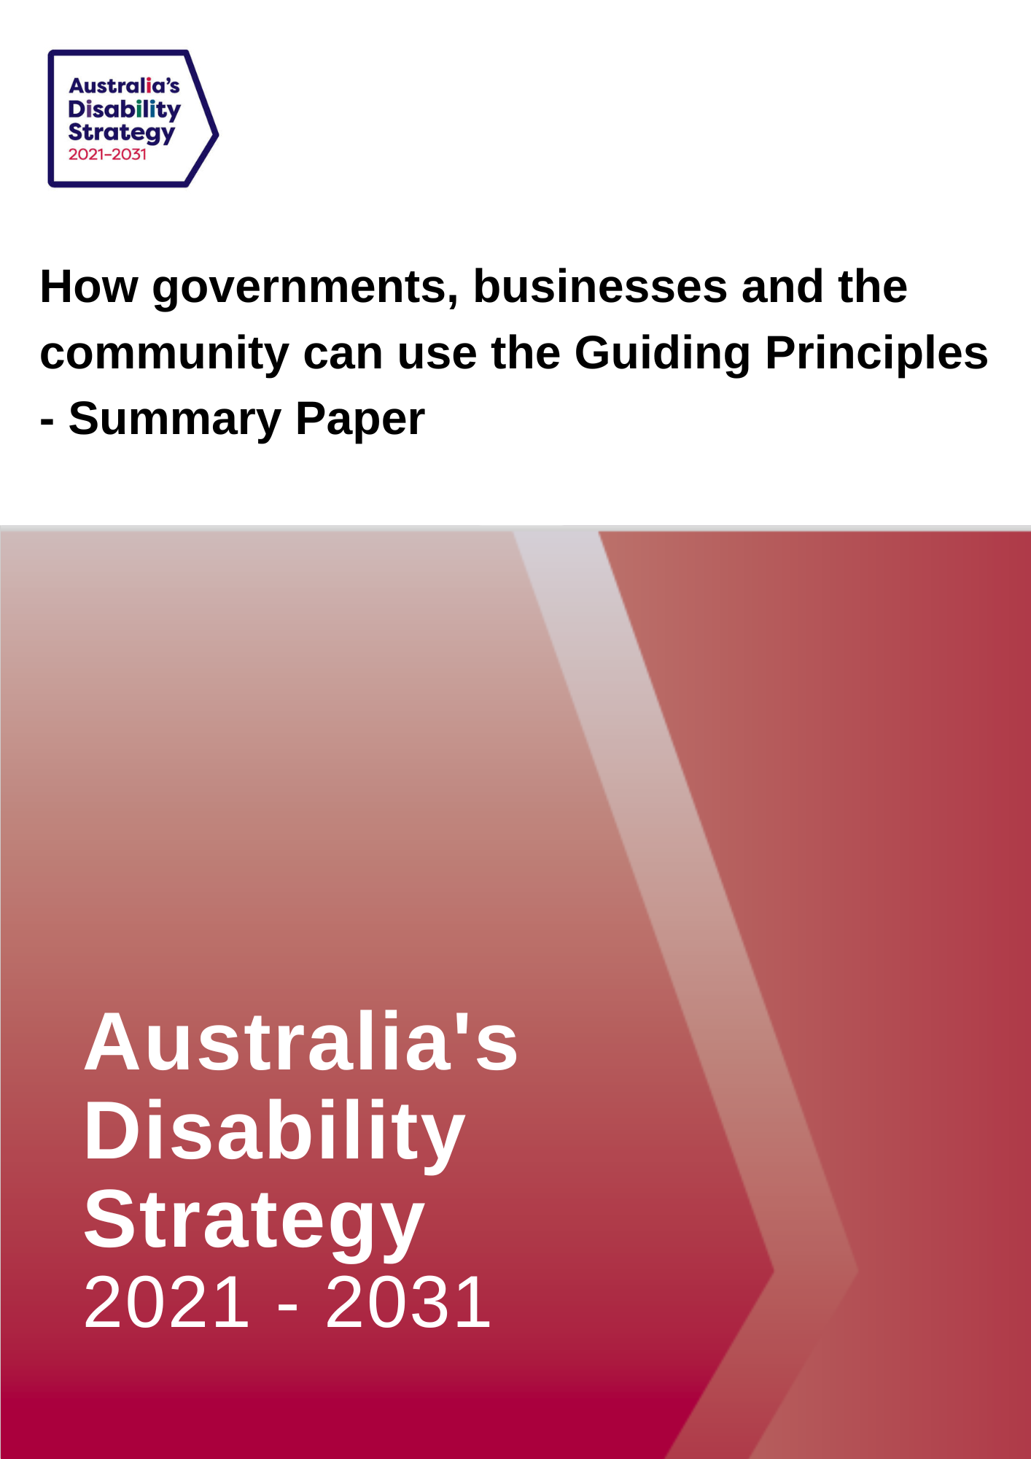

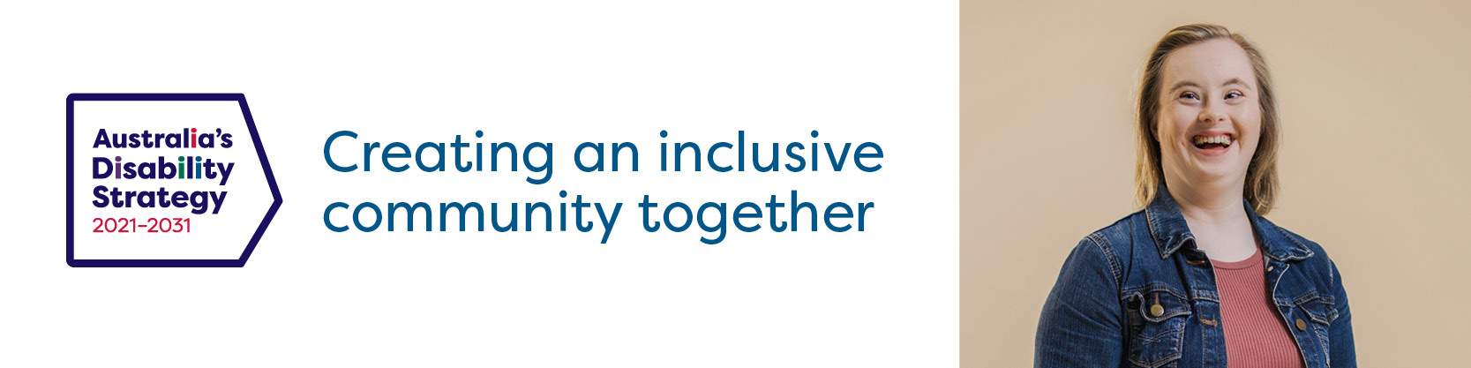

Summary Consultation Paper: How governments, businesses and the community can use the Guiding Principles

This is a summary consultation paper. It provides a quick overview of the Guiding Principles in Australia’s Disability Strategy 2021-2031 (the Strategy). We ask for examples of how the guiding principles might work. The full consultation paper provides more details on each of the issues, it gives definitions and asks additional questions.

The Strategy is a plan to make life better for people with disability. The Strategy was developed by all levels of government and with people with disability, their families, carers and representatives. It took two years of consultation to develop. The Strategy is available on the Disability Gateway.

Under this plan there are a set of eight principles to help governments, business and the community better include people with disability. These principles should be used across any new action of organisations, whether government, business or the community (e.g. when constructing new buildings or providing services to Australians).
The eight principles are based on the ones developed by the United Nations (UN), and set out in the Convention on the Rights of Persons with Disabilities (CRPD). The UN CRPD is an important international agreement that makes sure people with disability have the same rights as everybody else and that the human rights of people with disability are protected
To help governments, business and the community use all eight of these principles, governments are developing a guide and are seeking feedback to make sure it includes the things most important to people with disability.

Have your say:
For each principle please provide an example on:
1. what works well for people with disability
2. what is not working for people with disability

Principle 1: People are free to make their own choices
In applying this principle people are asked to consider if a proposed action will:
- assist people with disability to make their own choices in the same way as people without disability
- give people access to supported decision making when required.
Note - the full wording for this principle in the Strategy is “Respect for inherent dignity, individual autonomy including the freedom to make one’s own choices, and independence of persons”.

Principle 2: No one will be discriminated against (Non-discrimination)
In applying this principle people are asked to consider if a proposed action will:
- comply with the Disability Discrimination Act 1992, state and territory anti-discrimination legislation and the UN CRPD
- avoid indirect discrimination and support reasonable adjustments (For example, providing a person with vision impairment with a screen reader or other technology if that is what they need to do their job).

Principle 3: People with disability have the same rights to be included in society as anybody else
In applying this principle people are asked to consider if a proposed action will support:
- inclusion and participation in all aspects of community life
- people to fulfil their potential.
Note - the full wording for this principle in the Strategy is “Full and effective participation and inclusion in society”.

Principle 4: People with disability are to be respected for who they are
In applying this principle people are asked to consider if a proposed action will:
- respect and recognise the worth and dignity of all people with disability.
Note - the full wording for this principle in the Strategy is “Respect for difference and acceptance of persons with disabilities as part of human diversity and humanity.

Principle 5: Everyone should have equal opportunities (Equality of opportunity)
In applying this principle people are asked to consider if a proposed action will have:
- barriers or processes that unfairly limits people with disability from achieving their goals.

Principle 6: Everyone should have equal access (Accessibility)
In applying this principle people are asked to consider if a proposed action will:
- have accessible information, technology, services and locations
- apply the principles of universal design (so everyone can access services and buildings without the need for specialised or adapted features).

Principle 7: All people with disability should have equal opportunities, irrespective of their race, gender or other characteristics (Equality of people)
In applying this principle people are asked to consider if a proposed action will:
- support the full development, advancement, empowerment and equality of all people irrespective of differences and identities
- be culturally safe and appropriate.

Principle 8: Children with disability (0-18 years of age) should be respected for who they are as they grow up
In applying this principle people are asked to consider if a proposed action will:
- mean children with disability are being treated equally to children without disability
- treat the best interest of the child as the primary consideration
- give children with disability the opportunity to participate in decisions based on their age and maturity
- give access to supports so children with disability can make or participate in making decisions.
Additional Questions - Have your say:
1. Are there any other principles you think should be added to the list above?
2. Do you have other suggestions about how organisations could use these principles to improve their actions?
For more information, definitions and other ideas about feedback you can access the full Consultation Paper at https://engage.dss.gov.au/ads-consultations-develop-guide-evaluation

How you can provide feedback
Send us a written submission
You can send a submission in writing to:
Australia’s Disability Strategy Governance and Engagement Section
GPO Box 9820
Department of Social Services
Canberra, ACT 2601

Web
Via the consultation website at DSS Engage
Download this consultation paper
Download an Easy English version of this consultation paper
Enter or upload a written submission
Watch an Auslan video
Make a video or audio recording: if you want to send a video or audio recording of your submission, please visit DSS Engage to find out how.
If you upload your submission online, including via the online template, you will be asked to specify whether you would like your submission to be published on the DSS website.
If you send your submission via email or standard post, please specify whether you would like your submission to be published online.
Questions about the consultation process can be directed to disabilityreform@dss.gov.au
You can also call the Department of Social Services on 1800 334 505
The Closing Date for the Submission is Wednesday 30 November 2022 at 11:59pm, AEST.

