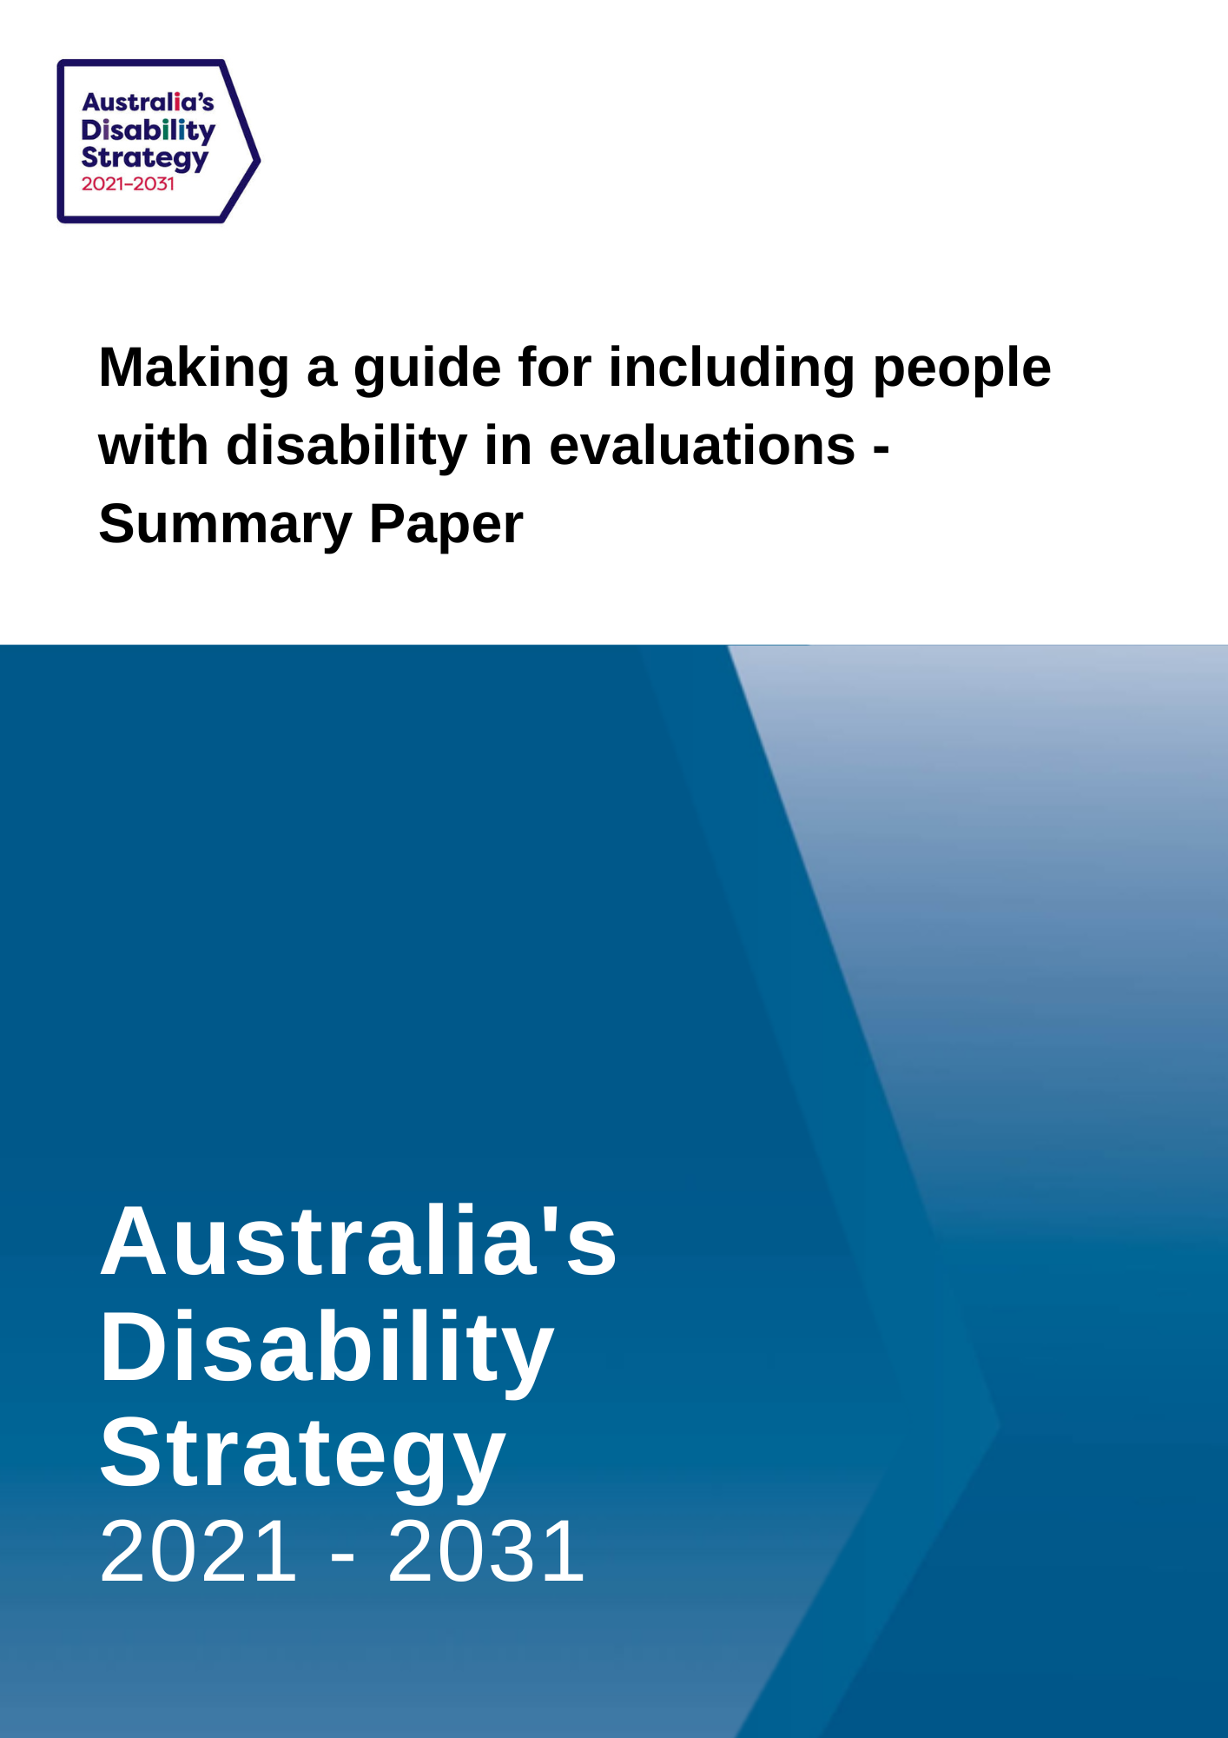

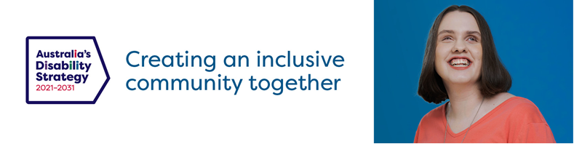

Summary Consultation Paper

Making a guide for including people with disability in evaluations

This is a summary consultation paper. It provides a quick overview of including people with disability in the stages and principles of evaluation. We ask for examples of how people might be included in each stage and for comments on the principles. The consultation paper provides more details on each stage, on the principles and asks additional questions.
Australia’s Disability Strategy 2021-2031 is a plan to make life better for people with disability.
Under this plan, the Government will write a guide about evaluations. This guide will make sure people with disability are included in evaluations about policies, programs and services that are important to people with disability.
Evaluations can help the Government know what is working well and how to improve things for people with disability.
We would like your thoughts on what should happen at each stage of an evaluation and about the principles for including people with disability in evaluation.

- Design stage
This is the part where parts of the evaluation are planned. This could include:
- what will the evaluation try to find out.
- who should be involved.
- who will be in the evaluation team.
- what type of evaluation. For example, online questions, in person or groups.
Have your say:
How can we make sure people with disability are included in this evaluation stage?

- Implementation and Analysis stage
This is the doing part of the evaluation. This could include:
- Asking people with disability to answer questions for the evaluation.
- Making sure people with all types of disability and life experiences can be involved if they want to. This includes consideration of time and effort like payments or gifts for participation.
- Looking at all the answers and what they tell us.
- Giving people with disability the opportunity to present the results.
Have your say:
How can we make sure people with disability are included in this evaluation stage?

- Actions from the results stage
In this part of the evaluation, decisions get made on what to do with the results. This could include:
- What should change as a result of the evaluation answers.
- How to make sure people with disability have a say in any changes.
Have your say:
How can we make sure people with disability are included in this evaluation stage?
Is there anything else we should know about making evaluations better for people with disability?
Principles for involving people with disability in evaluation
This is a summary of the principles:
- People with disability should know about and be included in decisions about all parts of the evaluation
- Evaluations need to be about what is important to people with disability and making life better for them.
- Make sure all parts of evaluations are accessible for people with disability
- People with disability with different experiences should be included (e.g. gender, race, location, impairment)
- People with disability should be included in presenting the results of the evaluation and in what is done with those results.
How you can provide feedback
Have your say:
Do you have any comments on these principles?
Should any be added or changed?
For more full text, more information and other ideas about feedback you can access the Consultation Paper at https://engage.dss.gov.au/ads-consultations-develop-guide-evaluation
Send us a written submission
You can send a submission in writing to:
Australia’s Disability Strategy Governance and Engagement Section
GPO Box 9820
Department of Social Services
Canberra, ACT 2601

Web
Via the consultation website at DSS Engage
Download this consultation paper
Download an Easy English version of this consultation paper
Enter or upload a written submission
Watch an Auslan video
Make a video or audio recording: if you want to send a video or audio recording of your submission, please visit DSS Engage to find out how.
If you upload your submission online, including via the online template, you will be asked to specify whether you would like your submission to be published on the DSS website.
If you send your submission via email or standard post, please specify whether you would like your submission to be published online.
Questions about the consultation process can be directed to disabilityreform@dss.gov.au
You can also call the Department of Social Services on 1800 334 505
The Closing Date for the Submission is Wednesday 30 November 2022 at 11:59pm, AEST.

