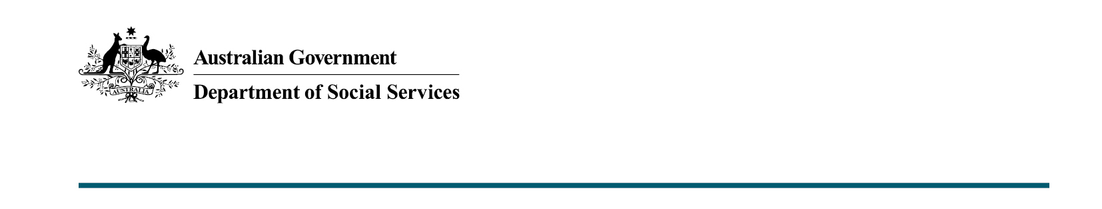

Frequently Asked Questions
  - Aboriginal and Torres Strait Islander Action Plan – DSS Engage Public Consultation
This Frequently Asked Questions (FAQ) document is intended to supplement the DSS Engage survey for input into the Aboriginal and Torres Strait Islander Action Plan, answering potential questions survey respondents may have about the consultation or Action Plan. This FAQ document may be updated during the consultation period, should key topics be raised that require further clarification.

About Participant Wellbeing

If you are experiencing, or at risk of family, domestic and sexual violence – help is available.
If you are in immediate danger, please call 000.
Violence against women and children can be hard to discuss. For information, support and counselling, you can contact: 1800RESPECT on 1800 737 732 or visit the website (www.1800Respect.org.au).
This is a free 24-hour online and telephone counselling and support service for people who have experienced, or are at risk of experiencing, family, domestic or sexual violence, their family and friends and frontline and isolated workers.

About the Action Plan and supporting documents

Q: What is the Action Plan and how is it different from the National Plan to End Violence against Women and Children?
A: The National Plan to End Violence against Women and Children 2022–2032 (National Plan) is our collective commitment to a country free of gender-based violence – where all people live free from fear and violence and are safe at home, at work, at school, in the community and online. The National Plan provides the foundation for a whole-of-society approach to end gender-based violence in one generation. It sets our direction for the next 10 years.
The Aboriginal and Torres Strait Islander Action Plan (Action Plan) forms part of the National Plan to End Violence against Women and Children 2022-2032. The Action Plan will ensure approaches to end violence against Aboriginal and Torres Strait Islander peoples are Community-led, Culturally-safe, Strengths-based, and Healing-informed. The Action Plan will also focus on addressing Target 13, ‘Aboriginal and Torres Strait Islander families and households are safe’ of The National Agreement on Closing the Gap, the immediate safety needs of First Nations families and communities; and serves as an interim measure while the standalone First Nations National Plan is developed.

Q: What is the Aboriginal and Torres Strait Islander Action Plan Framework?
A: The Framework is the first step in the development and consultation of the Aboriginal and Torres Strait Islander Action Plan. The Framework lays the foundations and outlines the guiding principles for the Action Plan.

Q: What does my feedback contribute to and how will it be used?
A: The Department will share the feedback with the Advisory Council who will consider the opinions provided by individuals and organisations in this survey when drafting the Action Plan.

Q: What is Closing the Gap and Target 13 and; how do they influence the Action Plan?
A: The National Agreement on Closing the Gap is a national agreement enabling Aboriginal and Torres Strait Islander people and governments to work together to overcome the inequality experienced by Aboriginal and Torres Strait Islander people, and achieve life outcomes equal to all Australians.
The National Agreement on Closing the Gap sets out 17 socio-economic targets across areas that impact the wellbeing of and life outcomes for Aboriginal and Torres Strait Islander people.
Target 13 under the National Agreement on Closing the Gap states: by 2031, the rate of all forms of family violence and abuse against Aboriginal and Torres Strait Islander women and children is reduced by 50%, as progress towards zero.
The Aboriginal and Torres Strait Islander Action Plan is an important mechanism for implementation of Target 13.
For more information on Closing the Gap and Target 13, please visit: www.closingthegap.gov.au.

Q: What is the First Nations National Plan?
A: The government has committed to developing a standalone National Plan for Aboriginal and Torres Strait Islander family safety acknowledging the need to listen and work together with Aboriginal and Torres Strait Islander peoples, with a willingness and commitment to doing things differently.
The development of the First Nations National Plan is expected to take some time to allow for a consultative process that supports genuine partnership and shared decision making as articulated in the National Agreement on Closing the Gap.
Aboriginal and Torres Strait Islander Action Plan under National Plan will ensure progress is still being made whilst the First Nations National Plan is being developed.

Q: Who is leading the development of the Aboriginal and Torres Strait Islander Action Plan?
A: Aboriginal and Torres Strait Islander Advisory Council on family, domestic and sexual violence (Advisory Council), is leading the development of the Action Plan in partnership with the Department of Social Services. The Advisory Council an external entity consisting of 16 recognised and respected First Nations leaders from a wide range of academic and professional backgrounds that work directly in, or intersect with Aboriginal and Torres Strait Islander family, sexual and domestic violence.

Q: Will information captured during the consultations be published?
A: The department will not be publicly publishing the individual responses captured during this consultation. Data collected during this consultation will only be shared in line with this survey’s privacy principles, found on the DSS Engage survey landing page.

Q: Will I be consulted on the Action Plan draft?
A: To ensure the voices and perspectives of First Nations peoples are at the centre of all efforts throughout the development of the Action Plan, the department will be assisting the Advisory Council to undertake specific consultations including; face-to-face interaction in every state and territory, and linking into planned events of other organisations around the country.

Q: Will my submission be responded to?
A: As the aim of the survey is to draw on First Nation communities knowledge, build support for and contribute to the design process of the Action Plan; the department will not be responding to survey submissions.

