Financial Counselling Industry Funding Model
  - Discussion Paper
  - November 2022

Contents
1 Acknowledgement of Country 1
2 Introduction 1
3 Overview of the proposed model 6
4 Quantum of funding required to address unmet demand 10
5 Suggested contributions from sectors and subsectors 13
5.1 Calculating suggested contributions within subsectors 18
5.2 Securing commitments from sectors and subsectors 20
6 Design of the independent body 23
7 Evaluation 29
8 Data improvements 30
9 Next steps 31
Glossary of key terms 32
Appendix A – Background on the review of financial counselling 33
Appendix B – Sectors and subsectors 34
Appendix C – Summary of results of the 2021 survey of financial counsellor time 37
Appendix D – Application of minimum threshold to survey results 40
Appendix E – Associated Peak Bodies 41

Acknowledgement of Country
The Department of Social Services acknowledges the traditional owners of Country throughout Australia on which we gather, live, work and stand. We acknowledge all traditional custodians, their Elders past, present and emerging and we pay our respects to their continuing connection to their culture, community, land, sea and water.

Introduction
Background
The Australian Government (the Government) is working with industry representatives, including from banking and finance, telecommunications, energy, insurance, online gambling, and the financial counselling sector to establish a funding model for financial counselling (industry funding model; the model). The industry funding model would allow direct industry contributions to boost supports for Australians who are experiencing financial difficulty. This is in addition to the current funding provided for financial counselling services by the Government, and state and territory governments.
The Government is committed to ensuring a strong future for Australian charities, including financial counselling agencies, to ensure they can continue to be the first line of support for the most vulnerable in the community. Financial counselling plays a vital role in supporting people to address their financial problems, manage debt and make informed choices about their money, providing a lifeline for vulnerable individuals experiencing financial stress. Having a strong and viable financial counselling sector is essential for supporting some of the most vulnerable in our community, ensuring no one is left behind.
A review into the coordination and funding of financial counselling services undertaken by Ms Louise Sylvan AM in March 2019, The Countervailing Power: Review of the coordination and funding for financial counselling services across Australia (the Sylvan Review), identified that funding is the largest impediment to more Australians in financial hardship being able to access financial counselling. The Sylvan Review recommended industry should contribute funding to address unmet demand for services, as they contribute to demand for services and benefit from their customers accessing financial counselling services. Further background on the Sylvan Review is at Appendix A.
Since the release of the Sylvan Review, extensive work has been undertaken with industry representatives and the financial counselling sector on the design of an industry funding model. This includes various workshops, surveying financial counsellors on the industries that they interact with in their work and the unmet demand for their services, modelling to forecast demand, and a Financial Counselling Industry Funding Advisory Group.
Informed by this work, this paper outlines the proposed design of a model to raise and distribute voluntary industry funding contributions needed to help more Australians in financial distress access financial counselling services, and seeks feedback from interested parties.
The model is anticipated to commence from 1 July 2023.
What is Financial Counselling?
Financial counselling services are delivered by community and local government organisations and are voluntary, free, and confidential. They are provided through face-to-face (or virtual), telephone and online supports. Approximately 125,000 face-to-face clients are helped each year by financial counsellors and 130,000 calls are made to the National Debt Helpline.
Financial Counselling Australia estimates there are 1,100 (full time equivalent) financial counsellors in Australia who provide financial counselling services in 192 agencies across 674 sites.
Financial counsellors provide free, independent expert advice and support to individuals in financial hardship, including through helping clients:
- understand which debts are priorities;
- develop budgets and plans;
- understand the pros and cons of different options to manage financial issues;
- access grants or concessions;
- negotiate with creditors, including debt waivers; and
- understand their rights and access legal help.
Financial counsellors require a Diploma of Financial Counselling and have specific knowledge about credit, bankruptcy and debt collection laws, concession frameworks and industry hardship practices. They are also trained in negotiation and counselling, and offer emotional support. Financial counsellors do not provide services such as financial planning advice, or endorse specific financial products or services.
Businesses that contribute to the industry funding model are likely to receive a number of broad benefits from increased financial counselling services and reduced appointment waiting times for their customers seeking these services. These benefits may include:
- improved customer outcomes, including the ability to manage and meet financial commitments, and receive proactive or preventative assistance;
- improved financial literacy and capability of their customers;
- reduced customer turnover;
- reputational benefits in supporting services provided to assist individuals experiencing financial hardship; and
- data and learnings fed back to industry that may help inform improved industry practices and policies, including emerging issues.
How does financial counselling support an individual in financial hardship?
Individuals and families seek financial counselling at some of the most vulnerable and difficult parts of their lives. This includes when experiencing economic coercion or abuse as well as unexpected financial shocks from major life events, such as a loss of their job, failure in business, a relationship breakdown or a major health issue.
Financial counsellors provide independent expert advice at no cost and help advocate for their clients. The majority of clients accessing financial counselling find their financial situation improved (68 per cent) and their financial difficulties resolved (66 per cent). Importantly, for both individuals and the businesses they support, financial counsellors can support their clients to avoid bankruptcy (53 per cent) and avoid or curtail legal actions (22 per cent).
There are also significant flow-on and direct effects of financial counselling on a client’s health and general wellbeing. The private nature of financial counselling sessions, the formal counselling training of financial counsellors and their ability to listen and provide emotional support have positive effects on the mental health of clients.
The strong link between financial wellbeing and mental health was recently examined in The Money and Mental Health Social Research Report, commissioned by the Australian Securities and Investments Commission (ASIC) in collaboration with Beyond Blue. The report found that financial challenges and mental health challenges are frequently experienced alongside each other, with 14 per cent of Australian adults experiencing both at any time over five years from 2014 to 2019. In fact, the report found that people become twice as likely to face mental health challenges when experiencing financial challenges.
How are financial counselling services funded?
Funding for financial counselling services is primarily provided by the Government alongside state and territory governments. Funding is also provided from philanthropic organisations and individual businesses.
Current Government funding provided through the Department of Social Services (DSS; the Department) includes an ongoing commitment of almost $44 million per annum for financial counselling services, including for generalist financial counselling services. This funding is provided via grants, with the current arrangements in place from 1 January 2019 to 30 June 2023.
To provide funding certainty to the financial counselling sector during the COVID-19 pandemic and the impact of natural disasters, a two-year extension is being offered for the current financial counselling grants to 30 June 2025. The approach for the timing of future grant rounds is to be determined.
As well as generalist services, DSS also funds specialist financial counselling supports for people affected by problem gambling, by helping to address their financial problems, manage debt and navigate out of financial crisis.
Around $30 million annually is contributed by state and territory governments to financial counselling services. State and territory governments also fund specialist financial counselling services, such as those targeting people affected by family violence or who have issues with gambling.
Industry funding model
The Government is also investing $10.5 million over four years to 2024-25 to support the design and evaluation of the industry funding model and to fund complementary initiatives to improve the capacity of the financial counselling sector. This includes $1.5 million in seed funding for the establishment of a new independent not-for-profit body to collect and distribute industry funding, once the model is agreed.
How is consultation on the proposed model taking place?
This paper outlines the proposed design of the model, informed by previous consultations with stakeholders. Feedback, through a series of discussion questions contained within this paper, is being sought.
Some aspects of the industry funding model are out-of-scope of this consultation process, as they are part of the next phase of implementation, including policies and procedures of the independent body, which will be developed by the body following its establishment. It is anticipated the body would undertake its own consultations to inform these decisions.
To capture stakeholder views on the design of the model, DSS invites written submissions in response to discussion questions. The discussion paper process will be complemented by a series of targeted virtual roundtables with industries and the financial counselling sector.
The consultation paper is open for six weeks, from 7 November 2022 to 16 December 2022.
Interested individuals and organisations are invited to provide written submissions to the Department through engage.dss.gov.au by the closing date 5.00pm 16 December 2022 (AEDT).
What is the purpose of the Financial Counselling Industry Funding Advisory Group?
The design of the model will also be informed by advice from the Financial Counselling Industry Funding Advisory Group (Advisory Group).
The Advisory Group was established in June 2022 to provide strategic and expert advice to the Department on the design of the model and comprises representatives from industry peak bodies, Financial Counselling Australia, the financial counselling sector and the Department. Membership is provided below:
- Mr Peter Kell (Independent Chair)
- Australia Banking Association
- Australian Energy Council
- Australian Finance Industry Association
- Care Inc.
- Communications Alliance
- Department of Social Services
- Financial Counselling Australia (two positions)
- Insurance Council of Australia
- Responsible Wagering Australia
- The Salvation Army.
The Advisory Group’s terms of reference include providing strategic, expert and evidence-based advice to the Department on:
- the design and establishment of the model, including ways to encourage industry funding contributions;
- consultation with industry sectors, businesses and the financial counselling sector;
- consultation with states and territories on state-regulated bodies and ongoing funding for financial counselling services;
- data and evaluation methodology to support the model;
- key steps and timing for the establishment of the model; and
- the scope and role of the independent body for industry funding under the model, including governance.
Where relevant, the Advisory Group may also:
- advise on opportunities for national coordination, particularly in relation to data and service delivery;
- undertake awareness raising and information sharing within respective sectors and the broader community sector on the model; and
- facilitate expert advice, as needed to inform Advisory Group discussions.
The initial term of the Advisory Group is 12 months to June 2023, with a possible extension of up to 12 months.
How are state and territory governments involved?
A forum has also been established between DSS and states and territories to ensure they are able to provide input into the development and implementation of the industry funding model, discuss funding commitments for financial counselling by all governments, and progress shared goals around national coordination of data.

Overview of the proposed model
The objective of the proposed industry funding model is to receive and distribute voluntary industry contributions to help address unmet demand for financial counselling services, so more people in financial hardship can access the support they need. Industry funding will help to increase free, independent financial counselling services for people in financial difficulty.
The industry funding model is comprised of two key components:
- a specified quantum of industry funding needed to help address unmet demand for services, and the split of the quantum among industry subsectors; and
- an independent body to collect and distribute industry contributions.
Based on the findings of the Sylvan Review and informed by feedback from stakeholders during previous consultations, the Department has devised the following six principles to guide the development of the two key components of the industry funding model:
- Industry funding helps to address unmet demand and improves the predictability and stability of funding for financial counselling services.
- Industries that contribute to the demand for, and benefit from, financial counselling, contribute to the funding of the services.
- Quantum and split of suggested industry contributions are determined on a fair and transparent basis.
- Industry funding provides an additional funding stream to current funding sources.
- The operation and effectiveness of the model is supported by robust data and evidence collection and analysis.
- The model contributes to improved coordination, innovation and capability building and enhanced service delivery across the financial counselling sector.
Discussion Question:
- What are your views on the proposed principles for developing the industry funding model?

What is the quantum of industry funding to be collected under the model?
Industry funding over three years from 2023-24 to 2025-26, has been calculated as:
- $18.1 million for 2023-24
- $18.7 million for 2024-25
- $19.4 million for 2025-26.
Based on modelling to forecast demand for services over this period, the above figures represent the funding gap that exists between funding from governments, maintained at current levels, and funding needed to meet demand for services. It also includes the operating costs for the independent body and funds for innovation and capability building in the financial counselling sector. The figures in the model reflect the wage inflation forecast set by the Department of Treasury.
Who is expected to contribute and how much?
Any business will be able to contribute funding voluntarily from 1 July 2023, however the focus of the proposed model is on specific subsectors that contribute to demand for financial counselling services. These subsectors have been determined based on the results of a 2021 survey of financial counsellor time spent on specific subsectors, with a minimum threshold applied. They are from the financial services, energy, telecommunications and water sectors.
The Department will seek formal funding commitments from these subsectors. A ‘subsector’, in this paper, refers to categories of businesses that belong to a given sector. For example, bank, debt collector or buyer and general insurer are subsectors in the financial services sector. Electricity retailer is a subsector in the energy sector.
Details on suggested contributions for industry subsectors are at Section 5.
What is the length of funding commitment?
The model is designed to be ongoing from 1 July 2023, with agreement to the funding quantum proposed for each of the first three years. The initial three-year period would balance the need for certainty of funding for the financial counselling sector, while allowing sufficient time for further refinements to determining unmet demand.
Is there a cap on the amount of funding expected to be contributed by identified industries?
While there are no limits to the quantum of funding that industries may choose to contribute, the funding commitment would not increase beyond the Australian Government’s contributions to generalist financial counselling, or the Sylvan Review’s recommendation of $45 million per annum, whichever is the greatest.
How will funding be collected and distributed?
It is proposed that a new independent not-for-profit body be established to distribute the contributions it receives for financial counselling from industry. The new independent body would:
- facilitate the coordination of funding;
- remove potential complexity that may occur if separate arrangements are set up; and
- allow for streamlined coordination with other funders of financial counselling, including the Government.
For the initial commitment between 1 July 2023 and 30 June 2026 (phase 1), the Department will seek to obtain letters of commitment from subsectors through their peak representatives. For the period post June-2026 (phase 2), it would be the role of the new independent body to obtain the funding recommitments.
Further details on the proposed roles and characteristics of the independent body are in Section 6 of the discussion paper.
How will we know if the model is working?
The voluntary nature of the proposed model is based on the assumption there is a recognition of the value of financial counselling in assisting individuals in financial hardship. If there is a lack of voluntary contributions, the Government may need to seek other methods for contributions, which may include a legislated contribution.
An evaluation of the model will be undertaken to determine its effectiveness to address unmet demand for financial counselling services, and provide stable and predictable funding. Further details on the proposed evaluation of the industry funding model are in Section 7 of the discussion paper.
Diagram 1 illustrates the operation of the model.

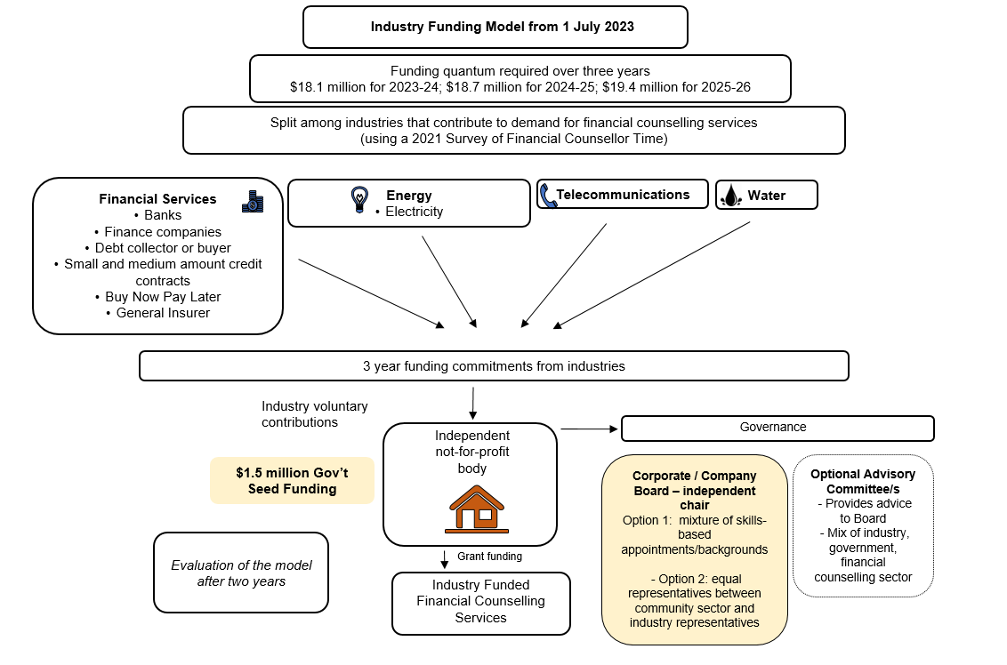
DIAGRAM 1 – Industry funding model from 1 July 2023

Quantum of funding required to address unmet demand
The start date of the industry funding model is 1 July 2023. The quantum of funding required to address unmet demand for each year is set out in Table 1. This is the funding gap between existing funding from governments and funding needed to meet demand for services based on modelling to forecast demand for services over this period. It also includes the operating costs for the independent body and funds for innovation and capability building in the financial counselling sector.
- Quantum of Funding from 2023-24 to 2025-26
 | 2023-24 | 2024-25 | 2025-26
Frontline service delivery | $16.7m | $17.3m | $17.9m
Body operating costs | $0.9m | $0.9m | $1.0m
Innovation and capability building | $0.5m | $0.5m | $0.5m
Total | $18.1m | $18.7m | $19.4m

The proposed methodology on the proposed splits between sectors and subsectors to apportion the quantum is outlined in Section 5 of the discussion paper.
How was the quantum derived?
The Sylvan Review identified additional funding of $45 million per year was needed for services to meet unmet demand. As the Sylvan Review’s estimate was made in 2019, and there have been changes in the Australian economic landscape since that time, including the impact of the COVID-19 pandemic, the Department recently undertook modelling to forecast demand for services, to derive an updated estimate of the funding gap.
The latest modelling predicts that, to meet unmet demand for services, the financial counselling sector requires an additional $18.1 million for 2023-24 and $18.7 million for 2024-25 and $19.4 million for 2025-26, inclusive of operating costs and funding for innovation and capability building.
The updated modelling forecasts the total number of additional ‘sessions’ with a financial counsellor required to meet demand for financial counselling services. It forecasts this demand by taking into account funding by governments, current unmet demand and historical demand. Consistent with the findings of the Sylvan Review, the modelling predicts funding provided by governments is not sufficient to meet the demand for financial counselling.
The assumption for current unmet demand in the financial counselling sector was derived using the results of a 2022 survey undertaken by financial counselling agencies, where they recorded the action taken for each request for financial counselling received during a standard two-week period, which captured whether an individual received an appointment within two-weeks. Unmet demand for the National Debt Helpline was derived by taking the percentage of busy/no answer/abandoned calls that comprises total calls in 2021-22, and determines how much funding would be required to answer these calls. These unmet demand assumptions remain constant across the first three years of the model.
How is unmet demand defined?
Demand for services is considered ‘unmet’ when there is an attempt by an individual to access services with a financial counsellor and the appointment cannot be booked within a two week period for face-to-face services, or an individual has attempted to contact the National Debt Helpline and cannot connect with a National Debt Helpline operator. Meeting unmet demand will ensure that every eligible person who requests access to financial counselling services is able to receive it within a reasonable period of time.
As the Sylvan Review was focussed on addressing unmet demand, the demand modelling does not estimate the population that may be eligible financial counselling but have not requested the service.
What are the proposed operating costs of the independent body?
The Government has committed $1.5 million in 2022-23 for one-off seed funding for the establishment of the body. It is estimated that the annual operating costs of the body could range from $0.7 million to $1 million from 2023-24. It is anticipated the ongoing operating costs would be sourced from industry contributions. The estimated operating costs cover board member sitting fees, body staff salaries, training and development, outsourced services such as IT support, ad-hoc legal advice and auditing, and assets and infrastructure.
How will the industry funding contributions be spent?
The majority of industry funding contributions would be spent directly on service delivery, with funding for generalist financial counselling being provided directly to financial counselling organisations (92 per cent). Five per cent of funding would be for the operating costs of the body and 3 per cent would be for innovation and capability building within the sector.

Figure 1. Breakdown of Funding Expenditure
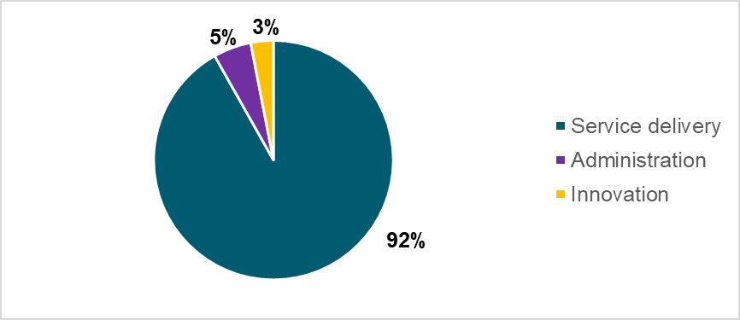

Will the requested industry contributions change?
The annual figures would be set for three years from 1 July 2023. The modelling to forecast demand will be repeated before the initial three-year period sunsets, providing an updated figure to inform future funding commitments.
Future iterations of the model could be refined as more data becomes available and through learnings from the model over the funding period of 2023-24 to 2025-26.
See Section 5 for a proposed review point, which would include updated demand modelling.
Discussion Question:
- What are your views on the proposed quantum for each year of the first three years of the model?

Suggested contributions from sectors and subsectors
Who will be identified to contribute?
On establishment of the industry funding model from 1 July 2023, any business will be able to contribute voluntarily to the model. Industries that contribute to demand for, and benefit from, the availability of financial counselling services for their customers are encouraged to contribute, including subsectors from financial services, energy, telecommunications and water.
The Sylvan Review identified businesses in the financial services, utilities (energy and water) and telecommunications sectors contribute to the demand for financial counselling and gain social and economic benefit from the availability of financial counselling services.
In mid-2021, the Department conducted a two-week survey of 200 financial counsellors on the time they spend on specific sectors and subsectors when assisting clients. The results of this survey support this Sylvan Review finding and identify subsectors within these sectors and other sectors that contribute to demand for financial counselling (refer to Appendix B for a list of subsectors included in the survey and Appendix C for the results of the 2021 survey).
While any sector or subsector will be able to contribute voluntarily to the model, the focus of the proposed model is on specific subsectors that contribute to demand for financial counselling services. These subsectors have been determined based on the results of a 2021 survey of financial counsellor time spent on specific subsectors, with a minimum threshold applied.
To ensure the focus is on subsectors that contribute to demand for services at a level that has a cost benefit greater than the time and resources required to encourage participation in the voluntary model, a minimum threshold is proposed. The minimum threshold proposed is three per cent, meaning subsectors (excluding government delivered services e.g. Centrelink) that contributed to at least three per cent of total financial counsellor time in the 2021 survey are the focus of the model.
Based on the survey and this threshold, the quantum of funding is apportioned to nine subsectors, which account for over 80 per cent of financial counsellor time. Appendix D shows the application of this threshold to the survey results. The subsectors with at least a three per cent survey result come from the following sectors:
- Financial services
- Energy
- Telecommunications
- Water
Guidance for suggested contributions for each subsector is provided below.

How much will each sector and subsector be expected to contribute?
To help ensure the model raises the proposed quantum for each year, guidance on how much funding each sector and subsector should contribute has been developed. The suggested contributions will help sectors and subsectors understand how they can do their part to ensure sufficient contributions are raised to fund additional financial counselling services.
The guidance is based on the results of the 2021 survey of financial counsellor time spent on specific sectors and subsectors to apportion the yearly quantum. Refer to Table 3 for the guidance.
While any approach will have limitations, the main benefits of using the survey results is that it is simple, based on where resources are expended when financial counsellors assist clients, and is easy to understand. The survey was not designed to measure the underlying reasons for why clients have sought financial counselling, nor the impact of various sectors, subsectors and firms on the level of financial distress experienced by clients.
For example, the Sylvan Review noted problem gambling can drive demand for financial counselling services, but debts to a gambling organisation is not the debt an individual seeks assistance with when receiving help from a financial counsellor. Further, the National Consumer Protection Framework for online wagering prohibits wagering service providers from offering lines of credit for wagering purposes.
Identifying underlying causes or apportioning the level of financial distress generated by different sectors and subsectors would be complex and is unlikely to translate into a method to apportion funding among sectors and subsectors. The 2021 survey results provide an empirical starting point for determining suggested contributions and could be revisited by the independent body at a later stage.
The use of financial counsellor time as a basis for a sector split is also broadly aligned with Australian Bureau of Statistics Household Expenditure Survey data (see Table 2).
Table 3 outlines the suggested contributions for subsectors encouraged to participate. The suggested contributions are the total amount for the subsector, and not the amount expected from individual businesses. Diagram 2 shows sector split by financial year.
Discussion Questions:
- Are there any evidence-based adjustments that could be made to the suggested contributions methodology? What are they and how could they be incorporated into the methodology?

- A comparison of the sector splits by different methods.
 | 2021 survey of financial counsellor time (excluding Government, and Housing sectors) | Household expenditure (all households) | Household expenditure (lowest two income quintiles)
Financial services | 71.79% | 68.13% | 58.35%
Energy | 16.30% | 13.89% | 19.09%
Telecommunications | 6.46% | 11.22% | 14.23%
Water | 5.10% | 5.17% | 6.37%
Gambling | 0.35% | 1.59% | 1.96%
 | 100.00% | 100.00% | 100.00%

- Suggested Total Contributions From Subsectors Encouraged To Participate
Sector | Subsector | Proportion of 2021 survey results - financial counselling time | Whole of subsector contribution for 2023-24 | Whole of subsector contribution for  2024-25 | Whole of subsector contribution for  2025-26
Financial services | Banking | 36.53% | $6.7 million | $6.8 million | $7.1 million
 | Other credit provider, including finance companies | 12.00% | $2.2 million | $2.2 million | $2.3 million
 | Debt collector or buyer | 10.18% | $1.8 million | $1.9 million | $2.0 million
 | Small or medium amount credit contract provider | 5.06% | $900,000 | $900,000 | $1 million
 | Buy now pay later | 4.32% | $750,000 | $800,000 | $800,000
 | General insurer | 3.60% | $650,000 | $700,000 | $700,000
Energy | Electricity retailer | 15.31% | $2.8 million | $2.9 million | $3 million
Telecommunications | Carriage Service Provider (CSP) | 7.26% | $1.3 million | $1.4 million | $1.4 million
Water | Water utility | 5.73% | $1 million | $1.1 million | $1.1 million
 |  | 100.00% | $18.1 million | $18.7 million | $19.4 million

DIAGRAM 2: Sector Split by Year
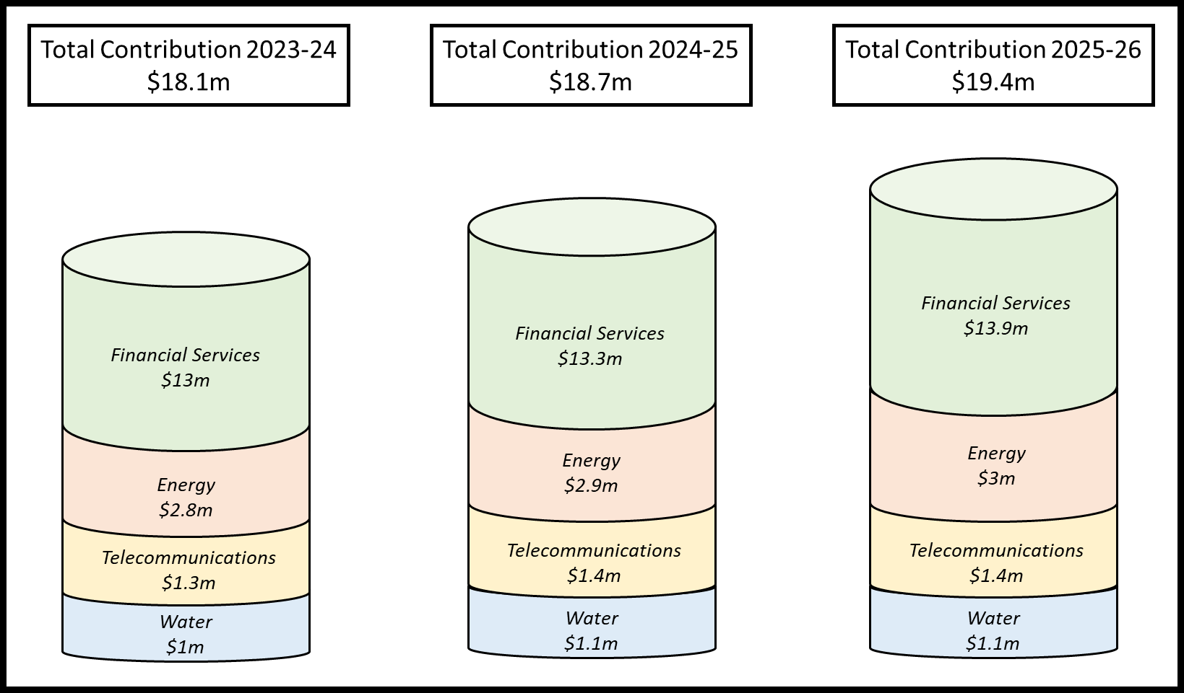

Calculating suggested contributions within subsectors
What options are available to calculate the suggested contributions at the business level (i.e. within subsectors)?
The 2021 survey of financial counsellor time does not provide the granular information needed to determine the contributions of individual businesses within each subsector. Collecting this information would have been administratively burdensome on the financial counsellors undertaking the survey, as there is no standardised approach to categorising cross-sector businesses.
A first step will be identifying whether any businesses within subsectors should be excluded from suggested contributions (e.g. small businesses).
To develop how individual contribution amounts are determined within each subsector, two options are available.
Option 1: peak body representatives work with their subsector to determine an appropriate methodology to apportion within subsector contributions, and advise the Department of the approach.
Option 2: subsectors and their peak body representatives work with the Department to determine an appropriate methodology to apportion within subsector contributions.
Below are potential methodologies for subsectors within the financial services, energy, telecommunications, and water sectors.
Subsectors within the Financial Services sector
Three approaches are outlined for subsectors within the financial services sector.
Method 1: Australian Financial Complaints Authority (AFCA) Membership Levy
This approach would utilise size categories calculated for the AFCA membership levy. These fees use metrics such as loan book size, funds held in deposits, and gross written premium on insurance to create a standard set of size categories that are comparable across subsectors within financial services subsectors.
Suggested contributions for businesses could be based on the proportions for average AFCA membership levy payable at each size category.
Method 2: ASIC Cost Recovery Implementation Statement: ASIC Industry Funding Model
Each year, ASIC publishes a Cost Recovery Implementation Statement (CRIS), which provides industry with estimates of the regulatory costs to be recovered through industry funding.
The methodology for determining industry levies set out in the CRIS could be adopted for the model. Subsectors would need to adjust the values referred to in the CRIS, to account for the suggested quantum of contributions and the number of contributing businesses. A limitation of this approach is the CRIS does not provide indicative levies for the Buy Now Pay Later and Debt Collector or Buyer categories.
Method 3: Apportion contributions between individual businesses based on business size
A third potential method for apportioning the suggested quantum within financial services subsectors is based on business size, as measured by an appropriate size metric. Due to the considerable variation in the nature and size of subsectors and businesses, the method to allocate contributions to individual businesses will likely be different for each subsector. Potential size metrics include but are not limited to:
- market share;
- annual revenue; and
- number of customers.
Energy sector
The number of small customers (residential and small business) attributed to each energy retailer could be used to apportion contributions between individual retailers. This is in line with how the Australian Energy Market Operator (AEMO) collects contributions from energy retailers. AEMO operates on a user-pays cost recovery basis and recovers all operating costs through fees paid by industry participants.
The Australian Energy Regulator has energy retailer client numbers for all states and territories, except Victoria, the Northern Territory and Western Australia. The Essential Services Commission Victoria, Utilities Commission, and Economic Regulation Authority hold energy retailer data for Victoria, the Northern Territory and Western Australia respectively.
The suggested quantum could be apportioned to energy retailers based on their share of total electricity small customers for electricity retailers and total gas small customers for gas retailers.
Telecommunications sector
A number of approaches could be used to determine Carriage Service Providers (CSPs) contribution towards the suggested quantum. The split for the telecommunications sector could be apportioned between individual CSPs in accordance with business size as measured by an appropriate size metric.
Previous consultation undertaken with the telecommunications sector suggested that a subset of CSPs could be captured. CSPs (as defined in s87 of the Telecommunications Act 1997) are ‘qualifying retail carriage service providers’ under ‘the Telecommunications (Consumer Complaints) Record-Keeping Rules 2018 (RKRs). These are CSPs that supply 30,000 or more ‘services in operation’ in accordance with s7 of the RKRs. This subset could also be the focus to encourage contributions for a voluntary industry funding model.
Water sector
The suggested quantum for water utilities providers could be apportioned between individual businesses in accordance with business size as measured by an appropriate metric.
Discussion Questions:
- Should any businesses within a subsector be excluded (e.g. small businesses)?
- What are your views on options 1 and 2 for determining the split within subsectors for voluntary contributions?
- What is your view on the different methods for within subsector splits, for your subsector?

Securing commitments from sectors and subsectors
What commitment is being sought from sectors and subsectors?
The Department will be seeking formal funding commitments for financial counselling from the sectors and subsectors identified as contributing to demand for, and benefit from, the availability of financial counselling services.
As part of the initial set up of the model, it is suggested the formal commitment is sought from the peak organisation for a subsector/s, on behalf of their members. The formal commitment would involve endorsement of the overall design of the model, and a commitment from members to provide the suggested contribution amounts for the subsector, for three years from 1 July 2023.
These commitments will be sought once the model is finalised, following completion of the consultation process.
This proposed approach does not mean only members of peak organisations will be encouraged to contribute to the model. In apportioning funding contributions at the individual business level, the Department will look at which businesses in a subsector should be encouraged to contribute (e.g. based on size), and an appropriate apportioning method, following feedback received on Section 5 of this paper. The Department will look at ways to engage businesses and encourage contributions who are not members of peak organisations.
Seed funding for the establishment of a new independent body to collect and distribute industry funding will be unlocked once 70 per cent of the total quantum of industry contributions are committed.
The respective roles and responsibilities of peak organisations and the Department in the process to secure formal commitments is outlined below. The role of peak organisations in obtaining commitments on behalf of their subsector is only proposed for the initial set up of the model as an efficient mechanism to confirm support for, and establish, the proposed model. This role would not be ongoing for peak organisations.

Design Phase
Peak organisations work with their subsector/s to inform design of the industry funding model

The Department provides support to workshop and develop subsector-specific design aspects

The Department finalises the model, following the consultation process

Commitment Phase
Peak organisations work with their subsector/s to secure formal commitment to the model

The Department supports peak organisations to secure formal commitment
Peak organisations submit formal commitments to the Department

If peak bodies are unable to undertake the role outlined above, an alternative option may be that the Department consult directly and seek formal commitments from only the largest businesses within each subsector (maximum 3-4 per subsector), to ensure certainty in industry contributions under the model. It would not be feasible for the Department to seek commitments from all individual businesses in the subsectors that are the focus of the model.
How long will participating subsectors need to commit funding for?
To ensure the ongoing and long term success of the industry funding model, the Department is proposing that participating businesses commit to providing funding over an initial three years. A three-year commitment is proposed as it provides the greatest balance between short-term flexibility, long-term predictability and accuracy of demand modelling.
An industry funding model, aimed at addressing unmet demand, must be flexible. Unmet demand can change and is sensitive to a number of factors. When funding commitments are shorter, funding levels can be updated more frequently to match unmet demand modelling. Shorter commitments also allow for more accurate demand modelling. The further ahead the model estimates, the less confident we can be about the accuracy of the model.
To balance this, funding commitments must ensure that the sector is being provided with appropriate stability and predictability of funding. The longer the commitment, the further ahead a provider can plan for, and it gives them (among other benefits) opportunity to undertake projects that ensure the long term viability of their operation. It also reduces the administrative burden when providers and funders need to implement fewer grant agreements.
The Department proposes that three years is an appropriate length to balance these needs. Any shorter than this time period is unlikely to give financial counselling agencies enough time to properly utilise the funding.
Funding is proposed to begin in July 2023, lasting for three years to June 2026.
When will a review of subsequent funding commitment occur?
A review would be undertaken in year two of the commitment (2024-25) that would inform any subsequent funding commitments. The review would involve:
- reviewing demand modelling methodology, including updating demand modelling to determine the new quantum of unmet demand; and
- seeking recommitment from funders.
It is anticipated the independent body would undertake the above, noting it may engage an independent party to validate or undertake the revised demand modelling.
Discussion Questions:
- What is your view on the proposed initial three-year commitment? Is this an appropriate length to ensure flexibility and stability of funding?
- When would an appropriate time be to review the functioning of the model?
- Are peak organisations an appropriate mechanism to obtain a formal commitment from subsectors as part of the initial set up of the model? Are there alternative methods to secure commitments that could be undertaken in a timely manner?

Design of the independent body
What is the proposed role and characteristics of the independent body?
It is proposed a new independent not-for-profit body is established, which would collect and distribute funding it receives for financial counselling services under the industry funding model.
It is proposed the body:
- be a not-for-profit company limited by guarantee that can receive and distribute contributions, and could seek Deductible Gift Recipient status;
- conduct grant or grant like processes, procure services and activities, cease funding and require reporting of activities and outcomes;
- collect and analyse data and reports; and
- engage with other funders of financial counselling on coordination and innovation of funding and services.
The body would receive and distribute voluntary industry contributions to ensure the coordination of industry funding and avoid administrative burden on financial counselling agencies. It may take time for the financial counselling sector to build capacity to be able to deliver additional services with the funding provided, as the sector will need to train and hire additional counsellors.
A single point of distribution would remove potential risks, complexities and inefficiencies that would occur if industries set up their own independent arrangements for providing contributions. Without a central mechanism to coordinate industry funding, there is a risk funding is not distributed to the financial counselling agencies based on a needs basis, potentially resulting in unmet demand continuing.
Further, the Sylvan Review highlighted the current landscape of multiple funding sources for financial counselling creates a burden for service providers when applying for and acquitting grants and takes the focus away from core business. A centralised body would avoid adding further administrative on financial counselling agencies.
Table 4 below outlines the proposed role and characteristics of the body and accompanying rationale.
The establishment of a body would be a collaboration between Government, industry and the financial counselling sector.
It is proposed the size of the independent body reflects the scale of funding commitments. It is anticipated the staffing of the body will likely start small and be scaled up as required to respond to increasing funding and additional grant processes.
Policies and procedures of the independent body, including funding allocation and prioritisation, will be a decision for the independent body and are out-of-scope for this discussion paper. The body will develop policies and procedures following its establishment, and it is anticipated the body will consult on funding allocation and prioritisation.
To encourage contribution to the industry funding model and provide recognition of contribution, the body may choose to acknowledge and publish the names of organisations contributing funding (with permission).
DSS is interested in stakeholder views about the desirable or priority characteristics of the body and whether the proposed characteristics would achieve the objective of the industry funding model.
Discussion Questions:
- What are your views on the proposed characteristics of the independent body as set out in Table 4? Are there other characteristics that should be considered?

- Proposed role and characteristics of the Independent body
 | Proposed Role and Characteristics | Rationale
Focus/objective | - Distribution of funding for financial counselling services to help address unmet demand in the sector. | - Distribution will enable equitable funding to financial counselling agencies to help address unmet demand. Single distribution point provides opportunities for efficiencies and innovation.
Structure/ Governance | - Not-for-profit company limited by guarantee.  - May seek Deductible Gift Recipient status.  - Supported by a reference or advisory committee.  - Flexibility to expand its focus (e.g. flexibility to fund capability initiatives) and governance arrangements. | - Clear governance arrangements will allow for better decision-making and accountability.
Grant activities | - Conduct grant or grant-like processes, to fund services and procure activities, and require reporting of activities and outcomes. | - Grant activities will enable the independent body to best target areas of need and allow the body to link targets to outcomes.
Data | - Have the capability, or ability to build capability, to collect and analyse data from the financial counselling services the body funds. | - Data capability initiatives will empower the independent body to construct an accurate picture of needs and availability for financial counselling services.
Coordination and innovation | - Have the capability to engage with other funders of financial counselling (e.g. Australian Government, state and territories) on coordination and innovation of funding and services. | - By coordinating activities and engaging with key stakeholders the body will be best place to see return on investment and encourage innovative practices.

How will the independent body be governed?
It is proposed the independent body be governed by a board (the board), which is responsible for making key decisions, guided by a strategic plan. The board will be comprised of a chair and directors.
There are two options for the composition of the board. This includes:
- independent chair, fixed term appointments, with the board members selected on the basis of specific skills and knowledge, for example, industry, the community and financial counselling sector, data, and finance; or
- independent chair, fixed-term appointments with equal representation between members with specific skills and knowledge of the community sector and industry representatives on the board. This is a structure utilised by external dispute resolution schemes, like the Australian Financial Complaints Authority.
An executive director or chief executive officer and staff will support the board. The number of staff required would initially be small, but could expand as funding commitments increase. Staff will be responsible for:
- implementing board decisions;
- ensuring requirements are met, such as legal requirements and operating rules;
- administering processes, including grants management, data and reporting;
- collecting and distributing funding to the financial counselling sector; and
- providing reports and updates to key stakeholders.
The Sylvan Review noted there should be ‘an independent body capable of receiving funds from a variety of sources, and crucially, supported by an advisory body of financial counsellors, government and industry’. An optional advisory committee/s are also proposed, which would provide information and insights to the board on their respective sectors. The formation of any advisory committee/s would be at the discretion of the independent body and its board.
Diagram 3 below provides an overview of how the governance for the independent body could work.
Discussion Questions:
- Which board composition option do you prefer and why? Are there other options?

DIAGRAM 3: Proposed Governance Structure to support the industry funding model and independent body
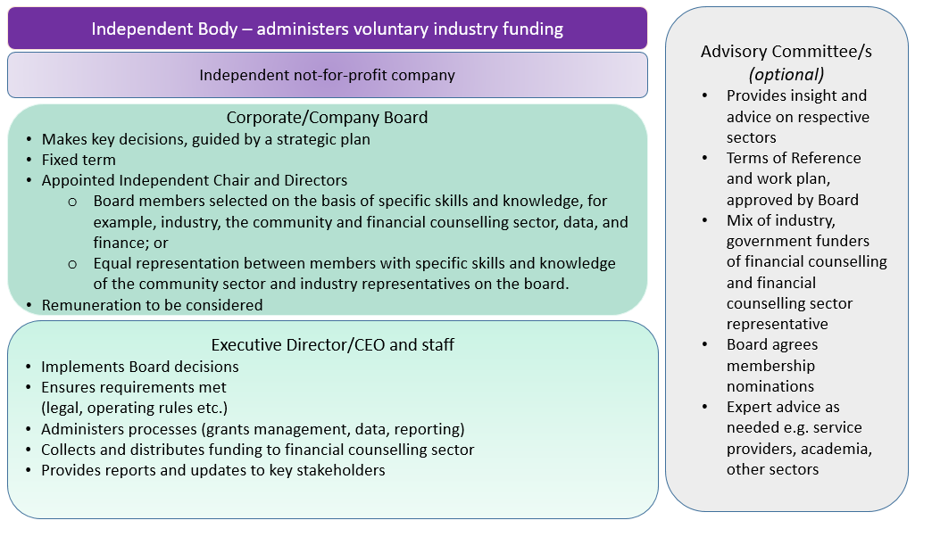

How will businesses make their funding contribution to the body?
It is proposed that industry peak bodies will have a role in working with the Department to secure initial industry funding commitments from their members. The ongoing role of securing commitments would be the responsibility of the independent body. While it is expected industry peaks will work with the Department to secure formal commitments from their subsectors, businesses could make their contribution directly to the body. The body could advise peak bodies how their subsector is tracking with their contributions.
Diagram 4 below outlines the proposed roles and responsibilities for businesses, the independent body and financial counselling agencies.
DIAGRAM 4: Proposed roles and responsibilities for funding pathway
Independent body
BUSINESSES
- Raise funds and deliver to the independent body
INDEPENDENT BODY
- Receives funds from businesses
- Holds funds securely until distribution
- Distributes funds to financial counselling agencies
FINANCIAL COUNSELLING AGENCIES
- Receive funds from independent body
- Spend funds on approved activities
Financial Counselling Agencies
Businesses

Evaluation
How will we know the industry funding model is working?
It is envisaged that an evaluation of the industry funding model would occur after two years of the model operating.
A key consideration in the evaluation will be whether the voluntary model appropriately contributes to the long-term viability of the financial counselling sector or if other mechanisms including a compulsory model should be considered.
Consistent with the principles proposed to guide the development of the model, the evaluation could assess the following questions, whether:
- Industry funding helps to address unmet demand and improves the predictability and stability of funding for financial counselling services.
- Industries that contribute to the demand for, and benefit from, financial counselling, contribute to the funding of the services.
- The model contributes to improved coordination, innovation and enhanced service delivery across the sector.
The Department will develop a monitoring and evaluation framework for the industry funding model, informed by feedback received from this discussion paper process.
The framework would include the planned monitoring and evaluation approach including identification of stakeholders who will be engaged throughout the process, evaluation questions, activities and associated timelines, as well as an overview of the data sources which will be used to measure program outcomes.
Discussion Question:
- What are your views on the proposed questions the evaluation could test?

Data improvements
What other initiatives will support the model?
The Department is currently undertaking key work to improve data collection and analysis in the financial counselling sector, which will support and/or have benefits for the industry funding modeI.
In the 2022-23 Budget process, $3.4 million over three years, from 2022-23 to 2024-25, was received for initiatives to improve data capture, consistency and availability, to build a robust evidence base for measuring demand for services and improving outcomes for clients and services. In addition to demand modelling, the initiatives are:
- scoping and designing a new data strategy;
- developing a national overview/report on financial counselling across Australia; and
- building the capacity of financial counselling agencies to collect and report on data.
A data strategy will provide a roadmap for work towards improving data in the sector. The framework would be developed in consultation with key stakeholders (the sector, governments, other funders). The framework could outline key themes and potential actions for improving data in the sector.
The national overview/report could be an annual or biennial data and research report providing a picture of financial counselling across Australia. The report could provide insights to financial counselling organisations and other stakeholders about key statistics, trends, challenges and opportunities. This would make key insights more broadly available and result in a better understanding of the needs of clients and improved client outcomes.
Funding for data capability initiatives would increase the data capability of financial counsellors and the financial counselling sector. Improvements to data capability would enable improvements in data quality, and improve the value derived from collected data. The Department has undertaken a number of workshops with the financial counselling sector and state and territory officials on possible initiatives, and is in the process of finalising options.

Next steps
This discussion paper invites you to have your say and your input will help inform the development of the industry funding model.
To support the discussion paper submissions, DSS intends to undertake a range of consultation activities to engage directly with:
- Financial Counselling Australia and the state/territory financial counselling associations;
- peak organisations representing industries;
- relevant industry organisations;
- providers of financial counselling; and
- other stakeholders identified in consultation with the Department.
The discussion paper will be supported by targeted roundtables with relevant stakeholders, to enable engagement on design aspects of the model in November and December 2022. Further information on the design on the model will be made available ahead of the anticipated commencement in July 2023.
When is the consultation open?
The consultation paper is open for six weeks, from: 7 November 2022 to 16 December 2022
Interested individuals and organisations are invited to provide written submissions to the Department through engage.dss.gov.au by 16 December 2022.
The closing date for submissions is 5.00pm 16 December 2022 (AEDT).

Glossary of key terms
Term | Definition
Financial Counsellor | Financial counsellors provide free, independent expert advice and support to individuals in financial hardship.  Financial counsellors hold diploma qualifications and have specific knowledge about credit, bankruptcy and debt collect laws, concession frameworks and industry hardship practices. They are also trained in negotiation and counselling, and offer emotional support. Financial counsellors do not provide services such as financial planning advice, financial lending or endorsement of specific financial products or services.
Unmet demand | Demand is ‘unmet’ when an eligible individual requests service, but does not receive a session within two weeks.
Unmet need | Distinct from unmet demand, unmet need refers to people who would be eligible for and benefit from financial counselling but who do not access services. For example, an individual’s need would be unmet where they could benefit from financial counselling but do not request services as they are unaware of the service or unable to access them.
Generalist Financial Counselling | Generalist financial counselling refers to services not targeted at specific demographics (e.g. Commonwealth Financial Counselling, National Debt Helpline and Money Support Hubs).
Grant | A grant is defined as the provision of financial assistance to a recipient (the grantee) to undertake activities. The grant conditions will define what activities the funding may or may not be used for.
Session | A session refers to an instance of service delivery which may include service provision directly with a client, follow-up actions on behalf of a client, and/or community education. For financial counselling, this may include intake and assessment of clients, provision of financial counselling, advocacy or support on behalf of a client, referrals to other programs and community education activities.
Demand model | A method used to forecast demand for services.
Sector | A sector is a high-level term referring to a category of industries, such as financial services, energy, water, or telecommunications.
Subsector | A subsector is a category of businesses. Each subsector falls within a larger sector. A subsector is specific to the work undertaken by the businesses within it. For example, within the sector ‘financial services’ there is the subsector ‘bank’.

Appendix A – Background on the review of financial counselling
In response to findings of the Royal Commission into Misconduct in the Banking, Superannuation and Financial Services Industry, a review into the coordination and funding of financial counselling services was undertaken by Ms Louise Sylvan AM in March 2019. The Countervailing Power: Review of the coordination and funding for financial counselling services across Australia (the Sylvan Review), engaged with state and territory governments, the private and not-for-profit sector, financial counselling and legal assistance sectors, and relevant Australian Government agencies to:
- assess whether existing financial counselling services adequately support client’s current, emerging or changing needs, including areas such as small business and natural disasters;
- explore the most efficient and appropriate way to deliver financial counselling services;
- consider how to improve the coordination and consistency of delivery of financial counselling services across Australia;
- recommend options for improving the predictability and sustainability of funding financial counselling services; and
- consider how the use of data can inform policy, service delivery and demand trends.

Appendix B – Sectors and subsectors
Sector | Subsector | Description
Financial services | Bank | Provides banking and other financial services to its customers; operates a deposit taking/payment systems, offers credit cards, provides consumer loans, housing finance, business finance.
Financial services | Customer owned bank (mutual bank, credit union, building society) | Community-based financial institution often owned by its members that offers traditional banking services like savings accounts and loans.
Financial services | Buy now pay later | A type of short-term financing that allows consumers to make purchases and pay by instalments over time, instead of paying the full amount upfront. Interest is not payable, but providers charge late fees. Some providers charge account keeping and other fees.
Financial services | Other credit provider, including finance companies | Provides credit for goods or services under a credit contract (other than SACCs / MACCs / payday lender / consumer lease). Includes finance companies. A finance company is an organisation that makes loans to individuals and businesses, such as car loans or provides credit cards. Unlike a bank, a finance company does not receive cash deposits from clients and offer transaction accounts.
Financial services | Small or medium amount credit contract (includes payday lenders) | A company that provides small amount credit contracts (SACCs) or medium amount credit contracts (MACCs). A SACC is a credit contract under which, in general terms, the amount of the loan is $2000 or less, and the term is 16 days to one year. A MACC may vary in length from 16 days to 2 years and can be from $2,001 to $5,000.
Financial services | Consumer lease | A consumer lease is a contract for the hire (rental) of goods where the consumer has no right to purchase the goods. Includes car leases and rental goods.
Financial services | Credit reporting agency | Maintains historical credit information on individuals and businesses; receives reports from lenders and various other sources which are compiled in a credit report that includes a credit score when issued.
Financial services | Debt collector or buyer | Collects overdue debts for themselves, or for a lender (such as a bank), service provider or debt collection agency. Buyers are companies that purchase debt from the original lender.
Financial services | Debt management firm | Debt management firms offer fee-based services to represent consumers in negotiations with creditors and credit reporting agencies.
Financial services | Financial advisor/planner | Authorised representative of an organisation that provides advice on investing, superannuation, retirement planning, estate planning, risk management, insurance, or taxation.
Financial services | Mortgage broker | Matches borrowers to lenders and arranges mortgage contracts between the two parties.
Financial services | General insurer | Provides motor vehicle insurance products, home building insurance products, home contents insurance products, sickness and accident insurance products, Consumer Credit Insurance products, travel insurance products, and personal and domestic property insurance products. Other insurance products that are not included here are not considered general insurance products.
Financial services | Health insurer | Health insurance is a type of insurance that covers the whole or a part of the risk of a person incurring medical expenses.
Financial services | Life insurer | Provides insurance policies that pay a set amount of money to an insured person’s beneficiaries when the insured person dies. Also known as term life insurance or death cover. Includes total and permanent disability (TPD) insurance and funeral expense insurance.
Gambling | Gambling - Online | Online gambling is any kind of gambling conducted on the internet. This includes virtual poker, casinos and sports betting.
Gambling | Gambling - Land-based | Gambling conducted from physical premises, as opposed to online.
Government | Australian Taxation Office | Collects taxation revenue on behalf of the Australian Government.
Government | Centrelink | Delivers Centrelink social security payments and services to Australians.
Government | Child support | Child support is an ongoing, periodic payment made by a parent for the financial benefit of a child following the end of a marriage or other relationship.
Government | HECS/HELP | HECS-HELP is the loan program that assists students in commonwealth-supported places with paying their course fees.
Government | State/local council fines and penalties | Fines and penalties issued to individuals by State governments/local councils.
Government | Local council | Rates and charges levied by local councils.
Utilities | Electricity | Energy retailers that sell electricity to end-use consumers.
Utilities | Gas | Energy retailers that sell natural gas to end-use consumers.
Utilities | Embedded network | An embedded electricity network is a private network within a building or self-contained site allowing the owner of the site to sell energy to all the tenants or residents based there.
Utilities | Water | Operate and supply water and sewerage services.
Telecommunications | Telecommunications | Carriage Service Providers that supply retail telecommunications services.
Superannuation | Super - Early access | Assisting clients to get early access to their superannuation.
Superannuation | Super - TPD/income protection | Assistance in relation to Total and Permanent Disability (TPD) and income protection insurance paid through superannuation accounts.
Superannuation | Super - Other | Any other assistance provided in relation to superannuation funds.
Housing | Rental - social housing tenancy | Social housing includes rental housing owned and managed by government or non-government organisations (including not-for-profit) which can be rented to eligible households.
Housing | Rental - private rental tenancy | A private rental agreement between landlord and tenants.
Housing | Body corporate fees | Body Corporate fees are paid by anyone who owns a property within a larger building complex, which is under a strata title.
Other | Other (no suitable category, other creditor) | A subsector that is not included in this list.

Appendix C – Summary of results of the 2021 survey of financial counsellor time
- Time that can be traced to a sector-subsector
Sector-Subsector | Aggregate time (minutes) | Proportion of sector total | Proportion of total
 | (1) | (2) | (3)
Financial services | 103,836.50 | 100.00% | 57.94%
Bank other debt | 29,721.50 | 28.62% | 16.59%
Bank mortgage | 19,257.00 | 18.55% | 10.75%
Debt collector or buyer | 13,652.00 | 13.15% | 7.62%
Other credit provider | 11,727.00 | 11.29% | 6.54%
Small amount of credit contracts | 6,791.00 | 6.54% | 3.79%
Buy now pay later | 5,798.00 | 5.58% | 3.24%
General insurer | 4,827.00 | 4.65% | 2.69%
Finance companies | 4,362.00 | 4.20% | 2.43%
Consumer lease | 3,692.00 | 3.56% | 2.06%
Debt management firm | 1,563.00 | 1.51% | 0.87%
Credit reporting agency | 1,043.00 | 1.00% | 0.58%
Customer owned bank | 845.00 | 0.81% | 0.47%
Health insurer | 298.00 | 0.29% | 0.17%
Life insurer | 175.00 | 0.17% | 0.10%
Mortgage broker | 60.00 | 0.06% | 0.03%
Financial advisor/planner | 25.00 | 0.02% | 0.01%
Utilities | 32,249.00 | 100.00% | 18.00%
Electricity | 20,530.00 | 63.67% | 11.46%
Water | 7,689.00 | 23.84% | 4.29%
Gas | 3,935.00 | 12.20% | 2.20%
Embedded network | 95.00 | 0.29% | 0.05%
Government | 21,738.50 | 100.00% | 12.13%
State/local fines and penalties | 6,294.00 | 28.96% | 3.50%
Centrelink | 5,461.00 | 25.12% | 3.05%
Australian taxation office | 4,607.50 | 21.20% | 2.57%
Local council | 4,544.00 | 20.90% | 2.54%
Child support | 477.00 | 2.19% | 0.27%
HECS/HELP | 355.00 | 1.63% | 0.20%
Telecommunications | 9,730.00 | 100.00% | 5.43%
Telecommunications | 9,730.00 | 100.00% | 5.43%
Housing | 6,837.00 | 100.00% | 3.81%
Private rental tenancy | 4,214.00 | 61.63% | 2.35%
Social housing tenancy | 2,193.00 | 32.08% | 1.22%
Body corporate fees | 430.00 | 6.29% | 0.24%
Super | 4,284.00 | 100.00% | 2.39%
Total and permanent disability/income protection | 1,700.00 | 39.68% | 0.95%
Early access | 1,564.00 | 36.51% | 0.87%
Other | 1,020.00 | 23.81% | 0.57%
Gambling | 530.00 | 100.00% | 0.30%
Online | 480.00 | 90.57% | 0.27%
Land-based | 50.00 | 9.43% | 0.03%
Total (excl. other and general activity) | 179,205.00 |  | 100.00%
Other
General activity | 80,005.50
Other (no suitable category, other creditor) | 10,872.00
Total (incl. other and general activity) | 270,082.50

Appendix D – Application of minimum threshold to survey results
- Application of a three per cent minimum threshold to subsectors (excluding government delivered services)
Subsector | Aggregate time (minutes) | Proportion of total (excl. government)
Bank other debt | 29,721.50 | 18.88%
Electricity (retail sale and supply) | 20,530.00 | 13.04%
Bank mortgage | 19,257.00 | 12.23%
Other credit provider, including finance companies | 16,089.00 | 10.22%
Debt collector or buyer | 13,652.00 | 8.67%
Telecommunications | 9,730.00 | 6.18%
Water | 7,689.00 | 4.88%
Small or medium amount credit contract providers | 6,791.00 | 4.31%
Buy now pay later | 5,798.00 | 3.68%
General insurer | 4,827.00 | 3.07%
Private rental tenancy | 4,214.00 | 2.68%
Gas | 3,935.00 | 2.50%
Consumer lease | 3,692.00 | 2.34%
Social housing tenancy | 2,193.00 | 1.39%
Superannuation - Total and permanent disability/income protection | 1,700.00 | 1.08%
Debt management firm | 1,563.00 | 0.99%
Superannuation - Early access | 1,564.00 | 0.99%
Credit reporting agency | 1,043.00 | 0.66%
Superannuation - Other | 1,020.00 | 0.65%
Customer owned bank | 845.00 | 0.54%
Gambling - Online | 480.00 | 0.30%
Body corporate fees | 430.00 | 0.27%
Health insurer | 298.00 | 0.19%
Life insurer | 175.00 | 0.11%
Embedded network | 95.00 | 0.06%
Mortgage broker | 60.00 | 0.04%
Gambling - Land-based | 50.00 | 0.03%
Financial advisor/planner | 25.00 | 0.02%
 | 157,466.50 | 100.00%

Appendix E – Associated Peak Bodies
Formal commitments to the industry funding model, on behalf of their members, will be sought from the following peak bodies:
- Australian Banking Association
- Australian Finance Industry Association
- Australian Collectors and Debt Buyers Association
- National Credit Providers Association
- Insurance Council of Australia
- Australian Energy Council
- Communications Alliance
- Water Services Association of Australia.

The Countervailing Power: Review of the coordination and funding for financial counselling services in Australia, Ms Louise Sylvan, 3 October 2019 [accessed on 14 September 2022]
Financial Counselling in a Nutshell - Financial Counselling Australia, May 2019 [accessed on 14 September 2022]
Nicola Brackertz, ‘The Impact of Financial Counselling on Alleviating Financial Stress in Low Income Households: A National Australian Empirical Study’, Social Policy & Society (2014) 13:3, 389-407. doi:10.1017/S1474746413000511
Ibid; Parvin Mahmoudi, Ann-Louise Hordacre & John Spoehr. 2014. Paying it forward: Cost benefit analysis of The Wyatt Trust funded financial counselling services. Adelaide: Australian Workplace Innovation and Social Research Centre, The University of Adelaide.
Money and mental health social research report, August 2022 [accessed on 15 September 2022]
The Countervailing Power: Review of the coordination and funding for financial counselling services in Australia, Ms Louise Sylvan, 3 October 2019 [accessed on 14 September 2022]
Generalist financial counselling refers to services not targeted at specific client cohorts (e.g. Commonwealth Financial Counselling, National Debt Helpline and Money Support Hubs).
The Australian Government also funds the Small Business Debt Helpline and Rural Financial Counselling Service. Industry Funding Model contributions will not be directed to these services, as the focus is on generalist financial counselling services.
The Sylvan Review recommended $20 million as the initial industry contribution.
Government owned corporations and companies are not excluded.
The survey results in Table 2 exclude the Government and Housing sectors as these are not included in Household Expenditure splits. Government is excluded as the table is considering the division of contributions between industry sectors.
Government (all levels) as a sector was identified as contributing to around 12 per cent of financial counsellor time, noting governments are already the main funding source for financial counselling. Government owned corporations and companies are not excluded from the above results.
Household expenditure for households in the bottom 40 per cent of household income.
Financial services includes superannuation in this table.
Figures in this column are calculated from survey results when subsectors below 3 per cent are removed from the results at Appendix D.
A review of the ASIC Industry Funding Model is currently underway. The review is considering how ASIC allocates costs to subsectors, which includes examination of subsector definitions, metrics and formulas.
Peak organisations will not be required to collect funding on behalf of their members. The list of associated peak bodies is included in Appendix E.
The Countervailing Power: Review of the coordination and funding for financial counselling services in Australia, Ms Louise Sylvan (Page 32), 3 October 2019 [accessed on 14 September 2022]
The Countervailing Power: Review of the coordination and funding for financial counselling services in Australia, Ms Louise Sylvan, 3 October 2019 [accessed on 14 September 2022]
Source: ARTD Financial Counsellors Survey, August-September 2021
Government owned corporations and companies are not excluded.
Finance companies are included in the other credit provider category however were included separately in survey results.
Private rental tenancy is not proposed for inclusion as it is private (person to person) in nature and would not align with the objective of industry contributing to financial counselling. The private rental tenancy subsector is not composed of businesses that have a direct relationship with customers.
Social housing tenancy is excluded as it is not a business. Social housing is owned or managed by a government authority or community housing providers and made available for rent to eligible persons.

