DES Quality Framework
Discussion Paper

Contents
Background and Context 1
Introduction 1
UNCRPD 1
Legislative Context 2
Disability Royal Commission 2
Australia’s Disability Strategy 2021-2031 3
Current DES Program Governance 3
Introduction to the draft DES Quality Framework 6
A Synthesis of existing frameworks 6
A Risk-based, earned autonomy model 7
Conceptual Map 7
Unpacking the Quality Elements 9
Quality Element One: Participants’ rights 9
Quality Element Two: Quality of Service 12
Quality Element Three: Provider Capability and Governance 14
Quality Element Four: Feedback and Complaints 17
Quality Element Five: Formal Assurance 19
Quality Scorecards and Quality Assessment ratings 20
Determining ratings 20
Framing of ratings 20
Quality Scorecards 21

Background and Context

Introduction
Through Disability Employment Services (DES), people with disability, injury or health condition may be able to receive assistance to prepare for, find and keep a job. DES Providers are a mix of large, medium and small for-profit and not-for-profit organisations experienced in supporting people with disability, as well as assisting employers to support employees with disability in the workplace.
DES has taken various forms over the years, with the most recent suite of reforms coming into effect in 2018. These reforms sought to empower DES participants, increase contestability and better align the programs incentives with desired outcomes.
In the 25 October 2022 Commonwealth Budget, the Australian Government announced that it would develop of a new specialist disability employment services model to replace the current DES program from 1 July 2025.
The Australian Government has also announced that the existing DES program will be extended for two years while this detailed reform work is conducted, noting that immediate adjustments will be made to the program to boost the quality of DES services and lift up the whole system to provide better outcomes for people living with disability.
At the centre of this is the development of a new Quality Framework to ensure the views of DES participants are embedded in the ratings system.
This discussion paper is part of a broader consultation process to guide the development of this new framework. It is important at the outset to recognise the broader disability employment policy context.

UNCRPD
The Australian Government is a signatory to the United Nations Convention on the Rights of Persons with Disabilities.
Article 27 of the UNCRPD requires that ratifying countries:
recognize the right of persons with disabilities to work, on an equal basis with others … [and to] gain a living by work freely chosen or accepted in a labour market and work environment that is open, inclusive and accessible to persons with disabilities.
State parties are required to safeguard and promote the realisation of this right by taking appropriate steps – this includes:
- Prohibiting discrimination in all employment matters including recruitment, employment and continuance of employment.
- Protecting the rights to just and favourable work conditions, equal opportunity and pay, safe working conditions and protection from discrimination.
- Enabling effective access to technical and vocational guidance, placement services and training.
- Promoting employment opportunities including assistance in finding, obtaining, maintaining and returning to employment.
- Ensuring that “reasonable accommodation” is provided to persons with disabilities in the workplace.

Legislative Context
The Disability Discrimination Act 1992 (DDA) makes it unlawful to discriminate against people with disability in employment, including with respect to recruitment processes, decision making, terms and conditions of employment, promotions (and other benefits) and dismissals (and other detriments). Employers must consider “reasonable adjustments” to support people with disability in employment.
The Disability Services Act 1986 (DSA) outlines arrangements for the provision of services for people with disability and aims to assist persons with disabilities to receive services necessary to enable them to work towards full participation as members of the community. The DSA also gives effect to the National Standards for Disability Services.
The Department is currently consulting on a new Act to replace the DSA - this public process is open until 12 February 2023.

Disability Royal Commission
The Royal Commission into Violence, Abuse, Neglect and Exploitation of People with Disability (DRC) sought responses, in its May 2020 Employment Issue Paper, to a range of questions including:
- The prevention of violence, abuse, neglect and exploitation in employment settings.
- Barriers to employment for people with disability.
- The effectiveness of current employment programs (including DES) and how they might be improved.
Systemic neglect of and discrimination against people with disability in job seeking and employment settings was a major theme in multiple responses. In particular, responses spoke to the failure of systems to provide appropriate and safe employment services, job opportunities, reasonable adjustments and opportunities for career development for people with disability.
Human rights was also a key theme of responses with one employment services provider noting that Australia’s international reputation is at risk if it does not improve employment outcomes for people with disability.
Structural barriers to employment were raised frequently. In the DES context, issues included the lack of appropriate supports, poor client outcomes, and clients being placed in jobs that did not match their skills, interests or abilities. Responses described experiences with DES consultants who lacked specialised disability knowledge or failed to act in the client’s best interests while others spoke of under resourced DES providers struggling with high caseloads. Another criticism was the perceived use of ‘punitive measures’ against participants in order to drive them into unsuitable jobs.

Australia’s Disability Strategy 2021-2031
Australia’s Disability Strategy 2021–2031 (ADS) calls on all Australians to ensure people with disability can participate as equal members of society.
The ADS includes the ‘Outcome Area’ of Employment and Financial Security, which sets out three clear policy priorities:
- Increase employment of people with disability.
- Improve the transition of young people with disability from education to employment.
- Strengthen financial independence of people with disability.
These priorities support the aim of increasing the economic security, mental and physical wellbeing and standard of living for Australians with disability.

Current DES Program Governance
The DES program essentially comprises three layers of governance aimed at driving and monitoring of performance and quality.
This includes the grant agreement (which includes both the Service Guarantee and the Code of Practice), certification against the National Standards for Disability Services and the 2018 DES Provider Performance Framework.
This structure exists to support the aim of the Disability Employment Services program to equip Australians with disability with the necessary education and training to secure long-term employment. Underpinning this aim are the core tenets of choice and control for participants, and ensuring that providers meets their specific needs and requirements.
“The overall aim…is to improve the quantity and quality of employment outcomes for people with a disability”

Grant Agreement

The agreement sets out the basic requirements for DES providers with respect to the provision of services. It also includes a Code of Practice for a providers and Service Guarantee which must be “prominently displayed” and made available to participants.

Provider Code of Practice
Embedded within the provider Code of Practice is a commitment to delivering quality employment services though:
- Ensuring staff have appropriate skills and experience.
- Working collaboratively.
- Ethics, honesty, due care and diligence.
- Openness and accountability.
- Avoiding bringing the program into disrepute.
- Sensitive management of information.
DES providers are expected to help job seekers find their pathway into employment. This includes:
- Meeting service guarantee
- Tailoring assistance
- The appropriate use of Government funding
- Treating participants with fairness and respect
- Providing a fair and accessible feedback process

Service Guarantee
DES providers are expected to use the Service Guarantee to explain available services to potential participants. It is also intended to support conversations with participants about their particular needs. This includes with respect to how those services can and will be delivered.

National Standards for Disability Services
Under clause 79.3 of the Grant Agreement, all DES providers are required to have a valid Certificate of Compliance against the National Standards for Disability Services (NSDS) which comprise the six standards developed through extensive consultation, validation and user testing:
- Rights
- Participation and Inclusion
- Individual Outcomes
- Feedback and Complaints
- Service Access
- Service Management.
This process follows a 36-month cycle involving an initial Certification Audit against all six standards, surveillance audits after 12 and 24 months and recertification audits after 36 months. Surveillance Audits only assess standards 1, 3, 6 plus one other.

DES 2018 Performance Framework
Under the existing framework, three Key Performance Indicators are in place to underpin performance:
- Efficiency: with the aim of minimising the average times taken by Providers to achieve employment outcomes for their Participants.

- Effectiveness: with the aim of maximising the numbers of outcomes achieved by Participants, as well as the number of Participants maintained in employment where assistance is required.

- Quality: with the aim of maximising the delivery of high quality, individualised Employment Services.
The Star Ratings measure performance with respect to efficiency and effectiveness. The grant agreement, the Service Guarantee and the Code of Practice underpin quality.
However, while the Star Ratings are a measurement tool, the Service Guarantee and Code of Practice are statements of requirements – not measurement mechanisms.
The 2018 Performance Framework envisaged regular Employment Services Outcomes Reports acting as a public facing measurement and reporting mechanism cutting across all three KPIs – however, the last DES specific report was published in October 2019 and only covered the period from January to December 2018.
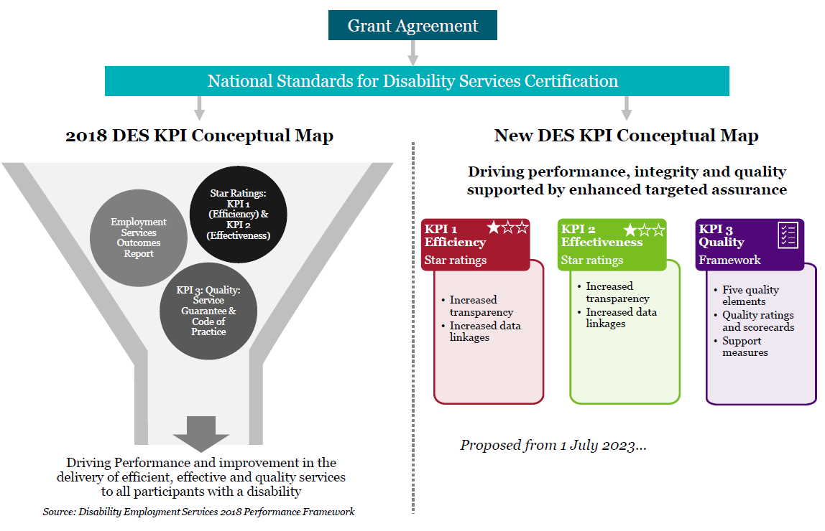

Introduction to the draft DES Quality Framework
Below is a diagram of a possible DES Quality Framework, which comprises five ‘Quality Elements’.

A Synthesis of existing frameworks
This draft represents a synthesis of a range of existing quality and provider performance frameworks already operating across a range of Australian Government programs.
Noting our intention to achieve appropriate coverage from both the employment services and disability services perspectives it is possible to combine and modify various elements/themes from these frameworks into a holistic set of quality to measures for the DES program.
Consideration has been given to the following frameworks:
- Workforce Australia Provider Performance Framework (WA Framework).
  - Aspects of the principles of three of five of the WA Framework modules.
  - The ‘Sustained Employment’ and ‘Progress to Employment’ modules are within the scope of the Star Ratings.
- National Standards for Disability Services (NSDS).
  - All six NSDS Standards have been considered.
  - Standard three: Individual Outcomes is also addressed under DES Star Ratings.
  - clause 79.3 of the Grant Agreement requires the DES Providers to be certified against the NSDS.
- NDIS Quality and Safeguards Commission - Practice Standards and Quality Indicators
  - All four NDIS Practice Standards core modules are covered.
- Community Development Program – KPIs and performance measures
(CDP framework).
  - Key risk and governance considerations are covered.
- The National Quality Standard Ratings (Childcare Standards).
  - Service quality and governance elements are covered.

A Risk-based, earned autonomy model
The process for developing a set of provider Quality Scorecards/Quality Assessment ratings would necessarily be risk-based similar to the model used by the Tertiary Education Quality and Standards Agency (TEQSA) and the Australian Skills Quality Authority (ASQA).
This would require leveraging provider-level risk profiles.

Low-risk providers could be allocated Quality Assessment ratings. Medium or high-risk could be targeted for further action. This might include additional information requests, formal breeches (as appropriate), additional site visits, etc. Providers could be temporarily assigned lower Quality Assessment ratings or could have ratings withheld during this period.
The opportunity to earn greater autonomy by demonstrating sustained high quality service over time is under consideration. Providers could be rewarded with reduced regularity of reassessment against the framework and additional flexibility in the delivery of certain aspects of DES support.
An application-based process could also be implemented – allowing providers to expedite their ‘earned autonomy status by opting to proactively demonstrate their service quality. This would mirror the ACECQA’s Childcare Standards rating process whereby providers can only achieve the top rating of ‘Excellent’ by addressing specific criteria via a voluntary application process
Discussion Questions
- What are your views on an application based model for demonstrating quality (and potentially as a means of attaining a higher quality ratings)?
- What are you views on the concept of earned autonomy within the DES program?
  - How can quality be demonstrated before additional flexibility is granted?
  - What kinds of flexibility would be appropriate?

Conceptual Map
The draft DES Quality Framework begins from the premise that sustained and meaningful quality improvement in the DES space requires the following:
- Informed participants to act as a driver of quality - well informed participants with a good understanding of their rights are likely to have high expectations with respect to service quality.
- Capable providers calibrated towards meeting those expectations - increased clarity around obligations and participant expectations will reshape provider practice for the better.
- Active, risk-based monitoring and support from government – transition supports (such as information products for providers and participants) will drive quality improvements in the short-term, while active monitoring and assurance processes will provide a safety net for participants. Overtime, the need for the latter will diminish as quality providers ‘earn’ autonomy.
Based on this, and supported by consideration of existing quality frameworks, five DES appropriate ‘Quality Elements’ have been identified.

Conceptual Map: draft DES Quality Framework

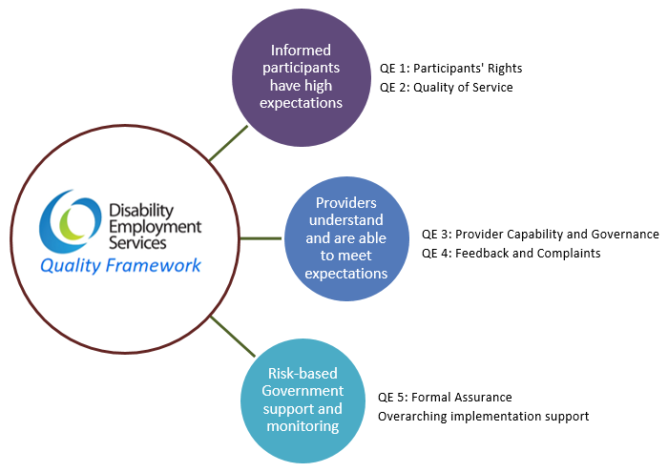

Unpacking the Quality Elements
Below is an explanation of each of the proposed ‘Quality Elements’ including diagrams highlighting where existing processes and products are being leveraged (including if modification is required) and where new processes or products need to be developed.

Key to Quality Element diagrams

Quality Element One: Participants’ rights

Aligned with:
- NSDS Standard One: Rights, Standard Two: Participation and Inclusion and Standard Three: Individual Outcomes.
- NDIS Practice Standards ‘Rights and responsibility for participants’ and ‘the provision of supports’ modules.

This element focuses on:
- The prevention of abuse and discrimination.
- Ensuring participants are treated with respect and dignity.
- Ensuring that they are receiving individualised supports.
The key driver for achieving these aims will be increased participant awareness and understanding of their rights.
Existing NSDS ‘certification audit’ and ‘surveillance audit’ information would be used for assessments. Data collected through participant surveys and a targeted program of site visits would supplement audit information.
Participant surveys are a recurrent theme across Quality Elements and will be key to supplementing point in time audit information with up-to-date user views. The department would need to work with an expert (such as an appropriate academic) to properly scope this data collection and to develop and test survey instruments.
The development of ‘know your rights’ information products aimed at current and potential DES participants would support this Quality Element. For example, fact sheets, check lists cheat sheets and guides to explain to participants their broad rights as they relate to DES. It is likely that certain basic products could be designed in-house with departmental led consultation (with Peak bodies, advocacy groups, AHRC, etc.). This could be supplemented over time by more focused, co-designed products that are developed by current/former/potential DES participants.
The National Standards for Disability Services – Evidence Guide would also need to be reviewed and updated. This would ensure that NSDS audits are aligned with the objectives of the DES Quality Framework. This guide contains detailed information to support disability service providers to understand the each of the NSDS Standards, including guidance on what they can do to meet the Standards and how to demonstrate compliance.

Quality/Risk indicators:
NSDS Standard One: Rights includes nine indicators of practice all of which are of direct relevance. They cover themes of dignity and respect; freedom of choice and expression; freedom from discrimination, exploitation, abuse, harm, neglect and violence, and; the safeguarding of participants’ rights (including through family support, advocacy and legal counsel). These indicators are already assessed for all DES providers through NSDS certification and surveillance audits every 12 months.
NSDS Standard Two: Participation and Inclusion is only subject to audits every 36 months but includes important quality indicators relating to recognising individuality and connections with community. Existing audit information will inform initial provider risk assessments.
NSDS Standard Three: Individual Outcomes is subject to audit every 12 months (as with
Standard One) and includes five quality indicators, which delve deeper into individualised service provision.
Leveraging audit information will provide a significant and regularly updated base set of information for assessing quality risk under Quality Element 1. Participant surveys will provide an ongoing source of up-to-date participant perceptions information with respect to selected NSDS quality indicators.
The NSDS Rights Standard is largely aligned to the NDIS Practice Standards ‘Rights and responsibility for participants’ module. However, the latter also covers some important ground that is not covered in the NSDS Standards.
Notably, it includes an indicator acknowledging participants “right to the dignity of risk in decision-making” – requiring that “… each participant is supported to make informed choices about the benefits and risks of the options under consideration”. Information on this indicator would also be collected through participant surveys and site visits.
Discussion Questions
- What other indicators or measures could be used to monitor and assess the practical application of DES participants’ human rights?
- What information products would be most useful in contextualising this Quality Element and bringing it to life?
- What are the key things the department should consider when developing participant surveys and considering changes to the conduct of site visits?
- What other support measures could be put in place to assist providers to implement and demonstrate quality practices in alignment with this element?

Quality Element Two: Quality of Service

Aligned with:
- NSDS Standard Two: Participation and Inclusion and Standard Five: Service Access.
- NDIS Practice Standards ‘Provision of supports’ module.
- Adheres to similar principles as the WA Framework ‘Quality of service to participants’ and ‘Quality of service to employers’ measures.
- Childcare Standards ‘Collaborative partnerships with families and communities’ Quality Area.

This element focuses on:
The direct experiences of both DES participants and employers. User views (garnered via surveys and broader consultation) could inform a new set of service quality benchmarks or quality expectations. Co-design, led by an appropriate external organisation would likely be the most effective way of developing a document, which outlines, in clear terms, the service level expectations of DES participants.

The existing Code of Practice and Service Guarantee would provide important context and serve as a leaping off point for co-design.
It may be possible for the resulting product(s) to be enshrined in DES guidelines and therefore subject to formal assurance/compliance processes.
Information products for both providers, participants and employers would also support increased awareness of rights and responsibilities with respect to service quality.

Quality/Risk indicators:
As under Quality Element One, the existing six quality indicators, audited under NSDS
Standard 2: Participation and Inclusion would provide insights on the range of services offered to DES participants.
Both the NSDS and NDIS Practice Standards include a focus on access and support. The inclusion of a quality indicator with respect to the provision of ‘Reasonable Adjustments’ to support participants would cover both physical access and customised service delivery.
The Workforce Australia Provider Performance Framework priorities ‘user views’ from both participants and employers using a survey-based measure of participant experience of progressing towards employment.
The DES Quality Framework would include similar measures driven by surveys to garner information on the level of differentiation and perceptions of service quality.
Discussion Questions
- What other indicators or measures could be used to monitor and assess quality of service from the perspective of participants and employers?
- What information products would be most useful in contextualising this Quality Element and bringing it to life?
- What other support measures could be put in place to assist providers to implement and demonstrate quality practices in alignment with this element?
- It is envisaged that new service quality ‘benchmarks’ (or a set of participant expectations) would be developed via a co-design process.
  - What kind of organisations could/should lead such a process?
  - Who should be involved (i.e. mix of stakeholders)?
  - What are the important contextual or other factors in scoping such a project?

Quality Element Three: Provider Capability and Governance

Aligned with:
- NSDS Standard Six: Service Management.
- NDIS Practice Standards ‘Governance and operational management’ module.
- CDP framework risk assessments.
- Childcare Standards ‘Governance and Leadership’ and ‘Staffing arrangements’ Quality Areas.

This element focuses on:
Ensuring providers have appropriate governance mechanisms and policies in place including:
- Human Resources frameworks:
  - Recruitment policies.
  - Criminal record Checks.
  - Working with children and vulnerable people checks.
- Training requirements).
- Financial management.
- Risk and contingency planning.
- Work Health and Safety.
- Continuous improvement mechanisms.
This will be supported by the development of information products to assist DES providers to ‘know your obligations’. These products would provide increased clarity around the technicalities of grant agreement and other existing legal requirements. It is not envisaged that this would constitute additional program guidelines. Instead, this would be pragmatic, daily reference material to assist providers in targeting quality improvement efforts. This would be about efficiency through clarity, not creating new burdens.
Consideration is also be given to the development of staff training resources which could include practice case studies, FAQs for new starters, and other training materials as well as continuous improvement planning tools for providers – such as a provider self-assessment tool. A self-assessment tool could provide a framework for providers to rate themselves against a number of criteria (aligned with the final DES Quality Framework) with a form of marking rubric with example statements to guide that assessment.

Quality/Risk indicators:
NSDS Standard Six: Service Management is subject to audit every 12 months and includes seven quality indicators relating to the skills of frontline staff and managers; WHS, HR and financial management systems, and; maintaining/strengthening or organisational capabilities. Again, leveraging audit information will provide a significant and regularly updated base set of information supplemented by targeted participant survey questions.
The NDIS Practice Standards cover the same elements but go significantly further in the following ways:
- The need for governance systems on the appropriate scale for the organisation.
- A more complete spectrum of risk factors – notably incident management, and emergency/disaster management.
- Greater emphasis of continuous improvement, using outcomes, risk related data, evidence-informed practice and feedback from participants.
- Incident management requirements – ensuring that incidents are acknowledged, respond to, well managed and learned from.
These additional elements could be addressed via two broad indicators for the DES Quality Framework. One that will use audit data, desktop research and information from site visits to determine if a provider’s systems are proportionate to its size and scale.
As well as a combined indicator which could be supported by a light touch compliance checklist to be developed requiring providers to confirm that all governance, system, process requirements (including those set out in the DES Grant Agreement and already subject to NSDS audits) are met.
Discussion Questions
- What other indicators or measures could be used to monitor and the connections between capability/governance mechanisms and quality?
- What information products would be most useful for providers in describing and contextualising obligations?
- What other support measures could be put in place to assist providers to implement and demonstrate quality practices in alignment with this element?
  - Would providers likely opt-in to using a voluntary self-assessment tool?
  - What would you like to see in a staff training tool kit?

Quality Element Four: Feedback and Complaints

Aligned with:
- NSDS ‘Feedback and Complaints’ standard.
- NDIS Practice Standards ‘The support provision environment’ module.
- Implicit in CDP framework and Childcare Standards as part of ‘governance’ focused measures.

This element focuses on:
Indicating to providers the intention to seek regular, ongoing feedback to inform DES service and provider-wide reviews and improvement. The grant agreement already provides direct mechanisms to implement and data is already collected though the Complaint Resolution and Referral Service (CRRS) and other means.
This is interconnected with the ‘Quality of Service’ element which will drive and clarify participant expectations as well as the ‘Provider Capability and Systems’ element which support providers to meet those expectations – in tandem, those elements will reduce the overall number of complaints and increase the usefulness of complaints/feedback that are received.

Quality/Risk indicators:
NSDS Standard Four: Feedback and Complaints is only subject to audits every 36 months but includes important quality indicators relating to support for making complaints; processes for handling and resolving complaints, and embedding feedback into organisational culture as a driver of continuous improvement. Existing audit information would inform initial provider risk assessments.
The department receives complaints in a number of ways – most notably the CRRS – and maintains a register of complaints data. As a means of using this data in a proactive way, the department will develop a system for weighting the seriousness of complaints that, combined with the overall volume of complaints as a proportion of caseload, will allow for quantitative analytics-based ratings for DES services.
DES participant and employer surveys could potentially be designed with a view to feeding into an additional metric, which will measure the overall skew (positive or negative) of feedback garnered through those mechanisms.
Discussion Questions
- What other indicators or measures could be used to make this a proactive quality element?
- What information products would be most useful in contextualising this Quality Element and bringing it to life?
- What other support measures could be put in place to assist providers to implement and demonstrate quality practices in alignment with this element?
  - What are the key considerations with respect to weighting and analysing feedback and complaints?

Quality Element Five: Formal Assurance

Aligned with:
- The princples of the WA Framework ‘Licensing Standards’ measure.
- Implicit in other frameworks.

This element focuses on:
Leveraging the existing powers and quality mechanisms under the grant agreement a proactive quality driver, not only as a reactive compliance tool.
‘Know your obligations’ information products aimed at DES providers could support this implementation of this Quality Element.

Quality/Risk indicators:
The draft includes a metric based on the number and severity of breaches incurred by providers against the requirements of the Grant Agreement (including guidelines and the Provider Code of Practice) and the NSDS.
Additionally, the department is considering leveraging the experience of FAMs, NSDS auditors and other departmental representatives engaged in site visits, to assess and quantify the willingness of providers/services to engage with the department, in good faith, on quality and compliance issues.

Discussion Questions
- What other indicators or measures could be used to make this a proactive quality element?
- What information products would be most useful in contextualising this Quality Element and bringing it to life?
- In measuring engagement between the department and providers – should we contemplate a mechanism for provider feedback to the department?
  - If so, what might this look like?
- What other support measures could be put in place to assist providers to implement and demonstrate quality practices in alignment with this element?
  - What are the key considerations with respect to weighting and analysing breeches?

Quality Scorecards and Quality Assessment ratings

Determining ratings
Each Quality Element would be individually measured and rated for each DES provider - feeding into a ‘Quality Assessment’ rating. Providers would receive detailed ‘Quality Scorecards’ to guide continuous improvement, while the overall ‘Quality Assessment’ ratings would be publicly available alongside Star Ratings to better support informed choice of DES provider.

Framing of ratings
Being based on a combination of quantitative and qualitative information, these Quality Assessment ratings would be more appropriately measured on a continuum rather than as hard and fast scores - for example:
Significant Improvement required → working towards quality standards → meeting quality standards → exceeding quality standards → significantly exceeding quality standards
This could also be simplified with fewer ratings. For example: working towards/meeting/exceeding quality expectations. It could also be binary – with those meeting quality standards being permitted to use a departmentally branded quality seal. Whatever the final number/phrasing of ratings is there will likely be the need for an explanatory document to contextualise ratings for participants.

Quality Scorecards
Quality Scorecards would be developed for each provider based on risk assessments. These would include a more detailed array of feedback against each Quality Element – e.g. a summary of the relevant audit information, survey data, etc. as well as analysis and recommendations for possible improvements.
Initial Quality Scorecards would be discussed with providers, allowing them the opportunity to respond to identified risk and provide additional information and context. These conversations may alter the final assessment.
Discussion Questions
- What is the appropriate number of rating levels and how could they be phrased/described?
- Is the notion of ‘Quality Scorecards’ appealing? How could this be implemented in a way that maximises utility but minimises burden?
- How could/should the Quality Elements be weighted as components of provider level Quality Assessment ratings?

Failure to provide “reasonable adjustments” for people with disability is discrimination under the Disability Discrimination Act 1992.
Article 27 – Work and employment | United Nations Enable
Disability discrimination (humanrights.gov.au)
A New Act to Replace the Disability Services Act (1986) | engage.dss.gov.au
Issues paper - Employment Issues paper (royalcommission.gov.au)
Overview of responses to the Employment Issues paper (royalcommission.gov.au)
Australia’s Disability Strategy 2021–2031 | Disability Gateway
des-grant-agreement.pdf (dss.gov.au)
DES Code of Practice | Department of Social Services, Australian Government (dss.gov.au)
DES Service Guarantee (dss.gov.au)
National Standards for Disability Services | Department of Social Services, Australian Government (dss.gov.au)
Workforce Australia - Provider Performance Framework training module
NDIS Practice Standards and Quality Indicators (ndiscommission.gov.au)
Assessment and rating process | ACECQA
Risk Assessment Framework | Tertiary Education Quality and Standards Agency (teqsa.gov.au)
Regulatory Risk Framework | Australian Skills Quality Authority (ASQA)
GuidelinesForApplicantsExcellentRating.pdf (acecqa.gov.au)
National Standards for Disability Services - Evidence Guide | Department of Social Services, Australian Government (dss.gov.au)

