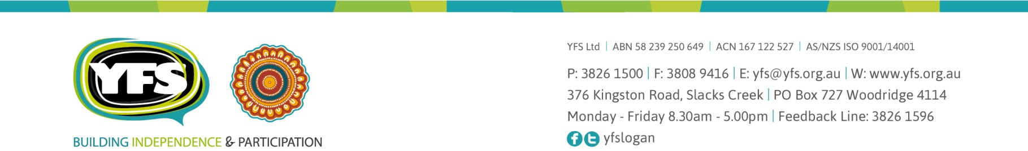

16 December 2022

Response to the Financial Counselling Industry Funding Model discussion paper
YFS is a community services organisation based in Logan, Queensland. We have been supporting people to overcome adversity and thrive for more than 36 years.
YFS provides a range of services and supports, including financial counselling and we are a member of Financial Counselling Australia (FCA).
YFS’ small team of financial counsellors serves Logan and surrounding areas. Demand for financial counselling services exceeds our current capacity and continues to grow.
We welcome the Industry Funding Model to deliver additional financial counsellors in the sector. YFS supports the position of FCA and looks forward to this model being implemented in the near future.

Cath Bartolo
CEO
YFS Ltd

PP_YFS_LH_eDoc_v4_0219_102079

