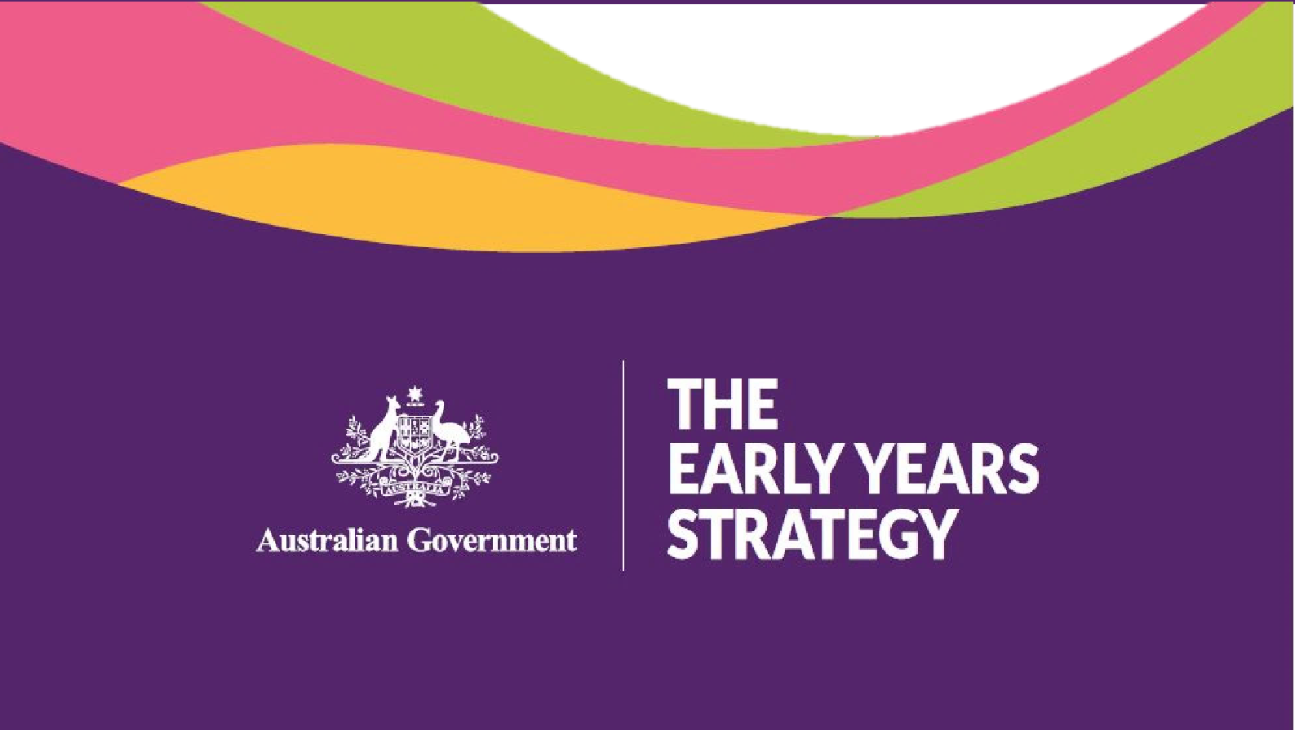

DISCUSSION PAPER

FEBRUARY 2023

Foreword (Ministers) 3
Consultation process 4
Acknowledgement of Country 5
Section 1. Introduction 5
Discussion paper 5
The purpose of an Early Years Strategy 5
Approach to developing an Early Years Strategy 5
Stakeholder engagement and consultation 5
Scope and key considerations 6
First five years 6
Commonwealth Government focus 6
A focus on breaking down silos 6
Relationship with other Commonwealth Government Strategies 7
International obligations 7
Strengths-based 7
Child and family centred 7
First Nations 8
Respectful of diversity and inclusivity 8
Data 8
Section 2. The case for an Early Years Strategy 9
The evidence. 9
How children are faring 10
Section 3. Your views 11
- Proposed structure of Early Years Strategy 11
- Vision 11
- Outcomes 12
- Policy priorities 12
- Principles 12
- Evidence-based approach 13
Attachment A 15
Attachment B 16
References 18

Every child deserves the opportunity for the best start to life; a chance to achieve their goals and dreams.

Australia should have the highest ambitions and aspirations for all young children, their families and kin. The Early Years Strategy will celebrate the successes of Australian children, recognising that many are happy and thriving. It will aspire to do more and will build on these good foundations
to ensure that no child or family is held back, or left behind.

The early years are a window of opportunity to positively influence children’s development, their sense of identity, health and wellbeing, learning, safety, and happiness. A strong start in the early years will increase the likelihood of success that can carry children in good stead throughout life.

The Early Years Strategy will be the roadmap that sets out a shared understanding of what children and families in Australia need in the early years. A road map that can shape Government policy in a holistic way and ensure we have a common agenda to drive Government actions.

We want to reinforce the importance of the early years to the nation by developing a vision to guide our efforts in how we support children in their first five years, while also honouring childhood. By focusing on the early years, we are safeguarding and uplifting the wellbeing and skills of the next generation. This will enable children to reach their full potential, and has broader, positive implications for our communities, the economy, and the nation across current and future generations.

The Commonwealth Government is committed to supporting children in the early years. We have invested in making early childhood education and care more affordable, funded new playgroups and toy libraries, and reformed Paid Parental Leave. The establishment of the Early Childhood Care and Development Policy Partnership will drive community-led policies and programs to support First Nations children.

There is currently no overarching Commonwealth strategy to support the early years in Australia. We are committed to developing a Commonwealth Early Years Strategy to create a new, integrated approach to the early years and prioritise the wellbeing, education and development of Australia’s children. It will improve coordination between Commonwealth Government programs, funding and frameworks impacting early childhood development.

The Strategy will be informed by you, and will keep children and families at the centre of its design. It will reflect the important role of families and carers, kin and culture, and communities, as well as a wide range of services for young children, including early childhood education and care, playgroups and maternal health supports. We are keen to hear from all Australians.

When the youngest members of our communities thrive, we all benefit.

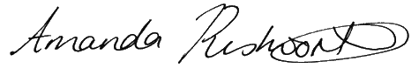

Minister Rishworth Minister Aly

Closing date for submissions: 30 April 2023

Email: earlyyearsengagement@dss.gov.au
Mail: Early Years Strategy GPO Box 9820
Department of Social Services Canberra ACT 2601

Enquiries: All enquiries should be sent to earlyyearsengagement@dss.gov.au.

This discussion paper is not Government policy. It will shape the way that the Commonwealth Government understands what the Australian community wants for our young children (a vision), what we want them to achieve (outcomes) and what we should prioritise to ensure the best outcomes for all children (priority reform areas).

Public consultation on this paper is an opportunity to work together and share in the ownership of a new Early Years Strategy (the Strategy).

Acknowledgement of Country
The Commonwealth Government acknowledges the traditional owners of Country throughout Australia on which we gather, live, work and stand. We acknowledge all traditional custodians, their Elders past, present and emerging and we pay our respects to their continuing connection to their culture, community, land, sea and water.

Section 1. Introduction

Discussion paper
This discussion paper supports a submission process and includes questions to guide submissions.

Developing the Early Years Strategy is an opportunity to have a national conversation about what we want for young children and their families, and where we should direct our efforts to achieve these aspirations.

While everyone has a role to play in securing good early years outcomes for our children, the focus of this paper and of the Strategy is on the role of the Commonwealth Government in supporting children in the early years. We want to hear from parents, families, carers and caregivers, educators, early childhood professionals and other experts about a national approach that would benefit children and families everywhere.

The purpose of an Early Years Strategy
The Strategy will create an enduring vision for Australia’s children and their families. It will be a road map to guide early years’ policies and programs across the Commonwealth for the next decade, providing a vision of what Australia wants to achieve for children and families in the early years.

The Strategy will be a framework for action and reform. The intention is to create an integrated approach to the early years, including by reducing program and funding silos across Commonwealth departments and better integrating and coordinating functions. This will increase accountability for the wellbeing, education, health (including mental health), safety and development of Australia’s children.

Approach to developing an Early Years Strategy

Stakeholder engagement and consultation
Consultation and stakeholder engagement will help shape the Commonwealth Government’s understanding of what the Australian community wants for young children, what we all want them to achieve and what we should prioritise to ensure the best outcomes for all children.

There will be various opportunities for people to contribute their views, including surveys, public submission process and participating in roundtables. There will also be local engagement and consultation with children and families.

To find out more about other opportunities to have your say and how an expert advisory panel is guiding the development of the Strategy, you can visit the Early Years Strategy website (https://www.dss.gov.au/families-and-children-programs-services/early-years-strategy).

Scope and key considerations

First five years
The Strategy will focus on the first five years, including the antenatal period. While important life transitions and developmental milestones continue beyond the age of five into the schooling years, this time is a critical developmental window that sets children up for lifelong success.

Commonwealth Government focus
All governments play an important role in supporting the early years through programs and policies. The Strategy will focus on the Commonwealth’s role and will aim to maximise the outcomes of the Commonwealth’s investment in the early years.

This will be a Commonwealth Strategy because of the inherent value in a national overlay and the substantial contribution that the Commonwealth makes in the early years with policies and programs that cover many areas of early childhood health, development and education. There is scope for the Commonwealth to improve the way in which children and families are supported across portfolios. A national Strategy will seek to ensure that all children, wherever they live, enjoy the same opportunities to learn, develop and thrive.

A focus on breaking down silos
The Commonwealth’s footprint includes everything from universal services for all families and children, targeted support for families and children who face particular challenges, and tertiary interventions where needed to help address challenges to achieving the best outcomes for children in the early years.

The Commonwealth funds health, maternal and child health and wellbeing programs and early intervention health services. It supports the family law system and programs that prevent and respond to child sexual abuse and domestic family and sexual violence. It offers direct financial support to families, including paid parental leave, and programs supporting families and carers with young children. Through a mix of direct and indirect funding mechanisms, the Commonwealth aims to provide all young children with access to affordable quality early childhood education and care as well as enriching home based learning environments through programs such as playgroups and toy libraries.

In addition to programs for the general population, the Commonwealth invests in measures to improve the health, development and education of First Nations children to reduce systemic and multi-generational disadvantage. There are also programs of supports for children with developmental delay or disability, as well as those at risk of disadvantage due to displacement, poverty or traumatic experiences.

Many of these Commonwealth early childhood policies and programs and their funding are delivered across different departments and agencies. This structure tends to create silos that discourage collaboration across organisations and may hamper the Commonwealth’s efforts to deliver the best outcomes for children and families. While some inroads have been made into improving service delivery and coordination in the early years, there is still more to be done. The Connected Beginnings program is an example of collaboration across two portfolios - health and education. The program helps First Nations children to get steady, wrap-around support to help meet learning and development milestones needed for a smooth start to school.

Relationship with other Commonwealth Government Strategies
The Strategy will build on, align with, and amplify, existing Commonwealth Government strategies across multiple portfolios, and commitments under the National Agreement on Closing the Gap, including the National Aboriginal and Torres Strait Islander Early Childhood Strategy. A list of relevant Strategies is at Attachment A. Many of these strategies have a focus on particular cohorts and particular issues or experiences in early childhood.

Consideration of how the Commonwealth connects to broader supports in the early years will be important
Communities, families, parents, carers and kin all play an important role in shaping the early years. Commonwealth policies and programs should be well connected and operate effectively with early childhood supports offered by others, including state and territory governments. State and territory governments are responsible for antenatal and birthing services, maternal and child health services, preschool delivery, child protection systems and ensuring the quality of Early Childhood Education and Care (ECEC) services and continuous improvement in the sector.

Effective collaboration and well-coordinated government and non-government activities at the federal, state and local level help to create an effective early childhood system. For example, there is significant collaborative work underway between the Commonwealth and States and Territories, including tasking from National Cabinet to develop a national long-term vision for ECEC, progress efforts to address ECEC workforce shortages, and identify priority areas where governments can collaborate to support better outcomes across the ECEC system.

This Strategy will focus on maximising the value and impact of the Commonwealth's role in supporting the early years. The Strategy will not focus on state and territory policies and programs, but may note their points of intersection with Commonwealth activities.

International obligations
The Strategy will acknowledge and respect the Commonwealth Government’s commitments through the United Nations (UN) Convention on the Rights of the Child, the UN Declaration on the Rights of Indigenous Peoples and the UN Declaration on the Rights of Persons with Disabilities.

Strengths-based
The Strategy will have a focus on strengths. A strengths-based approach relies on the positive resources and abilities that children and families and communities have, and uses these. The Strategy does not seek to identify one right way to raise and support a child, instead it seeks to ensure that each family and community has what it needs to undertake this vital task.

Child and family centred
Childhood experiences occur in the context of families. This Strategy will be child and family centred, based on children and families’ voices, needs, interests, strengths, understandings and capacity, and will reflect the range and variety of experiences of children, their interests and diversity.

The Strategy will genuinely listen and include the voices of children and seek to capture their ideas and intentions. We acknowledge connections between children, families, kin and communities, and the importance of reciprocal relationships and partnerships. The Strategy will value the cultural and social contexts of children and their families.

The Strategy will honour the experiences and activities of childhood. The early years are not just about setting the right foundations for the future, but also about the present. Young children thrive in loving family relationships with plentiful opportunities for play, friendships and joyful experiences.

First Nations
Aboriginal and Torres Strait Islander children have the right to thrive and to grow up healthy, supported by strong families and proud in culture. Cultural identity, kinship structures and connection are strongly recognised as protective factors for children’s safety, health, wellbeing and development. Families and communities who have been impacted by intergenerational trauma and discriminatory policies that perpetuate disadvantage often have complex needs, and are most in need of targeted and intensive healing and support services that are culturally-safe and welcoming.

The Strategy will build on the Government’s commitment to Closing the Gap and the National Aboriginal and Torres Strait Islander Early Childhood Strategy, which aims to align and coordinate cross-portfolio effort across the whole-of-government and the early childhood systems and sectors. The new Early Childhood Care and Development Policy Partnership (ECPP) brings together Australian governments and First Nations representatives to develop recommendations to support First Nations children in their early years and enable First Nations peoples to work in genuine partnership with governments to drive community-led and holistic early childhood outcomes. The ECPP has been commissioned to support the development of the Strategy.

Respectful of diversity and inclusivity
The Strategy will be inclusive. Children with disability or with developmental concerns deserve the same positive experiences and opportunities to thrive as all children. Australia’s Disability Strategy and the Early Childhood Targeted Action Plan set out actions to ensure these children are supported to reach their full potential. The Strategy will complement these efforts and will be developed closely with the new National Autism Strategy.

The Strategy will recognise that families in Australia are diverse in culture, religion, language, ability, location and family composition and this includes the LGBTIQA+ community. The Strategy will also recognise that children may live with carers, kin, or in other care arrangements, such as foster, residential and respite care.

Data
In Australia, we have rich sources of data about children and families that can be used to guide the priorities and performance of the Strategy. These include:

- population level data on children’s health, education, social supports, income, housing and safety, like those summarised in the Australian Institute of Health and Welfare’s report Australia’s Children 2022^{i};
- the Australian Early Development Census, a nationwide data collection of early childhood development at the time children start their first year of full-time school;
- cohort studies such as the Longitudinal Study of Australian Children and the Longitudinal Study of Indigenous Children; and
- data linkage research projects that provide whole-of-life insights about population groups in Australia, like those using the Multi-Agency Data Integration Project (MADIP) data.

There will be opportunities to use and improve data on the early years of children’s life to ensure the Strategy’s priorities and policies are targeted to have the most impact, and outcomes can be measured.

Section 2. The case for an Early Years Strategy

The evidence
The first years of a child’s life, prior to birth to age five, are a critical window for development. During this time, the early relationships, experiences and care they receive actively shape lifetime health, learning, and identity. In the first few years of life, brain development occurs more quickly than any other time and more than 1 million new neural connections are formed every second. After this period of rapid growth, connections are reduced through a process called pruning so that brain circuits become more efficient and more complex brain circuits can be built upong earlier, simpler circuits. The flexibility of early brain development means it is easier and more effective to influence a baby’s developing brain architecture than to rewire parts of its circuitry in the adult years^{ii}.

Positive experiences, relationships and environments in the early years (including the pre-birth period) support development and learning, and set children up for lifelong success in health, mental health, educational attainment, employment and relationships^{iii}. This is because we know that quality antenatal care during pregnancy, and regular antenatal care in the first trimester, is associated with better maternal health in pregnancy, fewer interventions in late pregnancy and positive child health outcomes^{iv}.

Intervening as early as possible in a child’s development enhances the preventative effect and improves the impact of the intervention^{v}. The first 1000 days (from conception, throughout pregnancy and to the end of the second year) is particularly important to health and development. This is the time when there is most capacity to shape outcomes^{vi}. As children get older it can become harder to reverse the impacts of early adverse experiences and improve their life trajectory^{vii}. Gaps in early childhood continue throughout life. If a gap emerges and doesn’t close by the age of 5 it is likely to persist, especially for children experiencing vulnerability or disadvantage^{viii}.

The evidence for a return on investment in the early years is strong. For example, research by Access Economics in 2010 found that the potential value of future benefits that can be realised as a result of early intervention and prevention is over $5.4 billion per annum^{ix}. A 2019 report from Telethon Kids found that Australian governments are spending $15.2 billion each year of high-intensity and crisis services from problems that may have been avoided through early intervention^{x}.

Economist Dr James Heckman has shown high quality early childhood programs for disadvantaged children can yield returns of between $4 and $16 for every $1 invested^{xi}. His recent research on comprehensive, high-quality, birth to 5 years old early childhood programs for disadvantaged children yielded a 13 per cent return on investment per child per annum, through better education, economic, health and social outcomes.

Economic analysis conducted by PricewaterhouseCoopers and The Front Project in 2019 identified a $2 benefit for every $1 invested in high quality Early Education and Care over a child’s life^{xii}.

The additional benefit of investing in the early years is that programs that support good early childhood outcomes, such as Paid Parental Leave that encourages greater involvement by fathers, also support workforce participation, improving women’s economic security.

How children are faring
Many Australian children from birth to 5 years in Australia are happy, healthy, and experience good overall outcomes. There are 1.5 million children aged 0-5 years old in Australia¹, and many of them have the things they need for a great start in life. This includes access to health care and proper nutrition, protection from harm, opportunities for early learning and responsive caregiving. Although more babies are born each year than ever before in Australia’s history, Australia’s population is ageing and the proportion of young people is smaller and projected to continue to decrease over time^{xiii}.

Immunisation rates have improved and are above 94 per cent for one year olds, and less mothers are smoking during their pregnancy^{xiv}. The quality of ECEC services has consistently risen in recent years, with 88 per cent of the 15,000 approved ECEC services in Australia meeting or exceeding the National Quality Standards^{xv}.

A population measure of early childhood development which is completed by teachers on all children starting school every three years, the Australian Early Development Census (AEDC) measures how children’s development is tracking when they start school. It looks at children’s physical health, social skills, emotional maturity, their early literacy and numeracy skills, and their communication and general knowledge. In 2021—the most recent AEDC—55 per cent of children were developmentally on track on all five domains.

However, we also know that some children are not getting the best start in life and are falling behind. While just over half of all children were on track on all domains in 2021, nearly 45 per cent were developmentally at risk or developmentally vulnerable on one or more domain; and over one in five children (22 per cent) were assessed as developmentally vulnerable in at least one domain^{xvi}, meaning they were not where we would expect a healthy, thriving child to be at that age.

Across Australia the place in which children are born and raised can impact on their chances of success in later years. The AEDC shows the development of children in disadvantaged communities has improved only slightly in recent years, and in some cases is going backwards. Children living in major cities are less likely to be developmentally vulnerable on the AEDC domains than those who live outside the major cities, although this gap has fluctuated from 2009 to 2021.

The AEDC results also show that in 2021, the gap between the most socio-economically disadvantaged locations and the least disadvantaged areas increased across all domains, with children from more disadvantaged locations 2 to 4.4 times as likely to be developmentally vulnerable, depending on the domain of development^{xvii}.

Children from disadvantaged backgrounds (especially those whose parents have lower formal education levels, or who have lower household and neighbourhood socio-economic status backgrounds) are more likely to be developmentally vulnerable on school entry^{xviii}.

Likewise, some groups are more likely to experience developmental vulnerability - First Nations children, children in regional and remote areas, children with language backgrounds other than English, and children with disability^{xix}. The gap between First Nations children and non-First Nations children increased to 24.7 percentage points in the language and cognitive development domain. Children frequently experience more than one kind of disadvantage. For example, children with disability are more likely to live in single income households (Sollis, 2019); and regional and remote

1 This figure is derived from the 2021 census data and counts children aged 0 to 5 exclusive. This means it counts children aged 0 up to the date of their fifth birthday.

areas are more likely to be socio-economically disadvantaged (ABS, 2016). These multiple types of vulnerability compound and make it harder for children and families to thrive without the right support.

Experiences, expectations and cultural norms in our homes and communities influence children as they learn about the world. For example, children are influenced by the gendered stereotypes that their families, friends, education and media present to them. Entrenched gender-bias and stereotyping from childhood continues to influence learning throughout a child’s life, and creates barriers to a person’s choices and opportunities later in life^{xx}. In particular, this has had a compounding and detrimental effect on girls, preventing them from realising their full potential.

Section 3. Your views
The following section invites responses on a range of questions. You are welcome to respond to some or all of the questions, or provide any other feedback that you think is relevant to the
development of the Strategy. This will ensure the Strategy incorporates as many voices as it can.

Proposed structure of Early Years Strategy
The proposed structure of the Strategy includes a vision, outcomes, policy priorities and indicators which will measure success against each of the outcomes and priority reform areas. It is proposed that indicators will be developed after the policy priorities are established. A diagram of the proposed structure is at Attachment B.

Implementation Action Plans will be developed after the Strategy is finalised and will set out what will be done to respond to the priority reforms. An Outcomes and Evaluation Framework will also be developed to monitor performance.
QUESTION
1. Do you have any comments on the proposed structure of the Strategy?

Vision
The Strategy’s vision will describe the Commonwealth Government’s aspirations and ambitions for children in the early years. The Strategy’s vision will describe how we want the next generation of Australians to experience their first five years of life. It will be informed by what we hear from the Australian community about what they want for young children in Australia, especially in the critical years from before birth to age five.

Note: the vision for the Strategy is intended to be broader than the vision for the ECEC sector that the Commonwealth Government is developing in collaboration with State and Territory Governments. The Strategy’s vision should encompass aspirations for children across all aspects of their lives.
QUESTION
2. What vision should our nation have for Australia’s youngest children?

Outcomes
An outcome should describe what the Strategy will achieve. There are a range of outcomes that children need to do well in life. The Strategy will identify the most important short, medium and long term outcomes to support the early years.

The type of outcomes the Strategy could include might be statements about children being physically and emotionally healthy, learning and developing, being safe or having a positive sense of identity. It could also include references to meeting basic needs or having opportunities to participate in social and community activities, acknowledging culture or ensuring that the early years are inclusive of different families and their needs.

There are many interconnected factors that contribute to good outcomes in the early years. This question asks you to think about the outcomes that should be included in the Strategy.
QUESTION
3. What mix of outcomes are the most important to include in the Strategy?

Policy priorities
For the Strategy to be effective, it is important to identify specific areas (policy priorities) where the Government should focus its efforts.

One area that the Government has already identified as a priority is for the Commonwealth Government to address and break down silos. If there is not a coordinated, joined up approach across Government, there is a lack of ultimate responsibility and accountability for Australia’s children. A siloed approach also risks duplicating functions, unnecessary competing for resources and missing opportunities to work collaboratively to improve outcomes.

Some priorities will emerge as the vision and outcomes for the Strategy take shape. We welcome early ideas on priorities for the Strategy.
QUESTIONS
- What specific areas/policy priorities should be included in the Strategy and why?
- What could the Commonwealth do to improve outcomes for children—particularly those who are born or raised in more vulnerable and/or disadvantaged circumstances?
- What areas do you think the Commonwealth could focus on to improve coordination and collaboration in developing policies for children and families?

Principles
A set of principles will be developed to guide policy and implementation under the Strategy.

Guiding principles could include things such as being child and family centred, listening to the views of children and families, and being inclusive of diverse children and families. They could also consider the needs of children and families across the service system and over time.
QUESTION
7. What principles should be included in the Strategy?

Evidence-based approach
Researchers and practitioners have developed many frameworks to guide policy and practice for the early years. These models or frameworks highlight how different parts of a child’s life work together to contribute to positive childhood outcomes. Some of these are described below.

The purpose of these frameworks is similar – to put children at the centre of all policy development and show the interconnections and important elements of early childhood development. These frameworks may help shape the Strategy. Examples include the public health model, ecological systems theory, the Australian Research Alliance for Children and Youth child wellbeing framework (the Nest), and the Organisation for Economic Cooperation and Development (OECD) well-being frameworks. Further information about example frameworks is listed below. It’s important to note these frameworks are not the only source of evidence and data that will be drawn upon. The Strategy will recognise the importance of Aboriginal and Torres Strait Islander knowledge bases, recognising there are gaps in current evidence and data, a key priority under the current Closing the Gap Agreement.

- The public health model identifies areas of risk in children’s development and prevents problems before they occur by addressing that risk. The model provides different levels of support, from universal services available to everyone to highly targeted offerings. Universal services include things like our health and education systems; targeted (or secondary) services include policies such as parental leave; and tertiary services address acute issues such as child protection^{xxi}.

- The ecological systems theory developed by Urie Bronfenbrenner shows a child’s development is influenced by their surrounding environment, which ranges from a child’s immediate environment, through their family, community, and up to the influence of society^{xxii}.

- The Nest conceptualises wellbeing as six interconnected domains that support each other to help children both thrive in childhood and reach their full potential as they grow. To have optimal wellbeing, a child needs to have their needs met in all six domains, in an ecological model based on Bronfenbrenner’s^{xxiii}.

- The OECD has two key frameworks for measuring wellbeing. The first is a general wellbeing model that considers diverse experiences and living conditions of people and is built around three components, including current wellbeing, inequalities in wellbeing outcomes and resources for future wellbeing (Figure 1). A second more recent framework developed by the OECD is an aspirational model to pinpoint the aspects of children’s lives that should be measured to best monitor their wellbeing (Figure 2). It is centred on the idea that children should be able to both enjoy a happy childhood and develop skills and abilities that set them up for the future^{xxiv}.
QUESTION
8. Are there gaps in existing frameworks or other research or evidence that need to be considered for the development of the Strategy?

FIGURE 1
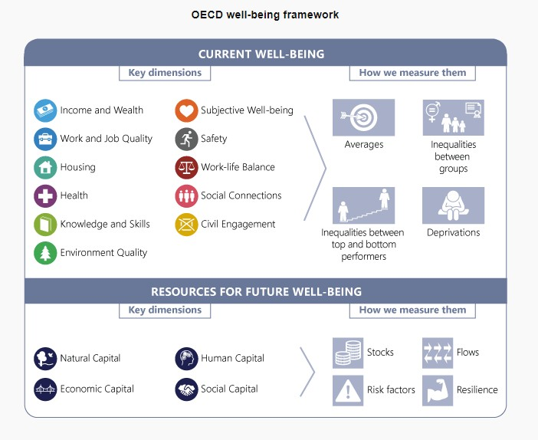

FIGURE 2

OECD Aspirational Child Well-being Measurement Framework
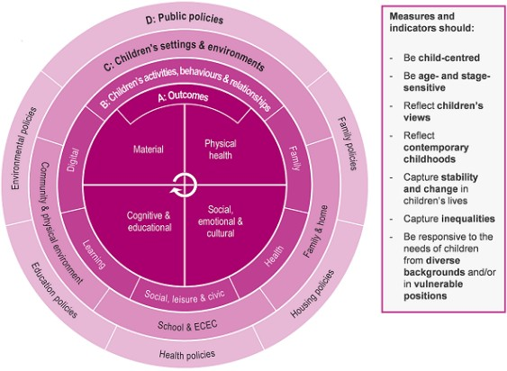

Attachment A – relevant Commonwealth Government initiatives
The Commonwealth Government has a range of strategies, initiatives and reforms that interact with the early years including the following:

Early Childhood Education and Care (ECEC):
- Cheaper Child Care for Working Families election commitment National Quality Framework (NQF) Review – implementation of changes to the Education and Care Services National Law and National Regulations and guidance for the sector
- Productivity Commission Inquiry into Child Care Sector
- Preschool Reform Agreement 2022-2025
- Shaping Our Future: National Children’s Education and Care Workforce Strategy – development of implementation plan and commitments to boost ECEC workforce – incl. fee- free TAFE places, Y Care Careers program
Disability:
- Australia’s Disability Strategy 2021-2031
- National Autism Strategy First Nations:
- Early Childhood Care and Development Policy Partnership 2022
- Early Childhood Care Development Sector Strengthening Plan
- National Aboriginal and Torres Strait Islander Early Childhood Strategy National Agreement on Closing the Gap
Health and Wellbeing
- National Action Plan for the Health of Children and Young People 2020-2030
- National Children’s Mental Health and Wellbeing Strategy
- National Fetal Alcohol Spectrum Disorder (FASD) Strategic Action Plan 2018-2028
- National Mental Health and Suicide Prevention Agreement
- National Preventive Health Strategy 2021-2030
- Treasury Wellbeing Framework
- National Strategy to Achieve Gender Equality Safety:
- National Plan to End Violence against Women and Children 2022-2032
- Safe and Supported: the National Framework for Protecting Australia’s Children 2021-2031

Attachment B - Proposed structure of the Early Years Strategy
This diagram provides a general description of the proposed structure of the Early Years Strategy, noting the number of outcomes and policy priorities have not yet been decided. There are a number of key design elements including:

- Vision – to set out an overarching and aspirational statement for the Strategy
- Outcomes – to establish the short and long term intended changes when the Strategy is implemented
- Policy Priorities – the focus areas under the Strategy that are considered most likely to have a positive effect on outcomes
- Indicators – measures that show if progress is being made towards reaching the planned outcomes
- Principles – the rules and guidelines for setting the direction and making decisions under the Strategy
- Evidence – evaluated and tested information to support the direction of the Strategy

Vision
Outcome/s
Outcome/s
Outcome/s
Policy Priorities
Policy Priorities
Policy Priorities
Indicators
Principles

Evidence

Proposed structure of the Implementation Action Plan

The proposed Implementation Action Plan will describe how the Strategy will be implemented and will include detailed action plans and will be underpinned by a framework to evaluated the effectiveness of the Strategy.

Implementation Action Plan/s
Policy Priority 1
Policy Priority 2
Policy Priority 3
Targeted action plans
Targeted action plans
Targeted action plans
Outcomes and Evaluation Framework

References

i Australian Institute of Health and Welfare, Australia's children, web report, lsat updated 25 February 2022. Accessed 24 Jan 2023.
ii Center on the Developing Child (2007). The Science of Early Childhood Development (InBrief). Retrieved from www.developingchild.harvard.edu
iii TG Moore, N Arefadib, A Deery, and S West, The First Thousand Days: An Evidence Paper, 2017, Parkville, Victoria: Centre for Community Child Health, Murdoch Children’s Research Institute. https://doi.org/10.25374/MCRI.5471779 ; J Heckman, Invest in Early Childhood Development: Reduce Deficits, Strengthen the Economy, heckmanequation.org, n.d, accessed 6 December 2022; EA Shuey and M
Kankaraš, The power and promise of early learning, 2018, OECD Education Working Paper No. 186. Paris,
France: OECD publishing. DOI: https://doi.org/10.1787/f9b2e53f-en
iv Australian Institute of Health and Welfare, Australia’s mothers and babies, web report, last updated 29 Nov 2022. Accessed on 6 Dec 2022.
v T Moore and N Arefadib, Tasmanian Play2Learn+ Trial: Evidence Review, 2022, Parkville, Victoria, Centre for Community Child Health, the Murdoch Children’s Research Institute. (To be published on MCRI website on 11 Dec); S Fox, A Southwell, N Stafford, R Goodhue, D Jackson, and C Smith. Better Systems, Better Chances: A Review of Research and Practice for Prevention and Early Intervention, 2015. Canberra, ACT: Australian Research Alliance for Children and Youth (ARACY); TG Moore and M McDonald, Acting Early, Changing Lives: How prevention and early action saves money and improves wellbeing, 2013, Prepared for The Benevolent Society. Parkville, Victoria: Centre for Community Child Health, Murdoch Childrens Research Institute, The Royal Children’s Hospital. DOI: 10.4225/50/5578D0A59EA66.
vi TG Moore, N Arefadib, A Deery, and S West, The First Thousand Days: An Evidence Paper, 2017, Parkville, Victoria: Centre for Community Child Health, Murdoch Children’s Research Institute. https://doi.org/10.25374/MCRI.5471779
vii TG Moore, N Arefadib, A Deery, and S West, The First Thousand Days: An Evidence Paper, 2017, Parkville, Victoria: Centre for Community Child Health, Murdoch Children’s Research Institute, p.70 https://doi.org/10.25374/MCRI.5471779
viii OECD (2022), Improving Early Equity: From Evidence to Action, OECD Publishing, Paris, https://doi.org/10.1787/6eff314c-en
ix Research by Access Economics in 2010 found that the potential value of future benefits that can be realised as a result of early intervention and prevention is over $5.4 billion per annum
x CoLab – Collaborate for Kids, How Australia can invest in children and return more: A new look at the $15bn cost of late action https://www.telethonkids.org.au/our-research/impact/2020/collaboration/counting-the- cost-of-late-intervention/
xi; J Heckman, Invest in Early Childhood Development: Reduce Deficits, Strengthen the Economy, heckmanequation.org, n.d, accessed 6 December 2022.
xii PWC for the Front Project, A Smart Investment for a Smarter Australia: Economic analysis of universal early childhood education in the year before school in Australia, June 2019, accessed 6 December 2022.
xiii Centre for Population (2023), 2022 Population Statement, The Australian Government, Canberra
xiv Australian Institute of Health and Welfare, Australia's mothers and babies, Smoking during pregnancy - Australian Institute of Health and Welfare (aihw.gov.au), 29 November 2022.
xv The Australian Children’s Education and Care Quality Authority, National Quality Framework Snapshots, accessed 6 December 2022.
xvi AEDC - Nearly 45% of children are starting school developmentally vulnerable or at risk on at least one domain
xvii Australian Government Department of Education, Skills and Employment Australian Early Development Census National Report 2021: Early Childhood Development in Australia, accessed 15 December 2022.
xviii Children from disadvantaged backgrounds (especially those whose parents have lower formal education levels, or who have lower household and neighbourhood socio-economic status backgrounds) are more likely to be developmentally vulnerable on school entry
xix AEDC and; B Edwards and J Baxter, The Tyrannies of Distance and Disadvantage: Factors related to children’s development in regional and disadvantaged areas of Australia, November 2013, Australian Institute of Family Studies.
xx Deloitte Access Economics, Breaking the Norm: Unleashing Australia’s Economic Potential, November 2022.

xxi The Australian Institute of Family Studies, The public health approach to preventing child maltreatment, June 2016, accessed 6 December 2022; NSW Department of Communities and Justice, the public health model for child protection and wellbeing, accessed 6 December 2022.
xxii O Guy-Evans, Bronfenbrenner’s Ecological Systems Theory, published 9 November 2020, simplypsychology.org.
xxiii Goodhue, R., Dakin, P., Noble, K. 2021 What’s in the Nest? Exploring Australia’s Wellbeing Framework for Children and Young People, ARACY, Canberra
xxiv OECD (2021), Measuring What Matters for Child Well-being and Policies, OECD Publishing, Paris, https://doi.org/10.1787/e82fded1-en

